
API application manual

Topic: | API application manual For Vending

Summary | API application manual  By reading this document, you can quickly use the API, generate Vending Token，Clear Credit Token and so on.
API application manual For Vending
Catalogue
1 FOREWORD 3
1.1 Prepare 3
1.2 Web Site：Test platform 3
2 Vending API 4
2.1 Send a Clear Credit request to the server 4
2.2 Send a directly Clear Credit request to the server 5
2.3 Send a Clear Tamper request to the server 6
2.4 Send a directly Clear Tamper request to the server 7
2.5 Send a Query Customer Customer Cedit request to the server 8
2.6 Send a Query Customer Information record request to the server 9
2.7 Send a Query Meter Credit request to the server 10
2.8 Send a Query Meter ID Information record request to the server 11
2.9 Send a Vending request to the server 12
2.10 Send a Vending directly request to the server 14

FOREWORD

Prepare
- Before calling the api, you can input basic data, such as meter number, price, customer information, and account opening information, into the system through our Vending management system, so that the API can be executed correctly.
- The account of the Vending management system can be obtained by asking our sales staff.

Web Site：Test platform
Follow these serveral steps to get token easily using the API，More detailed API description ，Please refer to the website
http://www.server-newv.stronpower.com/swagger

Vending API

Send a Clear Credit request to the server
Request URL as follows:
http://www.server-newv.stronpower.com/api/ClearCredit
If we want Clear Credit. And the Post Body as follows：
{
"CompanyName": "your company name",
"UserName": "your user name",
"PassWord": "your password",
"CustomerID": "your customer’s id , This number is your own definition",
"METER_ID": " your customer’s Meter id"
}

If I want to Clear Credit of meter 58100711868 ，and Customer Id is CTS-00003 , MeterNumber is 58100711868
Post Body as follows：
{
"CompanyName": "Stron-Good",
"UserName": "Admin01",
"PassWord": "123456",
"CustomerId": "CTS-00003",
"METER_ID": "58100711868"
}
Operation instance：
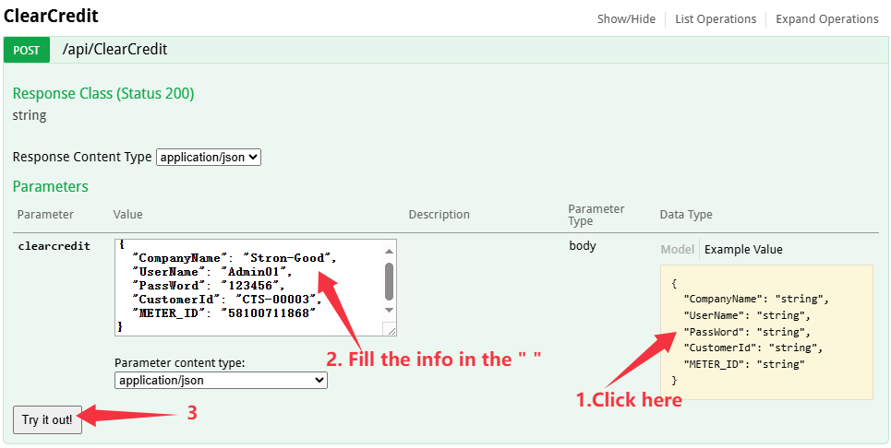
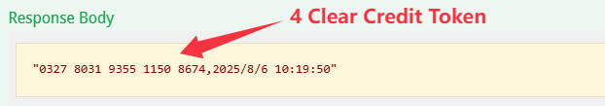

Send a directly Clear Credit request to the server
Request URL as follows:
http://www.server-newv.stronpower.com/api/ClearCreditDirectly
If you want generate the Clear Credit Token, and don’t want New Price,district, Sales Satations and Customer information into Server. So you can use this kind of API ClearCreditDirectly.

If we want get Clear Credit Token directly. And the Post Body as follows：
{
"CompanyName": "Your company name",
"UserName": "Your name",
"PassWord": "Your password",
"Meter_ID": "58100711868"
}

Operation instance：

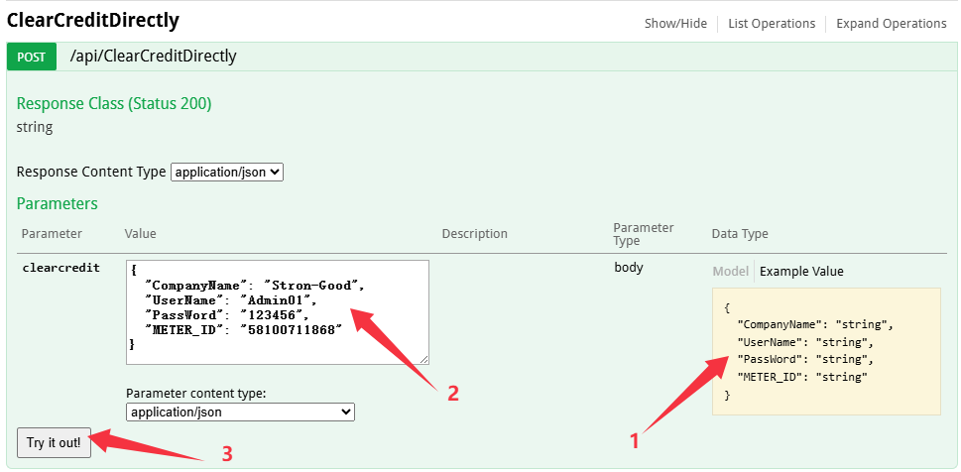
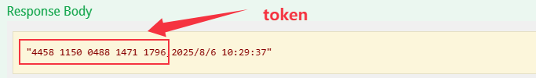

Send a Clear Tamper request to the server
Request URL as follows:
http://www.server-newv.stronpower.com/api/ClearTamper

If we want Clear Tamper. And the Post Body as follows：
{
"CompanyName": "your company name",
"UserName": "your user name",
"PassWord": "your password",
"CustomerID": "your customer’s id , This number is your own definition",
"METER_ID": " your customer’s Meter id"
}

If I want to Clear Tamper of meter 58100711868 ，and Customer Id is CTS-00003, MeterNumber is 58100711868
Post Body as follows：
{
"CompanyName": "Stron-Good",
"UserName": "Admin01",
"PassWord": "123456",
"CustomerId": "CTS-00003",
"METER_ID": "58100711868"
}
Operation instance：
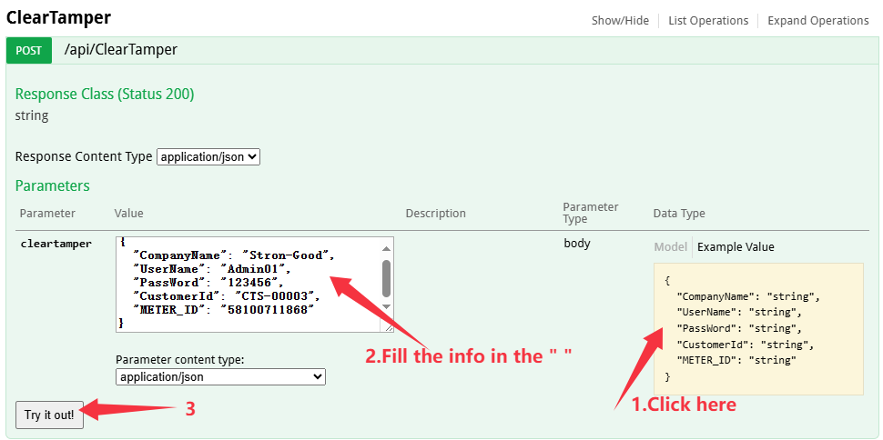
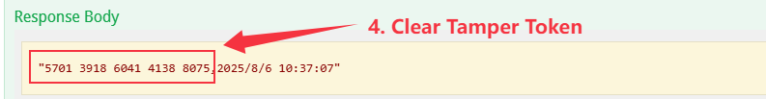

Send a directly Clear Tamper request to the server
Request URL as follows:
http://www.server-newv.stronpower.com/api/ClearTamperDirectly
If you want generate the Clear Tamper Token, and don’t want New Price,district, Sales Satations and Customer information into Server. So you can use this kind of API ClearTamperDirectly.

If we want get Clear Tamper Token directly 。And the Post Body as follows：
{
"CompanyName": "Your company name",
"UserName": "Your name",
"PassWord": "Your password",
"Meter_ID": "58100711868"
}

Operation instance：

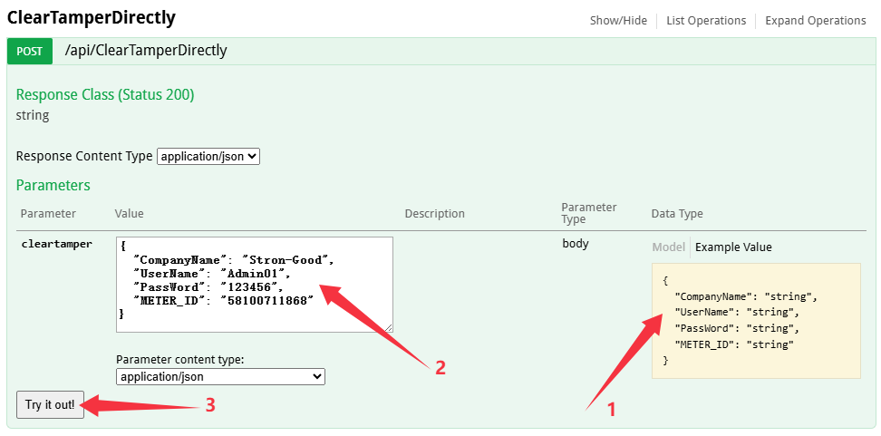
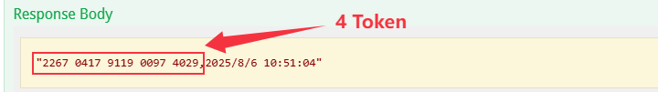

Send a Query Customer Customer Cedit request to the server
Request URL as follows:
http://www.server-newv.stronpower.com/api/QueryCustomerCredit

If I want to query credit record of company “Stron-Good ” ，and Customer ID is CTS-00003
Post Body as follows：
{
"CompanyName": "Stron-Good",
"UserName": "Admin01",
"PassWord": "123456",
"CustomerId": "CTS-00003"
}
Operation instance：
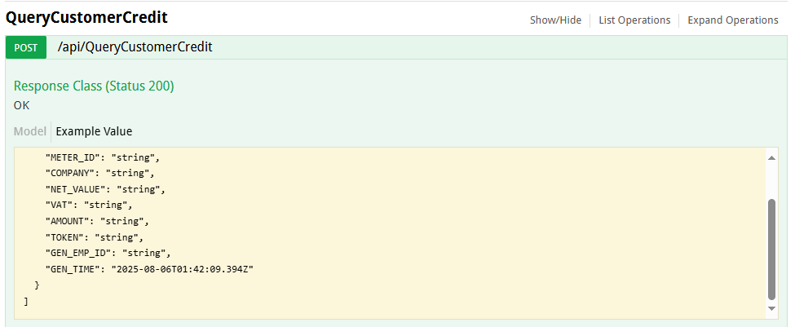
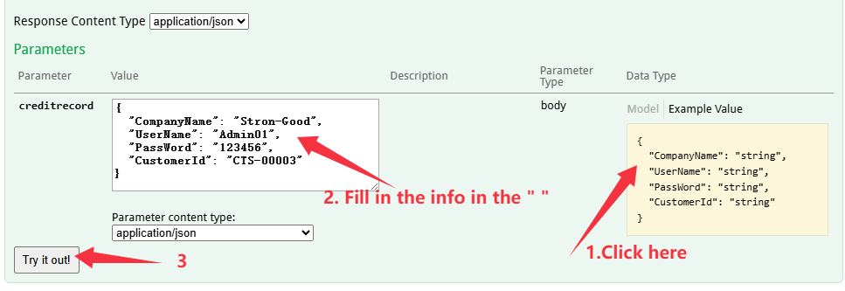
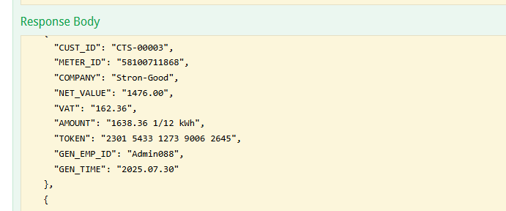

Send a Query Customer Information record request to the server
Request URL as follows:
http://www.server-newv.stronpower.com/api/QueryCustomerInfo

If I want to query credit record of company “Stron-Good ” ，and Customer ID is CTS-00003
Post Body as follows：
{
"CompanyName": "Stron-Good ",
"UserName": "Admin01",
"PassWord": "123456",
"CustomerId": "CTS-00003"
}

Operation instance：

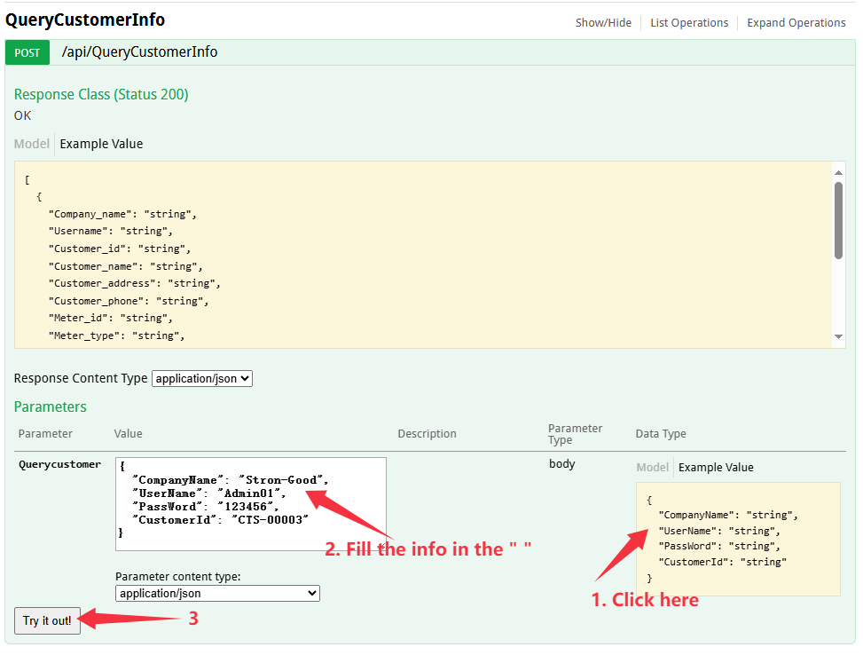
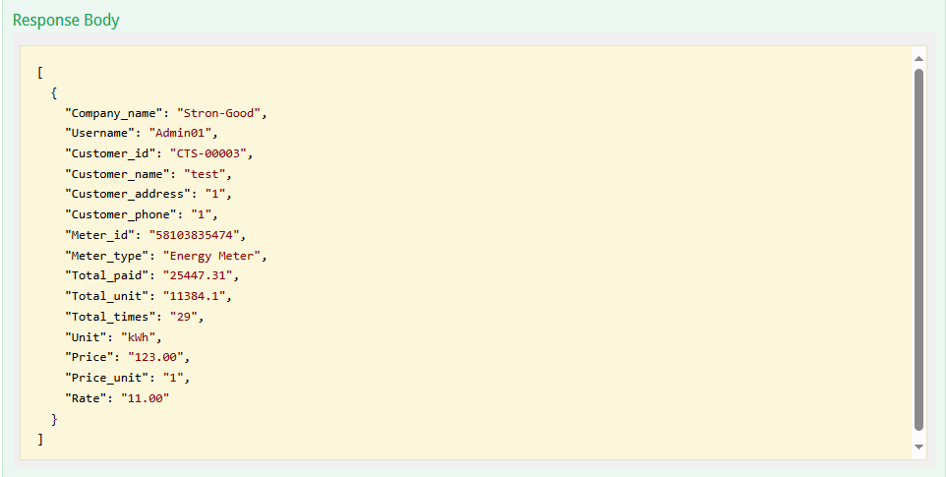

Send a Query Meter Credit request to the server
Request URL as follows:
http://www.server-newv.stronpower.com/api/QueryMeterCredit

If I want to query credit record of company “Stron-Good ” ，and Meter ID is 58100711868
Post Body as follows：
{
"CompanyName": "Stron-Good",
"UserName": "Admin01",
"PassWord": "123456",
"MeterId": "58100711868"
}

Operation instance：

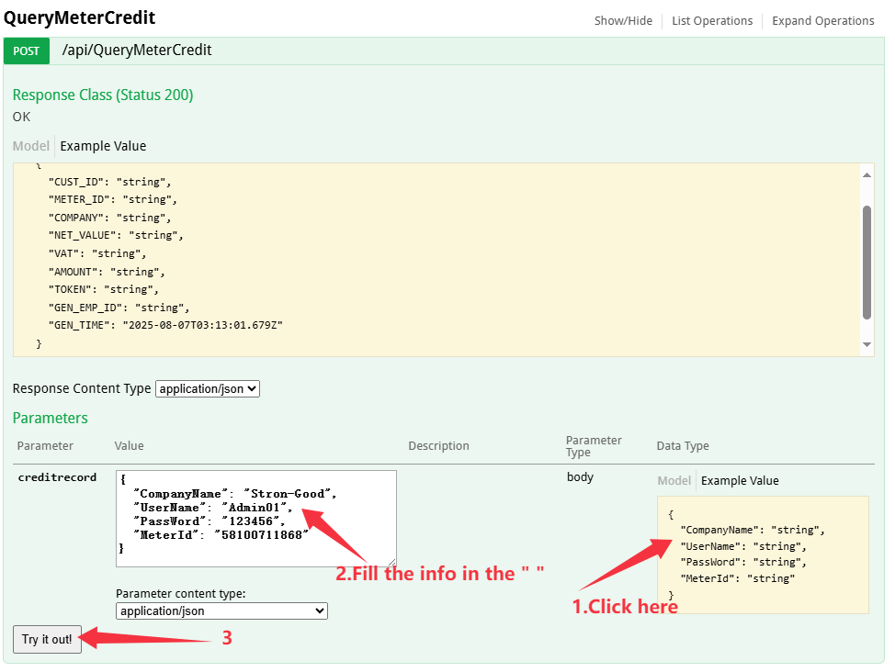
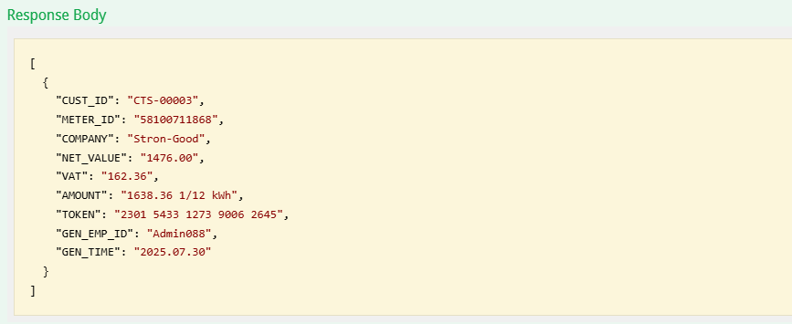

Send a Query Meter ID Information record request to the server
Request URL as follows:
http://www.server-newv.stronpower.com/api/QueryMeterInfo

If I want to query credit record of company “Stron-Good” ，and Meter ID is 58100711868
Post Body as follows：
{
"CompanyName": "Stron-Good",
"UserName": "Admin01",
"PassWord": "123456",
" MeterId": "58100711868"
}
Operation instance：

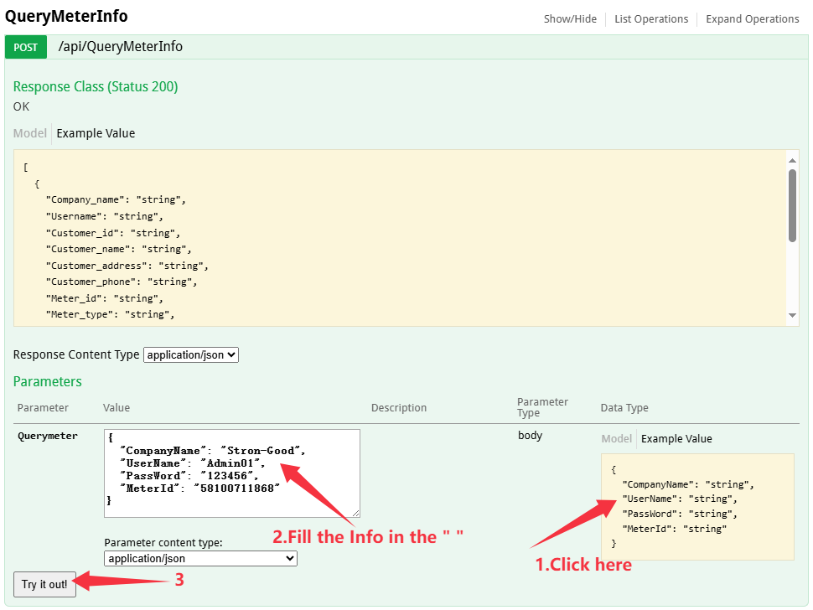
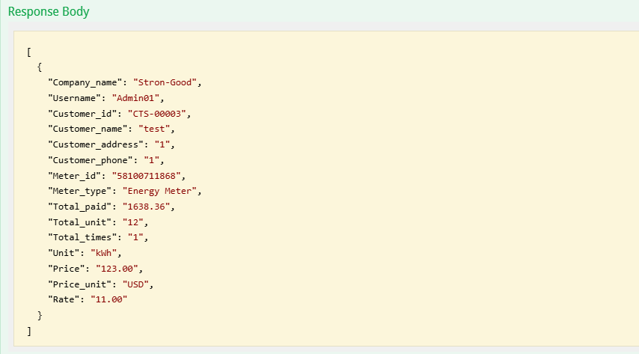

Send a Vending request to the server
Request URL as follows:
http://www.server-newv.stronpower.com/api/VendingMeter

Parameter | Value | Explanation
is_vend_by_unit | true | Vending by unit
 | false | Vending by money

the post Body as follows：

{
"CompanyName": " your company name ",
"UserName": " your user name ",
"PassWord": " your password ",
"MeterID": "string",
"is_vend_by_unit": "true: vending unit . false: vending money ",
"Amount": 0
}

For example , If I want to top up the first meter , and meter ID is 58100711868, and recharge money 100 USD. the post Body as follows：
{
"CompanyName": "Stron-Good ",
"UserName": "Admin01",
"PassWord": " 123456 ",
"MeterID": "58100711868",
"is_vend_by_unit": "false ",
"Amount": 100
}

Notes： if you want vending by unit, and the value of is_vend_by_unit is true.

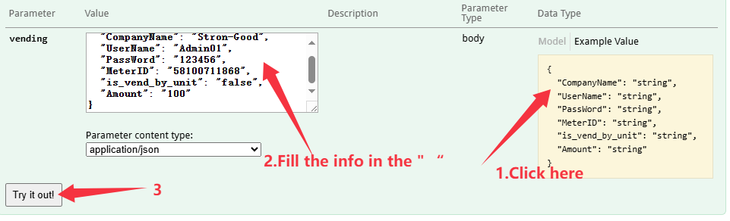
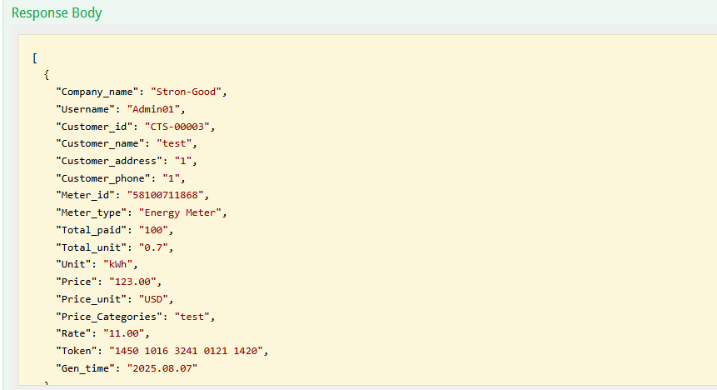

Send a Vending directly request to the server
Request URL as follows:
http://www.server-api.stronpower.com/api/VendingMeterDirectly
If you want generate the Token, and don’t want New Price,district, Sales Satations and Customer information into Server. So you can use this kind of API VendingMeterDirectly.
So if we want generate the Token for Meter 58100711868, Meter type is Energy Meter,and recharge 10 kWh.
Post Body as follows：
{
"CompanyName": "your Company Name",
"UserName": "xxxxx",
"PassWord": "xxxxxxxxxxx",
"MeterId": "58100711868",
"Amount": "30"
}
Operation instance：
