**Games Programming Taster**

**Cannon Fodder: An Introduction to Unity Development**

**Getting Started**

Load the Project indicated by the lecturer.

Sometimes when a Project has been packaged a certain way, an untitled and empty Scene opens:

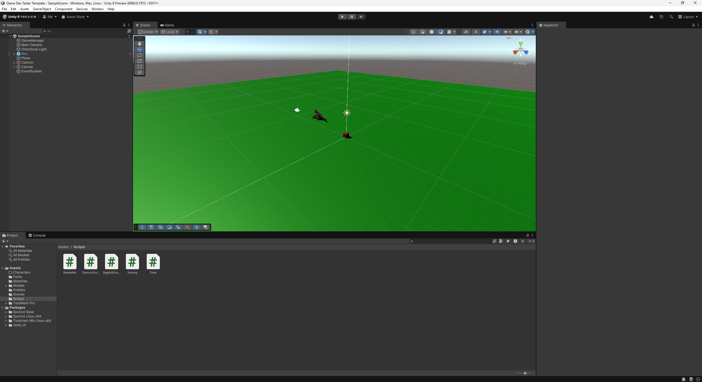

You may like to change your layout so you can see the Scene AND Game panes together. ‘2 by 3’ is one option:

We will be working with the CannonController script file located in the Project Pane under the ‘Scripts’ folder:

Open the file using Visual Studio 2022 and you will see something like this:

Edit to reflect the following:

|  |
| --- |
| using UnityEngine;  public class CannonController : MonoBehaviour  {  // START HERE  public GameObject barrel;  public GameObject shotSpawn;  public GameObject shot;  public float rateOfFire = 2f;  public float shotSpeed = 800f;  float fireDelay;  // Update is called once per frame  void Update()  {  float rotation = Input.GetAxis("Horizontal");  transform.Rotate(0f, rotation, 0f);  float pitch = Input.GetAxis("Vertical") +  barrel.transform.rotation.eulerAngles.x;  pitch = Mathf.Clamp(pitch, 320f, 359f);  Quaternion barrelRotation = Quaternion.Euler(pitch, 0f, 0f);  barrel.transform.localRotation = barrelRotation;  if (Input.GetButton("Fire3") && Time.time > fireDelay)  {  fireDelay = Time.time + rateOfFire;  GameObject shotInstance = Instantiate(shot,  shotSpawn.transform.position,  shotSpawn.transform.rotation);    shotInstance.GetComponent<Rigidbody>()  .AddForce(shotSpawn.transform.forward * shotSpeed);  }  }  } |

Run the game by clicking the run button:

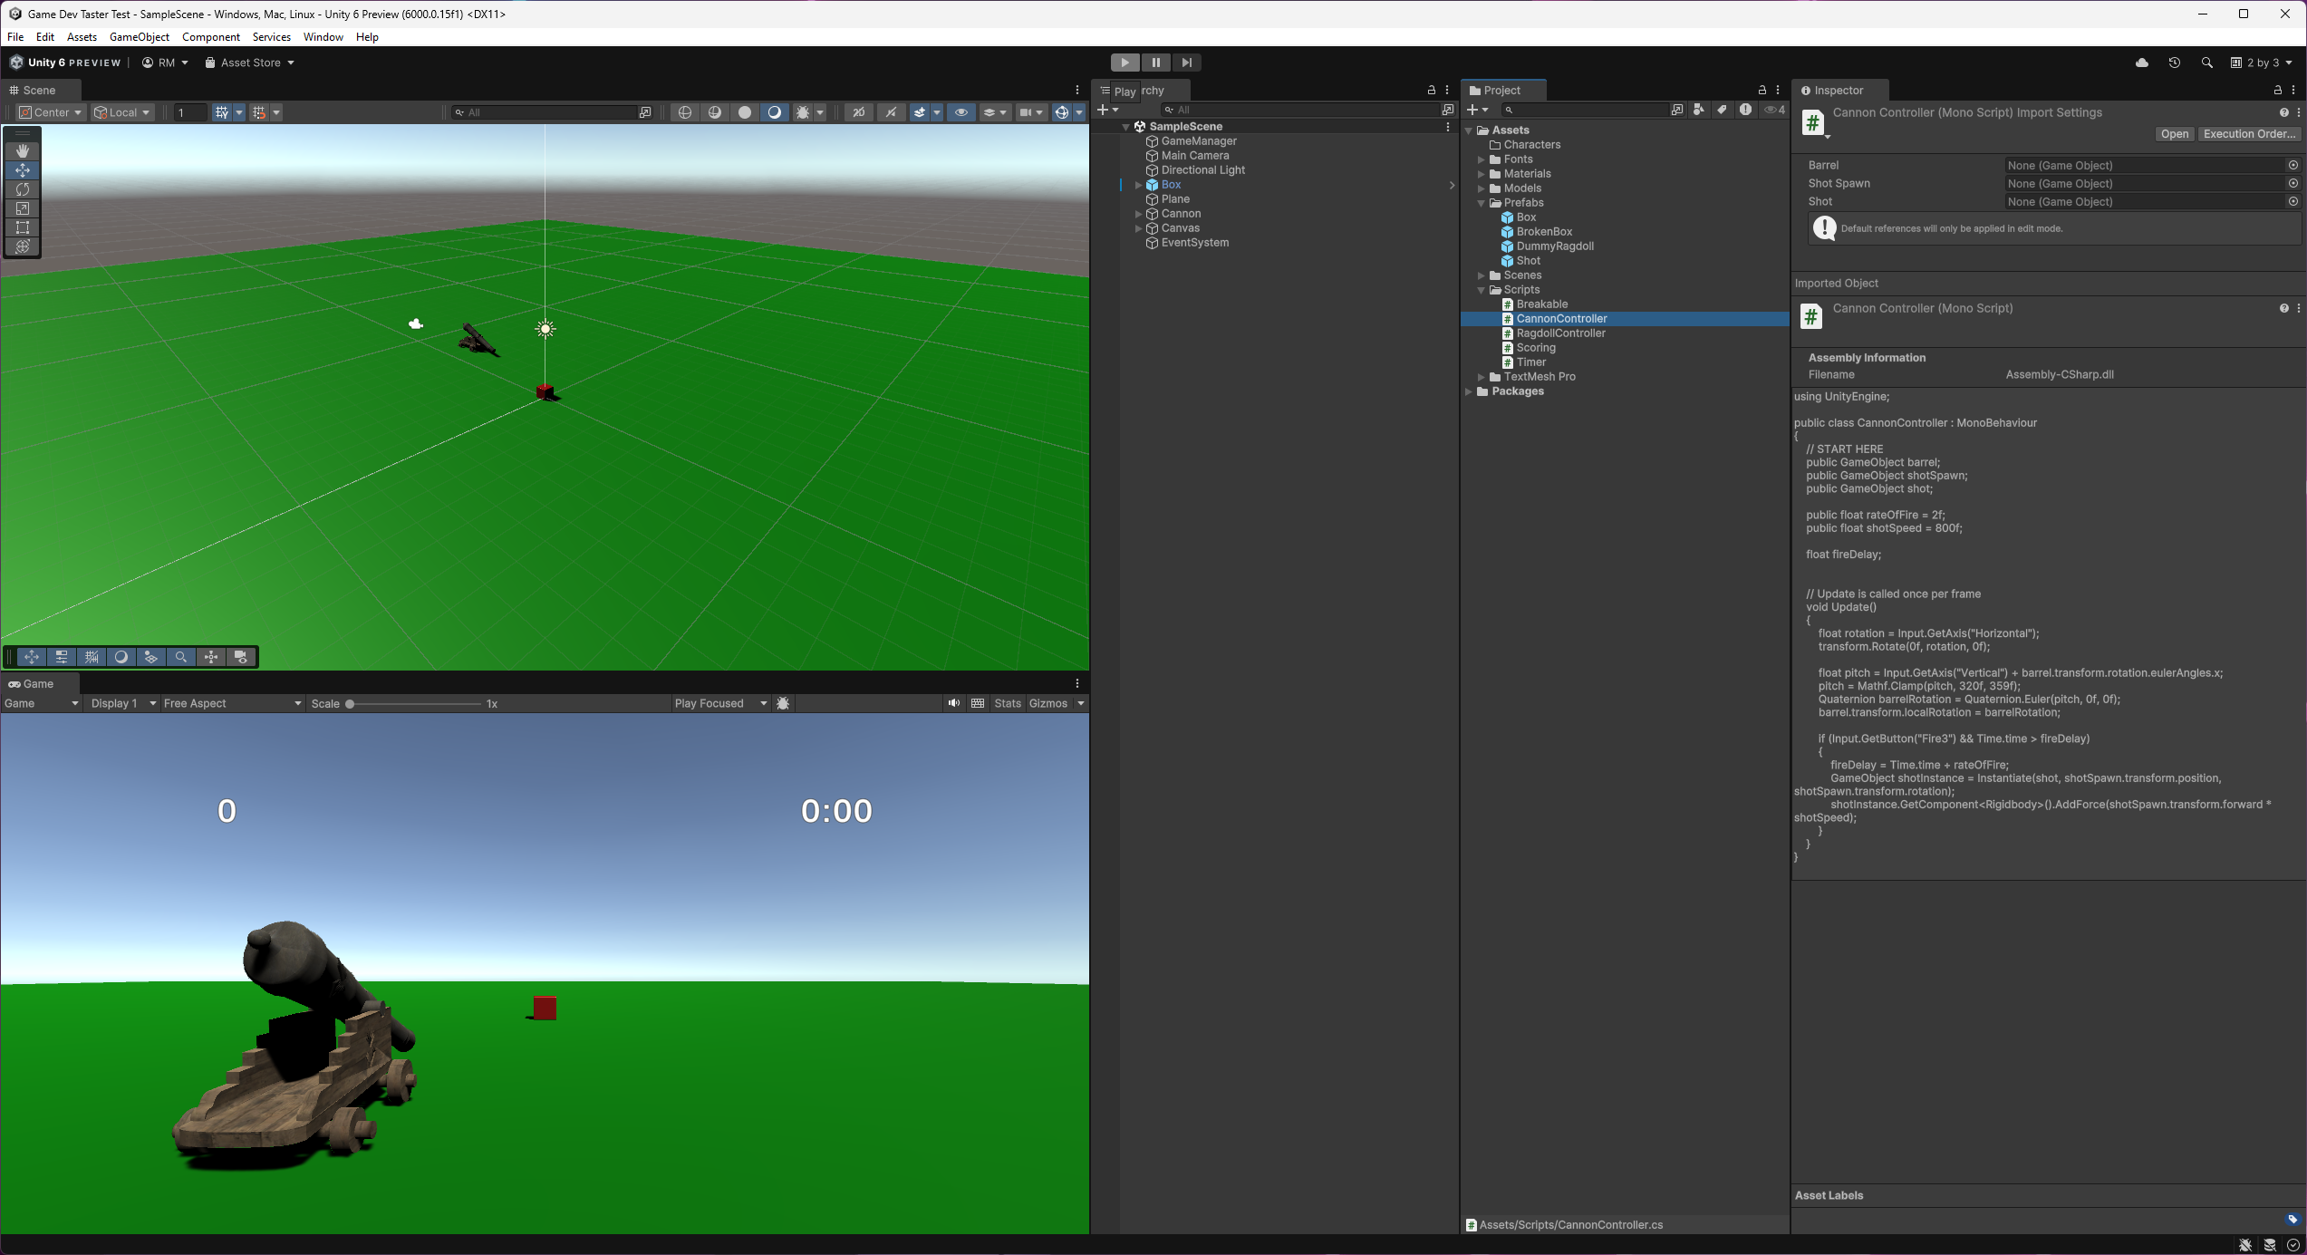

Test everything works:

* Rotating the cannon (A and D or arrows LEFT and RIGHT)
* Pitching the barrel (W and S or arrows UP and DOWN)
* Firing a shot (using SHIFT)

Try and hit the red block. It should smash if you hit it and the score should increment.

Settings can be changed in the inspector for things like power and smash intensity.

