Hyperledger Fabric Documentation

Introduction
In general terms, a blockchain is an immutable transaction ledger, maintained within a distributed network of peer nodes. These nodes each maintain a copy of the ledger by applying transactions that have been validated by a consensus protocol, grouped into blocks that include a hash that bind each block to the preceding block.
The first and most widely recognized application of blockchain is the Bitcoin cryptocurrency, though others have followed in its footsteps. Ethereum, an alternative cryptocurrency, took a different approach, integrating many of the same characteristics as Bitcoin but adding smart contracts to create a platform for distributed applications. Bitcoin and Ethereum fall into a class of blockchain that we would classify as public permissionless blockchain technology. Basically, these are public networks, open to anyone, where participants interact anonymously.
As the popularity of Bitcoin, Ethereum and a few other derivative technologies grew, interest in applying the underlying technology of the blockchain, distributed ledger and distributed application platform to more innovative enterprise use cases also grew. However, many enterprise use cases require performance characteristics that the permissionless blockchain technologies are unable (presently) to deliver. In addition, in many use cases, the identity of the participants is a hard requirement, such as in the case of financial transactions where Know-Your-Customer (KYC) and Anti-Money Laundering (AML) regulations must be followed.
For enterprise use, we need to consider the following requirements:
- Participants must be identified/identifiable
- Networks need to be permissioned
- High transaction throughput performance
- Low latency of transaction confirmation
- Privacy and confidentiality of transactions and data pertaining to business transactions
While many early blockchain platforms are currently being adapted for enterprise use, Hyperledger Fabric has been designed for enterprise use from the outset. The following sections describe how Hyperledger Fabric (Fabric) differentiates itself from other blockchain platforms and describes some of the motivation for its architectural decisions.
Hyperledger Fabric is an open source enterprise-grade permissioned distributed ledger technology (DLT) platform, designed for use in enterprise contexts, that delivers some key differentiating capabilities over other popular distributed ledger or blockchain platforms.
One key point of differentiation is that Hyperledger was established under the Linux Foundation, which itself has a long and very successful history of nurturing open source projects under open governance that grow strong sustaining communities and thriving ecosystems. Hyperledger is governed by a diverse technical steering committee, and the Hyperledger Fabric project by a diverse set of maintainers from multiple organizations. It has a development community that has grown to over 35 organizations and nearly 200 developers since its earliest commits.
Fabric has a highly modular and configurable architecture, enabling innovation, versatility and optimization for a broad range of industry use cases including banking, finance, insurance, healthcare, human resources, supply chain and even digital music delivery.
Fabric is the first distributed ledger platform to support smart contracts authored in general-purpose programming languages such as Java, Go and Node.js, rather than constrained domain-specific languages (DSL). This means that most enterprises already have the skill set needed to develop smart contracts, and no additional training to learn a new language or DSL is needed.
The Fabric platform is also permissioned, meaning that, unlike with a public permissionless network, the participants are known to each other, rather than anonymous and therefore fully untrusted. This means that while the participants may not fully trust one another (they may, for example, be competitors in the same industry), a network can be operated under a governance model that is built off of what trust does exist between participants, such as a legal agreement or framework for handling disputes.
One of the most important of the platform’s differentiators is its support for pluggable consensus protocols that enable the platform to be more effectively customized to fit particular use cases and trust models. For instance, when deployed within a single enterprise, or operated by a trusted authority, fully byzantine fault tolerant consensus might be considered unnecessary and an excessive drag on performance and throughput. In situations such as that, a crash fault-tolerant (CFT) consensus protocol might be more than adequate whereas, in a multi-party, decentralized use case, a more traditional byzantine fault tolerant (BFT) consensus protocol might be required.
Fabric can leverage consensus protocols that do not require a native cryptocurrency to incent costly mining or to fuel smart contract execution. Avoidance of a cryptocurrency reduces some significant risk/attack vectors, and absence of cryptographic mining operations means that the platform can be deployed with roughly the same operational cost as any other distributed system.
The combination of these differentiating design features makes Fabric one of the better performing platforms available today both in terms of transaction processing and transaction confirmation latency, and it enables privacy and confidentiality of transactions and the smart contracts (what Fabric calls “chaincode”) that implement them.
Let’s explore these differentiating features in more detail.

Modularity
Hyperledger Fabric has been specifically architected to have a modular architecture. Whether it is pluggable consensus, pluggable identity management protocols such as LDAP or OpenID Connect, key management protocols or cryptographic libraries, the platform has been designed at its core to be configured to meet the diversity of enterprise use case requirements.
At a high level, Fabric is comprised of the following modular components:
- A pluggable ordering service establishes consensus on the order of transactions and then broadcasts blocks to peers.
- A pluggable membership service provider is responsible for associating entities in the network with cryptographic identities.
- An optional peer-to-peer gossip service disseminates the blocks output by ordering service to other peers.
- Smart contracts (“chaincode”) run within a container environment (e.g. Docker) for isolation. They can be written in standard programming languages but do not have direct access to the ledger state.
- The ledger can be configured to support a variety of DBMSs.
- A pluggable endorsement and validation policy enforcement that can be independently configured per application.
There is fair agreement in the industry that there is no “one blockchain to rule them all”. Hyperledger Fabric can be configured in multiple ways to satisfy the diverse solution requirements for multiple industry use cases.

Permissioned vs Permissionless Blockchains
In a permissionless blockchain, virtually anyone can participate, and every participant is anonymous. In such a context, there can be no trust other than that the state of the blockchain, prior to a certain depth, is immutable. In order to mitigate this absence of trust, permissionless blockchains typically employ a “mined” native cryptocurrency or transaction fees to provide economic incentive to offset the extraordinary costs of participating in a form of byzantine fault tolerant consensus based on “proof of work” (PoW).
Permissioned blockchains, on the other hand, operate a blockchain amongst a set of known, identified and often vetted participants operating under a governance model that yields a certain degree of trust. A permissioned blockchain provides a way to secure the interactions among a group of entities that have a common goal but which may not fully trust each other. By relying on the identities of the participants, a permissioned blockchain can use more traditional crash fault tolerant (CFT) or byzantine fault tolerant (BFT) consensus protocols that do not require costly mining.
Additionally, in such a permissioned context, the risk of a participant intentionally introducing malicious code through a smart contract is diminished. First, the participants are known to one another and all actions, whether submitting application transactions, modifying the configuration of the network or deploying a smart contract are recorded on the blockchain following an endorsement policy that was established for the network and relevant transaction type. Rather than being completely anonymous, the guilty party can be easily identified and the incident handled in accordance with the terms of the governance model.

Smart Contracts
A smart contract, or what Fabric calls “chaincode”, functions as a trusted distributed application that gains its security/trust from the blockchain and the underlying consensus among the peers. It is the business logic of a blockchain application.
There are three key points that apply to smart contracts, especially when applied to a platform:
- many smart contracts run concurrently in the network,
- they may be deployed dynamically (in many cases by anyone), and
- application code should be treated as untrusted, potentially even malicious.
Most existing smart-contract capable blockchain platforms follow an order-execute architecture in which the consensus protocol:
- validates and orders transactions then propagates them to all peer nodes,
- each peer then executes the transactions sequentially.
The order-execute architecture can be found in virtually all existing blockchain systems, ranging from public/permissionless platforms such as Ethereum (with PoW-based consensus) to permissioned platforms such as Tendermint, Chain, and Quorum.
Smart contracts executing in a blockchain that operates with the order-execute architecture must be deterministic; otherwise, consensus might never be reached. To address the non-determinism issue, many platforms require that the smart contracts be written in a non-standard, or domain-specific language (such as Solidity) so that non-deterministic operations can be eliminated. This hinders wide-spread adoption because it requires developers writing smart contracts to learn a new language and may lead to programming errors.
Further, since all transactions are executed sequentially by all nodes, performance and scale is limited. The fact that the smart contract code executes on every node in the system demands that complex measures be taken to protect the overall system from potentially malicious contracts in order to ensure resiliency of the overall system.

A New Approach
Fabric introduces a new architecture for transactions that we call execute-order-validate. It addresses the resiliency, flexibility, scalability, performance and confidentiality challenges faced by the order-execute model by separating the transaction flow into three steps:
- execute a transaction and check its correctness, thereby endorsing it,
- order transactions via a (pluggable) consensus protocol, and
- validate transactions against an application-specific endorsement policy before committing them to the ledger
This design departs radically from the order-execute paradigm in that Fabric executes transactions before reaching final agreement on their order.
In Fabric, an application-specific endorsement policy specifies which peer nodes, or how many of them, need to vouch for the correct execution of a given smart contract. Thus, each transaction need only be executed (endorsed) by the subset of the peer nodes necessary to satisfy the transaction’s endorsement policy. This allows for parallel execution increasing overall performance and scale of the system. This first phase also eliminates any non-determinism, as inconsistent results can be filtered out before ordering.
Because we have eliminated non-determinism, Fabric is the first blockchain technology that enables use of standard programming languages.

Privacy and Confidentiality
As we have discussed, in a public, permissionless blockchain network that leverages PoW for its consensus model, transactions are executed on every node. This means that neither can there be confidentiality of the contracts themselves, nor of the transaction data that they process. Every transaction, and the code that implements it, is visible to every node in the network. In this case, we have traded confidentiality of contract and data for byzantine fault tolerant consensus delivered by PoW.
This lack of confidentiality can be problematic for many business/enterprise use cases. For example, in a network of supply-chain partners, some consumers might be given preferred rates as a means of either solidifying a relationship, or promoting additional sales. If every participant can see every contract and transaction, it becomes impossible to maintain such business relationships in a completely transparent network — everyone will want the preferred rates!
As a second example, consider the securities industry, where a trader building a position (or disposing of one) would not want her competitors to know of this, or else they will seek to get in on the game, weakening the trader’s gambit.
In order to address the lack of privacy and confidentiality for purposes of delivering on enterprise use case requirements, blockchain platforms have adopted a variety of approaches. All have their trade-offs.
Encrypting data is one approach to providing confidentiality; however, in a permissionless network leveraging PoW for its consensus, the encrypted data is sitting on every node. Given enough time and computational resource, the encryption could be broken. For many enterprise use cases, the risk that their information could become compromised is unacceptable.
Zero knowledge proofs (ZKP) are another area of research being explored to address this problem, the trade-off here being that, presently, computing a ZKP requires considerable time and computational resources. Hence, the trade-off in this case is performance for confidentiality.
In a permissioned context that can leverage alternate forms of consensus, one might explore approaches that restrict the distribution of confidential information exclusively to authorized nodes.
Hyperledger Fabric, being a permissioned platform, enables confidentiality through its channel architecture and private data feature. In channels, participants on a Fabric network establish a sub-network where every member has visibility to a particular set of transactions. Thus, only those nodes that participate in a channel have access to the smart contract (chaincode) and data transacted, preserving the privacy and confidentiality of both. Private data allows collections between members on a channel, allowing much of the same protection as channels without the maintenance overhead of creating and maintaining a separate channel.

Pluggable Consensus
The ordering of transactions is delegated to a modular component for consensus that is logically decoupled from the peers that execute transactions and maintain the ledger. Specifically, the ordering service. Since consensus is modular, its implementation can be tailored to the trust assumption of a particular deployment or solution. This modular architecture allows the platform to rely on well-established toolkits for CFT (crash fault-tolerant) or BFT (byzantine fault-tolerant) ordering.
Fabric currently offers a CFT ordering service implementation based on the etcd library of the Raft protocol.
Note also that these are not mutually exclusive. A Fabric network can have multiple ordering services supporting different applications or application requirements.

Performance and Scalability
Performance of a blockchain platform can be affected by many variables such as transaction size, block size, network size, as well as available hardware resources such as CPU, Memory, Disk Space, Disk and network I/O.

Conclusion
Any serious evaluation of blockchain platforms should include Hyperledger Fabric in its short list.
Combined, the differentiating capabilities of Fabric make it a highly scalable system for permissioned blockchains supporting flexible trust assumptions that enable the platform to support a wide range of industry use cases ranging from government, to finance, to supply-chain logistics, to healthcare and so much more.
Hyperledger Fabric is the most active of the Hyperledger projects. The community building around the platform is growing steadily, and the innovation delivered with each successive release far out-paces any of the other enterprise blockchain platforms.

What’s new in Hyperledger Fabric v2.x

What’s New in Hyperledger Fabric v2.5

Purge history of private data
While it has always been possible to delete private data from current state, this new feature enables purging the history of private data from a peer while preserving a hash of the private data as immutable evidence on the blockchain.
- Useful for purging private data on demand for privacy reasons or to adhere to government regulations.
- Deletes private data from state and from peer’s private data history so that it can no longer be queried from block events or from other peers.
- Available as a new chaincode API PurgePrivateData().
- Requires setting application capability to V2_5 in channel configuration

Multi-architecture binaries and docker images are now available
The release binaries and docker images have been updated as follows:
- Support for amd64 and arm64.
- Release binaries are statically linked for maximum portability.
- Docker images utilize dynamically linked binaries and are now based on Ubuntu (rather than Alpine) to make them more consistent with typical production runtime environments (production runtime environments are typically based on glibc and often require dynamic linking of HSM modules).
Fabric v2.5.x is the current long-term support (LTS) release. A simple in-place upgrade from the prior LTS (Fabric v2.2.x) release is possible.

What’s New in Hyperledger Fabric v2.4

Fabric Gateway
Fabric Gateway is a new service running on peer nodes that manages transaction submission and processing for client applications, with the following benefits:
- Simplifies client applications and SDKs - Your client application can simply delegate transaction submission to a trusted peer. There is no need for your application to open connections to peer nodes and ordering service nodes from other organizations.
- Fabric Gateway manages the collection of transaction endorsements from other organizations and submission to the ordering service on behalf of client applications.
- Fabric Gateway has intelligence to determine what endorsements are required for a given transaction, even if your solution utilizes a combination of chaincode-level endorsement policies, private data collection endorsement policies, and state-based endorsement policies.
New lightweight Gateway SDKs (v1.0.0) are available for Node, Java, and Go. The SDKs support flexible application patterns:
- You can utilize the high-level programming model similar to prior SDK versions, allowing your application to simply call a single SubmitTransaction() function.
- More advanced applications can leverage the gateway’s individual Endorse, Submit, and CommitStatus services for transaction submission, and the Evaluate service for queries.
- You can delegate transaction endorsement entirely to the gateway, or if needed, specify the endorsing organizations and the gateway will utilize a peer from each organization.

Peer node unjoin
You can now unjoin a peer from a channel when the channel is no longer needed. All channel resources will be removed from the peer and the peer will no longer process blocks from the channel.

Calculate package ID of a packaged chaincode
You can calculate the package ID from a packaged chaincode without installing the chaincode on peers using the new peer lifecycle chaincode calculatepackageid command. This command will be useful, for example, in the following scenarios:
- When multiple chaincode packages with the same label name are installed, it is possible to identify which ID corresponds to which package later.
- To check whether a particular chaincode package is installed or not without installing that package.

What’s New in Hyperledger Fabric v2.3
Hyperledger Fabric v2.3 introduces two new features for improved orderer and peer operations.

Orderer channel management without a system channel
To simplify the channel creation process and enhance the privacy and scalability of channels, it is now possible to create application channels without first creating a “system channel” managed by the ordering service. This process allows ordering nodes to join (or leave) any number of channels as needed, similar to how peers can participate in multiple channels.
Benefits of the new process:
- Increased privacy: Because all ordering nodes used to be joined to the system channel, every ordering node in a network knew about the existence of every channel on that ordering service. Now, an ordering node only knows about the channels it is joined to.
- Scalability: When there is a large number of ordering nodes and channels defined on the system channel, it can take a long time for ordering nodes to reach consensus on the membership of all the channels. Now, an ordering service can scale horizontally in a decentralized fashion by independently joining ordering nodes to specific channels.
- Operational benefits
  - Simple process to join an ordering node to a channel.
  - Ability to list the channels that the ordering node is a consenter on.
  - Simple process to remove a channel from an ordering node, which automatically cleans up the blocks associated with that channel.
  - Peer organizations do not need to coordinate with an admin of the system channel to create or update its MSP.

Ledger snapshot
It is now possible to take a snapshot of a peer’s channel information, including its state database, and join new peers (in the same organization or different organizations) to the channel based on the snapshot.
Using ledger snapshots has the following advantages:
- Peers don’t need to process all blocks since genesis block: Peers can join a channel without processing all previous blocks since the genesis block, greatly reducing the time it takes to join a peer to an existing channel.
- Peers can join channels using latest channel configuration: Because snapshots include the latest channel configuration, peers can now join a channel using the latest channel configuration. This is especially important if critical channel configuration such as orderer endpoints or TLS CA certificates have been updated since the genesis block.
- Reduced storage costs: Peers that join by snapshot do not incur the storage cost of maintaining all blocks since the genesis block.
- State checkpoints: Peer administrators can snapshot current channel state and compare with other peers, in the same organization or different organizations, to verify the consistency and integrity of the ledger on each peer. Agreed upon snapshots can be used as a checkpoint and basis for newly joining peers.
While Fabric v2.3.0 introduces new features, Fabric v2.2.x remains the current long-term support release until the next LTS release is announced.

What’s New in Hyperledger Fabric v2.0, v2.1, v2.2
The first Hyperledger Fabric major release since v1.0, Fabric v2.0 delivers important new features and changes for users and operators alike, including support for new application and privacy patterns, enhanced governance around smart contracts, and new options for operating nodes.
v2.1 and v2.2 build on the v2.0 release with minor features, improvements, and bug fixes, with v2.2 being the first long-term support (LTS) release of Fabric v2.x. Fixes will be provided on the v2.2.x release stream until after the next LTS release is announced.
Let’s take a look at some of the highlights of the Fabric v2.0 release…

Decentralized governance for smart contracts
Fabric v2.0 introduces decentralized governance for smart contracts, with a new process for installing a chaincode on your peers and starting it on a channel. The new Fabric chaincode lifecycle allows multiple organizations to come to agreement on the parameters of a chaincode, such as the chaincode endorsement policy, before it can be used to interact with the ledger. The new model offers several improvements over the previous lifecycle:
- Multiple organizations must agree to the parameters of a chaincode: In the release 1.x versions of Fabric, one organization had the ability to set parameters of a chaincode (for instance the endorsement policy) for all other channel members, who only had the power to refuse to install the chaincode and therefore not take part in transactions invoking it. The new Fabric chaincode lifecycle is more flexible since it supports both centralized trust models (such as that of the previous lifecycle model) as well as decentralized models requiring a sufficient number of organizations to agree on an endorsement policy and other details before the chaincode becomes active on a channel.
- More deliberate chaincode upgrade process: In the previous chaincode lifecycle, the upgrade transaction could be issued by a single organization, creating a risk for a channel member that had not yet installed the new chaincode. The new model allows for a chaincode to be upgraded only after a sufficient number of organizations have approved the upgrade.
- Simpler endorsement policy and private data collection updates: Fabric lifecycle allows you to change an endorsement policy or private data collection configuration without having to repackage or reinstall the chaincode. Users can also take advantage of a new default endorsement policy that requires endorsement from a majority of organizations on the channel. This policy is updated automatically when organizations are added or removed from the channel.
- Inspectable chaincode packages: The Fabric lifecycle packages chaincode in easily readable tar files. This makes it easier to inspect the chaincode package and coordinate installation across multiple organizations.
- Start multiple chaincodes on a channel using one package: The previous lifecycle defined each chaincode on the channel using a name and version that was specified when the chaincode package was installed. You can now use a single chaincode package and deploy it multiple times with different names on the same channel or on different channels. For example, if you’d like to track different types of assets in their own ‘copy’ of the chaincode.
- Chaincode packages do not need to be identical across channel members: Organizations can extend a chaincode for their own use case, for example to perform different validations in the interest of their organization. As long as the required number of organizations endorse chaincode transactions with matching results, the transaction will be validated and committed to the ledger. This also allows organizations to individually roll out minor fixes on their own schedules without requiring the entire network to proceed in lock-step.
For existing Fabric deployments, you can continue to use the prior chaincode lifecycle with Fabric v2.x. The new chaincode lifecycle will become effective only when the channel application capability is updated to v2.0. See the Fabric chaincode lifecycle concept topic for an overview of the new chaincode lifecycle.

New chaincode application patterns for collaboration and consensus
The same decentralized methods of coming to agreement that underpin the new chaincode lifecycle management can also be used in your own chaincode applications to ensure organizations consent to data transactions before they are committed to the ledger.
- Automated checks: As mentioned above, organizations can add automated checks to chaincode functions to validate additional information before endorsing a transaction proposal.
- Decentralized agreement: Human decisions can be modeled into a chaincode process that spans multiple transactions. The chaincode may require actors from various organizations to indicate their terms and conditions of agreement in a ledger transaction. Then, a final chaincode proposal can verify that the conditions from all the individual transactors are met, and “settle” the business transaction with finality across all channel members. For a concrete example of indicating terms and conditions in private, see the asset transfer scenario in the Private data documentation.

Private data enhancements
Fabric v2.0 also enables new patterns for working with and sharing private data, without the requirement of creating private data collections for all combinations of channel members that may want to transact. Specifically, instead of sharing private data within a collection of multiple members, you may want to share private data across collections, where each collection may include a single organization, or perhaps a single organization along with a regulator or auditor.
Several enhancements in Fabric v2.x make these new private data patterns possible:
- Sharing and verifying private data: When private data is shared with a channel member who is not a member of a collection, or shared with another private data collection that contains one or more channel members (by writing a key to that collection), the receiving parties can utilize the GetPrivateDataHash() chaincode API to verify that the private data matches the on-chain hashes that were created from private data in previous transactions.
- Collection-level endorsement policies: Private data collections can now optionally be defined with an endorsement policy that overrides the chaincode-level endorsement policy for keys within the collection. This feature can be used to restrict which organizations can write data to a collection, and is what enables the new chaincode lifecycle and chaincode application patterns mentioned earlier. For example, you may have a chaincode endorsement policy that requires a majority of organizations to endorse, but for any given transaction, you may need two transacting organizations to individually endorse their agreement in their own private data collections.
- Implicit per-organization collections: If you’d like to utilize per-organization private data patterns, you don’t even need to define the collections when deploying chaincode in Fabric v2.x. Implicit organization-specific collections can be used without any upfront definition.

External chaincode launcher
The external chaincode launcher feature empowers operators to build and launch chaincode with the technology of their choice. Use of external builders and launchers is not required as the default behavior builds and runs chaincode in the same manner as prior releases using the Docker API.
- Eliminate Docker daemon dependency: Prior releases of Fabric required peers to have access to a Docker daemon in order to build and launch chaincode - something that may not be desirable in production environments due to the privileges required by the peer process.
- Alternatives to containers: Chaincode is no longer required to be run in Docker containers, and may be executed in the operator’s choice of environment (including containers).
- External builder executables: An operator can provide a set of external builder executables to override how the peer builds and launches chaincode.
- Chaincode as an external service: Traditionally, chaincodes are launched by the peer, and then connect back to the peer. It is now possible to run chaincode as an external service, for example in a Kubernetes pod, which a peer can connect to and utilize for chaincode execution.

State database cache for improved performance on CouchDB
- When using external CouchDB state database, read delays during endorsement and validation phases have historically been a performance bottleneck.
- With Fabric v2.0, a new peer cache replaces many of these expensive lookups with fast local cache reads. The cache size can be configured by using the core.yaml property cacheSize.

Alpine-based docker images
Starting with v2.0, Hyperledger Fabric Docker images will use Alpine Linux, a security-oriented, lightweight Linux distribution. This means that Docker images are now much smaller, providing faster download and startup times, as well as taking up less disk space on host systems. Alpine Linux is designed from the ground up with security in mind, and the minimalist nature of the Alpine distribution greatly reduces the risk of security vulnerabilities.

Sample test network
The fabric-samples repository now includes a new Fabric test network. The test network is built to be a modular and user friendly sample Fabric network that makes it easy to test your applications and smart contracts. The network also supports the ability to deploy your network using Certificate Authorities, in addition to cryptogen.

Upgrading to Fabric v2.x
A major new release brings some additional upgrade considerations. Rest assured though, that rolling upgrades from v1.4.x to v2.0 are supported, so that network components can be upgraded one at a time with no downtime. You can also upgrade directly from the v1.4.x LTS release to the v2.2.x LTS release or v2.5.x LTS release.

Introduction
Hyperledger Fabric is a platform for distributed ledger solutions underpinned by a modular architecture delivering high degrees of confidentiality, resiliency, flexibility, and scalability. It is designed to support pluggable implementations of different components and accommodate the complexity and intricacies that exist across the economic ecosystem.
We recommend first-time users begin by going through the rest of the introduction below in order to gain familiarity with how blockchains work and with the specific features and components of Hyperledger Fabric.

What is a Blockchain?
A Distributed Ledger
At the heart of a blockchain network is a distributed ledger that records all the transactions that take place on the network.
A blockchain ledger is often described as decentralized because it is replicated across many network participants, each of whom collaborate in its maintenance. We’ll see that decentralization and collaboration are powerful attributes that mirror the way businesses exchange goods and services in the real world.
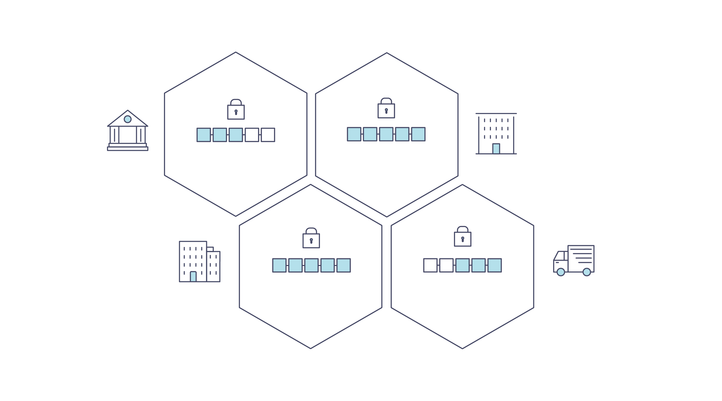
In addition to being decentralized and collaborative, the information recorded to a blockchain is append-only, using cryptographic techniques that guarantee that once a transaction has been added to the ledger it cannot be modified. This property of “immutability” makes it simple to determine the provenance of information because participants can be sure information has not been changed after the fact. It’s why blockchains are sometimes described as systems of proof.
Smart Contracts
To support the consistent update of information — and to enable a whole host of ledger functions (transacting, querying, etc) — a blockchain network uses smart contracts to provide controlled access to the ledger.
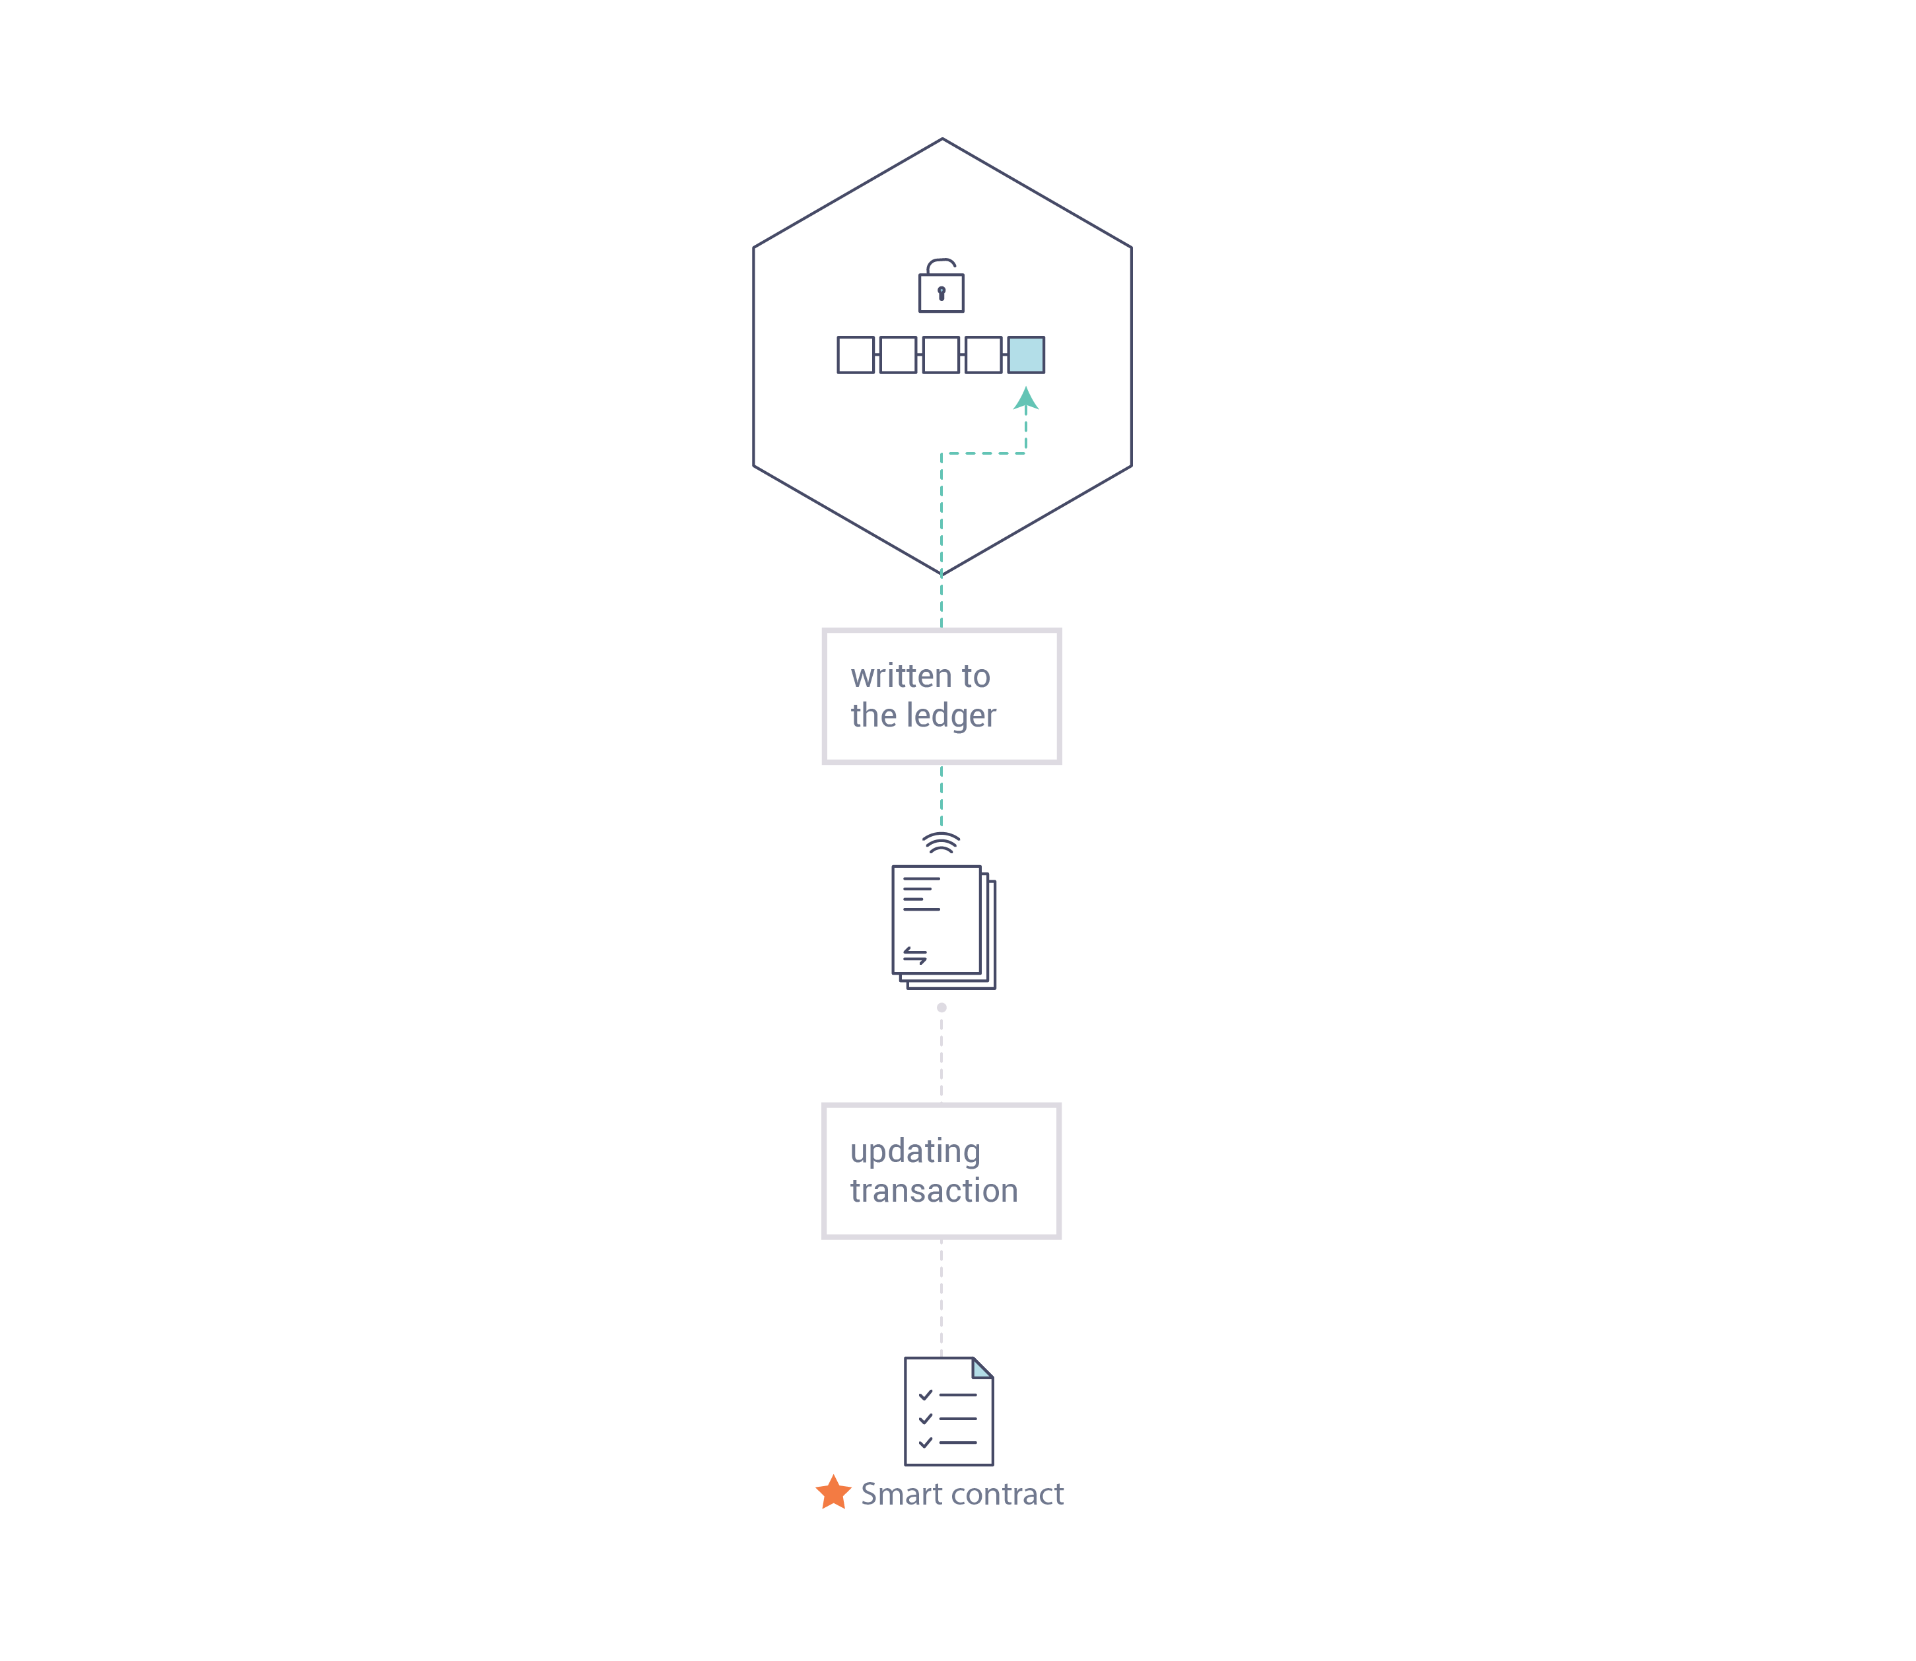
Smart contracts are not only a key mechanism for encapsulating information and keeping it simple across the network, they can also be written to allow participants to execute certain aspects of transactions automatically.
A smart contract can, for example, be written to stipulate the cost of shipping an item where the shipping charge changes depending on how quickly the item arrives. With the terms agreed to by both parties and written to the ledger, the appropriate funds change hands automatically when the item is received.
Consensus
The process of keeping the ledger transactions synchronized across the network — to ensure that ledgers update only when transactions are approved by the appropriate participants, and that when ledgers do update, they update with the same transactions in the same order — is called consensus.
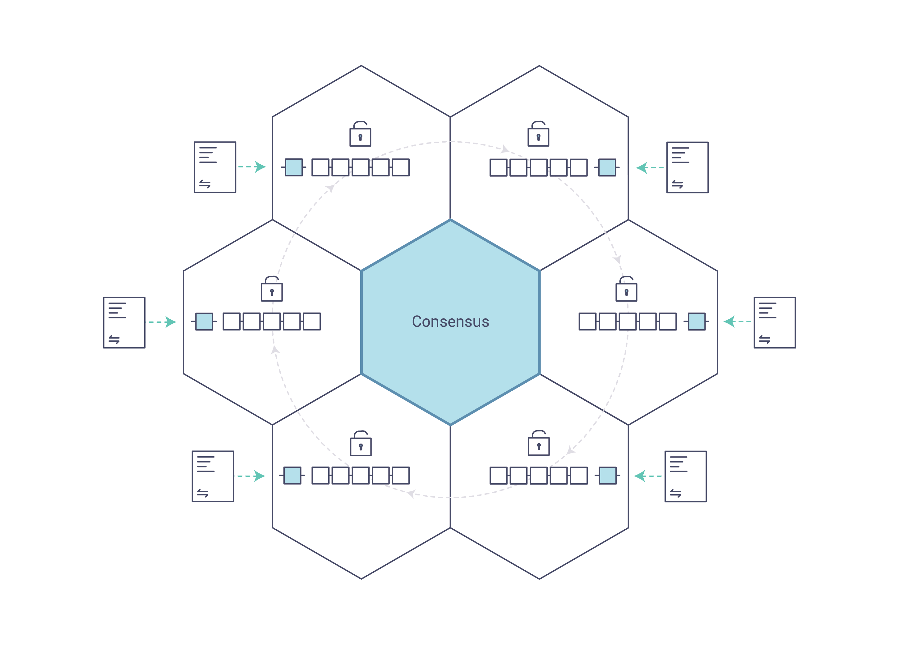
You’ll learn a lot more about ledgers, smart contracts and consensus later. For now, it’s enough to think of a blockchain as a shared, replicated transaction system which is updated via smart contracts and kept consistently synchronized through a collaborative process called consensus.

Why is a Blockchain useful?
Today’s Systems of Record
The transactional networks of today are little more than slightly updated versions of networks that have existed since business records have been kept. The members of a business network transact with each other, but they maintain separate records of their transactions. And the things they’re transacting — whether it’s Flemish tapestries in the 16th century or the securities of today — must have their provenance established each time they’re sold to ensure that the business selling an item possesses a chain of title verifying their ownership of it.
What you’re left with is a business network that looks like this:
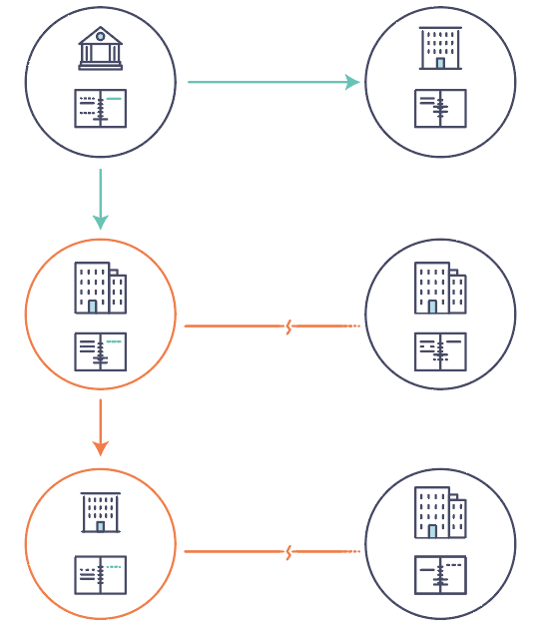
Modern technology has taken this process from stone tablets and paper folders to hard drives and cloud platforms, but the underlying structure is the same. Unified systems for managing the identity of network participants do not exist, establishing provenance is so laborious it takes days to clear securities transactions (the world volume of which is numbered in the many trillions of dollars), contracts must be signed and executed manually, and every database in the system contains unique information and therefore represents a single point of failure.
It’s impossible with today’s fractured approach to information and process sharing to build a system of record that spans a business network, even though the needs of visibility and trust are clear.
The Blockchain Difference
What if, instead of the rat’s nest of inefficiencies represented by the “modern” system of transactions, business networks had standard methods for establishing identity on the network, executing transactions, and storing data? What if establishing the provenance of an asset could be determined by looking through a list of transactions that, once written, cannot be changed, and can therefore be trusted?
That business network would look more like this:
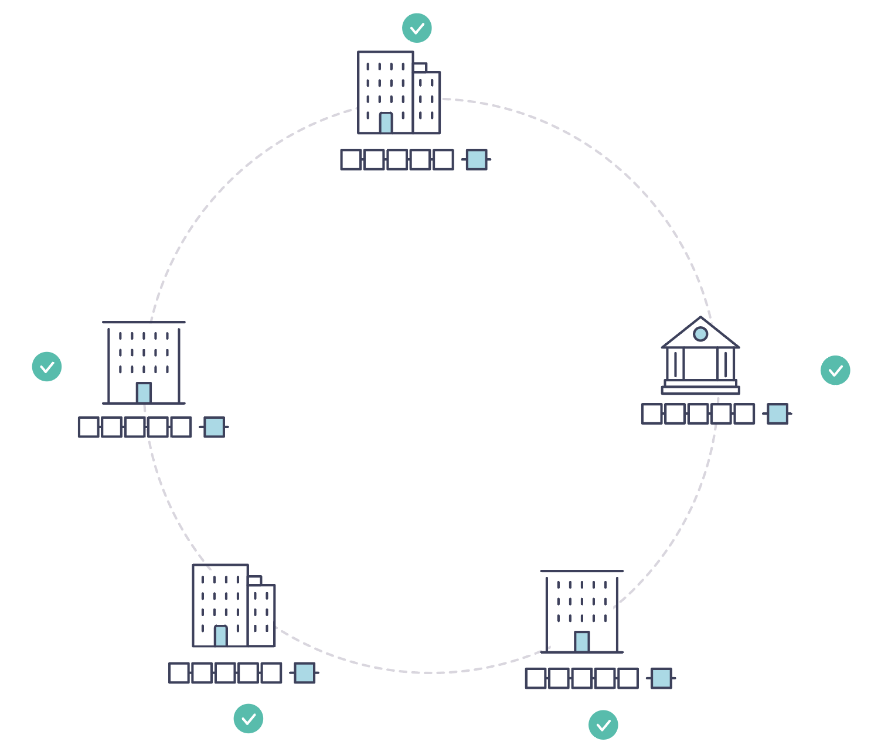
This is a blockchain network, wherein every participant has their own replicated copy of the ledger. In addition to ledger information being shared, the processes which update the ledger are also shared. Unlike today’s systems, where a participant’s private programs are used to update their private ledgers, a blockchain system has shared programs to update shared ledgers.
With the ability to coordinate their business network through a shared ledger, blockchain networks can reduce the time, cost, and risk associated with private information and processing while improving trust and visibility.
You now know what blockchain is and why it’s useful. There are a lot of other details that are important, but they all relate to these fundamental ideas of the sharing of information and processes.

What is Hyperledger Fabric?
The Linux Foundation founded the Hyperledger project in 2015 to advance cross-industry blockchain technologies. Rather than declaring a single blockchain standard, it encourages a collaborative approach to developing blockchain technologies via a community process, with intellectual property rights that encourage open development and the adoption of key standards over time.
Hyperledger Fabric is one of the blockchain projects within Hyperledger. Like other blockchain technologies, it has a ledger, uses smart contracts, and is a system by which participants manage their transactions.
Where Hyperledger Fabric breaks from some other blockchain systems is that it is private and permissioned. Rather than an open permissionless system that allows unknown identities to participate in the network (requiring protocols like “proof of work” to validate transactions and secure the network), the members of a Hyperledger Fabric network enroll through a trusted Membership Service Provider (MSP).
Hyperledger Fabric also offers several pluggable options. Ledger data can be stored in multiple formats, consensus mechanisms can be swapped in and out, and different MSPs are supported.
Hyperledger Fabric also offers the ability to create channels, allowing a group of participants to create a separate ledger of transactions. This is an especially important option for networks where some participants might be competitors and not want every transaction they make — a special price they’re offering to some participants and not others, for example — known to every participant. If two participants form a channel, then those participants — and no others — have copies of the ledger for that channel.
Shared Ledger
Hyperledger Fabric has a ledger subsystem comprising two components: the world state and the transaction log. Each participant has a copy of the ledger to every Hyperledger Fabric network they belong to.
The world state component describes the state of the ledger at a given point in time. It’s the database of the ledger. The transaction log component records all transactions which have resulted in the current value of the world state; it’s the update history for the world state. The ledger, then, is a combination of the world state database and the transaction log history.
The ledger has a replaceable data store for the world state. By default, this is a LevelDB key-value store database. The transaction log does not need to be pluggable. It simply records the before and after values of the ledger database being used by the blockchain network.
Smart Contracts
Hyperledger Fabric smart contracts are written in chaincode and are invoked by an application external to the blockchain when that application needs to interact with the ledger. In most cases, chaincode interacts only with the database component of the ledger, the world state (querying it, for example), and not the transaction log.
Chaincode can be implemented in several programming languages. Currently, Go, Node.js, and Java chaincode are supported.
Privacy
Depending on the needs of a network, participants in a Business-to-Business (B2B) network might be extremely sensitive about how much information they share. For other networks, privacy will not be a top concern.
Hyperledger Fabric supports networks where privacy (using channels) is a key operational requirement as well as networks that are comparatively open.
Consensus
Transactions must be written to the ledger in the order in which they occur, even though they might be between different sets of participants within the network. For this to happen, the order of transactions must be established and a method for rejecting bad transactions that have been inserted into the ledger in error (or maliciously) must be put into place.
This is a thoroughly researched area of computer science, and there are many ways to achieve it, each with different trade-offs. For example, PBFT (Practical Byzantine Fault Tolerance) can provide a mechanism for file replicas to communicate with each other to keep each copy consistent, even in the event of corruption. Alternatively, in Bitcoin, ordering happens through a process called mining where competing computers race to solve a cryptographic puzzle which defines the order that all processes subsequently build upon.
Hyperledger Fabric has been designed to allow network starters to choose a consensus mechanism that best represents the relationships that exist between participants. As with privacy, there is a spectrum of needs; from networks that are highly structured in their relationships to those that are more peer-to-peer.

Hyperledger Fabric Model
This section outlines the key design features woven into Hyperledger Fabric that fulfill its promise of a comprehensive, yet customizable, enterprise blockchain solution:
- Assets — Asset definitions enable the exchange of almost anything with monetary value over the network, from whole foods to antique cars to currency futures.
- Chaincode — Chaincode execution is partitioned from transaction ordering, limiting the required levels of trust and verification across node types, and optimizing network scalability and performance.
- Ledger Features — The immutable, shared ledger encodes the entire transaction history for each channel, and includes SQL-like query capability for efficient auditing and dispute resolution.
- Privacy — Channels and private data collections enable private and confidential multi-lateral transactions that are usually required by competing businesses and regulated industries that exchange assets on a common network.
- Security & Membership Services — Permissioned membership provides a trusted blockchain network, where participants know that all transactions can be detected and traced by authorized regulators and auditors.
- Consensus — A unique approach to consensus enables the flexibility and scalability needed for the enterprise.

Assets
Assets can range from the tangible (real estate and hardware) to the intangible (contracts and intellectual property). Hyperledger Fabric provides the ability to modify assets using chaincode transactions.
Assets are represented in Hyperledger Fabric as a collection of key-value pairs, with state changes recorded as transactions on a Channel ledger. Assets can be represented in binary and/or JSON form.

Chaincode
Chaincode is software defining an asset or assets, and the transaction instructions for modifying the asset(s); in other words, it’s the business logic. Chaincode enforces the rules for reading or altering key-value pairs or other state database information. Chaincode functions execute against the ledger’s current state database and are initiated through a transaction proposal. Chaincode execution results in a set of key-value writes (write set) that can be submitted to the network and applied to the ledger on all peers.

Ledger Features
The ledger is the sequenced, tamper-resistant record of all state transitions in the fabric. State transitions are a result of chaincode invocations (‘transactions’) submitted by participating parties. Each transaction results in a set of asset key-value pairs that are committed to the ledger as creates, updates, or deletes.
The ledger is comprised of a blockchain (‘chain’) to store the immutable, sequenced record in blocks, as well as a state database to maintain current fabric state. There is one ledger per channel. Each peer maintains a copy of the ledger for each channel of which they are a member.
Some features of a Fabric ledger:
- Query and update ledger using key-based lookups, range queries, and composite key queries
- Read-only queries using a rich query language (if using CouchDB as state database)
- Read-only history queries — Query ledger history for a key, enabling data provenance scenarios
- Transactions consist of the versions of keys/values that were read in chaincode (read set) and keys/values that were written in chaincode (write set)
- Transactions contain signatures of every endorsing peer and are submitted to ordering service
- Transactions are ordered into blocks and are “delivered” from an ordering service to peers on a channel
- Peers validate transactions against endorsement policies and enforce the policies
- Prior to appending a block, a versioning check is performed to ensure that states for assets that were read have not changed since chaincode execution time
- There is immutability once a transaction is validated and committed
- A channel’s ledger contains a configuration block defining policies, access control lists, and other pertinent information
- Channels contain Membership Service Provider instances allowing for crypto materials to be derived from different certificate authorities

Privacy
Hyperledger Fabric employs an immutable ledger on a per-channel basis, as well as chaincode that can manipulate and modify the current state of assets (i.e. update key-value pairs). A ledger exists in the scope of a channel — it can be shared across the entire network (assuming every participant is operating on one common channel) — or it can be privatized to include only a specific set of participants.
In the latter scenario, these participants would create a separate channel and thereby isolate/segregate their transactions and ledger. In order to solve scenarios that want to bridge the gap between total transparency and privacy, chaincode can be installed only on peers that need to access the asset states to perform reads and writes (in other words, if a chaincode is not installed on a peer, it will not be able to properly interface with the ledger).
When a subset of organizations on that channel need to keep their transaction data confidential, a private data collection (collection) is used to segregate this data in a private database, logically separate from the channel ledger, accessible only to the authorized subset of organizations.
Thus, channels keep transactions private from the broader network whereas collections keep data private between subsets of organizations on the channel.
To further obfuscate the data, values within chaincode can be encrypted (in part or in total) using common cryptographic algorithms such as AES before sending transactions to the ordering service and appending blocks to the ledger. Once encrypted data has been written to the ledger, it can be decrypted only by a user in possession of the corresponding key that was used to generate the cipher text.

Security & Membership Services
Hyperledger Fabric underpins a transactional network where all participants have known identities. Public Key Infrastructure is used to generate cryptographic certificates which are tied to organizations, network components, and end users or client applications. As a result, data access control can be manipulated and governed on the broader network and on channel levels. This “permissioned” notion of Hyperledger Fabric, coupled with the existence and capabilities of channels, helps address scenarios where privacy and confidentiality are paramount concerns.

Consensus
In distributed ledger technology, consensus has recently become synonymous with a specific algorithm, within a single function. However, consensus encompasses more than simply agreeing upon the order of transactions, and this differentiation is highlighted in Hyperledger Fabric through its fundamental role in the entire transaction flow, from proposal and endorsement, to ordering, validation and commitment. In a nutshell, consensus is defined as the full-circle verification of the correctness of a set of transactions comprising a block.
Consensus is achieved ultimately when the order and results of a block’s transactions have met the explicit policy criteria checks. These checks and balances take place during the lifecycle of a transaction, and include the usage of endorsement policies to dictate which specific members must endorse a certain transaction class, as well as system chaincodes to ensure that these policies are enforced and upheld. Prior to commitment, the peers will employ these system chaincodes to make sure that enough endorsements are present, and that they were derived from the appropriate entities. Moreover, a versioning check will take place during which the current state of the ledger is agreed or consented upon, before any blocks containing transactions are appended to the ledger. This final check provides protection against double spend operations and other threats that might compromise data integrity, and allows for functions to be executed against non-static variables.
In addition to the multitude of endorsement, validity and versioning checks that take place, there are also ongoing identity verifications happening in all directions of the transaction flow. Access control lists are implemented on hierarchical layers of the network (ordering service down to channels), and payloads are repeatedly signed, verified and authenticated as a transaction proposal passes through the different architectural components. To conclude, consensus is not merely limited to the agreed upon order of a batch of transactions; rather, it is an overarching characterization that is achieved as a byproduct of the ongoing verifications that take place during a transaction’s journey from proposal to commitment.

How Fabric networks are structured
This topic will describe, at a conceptual level, how Hyperledger Fabric allows organizations to collaborate in the formation of blockchain networks. If you’re an architect, administrator or developer, you can use this topic to get a solid understanding of the major structure and process components in a Hyperledger Fabric blockchain network. This topic will use a manageable example that introduces all of the major components in a blockchain network.
After reading this topic and understanding the concept of policies, you will have a solid understanding of the decisions that organizations need to make to establish the policies that control a deployed Hyperledger Fabric network. You’ll also understand how organizations manage network evolution using declarative policies – a key feature of Hyperledger Fabric. In a nutshell, you’ll understand the major technical components of Hyperledger Fabric and the decisions organizations need to make about them.
Note: in this topic, we’ll refer to the structure of a network that does not have a “system channel”, a channel run by the ordering service that ordering nodes are bootstrapped with.

What is a blockchain network?
A blockchain network is a technical infrastructure that provides ledger and smart contract (which are packaged as part of a “chaincode”) services to applications. Primarily, smart contracts are used to generate transactions which are subsequently distributed to every peer node in the network where they are immutably recorded on their copy of the ledger. The users of applications might be end users using client applications or blockchain network administrators.
In most cases, multiple organizations come together to form a channel on which transactions are invoked on chaincodes and where permissions are determined by a set of policies that are agreed to when the channel is originally configured. Moreover, policies can change over time subject to the agreement of the organizations.
In this topic, we’ll refer to both the “network” and the “channel”. In Hyperledger Fabric, these terms are effectively synonymous, as they both refer collectively to the organizations, components, policies, and processes that govern the interactions between organizations within a defined structure.

The sample network
Before we start, let’s show you what we’re aiming at! Here’s a diagram representing the final state of our sample network.
It might look complicated right now, but as we go through this topic, we will build up the network piece by piece, so that you see how the organizations R1, R2 and R0 contribute infrastructure to the network to help form it. This infrastructure implements the blockchain network, and it is governed by policies agreed by the organizations who form the network – for example, who can add new organizations. You’ll discover how applications consume the ledger and smart contract services provided by the blockchain network.
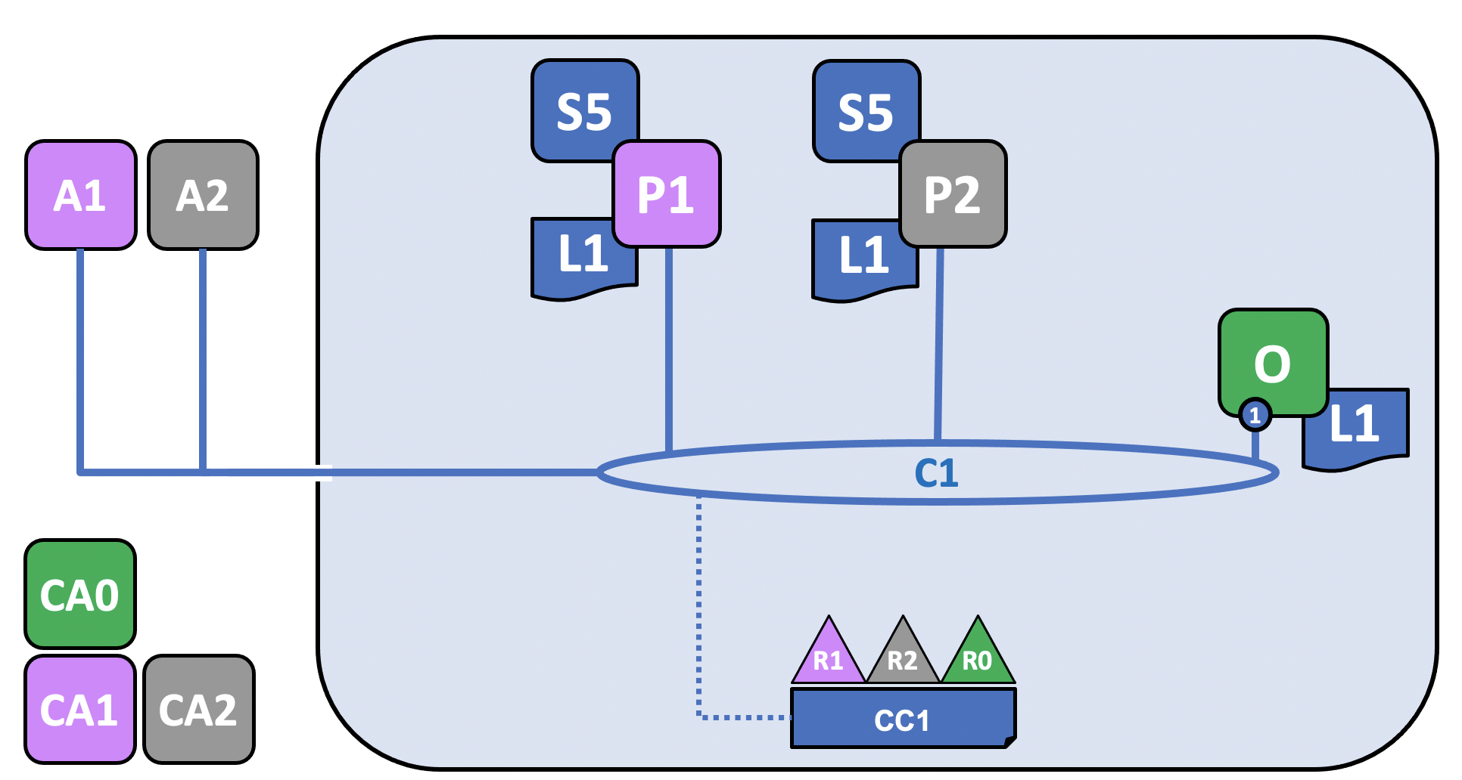
Three organizations, R1, R2, and R0 have jointly decided that they will establish a network. This network has a configuration, CC1, which all of the organizations have agreed to and which lists the definition of the organizations as well as the policies which define the roles each organization will play on the channel.
On this channel, R1 and R2 will join peers, named P1 and P2, to the channel, C1, while R0 owns O, the ordering service of the channel. All of these nodes will contain a copy of the ledger (L1) of the channel, which is where transactions are recorded. Note that the copy of the ledger kept by the ordering service does not contain a state database. R1 and R2 will also interact with the channel through the applications A1 and A2, which they own. All three organizations have a Certificate Authority that has generated the necessary certificates for the nodes, admins, organizations definitions, and applications of its organization.

Creating the network
The first step in creating a network or a channel is to agree to and then define its configuration:
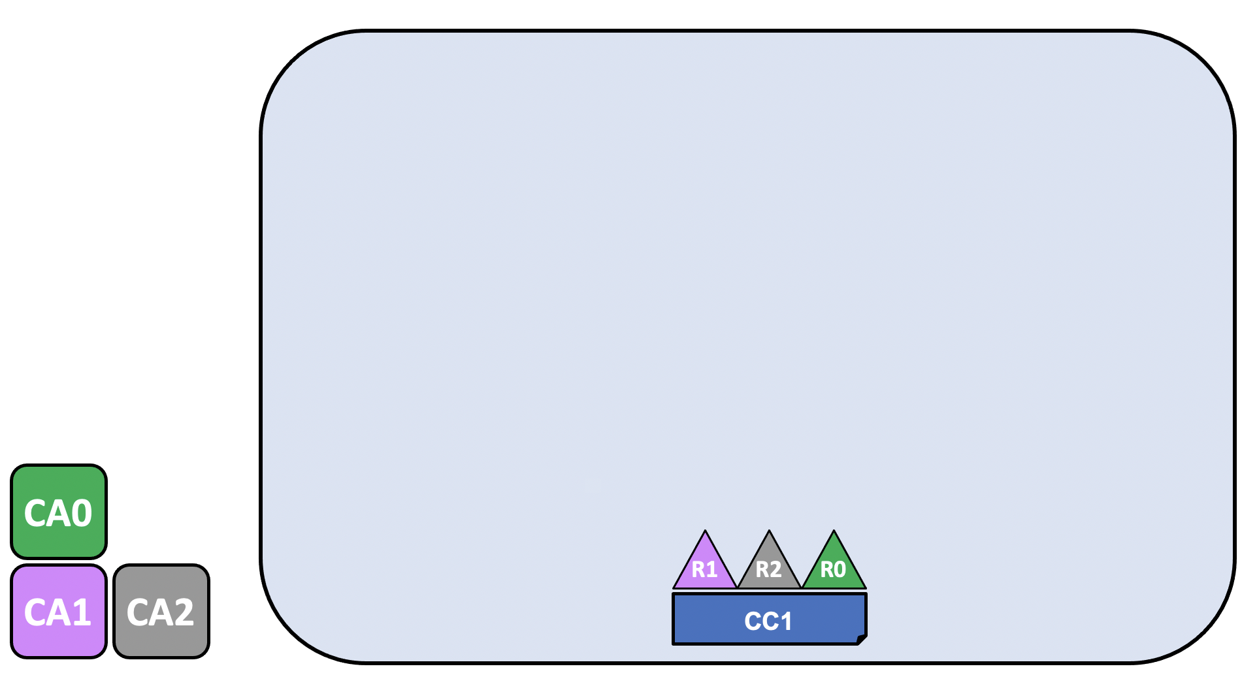
The channel configuration, CC1, has been agreed to by organizations R1, R2, and R0 and is contained in a block known as a “configuration block” that is, typically, created by the configtxgen tool from a configtx.yaml file. While it is possible for one organization to create this a channel unilaterally and then invite other organizations to it (we’ll explore this in Adding an organization to an existing channel), for now we’ll assume that the organizations wish to collaborate on the channel from the beginning.
Once a configuration block exists, a channel can be said to logically exist, even though no components are physically joined to it. This configuration block contains a record of the organizations that can join components and interact on the channel, as well as the policies that define the structure for how decisions are made and specific outcomes are reached. While the peers and applications are critical actors in the network, their behavior in a channel is dictated more by the channel configuration policy than any other factor. For more information about the policies and how they are defined in a channel configuration, check out Policies.
The definitions of these organizations, and the identities of their admins, must be created by a Certificate Authority (CA) associated with each organization. In our example, the organizations R1, R2, and R0 have had their certifications and organization definition created by CA1, CA2, and CA0, respectively. For information about how to create a CA, check out Planning for a CA. After the CA has been created, check out Registering and enrolling identities with a CA for information about how to define an organization and create identities for admins and nodes.

Certificate Authorities
Certificate Authorities play a key role in the network because they dispense X.509 certificates that can be used to identify components as belonging to an organization. Certificates issued by CAs can also be used to sign transactions to indicate that an organization endorses the transaction result – a precondition of it being accepted onto the ledger. Let’s examine these two aspects of a CA in a little more detail.
Firstly, different components of the blockchain network use certificates to identify themselves to each other as being from a particular organization. That’s why there is usually more than one CA supporting a blockchain network – different organizations often use different CAs. We’re going to use three CAs in our channel; one for each organization. Indeed, CAs are so important that Hyperledger Fabric provides you with a built-in one (called the Fabric-CA) to help you get going, though in practice, organizations will choose to use their own CA.
The mapping of certificates to member organizations is achieved via a structure called a Membership Services Provider (MSP), which defines an organization by creating an MSP which is tied to a root CA certificate to identify that components and identities were created by the root CA. The channel configuration can then assign certain rights and permissions to the organization through a policy (which will give a particular organization, such as R1, the right to add new organizations to the channel). We don’t show MSPs on these diagrams, as they would clutter them up, but because they define organizations, they are very important.
Secondly, we’ll see later how certificates issued by CAs are at the heart of the transaction generation and validation process. Specifically, X.509 certificates are used in client application transaction proposals and smart contract transaction responses to digitally sign transactions. Subsequently the network nodes who host copies of the ledger verify that transaction signatures are valid before accepting transactions onto the ledger.

Join nodes to the channel
Peers are a fundamental element of the network because they host ledgers and chaincode (which contain smart contracts) and are therefore one of the physical points at which organizations that transact on a channel connect to the channel (the other being an application). A peer can belong to as many channels as an organizations deems appropriate (depending on factors like the processing limitations of the peer pod and data residency rules that exist in a particular country).
The ordering service, on the other hand, gathers endorsed transactions from applications and orders them into transaction blocks, which are subsequently distributed to every peer node in the channel. At each of these committing peers, transactions are recorded and the local copy of the ledger updated appropriately. An ordering service is unique to a particular channel, with the nodes servicing that channel also known as a “consenter set”. Even if a node (or group of nodes) services multiple channels, each channel’s ordering service is considered to be a distinct instance of the ordering service.
Because R1, R2, and R0 are listed in the channel configuration, they are allowed to join peers (in the case of R1 and R2) or ordering nodes (in the case of R0) to the channel.
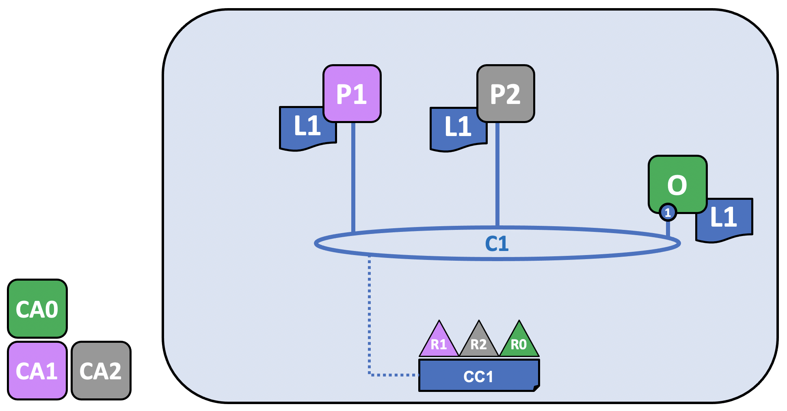
R1’s peer, P1, and R2’s peer, P2, along with R0’s ordering service, O, join the channel through the process described in the Create a channel tutorial. Note that while only one ordering node, 1, is joined to this channel, in a production scenario, an ordering service should contain at least three nodes. For the purposes of this topic, however, it is more important to conceptualize the interactions of the ordering service and the other components of the network than it is to understand how the needs of high availability impact configuration decisions. The nodes belonging to each organization have x.509 certificates created for them by the Certificate Authority associated with that organization. P1’s certificates are created by CA1, P2’s certificates are created by CA2, and so on.
Every node in the channel stores a copy of the ledger of the channel, L1, which will be updated with each new block (note that the ordering service only contains the blockchain portion of a ledger and not the state database). Because of this, we can think of L1 as being physically hosted on P1, but logically hosted on the channel C1. The best practice is for R1 and R2 to make their peers, P1 and P2, anchor peers, as this will bootstrap communication on the network between R1 and R2.
After the ordering service has been joined to the channel, it is possible to propose and commit updates to the channel configuration, but little else. Next, you must install, approve, and commit a chaincode on a channel.

Install, approve, and commit a chaincode
Chaincodes are installed on peers, and then defined and committed on a channel:
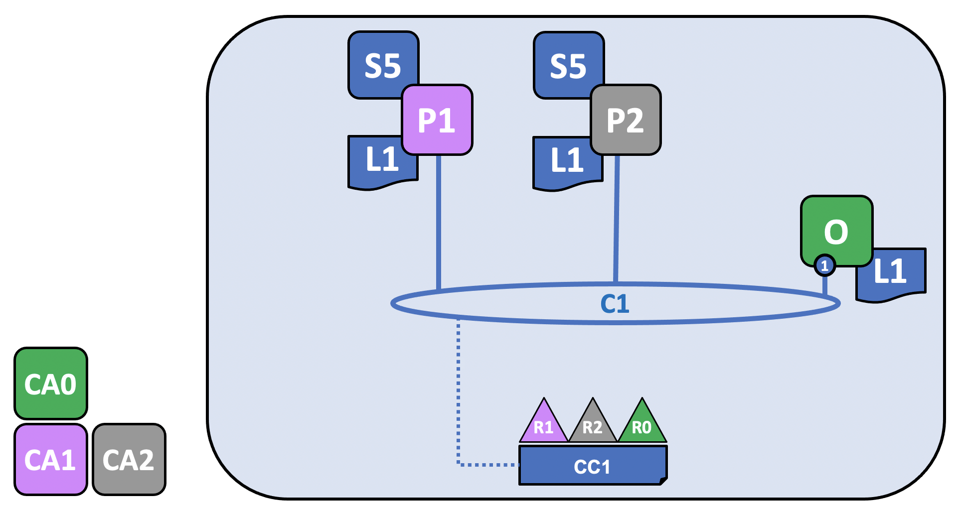
In Fabric, the business logic that defines how peer organizations interact with the ledger (for example, a transaction that changes the ownership of an asset), is contained in a smart contract. The structure that contains the smart contract, called chaincode, is installed on the relevant peers, approved by the relevant peer organizations, and committed on the channel. In this way, you can consider a chaincode to be physically hosted on a peer but logically hosted on a channel. In our example, the chaincode, S5, is installed on every peer, even though organizations are not required to install every chaincode. Note that the ordering service does not have the chaincode installed on it, as ordering nodes do not typically propose transactions. The process of installing, approving, and committing a chaincode is known as the “lifecycle” of the chaincode. For more information, check out Fabric chaincode lifecycle.
The most important piece of information supplied within the chaincode definition is the endorsement policy. It describes which organizations must endorse transactions before they will be accepted by other organizations onto their copy of the ledger. An endorsement policy can be set to any combination of members in a channel, depending on the use case. If an endorsement policy is not set, it is inherited from the default endorsement policy specified in the channel configuration.
Note that while some chaincodes include the ability to create private data transactions between members on a channel, private data is outside the scope of this topic.
While it’s now technically possible to drive transactions using the peer CLI, the best practice is to create an application and use it to invoke transactions on your chaincode.

Using an application on the channel
After a smart contract has been committed, client applications can be used to invoke transactions on a chaincode, via the Fabric Gateway service (the gateway). This completes the structure we showed in the first image:
Just like peers and orderers, a client application has an identity that associates it with an organization. In our example, client application A1 is associated with organization R1 and is connected to C1.
Starting in Fabric v2.4, the client application (developed using a Gateway SDK v1.x) makes a gRPC connection to the gateway service, which then handles the transaction proposal and endorsement process on behalf of the application. The transaction proposal serves as input to the chaincode, which uses it to generate a transaction response.
We can see that our peer organizations, R1 and R2, are fully participating in the channel. Their applications can access the ledger L1 via smart contract S5 to generate transactions that will be endorsed by the organizations specified in the endorsement policy and written to the ledger.
Note: Fabric v2.3 SDKs embed the logic of the v2.4 Fabric Gateway service in the client application

Joining components to multiple channels
Now that we have showed the process for how a channel is created, as well as the nature of the high level interactions between organizations, nodes, policies, chaincodes, and applications, let’s expand our view by adding a new organization and a new channel to our scenario. To show how Fabric components can be joined to multiple channels, we’ll join R2 and its peer, P2, to the new channel, while R1 and P1 will not be joined.

Creating the new channel configuration
As we’ve seen, the first step in creating a channel is to create its configuration. This channel will include not just R2 and R0, but a new organization, R3, which has had its identities and certificates created for it by CA3. R1 will have no rights over this channel and will not be able to join components to it. In fact, it has no way to know it even exists!
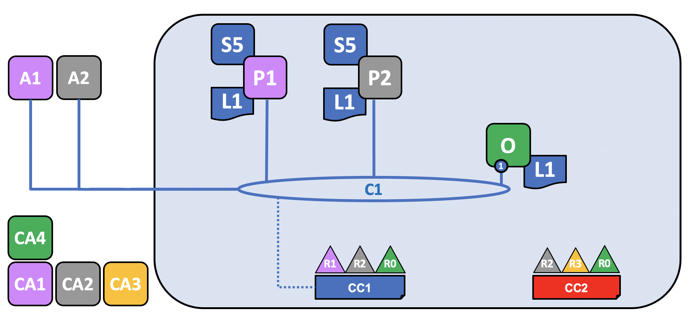
As before, now that the channel configuration, CC2, has been created, the channel can be said to logically exist, even though no components are joined to it.
So let’s join some components to it!

Join components to the new channel
Just as we did with C1, let’s join our components to C2. Because we already showed how all channels have a ledger and how chaincodes are installed on peers and committed to a channel (in this case, the chaincode is called S6), we’ll skip those steps for now to show the end state of C2. Note that this channel has its own ledger, L2, which is completely separate from the ledger of C1. That’s because even though R2 (and its peer, P2) are joined to both channels, the two channels are entirely separate administrative domains.

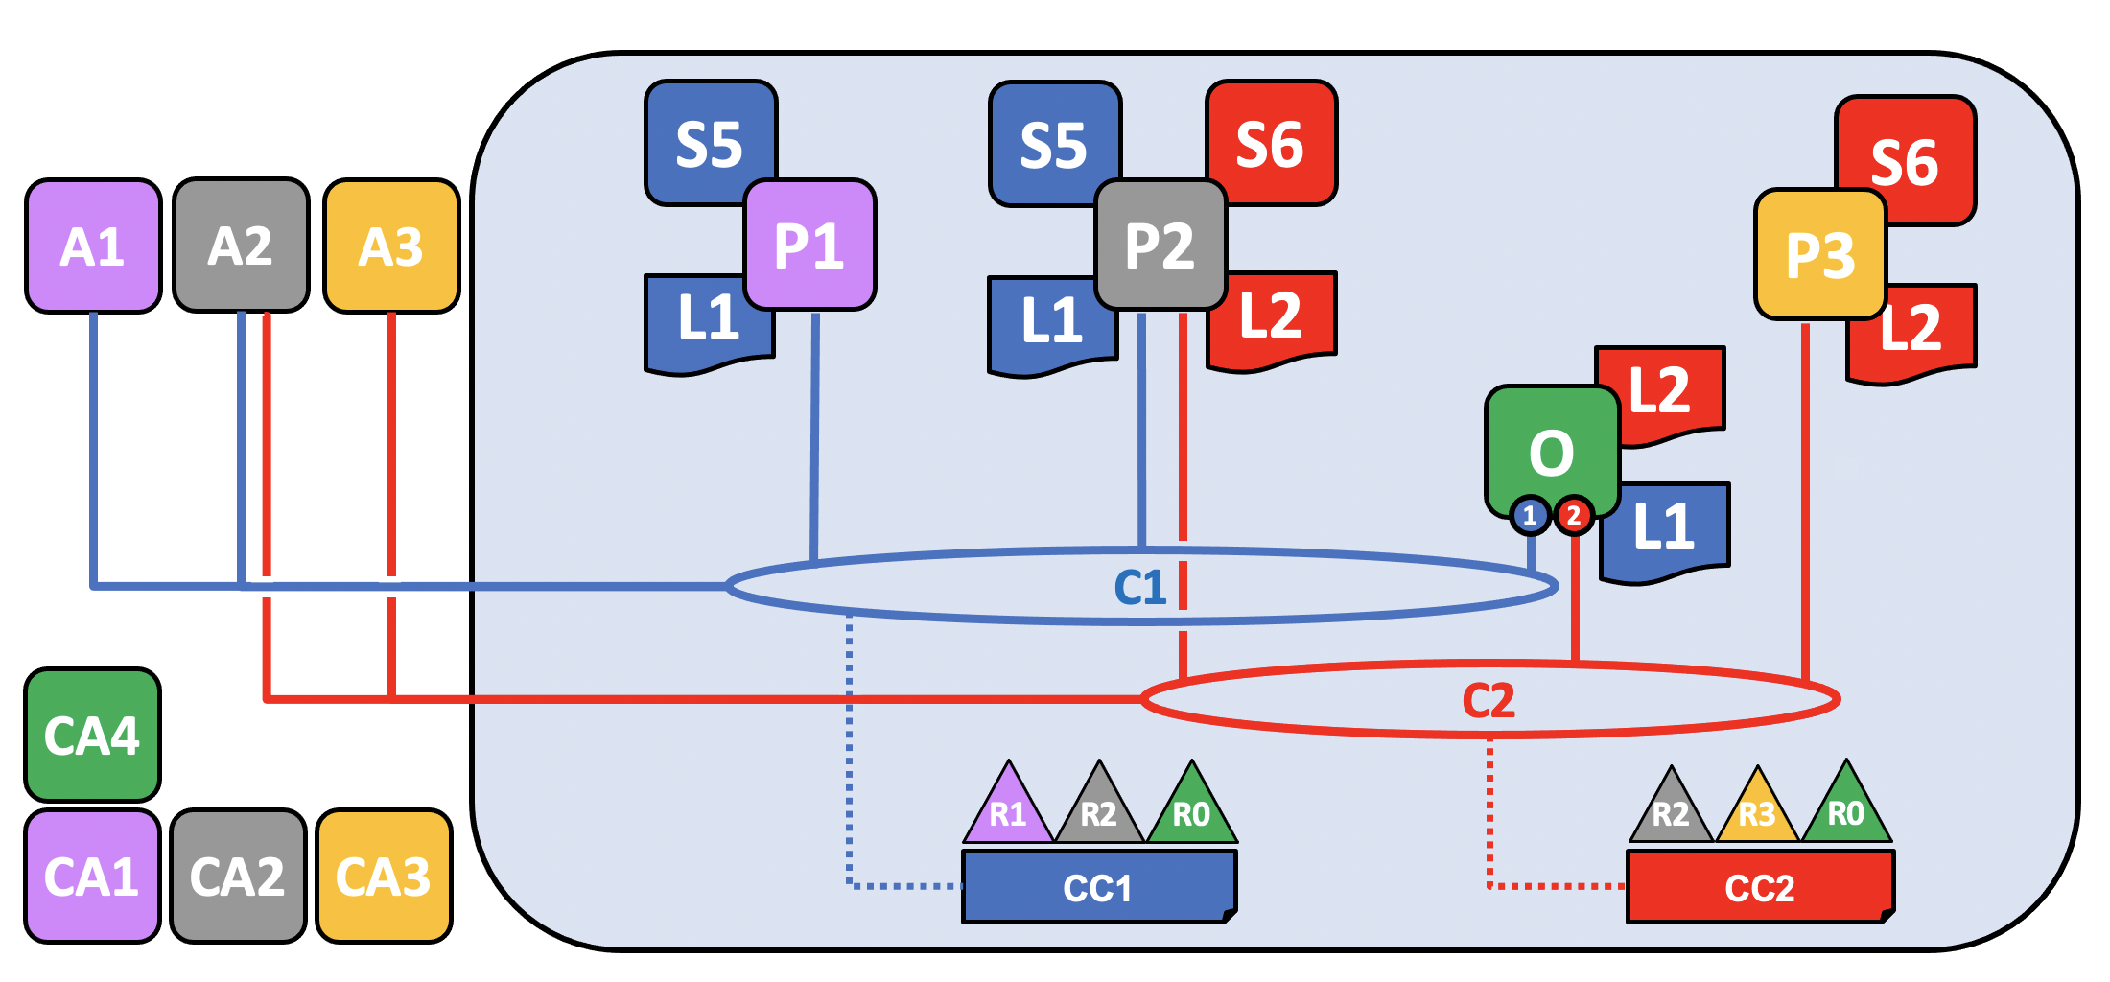
Note that while both C1 and C2 both have the same orderer organization joined to it, R0, different ordering nodes are servicing each channel. This is not a mandatory configuration because even if the same ordering nodes are joined to multiple channels, each channel has a separate instance of the ordering service, and is more common in channels in which multiple orderer organizations come together to contribute nodes to an ordering service. Note that only the ordering node joined to a particular channel has the ledger of that channel.
While it would also be possible for R2 to deploy a new peer to join to channel C2, in this case they have chosen to deploy the P2 to C2. Note that P2 has both the ledger of C1 (called L1) and the ledger of C2 (called L2) on its file system. Similarly, R2 has chosen to modify its application, A2, to be able to be used with C2, while R3’s application, A3, is being used with C2.
Logically, this is all very similar to the creation of C1. Two peer organizations come together with an ordering organization to create a channel and join components and a chaincode to it.
Think about this configuration from the standpoint of R2, which is joined to both channels. From their perspective, they might think about both C1 and C2, as well as the components they have joined to both, as the “network”, even though both channels are distinct from each other. In this sense, a “network” can also be seen as existing within the perspective of a particular organization as “all of the channels I am a member of and all of the components I own”.
Now that we have shown how organizations and their components can be joined to multiple channels, let’s talk about how an organization and its components are added to an existing channel.

Adding an organization to an existing channel
As channels mature, it is natural that its configuration will also mature, reflecting changes in the world that must be reflected in the channel. One of the more common ways a channel will be modified is to add new organizations to it. While it also possible to add more orderer organizations (who may or may not contribute their own nodes), in this example we’ll describe the process of how a peer organization, R3, is added to the channel configuration CC1 of channel C1.
Note that rights and permissions are defined at a channel level. Just because an organization is an administrator of one channel does not mean it will be an administrator of a different channel. Each channel is a distinct administrative zone and fully customizable to the use case it’s serving.
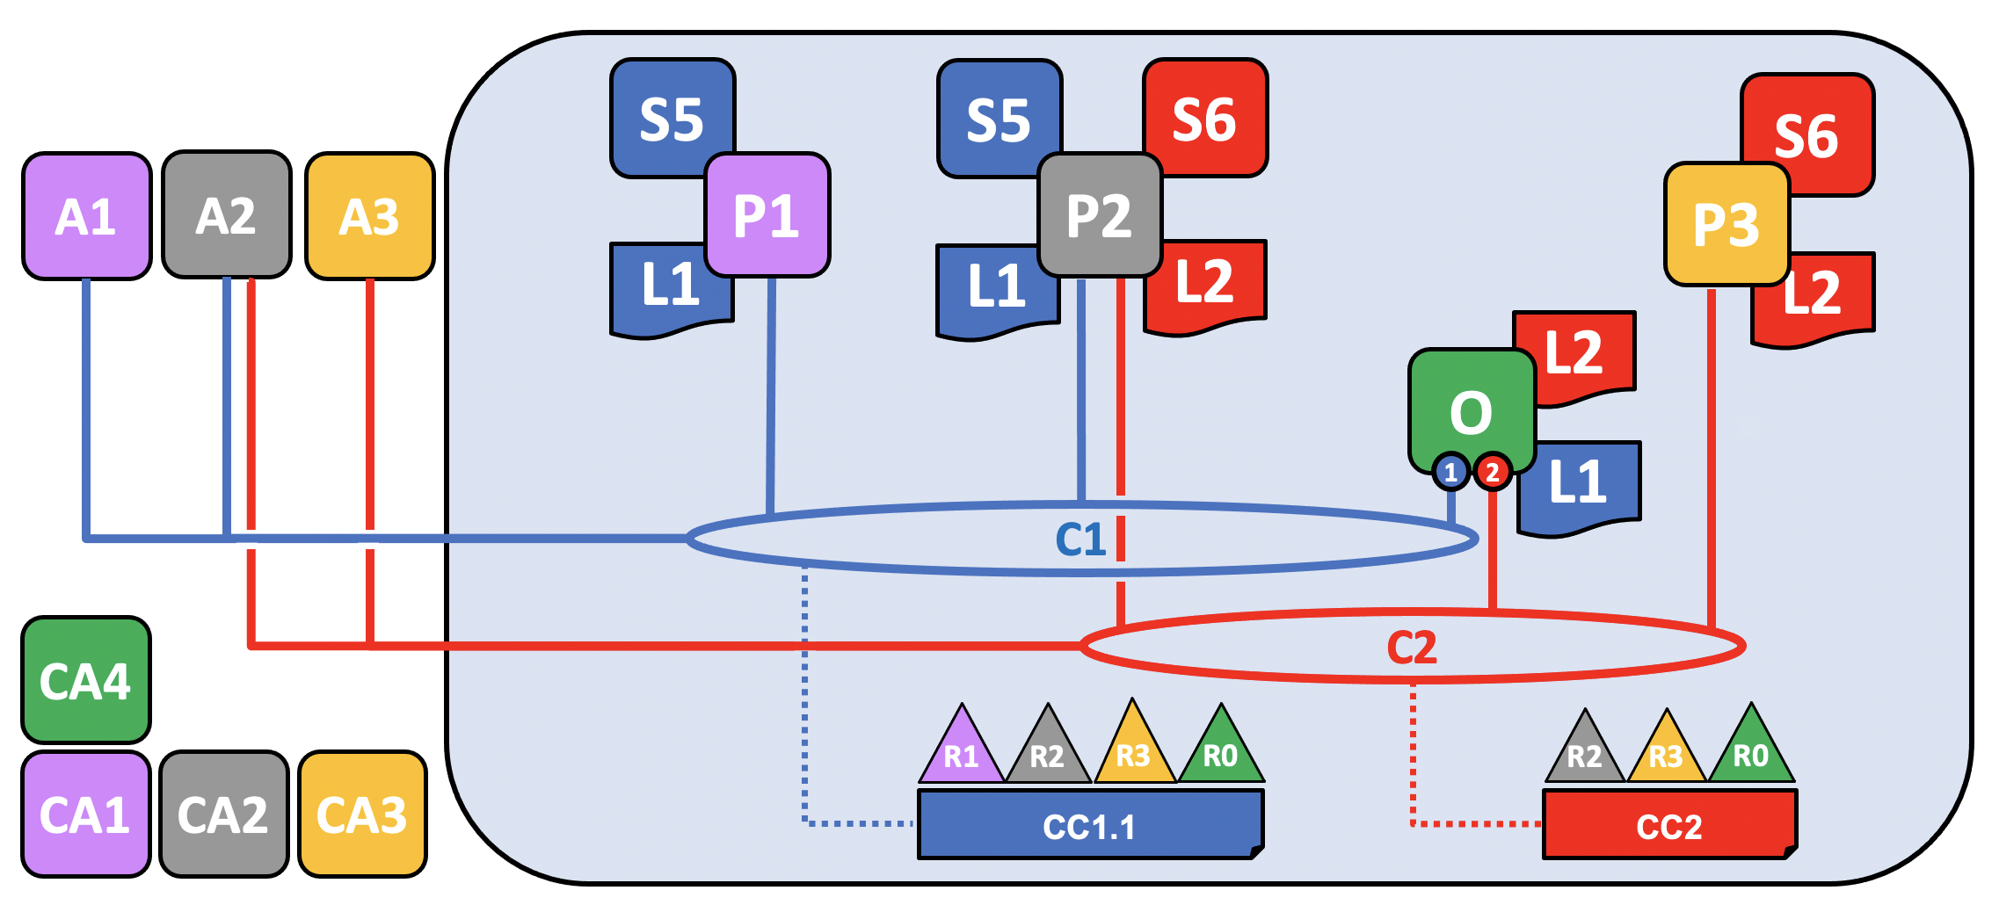
Although the update to the diagram looks like one simple step, adding a new organization to a channel is, at a high level, a three step process:
- Decide on the new organization’s permissions and role. The full scope of these rights must be agreed to before R3 is added to C1 and is beyond the scope of this topic, but comprise the same kinds of questions that must be answered when creating a channel in the first place. What kind of permissions and rights will R3 have on C1? Will it be an admin on the channel? Will its access to any channel resources be restricted (for example, R3 might only be able to write to C1, which means it can propose changes but not sign them)? What chaincodes will R3 install on its peers?
- Update the channel, including the relevant chaincodes, to reflect these decisions.
- The organization joins its peer nodes (and potentially ordering nodes) to the channel and begins participating.
In this topic, we’ll assume that R3 will join C1 with the same rights and status enjoyed by R1 and R2. Similarly, R3 will also be joined as an endorser of the S5 chaincode, which means that R1 or R2 must redefine S5 (specifically, the endorsement policy section of the chaincode definition) and approve it on the channel.
Updating the channel configuration creates a new configuration block, CC1.1, which will serve as the channel configuration until it is updated again. Note that even though the configuration has changed, the channel still exists and P1 and P2 are still joined to it. There is no need to re-add organizations or peers to the channel.

Adding existing components to the newly joined channel
Now that R3 is able to fully participate in channel C1, it can add its components to the channel. Rather than do this one component at a time, let’s show how its peer, its local copy of a ledger, a smart contract and a client application can be joined all at once!
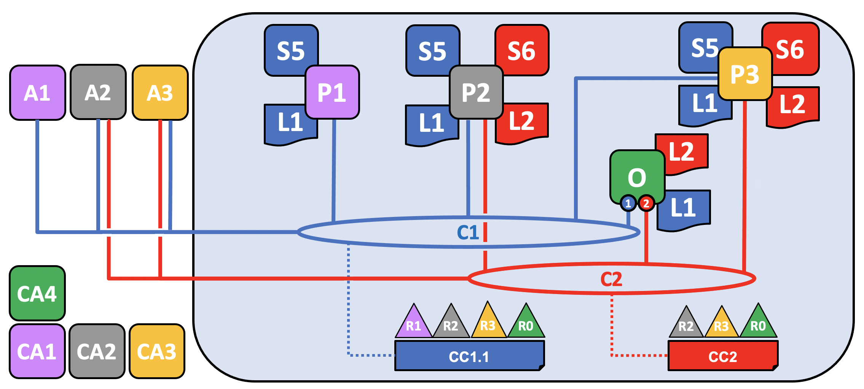
In this example, R3 adds P3, which was previously joined to C2, to C1. When it does this, P3 pulls C1’s ledger, L1. As we mentioned in the previous section, R3 has been added to C1 with equivalent rights as R1 and R2. Similarly, because the chaincode S5 was redefined and reapproved on the channel to include R3, R3 can now install S5 and begin transacting. Just as R2 modified its application A2 to be able to be used with channel C2, A3 is also now able to invoke transactions on C1.

Network recap
We’ve covered a lot of ground in this topic. We’ve gone from a simple configuration with two organizations transacting on a single channel to multiple organizations transacting on multiple channels as well as the process for joining an organization to a channel that already exists.
While this topic represents a relatively simple case, there are endless combinations of sophisticated topologies which are possible to achieve in Fabric, supporting an endless number of operational goals, and no theoretical limit to how big a network can get. The careful use of network and channel policies allow even large networks to be well-governed.

Identity

What is an Identity?
The different actors in a blockchain network include peers, orderers, client applications, administrators and more. Each of these actors — active elements inside or outside a network able to consume services — has a digital identity encapsulated in an X.509 digital certificate. These identities really matter because they determine the exact permissions over resources and access to information that actors have in a blockchain network.
A digital identity furthermore has some additional attributes that Fabric uses to determine permissions, and it gives the union of an identity and the associated attributes a special name — principal. Principals are just like userIDs or groupIDs, but a little more flexible because they can include a wide range of properties of an actor’s identity, such as the actor’s organization, organizational unit, role or even the actor’s specific identity. When we talk about principals, they are the properties which determine their permissions.
For an identity to be verifiable, it must come from a trusted authority. A membership service provider (MSP) is that trusted authority in Fabric. More specifically, an MSP is a component that defines the rules that govern the valid identities for this organization. The default MSP implementation in Fabric uses X.509 certificates as identities, adopting a traditional Public Key Infrastructure (PKI) hierarchical model (more on PKI later).

A Simple Scenario to Explain the Use of an Identity
Imagine that you visit a supermarket to buy some groceries. At the checkout you see a sign that says that only Visa, Mastercard and AMEX cards are accepted. If you try to pay with a different card — let’s call it an “ImagineCard” — it doesn’t matter whether the card is authentic and you have sufficient funds in your account. It will be not be accepted.
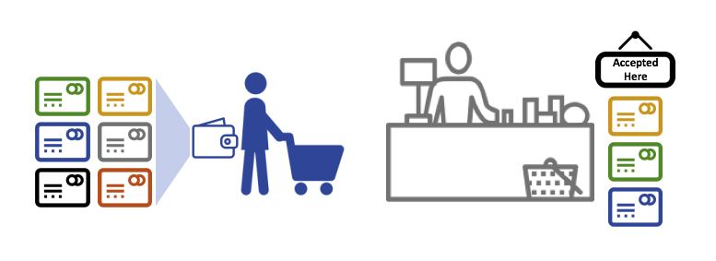
Having a valid credit card is not enough — it must also be accepted by the store! PKIs and MSPs work together in the same way — a PKI provides a list of identities, and an MSP says which of these are members of a given organization that participates in the network.
PKI certificate authorities and MSPs provide a similar combination of functionalities. A PKI is like a card provider — it dispenses many different types of verifiable identities. An MSP, on the other hand, is like the list of card providers accepted by the store, determining which identities are the trusted members (actors) of the store payment network. MSPs turn verifiable identities into the members of a blockchain network.
Let’s drill into these concepts in a little more detail.

What are PKIs?
A public key infrastructure (PKI) is a collection of internet technologies that provides secure communications in a network. It’s PKI that puts the S in HTTPS — and if you’re reading this documentation on a web browser, you’re probably using a PKI to make sure it comes from a verified source.
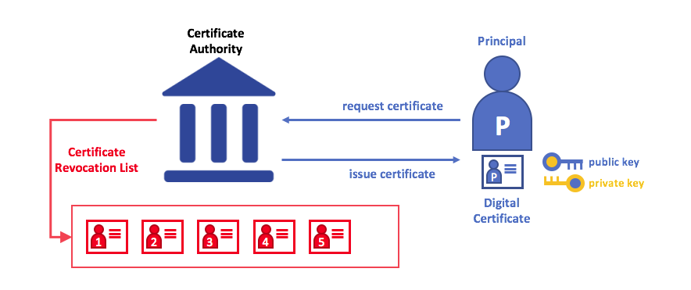
The elements of Public Key Infrastructure (PKI). A PKI is comprised of Certificate Authorities who issue digital certificates to parties (e.g., users of a service, service provider), who then use them to authenticate themselves in the messages they exchange in their environment. A CA’s Certificate Revocation List (CRL) constitutes a reference for the certificates that are no longer valid. Revocation of a certificate can happen for a number of reasons. For example, a certificate may be revoked because the cryptographic private material associated to the certificate has been exposed.
Although a blockchain network is more than a communications network, it relies on the PKI standard to ensure secure communication between various network participants, and to ensure that messages posted on the blockchain are properly authenticated. It’s therefore important to understand the basics of PKI and then why MSPs are so important.
There are four key elements to PKI:
- Digital Certificates
- Public and Private Keys
- Certificate Authorities
- Certificate Revocation Lists

Digital Certificates
A digital certificate is a document which holds a set of attributes relating to the holder of the certificate. The most common type of certificate is the one compliant with the X.509 standard, which allows the encoding of a party’s identifying details in its structure.
For example, Mary Morris in the Manufacturing Division of Mitchell Cars in Detroit, Michigan might have a digital certificate with a SUBJECT attribute of C=US, ST=Michigan, L=Detroit, O=Mitchell Cars, OU=Manufacturing, CN=Mary Morris /UID=123456. Mary’s certificate is similar to her government identity card — it provides information about Mary which she can use to prove key facts about her. There are many other attributes in an X.509 certificate, but let’s concentrate on just these for now.
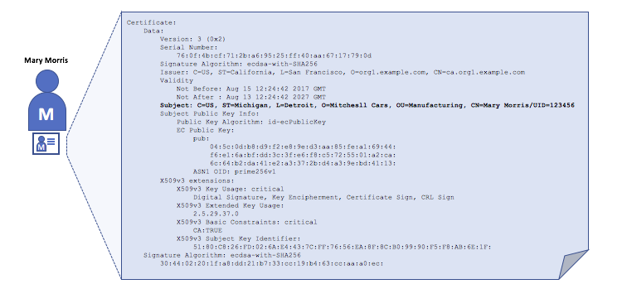
A digital certificate describing a party called Mary Morris. Mary is the SUBJECT of the certificate, and the highlighted SUBJECT text shows key facts about Mary. The certificate also holds many more pieces of information, as you can see. Most importantly, Mary’s public key is distributed within her certificate, whereas her private signing key is not. This signing key must be kept private.
What is important is that all of Mary’s attributes can be recorded using a mathematical technique called cryptography (literally, “secret writing”) so that tampering will invalidate the certificate. Cryptography allows Mary to present her certificate to others to prove her identity so long as the other party trusts the certificate issuer, known as a Certificate Authority (CA). As long as the CA keeps certain cryptographic information securely (meaning, its own private signing key), anyone reading the certificate can be sure that the information about Mary has not been tampered with — it will always have those particular attributes for Mary Morris. Think of Mary’s X.509 certificate as a digital identity card that is impossible to change.

Authentication, Public keys, and Private Keys
Authentication and message integrity are important concepts in secure communications. Authentication requires that parties who exchange messages are assured of the identity that created a specific message. For a message to have “integrity” means that cannot have been modified during its transmission. For example, you might want to be sure you’re communicating with the real Mary Morris rather than an impersonator. Or if Mary has sent you a message, you might want to be sure that it hasn’t been tampered with by anyone else during transmission.
Traditional authentication mechanisms rely on digital signatures that, as the name suggests, allow a party to digitally sign its messages. Digital signatures also provide guarantees on the integrity of the signed message.
Technically speaking, digital signature mechanisms require each party to hold two cryptographically connected keys: a public key that is made widely available and acts as authentication anchor, and a private key that is used to produce digital signatures on messages. Recipients of digitally signed messages can verify the origin and integrity of a received message by checking that the attached signature is valid under the public key of the expected sender.
The unique relationship between a private key and the respective public key is the cryptographic magic that makes secure communications possible. The unique mathematical relationship between the keys is such that the private key can be used to produce a signature on a message that only the corresponding public key can match, and only on the same message.
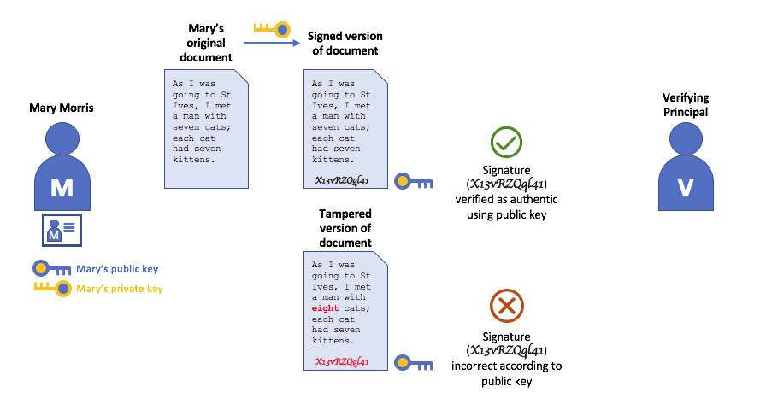
In the example above, Mary uses her private key to sign the message. The signature can be verified by anyone who sees the signed message using her public key.

Certificate Authorities
As you’ve seen, an actor or a node is able to participate in the blockchain network, via the means of a digital identity issued for it by an authority trusted by the system. In the most common case, digital identities (or simply identities) have the form of cryptographically validated digital certificates that comply with X.509 standard and are issued by a Certificate Authority (CA).
CAs are a common part of internet security protocols, and you’ve probably heard of some of the more popular ones: Symantec (originally Verisign), GeoTrust, DigiCert, GoDaddy, and Comodo, among others.
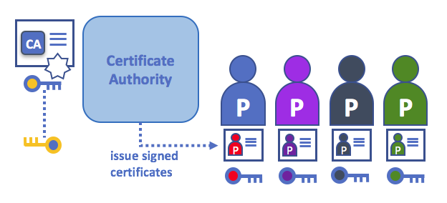
A Certificate Authority dispenses certificates to different actors. These certificates are digitally signed by the CA and bind together the actor with the actor’s public key (and optionally with a comprehensive list of properties). As a result, if one trusts the CA (and knows its public key), it can trust that the specific actor is bound to the public key included in the certificate, and owns the included attributes, by validating the CA’s signature on the actor’s certificate.
Certificates can be widely disseminated, as they do not include either the actors’ nor the CA’s private keys. As such they can be used as anchor of trusts for authenticating messages coming from different actors.
CAs also have a certificate, which they make widely available. This allows the consumers of identities issued by a given CA to verify them by checking that the certificate could only have been generated by the holder of the corresponding private key (the CA).
In a blockchain setting, every actor who wishes to interact with the network needs an identity. In this setting, you might say that one or more CAs can be used to define the members of an organization’s from a digital perspective. It’s the CA that provides the basis for an organization’s actors to have a verifiable digital identity.

Root CAs, Intermediate CAs and Chains of Trust
CAs come in two flavors: Root CAs and Intermediate CAs. Because Root CAs (Symantec, Geotrust, etc) have to securely distribute hundreds of millions of certificates to internet users, it makes sense to spread this process out across what are called Intermediate CAs. These Intermediate CAs have their certificates issued by the root CA or another intermediate authority, allowing the establishment of a “chain of trust” for any certificate that is issued by any CA in the chain. This ability to track back to the Root CA not only allows the function of CAs to scale while still providing security — allowing organizations that consume certificates to use Intermediate CAs with confidence — it limits the exposure of the Root CA, which, if compromised, would endanger the entire chain of trust. If an Intermediate CA is compromised, on the other hand, there will be a much smaller exposure.
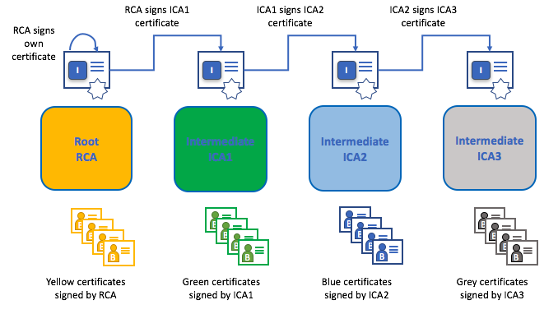
A chain of trust is established between a Root CA and a set of Intermediate CAs as long as the issuing CA for the certificate of each of these Intermediate CAs is either the Root CA itself or has a chain of trust to the Root CA.
Intermediate CAs provide a huge amount of flexibility when it comes to the issuance of certificates across multiple organizations, and that’s very helpful in a permissioned blockchain system (like Fabric). For example, you’ll see that different organizations may use different Root CAs, or the same Root CA with different Intermediate CAs — it really does depend on the needs of the network.

Fabric CA
It’s because CAs are so important that Fabric provides a built-in CA component to allow you to create CAs in the blockchain networks you form. This component — known as Fabric CA is a private root CA provider capable of managing digital identities of Fabric participants that have the form of X.509 certificates. Because Fabric CA is a custom CA targeting the Root CA needs of Fabric, it is inherently not capable of providing SSL certificates for general/automatic use in browsers. However, because some CA must be used to manage identity (even in a test environment), Fabric CA can be used to provide and manage certificates. It is also possible — and fully appropriate — to use a public/commercial root or intermediate CA to provide identification.

Certificate Revocation Lists
A Certificate Revocation List (CRL) is easy to understand — it’s just a list of references to certificates that a CA knows to be revoked for one reason or another. If you recall the store scenario, a CRL would be like a list of stolen credit cards.
When a third party wants to verify another party’s identity, it first checks the issuing CA’s CRL to make sure that the certificate has not been revoked. A verifier doesn’t have to check the CRL, but if they don’t they run the risk of accepting a compromised identity.
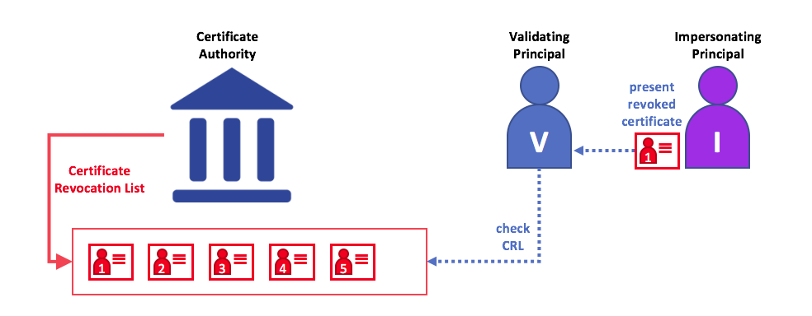
Using a CRL to check that a certificate is still valid. If an impersonator tries to pass a compromised digital certificate to a validating party, it can be first checked against the issuing CA’s CRL to make sure it’s not listed as no longer valid.
Note that a certificate being revoked is very different from a certificate expiring. Revoked certificates have not expired — they are, by every other measure, a fully valid certificate. For more in-depth information about CRLs, click here.
Now that you’ve seen how a PKI can provide verifiable identities through a chain of trust, the next step is to see how these identities can be used to represent the trusted members of a blockchain network. That’s where a Membership Service Provider (MSP) comes into play — it identifies the parties who are the members of a given organization in the blockchain network.

Membership Service Provider (MSP)
Note: this topic describes a network that does not use a “system channel”, a channel that the ordering service is bootstrapped with and the ordering service exclusively controls. Since the release of v2.3, using system channel is now considered the legacy process as compared to the process to Create a channel without a system channel.

Why do I need an MSP?
Because Fabric is a permissioned network, blockchain participants need a way to prove their identity to the rest of the network in order to transact on the network. If you’ve read through the documentation on Identity you’ve seen how a Public Key Infrastructure (PKI) can provide verifiable identities through a chain of trust. How is that chain of trust used by the blockchain network?
Certificate Authorities issue identities by generating a public and private key which forms a key-pair that can be used to prove identity. This identity needs a way to be recognized by the network, which is where the MSP comes in. For example, a peer uses its private key to digitally sign, or endorse, a transaction. The MSP is used to check that the peer is allowed to endorse the transaction. The public key from the peer’s certificate is then used to verify that the signature attached to the transaction is valid. Thus, the MSP is the mechanism that allows that identity to be trusted and recognized by the rest of the network.
Recall from the credit card scenario in the Identity topic that the Certificate Authority is like a card provider — it dispenses many different types of verifiable identities. An MSP, on the other hand, determines which credit card providers are accepted at the store. In this way, the MSP turns an identity (the credit card) into a role (the ability to buy things at the store).
This ability to turn verifiable identities into roles is fundamental to the way Fabric networks function, since it allows organizations, nodes, and channels the ability establish MSPs that determine who is allowed to do what at the organization, node, and channel level.
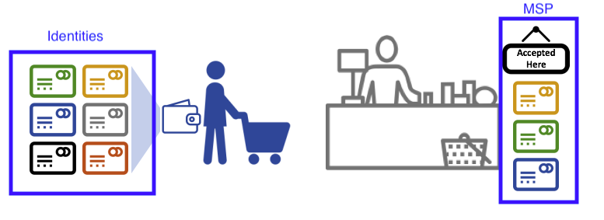
Identities are similar to your credit cards that are used to prove you can pay. The MSP is similar to the list of accepted credit cards.
Consider a group of banks that operate a blockchain network. Each bank operates peer and ordering nodes, and the peers endorse transactions submitted to the network. However, each bank would also have departments and account holders. The account holders would belong to each organization, but would not run nodes on the network. They would only interact with the system from their mobile or web application. So how does the network recognize and differentiate these identities? A CA was used to create the identities, but like the card example, those identities can’t just be issued, they need to be recognized by the network. MSPs are used to define the organizations that are trusted by the network members. MSPs are also the mechanism that provide members with a set of roles and permissions within the network. Because the MSPs defining these organizations are known to the members of a network, they can then be used to validate the network entities that attempt to perform the actions they are allowed to.
Finally, consider if you want to join an existing network, you need a way to turn your identity into something that is recognized by the network. The MSP is the mechanism that enables you to participate on a permissioned blockchain network. To transact on a Fabric network a member needs to:
- Have an identity issued by a CA that is trusted by an organization. The organization MSP determines which CAs are trusted by the organization.
- Check that the organization MSP is added to the channel. This means that the organization is recognized and approved by the network members.
- Ensure the MSP is included in the policy definitions on the network.

What is an MSP?
Despite its name, the Membership Service Provider does not actually provide anything. Rather, the implementation of the MSP requirement is a set of folders that are added to the configuration of the network and is used to define an organization both inwardly (organizations decide who its admins are) and outwardly (by allowing other organizations to validate that entities have the authority to do what they are attempting to do). Whereas Certificate Authorities generate the certificates that represent identities, the MSP contains a list of permissioned identities.
The MSP identifies which Root CAs and Intermediate CAs are accepted to define the members of a trust domain by listing the identities of their members, or by identifying which CAs are authorized to issue valid identities for their members.
But the power of an MSP goes beyond simply listing who is a network participant or member of a channel. It is the MSP that turns an identity into a role by identifying specific privileges an actor has on a node or channel. Note that when a user is registered with a Fabric CA, a role of admin, peer, client, orderer, or member must be associated with the user. For example, identities registered with the “peer” role should, naturally, be given to a peer. Similarly, identities registered with the “admin” role should be given to organization admins. We’ll delve more into the significance of these roles later in the topic.
In addition, an MSP can allow for the identification of a list of identities that have been revoked — as discussed in the Identity documentation — but we will talk about how that process also extends to an MSP.

MSP domains
MSPs occur in two domains in a blockchain network:
- Locally on an actor’s node (local MSP)
- In channel configuration (channel MSP)
The key difference between local and channel MSPs is not how they function – both turn identities into roles – but their scope. Each MSP lists roles and permissions at a particular level of administration.

Local MSPs
Local MSPs are defined for clients and for nodes (peers and orderers). Local MSPs define the permissions for a node (who are the peer admins who can operate the node, for example). The local MSPs of clients (the account holders in the banking scenario above), allow the user to authenticate itself in its transactions as a member of a channel (e.g. in chaincode transactions), or as the owner of a specific role into the system such as an organization admin, for example, in configuration transactions.
Every node must have a local MSP defined, as it defines who has administrative or participatory rights at that level (peer admins will not necessarily be channel admins, and vice versa). This allows for authenticating member messages outside the context of a channel and to define the permissions over a particular node (who has the ability to install chaincode on a peer, for example). Note that one or more nodes can be owned by an organization. An MSP defines the organization admins. And the organization, the admin of the organization, the admin of the node, and the node itself should all have the same root of trust.
An orderer local MSP is also defined on the file system of the node and only applies to that node. Like peer nodes, orderers are also owned by a single organization and therefore have a single MSP to list the actors or nodes it trusts.

Channel MSPs
In contrast, channel MSPs define administrative and participatory rights at the channel level. Peers and ordering nodes on an application channel share the same view of channel MSPs, and will therefore be able to correctly authenticate the channel participants. This means that if an organization wishes to join the channel, an MSP incorporating the chain of trust for the organization’s members would need to be included in the channel configuration. Otherwise transactions originating from this organization’s identities will be rejected. Whereas local MSPs are represented as a folder structure on the file system, channel MSPs are described in a channel configuration.
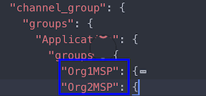
Snippet from a channel config.json file that includes two organization MSPs.
Channel MSPs identify who has authorities at a channel level. The channel MSP defines the relationship between the identities of channel members (which themselves are MSPs) and the enforcement of channel level policies. Channel MSPs contain the MSPs of the organizations of the channel members.
Every organization participating in a channel must have an MSP defined for it. In fact, it is recommended that there is a one-to-one mapping between organizations and MSPs. The MSP defines which members are empowered to act on behalf of the organization. This includes configuration of the MSP itself as well as approving administrative tasks that the organization has role, such as adding new members to a channel. If all network members were part of a single organization or MSP, data privacy is sacrificed. Multiple organizations facilitate privacy by segregating ledger data to only channel members. If more granularity is required within an organization, the organization can be further divided into organizational units (OUs) which we describe in more detail later in this topic.
The channel MSP includes the MSPs of all the organizations on a channel. This includes not just “peer organizations”, which own peers and invoke chaincodes, but the organizations that own and run the ordering service.
Local MSPs are only defined on the file system of the node or user to which they apply. Therefore, physically and logically there is only one local MSP per node. However, as channel MSPs are available to all nodes in the channel, they are logically defined once in the channel configuration. However, a channel MSP is also instantiated on the file system of every node in the channel and kept synchronized via consensus. So while there is a copy of each channel MSP on the local file system of every node, logically a channel MSP resides on and is maintained by the channel or the network.
The following diagram illustrates how local and channel MSPs coexist on the network:
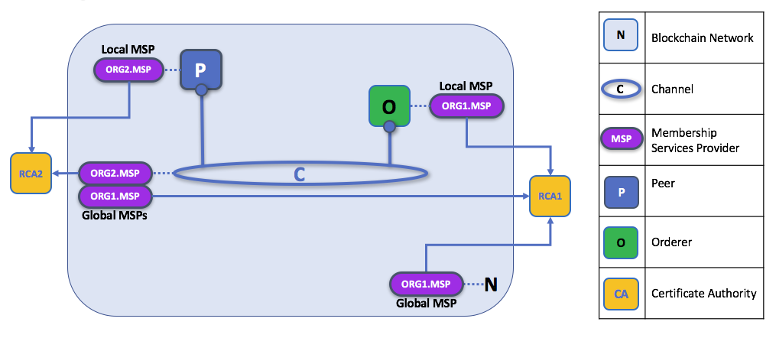
In this figure, ORG1, owns the ordering node joined to the channel. The MSPs related to ORG1, the local MSP of the node and the global MSP that formally represents ORG1 on the channel, have been created by RCA1, the CA for ORG1. The peer organization, ORG2, also has a local MSP for its peer and another global MSP that represents ORG2 on the channel. Both ORG1 and ORG2 are channel members, and manage the channel in their areas of administration, and trust identities created by each other’s CA. Note that in a production scenario, it is likely that there will be several peer organizations who collaborate in the administration of the channel, and potentially more than one orderer organization as well.

What role does an organization play in an MSP?
An organization is a logical managed group of members. This can be something as big as a multinational corporation or a small as a flower shop. What’s most important about organizations (or orgs) is that they manage their members under a single MSP. The MSP allows an identity to be linked to an organization. Note that this is different from the organization concept defined in an X.509 certificate, which we mentioned above.
The exclusive relationship between an organization and its MSP makes it sensible to name the MSP after the organization, a convention you’ll find adopted in most policy configurations. For example, organization ORG1 would likely have an MSP called something like ORG1-MSP. In some cases an organization may require multiple membership groups — for example, where channels are used to perform very different business functions between organizations. In these cases it makes sense to have multiple MSPs and name them accordingly, e.g., ORG2-MSP-NATIONAL and ORG2-MSP-GOVERNMENT, reflecting the different membership roots of trust within ORG2 in the NATIONAL sales channel compared to the GOVERNMENT regulatory channel.

Organizational Units (OUs) and MSPs
An organization can also be divided into multiple organizational units, each of which has a certain set of responsibilities, also referred to as affiliations. Think of an OU as a department inside an organization. For example, the ORG1 organization might have both ORG1.MANUFACTURING and ORG1.DISTRIBUTION OUs to reflect these separate lines of business. When a CA issues X.509 certificates, the OU field in the certificate specifies the line of business to which the identity belongs. A benefit of using OUs like this is that these values can then be used in policy definitions in order to restrict access or in smart contracts for attribute-based access control. Otherwise, separate MSPs would need to be created for each organization.
Specifying OUs is optional. If OUs are not used, all of the identities that are part of an MSP — as identified by the Root CA and Intermediate CA folders — will be considered members of the organization.

Node OU Roles and MSPs
Additionally, there is a special kind of OU, sometimes referred to as a Node OU, that can be used to confer a role onto an identity. These Node OU roles are defined in the $FABRIC_CFG_PATH/msp/config.yaml file and contain a list of organizational units whose members are considered to be part of the organization represented by this MSP. This is particularly useful when you want to restrict the members of an organization to the ones holding an identity (signed by one of MSP designated CAs) with a specific Node OU role in it. For example, with node OU’s you can implement a more granular endorsement policy that requires Org1 peers to endorse a transaction, rather than any member of Org1.
In order to use the Node OU roles, the “identity classification” feature must be enabled for the network. When using the folder-based MSP structure, this is accomplished by enabling “Node OUs” in the config.yaml file which resides in the root of the MSP folder:
NodeOUs:
Enable: true
ClientOUIdentifier:
Certificate: cacerts/ca.sampleorg-cert.pem
OrganizationalUnitIdentifier: client
PeerOUIdentifier:
Certificate: cacerts/ca.sampleorg-cert.pem
OrganizationalUnitIdentifier: peer
AdminOUIdentifier:
Certificate: cacerts/ca.sampleorg-cert.pem
OrganizationalUnitIdentifier: admin
OrdererOUIdentifier:
Certificate: cacerts/ca.sampleorg-cert.pem
OrganizationalUnitIdentifier: orderer
In the example above, there are 4 possible Node OU ROLES for the MSP:
- client
- peer
- admin
- orderer
This convention allows you to distinguish MSP roles by the OU present in the CommonName attribute of the X509 certificate. The example above says that any certificate issued by cacerts/ca.sampleorg-cert.pem in which OU=client will identified as a client, OU=peer as a peer, etc. Starting with Fabric v1.4.3, there is also an OU for the orderer and for admins. The new admins role means that you no longer have to explicitly place certs in the admincerts folder of the MSP directory. Rather, the admin role present in the user’s signcert qualifies the identity as an admin user.
These Role and OU attributes are assigned to an identity when the Fabric CA or SDK is used to register a user with the CA. It is the subsequent enroll user command that generates the certificates in the users’ /msp folder.
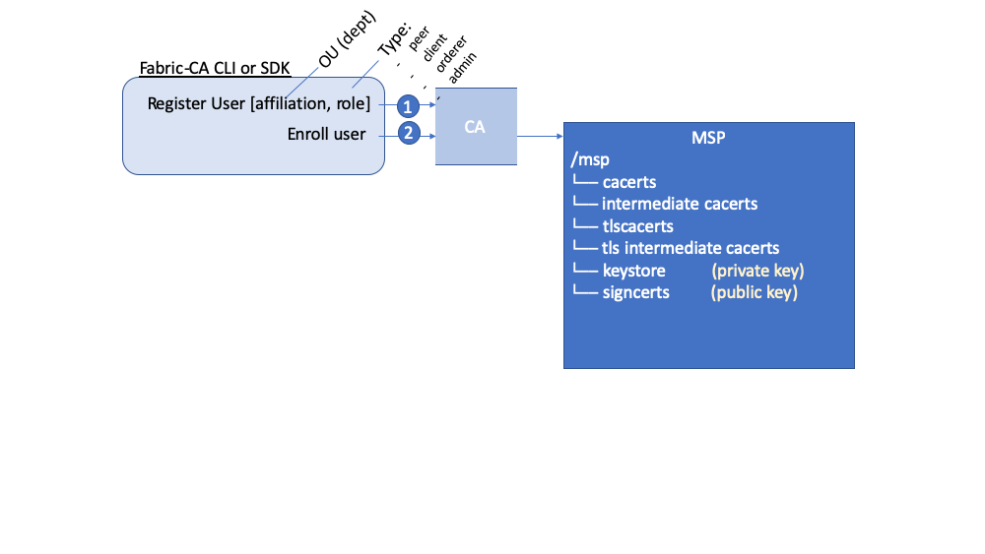
The resulting ROLE and OU attributes are visible inside the X.509 signing certificate located in the /signcerts folder. The ROLE attribute is identified as hf.Type and refers to an actor’s role within its organization, (specifying, for example, that an actor is a peer). See the following snippet from a signing certificate shows how the Roles and OUs are represented in the certificate.
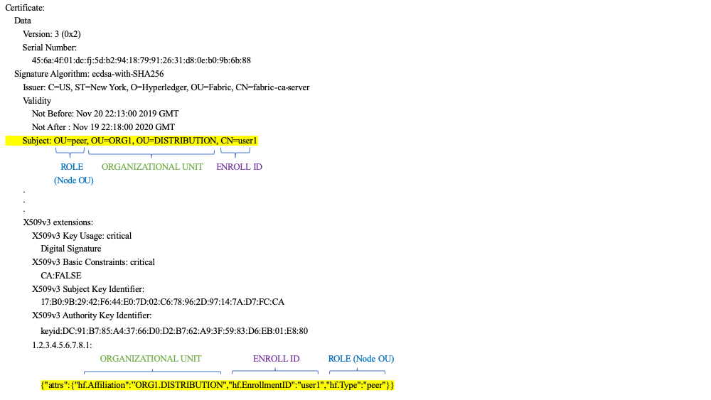
Note: For Channel MSPs, just because an actor has the role of an administrator it doesn’t mean that they can administer particular resources. The actual power a given identity has with respect to administering the system is determined by the policies that manage system resources. For example, a channel policy might specify that ORG1-MANUFACTURING administrators, meaning identities with a role of admin and a Node OU of ORG1-MANUFACTURING, have the rights to add new organizations to the channel, whereas the ORG1-DISTRIBUTION administrators have no such rights.
Finally, OUs could be used by different organizations to distinguish each other. But in such cases, the different organizations have to use the same Root CAs and Intermediate CAs for their chain of trust, and assign the OU field to identify members of each organization. When every organization has the same CA or chain of trust, this makes the system more centralized than what might be desirable and therefore deserves careful consideration on a blockchain network.

MSP Structure
Let’s explore the MSP elements that render the functionality we’ve described so far.
A local MSP folder contains the following sub-folders:
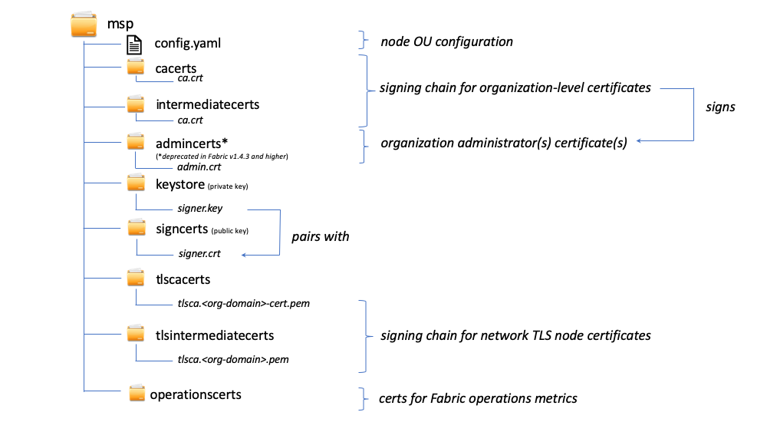
The figure above shows the subfolders in a local MSP on the file system
- config.yaml: Used to configure the identity classification feature in Fabric by enabling “Node OUs” and defining the accepted roles.
- cacerts: This folder contains a list of self-signed X.509 certificates of the Root CAs trusted by the organization represented by this MSP. There must be at least one Root CA certificate in this MSP folder.
This is the most important folder because it identifies the CAs from which all other certificates must be derived to be considered members of the corresponding organization to form the chain of trust.
- intermediatecerts: This folder contains a list of X.509 certificates of the Intermediate CAs trusted by this organization. Each certificate must be signed by one of the Root CAs in the MSP or by any Intermediate CA whose issuing CA chain ultimately leads back to a trusted Root CA.
An intermediate CA may represent a different subdivision of the organization (like ORG1-MANUFACTURING and ORG1-DISTRIBUTION do for ORG1), or the organization itself (as may be the case if a commercial CA is leveraged for the organization’s identity management). In the latter case intermediate CAs can be used to represent organization subdivisions. Here you may find more information on best practices for MSP configuration. Notice, that it is possible to have a functioning network that does not have an Intermediate CA, in which case this folder would be empty.
Like the Root CA folder, this folder defines the CAs from which certificates must be issued to be considered members of the organization.
- admincerts (Deprecated from Fabric v1.4.3 and higher): This folder contains a list of identities that define the actors who have the role of administrators for this organization. In general, there should be one or more X.509 certificates in this list.
Note: Prior to Fabric v1.4.3, admins were defined by explicitly putting certs in the admincerts folder in the local MSP directory of your peer. With Fabric v1.4.3 or higher, certificates in this folder are no longer required. Instead, it is recommended that when the user is registered with the CA, that the admin role is used to designate the node administrator. Then, the identity is recognized as an admin by the Node OU role value in their signcert. As a reminder, in order to leverage the admin role, the “identity classification” feature must be enabled in the config.yaml above by setting “Node OUs” to Enable: true. We’ll explore this more later.
And as a reminder, for Channel MSPs, just because an actor has the role of an administrator it doesn’t mean that they can administer particular resources. The actual power a given identity has with respect to administering the system is determined by the policies that manage system resources. For example, a channel policy might specify that ORG1-MANUFACTURING administrators have the rights to add new organizations to the channel, whereas the ORG1-DISTRIBUTION administrators have no such rights.
- keystore: (private Key) This folder is defined for the local MSP of a peer or orderer node (or in a client’s local MSP), and contains the node’s private key. This key is used to sign data — for example to sign a transaction proposal response, as part of the endorsement phase.
This folder is mandatory for local MSPs, and must contain exactly one private key. Obviously, access to this folder must be limited only to the identities of users who have administrative responsibility on the peer.
The channel MSP configuration does not include this folder, because channel MSPs solely aim to offer identity validation functionalities and not signing abilities.
Note: If you are using a Hardware Security Module(HSM) for key management, this folder is empty because the private key is generated by and stored in the HSM.
- signcert: For a peer or orderer node (or in a client’s local MSP) this folder contains the node’s certificate issued by CA. The certificate represents the node’s identity, and this certificate’s corresponding private key can be used to generate signatures which may be verified by anyone with a copy of this certificate.
This folder is mandatory for local MSPs, and must contain exactly one public key. Obviously, access to this folder must be limited only to the identities of users who have administrative responsibility on the peer.
Configuration of a channel MSP does not include this folder, as channel MSPs solely aim to offer identity validation functionalities and not signing abilities.
- tlscacerts: This folder contains a list of self-signed X.509 certificates of the Root CAs trusted by this organization for secure communications between nodes using TLS. An example of a TLS communication would be when a peer needs to connect to an orderer so that it can receive ledger updates.
MSP TLS information relates to the nodes inside the network — the peers and the orderers, in other words, rather than the applications and administrations that consume the network.
There must be at least one TLS Root CA certificate in this folder. For more information about TLS, see Securing Communication with Transport Layer Security (TLS).
- tlsintermediatecacerts: This folder contains a list intermediate CA certificates CAs trusted by the organization represented by this MSP for secure communications between nodes using TLS. This folder is specifically useful when commercial CAs are used for TLS certificates of an organization. Similar to membership intermediate CAs, specifying intermediate TLS CAs is optional.
- operationscerts: This folder contains the certificates required to communicate with the Fabric Operations Service API.
A channel MSP includes the following additional folder:
- Revoked Certificates: If the identity of an actor has been revoked, identifying information about the identity — not the identity itself — is held in this folder. For X.509-based identities, these identifiers are pairs of strings known as Subject Key Identifier (SKI) and Authority Access Identifier (AKI), and are checked whenever the certificate is being used to make sure the certificate has not been revoked.
This list is conceptually the same as a CA’s Certificate Revocation List (CRL), but it also relates to revocation of membership from the organization. As a result, the administrator of a channel MSP can quickly revoke an actor or node from an organization by advertising the updated CRL of the CA. This “list of lists” is optional. It will only become populated as certificates are revoked.
If you’ve read this doc as well as our doc on Identity, you should now have a pretty good grasp of how identities and MSPs work in Hyperledger Fabric. You’ve seen how a PKI and MSPs are used to identify the actors collaborating in a blockchain network. You’ve learned how certificates, public/private keys, and roots of trust work, in addition to how MSPs are physically and logically structured.

Policies
Audience: Architects, application and smart contract developers, administrators
In this topic, we’ll cover:
- What is a policy
- Why are policies needed
- How are policies implemented
- How do you write a policy in Fabric
- Fabric chaincode lifecycle
- Overriding policy definitions
Note: this topic describes a network that does not use a “system channel”, a channel that the ordering service is bootstrapped with and the ordering service exclusively controls. Since the release of v2.3, using system channel is now considered the legacy process as compared to the process to Create a channel without a system channel.

What is a policy
At its most basic level, a policy is a set of rules that define the structure for how decisions are made and specific outcomes are reached. To that end, policies typically describe a who and a what, such as the access or rights that an individual has over an asset. We can see that policies are used throughout our daily lives to protect assets of value to us, from car rentals, health, our homes, and many more.
For example, an insurance policy defines the conditions, terms, limits, and expiration under which an insurance payout will be made. The policy is agreed to by the policy holder and the insurance company, and defines the rights and responsibilities of each party.
Whereas an insurance policy is put in place for risk management, in Hyperledger Fabric, policies are the mechanism for infrastructure management. Fabric policies represent how members come to agreement on accepting or rejecting changes to the network, a channel, or a smart contract. Policies are agreed to by the channel members when the channel is originally configured, but they can also be modified as the channel evolves. For example, they describe the criteria for adding or removing members from a channel, change how blocks are formed, or specify the number of organizations required to endorse a smart contract. All of these actions are described by a policy which defines who can perform the action. Simply put, everything you want to do on a Fabric network is controlled by a policy.

Why are policies needed
Policies are one of the things that make Hyperledger Fabric different from other blockchains like Ethereum or Bitcoin. In those systems, transactions can be generated and validated by any node in the network. The policies that govern the network are fixed at any point in time and can only be changed using the same process that governs the code. Because Fabric is a permissioned blockchain whose users are recognized by the underlying infrastructure, those users have the ability to decide on the governance of the network before it is launched, and change the governance of a running network.
Policies allow members to decide which organizations can access or update a Fabric network, and provide the mechanism to enforce those decisions. Policies contain the lists of organizations that have access to a given resource, such as a user or system chaincode. They also specify how many organizations need to agree on a proposal to update a resource, such as a channel or smart contracts. Once they are written, policies evaluate the collection of signatures attached to transactions and proposals and validate if the signatures fulfill the governance agreed to by the network.

How are policies implemented
Policies are defined within the relevant administrative domain of a particular action defined by the policy. For example, the policy for adding a peer organization to a channel is defined within the administrative domain of the peer organizations (known as the Application group). Similarly, adding ordering nodes in the consenter set of the channel is controlled by a policy inside the Orderer group. Actions that cross both the peer and orderer organizational domains are contained in the Channel group.
Typically, these policies default to the “majority of admins” of the group they fall under (a majority of peer organization admins for example, or in the case of Channel policies, a majority of both peer organizations and orderer organizations), though they can be specified to any rule a user wishes to define.

Access control lists (ACLs)
Network administrators will be especially interested in the Fabric use of ACLs, which provide the ability to configure access to resources by associating those resources with existing policies. These “resources” could be functions on system chaincode (e.g., “GetBlockByNumber” on the “qscc” system chaincode) or other resources (e.g.,who can receive Block events). ACLs refer to policies defined in an application channel configuration and extends them to control additional resources. The default set of Fabric ACLs is visible in the configtx.yaml file under the Application: &ApplicationDefaults section but they can and should be overridden in a production environment. The list of resources named in configtx.yaml is the complete set of all internal resources currently defined by Fabric.
In that file, ACLs are expressed using the following format:
# ACL policy for chaincode to chaincode invocation
peer/ChaincodeToChaincode: /Channel/Application/Writers
Where peer/ChaincodeToChaincode represents the resource being secured and /Channel/Application/Writers refers to the policy which must be satisfied for the associated transaction to be considered valid.
For a deeper dive into ACLS, refer to the topic in the Operations Guide on ACLs.

Smart contract endorsement policies
Every smart contract inside a chaincode package has an endorsement policy that specifies how many peers belonging to different channel members need to execute and validate a transaction against a given smart contract in order for the transaction to be considered valid. Hence, the endorsement policies define the organizations (through their peers) who must “endorse” (i.e., approve of) the execution of a proposal.

Modification policies
There is one last type of policy that is crucial to how policies work in Fabric, the Modification policy. Modification policies specify the group of identities required to sign (approve) any configuration update. It is the policy that defines how the policy is updated. Thus, each channel configuration element includes a reference to a policy which governs its modification.

How do you write a policy in Fabric
If you want to change anything in Fabric, the policy associated with the resource describes who needs to approve it, either with an explicit sign off from individuals, or an implicit sign off by a group. In the insurance domain, an explicit sign off could be a single member of the homeowners insurance agents group. And an implicit sign off would be analogous to requiring approval from a majority of the managerial members of the homeowners insurance group. This is particularly useful because the members of that group can change over time without requiring that the policy be updated. In Hyperledger Fabric, explicit sign offs in policies are expressed using the Signature syntax and implicit sign offs use the ImplicitMeta syntax.

Signature policies
Signature policies define specific types of users who must sign in order for a policy to be satisfied such as OR('Org1.peer', 'Org2.peer'). These policies are considered the most versatile because they allow for the construction of extremely specific rules like: “An admin of org A and 2 other admins, or 5 of 6 organization admins”. The syntax supports arbitrary combinations of AND, OR and NOutOf. For example, a policy can be easily expressed by using AND('Org1.member', 'Org2.member') which means that a signature from at least one member in Org1 AND one member in Org2 is required for the policy to be satisfied.

ImplicitMeta policies
ImplicitMeta policies are only valid in the context of channel configuration which is based on a tiered hierarchy of policies in a configuration tree. ImplicitMeta policies aggregate the result of policies deeper in the configuration tree that are ultimately defined by Signature policies. They are Implicit because they are constructed implicitly based on the current organizations in the channel configuration, and they are Meta because their evaluation is not against specific MSP principals, but rather against other sub-policies below them in the configuration tree.
The following diagram illustrates the tiered policy structure for an application channel and shows how the ImplicitMeta channel configuration admins policy, named /Channel/Admins, is resolved when the sub-policies named Admins below it in the configuration hierarchy are satisfied where each check mark represents that the conditions of the sub-policy were satisfied.
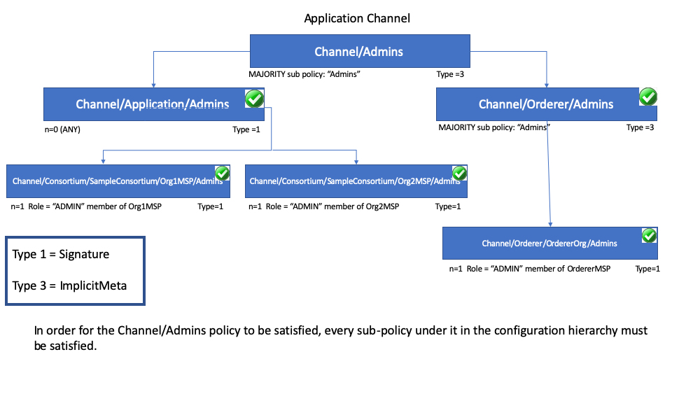
As you can see in the diagram above, ImplicitMeta policies, Type = 3, use a different syntax, "<ANY|ALL|MAJORITY> <SubPolicyName>", for example:
`MAJORITY sub policy: Admins`
The diagram shows a sub-policy Admins, which refers to all the Admins policy below it in the configuration tree. You can create your own sub-policies and name them whatever you want and then define them in each of your organizations.
As mentioned above, a key benefit of an ImplicitMeta policy such as MAJORITY Admins is that when you add a new admin organization to the channel, you do not have to update the channel policy. Therefore ImplicitMeta policies are considered to be more flexible as organizations are added. Recall that ImplicitMeta policies ultimately resolve the Signature sub-policies underneath them in the configuration tree as the diagram shows.
You can also define an application level implicit policy to operate across organizations, in a channel for example, and either require that ANY of them are satisfied, that ALL are satisfied, or that a MAJORITY are satisfied. This format lends itself to much better, more natural defaults, so that each organization can decide what it means for a valid endorsement.
Further granularity and control can be achieved if you include NodeOUs in your organization definition. Organization Units (OUs) are defined in the Fabric CA client configuration file and can be associated with an identity when it is created. In Fabric, NodeOUs provide a way to classify identities in a digital certificate hierarchy. For instance, an organization having specific NodeOUs enabled could require that a ‘peer’ sign for it to be a valid endorsement, whereas an organization without any might simply require that any member can sign.

An example: channel configuration policy
Understanding policies begins with examining the configtx.yaml where the channel policies are defined. We can use the configtx.yaml file in the Fabric test network to see examples of both policy syntax types. We are going to examine the configtx.yaml file used by the fabric-samples/test-network sample.

Member Organizations Section
The first section of the file defines the organizations that will be members of the channel. Inside each organization definition are the default policies for that organization, Readers, Writers, Admins, and Endorsement, although you can name your policies anything you want. Each policy has a Type which describes how the policy is expressed (Signature or ImplicitMeta) and a Rule.
The test network example below shows the Org1 organization definition in the channel, where the policy Type is Signature and the Endorsement: policy rule is defined as "OR('Org1MSP.peer')". This policy specifies that a peer that is a member of Org1MSP is required to sign. It is these signature policies that become the sub-policies that the ImplicitMeta policies point to.

Application and Roles Section
The next example shows the ImplicitMeta policy type used in the Application section of the configtx.yaml. These set of policies lie on the /Channel/Application/ path. If you use the default set of Fabric ACLs, these policies define the behavior of many important features of application channels, such as who can query the channel ledger, invoke a chaincode, or update a channel config. These policies point to the sub-policies defined for each organization. The Org1 defined in the section above contains Reader, Writer, and Admin sub-policies that are evaluated by the Reader, Writer, and Admin ImplicitMeta policies in the Application section. Because the test network is built with the default policies, you can use the example Org1 to query the channel ledger, invoke a chaincode, and approve channel updates for any test network channel that you create.
Click here to see an example of ImplicitMeta policies

Fabric chaincode lifecycle
In the Fabric 2.0 release, a new chaincode lifecycle process was introduced, whereby a more democratic process is used to govern chaincode on the network. The new process allows multiple organizations to vote on how a chaincode will be operated before it can be used on a channel. This is significant because it is the combination of this new lifecycle process and the policies that are specified during that process that dictate the security across the network. More details on the flow are available in the Fabric chaincode lifecycle concept topic, but for purposes of this topic you should understand how policies are used in this flow. The new flow includes two steps where policies are specified: when chaincode is approved by organization members, and when it is committed to the channel.
The Application section of the configtx.yaml file includes the default chaincode lifecycle endorsement policy. In a production environment you would customize this definition for your own use case.
################################################################################
#
# SECTION: Application
#
# - This section defines the values to encode into a config transaction or
# genesis block for application related parameters
#
################################################################################
Application: &ApplicationDefaults

# Organizations is the list of orgs which are defined as participants on
# the application side of the network
Organizations:

# Policies defines the set of policies at this level of the config tree
# For Application policies, their canonical path is
# /Channel/Application/<PolicyName>
Policies:
Readers:
Type: ImplicitMeta
Rule: "ANY Readers"
Writers:
Type: ImplicitMeta
Rule: "ANY Writers"
Admins:
Type: ImplicitMeta
Rule: "MAJORITY Admins"
LifecycleEndorsement:
Type: ImplicitMeta
Rule: "MAJORITY Endorsement"
Endorsement:
Type: ImplicitMeta
Rule: "MAJORITY Endorsement"
- The LifecycleEndorsement policy governs who needs to approve a chaincode definition.
- The Endorsement policy is the default endorsement policy for a chaincode. More on this below.

Chaincode endorsement policies
The endorsement policy is specified for a chaincode when it is approved and committed to the channel using the Fabric chaincode lifecycle (that is, one endorsement policy covers all of the state associated with a chaincode). The endorsement policy can be specified either by reference to an endorsement policy defined in the channel configuration or by explicitly specifying a Signature policy.
If an endorsement policy is not explicitly specified during the approval step, the default Endorsement policy "MAJORITY Endorsement" is used which means that a majority of the peers belonging to the different channel members (organizations) need to execute and validate a transaction against the chaincode in order for the transaction to be considered valid. This default policy allows organizations that join the channel to become automatically added to the chaincode endorsement policy. If you don’t want to use the default endorsement policy, use the Signature policy format to specify a more complex endorsement policy (such as requiring that a chaincode be endorsed by one organization, and then one of the other organizations on the channel).
Signature policies also allow you to include principals which are simply a way of matching an identity to a role. Principals are just like user IDs or group IDs, but they are more versatile because they can include a wide range of properties of an actor’s identity, such as the actor’s organization, organizational unit, role or even the actor’s specific identity. When we talk about principals, they are the properties which determine their permissions. Principals are described as 'MSP.ROLE', where MSP represents the required MSP ID (the organization), and ROLE represents one of the four accepted roles: Member, Admin, Client, and Peer. A role is associated to an identity when a user enrolls with a CA. You can customize the list of roles available on your Fabric CA.
Some examples of valid principals are:
- ‘Org0.Admin’: an administrator of the Org0 MSP
- ‘Org1.Member’: a member of the Org1 MSP
- ‘Org1.Client’: a client of the Org1 MSP
- ‘Org1.Peer’: a peer of the Org1 MSP
- ‘OrdererOrg.Orderer’: an orderer in the OrdererOrg MSP
There are cases where it may be necessary for a particular state (a particular key-value pair, in other words) to have a different endorsement policy. This state-based endorsement allows the default chaincode-level endorsement policies to be overridden by a different policy for the specified keys.
For a deeper dive on how to write an endorsement policy refer to the topic on Endorsement policies in the Operations Guide.
Note: Policies work differently depending on which version of Fabric you are using:
- In Fabric releases prior to 2.0, chaincode endorsement policies can be updated during chaincode instantiation or by using the chaincode lifecycle commands. If not specified at instantiation time, the endorsement policy defaults to “any member of the organizations in the channel”. For example, a channel with “Org1” and “Org2” would have a default endorsement policy of “OR(‘Org1.member’, ‘Org2.member’)”.
- Starting with Fabric 2.0, Fabric introduced a new chaincode lifecycle process that allows multiple organizations to agree on how a chaincode will be operated before it can be used on a channel. The new process requires that organizations agree to the parameters that define a chaincode, such as name, version, and the chaincode endorsement policy.

Overriding policy definitions
Hyperledger Fabric includes default policies which are useful for getting started, developing, and testing your blockchain, but they are meant to be customized in a production environment. You should be aware of the default policies in the configtx.yaml file. Channel configuration policies can be extended with arbitrary verbs, beyond the default Readers, Writers, Admins in configtx.yaml.

Peers
A fundamental element of a Hyperledger Fabric blockchain network is the set of peer nodes (or, simply, peers). Peers are fundamental because they manage ledgers and smart contracts. Starting in Hyperledger Fabric v2.4, peers also manage transaction proposals and endorsements by running the Fabric Gateway service. Recall that a ledger immutably records all of the transactions generated by smart contracts (which in Hyperledger Fabric are contained in chaincode, more on this later) and endorsed by the required organizations. Smart contracts and ledgers encapsulate the processes and information, respectively, that are shared by channel peers. These aspects of peers make them a good starting point for understanding a Fabric network.
Besides peers, other elements of a Fabric blockchain network are also important:
ledgers and smart contracts, orderers, policies, channels, client applications, organizations, identities, and membership, which you can read about in their own dedicated sections. This section focuses on peers, and their relationships to these other elements in a Fabric network.
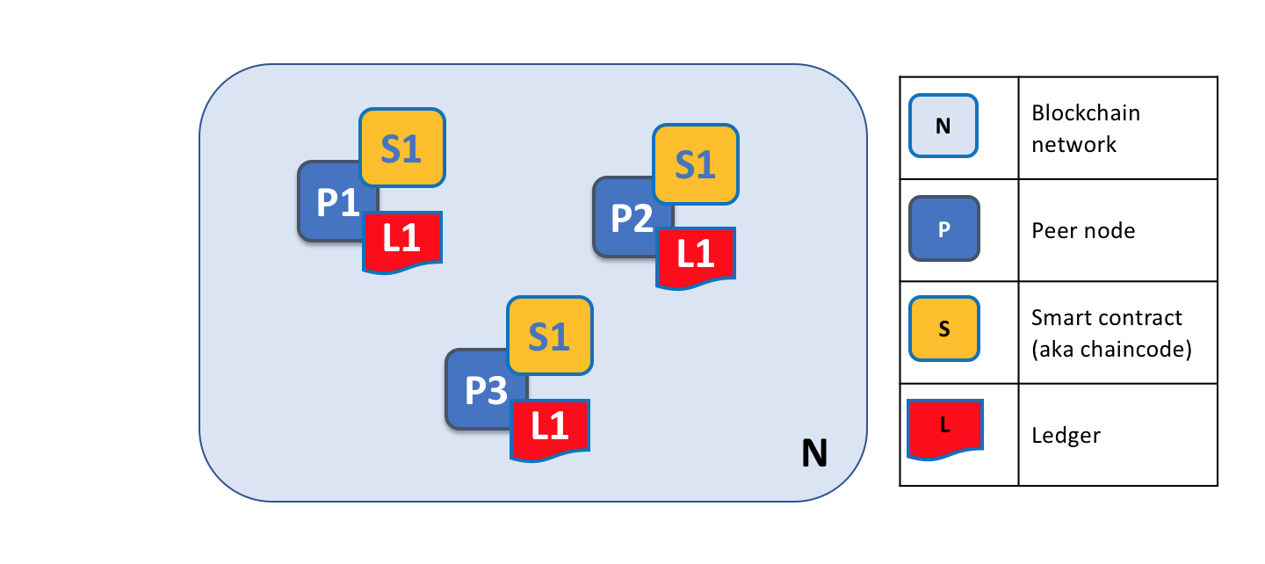
A Fabric blockchain network (above) is comprised of peers (non-ordering nodes), each of which stores and manages copies of ledgers and smart contracts. In this example, the Fabric network N consists of peers P1, P2 and P3, each of which maintains its own instance of the distributed ledger L1. P1, P2 and P3 each invoke the same chaincode, S1, to access their respective copies of the distributed ledger.
Peers are a flexible and redundant element that can be created, started, stopped, reconfigured and deleted. Peers expose a set of APIs that enable client applications to interact with the services that peers provide — the Fabric Gateway service in particular.

Chaincode terminology
Fabric implements smart contracts through a type of logic called chaincode — code that accesses the ledger — which is written using the chaincode APIs. In this topic, we use the term chaincode, but feel free to interpret chaincode as a smart contract if that concept is more familiar. To learn more about chaincode and smart contracts, check out the documentation on smart contracts and chaincode.

Ledgers and Chaincode
Now let’s look at a peer in a little more detail. We can see that it’s the peer that hosts both the ledger and chaincode, in addition to services such as Fabric Gateway. More precisely, the peer hosts instances of the ledger, and instances of chaincode, because blockchain requires consistent replicas of data and smart contracts across peers in a channel. This design provides a deliberate redundancy in a Fabric network — avoiding single points of failure and providing consistent, current ledgers. We’ll learn more about the distributed and decentralized nature of a Fabric blockchain network later in this section.
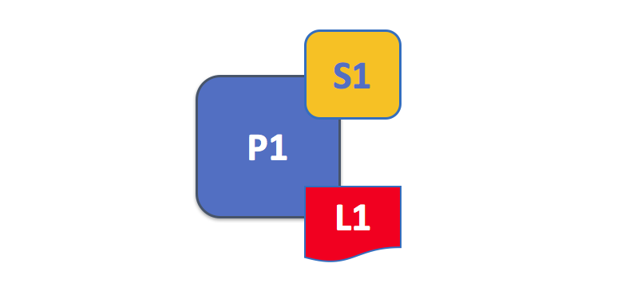
A peer hosts instances of ledgers and instances of chaincodes (above). In this example, P1 hosts an instance of ledger L1 and an instance of chaincode S1. There can be many ledgers and chaincodes hosted on any individual peer.
Because a peer is a host for ledgers, chaincodes and services, client applications and administrators must interact with a peer to access these resources. That’s why peers are considered the fundamental building blocks of a Fabric network. We’ll see later how ledgers get created, and how chaincodes get installed, on peers.

Multiple Ledgers
A peer is capable of hosting more than one ledger, which is useful because it allows for a flexible system design where a single peer can belong to multiple channels in a Fabric network. In the simplest configuration, a peer hosts a single ledger, and therefore belongs to a single channel. But it is not uncommon for a peer to host multiple ledgers because it belongs to multiple channels.
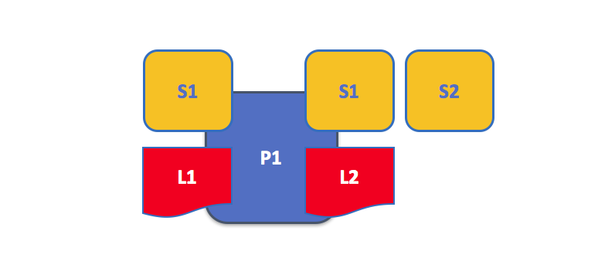
A peer hosting multiple ledgers (above). Peers host one or more ledgers and the chaincodes that access them. In this example, peer P1 hosts ledgers L1 and L2. Ledger L1 is accessed using chaincode S1; Ledger L2 can be accessed using either chaincode S1 or S2.
Chaincodes installed on a peer can query or update (write to) a ledger. Note that peers also host special system chaincodes which relate to the overall configuration of the Fabric network.

Multiple Chaincodes
A chaincode is instantiated on a single channel. Each channel (and ledger) can have multiple chaincodes that interact with it.
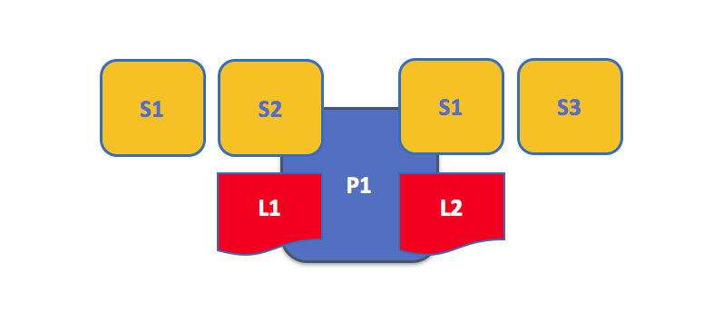
An example of a peer hosting multiple chaincodes (above). Each ledger can have many chaincodes which access it. In this example, peer P1 hosts ledgers L1 and L2, where L1 is accessed by chaincodes S1 and S2, and L2 is accessed by S1 and S3. S1 can access both L1 and L2.
We’ll see a little later why the concept of channels in Fabric is important to hosting multiple ledgers and multiple chaincodes on a peer.

Fabric Gateway service
Starting in Hyperledger Fabric v2.4, the Fabric Gateway service is installed and enabled on each peer by default. The gateway service, as opposed to the client application (in Fabric v2.3 and earlier), manages transaction proposals and endorsements on the peer. The Gateway SDKs (v1.0.0 for Go, Node and Java) incorporate this peer-centric model of transaction processing, enabling simplified application development. Client applications developed with Fabric v2.3 or earlier SDKs will continue to run in Fabric v2.4.

Applications and Peers
We’re now going to show how client applications interact with peers, and more specifically, with the Fabric Gateway service running on peers, to access the ledger. Ledger-queries involve a simple dialogue between an application and a peer, while ledger-updates (writes) involve additional steps.
A client application connects to the Fabric Gateway service on a peer in order to access ledgers and chaincodes. Starting in Fabric v2.4, the Gateway SDKs (v1.x) make this easy for programmers. The APIs enable applications, via the gateway, to submit transaction proposals (which invokes chaincode), request endorsement, receive events, and forward endorsed transactions to the ordering service.
Through a peer connection on the gateway, applications can run chaincodes to query or update the ledger. The result of a ledger query transaction is returned with simple processing, whereas a ledger update (write) involves a more complex workflow
between applications, peers and orderers. Let’s investigate this ledger update process in detail.
Peers, in conjunction with orderers, ensure that the ledger is kept consistent and current on every peer in a channel. The following sequence, in three phases, describes how interactions between a client application, the gateway service running on a peer, orderer nodes and additional peers update the ledger.
Attention: The three transaction phases which follow explain the internal methods of how Fabric manages transactions. The Fabric Gateway SDKs implement these phases seamlessly; developers only need to use a Gateway SDK (1.x).

Phase 1 - Transaction Proposal and Endorsement
Phase 1 of a ledger update (write) consists of transaction proposal submission, execution and endorsement:
a) Transaction proposal — The client application (A1) submits a signed transaction proposal by connecting to the gateway service on P1. A1 must either delegate the selection of endorsing organizations to the gateway service or explicitly identify the organizations required for endorsement.
b) Transaction execution — The gateway service selects P1, or another peer in its organization, to execute the transaction. The selected peer executes the chaincode (S1) specified in the proposal, generates a proposal response (containing the read-write set). The selected peer signs the proposal response and returns it to the gateway.
c) Transaction endorsement — The gateway repeats transaction execution (b) for each organization required by the chaincode (smart contract) endorsement policies. The gateway service collects the signed proposal responses and creates a transaction envelope — which it returns to the client (SDK) for signing.

Phase 2 - Transaction Submission and Ordering
Phase 2 of a ledger update consists of transaction submission and ordering into blocks:
a) Transaction submission — The client (SDK) sends the signed transaction envelope to the gateway service. The gateway forwards the envelope to an ordering node and returns a success message to the client.
b) Transaction ordering — The ordering node (O1) verifies the signature, and the ordering service orders the transaction, and packages it with other ordered transactions into blocks. The ordering service then distributes the block to all peers in the channel for validation and commitment to the ledger.

Phase 3 - Transaction Validation and Commitment
Phase 3 of a ledger update consists of transaction validation, ledger commitment and a commit event:
a) Transaction validation — Each peer checks that the client signature on the transaction envelope matches the signature on the original transaction proposal. Each peer also checks that all read-write sets and status responses are equivalent (i.e. the endorsements from all peers match) and that the endorsements satisfy the endorsement policies. Each peer then marks each transaction as valid or invalid for commitment to the ledger.
b) Transaction commitment — Each peer commits the ordered block of transactions to the channel ledger (L1). The commit is an immutable ledger update (write) to the channel ledger. The world state (essentially, the sum of all valid transactions) of the channel is updated with results of valid transactions only.
c) Commit event — Each peer that commits to the ledger sends the client a commit status event with proof of the ledger update.
Note: Fabric v2.3 SDKs, which embed transaction proposal and endorsement functionality in the client application, remain supported in Fabric v2.4. Refer to the v2.3 Applications and Peers topic for details.

Peers and Channels
It is worth spending some time understanding how peers interact with each other, and with applications, on a channel — a mechanism by which components within a Fabric blockchain network communicate and transact privately.
Channel components include peer nodes, orderer nodes and applications, and by joining a channel, they agree to collaborate to collectively manage and share identical copies of the ledger. Conceptually, you can compare channels to groups of friends; a person might have several groups of friends with each group participating in different activities. These groups might be entirely separate (a group of work friends as compared to a group of hobby friends), or there can be some crossover membership between them. Nevertheless, each friend group is its own entity, with specific rules (or expectations) that establish and maintain membership.
Channel membership works the same way as in other groups; any one peer may belong to several channels and maintain a ledger and chaincodes specific to each channel. Or a peer may belong to only a single channel, and therefore have only one set of rules to follow.
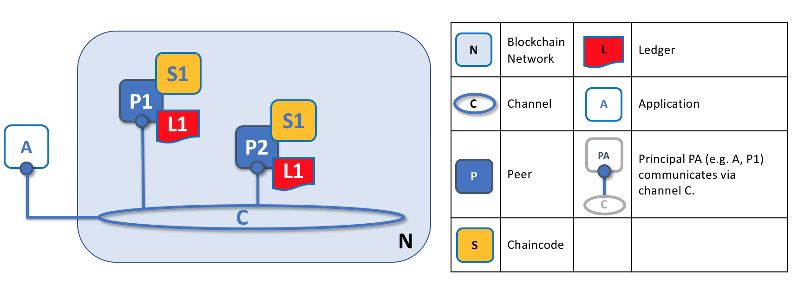
*Channels allow a specific set of applications and peers (and organizations) to communicate with each other on a Fabric blockchain network. In the example above, application A communicates with peers P1 and P2, through the gateway service, on channel C. The channel is a pathway for communications between specific applications and peers.
We see that channels don’t exist in the same way that peers do — it’s more accurate to think of a channel as a logical structure that is formed by a collection of physical peers. It is vital to understand this point — peers provide the control point for access to, and management of, channels.

Peers and Organizations
Now that you understand peers and their relationship to ledgers, chaincodes and channels, you’ll be able to see how multiple organizations come together to form a blockchain network.
Fabric blockchain networks are administered by a collection of organizations rather than a single organization. Peers are central to how this kind of distributed network is built because they are owned by — and are the network connection points for — these organizations.
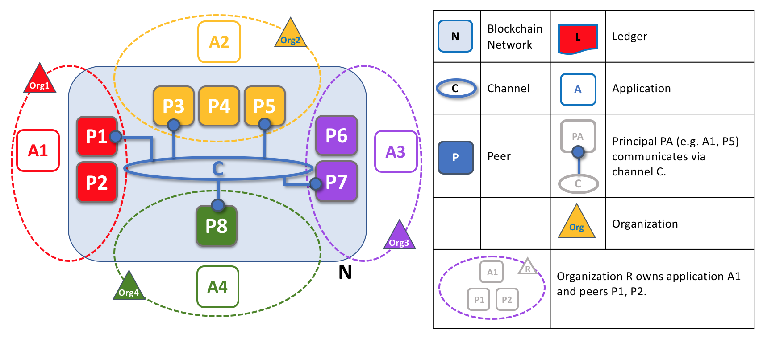
*The example above shows organizations and their peers in a Fabric blockchain network. We see four organizations contributing a total of eight peers to form a network. Channel C connects five of these peers in the network N — P1, P3, P5, P7 and P8. The other peers owned by these organizations have not joined channel C, but typically join at least one other channel. Applications developed by an organization connect to peers, via the Fabric Gateway service, in the same organization as well as peers in other organizations on a channel.
It is important to notice what happens during the formation of a Fabric blockchain network. The network is both formed and managed by the multiple organizations that contribute resources to it. Peers are the resources that we’re discussing in this topic, but organizations provide other resources too, such as chaincode and ordering service nodes. There’s a principle at work here — the network literally does not exist without organizations contributing their individual resources to the collective network. Moreover, the network grows as resources are provided by collaborating organizations, increasing the resiliency and security of the network.
You can see that (other than the ordering service, to some degree) there are no centralized resources — in the previous diagram, the network N would not exist if the organizations did not contribute their peers and other resources. Moreover, the network does not depend on any individual organization — it continues to exist despite departures as long as its membership meets the self-defined requirements of the network. This is at the heart of what it means for a network to be decentralized; all of its member organizations share and contribute equally.
Applications used by organizations, as in the previous diagram, may or may not be the same, because each organization can decide how it wants to use data on the ledger. Both application and presentation logic can therefore vary across organizations, even though all peers host an equivalent copy of the ledger.

Peers and Identity
Now that you’ve seen how peers from different organizations come together to form a blockchain network, it’s worth spending a few moments understanding how peers get assigned to organizations by their administrators.
Peers have an identity assigned to them via a digital certificate from a particular certificate authority. You can read a lot more about how X.509 digital certificates work elsewhere in this guide, but for now, think of a digital certificate as like an ID card that provides verifiable information about a peer. Each and every peer in the network is assigned a digital certificate by an administrator from its owning organization.
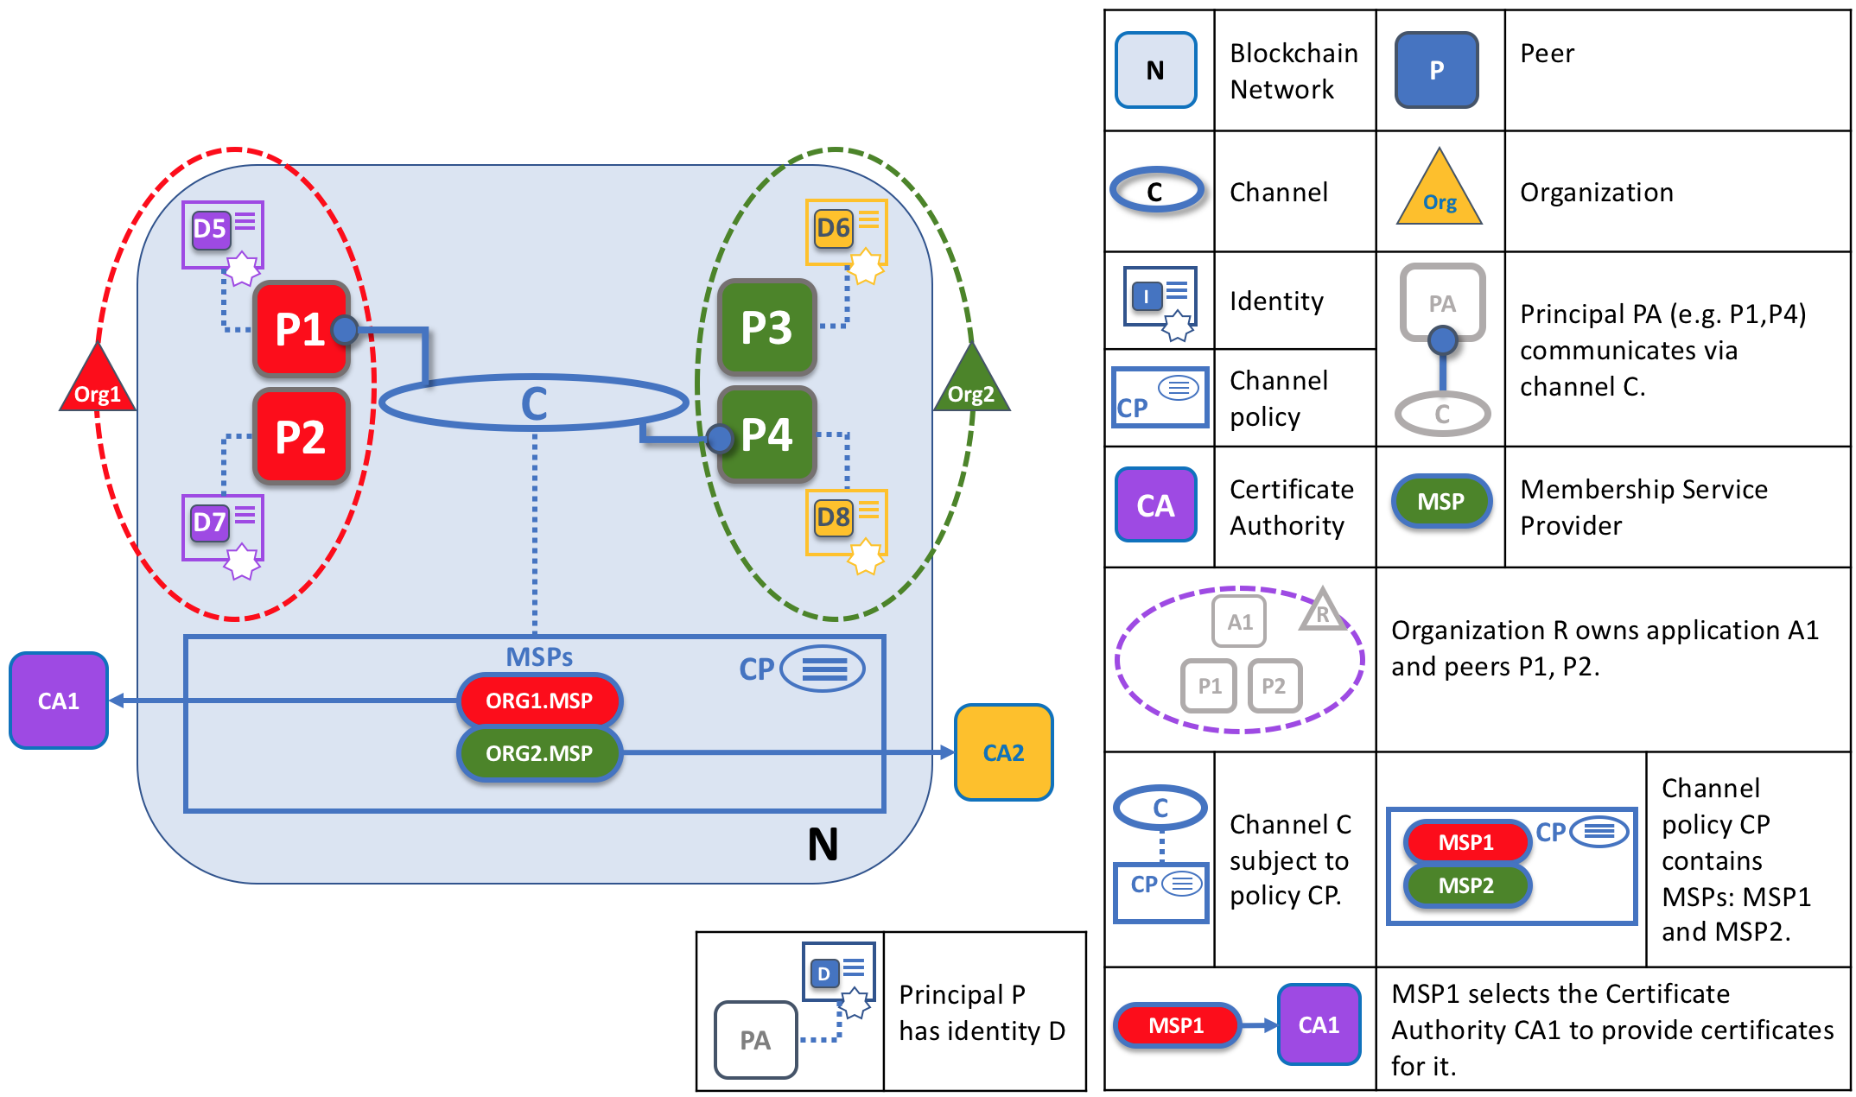
When a peer connects to a channel, its digital certificate identifies its owning organization via a channel MSP. In the example above, P1 and P2 have identities issued by a certificate authority (CA1). Channel C determines, from a policy in its channel configuration, that identities from CA1 should be associated with Org1 using ORG1.MSP. Similarly, P3 and P4 are identified by ORG2.MSP as part of Org2.
Whenever a peer connects to a Fabric network channel, a policy in the channel configuration uses the peer’s identity to determine its rights. The mapping of identity to organization is provided by a component called a Membership Service Provider (MSP) — which determines how a peer gets assigned to a specific role in a particular organization and accordingly, gains authorized access to resources. Moreover, a peer can be owned only by a single organization, and is therefore associated with a single MSP. Think of an MSP as linking an individual identity with a particular organizational role in a Fabric network.
Peers, and anything that interacts with a Fabric network, acquire their organizational identity from their digital certificate and an MSP. Peers, applications, end users, administrators and orderers must each have an identity, and an associated MSP, to interact with the network. Any entity that interacts with a blockchain network using an identity is known as a principal. Note that identity is distinct from where the peer is physically located — it could reside in the cloud, or in a data center owned by one of the organizations, or on a local machine — the digital certificate associated with the peer is what identifies it as owned by a particular organization. In the previous example diagram, P3 could be hosted in Org1’s data center, but as long as the digital certificate associated with it is issued by CA2, it is owned by Org2.

Peers and Orderers
We’ve seen that peers form the basis for a Fabric blockchain network, hosting ledgers and smart contracts which can be queried and updated by peer-connected applications. The mechanism by which applications and peers interact with each other to keep the ledger current and consistent across a channel is mediated by special nodes called orderers. It’s to these orderer nodes that we now turn our attention.
A ledger update transaction is different from a query transaction because a single peer cannot, on its own, update the ledger — that requires the consent of other peers in the network, a process known as consensus. When the peers required to approve the transaction do so, and the transaction is committed to the ledger, the gateway service notifies the applications that the ledger has been updated. Peers and orderers work together to manage consensus.

Orderers and the Three Phases
Previously, in the Applications and Peers topic, we saw how a client application that requests a ledger update initiates a three-phase process which, with help from the Fabric Gateway service, ensures that all peers in a Fabric network maintain current and consistent copies of the ledger. As described, orderers are also involved; the following sections take a closer look at the three-phase process from the perspective of ordering nodes and peers (i.e. the ordering service and the gateway service).

Phase 1: Transaction Proposal
Phase 1 of the transaction workflow involves an interaction between a client application, peers and orderers. In Phase 1, the client application initiates a request to the Fabric Gateway service to evaluate a transaction proposal.
The target peer, selected by the client application, executes the transaction by invoking chaincode — this step can be described as simulating the transaction, because it runs the transaction without any effect on the ledger. The peer then returns its transaction result to the client.
The gateway service also forwards the transaction proposal to the required endorsing peers (based on the endorsement policies), which also execute the transaction and return their results to the peer. The gateway service collects all responses, and if they collectively satisfy the endorsement policies, forwards the transaction to the ordering service.
If the proposed transaction would write to a private data collection, (as transient data) the client application must explicitly specify the organizations required for endorsement.
Note that a peer endorses a proposal response by adding its digital signature, and signing the entire payload using its private key. This endorsement can be subsequently used to prove that this organization’s peer generated a particular response.

Phase 2: Transaction Ordering
The second phase of the transaction workflow is the ordering and packaging phase. The ordering service (running on orderer nodes) receives transactions containing signed and endorsed proposal responses, from one or more applications via the gateway service, and orders and packages the transactions into blocks. These are the blocks (which are also ordered) — consisting of endorsed and ordered transactions — that make up a Fabric blockchain ledger.
For details about the ordering and packaging phase, see the conceptual information about the ordering phase.

Phase 3: Validation and Commitment
The third and final phase of the transaction workflow is the distribution of ordered transactions from orderers to peers. Each peer then validates each transaction, in the correct order, and ensures that each transaction has been consistently endorsed by all required organizations. Only then does the peer commit the block to its copy of the channel ledger.
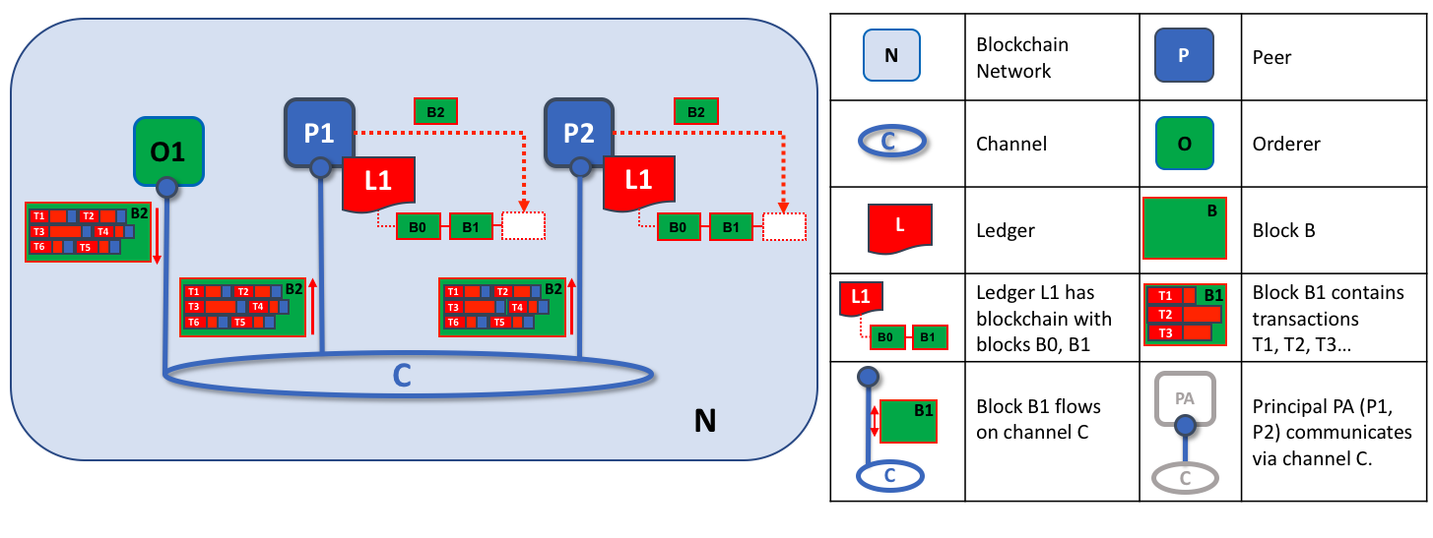
An orderer node distributes ordered blocks to peers for validation and commitment. In this example above, orderer O1 distributes block B2 to peers P1 and P2. Peer P1 processes block B2, resulting in a new block being added to ledger L1 on P1. In parallel, peer P2 processes block B2, resulting in a new block being added to ledger L1 on P2. Once complete, the ledger L1 has been consistently updated on peers P1 and P2, and the gateway service informs the relevant applications that the transaction has been committed.
Phase 3 begins with the orderer distributing blocks to all peers connected to it. Peers are connected to orderers on channels such that when a new block is generated, all of the peers connected to the orderer will be sent a copy of the new block. Each peer will process this block independently, but in exactly the same way as every other peer on the channel. In this way, we’ll see that the ledger can be kept consistent. It’s also worth noting that not every peer needs to be connected to an orderer — peers can cascade blocks to other peers using the gossip protocol, who also can process them independently. But let’s leave that discussion to another time!
Upon receipt of a block, a peer will process each transaction in the sequence specified in the block. For each transaction, the peer will verify that the transaction has been endorsed by the required organizations according to the endorsement policies for the chaincode which generated the transaction. For example, some transactions may only need to be endorsed by a single organization, whereas others may require multiple endorsements to be valid. This process of validation verifies that all relevant organizations have generated the same outcome or result.
If a transaction has been endorsed correctly, the peer will attempt to apply it to the ledger. To do this, a peer must perform a ledger consistency check to verify that the current state of the ledger is compatible with the state of the ledger when the proposed update was generated. This may not always be possible, even when the transaction has been fully endorsed. For example, another transaction may have updated the same asset in the ledger such that the transaction update is no longer valid and therefore can no longer be applied. In this way, the ledger is kept consistent across each peer in the channel because they each follow the same rules for validation.
After a peer has successfully validated each individual transaction, it updates the ledger. Failed transactions are not applied to the ledger, but they are retained for audit purposes, as are successful transactions. This means that peer blocks are almost exactly the same as the blocks received from the orderer, except for a valid or invalid indicator on each transaction in the block.
Note that phase 3 does not require running chaincode — this is done only during phase 1, and that’s important. It means that chaincodes only have to be available on endorsing nodes, rather than throughout the blockchain network. This keeps the logic of the chaincode confidential to endorsing organizations only. This is in contrast to the output of the chaincodes (transaction proposal responses), which are shared with every peer in the channel, whether or not they endorsed the transaction. This specialization of endorsing peers is designed to help scalability and confidentiality.
Finally, each time a block is committed to a peer’s ledger, that peer generates an event. Block events include the full block content, while block transaction events include summary information only, such as whether each transaction in the block has been validated or invalidated. Chaincode events that the chaincode execution has produced can also be published at this time. Applications can register for these event types for notification. The commit event notification concludes the third and final phase of the transaction workflow.
In summary, phase 3 sees the transaction blocks which are generated by the orderer validated and consistently applied to the ledger. The strict ordering of transactions into blocks allows each peer to validate that transaction updates are consistently applied across the channel.

Orderers and Consensus
This entire transaction workflow process is called consensus, because peers have to collectively reach agreement on the order and content of transactions, with mediation from orderers. Consensus is a multi-step process and ledger updates only occur when the process completes successfully — which can happen at slightly different times on different peers. Think of the orderers as nodes which sequence and distribute proposed ledger updates for peers to endorse and add to the ledger.

Peers Summary
That’s it! We’ve now finished our detailed tour of peers and their interactions with other Fabric components, including client applications, chaincodes and orderers. We’ve seen that peers are in many ways the most fundamental element of Hyperledger Fabric architecture — they form the network, host chaincodes and the ledger, handle transaction proposals and responses, and keep the ledger updated and consistent with validated and endorsed transactions.

Ledger
Audience: Architects, Application and smart contract developers, administrators
A ledger is a key concept in Hyperledger Fabric; it stores important factual information about business objects; both the current value of the attributes of the objects, and the history of transactions that resulted in these current values.
In this topic, we’re going to cover:
- What is a Ledger?
- Storing facts about business objects
- A blockchain ledger
- The world state
- The blockchain data structure
- How blocks are stored in a blockchain
- Transactions
- World state database options
- The Basic example ledger
- Ledgers and namespaces
- Ledgers and channels

What is a Ledger?
A ledger contains the current state of a business as a journal of transactions. The earliest European and Chinese ledgers date from almost 1000 years ago, and the Sumerians had stone ledgers 4000 years ago – but let’s start with a more up-to-date example!
You’re probably used to looking at your bank account. What’s most important to you is the available balance – it’s what you’re able to spend at the current moment in time. If you want to see how your balance was derived, then you can look through the transaction credits and debits that determined it. This is a real life example of a ledger – a state (your bank balance), and a set of ordered transactions (credits and debits) that determine it. Hyperledger Fabric is motivated by these same two concerns – to present the current value of a set of ledger states, and to capture the history of the transactions that determined these states.

Ledgers, Facts, and States
A ledger doesn’t literally store business objects – instead it stores facts about those objects. When we say “we store a business object in a ledger” what we really mean is that we’re recording the facts about the current state of an object, and the facts about the history of transactions that led to the current state. In an increasingly digital world, it can feel like we’re looking at an object, rather than facts about an object. In the case of a digital object, it’s likely that it lives in an external datastore; the facts we store in the ledger allow us to identify its location along with other key information about it.
While the facts about the current state of a business object may change, the history of facts about it is immutable, it can be added to, but it cannot be retrospectively changed. We’re going to see how thinking of a blockchain as an immutable history of facts about business objects is a simple yet powerful way to understand it.
Let’s now take a closer look at the Hyperledger Fabric ledger structure!

The Ledger
In Hyperledger Fabric, a ledger consists of two distinct, though related, parts – a world state and a blockchain. Each of these represents a set of facts about a set of business objects.
Firstly, there’s a world state – a database that holds current values of a set of ledger states. The world state makes it easy for a program to directly access the current value of a state rather than having to calculate it by traversing the entire transaction log. Ledger states are, by default, expressed as key-value pairs, and we’ll see later how Hyperledger Fabric provides flexibility in this regard. The world state can change frequently, as states can be created, updated and deleted.
Secondly, there’s a blockchain – a transaction log that records all the changes that have resulted in the current world state. Transactions are collected inside blocks that are appended to the blockchain – enabling you to understand the history of changes that have resulted in the current world state. The blockchain data structure is very different to the world state because once written, it cannot be modified; it is immutable.
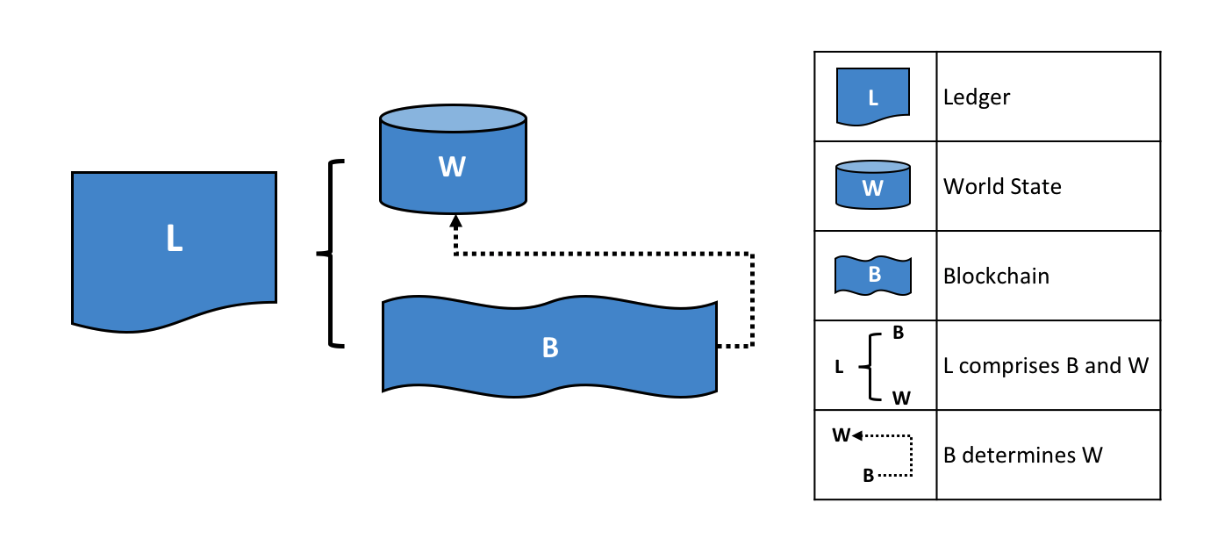 A Ledger L comprises blockchain B and world state W, where blockchain B determines world state W. We can also say that world state W is derived from blockchain B.
It’s helpful to think of there being one logical ledger in a Hyperledger Fabric network. In reality, the network maintains multiple copies of a ledger – which are kept consistent with every other copy through a process called consensus. The term Distributed Ledger Technology (DLT) is often associated with this kind of ledger – one that is logically singular, but has many consistent copies distributed throughout a network.
Let’s now examine the world state and blockchain data structures in more detail.

World State
The world state holds the current value of the attributes of a business object as a unique ledger state. That’s useful because programs usually require the current value of an object; it would be cumbersome to traverse the entire blockchain to calculate an object’s current value – you just get it directly from the world state.
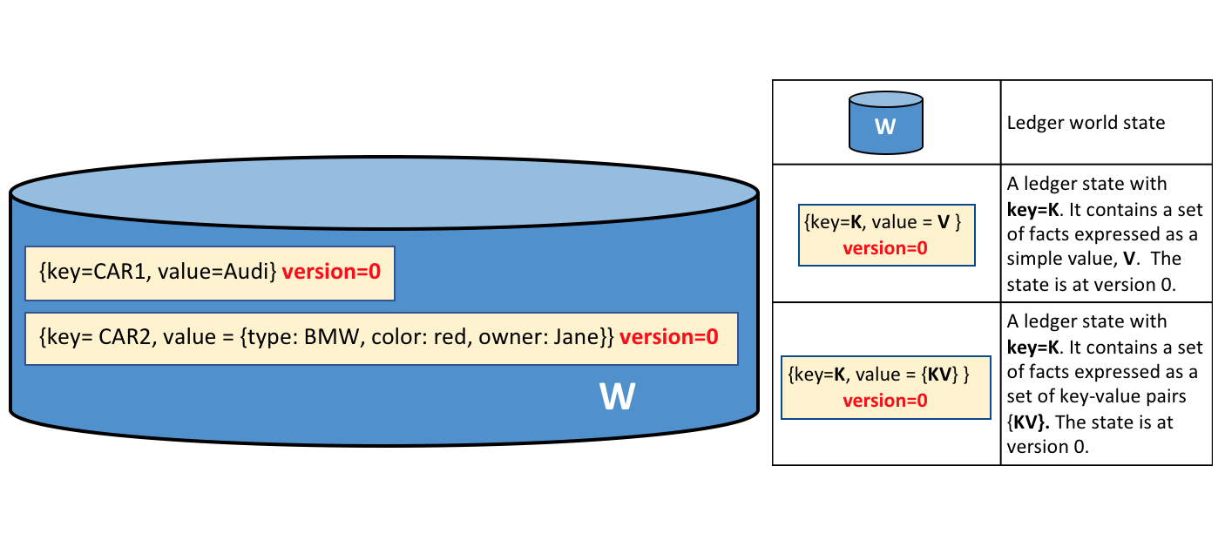
A ledger world state containing two states. The first state is: key=CAR1 and value=Audi. The second state has a more complex value: key=CAR2 and value={model:BMW, color=red, owner=Jane}. Both states are at version 0.
A ledger state records a set of facts about a particular business object. Our example shows ledger states for two cars, CAR1 and CAR2, each having a key and a value. An application program can invoke a smart contract which uses simple ledger APIs to get, put and delete states. Notice how a state value can be simple (Audi…) or compound (type:BMW…). The world state is often queried to retrieve objects with certain attributes, for example to find all red BMWs.
The world state is implemented as a database. This makes a lot of sense because a database provides a rich set of operators for the efficient storage and retrieval of states. We’ll see later that Hyperledger Fabric can be configured to use different world state databases to address the needs of different types of state values and the access patterns required by applications, for example in complex queries.
Applications submit transactions which capture changes to the world state, and these transactions end up being committed to the ledger blockchain. Applications are insulated from the details of this consensus mechanism by the Hyperledger Fabric SDK; they merely invoke a smart contract, and are notified when the transaction has been included in the blockchain (whether valid or invalid). The key design point is that only transactions that are signed by the required set of endorsing organizations will result in an update to the world state. If a transaction is not signed by sufficient endorsers, it will not result in a change of world state. You can read more about how applications use smart contracts, and how to develop applications.
You’ll also notice that a state has a version number, and in the diagram above, states CAR1 and CAR2 are at their starting versions, 0. The version number is for internal use by Hyperledger Fabric, and is incremented every time the state changes. The version is checked whenever the state is updated to make sure the current states matches the version at the time of endorsement. This ensures that the world state is changing as expected; that there has not been a concurrent update.
Finally, when a ledger is first created, the world state is empty. Because any transaction which represents a valid change to world state is recorded on the blockchain, it means that the world state can be re-generated from the blockchain at any time. This can be very convenient – for example, the world state is automatically generated when a peer is created. Moreover, if a peer fails abnormally, the world state can be regenerated on peer restart, before transactions are accepted.

Blockchain
Let’s now turn our attention from the world state to the blockchain. Whereas the world state contains a set of facts relating to the current state of a set of business objects, the blockchain is an historical record of the facts about how these objects arrived at their current states. The blockchain has recorded every previous version of each ledger state and how it has been changed.
The blockchain is structured as sequential log of interlinked blocks, where each block contains a sequence of transactions, each transaction representing a query or update to the world state. The exact mechanism by which transactions are ordered is discussed elsewhere; what’s important is that block sequencing, as well as transaction sequencing within blocks, is established when blocks are first created by a Hyperledger Fabric component called the ordering service.
Each block’s header includes a hash of the block’s transactions, as well a hash of the prior block’s header. In this way, all transactions on the ledger are sequenced and cryptographically linked together. This hashing and linking makes the ledger data very secure. Even if one node hosting the ledger was tampered with, it would not be able to convince all the other nodes that it has the ‘correct’ blockchain because the ledger is distributed throughout a network of independent nodes.
The blockchain is always implemented as a file, in contrast to the world state, which uses a database. This is a sensible design choice as the blockchain data structure is heavily biased towards a very small set of simple operations. Appending to the end of the blockchain is the primary operation, and query is currently a relatively infrequent operation.
Let’s have a look at the structure of a blockchain in a little more detail.
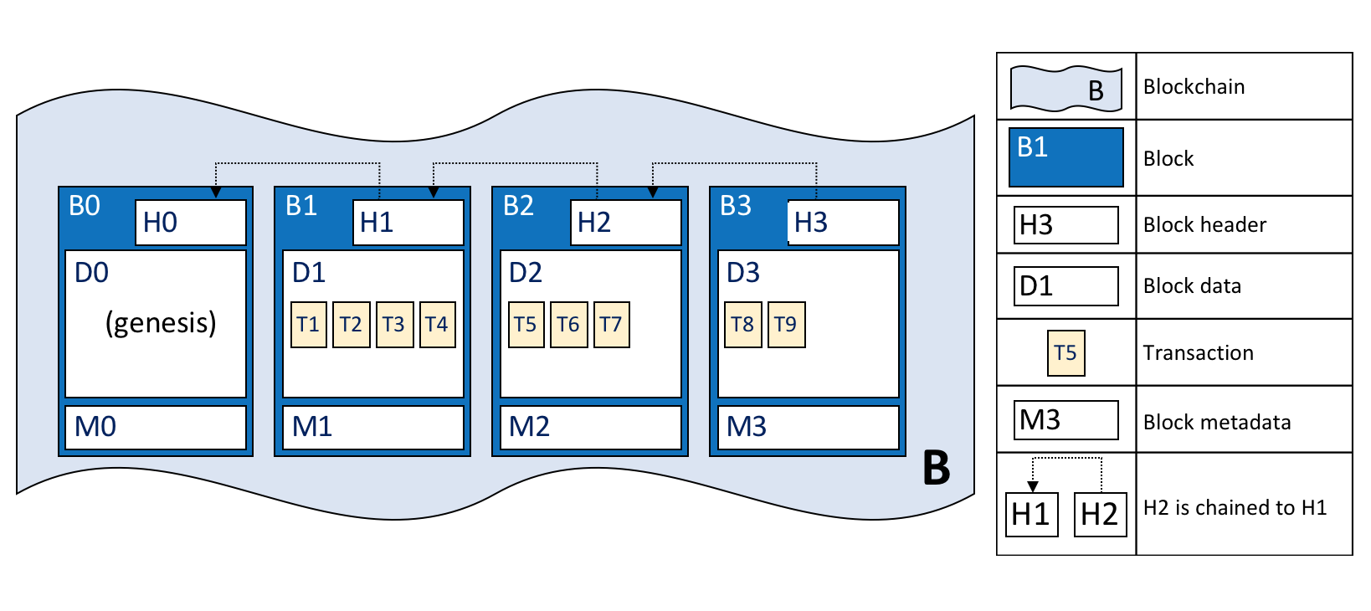
A blockchain B containing blocks B0, B1, B2, B3. B0 is the first block in the blockchain, the genesis block.
In the above diagram, we can see that block B2 has a block data D2 which contains all its transactions: T5, T6, T7.
Most importantly, B2 has a block header H2, which contains a cryptographic hash of all the transactions in D2 as well as a hash of H1. In this way, blocks are inextricably and immutably linked to each other, which the term blockchain so neatly captures!
Finally, as you can see in the diagram, the first block in the blockchain is called the genesis block. It’s the starting point for the ledger, though it does not contain any user transactions. Instead, it contains a configuration transaction containing the initial state of the network channel (not shown). We discuss the genesis block in more detail when we discuss the blockchain network and channels in the documentation.

Blocks
Let’s have a closer look at the structure of a block. It consists of three sections
- Block Header
This section comprises three fields, written when a block is created.
  - Block number: An integer starting at 0 (the genesis block), and increased by 1 for every new block appended to the blockchain.
  - Current Block Hash: The hash of all the transactions contained in the current block.
  - Previous Block Header Hash: The hash from the previous block header.
These fields are internally derived by cryptographically hashing the block data. They ensure that each and every block is inextricably linked to its neighbour, leading to an immutable ledger.
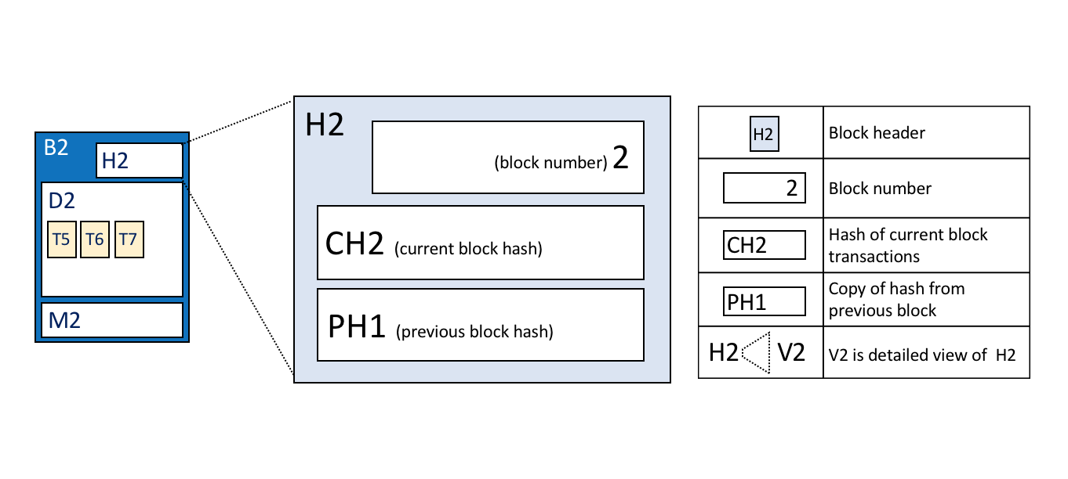
Block header details. The header H2 of block B2 consists of block number 2, the hash CH2 of the current block data D2, and the hash of the prior block header H1.
- Block Data
This section contains a list of transactions arranged in order. It is written when the block is created by the ordering service. These transactions have a rich but straightforward structure, which we describe later in this topic.
- Block Metadata
This section contains the certificate and signature of the block creator which is used to verify the block by network nodes. Subsequently, the block committer adds a valid/invalid indicator for every transaction into a bitmap that also resides in the block metadata, as well as a hash of the cumulative state updates up until and including that block, in order to detect a state fork. Unlike the block data and header fields, this section is not an input to the block hash computation.

Transactions
As we’ve seen, a transaction captures changes to the world state. Let’s have a look at the detailed blockdata structure which contains the transactions in a block.
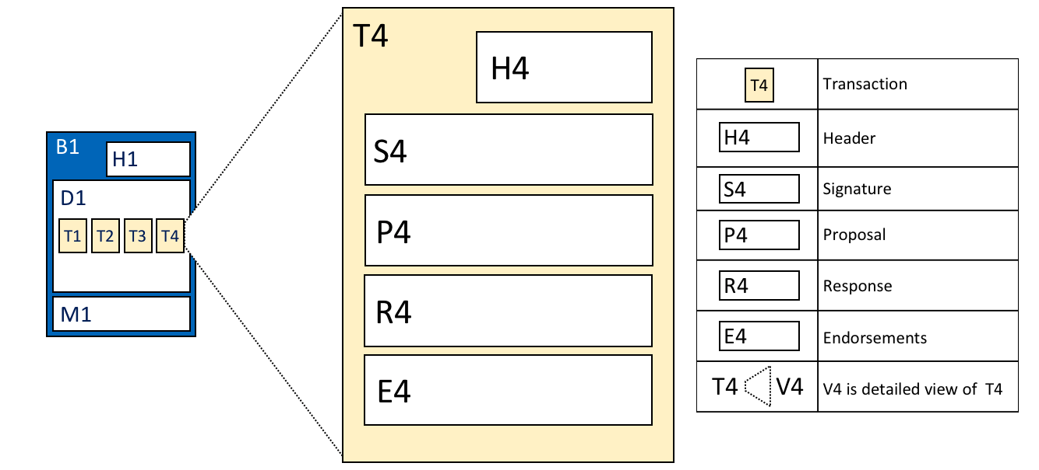 Transaction details. Transaction T4 in blockdata D1 of block B1 consists of transaction header, H4, a transaction signature, S4, a transaction proposal P4, a transaction response, R4, and a list of endorsements, E4.
In the above example, we can see the following fields:
- Header
This section, illustrated by H4, captures some essential metadata about the transaction – for example, the name of the relevant chaincode, and its version.
- Signature
This section, illustrated by S4, contains a cryptographic signature, created by the client application. This field is used to check that the transaction details have not been tampered with, as it requires the application’s private key to generate it.
- Proposal
This field, illustrated by P4, encodes the input parameters supplied by an application to the smart contract which creates the proposed ledger update. When the smart contract runs, this proposal provides a set of input parameters, which, in combination with the current world state, determines the new world state.
- Response
This section, illustrated by R4, captures the before and after values of the world state, as a Read Write set (RW-set). It’s the output of a smart contract, and if the transaction is successfully validated, it will be applied to the ledger to update the world state.
- Endorsements
As shown in E4, this is a list of signed transaction responses from each required organization sufficient to satisfy the endorsement policy. You’ll notice that, whereas only one transaction response is included in the transaction, there are multiple endorsements. That’s because each endorsement effectively encodes its organization’s particular transaction response – meaning that there’s no need to include any transaction response that doesn’t match sufficient endorsements as it will be rejected as invalid, and not update the world state.
That concludes the major fields of the transaction – there are others, but these are the essential ones that you need to understand to have a solid understanding of the ledger data structure.

World State database options
The world state is physically implemented as a database, to provide simple and efficient storage and retrieval of ledger states. As we’ve seen, ledger states can have simple or compound values, and to accommodate this, the world state database implementation can vary, allowing these values to be efficiently implemented. Options for the world state database currently include LevelDB and CouchDB.
LevelDB is the default and is particularly appropriate when ledger states are simple key-value pairs. A LevelDB database is co-located with the peer node – it is embedded within the same operating system process.
CouchDB is a particularly appropriate choice when ledger states are structured as JSON documents because CouchDB supports the rich queries and update of richer data types often found in business transactions. Implementation-wise, CouchDB runs in a separate operating system process, but there is still a 1:1 relation between a peer node and a CouchDB instance. All of this is invisible to a smart contract. See CouchDB as the StateDatabase for more information on CouchDB.
In LevelDB and CouchDB, we see an important aspect of Hyperledger Fabric – it is pluggable. The world state database could be a relational data store, or a graph store, or a temporal database. This provides great flexibility in the types of ledger states that can be efficiently accessed, allowing Hyperledger Fabric to address many different types of problems.

Example Ledger: Basic Asset Transfer
As we end this topic on the ledger, let’s have a look at a sample ledger. If you’ve run the basic asset transfer sample application, then you’ve created this ledger.
The basic sample app creates a set of 6 assets each with a unique identity; a different color, size, owner, and appraised value. Here’s what the ledger looks like after the first four assets have been created.
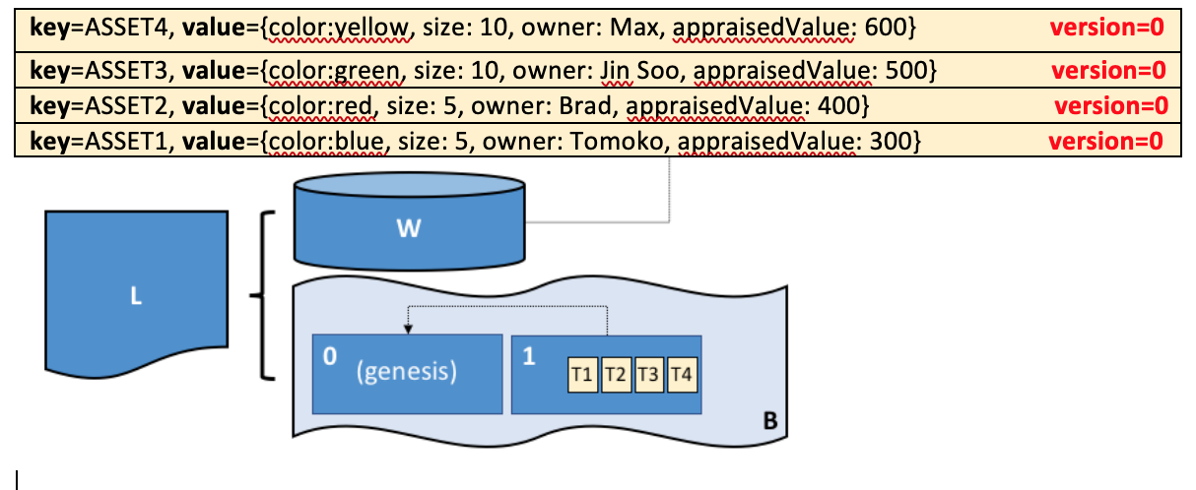
The ledger, L, comprises a world state, W and a blockchain, B. W contains four states with keys: ASSET1, ASSET2, ASSET3, and ASSET4. B contains two blocks, 0 and 1. Block 1 contains four transactions: T1, T2, T3, T4.
We can see that the world state contains states that correspond to ASSET1, ASSET2, ASSET3, and ASSET4. ASSET1 has a value which indicates that it is a blue with size 5, currently owned by Tomoko, and we can see similar states and values for the other cars. Moreover, we can see that all car states are at version number 0, indicating that this is their starting version number – they have not been updated since they were created.
We can also see that the blockchain contains two blocks. Block 0 is the genesis block, though it does not contain any transactions that relate to cars. Block 1 however, contains transactions T1, T2, T3, T4 and these correspond to transactions that created the initial states for ASSET1 to ASSET4 in the world state. We can see that block 1 is linked to block 0.
We have not shown the other fields in the blocks or transactions, specifically headers and hashes. If you’re interested in the precise details of these, you will find a dedicated reference topic elsewhere in the documentation. It gives you a fully worked example of an entire block with its transactions in glorious detail – but for now, you have achieved a solid conceptual understanding of a Hyperledger Fabric ledger. Well done!

Namespaces
Even though we have presented the ledger as though it were a single world state and single blockchain, that’s a little bit of an over-simplification. In reality, each chaincode has its own world state that is separate from all other chaincodes. World states are in a namespace so that only smart contracts within the same chaincode can access a given namespace.
A blockchain is not namespaced. It contains transactions from many different smart contract namespaces. You can read more about chaincode namespaces in this topic.
Let’s now look at how the concept of a namespace is applied within a Hyperledger Fabric channel.

Channels
In Hyperledger Fabric, each channel has a completely separate ledger. This means a completely separate blockchain, and completely separate world states, including namespaces. It is possible for applications and smart contracts to communicate between channels so that ledger information can be accessed between them.
Got to here: https://hyperledger-fabric.readthedocs.io/en/release-2.5/orderer/ordering_service.html

