Simulation Project Report

by Ron Mosness and Aakash Patel

**Abstract:**

This report presents an analysis of a coin game simulation aimed at studying the distribution of cycle lengths. The coin game involves two players who take turns based on the outcome of rolling a six-sided die. The objective of the simulation project was to explore the relationship between game parameters and the resulting distribution of cycle lengths. By varying the initial pot size and starting coins, we conducted multiple simulations to observe the expected number of cycles and analyze the resulting distributions. Our findings demonstrate that the game parameters significantly influence the distribution of cycle lengths. Different combinations of initial pot size and starting coins resulted in distribution patterns. These results suggest that the rules and parameters of the game play a crucial role in shaping the distribution of cycle lengths. The report discusses the implications of these findings and highlights the need for further investigation to understand the underlying factors driving the observed distribution variations. Overall, this analysis provides valuable insights into the relationship between game parameters and the resulting distribution of cycle lengths in the coin game simulation. These findings lay the groundwork for future research on modifying the game rules and parameters to achieve specific distribution characteristics.

**Background and Description of the Problem:**

The theory of probabilities is at the bottom nothing, but common sense reduced to calculus[i]

In this game, there are two players, A and B. The game starts with each player having 4 coins, and there are initially 2 coins in the pot. The players take turns, with player A going first, followed by player B, and so on.

During a player's turn, they roll a 6-sided die. The outcome of the roll determines the action they take:

If the player rolls a 1, they do nothing and the game proceeds to the next player's turn.

If the player rolls a 2, they take all the coins in the pot and add them to their own.

If the player rolls a 3, they take half of the coins in the pot, rounded down to the nearest whole number.

If the player rolls a 4, 5, or 6, they put a coin in the pot.

The game continues until one of the players is unable to perform the required action, specifically when they have 0 coins and need to put a coin in the pot. At that point, the player loses, and the game ends.

The objective of this project is to determine the expected number of cycles the game will last for. A cycle is defined as one complete round of both players taking their turns. If a player loses during a cycle, that cycle still counts as the final cycle.

To analyze this problem, we will employ both "first-step" analysis and simulation techniques. The "first-step" analysis will allow us to calculate the expected value, while simulation will provide a more comprehensive distribution of cycle lengths. By combining these approaches, we aim to gain insights into the dynamics and duration of the game.

While the coin game may seem trivial, it serves as an interesting model for studying probability and randomness. Understanding the factors that shape the distribution of cycle lengths can provide insights into the dynamics and outcomes of similar stochastic processes.

**Main Findings:**

This study investigated the expected number of cycles in a game involving two players, A and B, with specific rules and initial conditions. Our objective was to determine the average number of cycles the game would last for and analyze the distribution of cycle lengths.

To tackle this problem, we developed a simulation-based approach. We created a game simulation code that incorporated the rules of the game and allowed us to perform Monte Carlo experiments. The simulation code was implemented in R.

The code for the game simulation consisted of two main functions: **`simulate_turn`** and **`simulate_game**`. The **`simulate_turn`** function simulated a player's turn based on a random die roll and applied the corresponding rules, such as taking coins from the pot or adding coins to the pot. The **`simulate_game`** function simulated the entire game, alternating turns between players A and B until a player lost the game.

We conducted Monte Carlo experiments by running multiple simulations with varying initial pot sizes and starting coins. Each simulation involved simulating the game multiple times and recording the number of cycles it lasted for. By calculating the average number of cycles across simulations, we obtained estimates of the expected number of cycles.

The results of our simulations revealed interesting findings. For the given initial conditions (4 coins for each player and 2 coins in the pot), the expected number of cycles ranged from approximately 11 to 59, depending on the specific combination of initial pot size and starting coins.

To further analyze the distribution of cycle lengths, we plotted histograms based on the recorded cycle lengths from the simulations. These histograms provided visual representations of the frequencies of different cycle lengths, allowing us to observe the variability and shape of the distributions for each combination of initial conditions.

Our study demonstrates the effectiveness of Monte Carlo analysis and simulation techniques in understanding and analyzing complex game scenarios. The developed simulation code serves as a valuable tool for exploring different strategies, evaluating the impact of rule variations, and making informed decisions in similar game scenarios. The charts below show the underlying

distributions for various pot size and starting coins

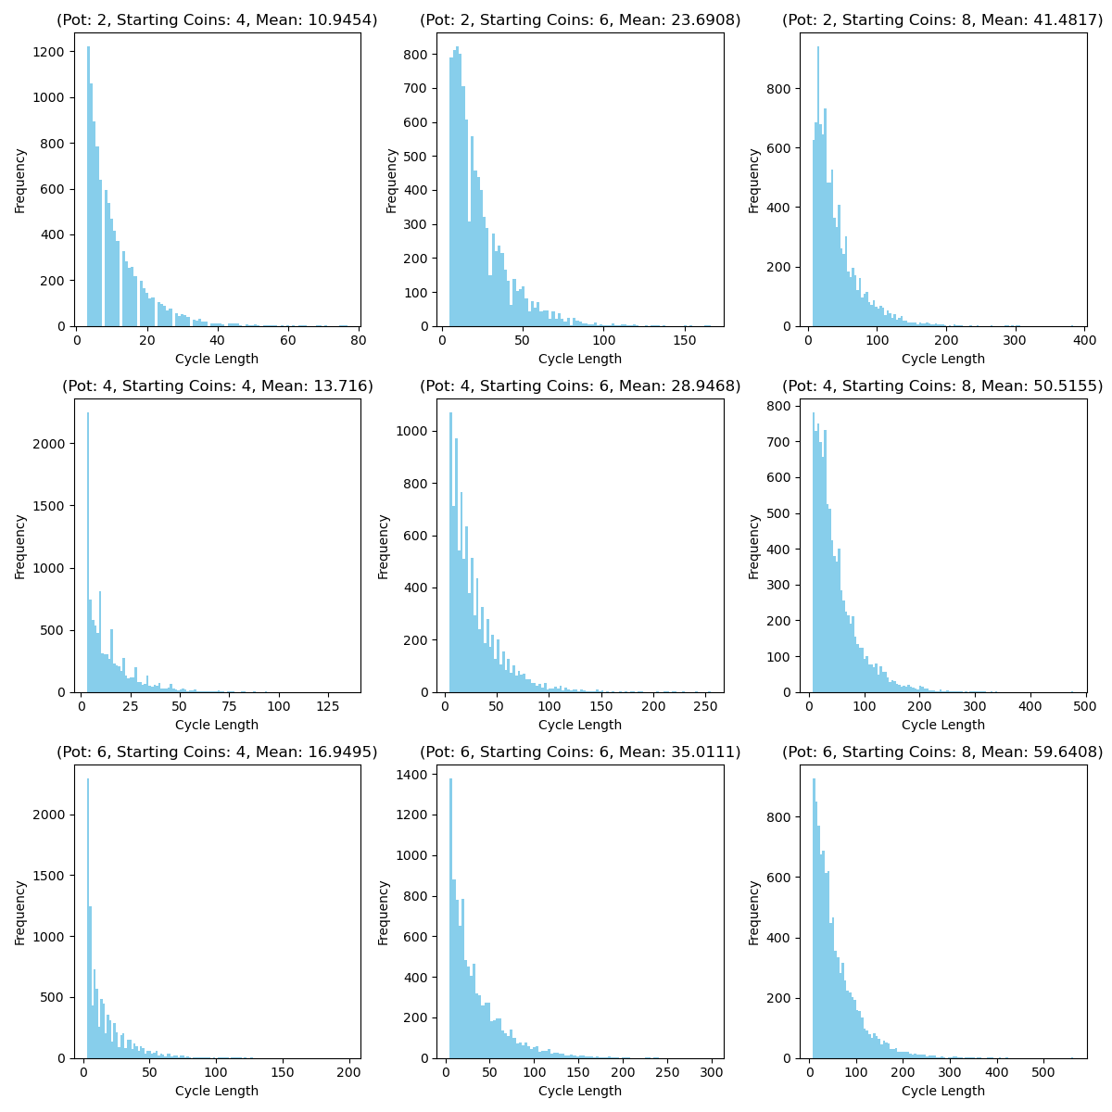*Fig1: Different Distributions for various pot sizes and starting coins*

**Conclusion:**

In this project, we investigated a game played by two players, A and B, with specific rules and initial conditions. Our objective was to determine the expected number of cycles the game would last for. Through simulation-based experiments, we estimated the expected number of cycles for different combinations of initial pot sizes and starting coins.

From our findings, we observed that the expected number of cycles varied depending on the initial conditions of the game. The game dynamics, including the players' actions and the randomness introduced by the die rolls, influenced the duration of the game. We also analyzed the distribution of cycle lengths, which provided insights into the variability of game outcomes.

As for future work, our project serves as a starting point for further exploration and analysis. Some potential avenues for future research and development include:

I. Analysis of strategies: Investigating optimal strategies for players A and B could provide insights into how different decision-making approaches impact the expected number of cycles. This could involve studying strategies that prioritize certain actions based on the current state of the game.

II. Sensitivity analysis: Conduct sensitivity analyzes to understand the impact of varying parameters, such as the number of coins, pot sizes, or die probabilities, on the expected number of cycles. This would provide a deeper understanding of how changes in the game setup affect its duration.

III. Extension to multiple players: Expanding the game to include more than two players and analyzing the dynamics and expected number of cycles in such scenarios. This could lead to interesting insights into competitive dynamics and the role of additional players in the game.

IV. Advanced statistical analysis: Applying more sophisticated statistical techniques, such as confidence intervals, hypothesis tests, or regression modeling, to analyze the simulation results rigorously and draw more robust conclusions.

Overall, this project sheds light on the expected number of cycles in a game with specific rules and initial conditions. It offers a foundation for further exploration and opens up possibilities for studying strategies, conducting sensitivity analyses, and expanding the game to more complex scenarios.

References[1] Batanero, C., Henry, M., & Parzysz, B. (2005). The nature of chance and probability. *Exploring probability in school: Challenges for teaching and learning*, 15-37.