group-40 – Release 2 Technical Report
ASD 2026 · Assessment 3 – Release 2: Multi-Agent Systems, Testing & Cloud Deployment · Canvas Group 40
GitHub repository: github.com/ronaldokwan/ASD-2026-Project-Specifications
Showcase video: https://www.youtube.com/watch?v=aBeqeT3EuwE

1. Project Overview
# | Student | Feature | Microservices (frontend / backend / database)
1 | Ronaldo Kwan (team leader) | Product Catalogue | 3001 / 8001 / 9001
2 | Jinying Li | Customer Orders | 3002 / 8002 / 9002
3 | Vishvak Ananthakrishnan Rameshkumar | Customer Account Management | 3003 / 8003 / 9003
4 | Jonathan Czesler | Inventory and Stock | 3004 / 8004 / 9004
5 | Alexander McGuinn | Reviews and Ratings | 3005 / 8005 / 9005

SmartShop is an Agentic AI retail application built as microservices. Each of the five features has its own frontend, backend/API and SQLite database microservice; locally they run under Docker Compose, in the cloud on AWS ECS Fargate. Release 0 added the shared AI-Mode agentic loop (Plan → Act → Observe) and Release 1 the shared MCP and RAG servers, all native host services. Release 2 extends the completed Release 1 application with:
Release 2 addition | Where
Shared Multi-Agent Server: Planner → Worker → Reviewer with a Human Review gate, workflow history and a coordination audit log; callable from the backends and the terminal | ai-services/multi-agent/ (native, port 7004)
Agentic-loop review modes Multi-Agent Workflow, Testing Report and Cloud Deployment Report, alongside the Release 1 MCP and RAG modes; each pairs a deterministic evidence gate with the model review and saves a validation log | ai-services/ai-mode/agent/review_modes.py
Local pre-commit security scans and post-commit endpoint tests | .pre-commit-config.yaml, student-x.yml
AWS deployment: Terraform, reusable scripts and a gated deployment workflow, with AI services disabled by default | infra/aws/, scripts/aws/, cloud-deployment.yml

2. Final Repository Structure
Release 2 additions are marked R2.
ASD-2026-Project-Specifications/
├── .github/workflows/ student-1.yml … student-5.yml · cloud-deployment.yml (R2)
├── .pre-commit-config.yaml Ruff security, detect-secrets, pip-audit hooks (R2)
├── docker-compose.yml frontends, backends, databases, shared home, Ollama
├── ai-services/ native host services, not in Docker Compose
│ ├── ai-mode/ R0 agentic loop · R1 MCP/RAG validation · R2 review modes
│ ├── mcp-server/ R1 MCP server (Streamable HTTP, :7002/mcp)
│ ├── rag-server/ R1 RAG server (:7003)
│ └── multi-agent/ R2 Planner → Worker → Reviewer → Human Review (:7004)
├── student-1/ … student-5/ frontend, backend/API, database and tests per student
├── shared/ team home page, theme and service config
├── infra/aws/ R2 Terraform: VPC, ALB, ECS Fargate, ECR, EFS, Cloud Map
│ └── github-oidc/ R2 GitHub OIDC deploy role
├── scripts/ run-local, run-ai-services, run-multi-agent, run-tests
│ ├── aws/ R2 bootstrap-state, init, build-push-images, deploy,
│ │ validate-runtime, destroy, setup-github-oidc
│ └── security/ R2 pip-audit hook
└── docs/ architecture, diagrams/, evidence/ (R2 logs), reports/

3. Release 2 Design Flow

3.1 Student 1 – Ronaldo Kwan – Product Catalogue
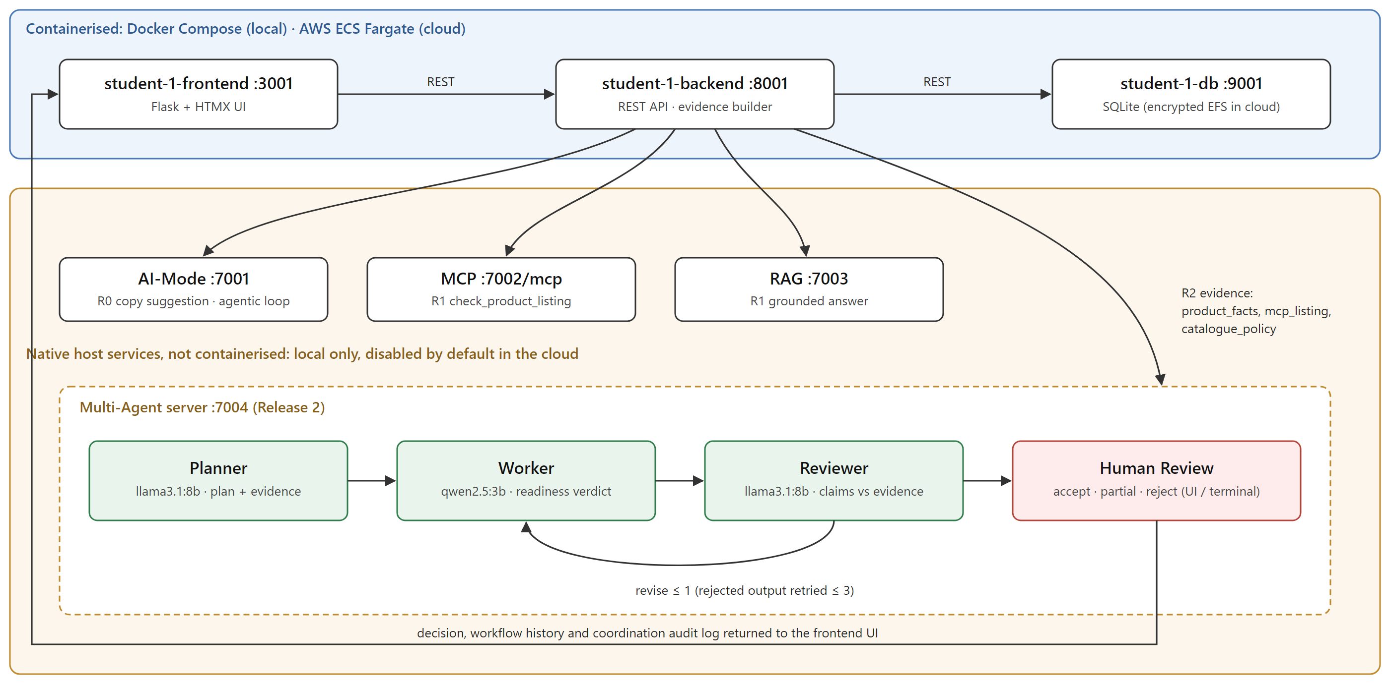
Figure 1. Student 1 Release 2 design flow: Frontend UI → Backend/API → Database, the Release 0/1 AI-Mode, MCP and RAG calls, and Multi-Agent Server → Planner → Worker → Reviewer → Human Review → response to the Frontend UI.
For a listing-readiness review the backend sends the Multi-Agent Server three evidence items: product_facts (stored fields plus the application's deterministic check of each Listing Readiness rule), the MCP check_product_listing result and the RAG catalogue policy. Missing MCP or RAG evidence is sent as unavailable, which forces the Reviewer to not_supported. The human decision is advisory: a product only changes through the catalogue form.

3.2 Student 2 – Jinying Li – Customer Orders
TODO (Student 2): Updated design flow including the Multi-Agent flow.

3.3 Student 3 – Vishvak Ananthakrishnan Rameshkumar – Customer Account Management
TODO (Student 3): Updated design flow including the Multi-Agent flow.

3.4 Student 4 – Jonathan Czesler – Inventory and Stock
TODO (Student 4): Updated design flow including the Multi-Agent flow.

3.5 Student 5 – Alexander McGuinn – Reviews and Ratings
TODO (Student 5): Updated design flow including the Multi-Agent flow.

4. Cloud Deployment and CI/CD Architecture
The group selected AWS. An internet-facing Application Load Balancer in two public subnets exposes only the home page (:80) and the five frontends (:3001–:3005). All 16 services run as ECS Fargate tasks in private subnets with no public IP and no NAT gateway; frontends reach backends and backends reach databases through Cloud Map private DNS. Each SQLite database runs as a single task on an encrypted EFS access point. Images come from ECR and logs go to CloudWatch through VPC endpoints. AI-Mode, MCP, RAG and Multi-Agent are disabled by default.
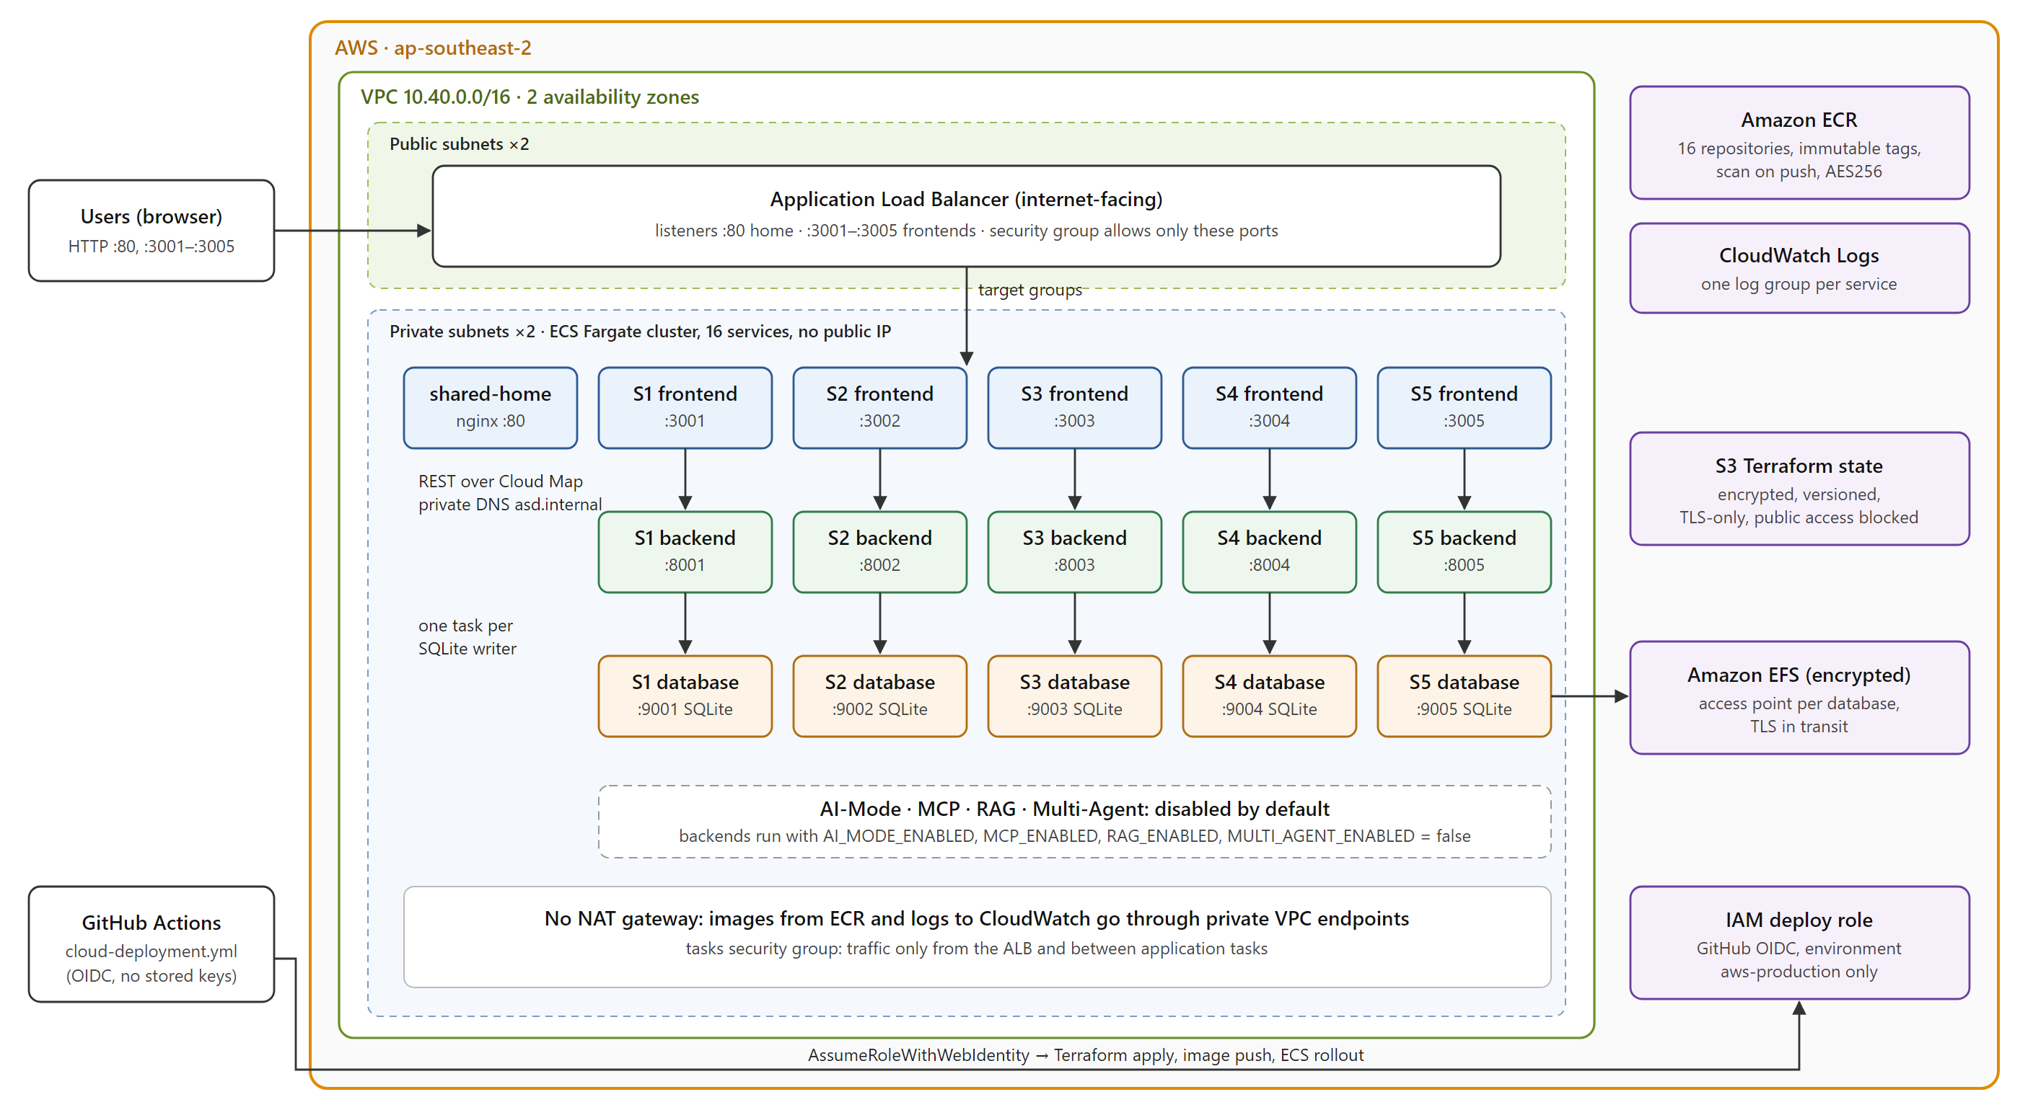
Figure 2. AWS reference architecture of the integrated group application (infra/aws/main.tf).
Infrastructure is Terraform (infra/aws/, remote state in S3 with locking); scripts/aws/ makes the deployment reusable and non-interactive: bootstrap-state.sh, init.sh, build-push-images.sh, deploy.sh, validate-runtime.sh and destroy.sh. cloud-deployment.yml deploys only after its required-ci job passes (security hooks, every student's tests, Terraform and Compose validation, all 16 image builds) and authenticates through a GitHub OIDC role, so no AWS keys are stored in GitHub.
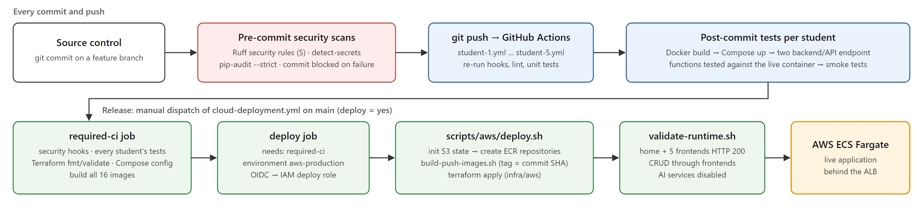
Figure 3. DevOps flow: source control → pre-commit security scans → GitHub Actions → post-commit endpoint tests → Docker build/validation → cloud-deployment.yml → AWS.

5. Pre-Commit Security Testing
The shared .pre-commit-config.yaml is installed with pre-commit install, so it runs on every git commit and blocks the commit on failure. cloud-deployment.yml runs the same hooks over all files before any deployment.
Hook | Version | Scope
Ruff security rules (--select S) | ruff 0.12.10 | Python in ai-services/, scripts/ and the Python student services listed in the config
detect-secrets | 1.5.0 | every staged file except .env, databases and logs
pip-audit --strict | 2.9.0 | 16 Python requirement files (scripts/security/pip-audit.sh); Student 2's Java services are built with Maven

5.1 Student 1 – Ronaldo Kwan
Hook run over all tracked files on 23 Oct 2026, exit code 0 (docs/evidence/student-1/release-2/01-pre-commit-security-scans.log); student-1.yml re-runs it on every push.
Hook | Scope | Result
Ruff security (--select S) | all Python in student-1/, ai-services/, scripts/ | Passed
detect-secrets | every tracked file except .env, databases, logs | Passed
pip-audit --strict | 16 requirement files | Passed (4 documented exceptions)

Findings resolved: S201 debug=True removed from the three Student 1 services and the MCP HTTP server; S104 (0.0.0.0) accepted per file for the native MCP/RAG servers, which containers reach through host.docker.internal. Accepted risk: chromadb 1.5.9 has four advisories with no fixed release; it backs only the local RAG server, not the cloud baseline, and is ignored by ID so any new advisory still fails the commit.
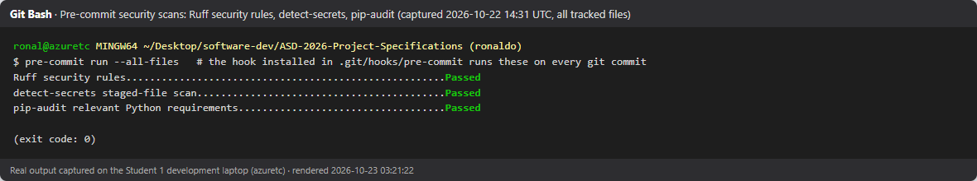
Figure 4. Pre-commit hook run: Ruff security rules, detect-secrets and pip-audit all Passed.
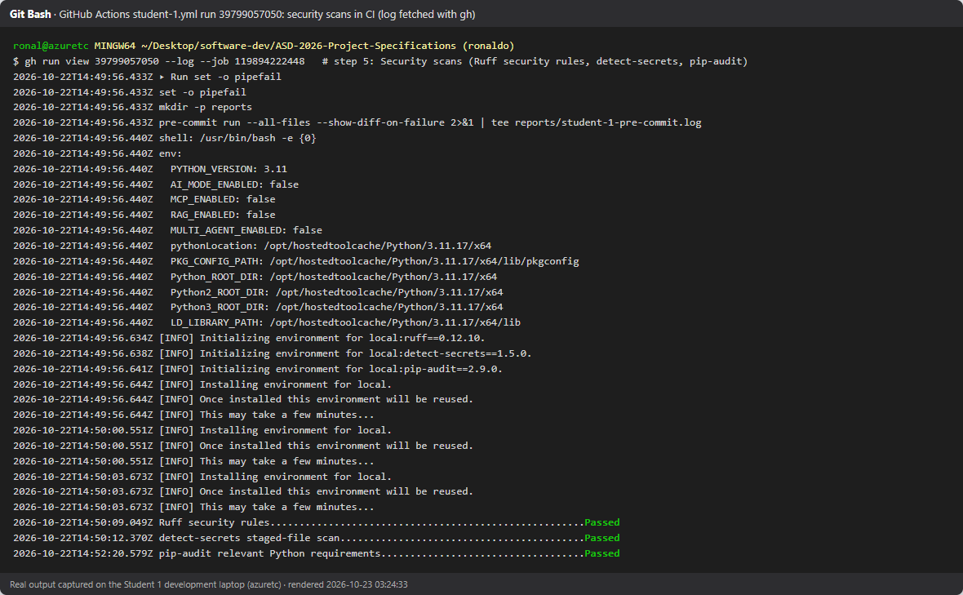
Figure 5. The same three security hooks passing in GitHub Actions (student-1.yml).

5.2 Student 2 – Jinying Li
TODO (Student 2): Pre-commit security testing report.

5.3 Student 3 – Vishvak Ananthakrishnan Rameshkumar
TODO (Student 3): Pre-commit security testing report.

5.4 Student 4 – Jonathan Czesler
TODO (Student 4): Pre-commit security testing report.

5.5 Student 5 – Alexander McGuinn
TODO (Student 5): Pre-commit security testing report.

6. Post-Commit CI/CD Testing

6.1 Student 1 – Ronaldo Kwan (student-1.yml)
Pipeline: security scans → lint → 149 unit/integration tests → shared AI service tests → Docker build → Compose up → endpoint tests against the live container → CRUD and frontend smoke tests → AI services disabled check.
Endpoint function | Route | Tests | Asserted
create_product | POST /api/products | 6 | 201 with normalised, persisted record; SKU generated when omitted; 400 for bad category, price or missing name; 409 duplicate SKU
update_product | PUT /api/products/<id> | 4 | partial update persists only supplied fields; invalid price 400 with record unchanged; empty body 400; unknown id 404

Hosted run 39799057050 (22 Oct 2026, commit 8241b55): success, 10/10 endpoint tests passed, 149 microservice tests passed, security hooks 3/3 passed. Artifacts: docs/evidence/student-1/release-2/ci-run-39799057050/.
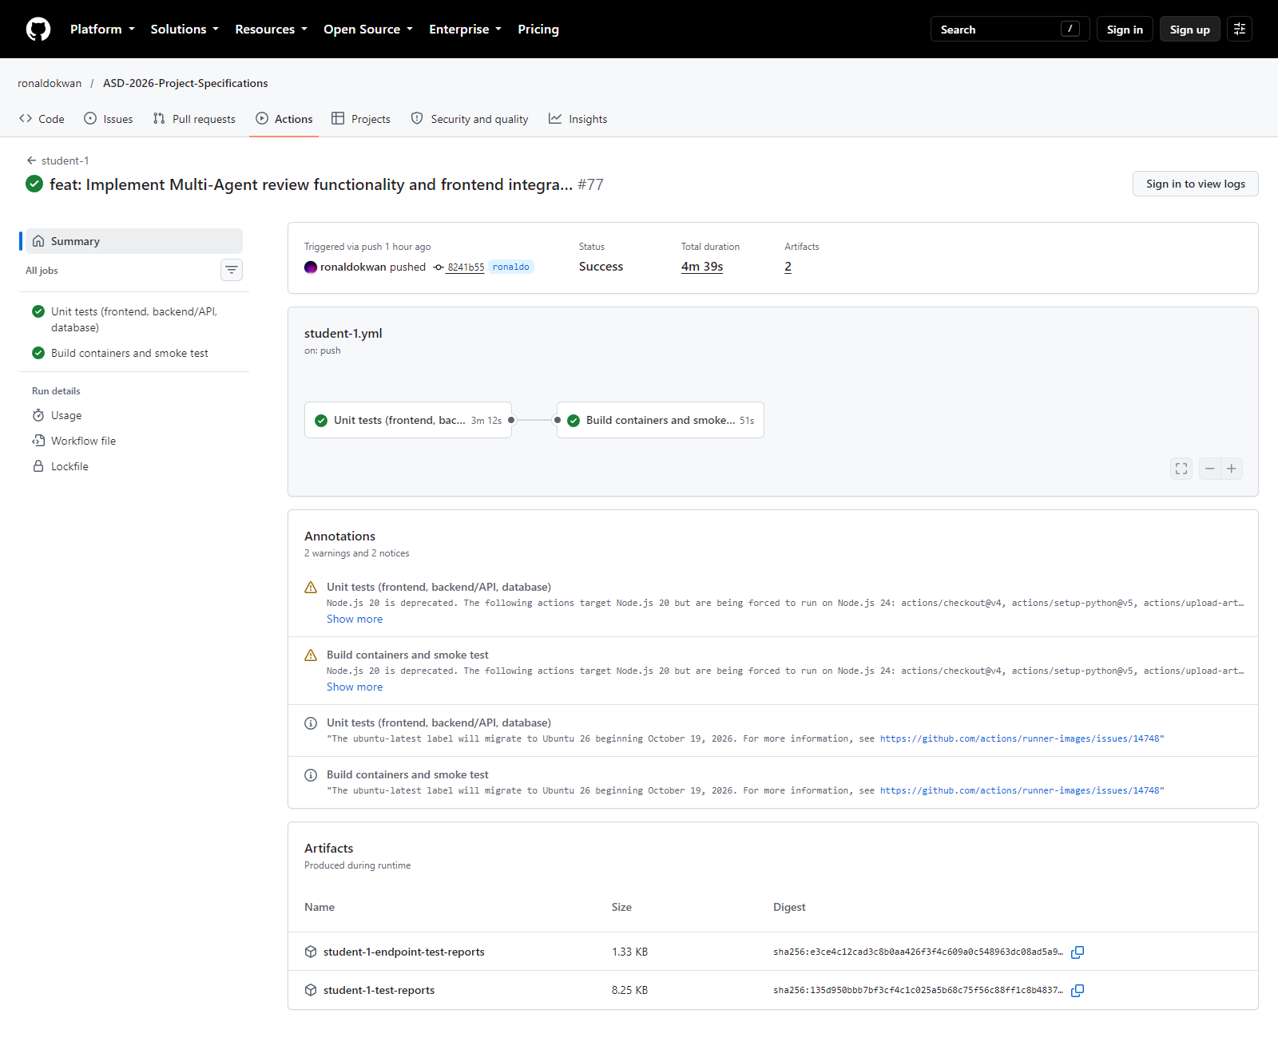
Figure 6. student-1.yml run 39799057050: success, both jobs, evidence artifacts uploaded.
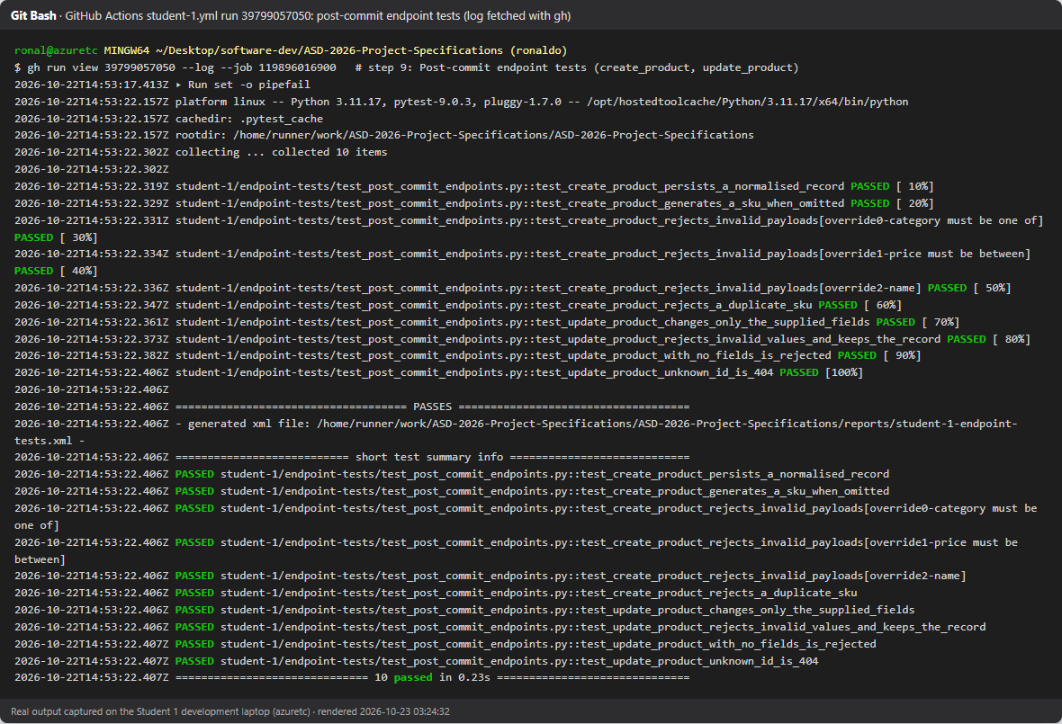
Figure 7. student-1.yml CI log: the 10 post-commit endpoint tests of create_product and update_product passed against the live container.

6.2 Student 2 – Jinying Li (student-2.yml)
TODO (Student 2): Post-commit tests of two backend/API endpoint functions and workflow evidence.

6.3 Student 3 – Vishvak Ananthakrishnan Rameshkumar (student-3.yml)
TODO (Student 3): Post-commit tests of two backend/API endpoint functions and workflow evidence.

6.4 Student 4 – Jonathan Czesler (student-4.yml)
TODO (Student 4): Post-commit tests of two backend/API endpoint functions and workflow evidence.

6.5 Student 5 – Alexander McGuinn (student-5.yml)
TODO (Student 5): Post-commit tests of two backend/API endpoint functions and workflow evidence.

7. Testing Review

7.1 Student 1 – Ronaldo Kwan
The agentic-loop Testing Review mode (llama3.1:8b) was run on local and hosted evidence:
Input | Gate | Model | Result | Evidence
Local hook log and endpoint run, GitHub Actions not run | incomplete | incomplete | incomplete | testing-review-local/
CI run 39799057050: hook log and endpoint JUnit, CI passed | passed | passed | passed | testing-review-ci/

The validation log records "All three pre-commit security hooks and at least two post-commit backend endpoint tests passed", with gate and model in agreement.
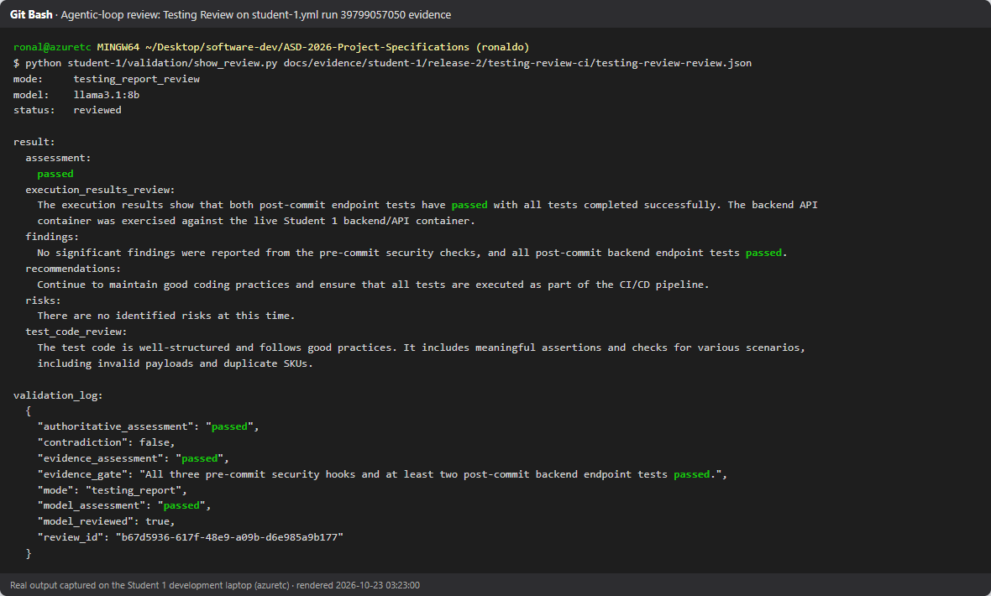
Figure 8. Agentic-loop Testing Review of the hosted CI evidence: passed, with its validation log.

7.2 Student 2 – Jinying Li
TODO (Student 2): Testing Review output and validation log.

7.3 Student 3 – Vishvak Ananthakrishnan Rameshkumar
TODO (Student 3): Testing Review output and validation log.

7.4 Student 4 – Jonathan Czesler
TODO (Student 4): Testing Review output and validation log.

7.5 Student 5 – Alexander McGuinn
TODO (Student 5): Testing Review output and validation log.

8. Local Deployment Evidence
docker compose up --build starts the shared home page, Ollama and all fifteen student microservices. AI-Mode (7001), MCP (7002), RAG (7003) and the Multi-Agent Server (7004) are not Compose services: bash scripts/run-ai-services.sh starts them natively in a second terminal, and backends reach them through host.docker.internal. A third terminal runs the checks.
TODO (group): Multi-terminal log of the integrated run for all five students.

8.1 Student 1 – Ronaldo Kwan
The three Student 1 containers run under Docker Compose (MULTI_AGENT_URL=host.docker.internal:7004); AI-Mode, MCP, RAG and Multi-Agent run natively.
Terminal | Command | Role
1 | docker compose up --build | containerised microservices
2 | bash scripts/run-ai-services.sh | native AI-Mode 7001, MCP 7002, RAG 7003, Multi-Agent 7004
3 | bash scripts/multi-server-check.sh | probes every service and Student 1's paths to the database, MCP, RAG and Multi-Agent; writes 05-multi-server-check.log

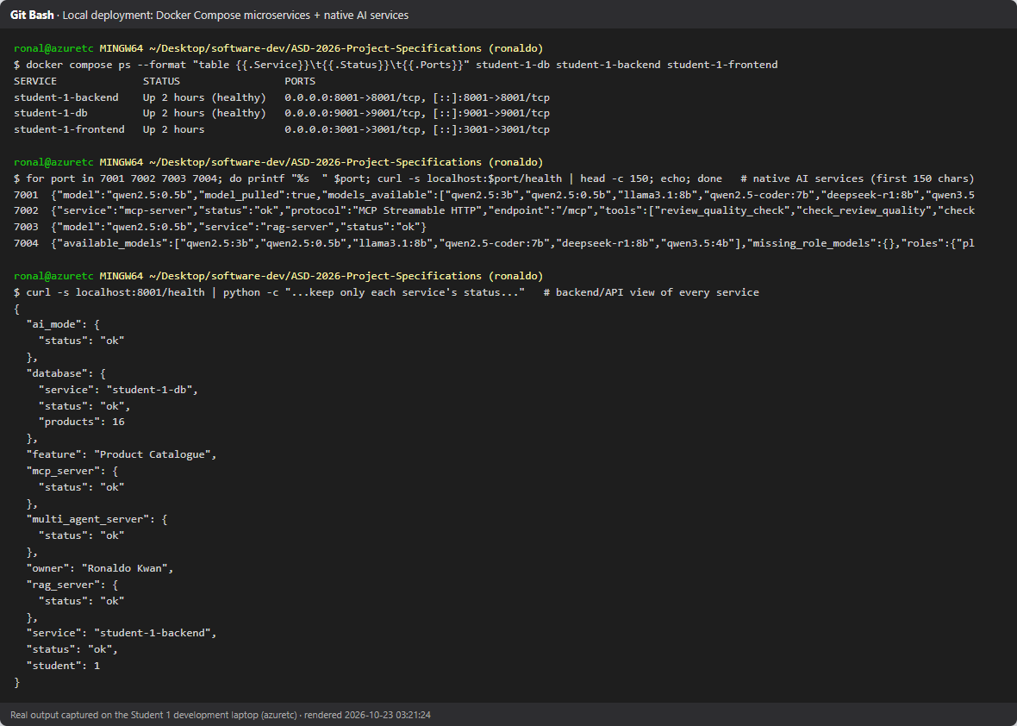
Figure 9. Local multi-server view: Compose containers, native AI services on 7001–7004 and backend health.
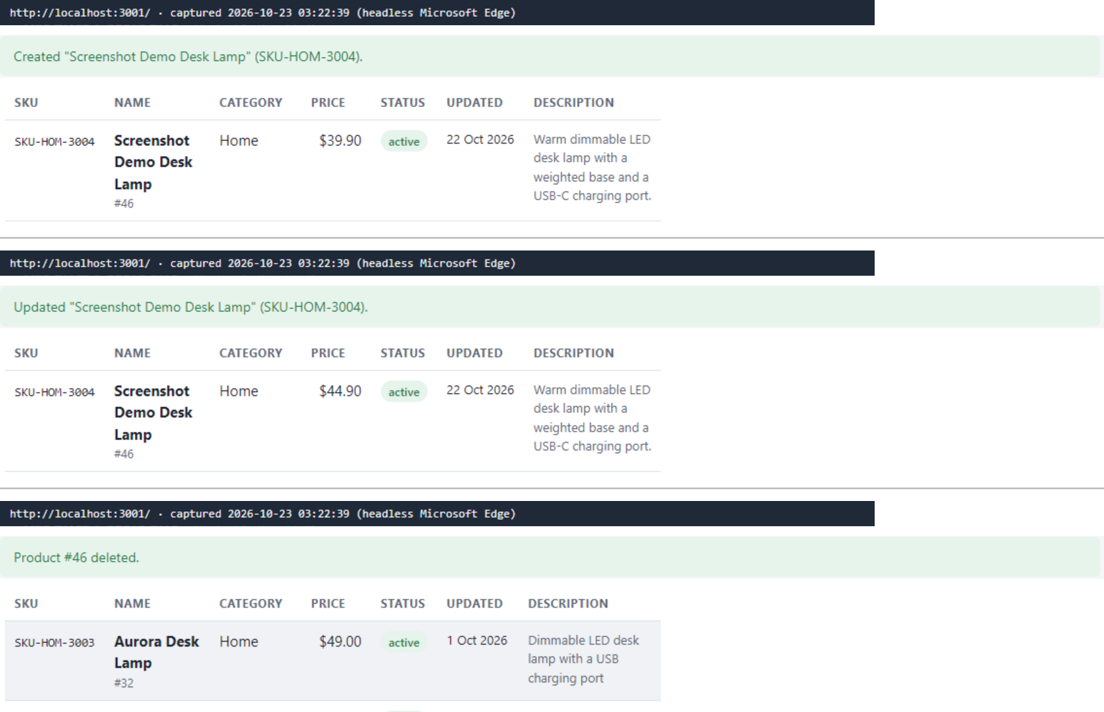
Figure 10. Local CRUD through the Student 1 frontend: create, update and delete.
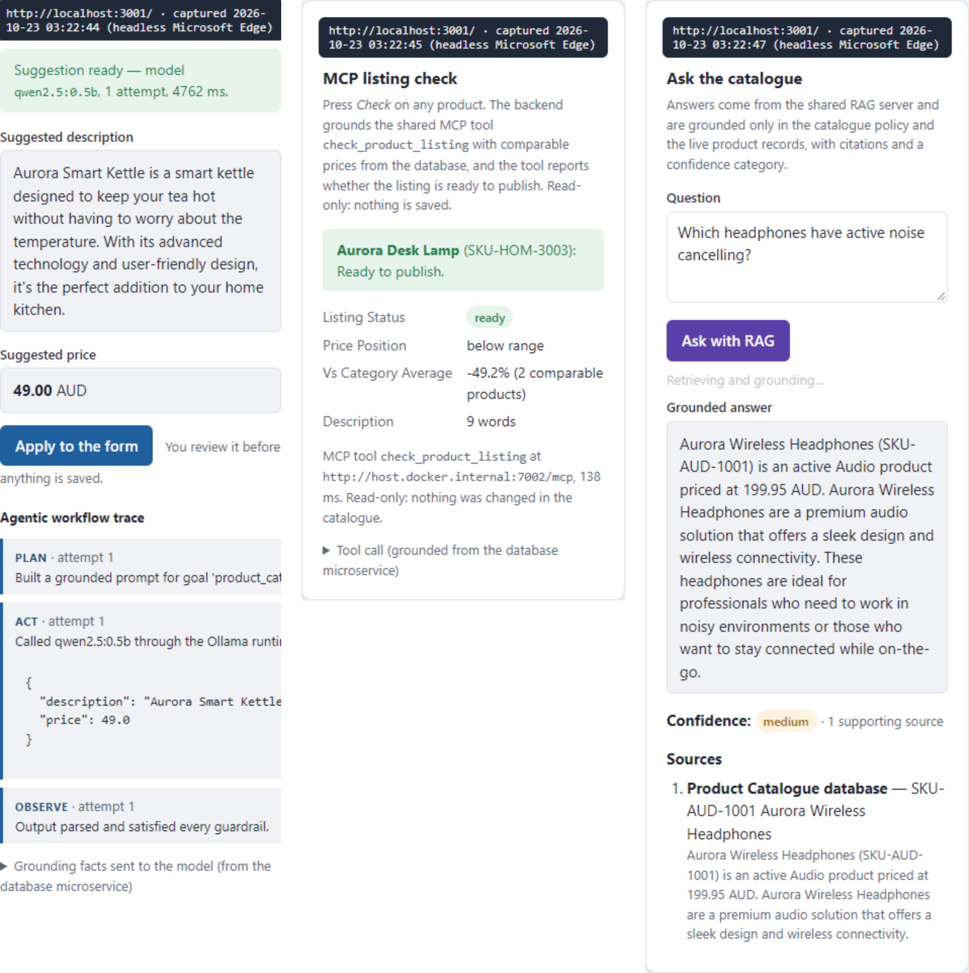
Figure 11. Release 0/1 services retained locally: AI-Mode suggestion with its Plan → Act → Observe trace, MCP listing check, grounded RAG answer.

8.2 Student 2 – Jinying Li
TODO (Student 2): Local deployment evidence.

8.3 Student 3 – Vishvak Ananthakrishnan Rameshkumar
TODO (Student 3): Local deployment evidence.

8.4 Student 4 – Jonathan Czesler
TODO (Student 4): Local deployment evidence.

8.5 Student 5 – Alexander McGuinn
TODO (Student 5): Local deployment evidence.

9. Cloud Deployment Report and Review
The integrated application was deployed on 23 Oct 2026 with scripts/aws/deploy.sh (image tag r2-202610230339): all 16 images were pushed to ECR, Terraform created the stack and ECS reported 16/16 services running. validate-runtime.sh passed: home page and all five frontends returned HTTP 200, Student 1 and Student 3 CRUD were verified through their public frontends and private databases, and the AI services reported disabled. The agentic-loop Cloud Deployment Review assessed the deployment as ready. The stack was then removed with destroy.sh. Evidence: docs/evidence/student-1/release-2/aws/ and cloud-review/.
Final human release decision: approve release. The group approves the AWS release on the evidence above: the integrated application and CRUD work in the cloud, AI-Mode, MCP, RAG and Multi-Agent stay disabled by default, and both the runtime validation and the Cloud Deployment Review report it ready.
TODO (group): cloud-deployment.yml GitHub Actions run log. The OIDC deploy role and the aws-production environment are now set up. Run 40342920579 (26 Oct) passed the security hooks, all tests and infrastructure validation, then failed building Student 2's images (Dockerfile paths); the deploy job was skipped. Push the path fix and re-run.

9.1 Student 1 – Ronaldo Kwan
Deployed on 23 Oct 2026 with scripts/aws/deploy.sh (ap-southeast-2, image tag r2-202610230339); validate-runtime.sh passed (docs/evidence/student-1/release-2/aws/).
Check | Result
Home page and frontends :3001–:3005 | HTTP 200
Student 1 CRUD: public frontend → private backend → EFS database | create, update, delete, list verified
Student 1 AI-Mode, MCP, RAG, Multi-Agent | all disabled (cloud baseline)

A first deploy failed validation and exposed four defects, fixed before the successful run: service-registry ports, duplicated load-balancer security-group rules, cloud frontends missing the shared theme, and the validator not following Student 2's redirect. The agentic-loop Cloud Deployment Review of the live deployment returned ready, with gate and model in agreement (cloud-review/).
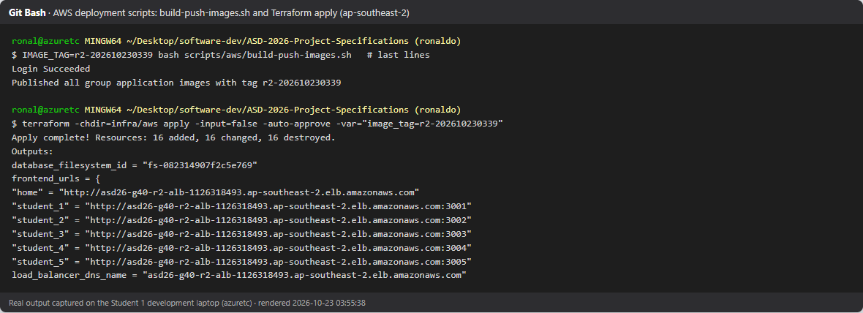
Figure 12. Deployment scripts: build-push-images.sh published every image; Terraform apply complete with the public URLs.
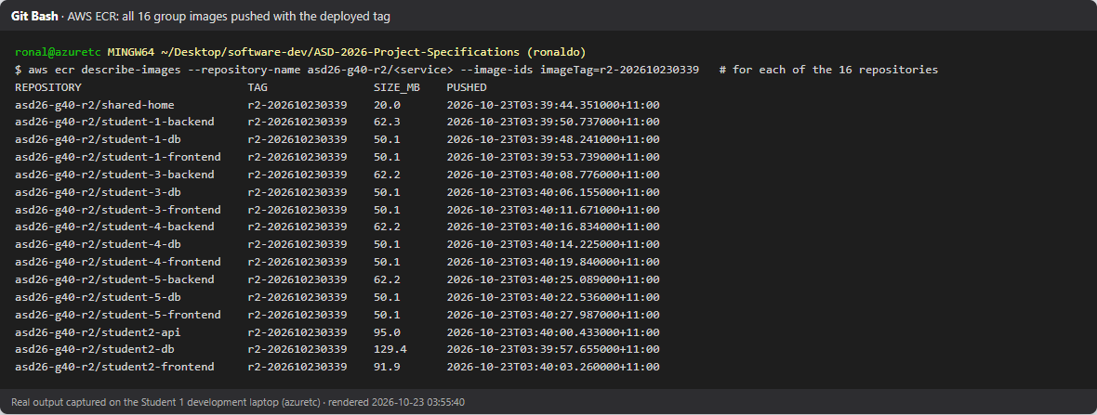
Figure 13. All 16 group images in Amazon ECR with the deployed tag.
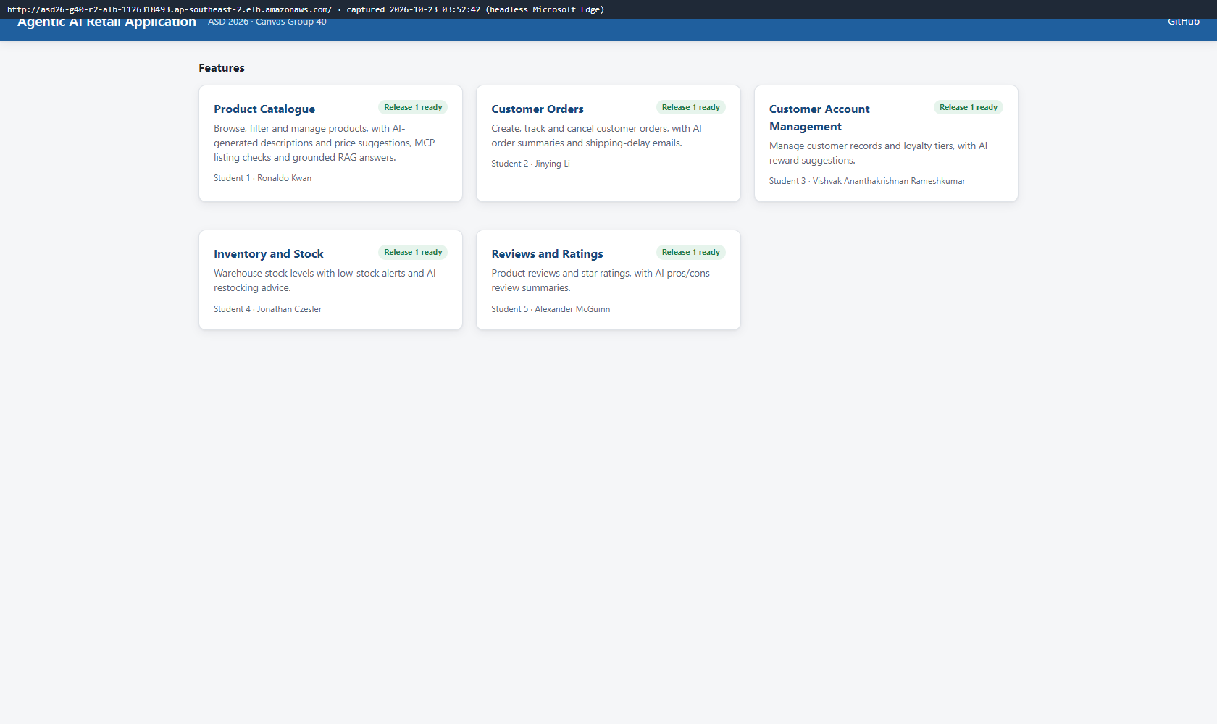
Figure 14. Group home page on the AWS load balancer.
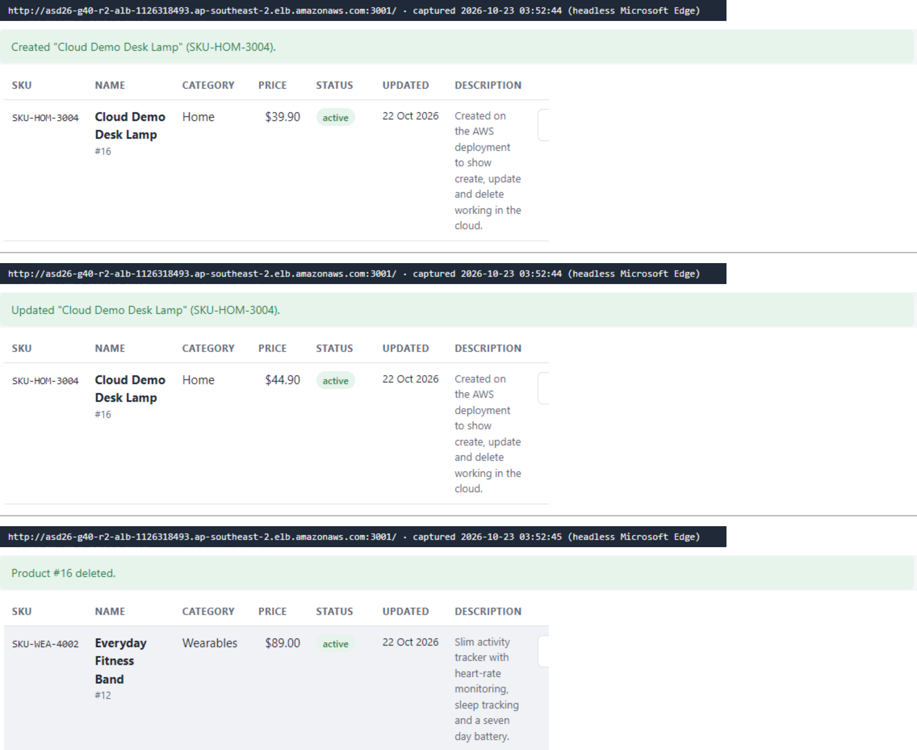
Figure 15. Cloud CRUD through the Student 1 AWS frontend: create, update and delete.
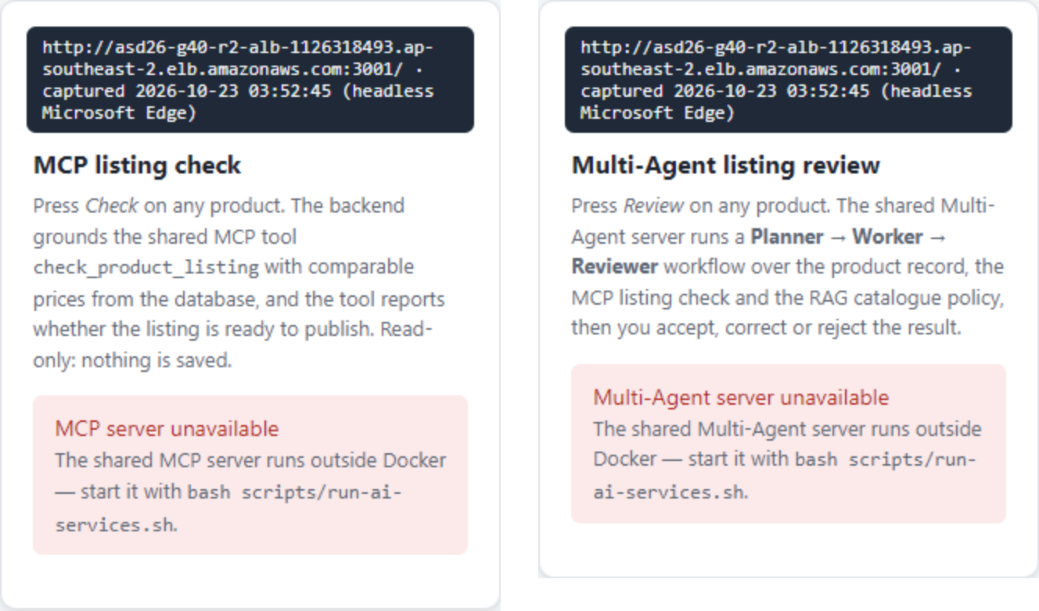
Figure 16. AWS frontend: MCP check and Multi-Agent review unavailable, as the AI services are not deployed in the cloud baseline.
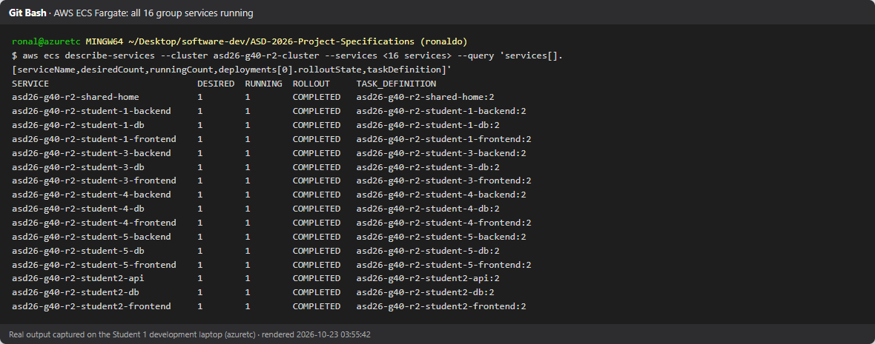
Figure 17. ECS Fargate: 16/16 services running, rollout completed.
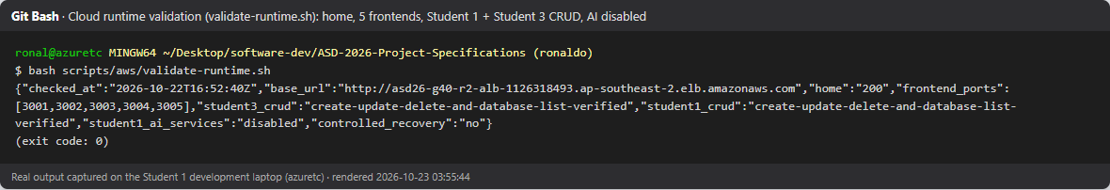
Figure 18. validate-runtime.sh: home page, five frontends, Student 1 and 3 CRUD, AI services disabled (exit 0).
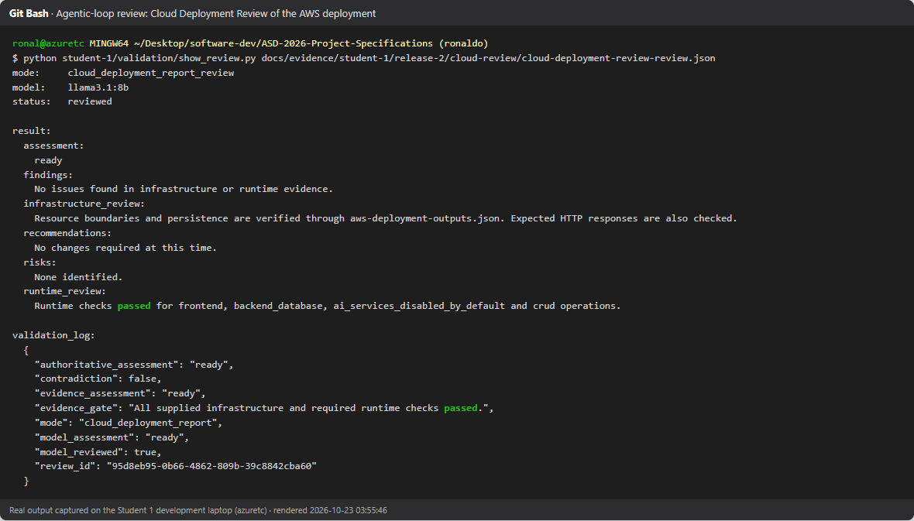
Figure 19. Agentic-loop Cloud Deployment Review of the live AWS deployment: ready.

9.2 Student 2 – Jinying Li
TODO (Student 2): Cloud deployment evidence for Customer Orders.

9.3 Student 3 – Vishvak Ananthakrishnan Rameshkumar
TODO (Student 3): Cloud deployment evidence for Customer Account Management.

9.4 Student 4 – Jonathan Czesler
TODO (Student 4): Cloud deployment evidence for Inventory and Stock.

9.5 Student 5 – Alexander McGuinn
TODO (Student 5): Cloud deployment evidence for Reviews and Ratings.

10. Multi-Agent Workflow Evidence

10.1 Student 1 – Ronaldo Kwan
The first live runs failed: the Worker (qwen2.5:3b) miscounted rule checks, and the Reviewer (deepseek-r1:8b) caught the error but marked every claim supported, so the shared server rejected the whole workflow. The fix moved rule arithmetic into the application (readiness_checks, failed_checks), added retries with escalation to Human Review, and switched the Reviewer to llama3.1:8b, which caught 3 of 4 wrong answers in a replay test with no wrong verdicts. An application cross-check of the Worker's verdict is shown beside the Reviewer at Human Review.
Run | Product | Worker | Reviewer | Cross-check | Human decision | Multi-Agent Review
Terminal | #2 Pebble Bluetooth Speaker | ready (correct) | claims supported | agrees | accept | supported
Frontend UI | #7 Dual Port USB-C Charger (draft) | ready (wrong) | rationale unsupported | disagrees | reject | issues_found

Each run's workflow history (multi-agent-workflow.json) and coordination audit log (coordination-audit-log.jsonl, 9 events from workflow_created to human_decision_recorded) are in docs/evidence/student-1/release-2/multi-agent-terminal-run/ and multi-agent-ui-run/.
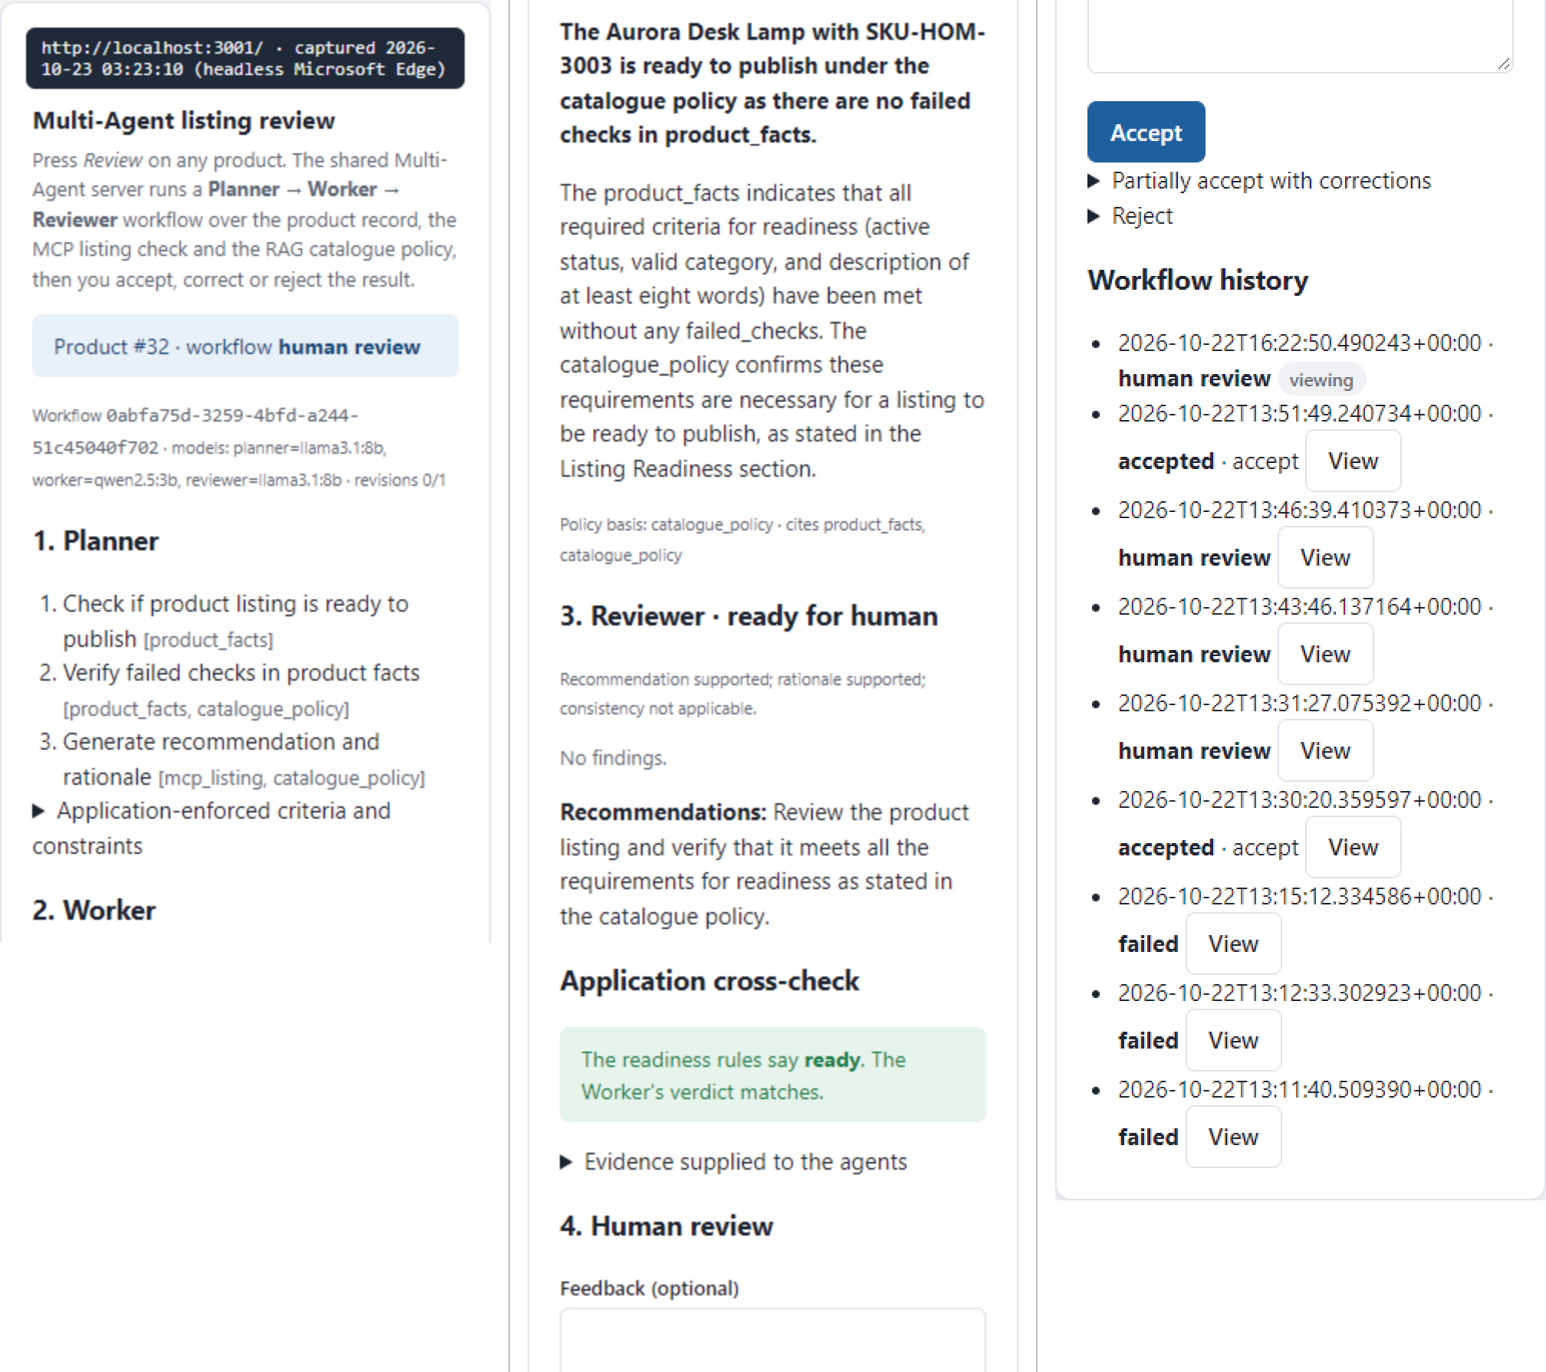
Figure 20. Frontend UI: Planner, Worker and Reviewer stages, application cross-check and the Human Review form.
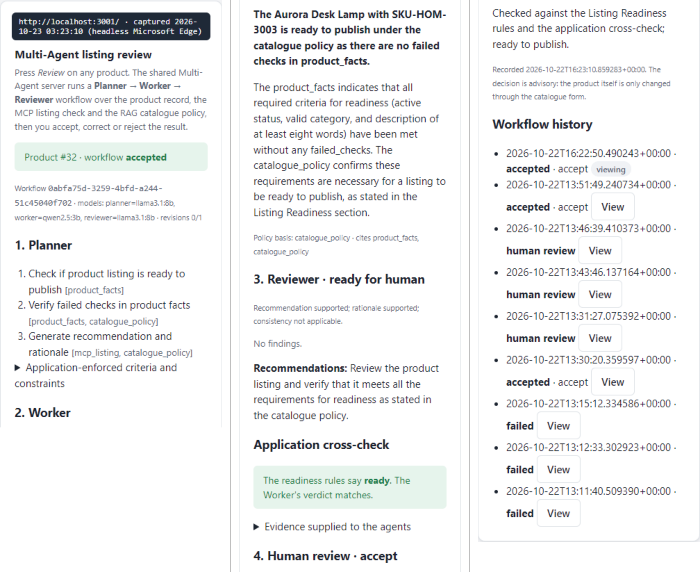
Figure 21. Frontend UI: Human Review decision recorded, with the per-product workflow history.
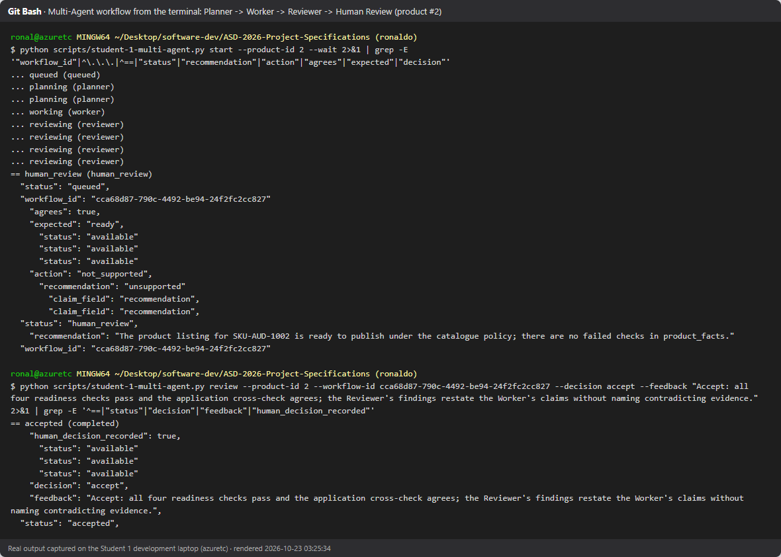
Figure 22. Terminal: student-1-multi-agent.py start → Planner → Worker → Reviewer → Human Review decision.
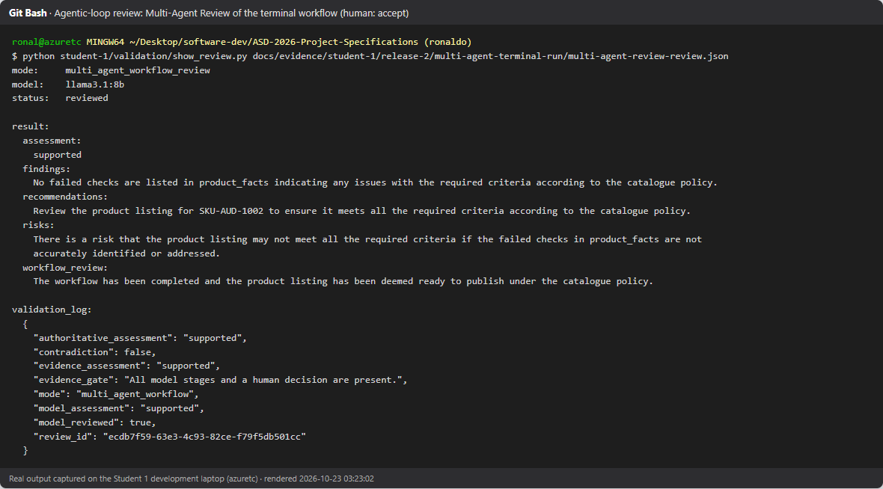
Figure 23. Agentic-loop Multi-Agent Review of the accepted terminal run: supported.
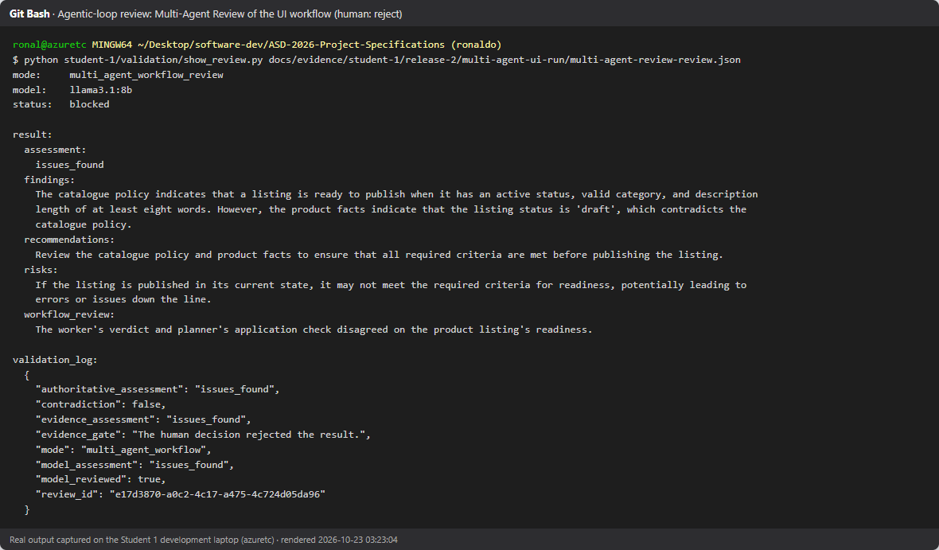
Figure 24. Agentic-loop Multi-Agent Review of the rejected UI run: issues_found, with its validation log.
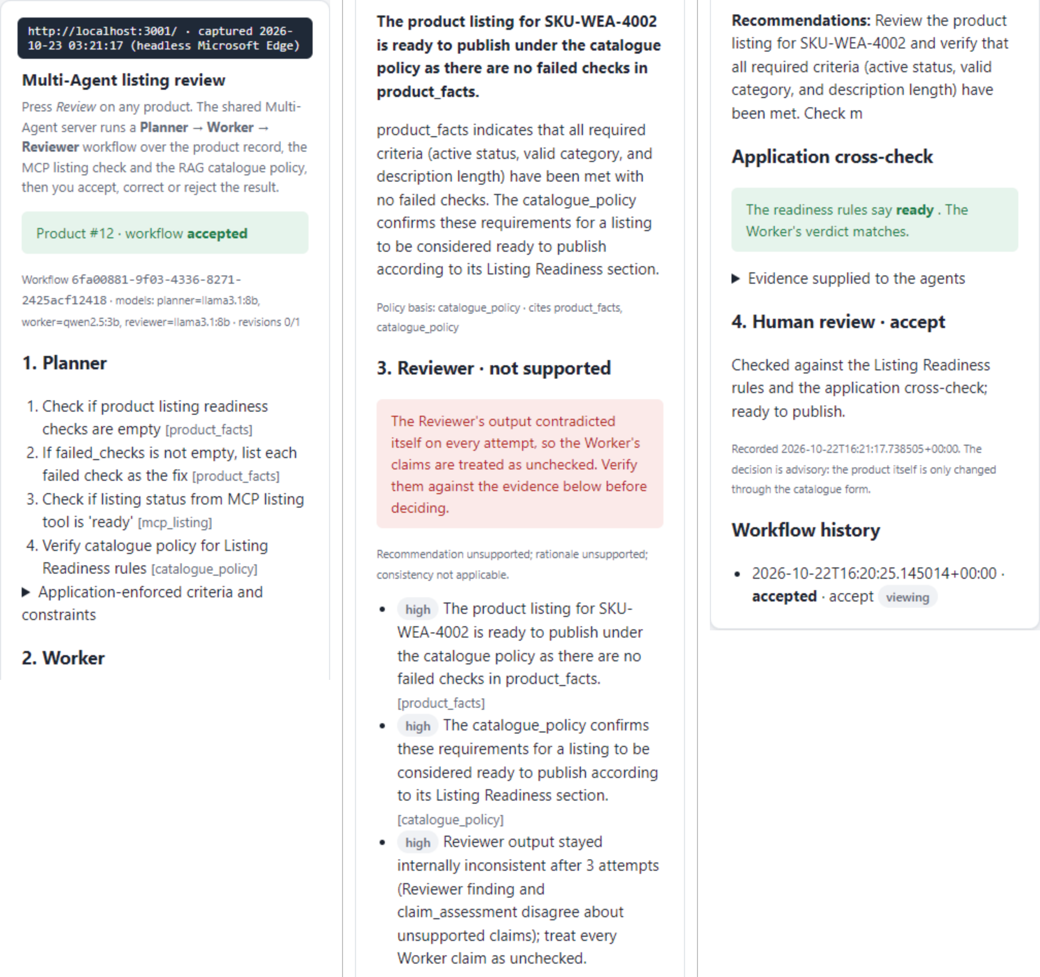
Figure 25. Robustness: a Reviewer that contradicted itself three times was escalated to Human Review flagged unchecked instead of failing the workflow.

10.2 Student 2 – Jinying Li
TODO (Student 2): Planner → Worker → Reviewer → Human Review run, workflow history and audit log.

10.3 Student 3 – Vishvak Ananthakrishnan Rameshkumar
TODO (Student 3): Planner → Worker → Reviewer → Human Review run, workflow history and audit log.

10.4 Student 4 – Jonathan Czesler
TODO (Student 4): Planner → Worker → Reviewer → Human Review run, workflow history and audit log.

10.5 Student 5 – Alexander McGuinn
TODO (Student 5): Planner → Worker → Reviewer → Human Review run, workflow history and audit log.

11. GitHub Commit Logs
Commit history: github.com/ronaldokwan/ASD-2026-Project-Specifications/commits/main
Student | Release 2 commits
1 – Ronaldo Kwan | ronaldokwan
2 – Jinying Li | JYL701, XanonymXX
3 – Vishvak Ananthakrishnan Rameshkumar | vishvak8, Vish7A
4 – Jonathan Czesler | Jono-Cz
5 – Alexander McGuinn | AlexMcGuinn

12. Contribution Logs

12.1 Student 1 – Ronaldo Kwan
Date | Work
22 Oct 2026 | Multi-Agent client, routes, UI panel with history and Human Review, terminal CLI; 38 new tests and 10 post-commit endpoint tests; student-1.yml Release 2 pipeline; pre-commit coverage for Student 1 and shared Ruff fixes
23 Oct 2026 | Diagnosed live Reviewer failures; deterministic readiness checks, application cross-check, shared-server retry and Human Review escalation; Reviewer model evaluation; terminal and UI Multi-Agent runs; Testing and Multi-Agent reviews
23 Oct 2026 | AWS deployment of the group application, four deployment defects fixed, runtime validation, Cloud Deployment Review, cloud and bonus evidence, teardown
27 Oct 2026 | GitHub OIDC deploy role (infra/aws/github-oidc/) and cloud-deployment.yml fixes for the hosted deploy; multi-server check script; evidence logs

12.2 Student 2 – Jinying Li
TODO (Student 2): Release 2 contribution record.

12.3 Student 3 – Vishvak Ananthakrishnan Rameshkumar
TODO (Student 3): Release 2 contribution record.

12.4 Student 4 – Jonathan Czesler
TODO (Student 4): Release 2 contribution record.

12.5 Student 5 – Alexander McGuinn
TODO (Student 5): Release 2 contribution record.

13. Bonus Evidence
Claimed: B5 Cloud Endpoint Security and B6 Cloud Data Security. B1–B4 (AI services in the cloud) are not claimed; the cloud deployment keeps them disabled.
Bonus | Controls (infra/aws/main.tf) | Validation
B5 Endpoint security | ALB security group admits only :80 and :3001–:3005; tasks run in private subnets without public IPs; the tasks security group accepts traffic only from the ALB and other application tasks | backend :8001 and database :9001 refuse connections from the internet; ECS reports no public IP (B5 screenshot below)
B6 Data security | EFS encrypted at rest, TLS in transit, IAM-authorised access point per database; S3 state bucket AES256, versioned, TLS-only, public access blocked; ECR AES256 with immutable tags; GitHub OIDC role instead of stored AWS keys | AWS CLI queries of EFS, S3 and ECR settings (B6 screenshot below)

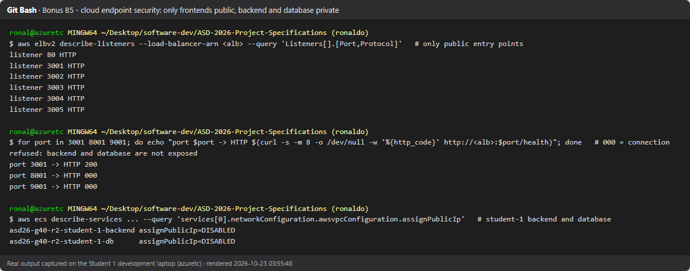
Figure 26. B5 endpoint security: only ports 80 and 3001–3005 are public; backend and database ports refuse connections; tasks have no public IP.
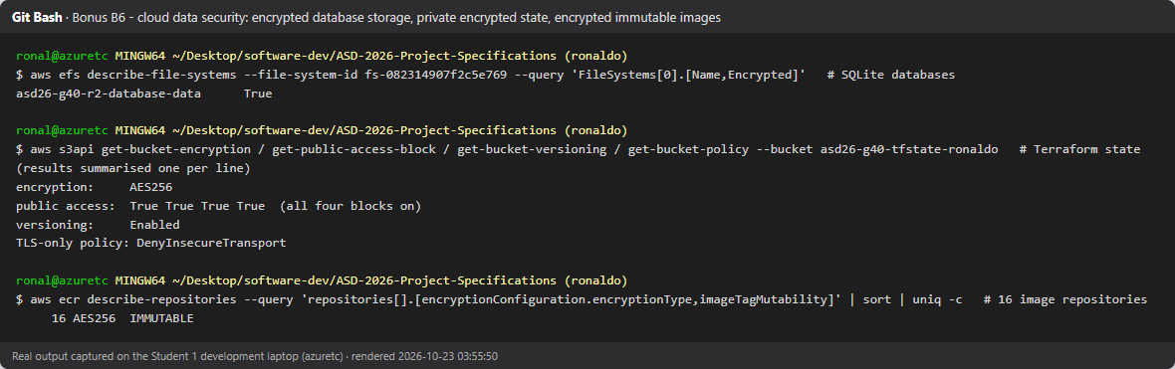
Figure 27. B6 data security: encrypted EFS, encrypted TLS-only state bucket, ECR AES256 with immutable tags.

14. Showcase Video URL
https://www.youtube.com/watch?v=aBeqeT3EuwE

