

**“A bizarre descent through a fractured world of forgotten drawings and unique creatures.”**

*Version 1.0*

*5/14/25*

© Wei Wu, Damian Metovic, Trent McGovern

**TABLE OF CONTENTS**

### **Title Page (pg. 1)**

* Game Title and Subtitle
* Version and Authors
* Copyright

### **Design History (pg. 9)**

* Unity Version Control History

### **Section I – Game Overview (pg. 13)**

1. **Game Concept**
2. **Feature Set**
3. **Genre**
4. **Target Audience**
5. **Game Flow Summary**
6. **Look and Feel**
7. **Project Scope**
   * Locations
   * Levels
   * NPCs
   * Weapons

### **Section II – Gameplay & Mechanics (pg. 21)**

1. **Gameplay Structure and Progression**
2. **Mission / Challenge Objectives**
3. **Mechanics**
   * Health & Stamina System
   * Melee Combat
   * Parry & Dodge
   * Dash Movement
   * Double Jump
4. **Physics and Movement**
   * General Movement
   * Jumping, Dashing, and Aerial Control
5. **Combat System**
6. **Screen Flow**
   * Title Screen
   * Tutorial Canvas
   * Game Over/Victory Screen
7. **Game Options** *(Minimal interface by design)*

### **Section III – Story, Setting, and Characters (pg. 25)**

1. **Narrative Overview**
   * The Creator’s Journey
   * Inspector Whiskers
2. **Story Progression**
   * Tutorial Introduction
   * Boss World: Basketball Court
3. **Game World / Canvases**
   * Tutorial World
   * Royal Basketball Arena
4. **Characters**
   * The Creator
   * Inspector Whiskers
   * Basketball Monarch
   * Final Exam Dummy
5. **Tutorial Canvas**
   * Intro Mechanics
   * Final Exam
6. **Boss Level: Basketball Court**
   * Layout
   * Combat Arena
   * Boss Phases

### **Section V – Interface (pg. 27)**

1. **HUD Elements**
   * Player Health
   * Boss Health
   * Stagger Bar
2. **Menus**
   * Title Screen
   * Game Over/Victory Screen
3. **Rendering & Camera**
   * Pixel Art Style
   * Static 2D Camera
4. **Controls**
   * Keyboard & Mouse Layout
5. **Audio**
   * Sound Effects
   * Music / Chiptune Aesthetic

### **Section VI – Artificial Intelligence (pg. 30)**

1. **Boss AI**
   * Pattern-based Behavior
   * Stagger Mechanic
2. **Friendly AI**
   * Inspector Whiskers (Tutorial Guide)
3. **Player Collision and State System**

### **Section VII – Technical (pg. 32)**

1. **Target Hardware**
2. **Development Tools**
   * Unity Engine
   * C#
   * Visual Studio
3. **Version Control**
   * Unity Version Control

### **Section VIII – Game Art**

1. **Concept and Sprite Art**
2. **Animations**
   * The Creator
   * Basketball Monarch
3. **Environment Art**
   * Tutorial Background
   * Boss Arena

### **Section X – Management (pg. 46)**

1. **Team Roles**
2. **Development Workflow**
   * Discord Communication
   * Weekly Meetings
3. **Division of Labor**

### **Appendices (pg.47)**

1. **Asset List**
   * Sprites / Models
   * Animation Sheets
   * Effect Assets
2. **Interface Assets**
3. **Cutscene Backgrounds**
4. **Sound List**
   * Environmental Sounds
   * Weapon SFX
   * Music

**DESIGN HISTORY**

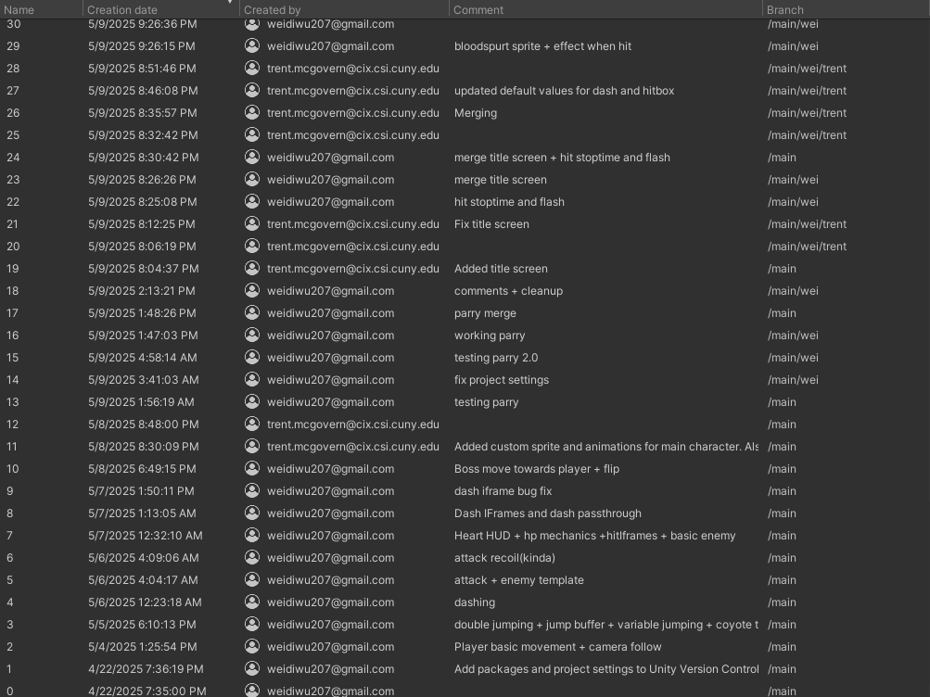

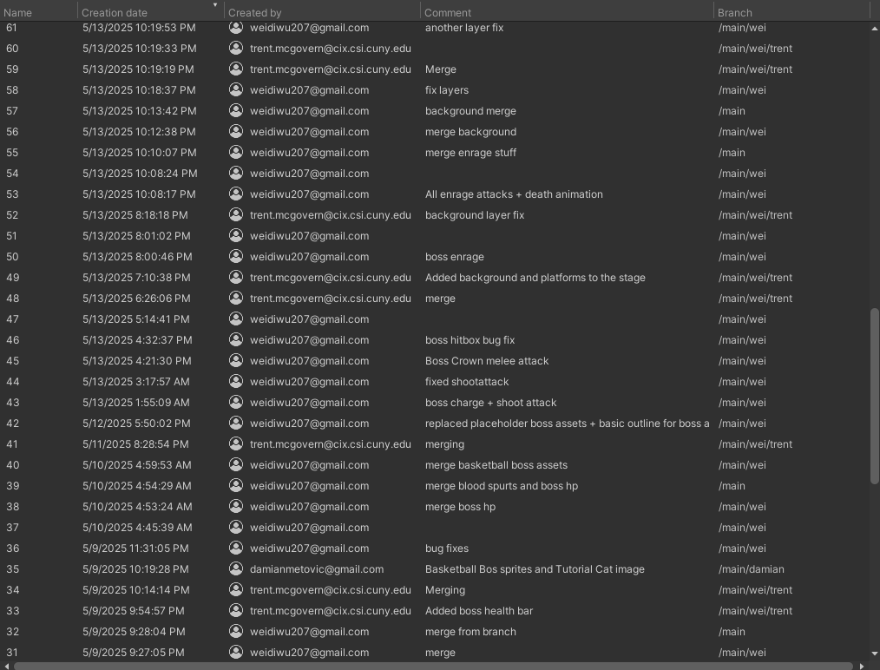

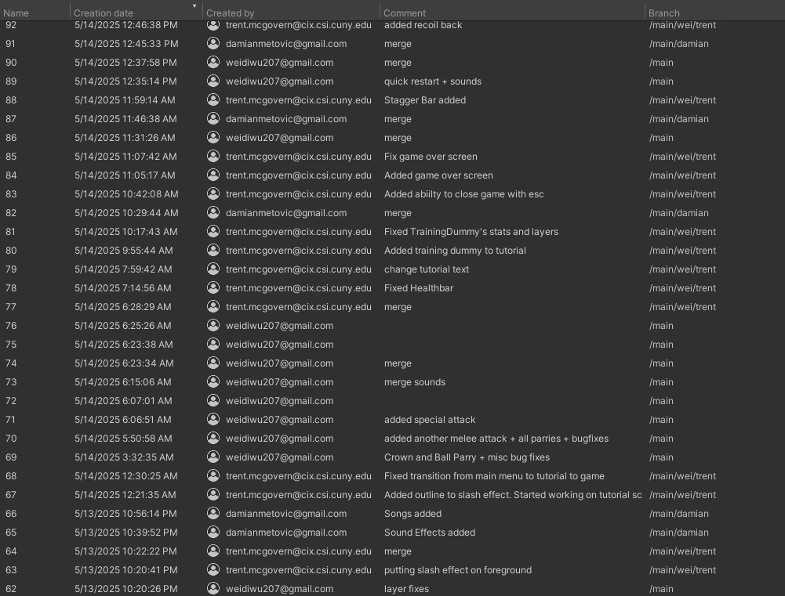

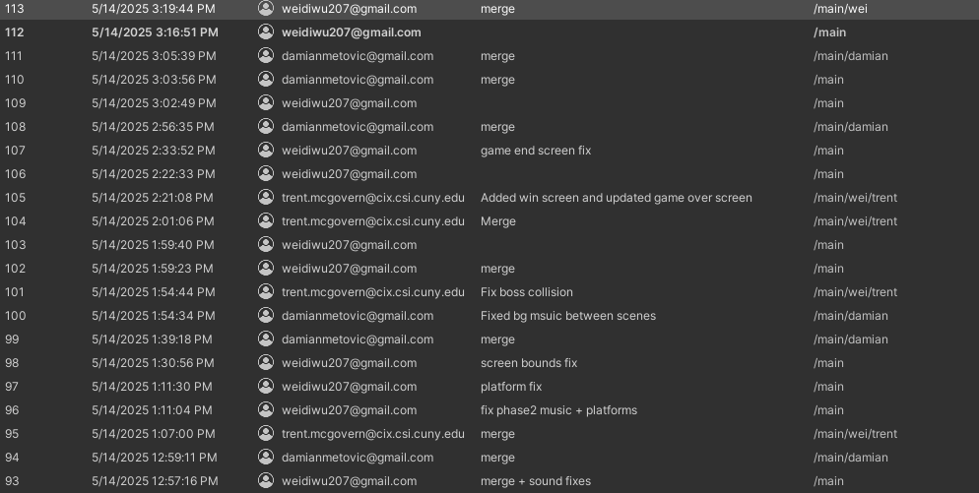

Brainstorming Sprite Ideas - 4/22/25

Creation of the Creator and Basketball Monarch sprites - 4/29/25

Started to script - 5/2/25

Creation of level backgrounds + title screen - 5/12/25

**GAME OVERVIEW**

*Hollow Souls* is a 2D pixel-art action-adventure game that blends atmospheric exploration, reactive sword combat, and surreal entities. You play as **The Creator**, a mysterious figure with long, tattered hair, a weatherworn beard, and a relic-bound sword, drawn into a dimension of drawings and sketches of his own design. These fragmented worlds are each ruled by unpredictable, often absurd bosses.

The universe is split into **“Canvases"**, self-contained boss territories with unique themes, physics, and logic. One Canvas might resemble a royal basketball court ruled by the king of street basketball; another, a kingdom guarded by a giant knight. The randomness isn't just aesthetic; each boss plays by its own rules, with mechanics that shift how combat and/or movement work in their domain.

### **1. Melee Combat System**

* **Description**:  
  Players control *The Creator*, utilising a melee-based combat system built around timing, spacing, and tactical engagement.
* **Features**:  
  + Light and heavy attacks with variable wind-ups and cooldowns.
  + Interruptions are allowed via movement or damage taken.
* **Design Goals**:  
  + Emphasise intentionality, and button-mashing will be eliminated.
  + Encourage players to learn enemy tells and spacing.

### **2. Dodge & Parry Mechanics**

* **Dodge**:  
  + Directional dodge roll with brief invincibility frames.
  + Used to evade attacks or reposition.
* **Parry**:  
  + Timed defensive action to deflect melee or projectile attacks.
  + A successful parry stuns the enemy and allows a critical counter.
  + The window of success is short; it encourages mastery.
* **Design Goals**:  
  + Add depth to combat.
  + Reward precision and defensive skill over brute force.

### **3. Dash Movement**

* **Functionality**:  
  + Short-range, momentum-based burst movement.
  + Usable in horizontal directions.
  + It can be executed on the ground or in mid-air.
  + Consumes stamina.
* **Design Goals**:  
  + Enhance mobility and verticality.
  + Allow for traversal and emergency repositioning in boss arenas.

### **4. Health & Stamina System**

* **Health (HP)**:  
  + Determines player survivability.
  + Damage taken from enemy attacks, environmental hazards.
* **UI**:  
  + Visual health bars are integrated into the HUD.

### **5. Unique Boss Animations & Attacks**

* **Overview**:  
  + Each boss features a distinct animation set, behaviour patterns, and combat logic.
  + No reused attack animations between major bosses.
* **Implementation**:  
  + Frame-by-frame sprite animation for maximum expressiveness.
  + Per-boss AI scripting and attack telegraph systems.
* **Design Goals**:  
  + Ensure every boss feels like a “main event.”
  + Challenge players to adapt strategy, not just improve stats.

### **6. Double Jump Mechanic**

* **Functionality**:  
  + The player can perform a second jump while airborne.
  + The second jump resets only after touching ground or landing on a valid surface.
  + Can be used in combination with dashing and dodging for advanced movement strategies.
* **Design Goals**:  
  + Expand vertical traversal options.
  + Enable access to high or distant platforms in both exploration and combat arenas.
  + Enhance player expression during aerial combat (e.g., jump → dash → double jump → attack).
* **Balance Considerations**:  
  + Prevent exploitation via jump-cancelling or infinite air time.
  + Ensure level geometry and boss arenas are designed with vertical layers in mind.

Hollow Souls is a 2D Action-Adventure Metroidvania with strong Soulslike influences. The game focuses on precision-based melee combat, platforming traversal, and nonlinear world exploration. Players navigate an interconnected, fragmented world where progression is gated by movement abilities such as double jumping and dashing. Each region introduces unique mechanics and culminates in challenging, thematically distinct boss encounters that require strategic use of dodging, parrying, and timing. Drawing inspiration from titles like Hollow Knight and Blasphemous, Hollow Souls blends atmospheric storytelling and reactive combat with a surreal, unpredictable tone that distinguishes it from traditional genre entries.

*Hollow Souls* is aimed at players who enjoy **challenging, skill-based gameplay** combined with **atmospheric exploration**. The core audience includes fans of 2D action-adventure games, Metroidvanias, and Soulslike titles who seek tight combat systems, unique boss designs, and nonlinear progression. These players typically appreciate high difficulty, mastery of mechanics, and environmental storytelling over direct exposition.

The game also appeals to indie game enthusiasts who value **handcrafted pixel art**, **surreal or abstract aesthetics**, and **experimental tone**. Players who enjoyed games like *Hollow Knight*, *Salt and Sanctuary*, *Dead Cells*, *Blasphemous*, or *Hyper Light Drifter* would be particularly drawn to *Hollow Souls*. The tone and visual style may also attract fans of existential themes.

Demographically, the target audience skews toward **ages 16–35**, across PC, especially those active in online gaming communities, indie forums, and Soulslike subreddits.

The core structure of *Hollow Souls* follows a **deliberately linear progression**, guiding the player through a focused gameplay experience from the outset. Players begin at the **Title Screen**, which leads directly into the **Tutorial Canvas**, a training level where the player learns essential mechanics such as movement, jumping, attacking, and dodging, all while accompanied by **Inspector Whiskers**, a silent but watchful guide. Once the player has practised their abilities and defeated the **Final Exam dummy**, they can **press Enter to transition directly into the boss fight**. If the player is defeated during the boss fight, they are sent to a Game Over/Victory screen (depending on the outcome of the boss battle) with options to retry, return to the main menu, or exit the game. This flow ensures a structured onboarding experience while still immersing players in the game’s central content: its surreal and challenging boss encounters. While progression is currently linear, each boss world, or **Canvas**, still introduces radically different rules, visuals, and gameplay mechanics, ensuring that each encounter feels fresh and distinct.

#### **Tutorial Sequence – "The Guide"**

All players must first complete a short **interactive tutorial**. This sequence introduces the game’s movement and combat mechanics (including double jumping, dashing, dodging, parrying, and basic melee attacks) in a controlled, narrative-driven environment.

Players are guided by **Inspector Whiskers**, a mysterious cat dressed like a noir-style detective, who serves as both a comic relief character and a surprisingly insightful in-world tutorial guide. He explains the controls and basic enemy interactions in a safe space through light dialogue and hands-on instruction, leading the player through environmental obstacles and mock battles.

The tutorial ends with a "final exam" style encounter against a stationary training dummy, designed to test the player’s basic understanding of movement and combat. **When the player feels ready, they can press Enter to advance directly into the boss fight.**

Each selection launches the player directly into that boss's unique world (Canvases), bypassing unnecessary traversal. There is no interconnected overworld, this minimalist approach emphasises replayability, accessibility, and a focus on unique boss mechanics and visual identity.

*Hollow Souls* features a distinct **2D pixel art aesthetic**, blending traditional pixel animation with **hand-drawn illustrations** to create a world that feels both surreal and deeply textured. The visual style is intentionally rough and expressive, capturing a sense of decay, mystery, and dreamlike unpredictability that reflects the game’s fractured narrative and bizarre world design.

All in-game sprites—including the player, enemies, and bosses—are animated frame-by-frame, with an emphasis on **impactful poses** and **visual identity**. Each character or entity is designed to look and feel unique, with no reused animations across major characters.

Backgrounds and environmental set pieces are of pixel art.

The overall tone is a blend of **melancholy, absurdity, and unease**, driven by the art direction, making each encounter feel like stepping into a forgotten fable from a strange and hostile dimension.

*Hollow Souls* is a compact, design-focused 2D action-adventure game built around surreal boss encounters and stylised combat. The project is intentionally scoped for a contained but polished experience, emphasising quality over quantity in every element.

#### 

#### 

#### **Number of Locations: 2**

* **Tutorial World**: A piece of looseleaf where players are guided by Inspector Whiskers through the core mechanics.
* **Royal Basketball Court**: A crowded and packed basketball arena presided over by a flamboyant street basketball king (boss).

#### **Number of Levels: 2**

* Each location serves as a standalone level featuring its unique mechanics, visuals, and boss encounter.
* There is no overworld; each level follows a linear level progression.

#### **Number of NPCs: 4**

* **The Creator** (Main Character): A long-haired, bearded warrior wielding an ancient sword.
* **Inspector Whiskers** (Tutorial NPC): A noir detective cat who guides players through the tutorial.
* **Basketball Monarch** (Boss): A basketball-wielding, crown-wearing boss who rules the court with flair and chaos.
* **The Final Exam** (Training Dummy): A stationary scarecrow-like dummy marked with a glowing red spiral. It acts as a final test of the player’s combat skills at the end of the tutorial before entering the boss fight.

#### **Number of Weapons: 3**

* **Sword**: The primary melee weapon, used throughout all levels.
* **Basketball**: Used in specific phases during the Basketball Monarch boss fight as a thrown or bounce-based weapon mechanic.
* **Crown**: Wielded not as a symbol of power, but as a twisted weapon. During the Basketball Monarch boss battle, the king removes his royal crown and uses it as a dagger-like weapon to stab the main character in a dramatic, ritualistic attack.

The crown’s pronged design acts like sharpened golden spikes, and this moment marks a turning point in both narrative tone and player state. The player does not wield it, but its use has a significant visual, emotional, and mechanical impact.

**Gameplay & Mechanics**

*Hollow Souls* follows a **guided linear progression** that introduces players to the game’s mechanics and world before immersing them in its surreal boss encounters. The journey begins at the **Title Screen**, transitions through a focused **Tutorial Canvas**, where players learn controls and combat basics under the quiet guidance of Inspector Whiskers, and culminates in the game’s **boss fight**. This flow ensures a structured onboarding experience while still immersing players in the game’s hand-drawn, imaginative setting from the start.

While the current structure is linear, each **Canvas** the player enters is a **self-contained world** with its own unique rules, mechanics, and environmental logic. These domains are designed to feel distinct and unpredictable, challenging the player not only in skill but also in adaptability. Combat, movement, and even gravity can shift based on the logic of each boss’s realm. Victory over these rulers pushes the story forward, gradually revealing The Creator’s role in the collapse of the sketched universe.

The **central mission** in *Hollow Souls* remains simple yet rich in challenge: **defeat the major boss** hidden within the Creator’s fragmented imagination. Though the initial structure is linear, each encounter tests a different facet of player ability, blending fast-paced swordplay with world-specific mechanics.

The core mechanics of *Hollow Souls* are built around dynamic combat, reactive exploration, and world-specific rule shifts that keep players constantly adapting. At its heart, the game functions as a **combat-driven action-platformer**, with players controlling The Creator through a responsive control scheme involving swordplay, timed dodges, and environmental interactions.

The general movement system in *Hollow Souls* is responsive and fluid, designed to support both exploration and precision combat. Players can **walk, run, and jump**, with momentum playing a subtle but important role in traversal and enemy engagement. The Creator can **walk and attack simultaneously**, allowing for mobile combat encounters that reward timing and positioning. Movement animations are tightly linked to input, ensuring that every step and swing feels tactile. Level design supports this mobility, offering layered verticality and open platforms that encourage players to keep moving during battle.

Beyond standard locomotion, *Hollow Souls* introduces a set of advanced movement mechanics to increase player agility and open up combat variety. **Dashing** provides quick lateral bursts of movement, allowing players to evade attacks or reposition with precision. The dash is on a short cooldown, making it a core part of both offence and defence. Players can also **double jump**, granting access to higher platforms and enabling mid-air repositioning in complex boss arenas. Additionally, the game includes a **parry mechanic**—a skill-based action that lets The Creator deflect incoming attacks when timed correctly. A successful parry not only nullifies damage but can stagger enemies or open them up to counterattacks, rewarding mastery of enemy patterns. These layered movement tools work in harmony to make gameplay feel nimble and deliberate, essential for navigating the unpredictable environments of each Canvas.

The control scheme in *Hollow Souls* is designed for responsive, fast-paced gameplay using a keyboard. **Movement is handled via the A and D keys**, allowing the player to walk left and right, respectively. The player can walk and attack at the same time, which is essential for fluid, mobile combat.

**Jumping** is triggered with the **Spacebar**, and the system supports **coyote time** (allowing jumps shortly after stepping off ledges) and **jump buffering** (registering jump inputs slightly before landing), creating a smooth platforming experience. The player can also **double jump** by pressing **Space** again in mid-air, and releasing **Space** mid-jump reduces the jump height, enabling more precise control.

**Dashing** is executed using a button mapped to **Left Shift**. The dash grants temporary invincibility frames and disables gravity during the dash duration, allowing quick escapes or aggressive repositioning.

**Attacking** is mapped to the **Left Mouse Button** or **Left Ctrl**. Based on directional input, attacks can be aimed forward (neutral), upward (**W** + attack), or downward while in mid-air (**S** + attack), adding depth to combat. The system also includes a **parry mechanic**, which allows players to deflect incoming enemy attacks if timed correctly.

The overall control system emphasises **mobility and responsiveness**, rewarding players who master timing and positioning while maintaining momentum during exploration and combat.

Combat in *Hollow Souls* is fast, reactive, and skill-based, centring around The Creator's relic-bound sword and a set of directional attacks. Players can execute ground and aerial strikes depending on their current input, allowing for forward slashes, upward attacks, and downward plunges that create tactical flexibility during encounters. Each boss introduces new combat dynamics, forcing players to adapt their timing, spacing, and strategy. A **parry system** adds a high-risk, high-reward layer, enabling players to deflect incoming attacks with precise timing and punish enemies with counterstrikes. Attacks are not just about damage; they also trigger **recoil effects**, launching The Creator backward or upward depending on the hit direction, creating a rhythmic, dance-like flow to battle. Combined with the ability to dash, double jump, and strike while moving, combat in *Hollow Souls* is designed to feel **fluid, expressive, and punishingly fair**, rewarding players who study patterns and stay aggressive without becoming reckless.

The player can also press **R** at any point in the boss fight to quickly restart the level.

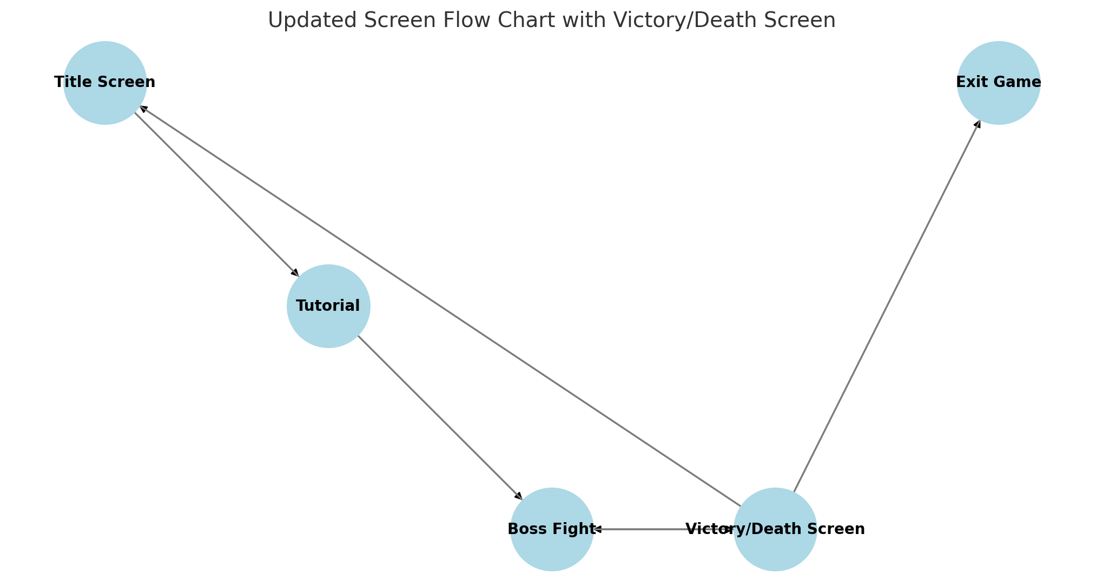

The title screen of *Hollow Souls* captures the essence of its surreal, creator-made universe with a striking **notebook-paper backdrop**, symbolising the sketched origin of the game's world. The game's title is handwritten in bold, pixelated type, “**HOLLOW**” highlighted with a pencil and a pink eraser, subtly nodding to the act of drawing, editing, and imagining. This isn’t just decoration, it reflects the protagonist’s identity as **The Creator**, a mysterious figure trapped inside his artistic manifestations. Flanking the title are two symbolic icons: a **pixel-art sword** representing The Creator’s primary tool of survival and expression, and a **basketball** tied to the game’s most absurd yet dangerous boss, the Basketball Monarch. The title screen immediately establishes the game’s tone: a collision of creative whimsy and dangerous imagination, where doodles become domains and sketches become stages for high-stakes combat. This screen welcomes players into a world born from ink, pixels, and fractured design. **Their journey into the Canvases begins here**.

**Story, Setting and Characters**

In Hollow Souls, you play as The Creator, a man who loves to create worlds and characters through his drawings. One day, a mysterious power brings all of his sketches to life, even ones from his childhood. These drawings are now wreaking havoc around the world, which means there is only one thing to do. He draws a powerful blade, which comes off the paper as his trusty weapon, and enters these worlds of his design. He must defeat the leaders of these worlds to turn them back into drawings and save the world.

The visual identity of *Hollow Souls* is rooted in **2D pixel art**, creating a nostalgic yet expressive aesthetic that supports the game’s surreal tone. The world is populated by **a deliberately random cast of characters**, from a bearded swordsman known as The Creator to bizarre bosses like the king of the stick figures, a culture in which their favourite game is basketball. The environments across the game’s Canvases vary wildly—some elegant, some chaotic—yet all retain a consistent pixelated art style that makes each world feel handcrafted and thematically distinct. Visual storytelling is emphasised through character animations and environmental details, with fluid movements, exaggerated expressions, and thematic props, conveying emotion and lore without the need for dialogue. The pixelated style allows for creative abstraction, giving players just enough visual information to understand the world while inviting them to imagine the deeper meaning beneath each scene.

This Canvas is a grand basketball court, one ruled by the **Basketball Monarch**, a crown-wearing tyrant who mixes slam dunks with ruthless aggression. The arena is packed with a pixel-art crowd of fans, both human and stick figure. The court itself isn't just decorative; it's fully integrated into the gameplay, with **basketball hoops doubling as elevated platforms** for movement, evasion, and attacks.

Before players are thrust into the surreal chaos of the Canvases, *Hollow Souls* opens with a focused training level designed to introduce essential gameplay mechanics in a safe, contained environment. This level takes place on the same stylised notebook-paper backdrop seen in the title screen, grounding the player in the game’s hand-drawn universe. Here, the Creator is not alone: he is guided by a mysterious pixelated cat named **Inspector Whiskers**, who acts as both a tutorial instructor and a source of light comic relief.

Tutorial text appears across the top of the screen, introducing **basic controls** like movement (WASD), jumping (Space), attacking (Left Click), and dodging (Shift). Players are given space to experiment with these mechanics without pressure, as Inspector Whiskers silently observes with judgmental curiosity.

At the end of the tutorial lies a stationary enemy known as the **Final Exam Dummy**, a scarecrow-like figure crowned with jagged gold trim and a glowing red bullseye spiralling from its chest. Though it doesn’t fight back, the Dummy provides a final test of the player’s timing, spacing, and ability to chain actions before continuing. This training sequence serves not only to build mechanical confidence but also reinforces the game’s narrative theme: a creator learning to survive within the world he once drew for others.

Once the player feels ready, they are prompted with a final instruction: **press Enter to proceed to the boss level** or **press Escape to close the game**. This choice gives players agency over their pacing and ensures they’re prepared before diving into the real chaos awaiting beyond the page.

**Interface**

In each **Canvas** encounter, the HUD prominently displays both the **player’s and the boss’s health** using a stylised array of pixel-art hearts. This visual approach keeps the interface minimal yet immediately readable, fitting the game's retro aesthetic. The Player's health is shown in the top-left corner, with a full red bar indicating remaining HP and hollow or cracked hearts representing damage taken. The boss’s health is displayed through a full red bar in the top-right corner of the screen, slowly emptying when damage is taken. This system avoids numeric clutter and reinforces the game’s emphasis on visual clarity and atmosphere. No matter how surreal each Canvas gets, the consistent presence of these heart meters provides players with clear, reliable feedback on the stakes of the battle.  
  
In addition to the heart-based health displays, the interface includes a **small stagger bar** located beneath the boss’s health indicator. This bar tracks the boss’s **stagger HP**, representing how close the boss is to being temporarily stunned. Unlike traditional health bars, the stagger bar depletes based on consistent, well-timed attacks, rewarding aggressive, skilful play. Once the bar is emptied, the boss enters a brief **stunned state**, opening a critical window for the player to deal uninterrupted damage. This mechanic adds a layer of strategy to boss fights, encouraging players to balance survival with offensive pressure.

*Hollow Souls* features a minimalist approach to menu design, with only two key menus: the **Title Screen** and the **Game Over/Victory Screen**. The Title Screen serves as the player's entry point, offering essential options such as pressing **Enter to begin the tutorial sequence**. The Game Over/Victory Screen presents simple choices: **retry**, **return to the title screen**, or **exit the game** through minimal UI prompts. The lack of additional menus such as pause screens, settings, or inventories reinforces the game’s focus on immersion and immediacy, minimising UI friction and allowing players to stay engaged with the action. This streamlined design supports a fast-paced, uninterrupted gameplay loop that emphasises core mechanics over navigation complexity.

Hollow Souls utilises a static 2D camera, consistent with its platformer genre roots. This fixed perspective ensures that gameplay remains focused and readable, especially during complex combat encounters and platforming sequences. The camera is intentionally limited to reinforce the game’s retro aesthetic and to prevent visual distractions, allowing players to fully engage with the environmental design, enemy animations, and precise movements required for survival.

*Hollow Souls* uses a focused and stylised set of sound effects to enhance gameplay feedback and match the retro tone of its pixel-art aesthetic. Each action in the game is paired with a distinct sound cue to reinforce player responsiveness and clarity during combat and traversal.

* **Movement sounds** include a light footstep effect for The Creator's walk cycle and a sharper, momentum-driven **dash sound** to emphasise burst movement.
* The **jump sound** is subtle but snappy, supporting the game’s tight platforming mechanics.
* **Combat effects** are varied: a slashing sound plays when The Creator attacks, a crisp **clang** is triggered on successful parries, and a unique **hurt sound** punctuates when The Creator takes damage.
* For bosses, audio cues play a similar role. The **Basketball Monarch’s dribbling** sound doubles as an audio signal for incoming movement or attacks, making his footsteps both thematic and mechanically relevant.

These audio effects are minimal but impactful, keeping with the game’s design philosophy—clear, expressive feedback without overwhelming the visual or narrative focus.

The soundtrack of *Hollow Souls* is built around a **lo-fi, 8-bit-inspired chiptune aesthetic**, reinforcing the game's hand-drawn, pixel-art tone. Each track is carefully paired with a specific part of the game to support immersion and emotional pacing without distracting from gameplay.

* The **title screen** features a looping 8-bit melody that introduces the player to the game's surreal and nostalgic atmosphere.
* The **tutorial level** is accompanied by a calmer, more instructional track, allowing players to focus on mastering controls and movement in a relaxed space.
* The **boss fight music** maintains a **similar tonal atmosphere to the tutorial track**. This intentional consistency is designed to help players maintain **focus and clarity** during high-stakes encounters, avoiding musical overstimulation in favour of concentration and rhythm-based engagement.

Altogether, the music of *Hollow Souls* helps define the emotional tone of each phase in the game—from curiosity, to mastery, to pressure—while remaining true to its retro-inspired roots.

**Artificial Intelligence**

Boss opponents in *Hollow Souls* are designed with a semi-predictable behaviour model that balances aggression with telegraphed patterns, creating an encounter that demands both observation and reaction. Each boss actively **tracks the player’s position**, adjusting its movement dynamically to close the distance and maintain pressure. The AI evaluates directional orientation to ensure it faces the player when engaging, and it attacks based on a timed cooldown system, delivering powerful strikes that require spacing and timing to avoid. Attacks can be **parried or interrupted** by the player, introducing a strategic element where well-timed counterplay can temporarily stun the boss and open a damage window. The system avoids randomness, instead favouring **pattern-based behaviour** that players can learn and exploit, mirroring the design philosophy of skill-forward action games. The result is a reactive, readable, but still challenging AI that evolves in difficulty based on timing and positioning rather than complex decision trees or randomness.

The primary friendly character in *Hollow Souls* is **Inspector Whiskers**, a curious, pixel-art cat who serves as the player’s silent guide during the tutorial level. Though he doesn’t speak directly, his presence beside The Creator establishes a sense of calm and mentorship in an otherwise strange world. Inspector Whiskers introduces players to the fundamentals of movement, combat, and dodging through on-screen text cues, creating a lighthearted and accessible entry point into the game. As the only non-hostile entity encountered in the early moments, he represents a rare anchor of familiarity and support in the fractured, unpredictable universe that lies ahead.

The player character in *Hollow Souls* utilises a tightly integrated **state-driven AI system** to handle movement, interactions, and collision responses. Core player actions—such as walking, jumping, dashing, and attacking—are tied to a real-time state tracker that monitors whether the player is airborne, facing a direction, dashing, or recoiling from an attack. Collision detection is implemented using precise **physics checks and overlap boxes**, allowing for directional attack detection (upward, downward, and horizontal), grounded checks for jump logic, and player-enemy interactions. The system also includes **damage invulnerability states (i-frames)** triggered during dashes or after being hit, providing short-term protection from follow-up attacks. Recoil is modelled with directional force application and timers that restrict movement briefly, adding a responsive layer of physical feedback when the player lands or receives hits. Altogether, this AI support ensures that the player character reacts intuitively to both input and environmental factors, offering a polished and consistent gameplay experience.

**Technical**

*Hollow Souls* is developed with **low-spec devices in mind**, prioritising broad accessibility and stable performance across a wide range of systems. As a **2D pixel-art platformer**, the game relies on lightweight assets and minimal system requirements, making it suitable for older PCs, laptops, and integrated graphics environments. Optimisation strategies such as sprite batching, limited particle effects, and low-overhead physics ensure the game runs smoothly even on hardware without dedicated GPUs.

The game was developed using the **Unity** engine, chosen for its strong 2D toolset, efficient animation pipeline, and robust support for cross-platform deployment. Unity’s prefab system and component-based architecture allowed for modular design of player mechanics, enemy behaviour, and environmental interactions, crucial for a game with varied boss encounters and world logic.

While *Hollow Souls* is a single-player experience, **Unity Version Control** was used to manage collaborative development and track changes across the project. This system ensured that updates to code, animations, and level design could be safely committed and merged, reducing the risk of conflicts and enabling parallel work across team members.

All scripting for *Hollow Souls* was done in **C#**, leveraging Unity’s MonoBehaviour framework for gameplay systems, AI behaviours, and animation control. The team used **Microsoft Visual Studio** as the primary Integrated Development Environment (IDE) due to its deep integration with Unity & powerful debugging tools.

**Game Art**

*Basketball Monarch*

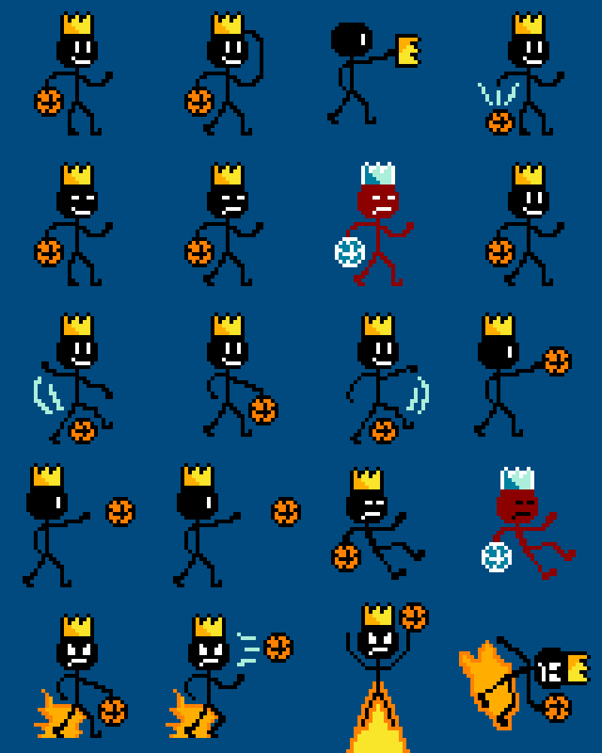

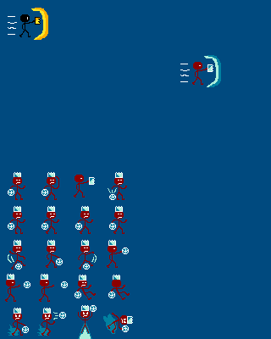

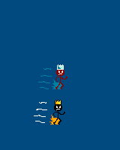

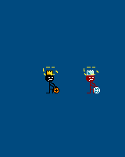

*The Creator*

Walking Cycle

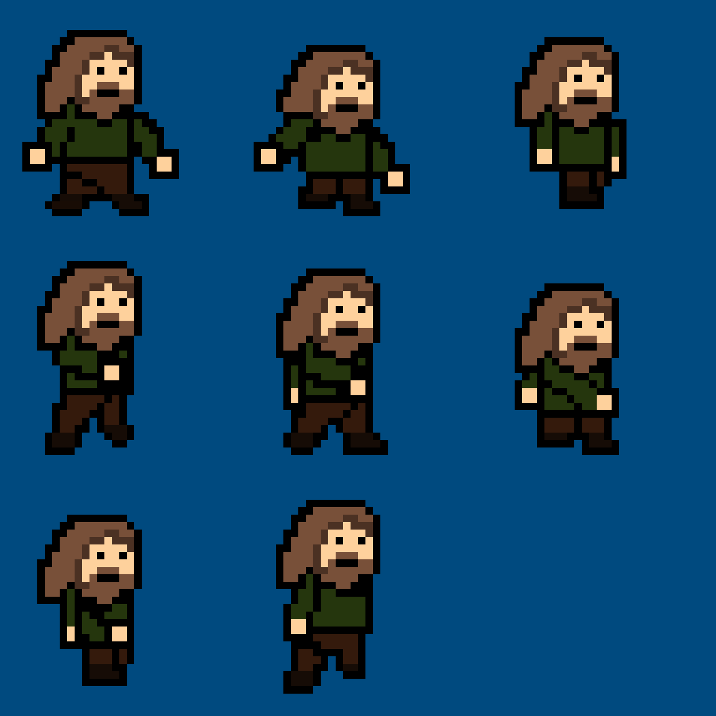

Walk & Sword Swing

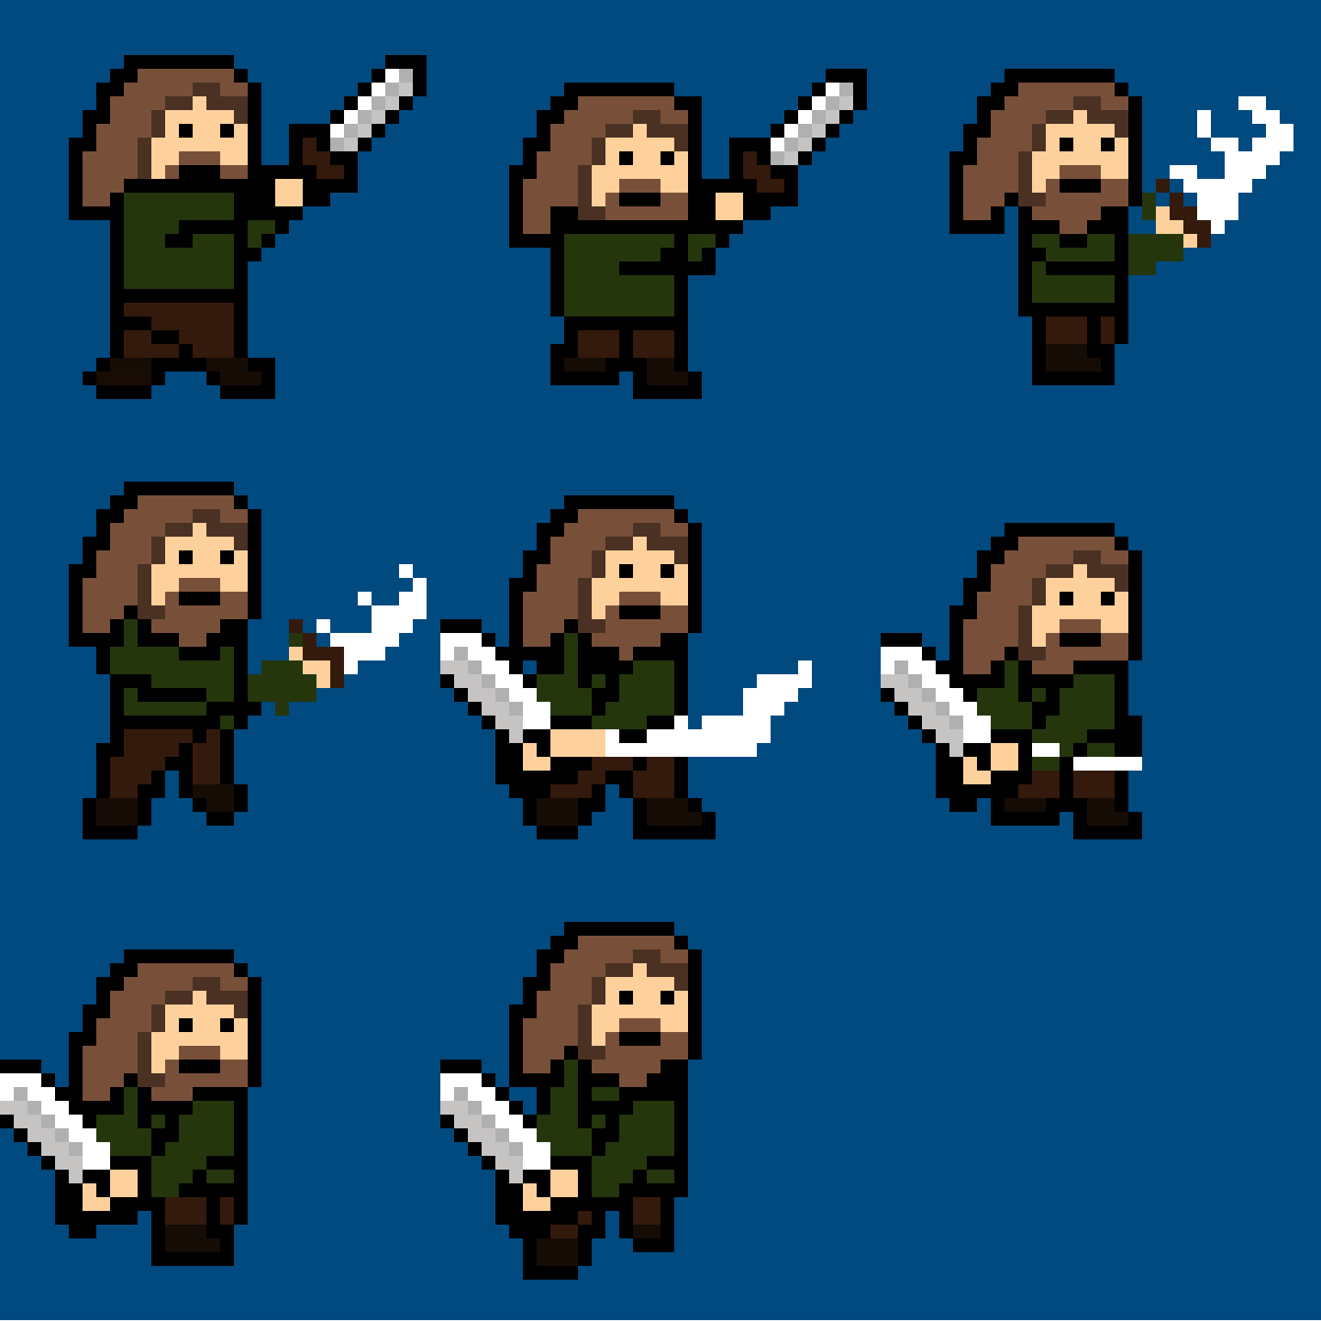

Sword Swing

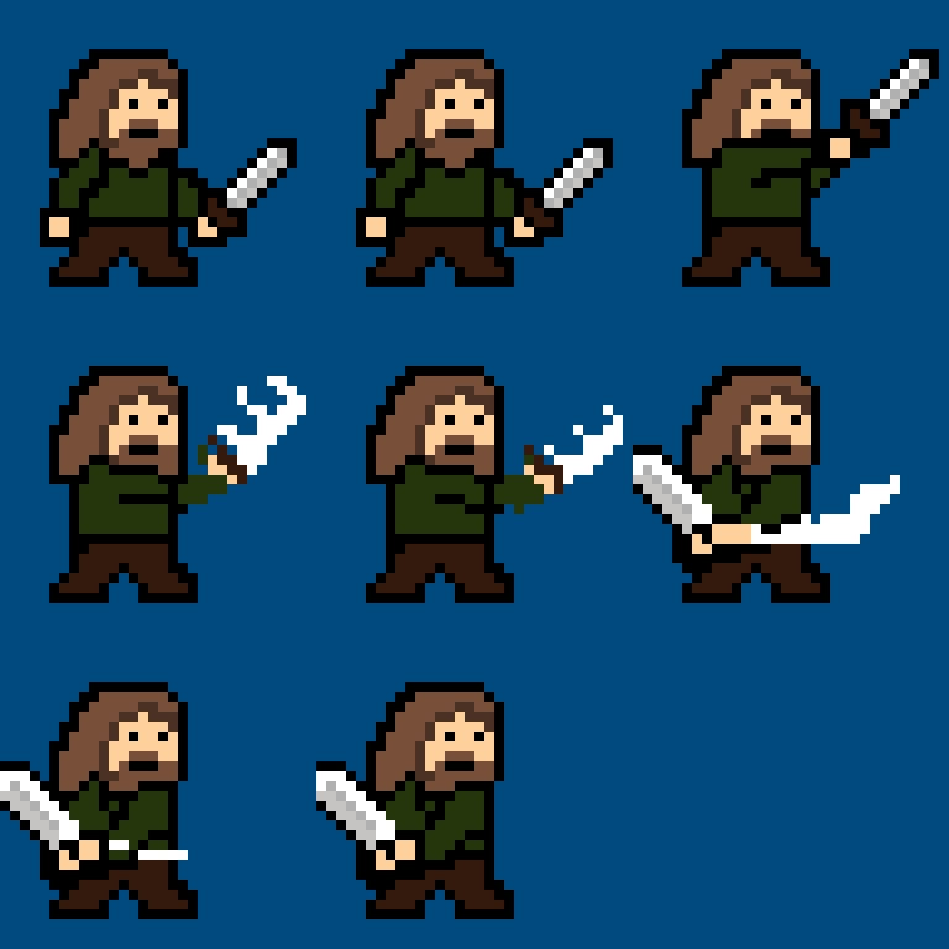

Jump + Swing

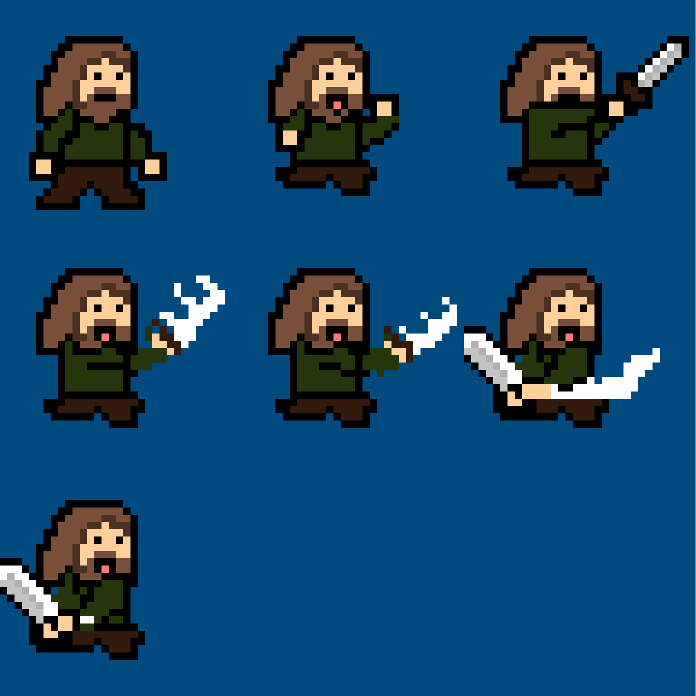

Slash



Inspector Whiskers



Basketball Net

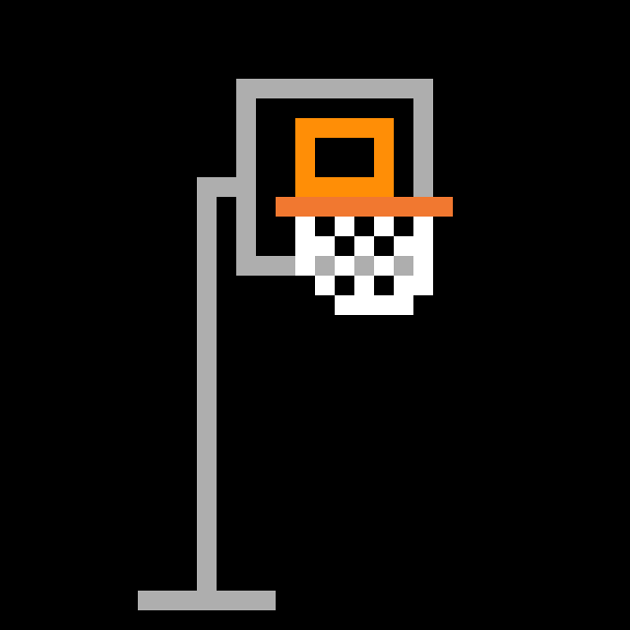

Training Dummy

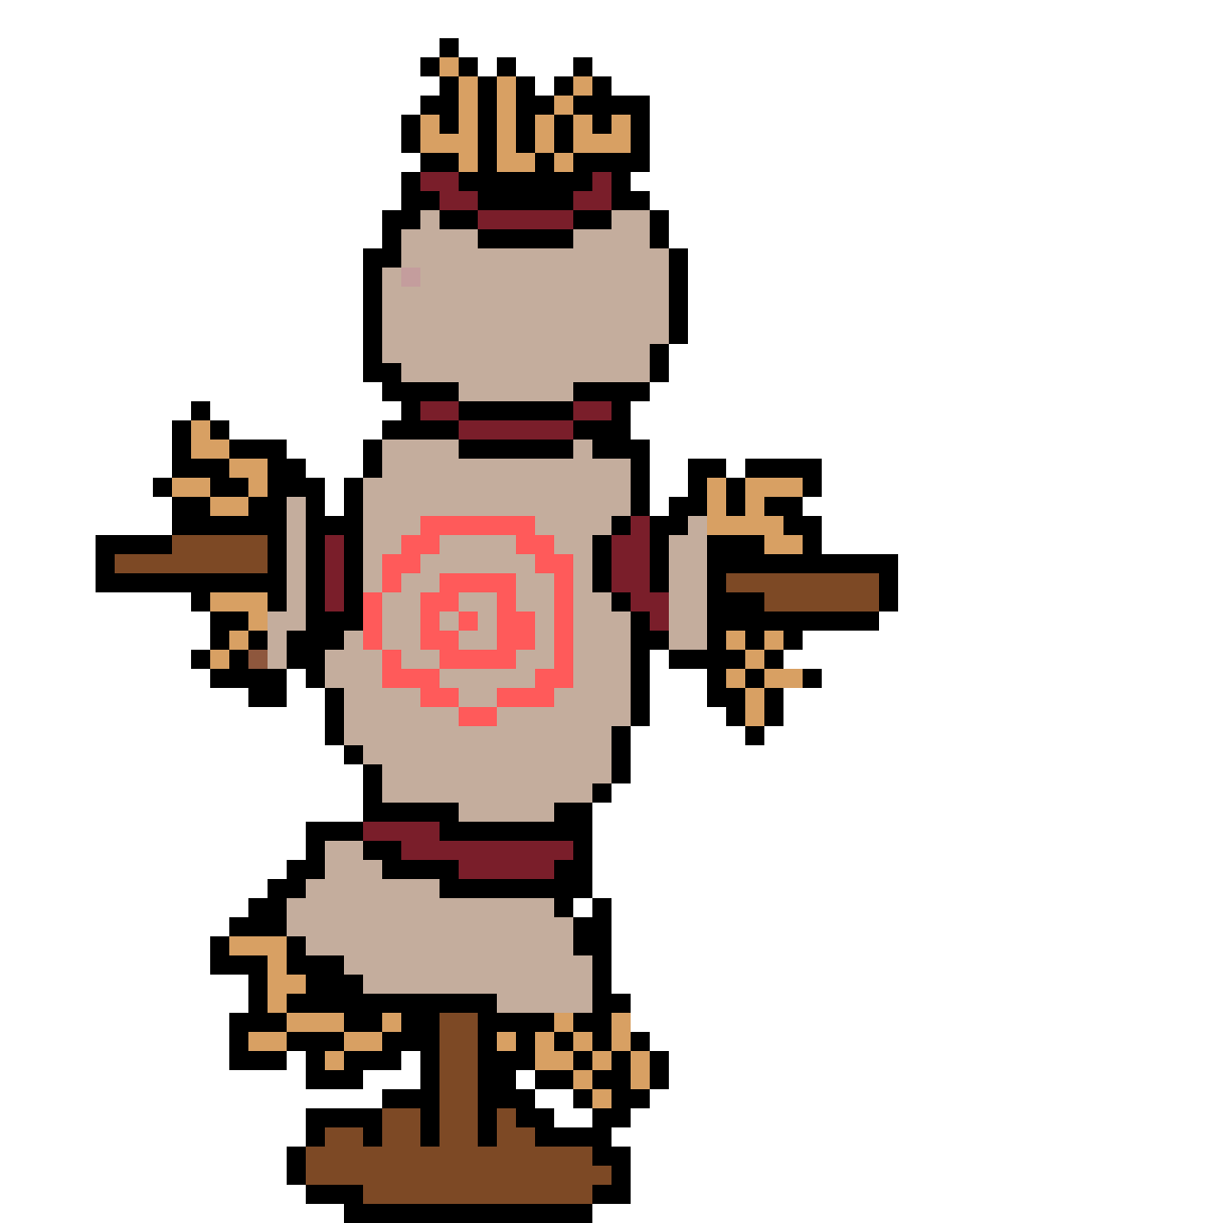

Title Screen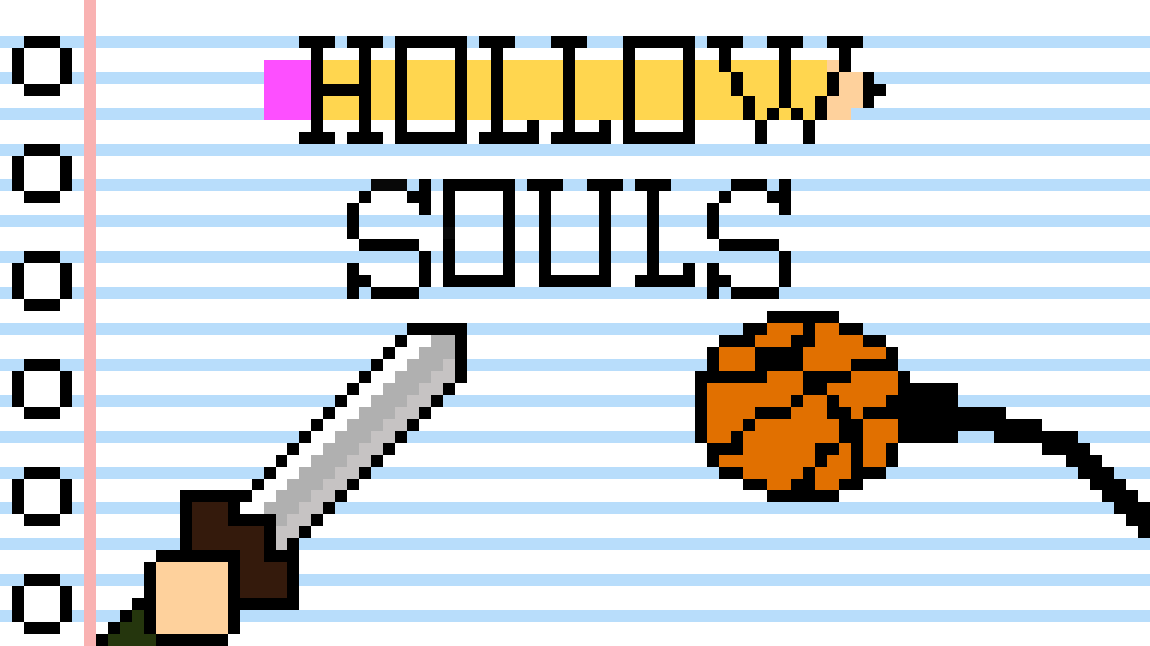

Tutorial Background



Basketball Court Background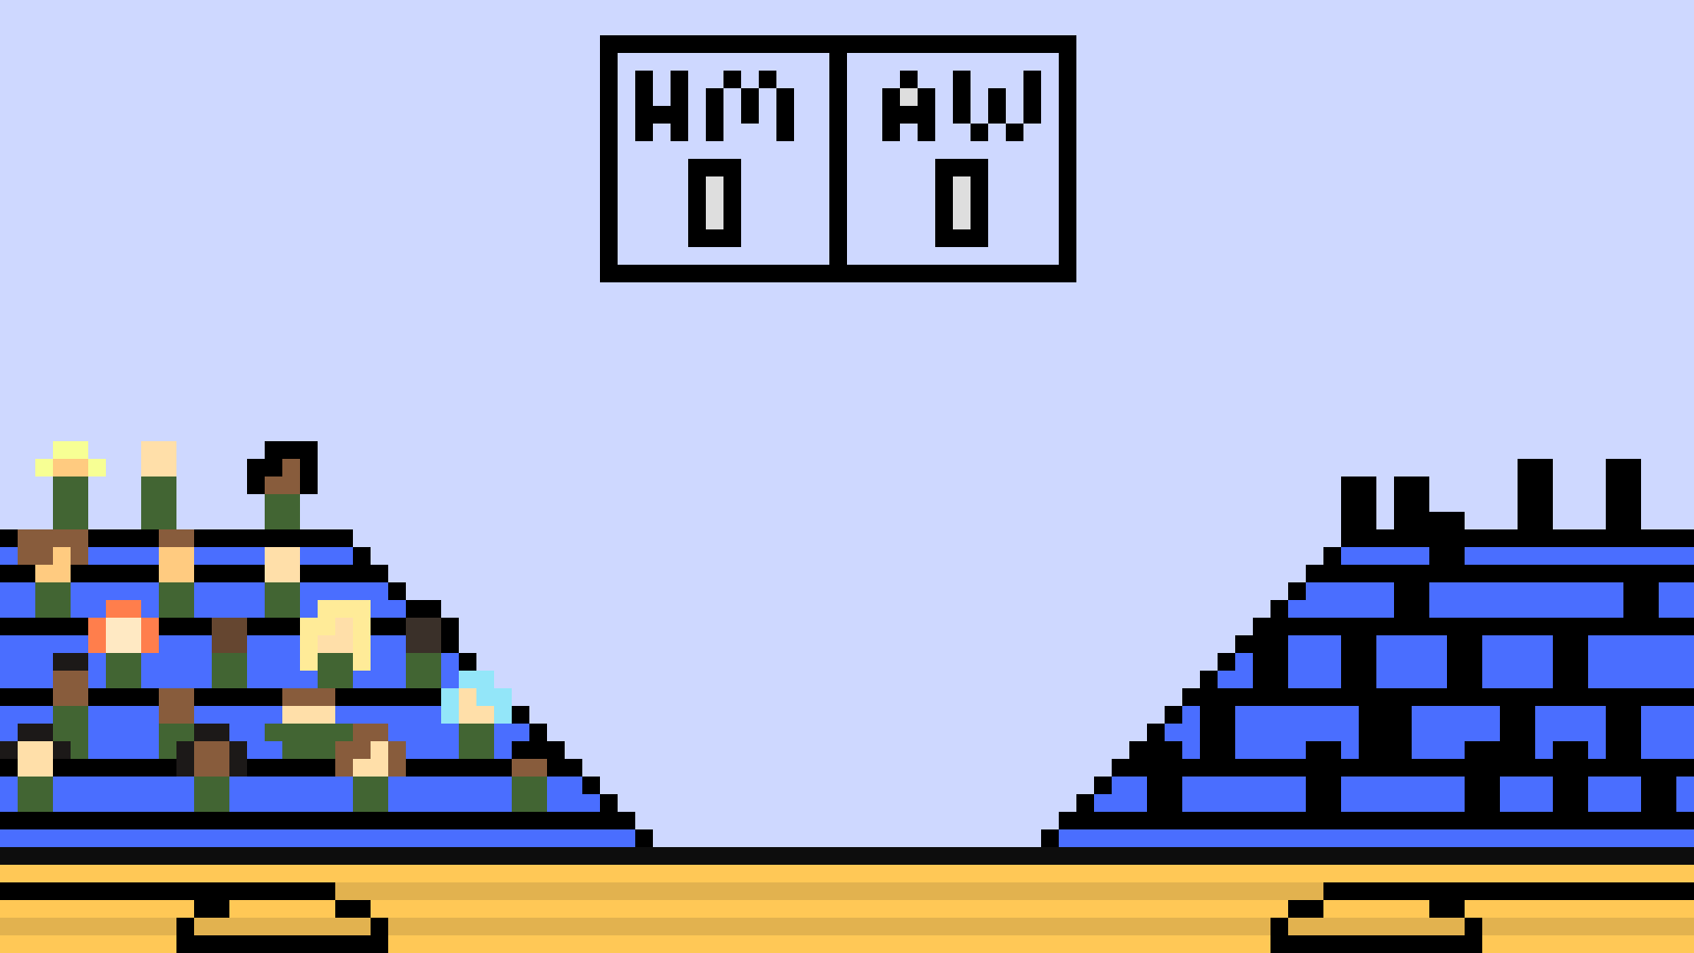

Thanks to a friend of the team, Salvatore Scotto Di Vetta, who provided us with various sketches that we were able to use as reference art for the game:

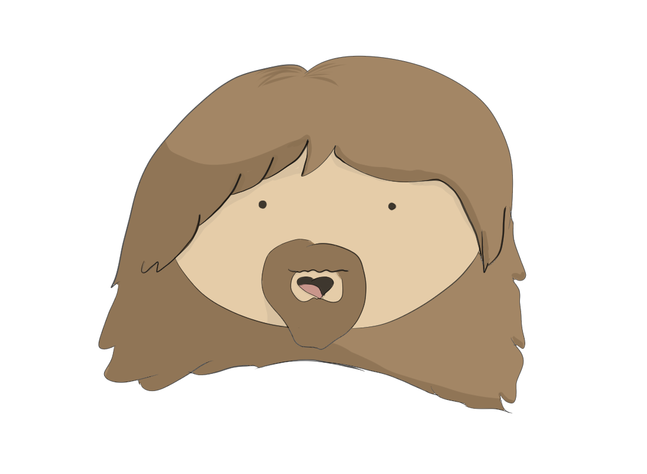

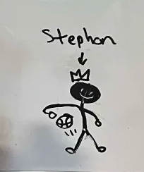

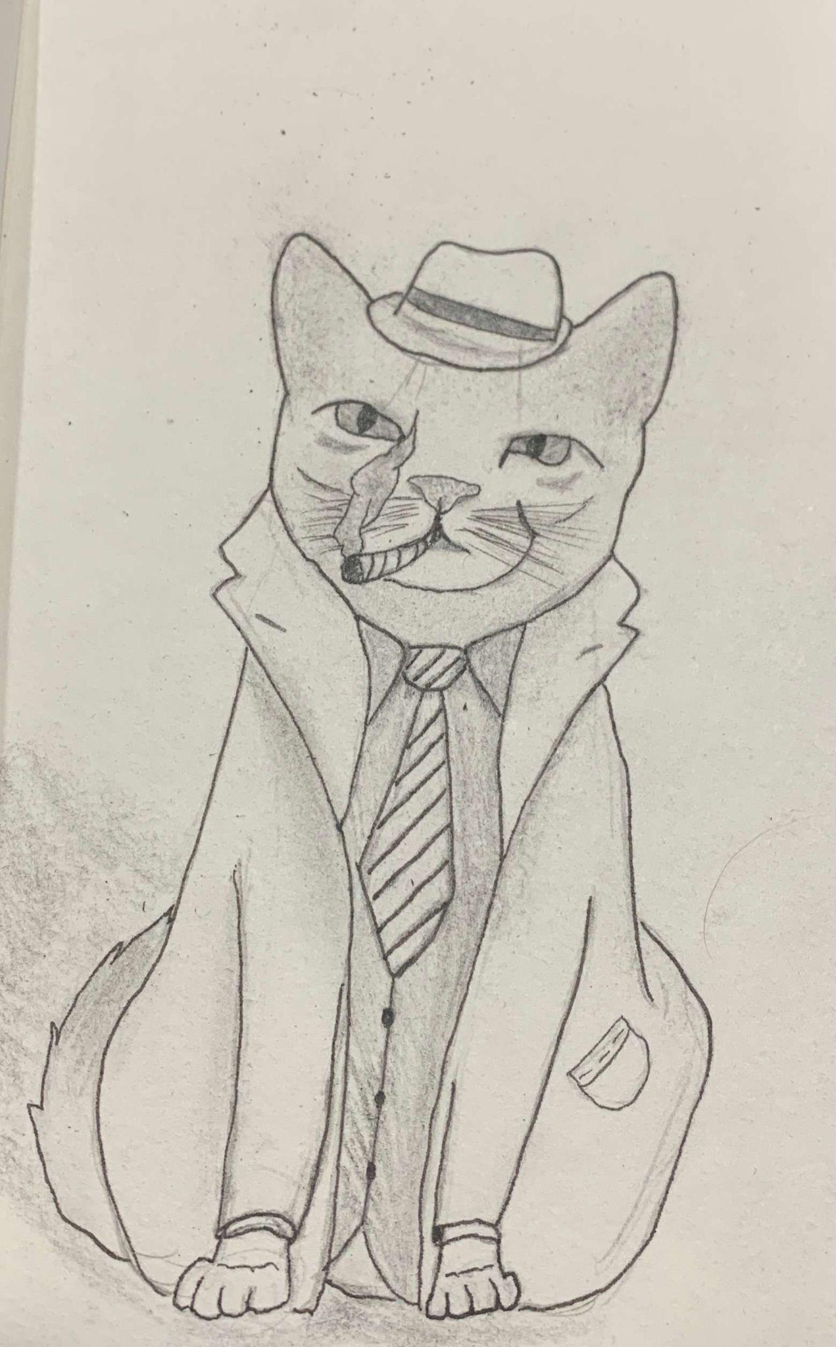

**Management**

The development of *Hollow Souls* was a collaborative effort structured around consistent and open communication. The team relied heavily on **Discord** for day-to-day coordination, using both **text channels** for asynchronous discussions and **voice calls** for real-time problem-solving and brainstorming. Additionally, we held **two weekly in-person meetings during our Intro to Game Development class**, where we reviewed progress, delegated tasks, and tested new features together.

Each team member brought a critical skill set to the project. **Wei** played a central role in scripting, implementing core gameplay mechanics such as movement, attack behaviour, boss logic, and parry systems. **Damian** focused on the **creation of sprite assets** and was also responsible for **compiling and formatting all design documentation,** ensuring the project stayed organised and presentable. In addition, Damian also gathered all necessary sound assets for the game. **Trent** contributed across disciplines, assisting with both **sprite creation** and **level design**, while also helping to script various player and enemy behaviours. Trent also contributed to developing the plotline and lore for the game. This division of roles allowed the team to work efficiently in parallel while supporting one another during key stages of development.

**Appendices**

Sprites/Models:

* “BasketballNet.png” (Basketball Hoop/Platform)
* “Cat.png” (Inspector Whiskers)
* “Training Dummy.png” (Final Exam NPC in the Tutorial World)

Animation list:

* “BasketBoss.png” (Basketball Monarch Spritesheet, contains most animations)
* “BasketBosscrown.png” (Basketball Monarch Crown Attack Spritesheet)
* “BasketBossEnrage.png” (Basketball Monarch Enraged Spritesheet)
* “Jump_JumpSwing.png” (Jumping Sword Attack Spritesheet for The Creator)
* “Sword Swing (without outline smear).png” (Standing Sword Attack Spritesheet for The Creator w/o effects)
* “Walk And Swing Sword.png” (Walking + Sword Attack Spritesheet for The Creator)
* “Walk Cycle.png” (Walking Spritesheet for The Wanderer)

Effects List:

* “blooddrop.png” (Self-explanatory)
* “Slash.png” (Sword Slashing Effect)
* “Slash(1).png” (Sword Slashing Effect)

Interface List:

* “Emptyheart.png” (Player Healthbar)
* “filledheart 1.png” (Player Healthbar)
* “halfheart.png” (Player Healthbar)
* “Title Screen(1).png” (Start/Title Screen)

Cutscene List:

* “Basket Ball Court.png” (Boss Fight Background)
* “Tutorial.png” (Tutorial Level Background)

Environmental Sounds:

* “Basketball Bounce.mp3” (Dribbling/Boss Walking Sound) [credit: https://pixabay.com/sound-effects/ball-bounce-94853/]
* “WalkingSound.mp3” (Walking Sound Effect for The Creator) [credit: Youtube Audio Library]
* “Dash.mp3” (Dash Sound Effect for The Creator) [credit: https://pixabay.com/sound-effects/high-speed-2-192899/]
* “Jump.mp3” (Jump Sound Effect for The Creator) [credit: https://creatorassets.com/a/8-bit-jump-sound-effects]
* “Stab.mp3” (Hurt Sound Effect for The Creator) [credit: https://pixabay.com/sound-effects/knife-stab-sound-effect-36354/]

Weapon Sounds:

* “SwordClang.mp3” (Parry Sound Effect) [credit: https://pixabay.com/sound-effects/sword-clang-178546/]
* “Sword 4.mp3” (Sword Slashing Sound Effect) [credit: https://pixabay.com/sound-effects/sword-swipes-7174/]

Ambient Music:

* “Song1.mp3” (Title Screen Music) [credit: https://pixabay.com/music/video-games-the-world-of-8-bit-games-301273/]
* “Song2.mp3” (Tutorial Level Background Music) [credit: https://pixabay.com/music/video-games-arcade-beat-323176/]
* “Song3.mp3” (Boss Fight Background Music) [credit: https://pixabay.com/music/video-games-retro-8bit-happy-videogame-music-246631/]