**HTML & CSS Validators:**

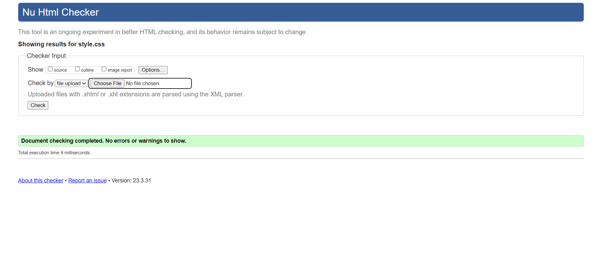

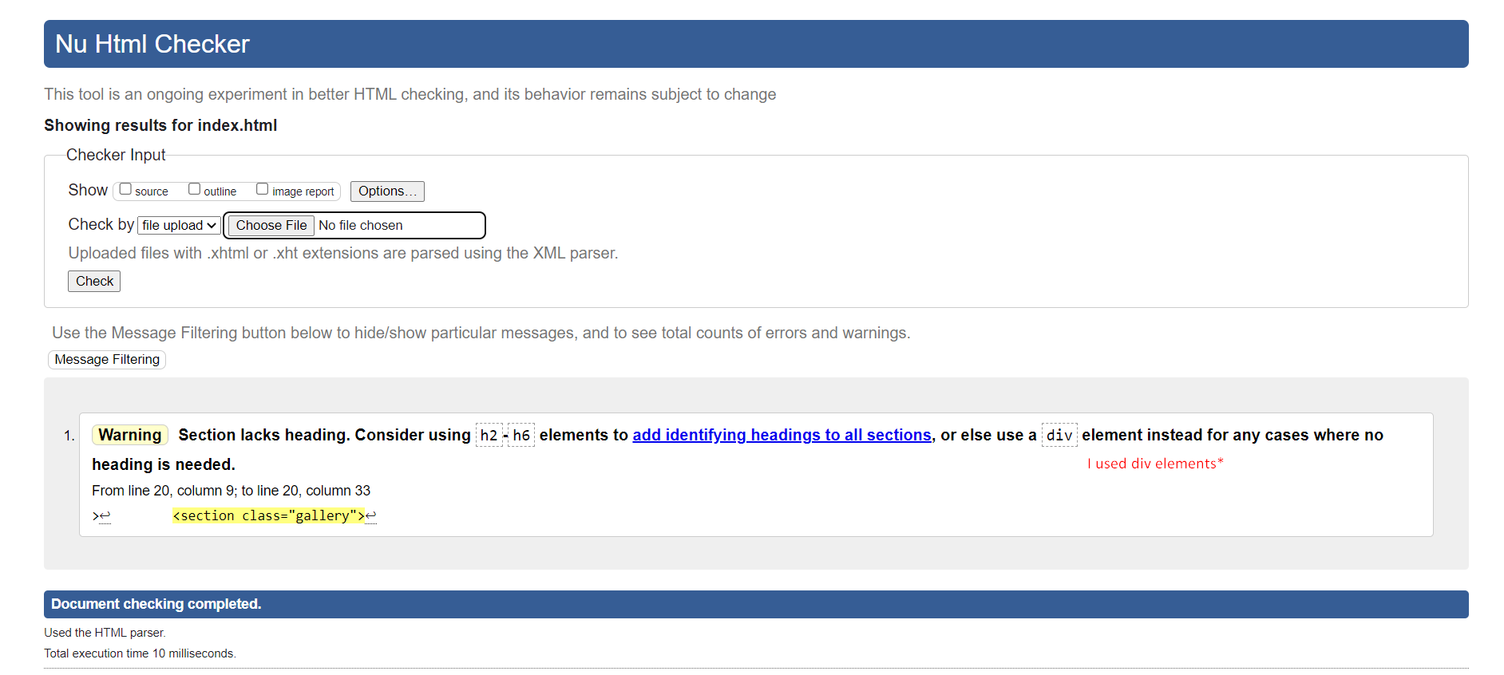

**Website Previews:**

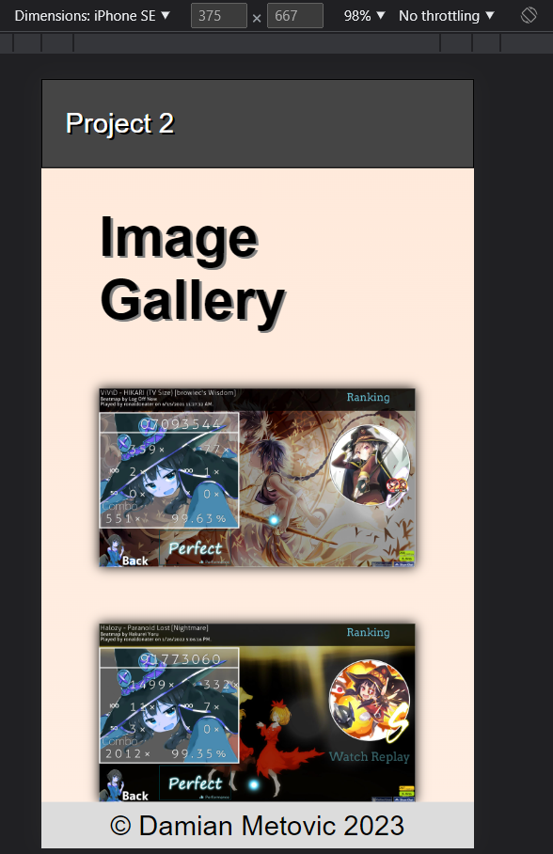

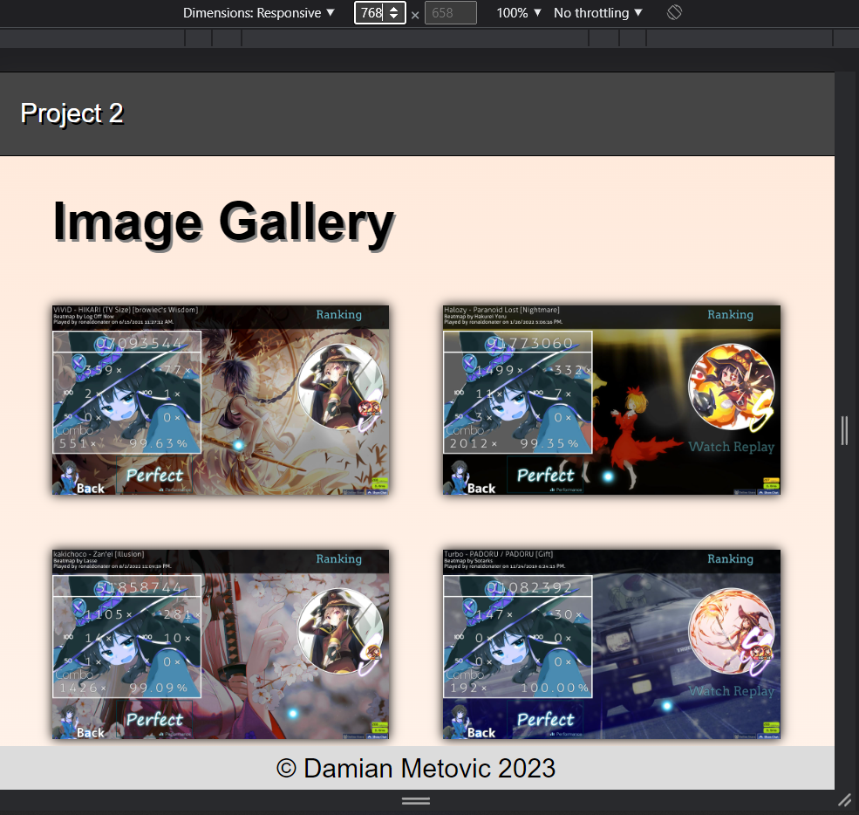

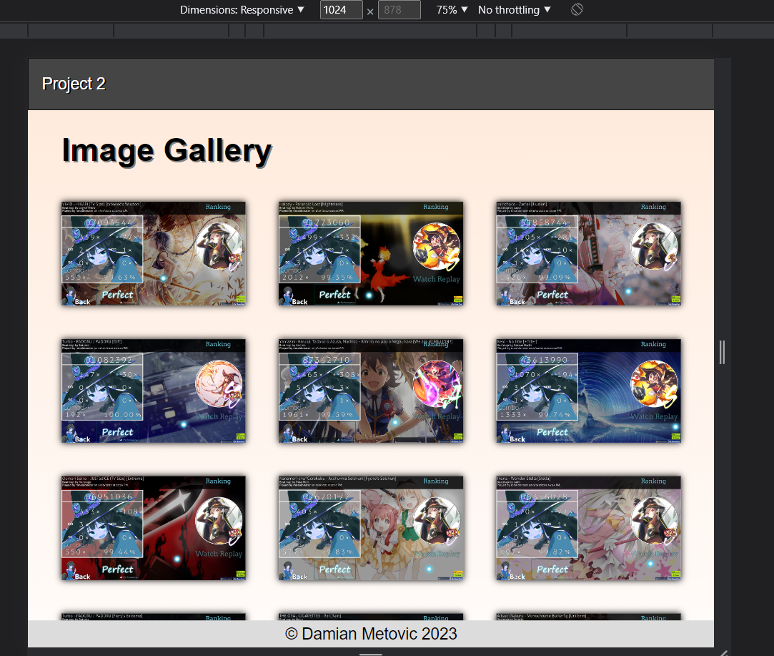

**HTML (index) Source Code:**

<!DOCTYPE html>

<html lang="en">

<head>

    <meta charset="UTF-8">

    <meta http-equiv="X-UA-Compatible" content="IE=edge">

    <meta name="viewport" content="width=device-width, initial-scale=1.0">

    <link rel="stylesheet" href="style.css">

    <link rel="stylesheet" href="normalize.css">

    <title>Project 2 CSC 225</title>

</head>

<body>

    <header>

      <nav class="navbar">

        <p class="project">Project 2</p>

      </nav>

    </header>

    <main>

        <h1>Image Gallery</h1>

        <section class="gallery">

        <div class="tile"><img src="images/image1.jpg" alt="ViViD - Hikari (TV Size) [browiec's Wisdom] + HDHR | 99.63% FC | 383PP"></div>

        <div class="tile"><img src="images/image2.jpg" alt="Halozy - Paranoid Lost [Nightmare] | 99.35% FC | 374PP"></div>

        <div class="tile"><img src="images/image3.jpg" alt="kakichoco - Zan'ei [Illusion] + HD | 99.09% FC | 373PP"></div>

        <div class="tile"><img src="images/image4.jpg" alt="Turbo - PADORU / PADORU [Gift] + HDHR | 100% FC | 372PP"></div>

        <div class="tile"><img src="images/image5.jpg" alt="Yamakazi Haruka, Tadokoro Azusa, Machico - Kimi to no Asu o Negau kara [We are all MILLION!!] | 99.59% 1x Miss | 371PP"></div>

        <div class="tile"><img src="images/image6.jpg" alt="Reol - No Title [+title-] | 99.74% FC | 370PP"></div>

        <div class="tile"><img src="images/image7.jpg" alt="Oomori Seiko - JUSTadICE (TV Size) [Extreme] + HDHR | 99.44% FC | 365PP"></div>

        <div class="tile"><img src="images/image8.jpg" alt="Nanamori-chu*Gorakubu - Acchu~ma Seishun! [Fycho's Seishun] + HDHR | 99.83% FC | 362PP"></div>

        <div class="tile"><img src="images/image9.jpg" alt="fhana - Wonder Stella [Stella] + HDHR | 99.82% FC | 359PP"></div>

        <div class="tile"><img src="images/image10.jpg" alt="Turbo - PADORU / PADORU [Fiery's Extreme] + HDHR | 100% FC | 356PP"></div>

        <div class="tile"><img src="images/image11.jpg" alt="THE ORAL CIGARETTES - ReI [Rain] | 98.62% FC | 353PP"></div>

        <div class="tile"><img src="images/image12.jpg" alt="Aitsuki Nakuru - Monochrome Butterfly [Uniform] + HDHR | 99.13% FC | 351PP"></div>

        </section>

    </main>

    <footer class="copyright">

      <p>&copy; Damian Metovic 2023</p>

    </footer>

  </body>

</html>

**CSS (style) Source Code:**

body {

    background:linear-gradient(to bottom, #ffe9da, white);

    width: 100%;

    height: 100%;

    font-size: 1.5rem;

    margin-right: auto;

    margin-left: auto;

    font-family: "Roboto", Arial, Helvetica, sans-serif;

    padding: 0;

  }

  .navbar {

    border: 1px solid black;

    width: 99.9%;

    display: flex;

    flex-direction: row;

    justify-content: flex-end;

    align-items: center;

    background-color: #454545;

  }

  .navbar p:first-child {

    color: white;

    text-shadow: 2px 2px black;

  }

  .project {

    margin-right: auto;

    padding: 0 20px;

  }

  h1 {

    margin-right: auto;

    padding: 0 50px;

    text-shadow: 2px 2px #808080;

  }

  .gallery {

    display: grid;

    grid-template-columns: repeat(1, 1fr);

    grid-gap: 50px;

    margin: 50px;

  }

  .tile {

    background: #fff;

    box-shadow: 0 0 10px rgba(0, 0, 0, 1);

    overflow: hidden;

  }

  .tile img {

    display: block;

    width: 100%;

  }

  .tile:hover img {

    transform: scale(1.2);

    transition: transform 2s;

  }

  .copyright {

    background-color: rgb(220, 220, 220);

    position: fixed;

    bottom: 0;

    height: 40px;

    width: 100%;

    display: flex;

    flex-direction: row;

    justify-content: center;

    align-items: center;

    padding-top: 1px;

  }

@media (min-width: 768px) {

    .gallery {

      grid-template-columns: repeat(2, 1fr);

    }

  }

  @media (min-width: 1024px) {

    .gallery {

      grid-template-columns: repeat(3, 1fr);

    }

  }

**CSS (normalize) Source Code:**

/*! normalize.css v8.0.1 | MIT License | github.com/necolas/normalize.css */

/* Document

   ========================================================================== */

/**

 * 1. Correct the line height in all browsers.

 * 2. Prevent adjustments of font size after orientation changes in iOS.

 */

 html {

    line-height: 1.15; /* 1 */

    -webkit-text-size-adjust: 100%; /* 2 */

  }

  /* Sections

     ========================================================================== */

  /**

   * Remove the margin in all browsers.

   */

  body {

    margin: 0;

  }

  /**

   * Render the `main` element consistently in IE.

   */

  main {

    display: block;

  }

  /**

   * Correct the font size and margin on `h1` elements within `section` and

   * `article` contexts in Chrome, Firefox, and Safari.

   */

  h1 {

    font-size: 2em;

    margin: 0.67em 0;

  }

  /* Grouping content

     ========================================================================== */

  /**

   * 1. Add the correct box sizing in Firefox.

   * 2. Show the overflow in Edge and IE.

   */

  hr {

    box-sizing: content-box; /* 1 */

    height: 0; /* 1 */

    overflow: visible; /* 2 */

  }

  /**

   * 1. Correct the inheritance and scaling of font size in all browsers.

   * 2. Correct the odd `em` font sizing in all browsers.

   */

  pre {

    font-family: monospace, monospace; /* 1 */

    font-size: 1em; /* 2 */

  }

  /* Text-level semantics

     ========================================================================== */

  /**

   * Remove the gray background on active links in IE 10.

   */

  a {

    background-color: transparent;

  }

  /**

   * 1. Remove the bottom border in Chrome 57-

   * 2. Add the correct text decoration in Chrome, Edge, IE, Opera, and Safari.

   */

  abbr[title] {

    border-bottom: none; /* 1 */

    text-decoration: underline; /* 2 */

    text-decoration: underline dotted; /* 2 */

  }

  /**

   * Add the correct font weight in Chrome, Edge, and Safari.

   */

  b,

  strong {

    font-weight: bolder;

  }

  /**

   * 1. Correct the inheritance and scaling of font size in all browsers.

   * 2. Correct the odd `em` font sizing in all browsers.

   */

  code,

  kbd,

  samp {

    font-family: monospace, monospace; /* 1 */

    font-size: 1em; /* 2 */

  }

  /**

   * Add the correct font size in all browsers.

   */

  small {

    font-size: 80%;

  }

  /**

   * Prevent `sub` and `sup` elements from affecting the line height in

   * all browsers.

   */

  sub,

  sup {

    font-size: 75%;

    line-height: 0;

    position: relative;

    vertical-align: baseline;

  }

  sub {

    bottom: -0.25em;

  }

  sup {

    top: -0.5em;

  }

  /* Embedded content

     ========================================================================== */

  /**

   * Remove the border on images inside links in IE 10.

   */

  img {

    border-style: none;

  }

  /* Forms

     ========================================================================== */

  /**

   * 1. Change the font styles in all browsers.

   * 2. Remove the margin in Firefox and Safari.

   */

  button,

  input,

  optgroup,

  select,

  textarea {

    font-family: inherit; /* 1 */

    font-size: 100%; /* 1 */

    line-height: 1.15; /* 1 */

    margin: 0; /* 2 */

  }

  /**

   * Show the overflow in IE.

   * 1. Show the overflow in Edge.

   */

  button,

  input { /* 1 */

    overflow: visible;

  }

  /**

   * Remove the inheritance of text transform in Edge, Firefox, and IE.

   * 1. Remove the inheritance of text transform in Firefox.

   */

  button,

  select { /* 1 */

    text-transform: none;

  }

  /**

   * Correct the inability to style clickable types in iOS and Safari.

   */

  button,

  [type="button"],

  [type="reset"],

  [type="submit"] {

    -webkit-appearance: button;

  }

  /**

   * Remove the inner border and padding in Firefox.

   */

  button::-moz-focus-inner,

  [type="button"]::-moz-focus-inner,

  [type="reset"]::-moz-focus-inner,

  [type="submit"]::-moz-focus-inner {

    border-style: none;

    padding: 0;

  }

  /**

   * Restore the focus styles unset by the previous rule.

   */

  button:-moz-focusring,

  [type="button"]:-moz-focusring,

  [type="reset"]:-moz-focusring,

  [type="submit"]:-moz-focusring {

    outline: 1px dotted ButtonText;

  }

  /**

   * Correct the padding in Firefox.

   */

  fieldset {

    padding: 0.35em 0.75em 0.625em;

  }

  /**

   * 1. Correct the text wrapping in Edge and IE.

   * 2. Correct the color inheritance from `fieldset` elements in IE.

   * 3. Remove the padding so developers are not caught out when they zero out

   *    `fieldset` elements in all browsers.

   */

  legend {

    box-sizing: border-box; /* 1 */

    color: inherit; /* 2 */

    display: table; /* 1 */

    max-width: 100%; /* 1 */

    padding: 0; /* 3 */

    white-space: normal; /* 1 */

  }

  /**

   * Add the correct vertical alignment in Chrome, Firefox, and Opera.

   */

  progress {

    vertical-align: baseline;

  }

  /**

   * Remove the default vertical scrollbar in IE 10+.

   */

  textarea {

    overflow: auto;

  }

  /**

   * 1. Add the correct box sizing in IE 10.

   * 2. Remove the padding in IE 10.

   */

  [type="checkbox"],

  [type="radio"] {

    box-sizing: border-box; /* 1 */

    padding: 0; /* 2 */

  }

  /**

   * Correct the cursor style of increment and decrement buttons in Chrome.

   */

  [type="number"]::-webkit-inner-spin-button,

  [type="number"]::-webkit-outer-spin-button {

    height: auto;

  }

  /**

   * 1. Correct the odd appearance in Chrome and Safari.

   * 2. Correct the outline style in Safari.

   */

  [type="search"] {

    -webkit-appearance: textfield; /* 1 */

    outline-offset: -2px; /* 2 */

  }

  /**

   * Remove the inner padding in Chrome and Safari on macOS.

   */

  [type="search"]::-webkit-search-decoration {

    -webkit-appearance: none;

  }

  /**

   * 1. Correct the inability to style clickable types in iOS and Safari.

   * 2. Change font properties to `inherit` in Safari.

   */

  ::-webkit-file-upload-button {

    -webkit-appearance: button; /* 1 */

    font: inherit; /* 2 */

  }

  /* Interactive

     ========================================================================== */

  /*

   * Add the correct display in Edge, IE 10+, and Firefox.

   */

  details {

    display: block;

  }

  /*

   * Add the correct display in all browsers.

   */

  summary {

    display: list-item;

  }

  /* Misc

     ========================================================================== */

  /**

   * Add the correct display in IE 10+.

   */

  template {

    display: none;

  }

  /**

   * Add the correct display in IE 10.

   */

  [hidden] {

    display: none;

  }