**Report**

**Makerere University Law Pre-Entry Admissions.**

**MAKERERE UNIVERSITY**

**BY**

**RUBANGAKENE RONALD**

**14/U/14392/ps 214018125**

**DEPARTMENT OF COMPUTER SCIENCE**

**SCHOOL OF COMPUTING AND INFORMATICS TECHNOLOGY**

**Background**

The analysis reports investigate key topics such as the demand for Law at higher education and outcomes at the end of the application. Application rates (the proportion of the population who apply) for those who submit their applications to Makerere University, give the first reliable indicator of demand for full-time higher education from young people in Uganda.

**Problem Statement**

Makerere University usually register new Law students manually but Manual systems of registration put pressure on people to be correct in all details of their work at all times, the problem being that people aren’t perfect, however much each of us wishes we were hence incorrect details. Also Reporting and checking that data is robust can be timely and expensive.

A Makerere university online system is complex for new users and many new students tend to pay for online registration procedures.

Hence ODK Collect App can work best as data collection tools for Student admissions.

**Objectives.**

To analyse student admission process using ODK Collect App.

**Application rates for students above 25 year olds increased to new high**

25 year olds students were more likely to apply for Law than in any previous year, with an application rate of 37 per cent. This is an increase of 0.4 percentage points on 2016, meaning that applicants were 1.2 per cent more likely to have applied this year than last year. However, this is the smallest increase in the application rate since the fall in 2012, and a third of the increase typically seen in recent cycles.

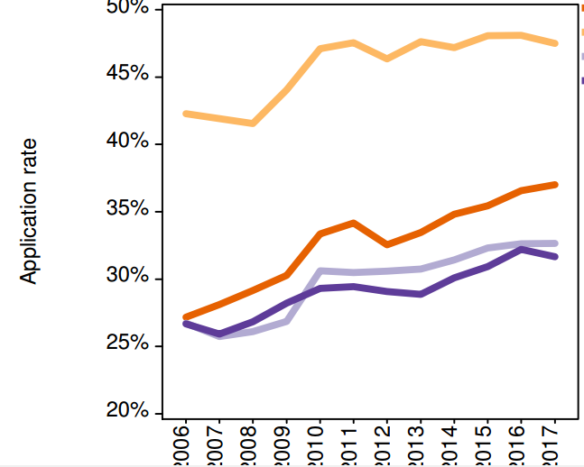

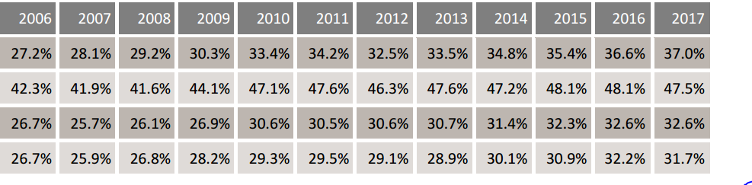

**Differences in application rates between men and women in 2017 remain  
high**

Across the Uganda, young men are more likely to apply for Law than young women, and the difference in application rates between them remains the highest on record. Young men are 35 per cent more likely than young women to apply for Law in Makerere University.

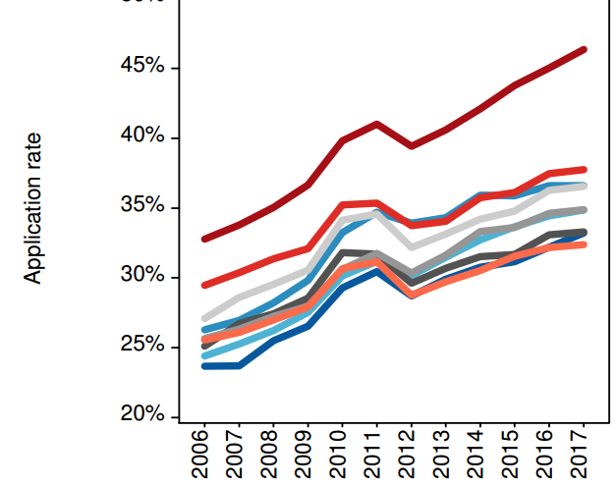

**Screen shots of the mobile application.**

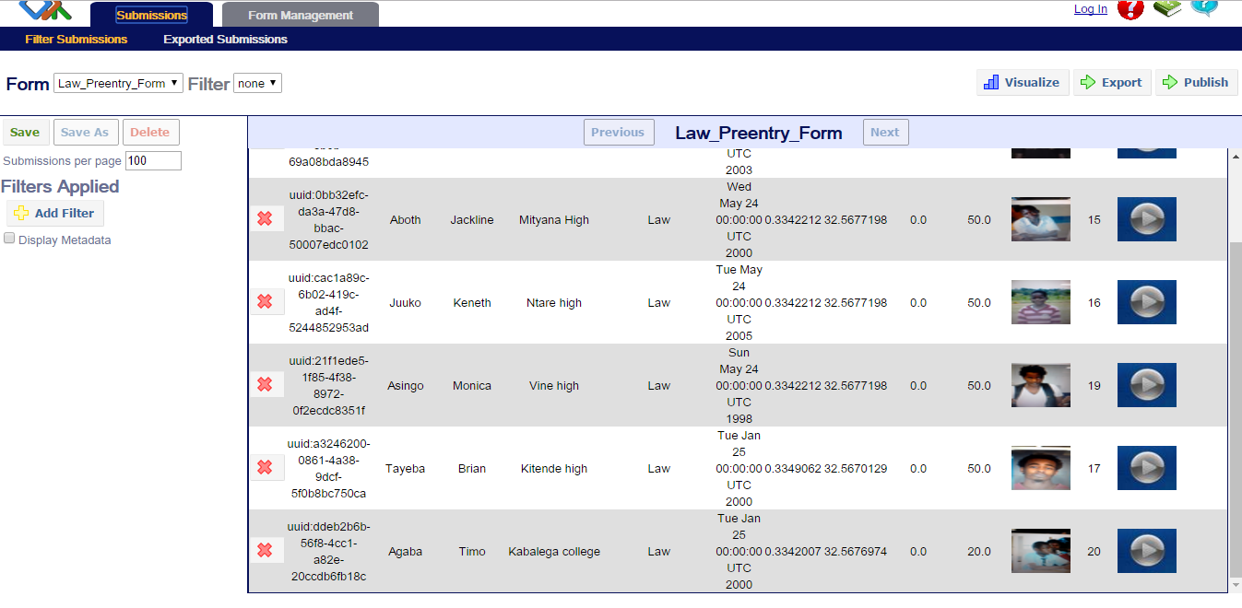

**Conclusions.**

Application rates – the proportion of the Students who apply for Law – are the best measures of changes in applicant interest towards a particular Programs.