Omni Notes

Software Requirements Specification

Version <1.0>

Revision History

|  |  |  |  |
| --- | --- | --- | --- |
| **Date** | **Version** | **Description** | **Author** |
| 05 April 2018 | 1.0 | Initiation | Kelompok 9 |
|  |  |  |  |
|  |  |  |  |
|  |  |  |  |

Table of Contents

1. Introduction 2

1.1 Purpose 2

1.2 Scope 2

1.3 Definitions, Acronyms and Abbreviations 2

1.4 References 2

1.5 Overview 2

2. Overall Description 2

3. Specific Requirements 2

3.1 Functionality 2

3.1.1 <Functional Requirement One> 2

3.2 Usability 2

3.2.1 <Usability Requirement One> 2

3.3 Reliability 2

3.3.1 <Reliability Requirement One> 2

3.4 Performance 2

3.4.1 <Performance Requirement One> 2

3.5 Supportability 2

3.5.1 <Supportability Requirement One> 2

3.6 Design Constraints 2

3.6.1 <Design Constraint One> 2

3.7 Online User Documentation and Help System Requirements 2

3.8 Purchased Components 2

3.9 Interfaces 2

3.9.1 User Interfaces 2

3.9.2 Hardware Interfaces 2

3.9.3 Software Interfaces 2

3.9.4 Communications Interfaces 2

3.10 Licensing Requirements 2

3.11 Legal, Copyright and Other Notices 2

3.12 Applicable Standards 2

4. Supporting Information 2

Software Requirements Specification

# Introduction

This section provides an overview of the entire document. It includes description about the purpose, scope, definitions, acronyms, abbreviations, references and overview of the document.

* 1. **Purpose**

The purpose of this document is to describe the basic needs of end users that the system should provide and attributes, propoerties, constraints, and qualities tha the system should meet in order the system to achieve the goal of the system, i.e. to enable software engineer to analyze the dependency between requirements given the artifacts and deliverables of the project.

The document also describes the external behavior of the application or subsystem identified. It also describes nonfunctional requirements, design constraints and other factors necessary to provide a complete and comprehensive description of the requirements for the software.

* 1. **Scope**

The software application should allow Submitter, to submit metadata of article into the software. This metadata will be processed in inserted into the article population. This article population is the basis for generating and updating a researcher graph. The researcher graph represent the evolution of researh community annualy. The software applicataion should also allow Policy Maker to graphically view the graph for the purpose of further analysis.

* 1. **Definitions, Acronyms and Abbreviations**

n.a.

* 1. **References**

UCS-CreateNewNote-1.0 Use Case Specification Document of ‘Create New Note’

UCS-EditNote-1.0 Use Case Specification Document of ‘Edit Note’

* 1. **Overview**

The rest of the document is organized as follows. The second section explain the overal description of the system to be implemented, i.e. the scenario and the context diagram of the system. The last setion describes the list of all functional and non-functional requirements.

# Overall Description

## Scenario

Budi adalah seorang mahasiswa di ITS. Dia menjabat sebagai ketua himpunan di jurusannya. Hari ini dia berjanji untuk menemui dosen untuk berkonsultasi. Dia juga harus hadir pada rapat penting dengan himpunan jurusan lain dan menyiapkan beberapa hal sebelum rapat tersebut. Untungnya Budi mencatat jadwalnya dan hal-hal yang perlu ia siapkan di Omni Notes. Sebelum berangkat, ia menyiapkan persiapan untuk rapatnya. Setelah bertemu dengan dosen,ia mengecek kembali catatannya di Omni Notes untuk rapat tersebut, hari-hari kegiatan Budi jadi lancar tanpa ada yang kelupaan dan Budi jadi jagoan di kampusnya.

## Context Diagram

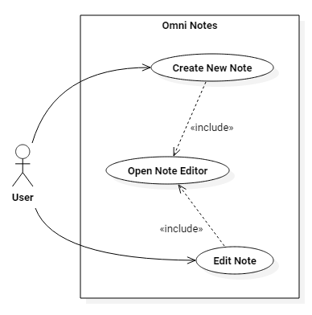

# Specific Requirements

n.a.

# Supporting Informations

n.a.