Omni Notes

Use Case Specification: Create New Note

Version 1.0

Revision History

|  |  |  |  |
| --- | --- | --- | --- |
| **Date** | **Version** | **Description** | **Author** |
| 05 April 2018 | 1.0 | Initiation | Kelompok 9 |
|  |  |  |  |
|  |  |  |  |
|  |  |  |  |

Table of Contents

1. Use Case Name 2

1.1 Brief Description 2

2. Flow of Events 2

2.1 Basic Flow 2

2.2 Alternative Flows 2

2.2.1 < First Alternative Flow > 2

2.2.2 < Second Alternative Flow > 2

3. Special Requirements 2

3.1 < First special requirement > 2

4. Pre-Conditions 2

4.1 < Pre-condition One > 2

5. Post-Conditions 2

5.1 < Post-condition One > 2

6. Extension Points 2

6.1 <name of extension point> 2

Use Case Specification: Create New Note

1. **Create New Note**
   1. **Brief Description**

This use case describe how the user create a new note in Omni Notes.

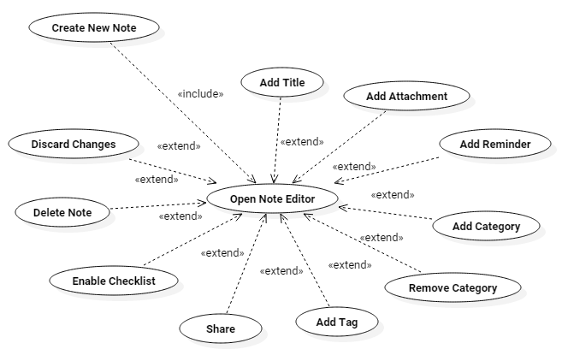

1. **Flow of Events**
   1. **Basic Flow**
2. The user clicks on Add Note Button.
3. The system **Open Note Editor**.
4. The user fill in the content of the note.
5. The user clicks on Back Button.
6. The system saves the note.
7. The system returns to the main window.
   1. **Alternative Flows**

n.a.

* 1. **Exceptions**

2j. Closing note editor without filling the content of the note. This event occurs when the user click on Back Button while editing the node without filling the content of the note.

2j.1. The user clicks on Back Button.

2j.2. The system shows the notification that the empty note was not saved.

1. **Special Requirements**

n.a.

1. **Pre-Conditions**

n.a.

1. **Post-Conditions**

n.a.

1. **Extension Points**

4a. User can **Add Title** of a note.

4a.1. User clicks on Title field.

4a.2. User fill in the title of the note.

4b. User can **Add Attachment** to a note.

4b.1. User clicks on Attachment menu.

4b.2. User selects media to be attached to the note.

4b.3. The system attaches the media to the note.

4b.4. The system returns to the note edittor.

4c. User can **Add Reminder** to a note.

4c.1. User clicks on Add Reminder Button.

4c.2. The system opens a Date Picker Dialog.

4c.3. User select the date to be reminded for.

4c.4. User clicks on Done Button.

4c.5. The system opens a Time Picker Dialog.

4c.6. User select the time to be reminded for.

4c.7. User clicks on Done Button.

4c.8. The system opens a Repeat Method Dialog.

4c.9. User select the repeat method of the reminder.

4c.10. User clicks on Done Button.

4c.11. The system set the reminder of the specified configuration to the note.

4c.12. The system returns to the note editor.

4d. User can **Add Category** to a note.

4d.1. User clicks on Category menu.

4d.2. User select a category for a note to be categorized as.

4d.3. The system categorize the note as the selected category.

4d.4. The system returns to the note editor.

4e. User can **Remove Category** of a note.

4e.1. User clicks on Category Menu.

4e.2. User clicks on Remove Category Button.

4e.3. The system remove the category of the note.

4e.4. The system returns to the note editor.

4f. User can **Add Tag** to a note.

4f.1. User clicks on Content field.

4f.2. User type the tag to be added by prepending a ‘#’ character to the tag.

4f.3. The system add the tag to the note.

4g. User can **Share** a note.

4g.1. User clicks on Share menu.

4g.2. The system shows a list of apps that can be shared a note with.

4g.3. User selects an app to be shared with.

4g.4. The system send the note to the selected app.

4h. User can **Delete** a note.

4h.1. User clicks on Trash menu.

4h.2. The system delete the note.

4h.3. The system returns to the main screen.

4i. User can **Discard Changes** of a note.

4i.1. User clicks on Discard Changes menu.

4i.2. The system discards all the changes that has not been saved.

4i.3. The system returns to the main window.