Omni Notes

Use Case Specification: Edit Note

Version 1.0

Revision History

|  |  |  |  |
| --- | --- | --- | --- |
| **Date** | **Version** | **Description** | **Author** |
| 05 April 2018 | 1.0 | Initiation | Kelompok 9 |
|  |  |  |  |
|  |  |  |  |
|  |  |  |  |

Table of Contents

1. Use Case Name 2

1.1 Brief Description 2

2. Flow of Events 2

2.1 Basic Flow 2

2.2 Alternative Flows 2

2.2.1 < First Alternative Flow > 2

2.2.2 < Second Alternative Flow > 2

3. Special Requirements 2

3.1 < First special requirement > 2

4. Pre-Conditions 2

4.1 < Pre-condition One > 2

5. Post-Conditions 2

5.1 < Post-condition One > 2

6. Extension Points 2

6.1 <name of extension point> 2

Use Case Specification: Edit Note

1. **Edit Note**
   1. **Brief Description**

This use case describe how the user create a new note in Omni Notes.

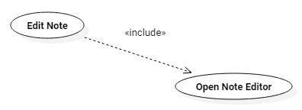

1. **Flow of Events**
   1. **Basic Flow**
2. The user clicks on a note.
3. The system **Open Note Editor** that contains the data of the note.
   1. **Alternative Flows**

n.a.

* 1. **Exceptions**

n.a.

1. **Special Requirements**

n.a.

1. **Pre-Conditions**

n.a.

1. **Post-Conditions**

n.a.

1. **Extension Points**

n.a.