STATE OF THE ART

**The emergence of morphodynamic modeling by the principle of constrained minimization**

*In this state of the art, we follow the work developed by* F. Bouchette *and*

B. Mohammadi*, which ranged from optimizing the shape or position of coastal defense structures to morphodynamic modeling by optimimzation.*

**Current chapter contents**

1. Introduction 32
2. Optimization on Coastal Protection Structures 32
   1. Optimal Shape of Structures 32
   2. Port of la Turballe 34
3. Optimization of the location of Costal Protection Structures 36
   1. Position of Optimal Protection Structure at the Pointe de l’Espiguette . 36
   2. Optimal Position of Geotextiles Tubes 37
   3. Position of Geotextiles Tubes Structure via OptiMorph 37
4. Towards a Model of Hydro-Morphodynamism by Optimization 38
   1. 2D Hydro-Morphodynamic Models Based on the Shallow-Water Equations 39
   2. 1D Hydro-Morphodynamic Models Based on Energy Minimization 40
5. Conclusion 40

# Introduction

ong time before the advent of morphodynamic modelling by minimization, a great deal of optimization work applied to the coast was carried out between the Geo- Sciences laboratory and the Alexander Grothendieck Institute in Montpellier. Frédéric

L

Bouchette, Bijan Mohammadi and Pascal

Azerad

have initiated these works.

They began in 2004 in partnership with the company BRLi, working on the formulation of an optimization theory adapted to the field of coastal hydromorphodynamics, and on numerical developments based on this theory and designed to invent optimal systems for coastal protection against submersion, coastal erosion, the impact of waves against struc- tures, and so on. This shape-optimization work lived through the two theses of Damien

Isèbe and Afaf Bouharguane. They developed numerous optimization models and

applied this work to places like Sète in France. In this state of the art, we follow all the coastal optimization concepts that gave rise to the idea of using this in morphodynamic modeling. This concept will be at the heart of the thesis.

# Optimization on Coastal Protection Structures

The first part of this state of the art will show the works that preceded the evolution of beach morphodynamics. At first, these works were mainly concerned with shoreline protection structures such as geotextiles tubes.

## Optimal Shape of Structures

This works of optimization of the shape of coastal defense structures focused at first on structures allowing breaking the wave agitation on a particular domain (Isèbe et al. 2008b). The hydrodynamics on the domain is modeled by Helmholtz (1868) wave equations which assumes a flat bottom, unlike Berkhoff (1972) model. This model is very suitable in deep water. Then, it is necessary to evaluate the cost function J which is the energy norm *L*2 of water waves free surface elevation *η*(*x*, *t*) in an admissible domain. Then an optimization method is used to obtain the optimal form. In this case, the cost function is compute so that the water height is the minimum on the whole domain. With this criterion, the optimal shape obtained resembles the following figure **0.1**:

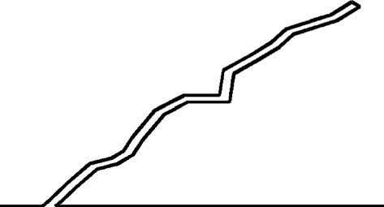

**Figure 0.1 –** Optimal shape minimizing a cost function J for a given parameterization

In order to be sure of the viability of this structure, it is convenient to represent the water height *η* in the 3 configurations of the following figure **0.2**:

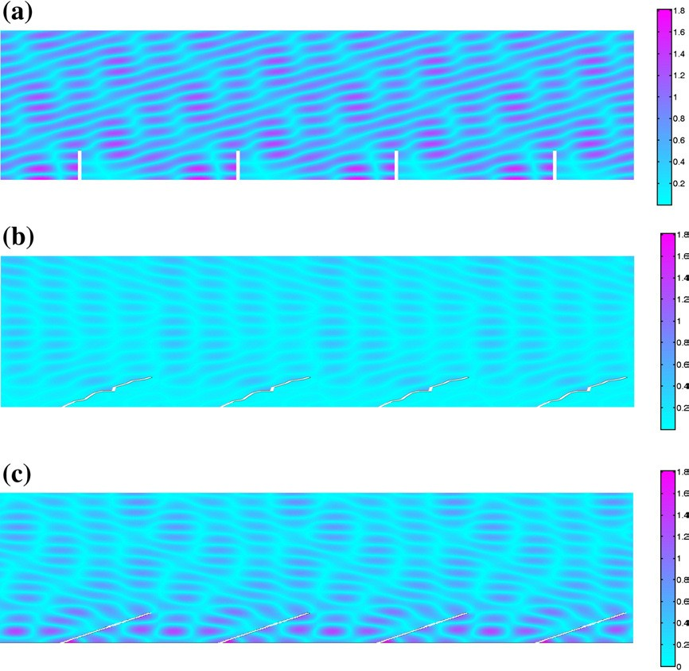

**Figure 0.2 –** Absolute value of *ξ* resulting from reflection (a) on rectangular structures perpendicular to the wall, (b) on optimized structures without feasibility constraints, (c) on structures with the same angle as the optimized structures but straight (NW incoming waves with T=2 s and a=0.5 m).

In the optimal structure configuration **0.2**.(b), the average *η* water height is signifi- cantly lower than the other configurations. It is also very surprising to see that in a case very similar to the optimal structure **0.2**.(c), the results seem to be very far from the optimal results.

With the knowledge of the current literature, it was appropriate to reject the shape of the structure figure **0.1**.

## Port of la Turballe

One of the major port development projects of the coming years is the development of the port of La Turballe. For the dimensioning of this work, BRLi, a consulting firm specialized in the fields related to water. They have hired Cook et al. (2021c) in order to confirm their idea on the optimal configuration of the harbor. The purpose of this study is to accommodate more boaters and reduce the agitation inside the harbor. The harbor extensions shown in the following figure **0.3** were proposed.

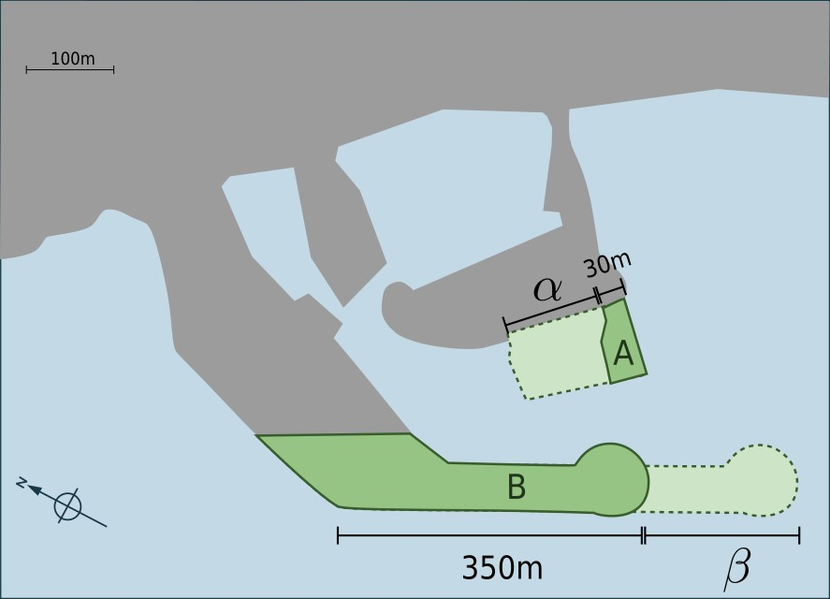

**Figure 0.3 –** Possible configurations for the port of La Turballe

In this figure, there are two parameters to manage, namely the lengths of the structures *A* and *B*. To manage this optimization, it is necessary to model the hydrodynamics of the harbor. To do this, the Helmholtz (1868) model has been solved. Then, it was necessary to create a cost function J minimizing the agitation in the port. This one was elaborated in the following way in the equation (**0.1**).

( ) = 1 1

∫J *ψn*

*K*(P) |Ω(*ψ*)|

Ω(*ψ*)

E*n*(*ψ*, ***x***)P(***x***)*d****x*** (0.1)

The quantity E*n*(*ψ*, ***x***) is the total surface energy denoted on the domain, associated with the forcing scenario *n* and the harbor configuration. The function P(***x***) is named spatial weight function, which allows to prioritize the minimization of the agitation on some privileged areas of the harbor as can be seen on the figure below **0.4**:

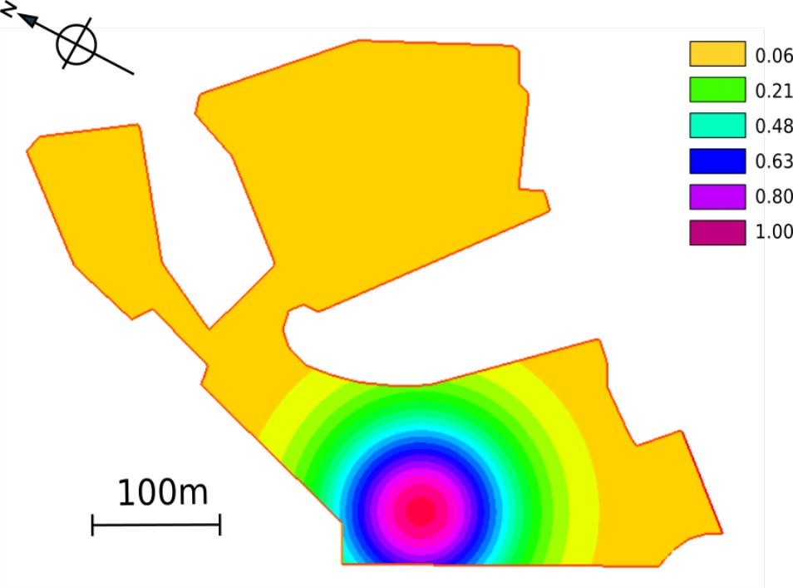

**Figure 0.4 –** Weight function P on Ω.

∫

The functions *K* and |Ω(*ψ*)| are equal to *K*(P, Ω(*ψ*)) = Ω(*ψ*) P(***x***)*d****x*** and the total area of the domain: this allows scaling the functional.

The functional cumulating the *n* scenarios is then computed in the following equation (**0.2**):

### J (*ψ*) =

*N*

*n*=1

∑

*ai*(*n*)J*n*(*ψ*)

(0.2)

*N*

∑

*n*=1

*ai*(*n*)

with the *ai*(*n*) corresponding to the weights of the given *n* scenario. Once this parame- terization is done, a grid of (*α*, *β*) ∈ [0, 150] x [0, 200] is created in order to compute all the values of the functional for all these configurations. Thus, the optimal configuration is the configuration where the couple (*α*, *β*) give the lowest functional J . This solution presents on figure **0.5**:

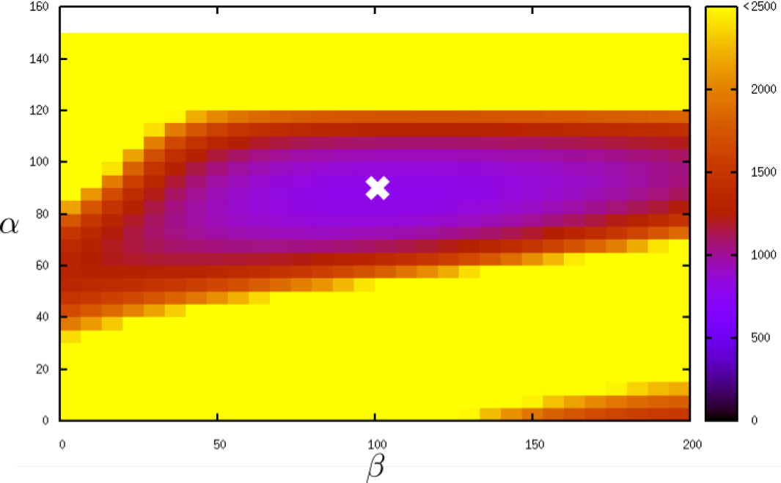

**Figure 0.5 –** Optimal pair of (*α*, *β*) for the configuration of the port of La Turballe.

shows us that there is a unique solution couple in the center of the domain. This work was able to confirm the opinion that BRLi had on the strategic choices of sizing the port. The solution was therefore chosen by BRLi for the completion of this project.

# Optimization of the location of Costal Protection Structures

A new approach in terms of optimization of costal protection structures is to look for the optimal position of a costal protection structure. Most of the time, we try to limit the agitation of the waves, beach erosion etc...

## Position of Optimal Protection Structure at the Pointe de l’Espiguette

The works of Isèbe et al. (2008b), Isèbe et al. (2014) allowed to find the optimal po- sition of a coastal defense structure which allows limiting the erosion of the beach of Le Grau du Roi-Le Boucanet.

Using a numerical model similar to the one of the part **2.1**, based on the resolution of Helmholtz (1868) equations, the optimal configuration is searched so that the cost func- tion J limits the erosion of the beach on a domain *D*.

Before defining the cost function, it is necessary to recall that observations of erosion by oceanographers show that waves can be roughly classified into two categories according to their height *H*, below or above a critical value *Hlim*. In principle, waves higher than *Hlim*, mainly present during storms, are erosive. They generate a great mechanical energy. On the other hand, when *H < Hlim*, the waves favor the reconstruction of eroded beaches. The first class of waves (*H > Hlim*) is called erosive and the second class constructive (*H < Hlim*). The cost function J*θ* is defined according to the direction of the wave *θ* taking into consideration this limit height as follows:

J = ∫*D EH>H*lim d*S* + ∥*U*orb∥ − ¨*U*initial¨

*D EH<H*lim d*S* orb

*θ*

+

+ ∫*D*

*EH<*

*H*lim

d*S* − ∫*D E*

initial lim

d*S*

+

*H<H*

(0.3)

with (*x*)+ = *max*(*x*, 0), *E* the wave energy, *H* the water height, *Hlim* the limiting water height, *Uorb* the orbital speed. This functional has therefore been defined in such a way that it gives a significant indication of the level of beach erosion.

In order to have a realistic estimate, J is computed as the sum of the cost functions taking into account in *pθ* the probability that a wave of direction *θ* arrives.

J = ∑ *pθ Jθ* (0.4)

Once this cost function has been evaluated, a large number of simulations are performed on the different possible positions of the structure in order to obtain the position corre- sponding to the minimum J . The results of the optimal configuration are represented on the following Figures **0.6** and **0.7**:

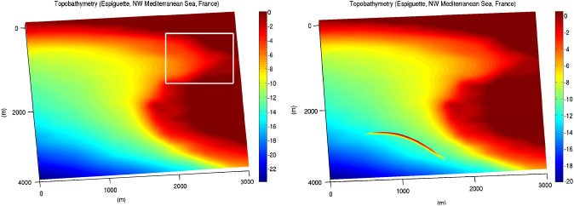

**Figure 0.6 –** Left: the initial bathymetry of region *D* for the cost function calculation; right: the modified bathymetry with the optimized protection structure.

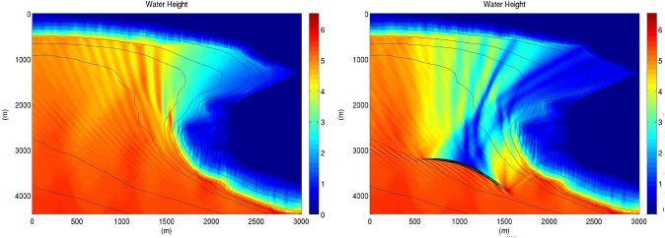

**Figure 0.7 –** The water height *H* in the whole domain: (left) for the initial configuration, (right) for the optimized configu- ration.

The results below clearly show that the protection system attenuates the swell along the coast. Indeed, a large area behind the structure is found with a very low water height *H*.

## Optimal Position of Geotextiles Tubes

The work of Isèbe et al. (2008b) can be applied to any types of costal protections struc- tures. However, theses works was mainly focused on geotextiles tubes. This work inspired Cook et al. (2021b) in his optimization test cases with the new hydro-morphodynamic modeling approach. The details of this approach will be presented in the section **4.2**.

## Position of Geotextiles Tubes Structure via OptiMorph

One of the applications of Cook et al. (2021b) compares several geotextiles tubes con- figurations on a linear beach to find the ideal configuration that limit sand displacement. The simulation aims to recreate the real conditions of a 20-day storm with a significant wave height *H* = 2 m and short period *T*0 = 2 s. The simulation configuration is as follows figure **0.8**:

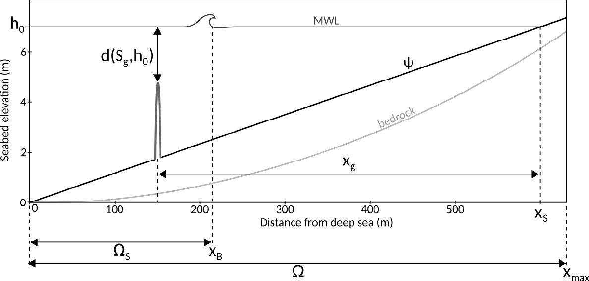

**Figure 0.8 –** Configuration of the geotube simulation.

Several types of J cost functions were then evaluated to limit physical phenomena such as beach erosion. For example, the results shown in figure **0.9** below:

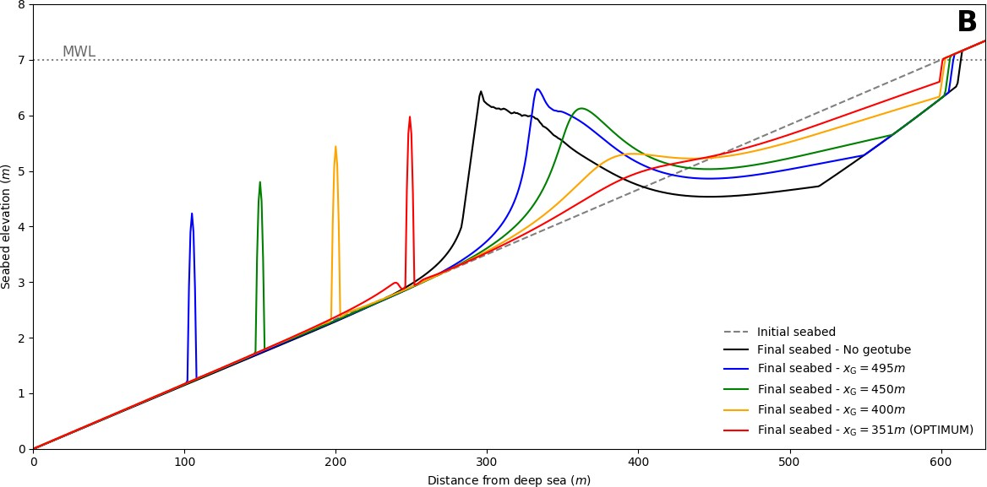

**Figure 0.9 –** Final seafloor profiles produced by the Opti-Morph morphodynamic model with variable geotube positions on the cross-shore profile.

show us that the optimal position of a geotextiles tubes is 351 m with J = Ω(*ψf* − *ψi*)*d*Ω: the sand displacement. Other strategic choices of J cost functions were made in the article (Cook et al. 2021b). The advantage of this code is that it leaves the user free to

∫

parameterize his own J cost functions, which allows him to obtain optimal configurations according to his precise criteria: practical, economic,...

# Towards a Model of Hydro-Morphodynamism by Optimiza- tion

After having carried out numerous works in the optimization of shapes and locations of shoreline protection structures, the works of Bouchette. F and Mohammadi. B have taken a whole new dimension. This new work focused on optimizing the shape of the sea bottom elevation. The sea bottom elevation acts this time as a flexible struc- ture and adapts to a certain hydrodynamic quantity. It is from there that the hydro- morphodynamic models by the principle of minimization are born.

*4. Towards a Model of Hydro-Morphodynamism by Optimization*

## 2D Hydro-Morphodynamic Models Based on the Shallow-Water Equa- tions

The first work on this new way of modeling morphodynamics were done with a very classical hydrodynamic model, namely the Shallow-Water model, here in 2D (Mohammadi et al. 2011; Mohammadi et al. 2014).

These two publications focused mainly on theoretical developments of the optimal trans- port morphodynamic modeling method.

This work has the advantage of directly solving a 2D hydro-morphodynamics. How- ever, it turns out that the numerical methods used for this model are very heavy. The method of solving the equations of Shallow-Water is made in finite volumes, the level-set method is used to locate the structure figure **0.10**. To perform the optimization, an auto- matic differentiation is used (Hascoet et al. 2004). The reason is that this hydrodynamic model is too complex to be derived analytically. Once these formalisms were established, functional were tried to account for realistic physics. The following functional of the equation (**0.5**) aims to minimize agitation and sandy displacements.

J (*ψ*) = ∫ *t*

*t*−*Tcoupl*

∫ ¨∇

**u**¨ + *ρ g*(*ψ*(*τ*) − *ψ*(*t* − *T*

))2 *dτd*Ω (0.5)

with *u* the velocity, *ψ* the bathymetry and *Tcoupl* indicates a time dependency window (s). It also permits to introduce a difference in time scales between seabed and flow motions: it define the coupling time interval between hydrodynamic and morphodynamic models. The morphodynamic results obtained with this functional are presented on figure **0.10**. They represent the morphodynamic evolution taking an initial linear sea bottom and a rigid cylinder.

Ω

*xy*

*s*

*coupl*

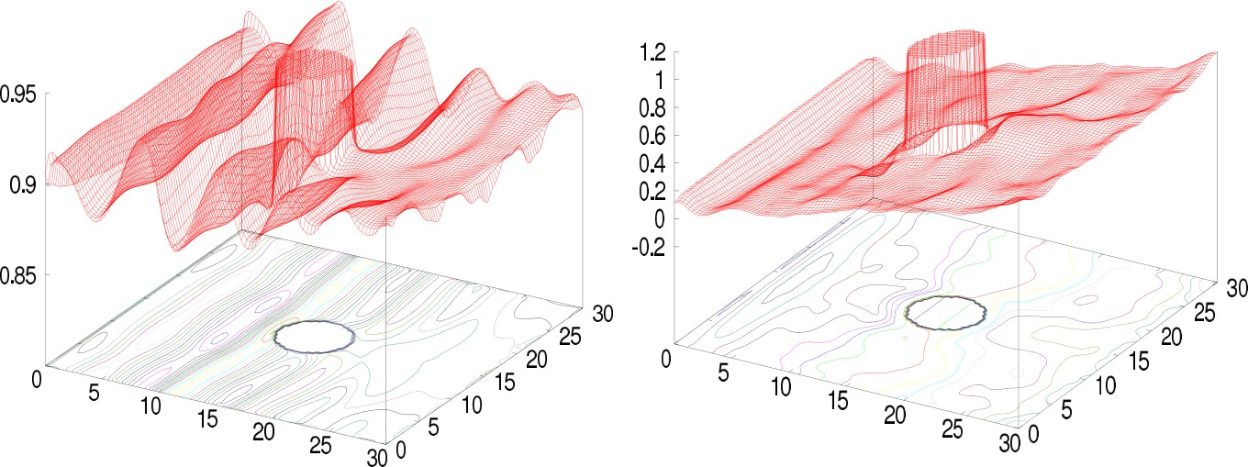

**Figure 0.10 –** Agitation on the left and final bathymetry on the right (initial bathymetry: linear)

The morphodynamics seems to be reacted in a very realistic way considering the simula- tion.

These papers conclude that using this method for morphodynamic problems could be a local approach similar to other classical Exner models. It was therefore necessary to go towards a simpler model with more robust physical criteria. It is therefore appropriate to

start with a 1D model, namely Optimorph.

## 1D Hydro-Morphodynamic Models Based on Energy Minimization

The new model developed by Cook (2021) is based on the principle that nature seeks to minimize the energy it expands. This time, the J cost function that governs the evolution of the seafloor has been developed according to the EH energy of the waves. This will be presented in the next chapter **1**.

# Conclusion

In this state of the art, optimization has been used in a wide range of applications. On the one hand, optimization of the shape or positioning of structures has been used to limit the effect of waves on our coasts. On the other hand, optimization has been used directly in morphodynamic modeling, through work that began in 2011. This latter point is based on the assumption that nature seeks to minimize the energy it expends, which we explained more clearly in the introductory part of this thesis. It is therefore on this point of morphodynamic modelling that this thesis is based.