**Cloud Computing Assignment Design Document**  
Student Name: Ronan Dillon Student Number: C12355251

The index.html is the home page of the web application. It contains links for logging in, uploading images and viewing images.

**Login**

The logging in is done using the PictureBoxServlet.java. It first checks to see if the user is logged in like so;  If myPrincipal is null then the user has not signed in and will be directed to sign in otherwise the user will be given the option to sign out or to return to the main menu.

**Upload Images**

Uploading is done using upload.jsp and upload.java. Together they allow the user to choose an image from their computer and click submit to try uploading the image. If the user has not been signed in they will be redirected to PictureBoxServlet.java to sign in otherwise it will upload. If the user is signed in on Mark Deegans or my own email account their image will be saved as a private image otherwise it will be saved as a public image.

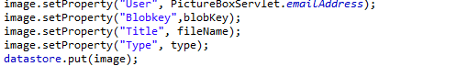

Using this piece of code I was able to story the users email address, the blobkey, type (public/private) and name of the file that had been uploaded.

**View Images**

Viewing the images that had been uploaded was done using the list.java. This is done using a loop which goes through every uploaded image. If the user is one of the admins they will be able to view and delete every image. If the user is just a member they can view every image but can only delete images they uploaded themselves. And users who aren’t signed in can just view public photos.

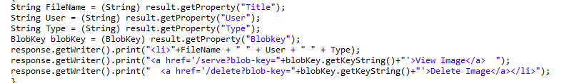

I used this code to retrieve the properties from the upload of the image and then displayed them in the list.java. View image can be clicked which will show the image that was uploaded.

Link to the app! <http://1-dot-ieditdillonronan.appspot.com/>

Github https://github.com/ronandillon/dt2283cloud-CA2