**Group Name:** GROUP_V

**Case Study:** Tennis Tournaments

**ERD Diagram:**

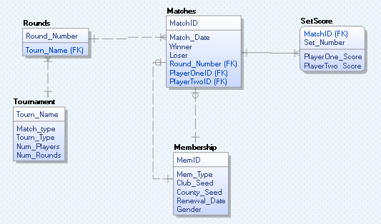

**Changes Made:**

1. Tournament attribute Num_Sets changed into Num_Rounds, as this is a more suitable name for its purpose.
2. An attribute “Loser” was added to the Matches table to make future transactions easier to deal with.
3. PlayerOne and PlayerTwo tables were deleted, instead the Matches tables now has two Members joined to it using the Membership Table.