**Software Engineering III – Assignment 1**Student Name: Ronan Dillon Student Number: C12355251  
Link to screencast: http://screencast-o-matic.com/watch/c2Xn07eIuh

**Project idea: Calorie Counter App.**The application I have chosen is a calorie counter app as I have a keen interest in health and fitness. I have designed the app for a user to enter their current weight and their weight goal i.e. the weight they want to achieve. The user can then enter meals, breakfast, lunch, dinner and snacks. By entering their meals throughout the day the user can track how many calories they have taken in. The user can also log any exercise they have done to check the calories the user has burnt. The user has their own profile and can login and register to check their progress.

**Use Case Diagram**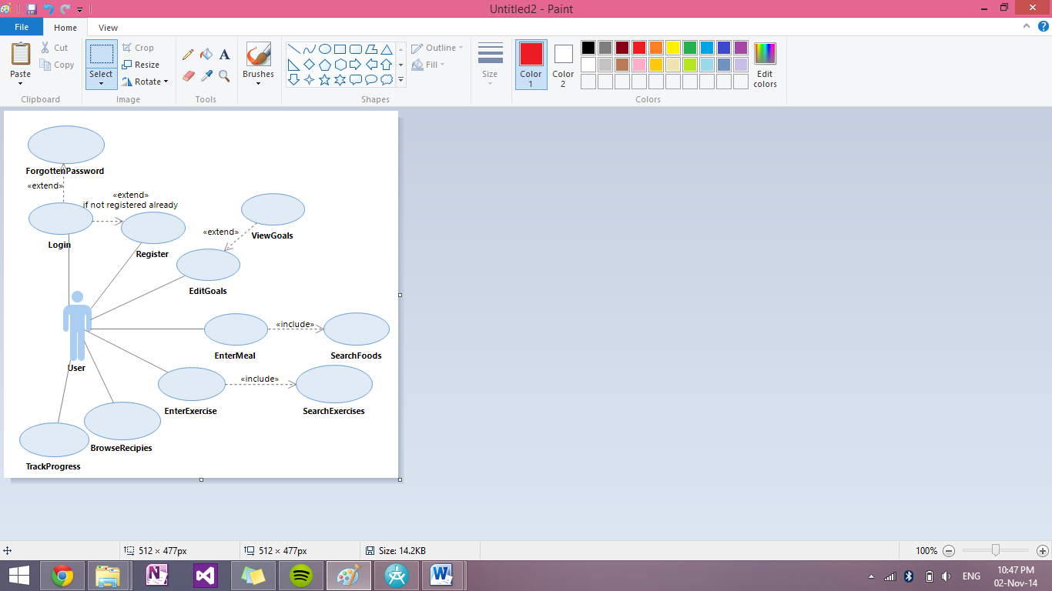

The use case diagram of the application shows how a user can register and login to their profile on the app, they can also view and edit their goals as well as enter meals and exercises.   
The user can also browse recipes in the app which can help with their calorie intake and also track their progress from when they joined the app.  
**EnterMeal**The enter meal use case is for the user when they want to enter something they have eaten throughout the day they enter the meal (i.e breakfast, lunch, dinner, snacks) and then the amount of calories contained in that meal.  
**EnterExercise**The enter exercise use case is when they user enters an exercise they have done. They enter the exercise, the duration and the calories burned.  
**EditGoals**This use case is for when a user decides to change their goal, the user can enter a new goal weight as they progress through the use of the app.

**Class Diagram**

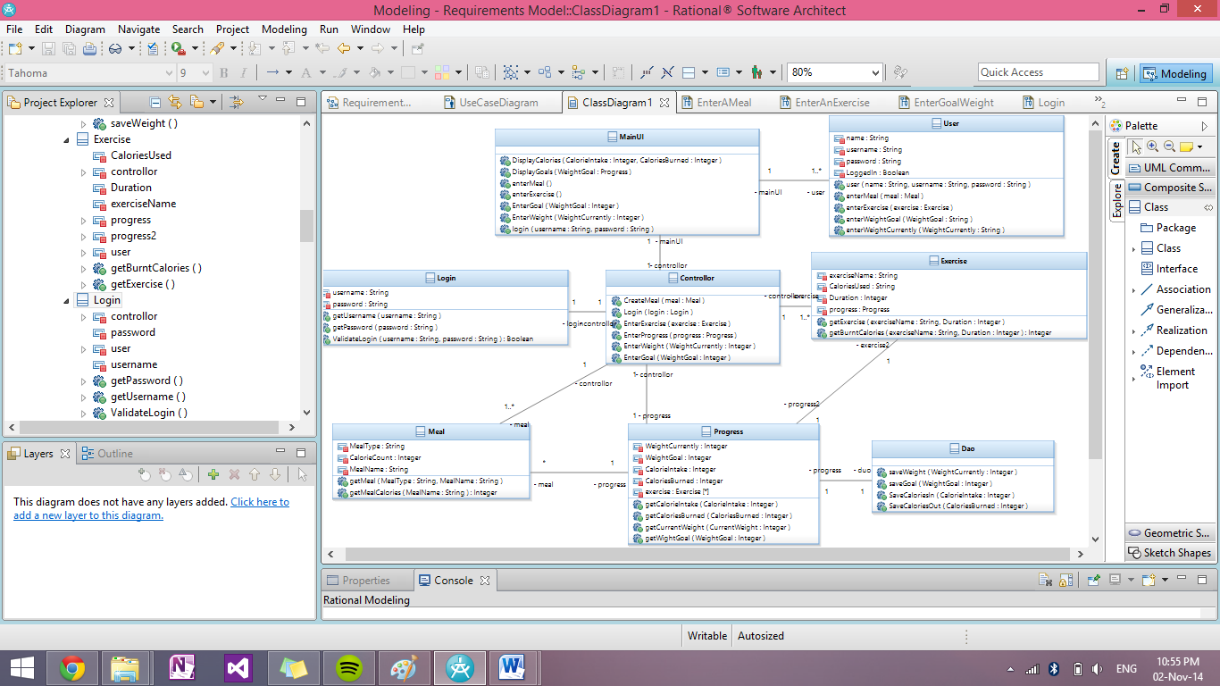

**Sequence Diagrams  
Enter Meal**

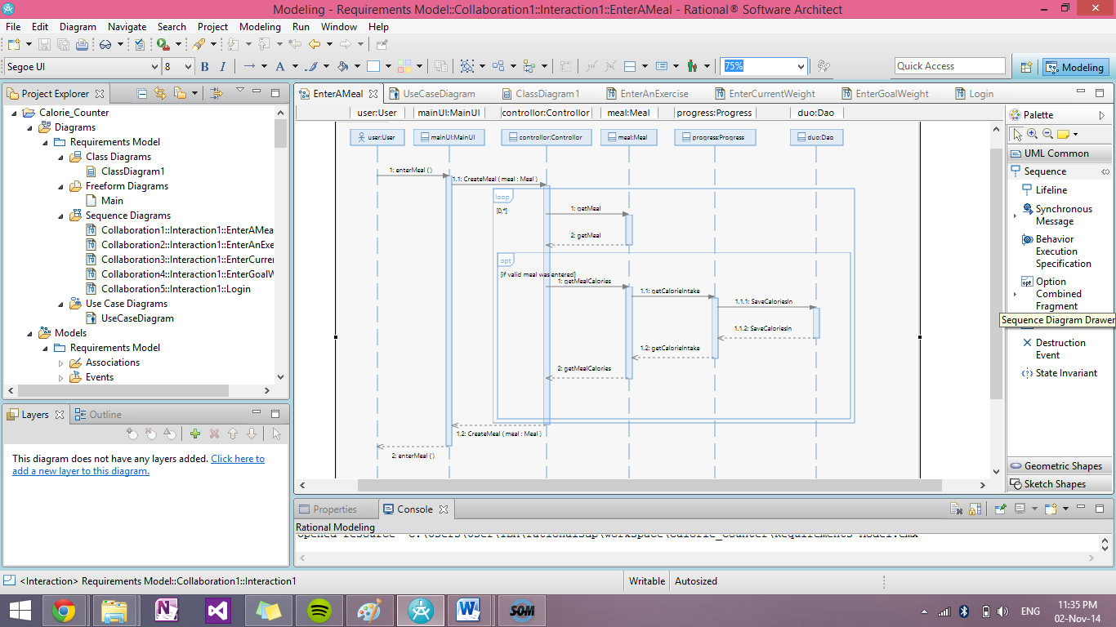

**Enter Exercise**

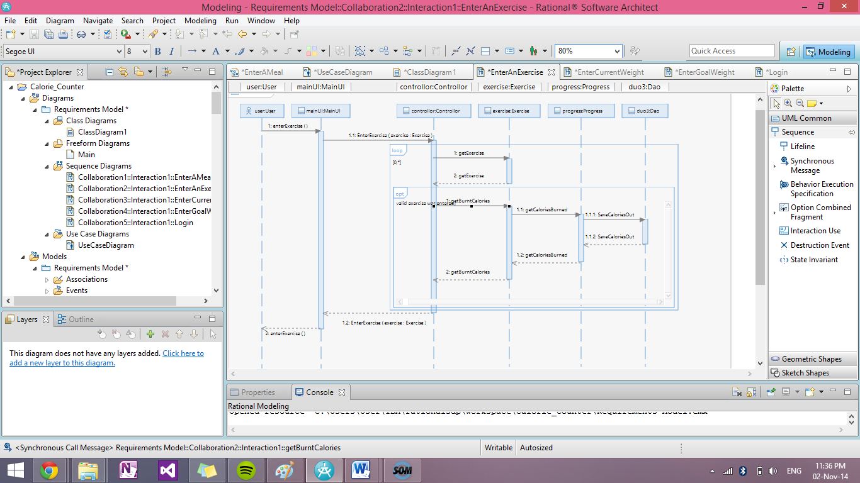

**Enter Current Weight**

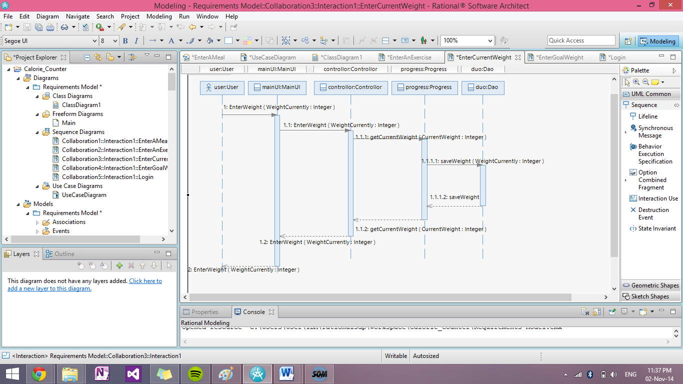

**Enter Goal Weight**

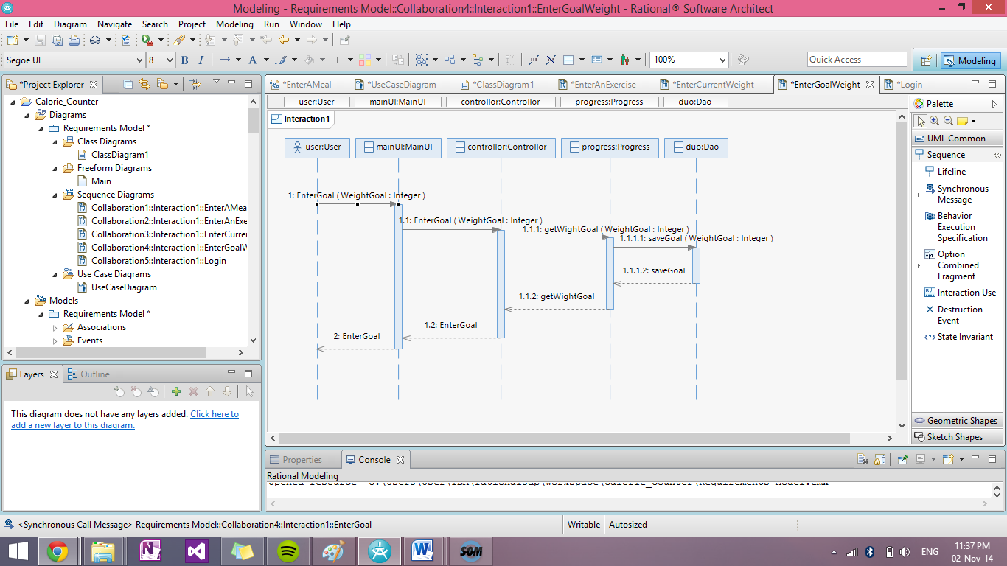

**Login**

