1. CREATE TABLE DEPARTMENT

(

ID_DEPT NUMBER,

DEPT_NAME VARCHAR2(500),

HEAD NUMBER

);

2 ALTER TABLE DEPARTMENT ADD CONSTRAINT DEPARTMENT_PK PRIMARY KEY (ID_DEPT);

3. DESCRIBE DEPARTMENT;

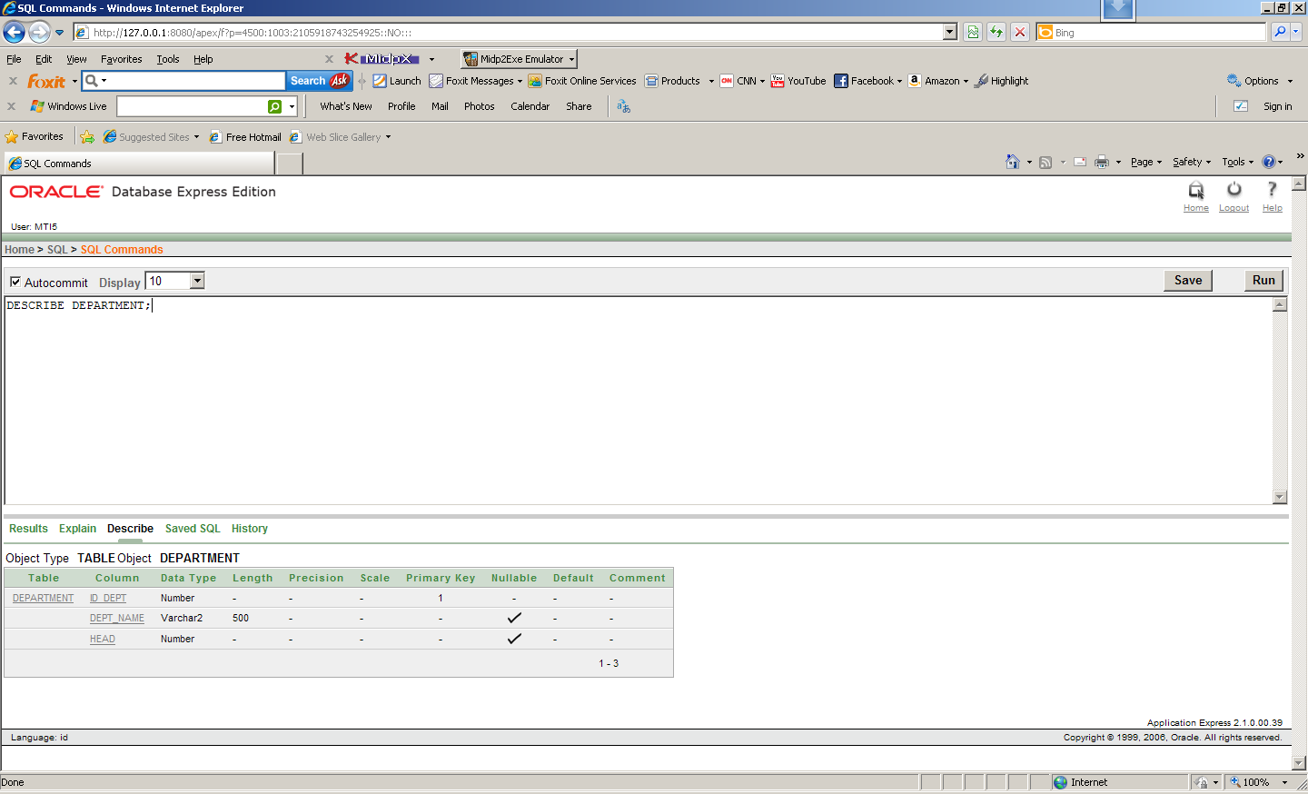

4

INSERT INTO DEPARTMENT VALUES(51,'Management','');

INSERT INTO DEPARTMENT VALUES(52,'Operations','');

INSERT INTO DEPARTMENT VALUES(53,'Finance','');

INSERT INTO DEPARTMENT VALUES(54,'Marketing','');

INSERT INTO DEPARTMENT VALUES(55,'Sales','');

Ini kenapa ngga bisa y ???

INSERT ALL  
  INTO DEPARTMENT VALUES(51,'Management','')

INTO DEPARTMENT VALUES(53,'Finance','')

INTO DEPARTMENT VALUES(52,'Operations','')

INTO DEPARTMENT VALUES(54,'Marketing','')

INTO DEPARTMENT VALUES(55,'Sales','')

SELECT * FROM DEPARTEMENT;

5. SELECT * FROM DEPARTEMENT;

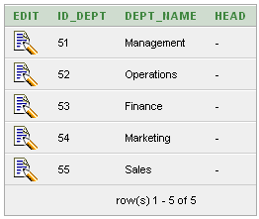

6 Buat sebuah sequence dengan konfigurasi standar!

CREATE SEQUENCE SEQ_EMP_ID

START WITH 1

INCREMENT BY 1

MINVALUE 1

NOCACHE

NOCYCLE

NOORDER

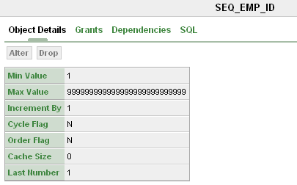

7.

CREATE TABLE EMPLOYEE

(

EMP_ID NUMBER,

NAME VARCHAR2(500),

SEX VARCHAR2(500),

POSITION VARCHAR(500),

SALARY NUMBER,

DEPT_ID NUMBER

);

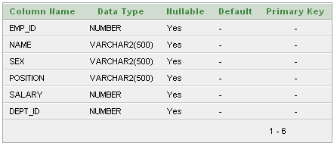

1. .Pada tabel EMPLOYEE, set kolom EMP_ID menjadi Primary Key!

ALTER TABLE EMPLOYEE ADD CONSTRAINT EMPLOYEE_PK PRIMARY KEY (EMP_ID);

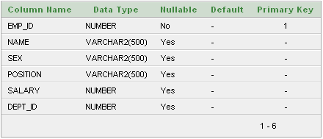

9.

DESCRIBE EMPLOYEE;

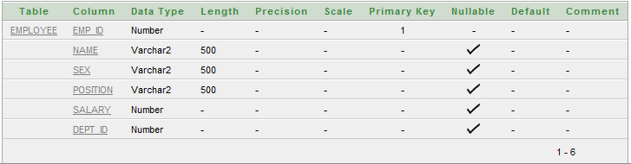

10.

Ga bs jg ....???

INSERT ALL

INTO EMPLOYEE (EMP_ID, NAME, SEX, POSITION, SALARY, DEPT_ID) VALUES (SEQ_EMP_ID.NEXTVAL,'Andi','Male','Manager',10000000,51)

INTO EMPLOYEE (EMP_ID, NAME, SEX, POSITION, SALARY, DEPT_ID) VALUES (SEQ_EMP_ID.NEXTVAL,'Bella','Female','Teller',5000000,52)

INTO EMPLOYEE (EMP_ID, NAME, SEX, POSITION, SALARY, DEPT_ID) VALUES (SEQ_EMP_ID.NEXTVAL,'Chintya','Perempuan','Accountant',4000000,53)

INTO EMPLOYEE (EMP_ID, NAME, SEX, POSITION, SALARY, DEPT_ID) VALUES (SEQ_EMP_ID.NEXTVAL,'Dimas','Laki-laki','',0,56)

INTO EMPLOYEE (EMP_ID, NAME, SEX, POSITION, SALARY, DEPT_ID) VALUES (SEQ_EMP_ID.NEXTVAL,'Eko','Male','Security',2500000,52)

SELECT EMP_ID, NAME, SEX, POSITION, SALARY, DEPT_ID FROM EMPLOYEE;

BEGIN

INSERT INTO EMPLOYEE VALUES(SEQ_EMP_ID.NEXTVAL,'Andi','Male','Manager',10000000,51);

INSERT INTO EMPLOYEE VALUES(SEQ_EMP_ID.NEXTVAL,'Bella','Female','Teller',5000000,52);

INSERT INTO EMPLOYEE VALUES(SEQ_EMP_ID.NEXTVAL,'Chintya','Perempuan','Accountant',4000000,53);

INSERT INTO EMPLOYEE VALUES(SEQ_EMP_ID.NEXTVAL,'Dimas','Laki-laki','',0,56);

INSERT INTO EMPLOYEE VALUES(SEQ_EMP_ID.NEXTVAL,'Eko','Male','Security',2500000,52);

END;

11.

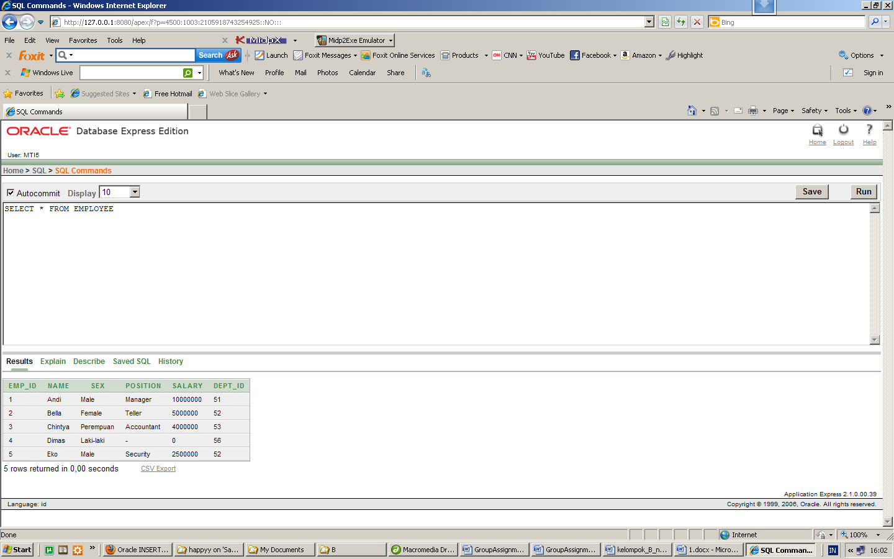

12.

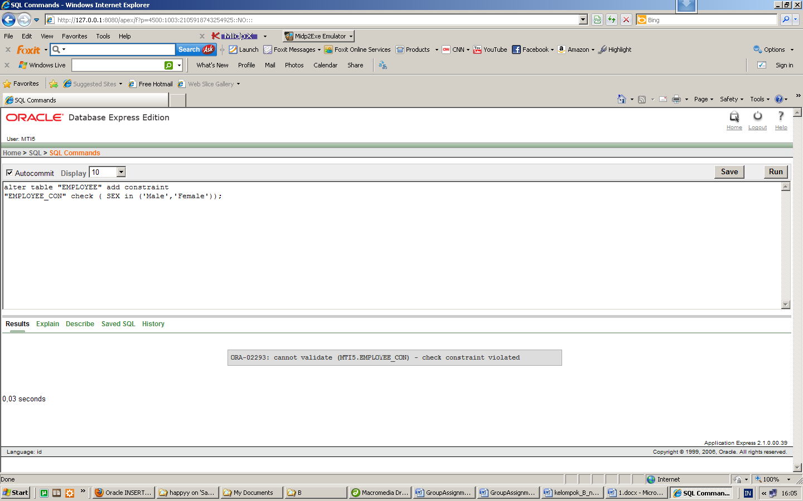

13.

SELECT * FROM EMPLOYEE WHERE SEX<>'Male' AND SEX<>'Female';

BEGIN

UPDATE EMPLOYEE SET SEX='Female' WHERE SEX='Perempuan';

UPDATE EMPLOYEE SET SEX='Male' WHERE SEX='Laki-laki';

END;

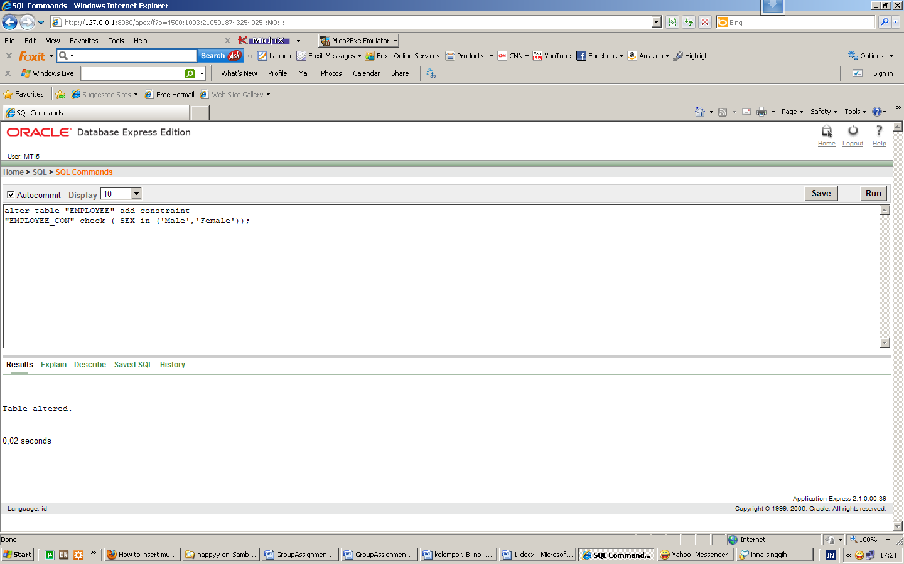

14.

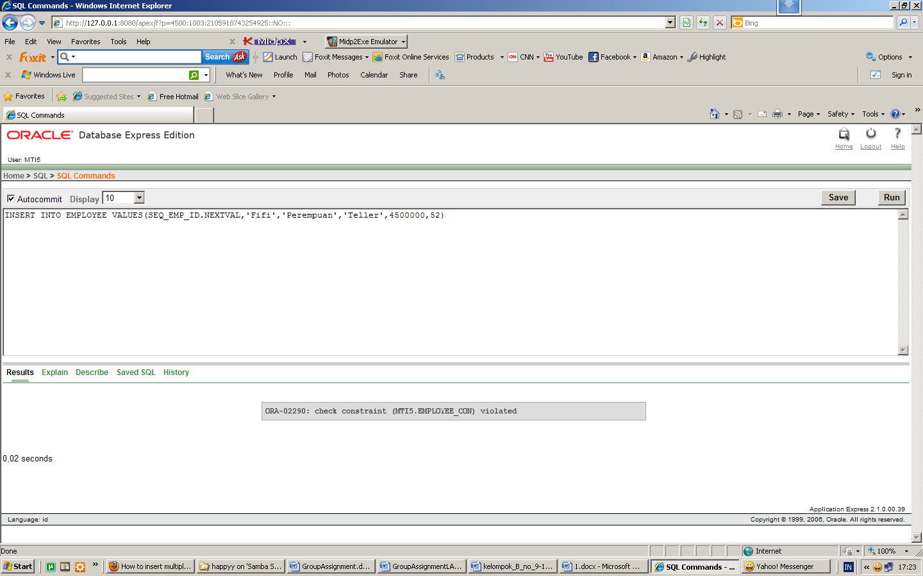

15.

INSERT INTO EMPLOYEE

VALUES(SEQ_EMP_ID.NEXTVAL,'Fifi','Female','Teller',4500000,52)

select * from employee;

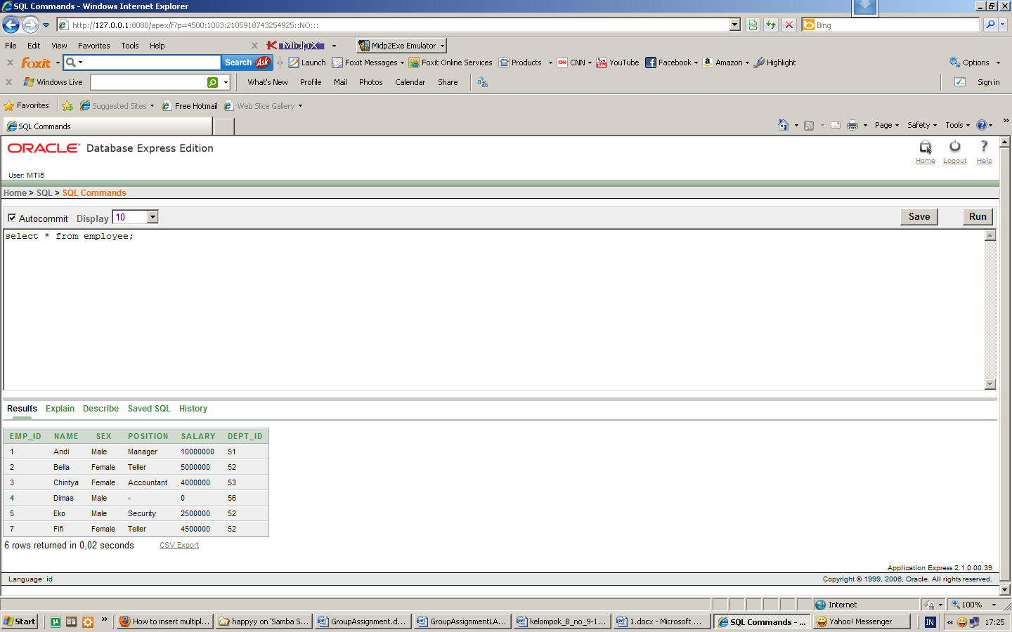

16.

alter table "EMPLOYEE" modify

("POSITION" VARCHAR2() NOT NULL)

Tidak Berhasil, karena ada nilai Position untuk data nomor 4 (Dimas) bernilai NULL.

17. ALTER TABLE EMPLOYEE ADD

CONSTRAINT EMPLOYEE_FK

FOREIGN KEY (DEPT_ID)

REFERENCES DEPARTMENT(ID_DEPT);

Tidak berhasil, karena ada nilai di field DEPT_ID yang tidak sesuai dengan nilai di tabel induk.

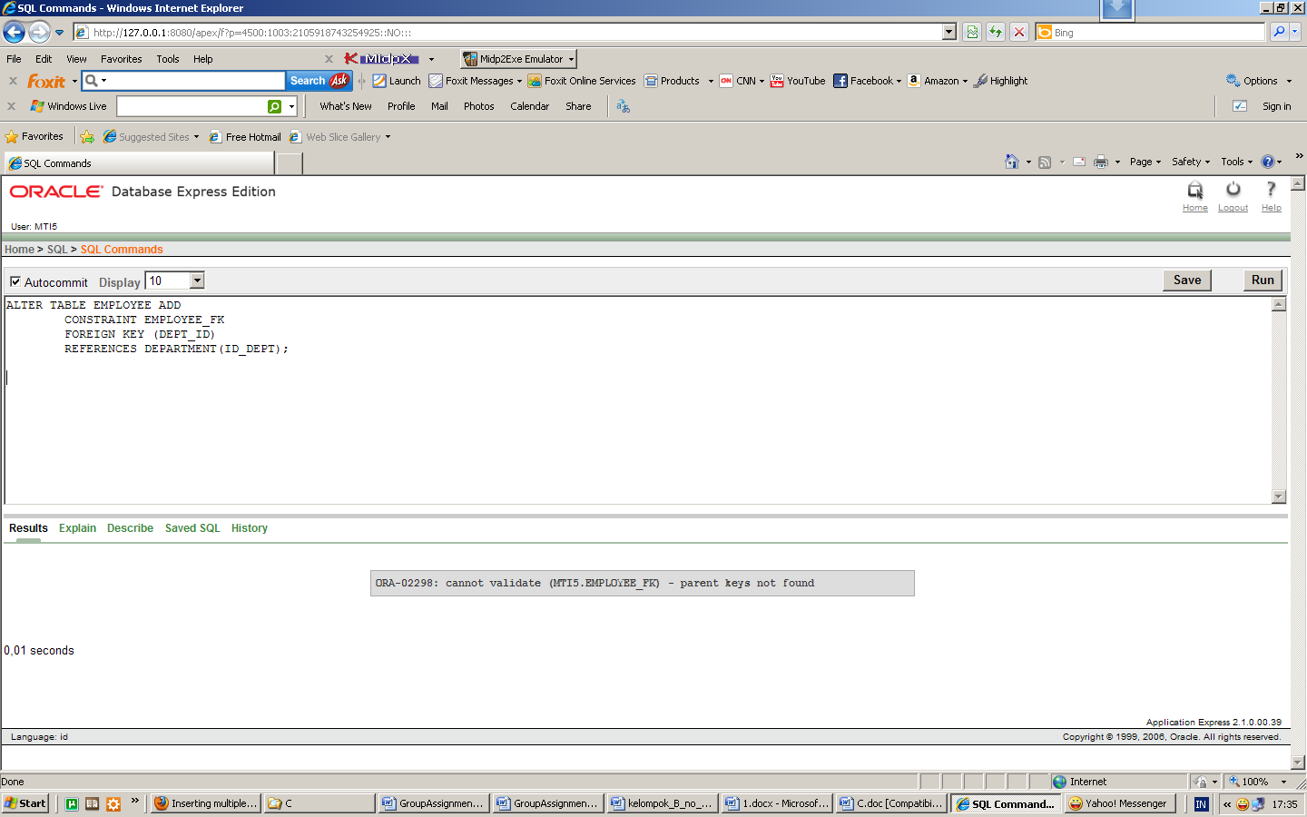

18 Berhasil

UPDATE EMPLOYEE

SET DEPT_ID = NULL

WHERE DEPT_ID NOT IN (SELECT ID_DEPT FROM DEPARTMENT);

--------

ALTER TABLE EMPLOYEE ADD

CONSTRAINT EMPLOYEE_FK

FOREIGN KEY (DEPT_ID)

REFERENCES DEPARTMENT(ID_DEPT);

19.

ALTER TABLE DEPARTMENT ADD

CONSTRAINT DEPARTMENT_FK

FOREIGN KEY (HEAD)

REFERENCES EMPLOYEE(EMP_ID);

20.

BEGIN

UPDATE DEPARTMENT SET HEAD = (SELECT EMP_ID FROM EMPLOYEE WHERE NAME = 'Andi') WHERE DEPT_NAME ='Management' OR DEPT_NAME = 'Operations';

UPDATE DEPARTMENT SET HEAD = (SELECT EMP_ID FROM EMPLOYEE WHERE NAME = 'Chintya') WHERE DEPT_NAME = 'Finance';

END;

21.

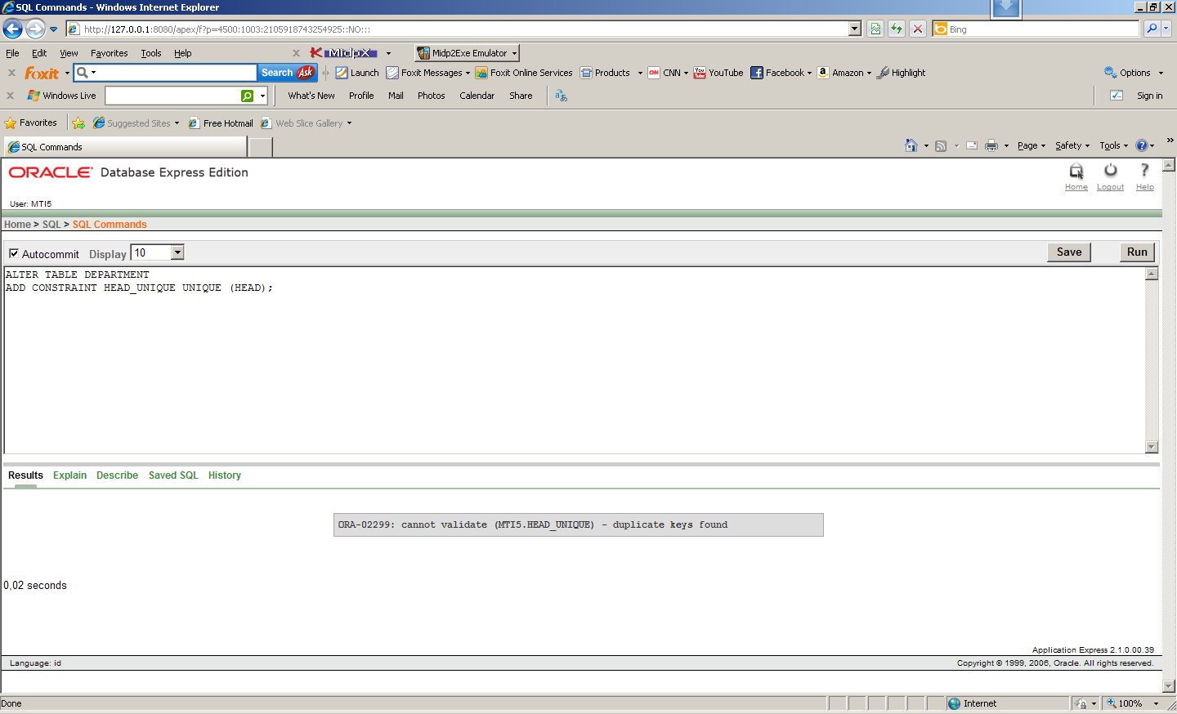

Gagal, karena ada duplikat keys

22.

Berhasil

UPDATE DEPARTMENT SET HEAD = (SELECT EMP_ID FROM EMPLOYEE WHERE NAME = 'Bella') WHERE DEPT_NAME = 'Operations';

---

ALTER TABLE DEPARTMENT

ADD CONSTRAINT HEAD_UNIQUE UNIQUE (HEAD);

23.

UPDATE DEPARTMENT SET HEAD = NULL

WHERE HEAD = (SELECT EMP_ID FROM EMPLOYEE WHERE NAME = 'Bella');

---

DELETE FROM EMPLOYEE WHERE NAME = 'Bella';

24.

SELECT * FROM DEPARTMENT WHERE HEAD IS NULL;

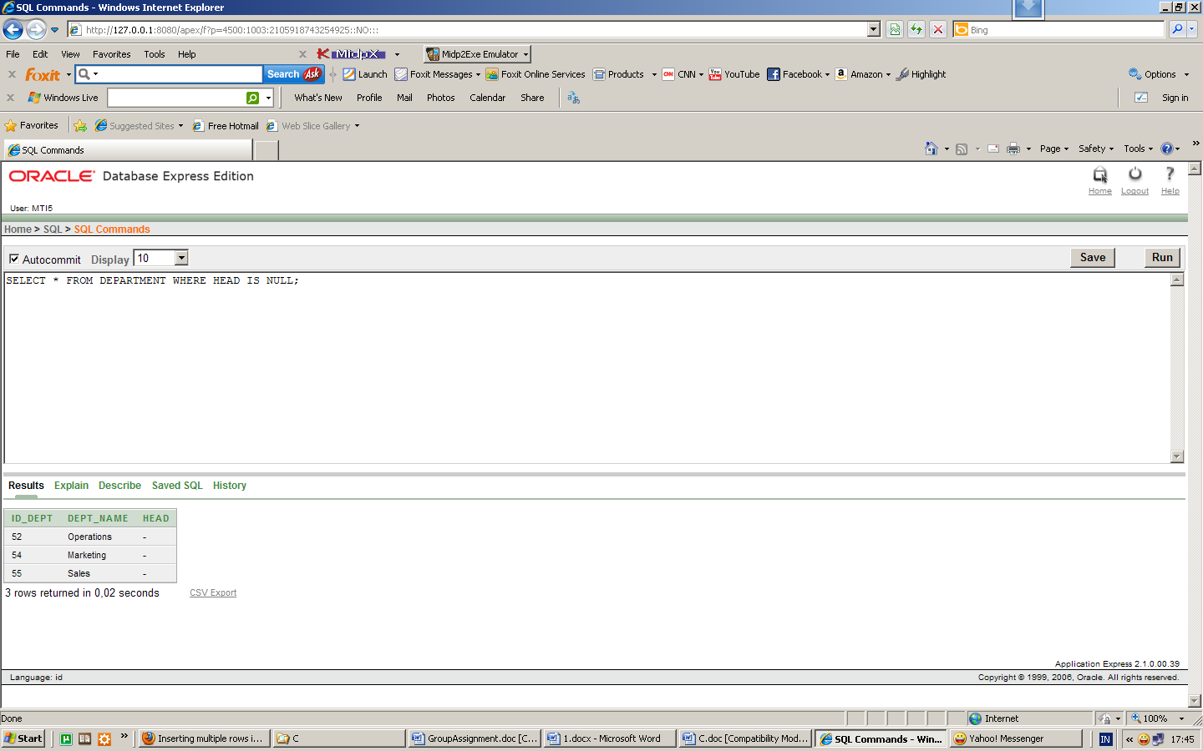

25.

SELECT COUNT(EMP_ID)AS jumlah FROM EMPLOYEE;

26.

SELECT * FROM EMPLOYEE WHERE POSITION = '';

27.

SELECT * FROM

( SELECT * FROM EMPLOYEE

ORDER BY SALARY DESC

)

WHERE ROWNUM = 1;

28. SELECT * FROM

( SELECT * FROM EMPLOYEE

ORDER BY SALARY

)

WHERE ROWNUM = 1;

29.

SELECT EMPLOYEE.NAME

FROM DEPARTMENT, EMPLOYEE

WHERE DEPARTMENT.HEAD=EMPLOYEE.EMP_ID;

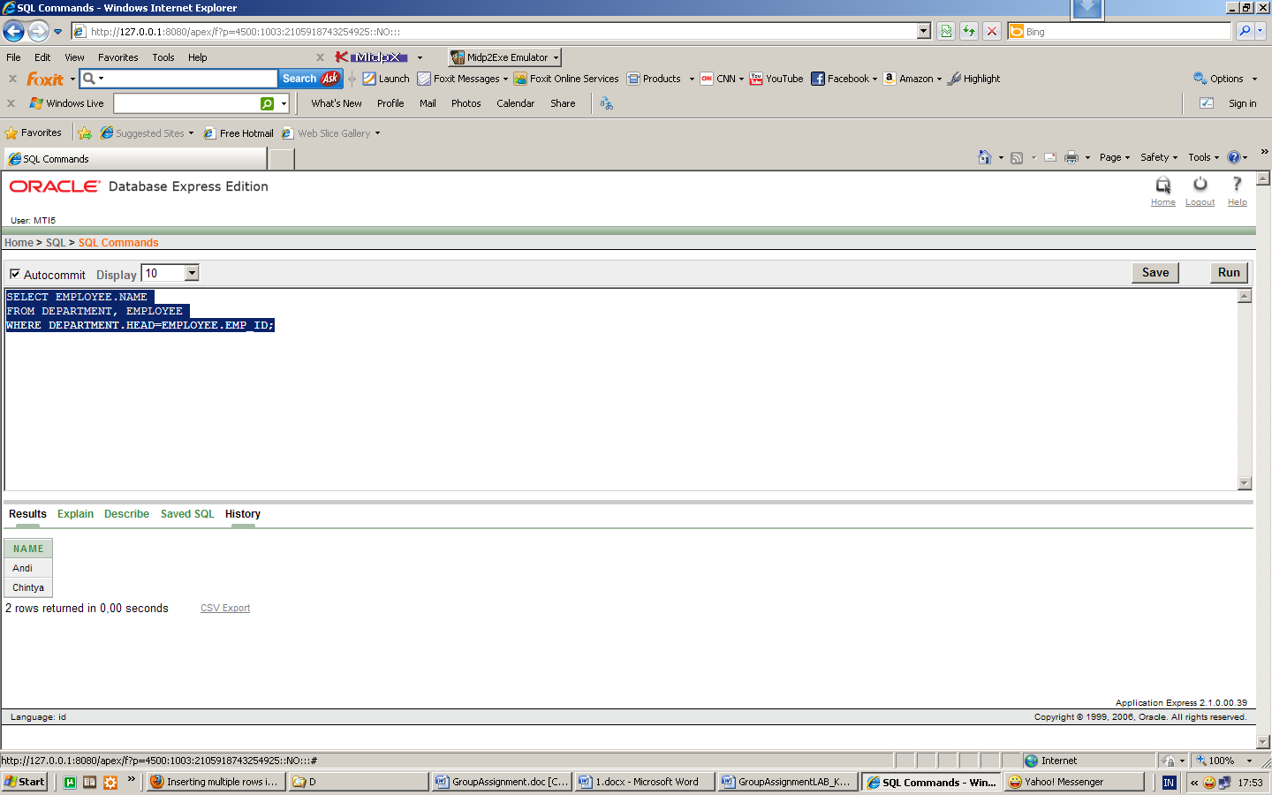

30.

SELECT DEPARTMENT.DEPT_NAME, EMPLOYEE.NAME

FROM DEPARTMENT, EMPLOYEE

WHERE DEPARTMENT.HEAD=EMPLOYEE.EMP_ID;

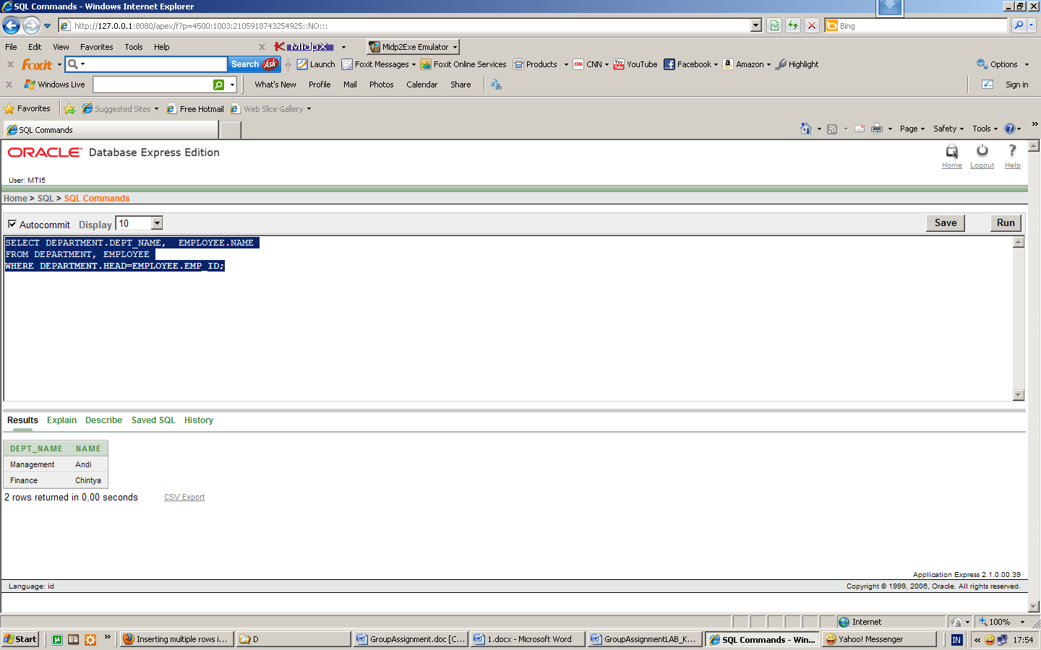

31.

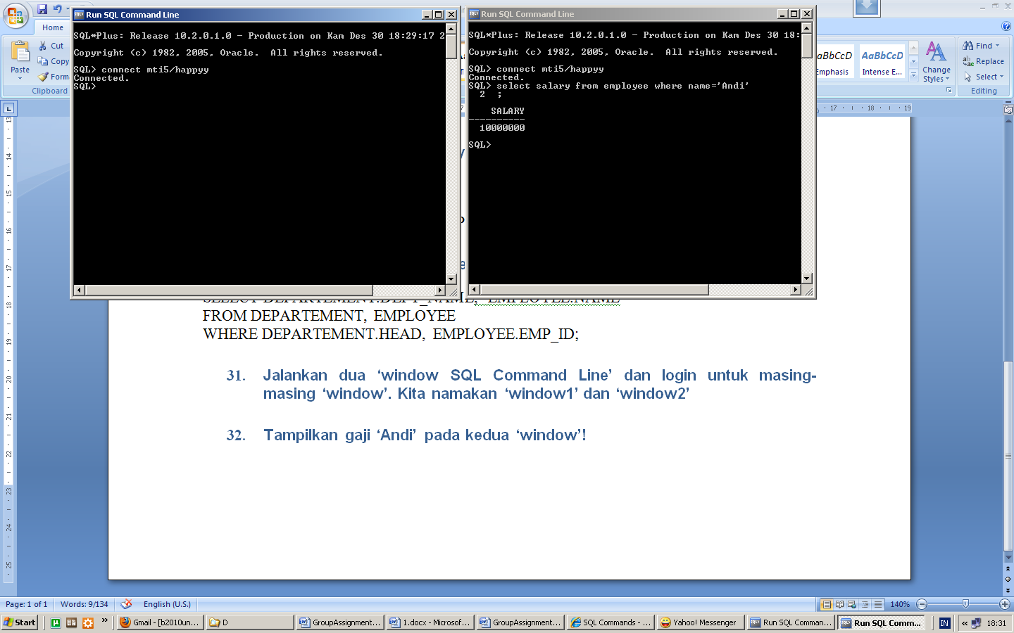

32

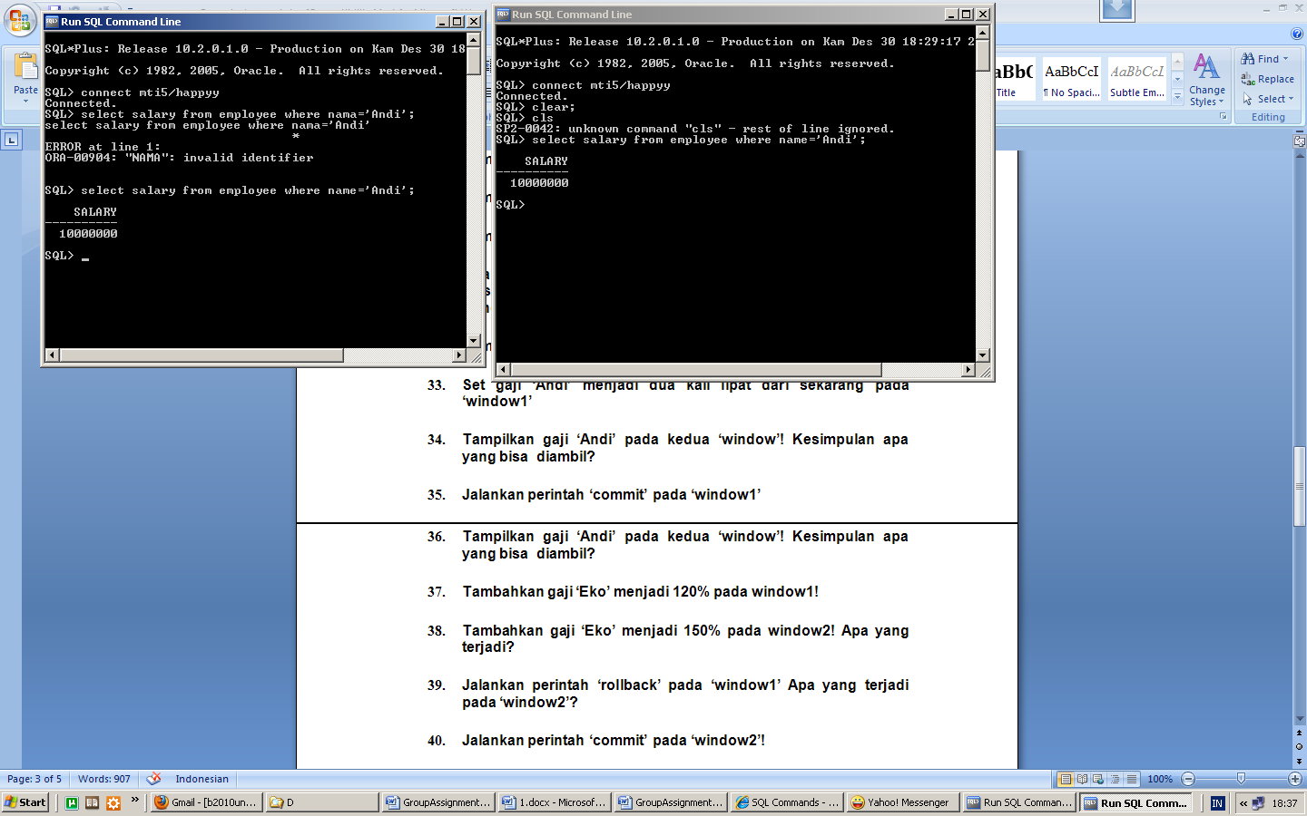

33.

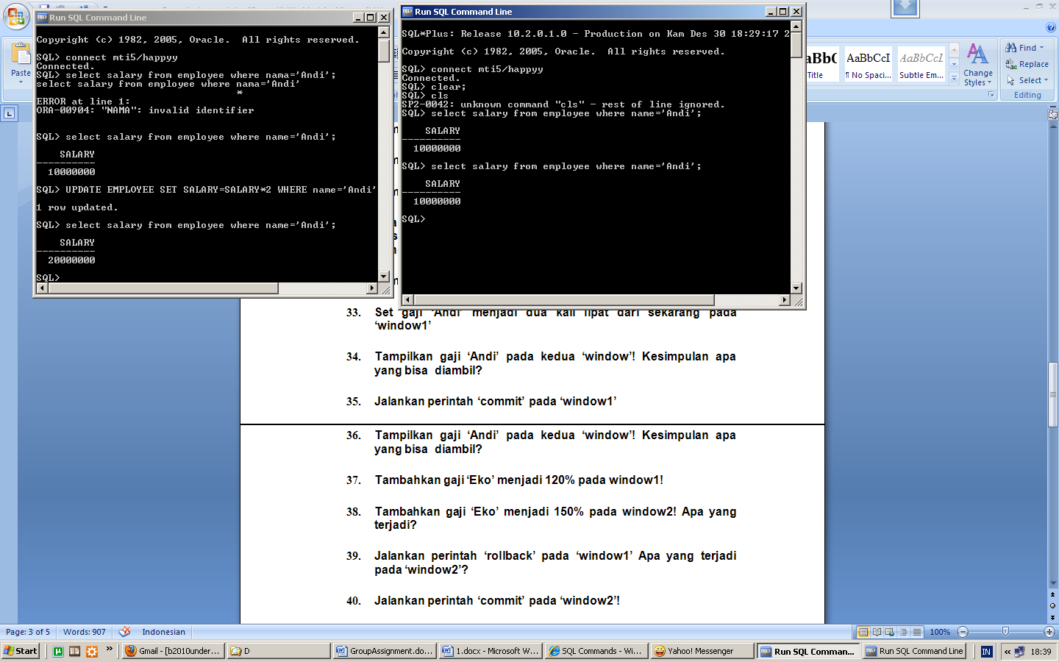

34-36

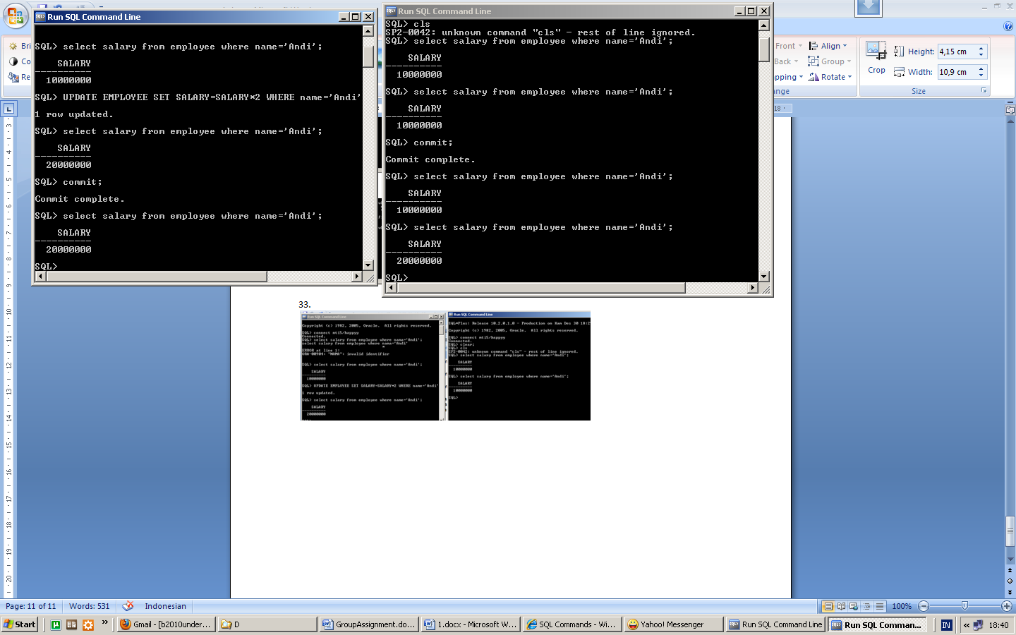

37.

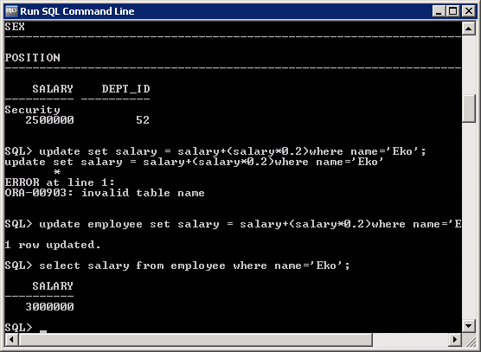

38.

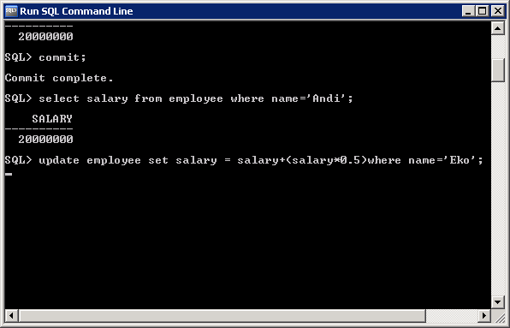

Dead lock

39.

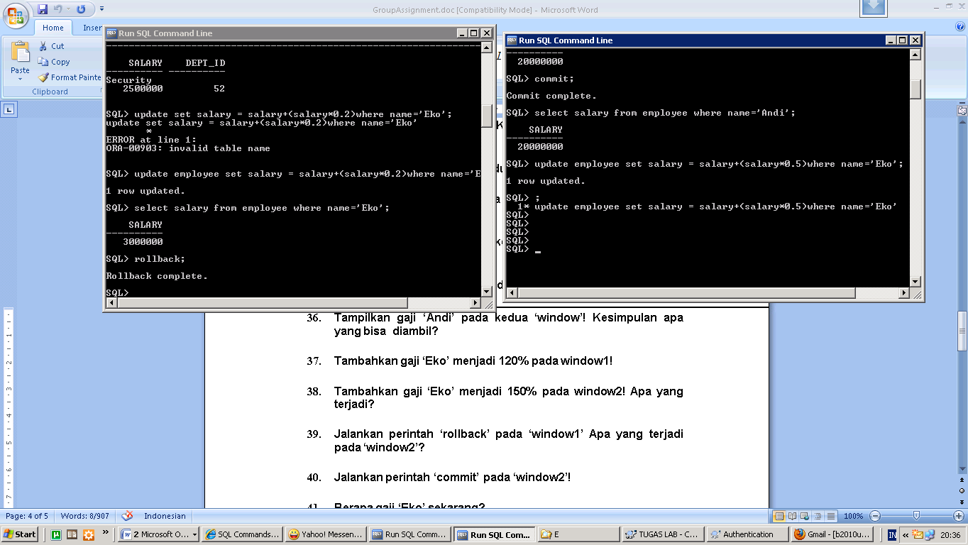

40. 