

SPS-XXXXXX Condition Assessment Report
Insert Date

Approvals Page

Site Information
Facility | SPS-XXXXXX
Document Type | Asset Condition Assessment

Technical Approval
Prepared by:
Reviewed by:
Reviewed by:
Approved by:

Document Control
Document Number | UW-XXX-XXXX
Version | Rev 0
Status | Draft
Data Issued | 21/07/2026

Contents
1. Introduction 3
2. Site Overview 3
2.1 Site Specific Issues 3
3. Inspection Scope of Works 3
4. SPS-XXXXXX Inspection Report 4
4.1 Bypass Connection Point 4
4.2 SPS Details 4
4.3 Pump Specifications 6
4.4 Well Openings 7
4.5 General Improvement Works 7
4.6 Condition Assessment 7
5. Condition Rating 10
5.1 Concrete Surface Profile (CSP) 11
6. Recommended Scope of Works 13
Appendix 1 – Site Inspection Photos 14
Appendix 2 - Drawings 15

unitywater.com

- Introduction
The AKaP business unit is carrying out condition assessments on Sewerage Pump Stations in the existing network. These assessments will document current condition and identify any required actions. The results will help determine whether assets need repair, restoration or replacement. This report outlines the inspection scope, observations and finding for each condition assessment completed by Unitywater.
- Site Overview
Provide a short insight into where the station pump to and from:
- Include asset ID’s, the type of pipe work and material.
- Include which council catchment that it operates in and SPS address.
- Provide the EP number from the master plan.
- The detention times for both day and night.
- Details about any emergency storage.

Insert GIS Overview Photo

Insert SCADA diagram Photo.

  - Site Specific Issues
Give a brief description of the issues that arose in the previous work orders of the SPS and why a visit was necessary. E.g. switchboard flooding, failing riser bends new valve chamber configuration.
- Inspection Scope of Works
Site Inspection and data capture
Conduct a full on-site condition assessment of the existing pump station, covering civil, mechanical, and coating components. Capture comprehensive 360-degree imagery from the top of the wet well of all accessible assets, including the wet well and valve chamber.
Post processing and review
Review all captured imagery off-site to verify and confirm observations made during the site inspection. This process ensures that all defects, asset conditions and structural details identified on site are validated through photographic evidence.
Report
Prepare a detailed condition assessment report summarising findings and supported by 360-degree photographic documentation. The report will outline recommended actions for repair, refurbishment, or replacement based on current state and condition rating of each asset. The report will also outline general site improvement opportunities, including upgrades to site access, safety and bypass arrangements. These broader considerations will be incorporated to provide a holistic view of the station’s operational performance and overall site functionality.

- SPS-XXXXXX Inspection Report
  - Bypass Connection Point
If applicable, include asset ID of bypass. - SPS-XXXXXX includes a permanent bypass point located within access chamber ID:XXXXXXX, which allows flows to be diverted around the wet well and pumping system whenever the station is taken offline, including during maintenance activities, operational faults, renewal works, or upgrade projects.

  - SPS Details
Table 1: SPS Detail Table
Parameter | Description / Value
SPS Name | SPS-XXXXXX
Emergency Storage
Detention Test Time (incl. Wet Wall Storage) | Daytime:  Nighttime:
Pump Station Well Manufacture Type
Build Date | Maximo - XX/XX/XXXX (ID:XXXXXXX)
Well No.1 – Diameter | XXXX mm
Well No 1 - Depth | XXXX mm
Zero maintenance hole diameter
Zero maintenance hole access cover internal diameter
Zero maintenance hole invert level | SL: XX.XX (from uMap)  IL: X.XX (from uMap)
Zero maintenance hole depth from top of cover | X.XX (from uMap)
Incoming Pipe Diameter | XXX mm
Outgoing Pipe Diameter – SRM mainline | XXX mm
Inlet Isolation Valve – SV, KGV, Penstock | XXX mm (SV, KGV, Penstock) (ID: XXXXXXX)
Spindle to Inlet Valve
Wet Well Inlet Pipe Type
Wet Well Inlet Pipe Suitable for Reuse?
Discharge pipe condition Through wall – Reuse or Replace
Discharge Bends (Riser Bends)
Support Brackets – Vertical well pipes
Sluice Valve Condition – 1 & 2
Check Valve Condition – 1 & 2
Extension Spindle to all Sluice Valves
Spindle Access Cover – Condition
Do any fittings require replacement inside well
Do any fittings require replacement outside the Well
Tapping Point Condition – Mainly tap to pipe
Ladder length – Valve Chamber
Ladder Length Wet Well
Do Ladders have stanchions
Handrail Condition – Valve Chamber to WW
Access Cover Valve Chamber – Condition
Valve Chamber – Fall Protection
Rail Safe Inserts in Place
Davit/s in place & adequate
Discharge Pipe Support Bracket condition – Valve Chamber
Flow Meter Chamber
Valve Chamber Drainage
Overflow

  - Pump Specifications
Table 2: SPS-XXXXXX Pump Specs
Pump Information | Pump 1 | Pump 2
Asset ID (Maximo)
Installation date (Maximo)
Make
Model
Year Manufacture
Weight
Kw
Amps
Motor RPM
Serial #
Curve
Impeller diameter
Discharge Diameter
Type & size of Guide Rails
Discharge Pedestal Type

  - Well Openings
Table 3: SPS-KED345 Well Opening Details
Measurement – Clear Opening Concrete | Measurement
L1 (mm)
L2 (mm)
Useable Width (U) – Guide Rail Centre to Inner Edge (mm)

  - General Improvement Works
Table 4: SPS-XXXXXX Improvement Comments
Condition | Comment
Site Conditions – pavements, sinkage, trip hazards
Noise
Odour and Ventilation
Safety (e.g., identity improvements required to lift pumps safely)
Safety (e.g., identify electrical safety improvements)
Water Meter & RPZV Device
Public Safety
Bypass connection point
Drain-pipe valve chamber to wet well
Scour & Gas Release Chamber
Zero Manhole

  - Condition Assessment
Table 5: SPS-XXXXXX Asset Condition Ratings
Condition | Rating  (1 = Excellent to  5 = Very Poor) | Comment
Signage
Access and Driveway
Switchboard
Property Pole
Telemetry
RPZ
Vent Pole / Base
Access Lid
Odour Seals
Fall Protection
Wet Well Wall
Ladder
Hand-railing
Inlet Penetration
Inlet Valve / Spindle
Dropper Pipe / Baffle
Benching
Pedestals
Pumps
Chains
Guide Rails
Guide Rail Brackets
Riser Pipework / Bends
Reflux Valves
Gate Valves / Spindles
Discharge Penetrations
Davit Base
Bypass
Zero Maintenance Hole

- Condition Rating
Unitywater uses a 1–5 asset condition scale aligned with WSAA/Queensland utility asset management frameworks, shown in Table 6.
Table 6: Asset Condition Rating Table
Rating | Estimated Remaining Useful Life (%) | Interpretation | Description for Pumps | Descriptions for Wet Wells | Description for Other
1 – As New | 85-100% | Asset is at or near the start of its service life. No degradation affecting life expectancy. | New, just installed | Concrete and/or lining in excellent condition with no defects | Excellent, no defects
2 – Good | 65-85% | Minor deterioration only. Normal ageing but no meaningful loss of service life. | Localised minor wear becoming apparent, not affecting performance | Minor deterioration with no impact on structural integrity. | Good condition, minor problems – e.g., small amount of paint peeling off
3 - Moderate | 35-65% | Mid-life condition. Active deterioration occurring. Life consumption accelerating depending on environment (H₂S, immersion, loading). | Areas of localised rust, evidence of erosion, a clear wear pattern, efficiency not affected | Moderate deterioration requiring planned maintenance or rehabilitation. | Moderate condition – structurally sound but covered in dust/muck/grease, paint peeling off, surface rust
4 - Poor | 10-35% | End-of-life approaching. Defects significantly reducing durability and performance. High probability of failure within short–medium term. | Significant surface rust, pitting or localised wear, affecting performance | Significant deterioration affecting durability and potentially structural performance. | Poor condition – structural rust, little paint left
5 – Very Poor | 0-10% | Asset is at or beyond end of useful life. Failure likely or already occurring. Replacement typically required. | Failed. Severe structural rust, wear, holes, integrity compromised, failure possible | Severe deterioration with structural capacity significantly reduced or compromised. | Structural condition is affecting operation of asset

  - Concrete Surface Profile (CSP)
Concrete Surface Profile (CSP) is a standardized scale defined by the International Concrete Repair Institute (ICRI) that measures the roughness and texture of a concrete surface. Ranging from CSP 1 (nearly smooth) to CSP 9 (extremely rough), it determines the level of mechanical adhesion required for different coatings, overlays, and repair materials (Figure 3). Table 7 aligns CSP with Unitywater Condition Rating to assist with planning maintenance, rehabilitation and cost estimation.
Table 7 Concrete Surface Profile (CSP) Appearance (shown in ICRI 310.2R-2013)
Unitywater Condition Rating | Typical Wet Well Wall Condition | Typical Defects | Typical ICRI CSP for Rehabilitation | Typical Surface Preparation
1 – As New | Concrete is in excellent condition with no deterioration. | No cracks, spalling, corrosion, or chemical attack. Minor staining only. | CSP 1–2 | Light grinding or acid etching.
2 – Good | Minor deterioration with no impact on structural integrity. | Hairline cracking, minor surface pitting, light H₂S attack, isolated aggregate exposure. | CSP 3–4 | Light shot blasting or scarifying.
3 - Moderate | Moderate deterioration requiring planned maintenance or rehabilitation. | Moderate concrete erosion, localised spalling, exposed aggregate, isolated reinforcement exposure, moderate chemical attack. | CSP 5–6 | Medium to heavy shot blasting.
4 - Poor | Significant deterioration affecting durability and potentially structural performance. | Extensive spalling, exposed and corroding reinforcement, deep concrete loss, significant H₂S attack, joint deterioration. | CSP 7–8 | Heavy scarifying, scabbling or hydro-demolition.
5 – Very Poor | Severe deterioration with structural capacity significantly reduced or compromised. | Large concrete loss, major cracking, delamination, severe reinforcement corrosion, wall movement or collapse risk. | CSP 9–10 | Hydro-demolition and structural concrete repair or replacement.

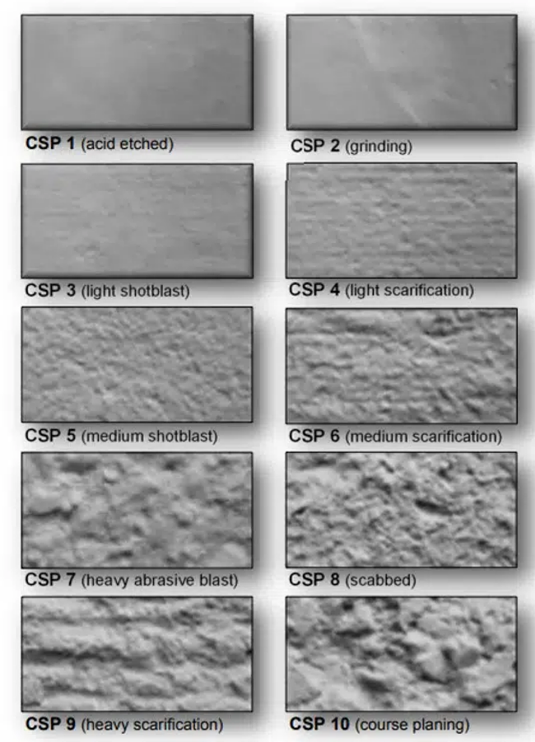
Figure 3 CSP Surface Roughness Preparation Method - https://specchem.com/resources/concrete-surface-preparation-concrete-repairs/

- Recommended Scope of Works
The inspection of SPS-XXXXXX identified the following assets as requiring consideration:
- List all required works to be done on SPS-XXXXXX

Appendix 1 – Site Inspection Photos
Site Layout

Switchboard

Davit Base | Top Slab

Bypass point | Property Pole

Wet Well

Vent Pole

Zero MH

Appendix 2 - Drawings

