SOC 2 Type I Audit
Scope & Planning Document
SOC Automation Lab — Ronan Kongala
Audit Date: April 7, 2026 | Document Version: 1.0

1. Purpose
This document defines the scope, boundaries, and planning parameters for a SOC 2 Type I audit of the SOC Automation Lab. The audit assesses the design of controls relevant to the selected Trust Service Criteria as of the audit date. It does not assess operating effectiveness over a period of time (that would be a Type II audit).
This project serves as a practical application of GRC and audit methodology, demonstrating hands-on experience with industry-standard compliance frameworks.

2. System Description

2.1 Service Organization
Field | Details
System name | SOC Automation Lab
Author / Auditor | Ronan Kongala
Affiliation | MS Cybersecurity, Northeastern University
Audit type | SOC 2 Type I (point-in-time)
Audit date | April 7, 2026
Repository | github.com/ronanlucky/SOC-Automation-Lab

2.2 System Overview
The SOC Automation Lab is an end-to-end security operations pipeline that automatically detects, analyzes, and responds to security threats. The system ingests Windows security events, processes them through a SIEM, enriches alerts using AI, and delivers notifications to a Slack channel.

2.3 System Components
Component | Technology | IP Address | Purpose
Event source | Windows 10 + Sysmon | 192.168.116.130 | Generate security events (Event ID 4625)
SIEM | Splunk Enterprise | 192.168.116.128 | Log aggregation, alerting, SPL queries
Orchestration | n8n (Docker) | 192.168.116.133 | Workflow automation and webhook routing
AI analysis | OpenAI GPT-4 | Cloud (API) | Threat intelligence and MITRE ATT&CK mapping
Notification | Slack | Cloud (SaaS) | Security alert delivery to #alerts channel

3. Trust Service Criteria

3.1 Selected Criteria
The following Trust Service Criteria (TSC) have been selected for this audit based on relevance to the system's function:

Criteria | Category | Rationale for inclusion
CC series | Security | Mandatory for all SOC 2 audits. Covers logical access, change management, risk assessment, and monitoring controls.
A series | Availability | The lab's detection pipeline must be operational for the SOC function to work. Uptime of Splunk and n8n is directly tied to security outcomes.

3.2 Excluded Criteria
The following TSC are excluded from this audit with documented rationale:

Criteria | Rationale for exclusion
Confidentiality (C series) | The lab does not process or store confidential customer data.
Processing Integrity (PI series) | The lab performs detection and alerting, not transaction processing requiring completeness guarantees.
Privacy (P series) | No personal information is collected or processed by the lab environment.

4. Scope Boundaries

4.1 In Scope
- Windows 10 VM (192.168.116.130) — event generation and Sysmon configuration
- Splunk Enterprise VM (192.168.116.128) — SIEM configuration, alert rules, access controls
- n8n automation VM (192.168.116.133) — workflow logic, webhook security, Docker configuration
- OpenAI GPT-4 API integration — API key management, prompt handling
- Slack integration — bot token management, channel access controls
- Network configuration — static IP assignment, inter-VM communication

4.2 Out of Scope
- Underlying VMware hypervisor and host operating system
- Internet-facing infrastructure beyond the lab VMs
- OpenAI and Slack platform-level security (those are vendor responsibilities)
- Physical security of the host machine

5. Audit Approach

5.1 Audit Type
This is a SOC 2 Type I audit, which evaluates whether controls are suitably designed as of a specific point in time (April 7, 2026). It does not assess whether controls operated effectively over a period. A future Type II audit would extend the observation window to 6-12 months.

5.2 Audit Phases
Phase | Activity | Description | Deliverable
1 | Scoping | Define system boundary, TSC selection, audit period | This document
2 | Risk assessment | Identify threats, rate likelihood and impact using NIST SP 800-30 | Risk register
3 | Control mapping | Map existing controls to SOC 2 TSC, identify gaps | Control matrix
4 | Audit report | Document findings, gaps, and remediation recommendations | Audit findings report

6. System Performance Baseline
The following metrics from the lab's implementation are noted as baseline performance indicators relevant to the Availability criteria:

Metric | Value
Detection rate | 100% of test events captured
Event-to-alert time | < 60 seconds
Average processing time | 8.95 seconds
Automation success rate | 5/5 executions (100%)
False positives during testing | 0

7. Document Control
Version | Date | Author | Notes
1.0 | April 7, 2026 | Ronan Kongala | Initial draft

Next phase: Risk Assessment (Phase 2) — build a risk register for the SOC Automation Lab using NIST SP 800-30.

Appendix A — Audit Evidence Exhibits
The following exhibits constitute the audit evidence supporting control assessments in this document. Each exhibit is referenced by letter in the control mapping and findings sections.

Exhibit A — Windows Event Viewer — Event ID 4625 (Failed Authentication)
Relevant control: CC6.7 — Logical Access Controls
Windows Event Viewer on DESKTOP-8QQP7R4 filtered for Event ID 4625, showing 27 audit failure events logged between October 4–6, 2025. This confirms the event source is generating and recording failed authentication attempts as expected. Event details panel confirms EventID=4625, Keywords=Audit Failure, TaskCategory=Logon.

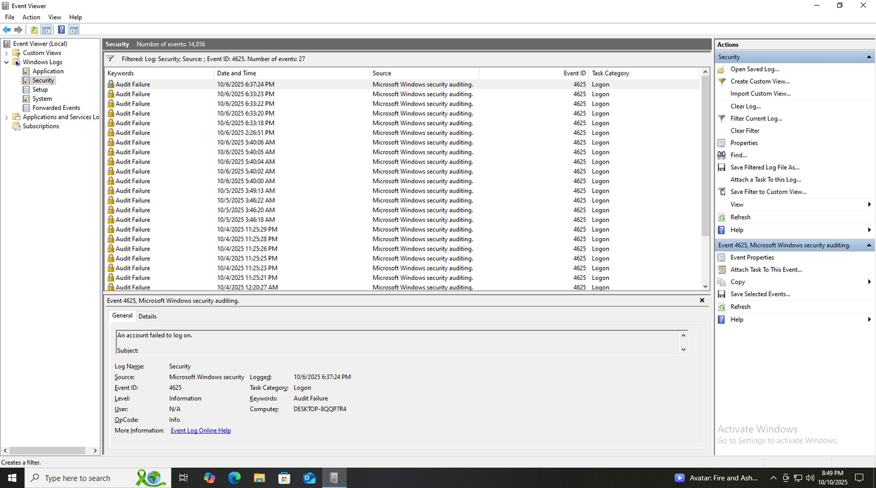

Exhibit B — Splunk Search — EventCode=4625 Detection
Relevant control: CC7.2 — System Monitoring
Splunk Enterprise (192.168.116.128) executing SPL query: index=soc_project EventCode=4625, returning 5 events within the 24-hour window (10/9/25 to 10/10/25). Confirms SIEM is ingesting Windows Security logs and correctly filtering on brute-force indicators. Selected fields include host, source, sourcetype, Account_Name, and authentication_method.

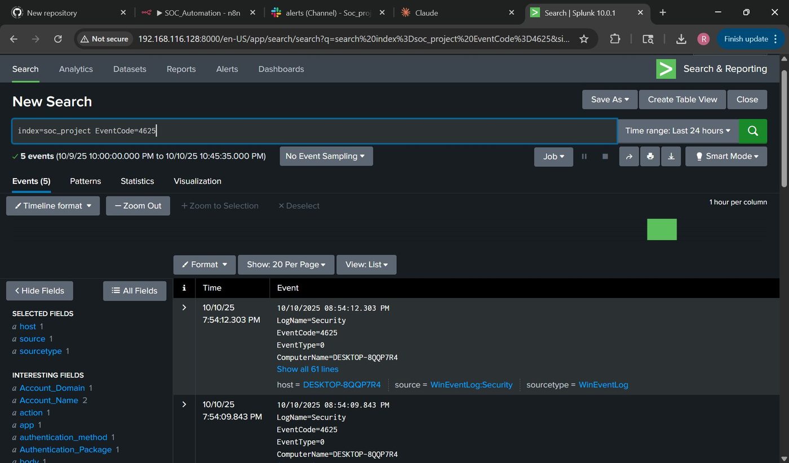

Exhibit C — Splunk Alert Configuration — test-brute-force
Relevant control: CC7.2 — Automated Alerting
Splunk Searches, Reports, and Alerts panel showing the “test-brute-force” alert configured, enabled, and scheduled (next run: 2025-10-10 22:30:00 UTC). Alert type is confirmed as Alert, owner is soc_splunk, app is search. Status shows green ✓ Enabled. This demonstrates a documented, operational monitoring control.

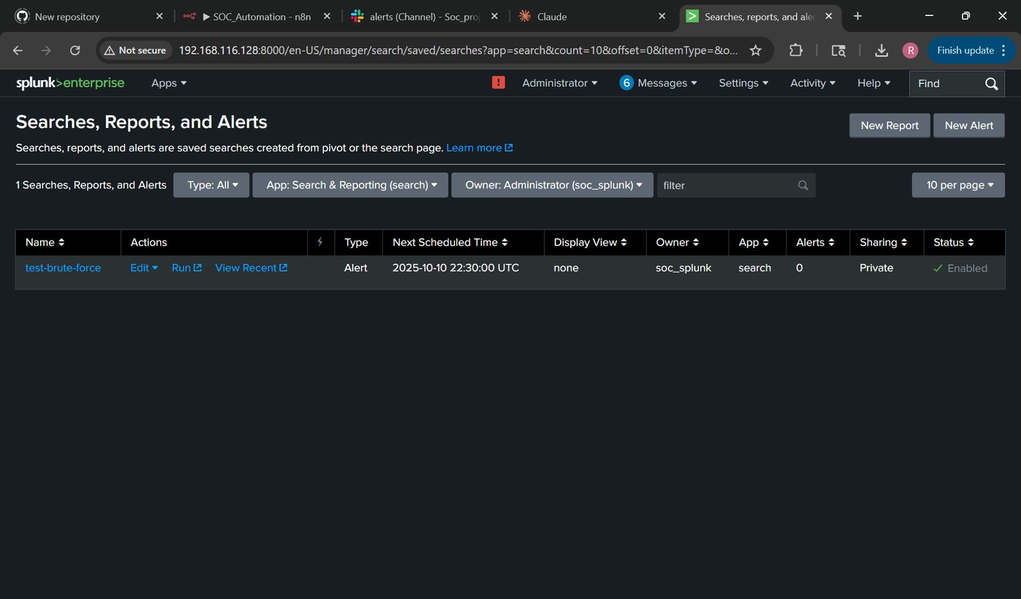

Exhibit D — n8n Workflow Executions — 5/5 Successful
Relevant control: A1.2 — System Availability
n8n workflow execution log (192.168.116.131:5678) showing 5 consecutive successful executions on October 6, 2025. Processing times range from 35ms to 8.954s. Workflow diagram confirms three-node pipeline: Webhook trigger → OpenAI GPT-4 (Message a model) → Slack (Send a message). All executions completed without error, demonstrating pipeline reliability.

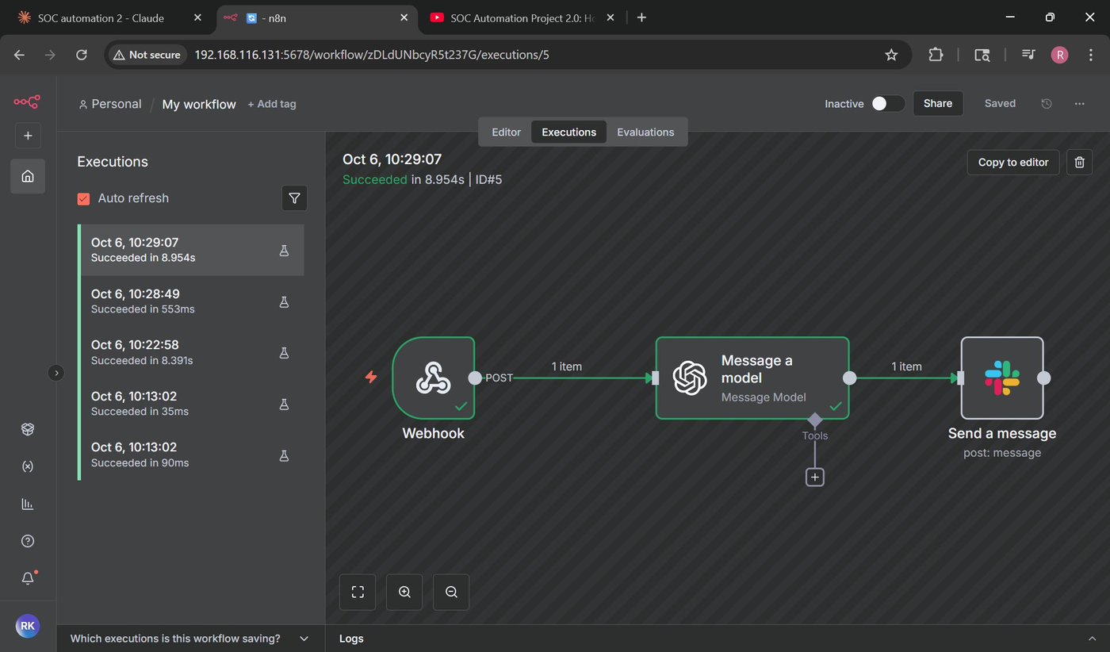

Exhibit E — Slack Alert Delivery — #alerts Channel
Relevant control: CC7.3 — Incident Response Notification
Slack #alerts channel (Soc_project workspace) showing AI-generated security alert delivered on October 6th. Alert header: “Security Alert: Failed Authentication.” Alert body contains structured JSON with Event Type (Windows Security Event ID 4625), Timestamp, Computer (DESKTOP-8QQP7R4), User (Ronan), Source IP (127.0.0.1), and Failed Attempts count. Confirms end-to-end notification delivery.

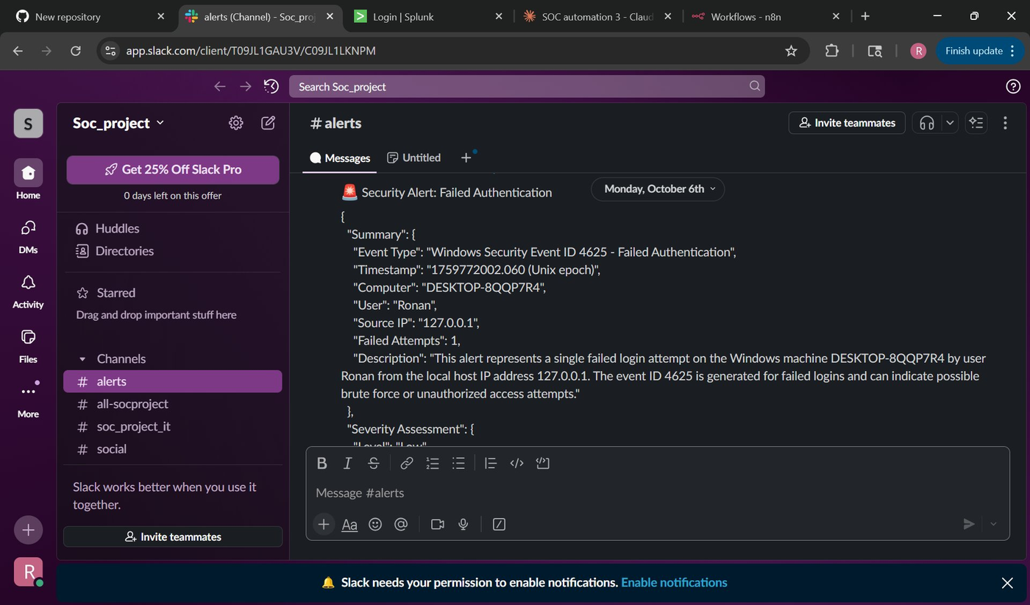

Exhibit F — Slack Alert — MITRE ATT&CK Mapping & Response Actions
Relevant control: CC7.3 — AI-Enriched Threat Intelligence
Continuation of Slack alert showing GPT-4 enrichment output. Severity Assessment: Low, with justification. MITRE ATT&CK Mapping: Tactic=Credential Access, Technique=Brute Force (T1110). Immediate Response Actions include: verify user login attempt, check for repeated failures, ensure account is not locked. Demonstrates automated threat intelligence and structured incident response guidance.

