SOC INVESTIGATION CASE STUDY

Multiple Failed Logins
Followed by a Successful Login
  - Microsoft Sentinel / Defender XDR identity investigation
Outcome Benign authentication activity. The alert logic grouped MFA prompts, an invalid session, and incomplete strong-authentication attempts under a broad “failed login” condition.

Portfolio field | Value
Analyst | Rona Playda
Role | SOC Analyst — training investigation
Alert severity | Medium
MITRE ATT&CK | T1110 — Brute Force (detection mapping reviewed)
Disposition | Benign
Report date | September 2, 2026

Portfolio notice Account names, tenant identifiers, public IP addresses, correlation IDs, and subscription details are masked. All activity occurred in an authorized training environment.

1. Executive Summary
A Microsoft Sentinel scheduled analytics rule generated a Medium-severity identity alert after it observed several non-success sign-in results associated with an account, followed by successful authentication. The alert’s wording suggested brute force or credential stuffing, but the investigation showed a more ordinary authentication sequence involving MFA prompts, an invalid session after a password change or expiration, and incomplete strong-authentication attempts.
The investigation used the raw alert, the original KQL logic, focused SigninLogs queries, device details, application context, and a seven-day account baseline. All relevant activity originated from one US public IP and consistent browser/device characteristics. Expected Microsoft and SOC training applications were accessed, and no competing IP, unfamiliar geography, suspicious application, lateral movement, or post-authentication malicious activity was identified.
Analyst decision Resolve as Benign. No containment is required. Improve the analytic so normal authentication interruptions do not inflate the brute-force threshold.

2. Investigation Objectives
- Identify the affected account, source IP, location, application, and device context.
- Determine whether the “failed” records were password failures, MFA events, session errors, or another authentication condition.
- Correlate the non-success events with subsequent successful sign-ins.
- Establish whether the source was consistent with the account’s available baseline.
- Validate the AI triage draft against primary evidence and document every unsupported claim.
- Choose a defensible resolution code and recommend an appropriate detection improvement.

3. Alert and Detection Context
Field | Sanitized finding
Alert | Identity — Multiple Failed Logins Followed by a Successful Login
Source | Microsoft XDR / Microsoft Sentinel scheduled analytic
Severity | Medium
Category | Credential Access
Activity window | 2026-08-11 01:24:45–01:43:06 UTC
Alert generated | 2026-08-11 01:48:58 UTC
Related result rows | 23 successful sign-in rows joined to one failure summary

The original analytic summarized all qualifying nonzero ResultType values per account over a five-hour lookback, then joined that summary to successful sign-ins in the most recent 30 minutes. This design is important: it does not require every non-success event to be an incorrect password, and it repeats the same failure count on every matching success row.
let min_failures = 5;
SigninLogs
| where ResultType != 0
| summarize FailCount = count() by UserPrincipalName
...
| join kind=inner (failedLogons) on UserPrincipalName
| where FailCount >= min_failures

Key interpretation “23 items” meant 23 joined query-result rows—not 23 alerts and not 23 failed logins. The alert contained one summarized failure count of six.

4. Step-by-Step Investigation

Step 1 — Validate the raw alert before forming a verdict
- Confirm the ticket title, severity, provider, UTC activity window, incident reference, and analytics rule name.
- Read the complete query instead of relying only on the plain-language description.
- Record what the alert actually provides and identify missing entities such as account, IP, or device.
- Treat the alert hypothesis—brute force or credential stuffing—as unconfirmed until the source events support it.

Step 2 — Reproduce the trigger with a focused SigninLogs query
The focused query used the rule’s exact lookback period, selected the affected account, retained the analytic’s exclusions, and projected the fields needed for a timeline. This made each contributing non-success event visible instead of leaving only the summarized count.
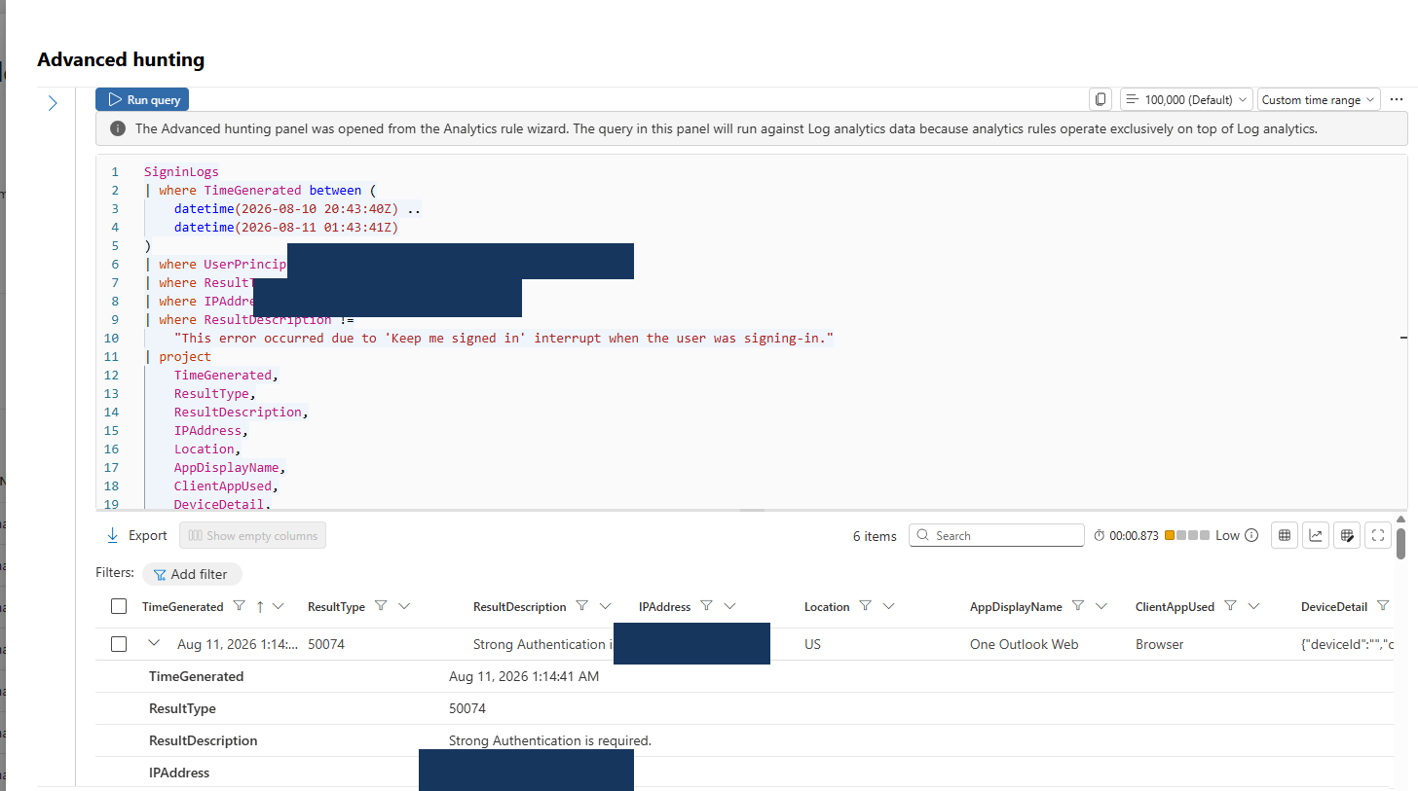
Figure 1. Sanitized focused KQL query and first expanded result. Sensitive account and IP values are masked.

Step 3 — Classify each non-success event
Six qualifying events were returned. Reading ResultType together with ResultDescription showed that the group was not six password failures.
UTC time | Code | Meaning | Analyst interpretation
01:14:41 | 50074 | Strong authentication required | MFA requirement; not a bad password
01:19:49 | 50074 | Strong authentication required | Second MFA requirement
01:22:46 | 50133 | Session invalid after password change/expiration | Session lifecycle condition
01:25:51 | 500121 | Strong authentication request failed | Incomplete/failed MFA attempt
01:35:18 | 500121 | Strong authentication request failed | Incomplete/failed MFA attempt
01:40:50 | 500121 | Strong authentication request failed | Incomplete/failed MFA attempt

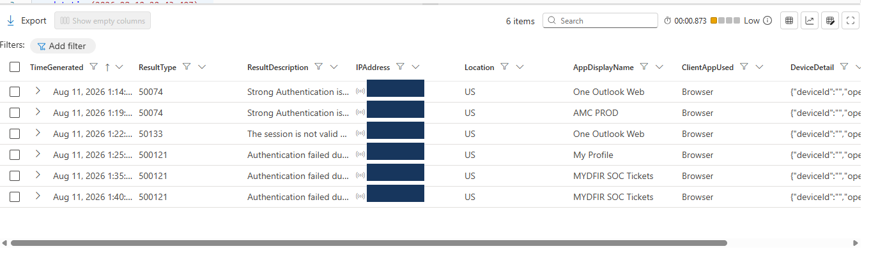
Figure 2. Sanitized six-event results table showing consistent time, code, application, location, client, and device context.

Step 4 — Correlate account, source, and device context
Every qualifying event used the same affected account, US location, browser client, and public source IP. DeviceDetail recorded Chrome on “Windows10,” with an empty device ID and unmanaged/noncompliant status. Browser-derived Entra telemetry may report Windows 11 as Windows10 because the underlying platform identifier is Windows NT 10.0; therefore the label alone is not an anomaly.
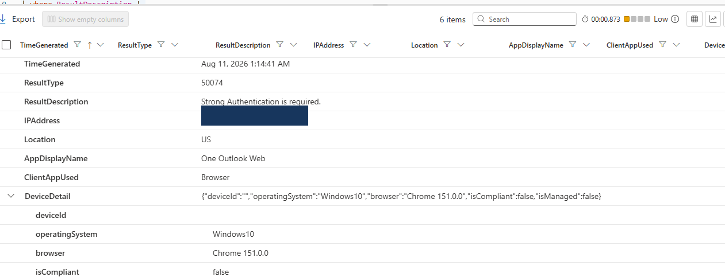
Figure 3. Sanitized expanded device details for an MFA-required event.
Evidence limitation The device ID was empty and the endpoint was unmanaged. The log could support device-profile consistency, but it could not uniquely identify a physical computer.

Step 5 — Establish the available account baseline
A seven-day baseline query found activity only during the investigation period. Although there was no older history for comparison, the available records formed a cohesive authentication session from one public IP: Windows/Chrome activity plus one Android Microsoft Authentication Broker event from the same network.
Platform | Total | Successful | Non-success | Context
Windows / Chrome | 38 | 25 | 13 | Expected Microsoft and SOC applications
Android / Chrome Mobile | 1 | 0 | 1 | Microsoft Authentication Broker

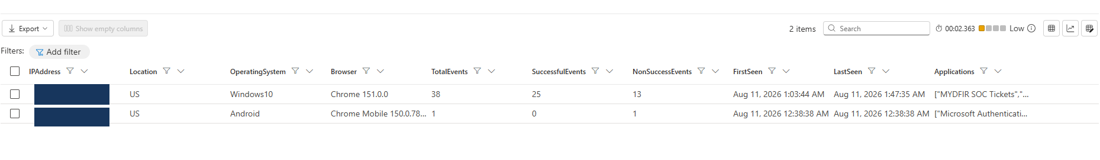
Figure 4. Sanitized baseline summary. Both platform profiles originated from the same public IP and US location.
The baseline contained 13 total non-success records, while the alert counted six. This difference reinforces the need to reproduce the rule precisely: some authentication interruptions were excluded by the analytic and did not contribute to the threshold.

Step 6 — Check for follow-on malicious behavior
- No second source IP or unfamiliar country was identified.
- No suspicious application outside the expected Microsoft and SOC training set appeared.
- No evidence supported SharePoint abuse, Microsoft Graph exploitation, lateral movement, or data exfiltration.
- No confirmed malicious indicator of compromise was identified.

5. AI Triage Quality-Control Review
The AI draft was treated as junior-analyst work and checked line by line against the raw query and SigninLogs. It was marked Needs work because it converted query text into unsupported event evidence and invented additional attack activity.
AI draft claim | Evidence-based correction
A different administrator account was compromised | The matching query results identified the SOC training account.
The excluded IP was the attack source | That address appeared only in an IPAddress != exclusion; a focused query returned zero events for it.
Five brute-force failures occurred | Six qualifying non-success events existed, but only three were failed/incomplete strong-authentication requests.
No MFA failures were captured | Codes 50074 and 500121 explicitly reflected MFA/strong-authentication activity.
SharePoint and Microsoft Graph were used | No supporting event showed either claim.
Lateral movement or exfiltration preparation occurred | No related evidence supported post-authentication malicious behavior.

Analyst lesson Operators must understand query operators. In KQL, != means “not equal.” An address in an exclusion condition is not automatically an observed source or IOC.

6. Timeline
UTC | Event | Significance
00:38:38 | Android Authentication Broker non-success | Same public IP; consistent with mobile authentication flow
01:03:44 | First Windows/Chrome baseline event | Start of concentrated browser activity
01:14:41 | MFA required (50074) | Expected strong-authentication challenge
01:19:49 | MFA required (50074) | Repeated challenge
01:22:46 | Invalid session (50133) | Password/session lifecycle issue
01:25:51 | Strong authentication failed (500121) | Incomplete MFA attempt
01:35:18 | Strong authentication failed (500121) | Incomplete MFA attempt
01:40:50 | Strong authentication failed (500121) | Incomplete MFA attempt
01:43:06 | Last alert-related successful sign-in | Success from consistent source context
01:48:58 | Alert generated | Scheduled analytic created one Medium alert

7. Five-W Analysis
Question | Evidence-based answer
Who | A sanitized SOC training account.
What | MFA requirements, one invalid session, and three incomplete strong-authentication attempts followed by successful access.
When | 2026-08-11; alert-related activity ended at 01:43:06 UTC.
Where | One US public IP using Windows/Chrome and an Android authentication-broker interaction.
Why | The analytic grouped multiple types of nonzero authentication results under a broad failed-login threshold.
How | Browser and MFA authentication across expected Microsoft and SOC applications.

8. Verdict and Recommended Resolution
Resolution code: Benign The alert detected real authentication events, but the evidence is consistent with legitimate MFA and session-establishment activity—not brute force or credential compromise.

The conclusion is based on observable telemetry rather than personal knowledge of the user. One consistent source, expected applications, a coherent MFA/session timeline, numerous successful authentications, and the absence of follow-on malicious behavior collectively support the benign disposition. The lack of older account history is documented as a limitation rather than ignored.

9. Recommendations
- No containment: do not reset credentials, isolate devices, or block the observed IP without additional malicious evidence.
- Tune the analytic: distinguish incorrect-password results from MFA-required, invalid-session, KMSI interruption, and incomplete-authentication events.
- Improve correlation: require tighter sequencing between failures and a later success, and consider source IP, device, application, and correlation ID.
- Retain analyst review: keep AI triage as an aid, but require verification against raw logs before disposition.
- Document limitations: note when device identity is missing or historical baseline data is unavailable.

10. Skills Demonstrated
- Microsoft Sentinel and Defender XDR alert navigation
- KQL filtering, projection, summarization, joins, and baseline analysis
- Microsoft Entra sign-in result interpretation
- UTC timeline construction and 5W reporting
- Identity alert triage and benign-versus-false-positive reasoning
- AI output validation and evidence-based correction
- MITRE ATT&CK mapping review and detection-engineering feedback

Appendix A — Reusable KQL Queries

A.1 Focused non-success authentication events
let StartTime = datetime(2026-08-10 20:43:40Z);
let EndTime = datetime(2026-08-11 01:43:41Z);
SigninLogs
| where TimeGenerated between (StartTime .. EndTime)
| where UserPrincipalName =~ "[SANITIZED_ACCOUNT]"
| where ResultType != 0
| where IPAddress != "[RULE_EXCLUDED_IP]"
| where ResultDescription !contains "Keep me signed in"
| project TimeGenerated, ResultType, ResultDescription, IPAddress,
Location, AppDisplayName, ClientAppUsed, DeviceDetail, CorrelationId
| order by TimeGenerated asc

A.2 Seven-day source and device baseline
SigninLogs
| where TimeGenerated between (datetime(2026-08-04) .. datetime(2026-08-11 01:48:59Z))
| where UserPrincipalName =~ "[SANITIZED_ACCOUNT]"
| extend OperatingSystem = tostring(DeviceDetail.operatingSystem),
Browser = tostring(DeviceDetail.browser)
| summarize TotalEvents=count(),
SuccessfulEvents=countif(ResultType == "0"),
NonSuccessEvents=countif(ResultType != "0"),
FirstSeen=min(TimeGenerated), LastSeen=max(TimeGenerated),
Applications=make_set(AppDisplayName)
by IPAddress, Location, OperatingSystem, Browser
| order by LastSeen desc

Appendix B — Detection Engineering Note
The original rule’s broad ResultType != 0 condition is useful for discovery but weak as a brute-force definition. It includes authentication states that are not equivalent to an incorrect password. A stronger analytic should explicitly identify the result codes that represent credential failure, enforce temporal ordering, compare failure and success sources, and suppress known authentication-flow interruptions. This reduces analyst workload while preserving visibility into genuine account compromise patterns.

