Tugas Iterable & Map

1. Array Merge

Input : [‘kazuya’, ’jin’ , ’lee’],[‘kazuya’,’feng’]

Output: [[‘kazuya’, ’jin’ , ’lee’, ’feng’ ]

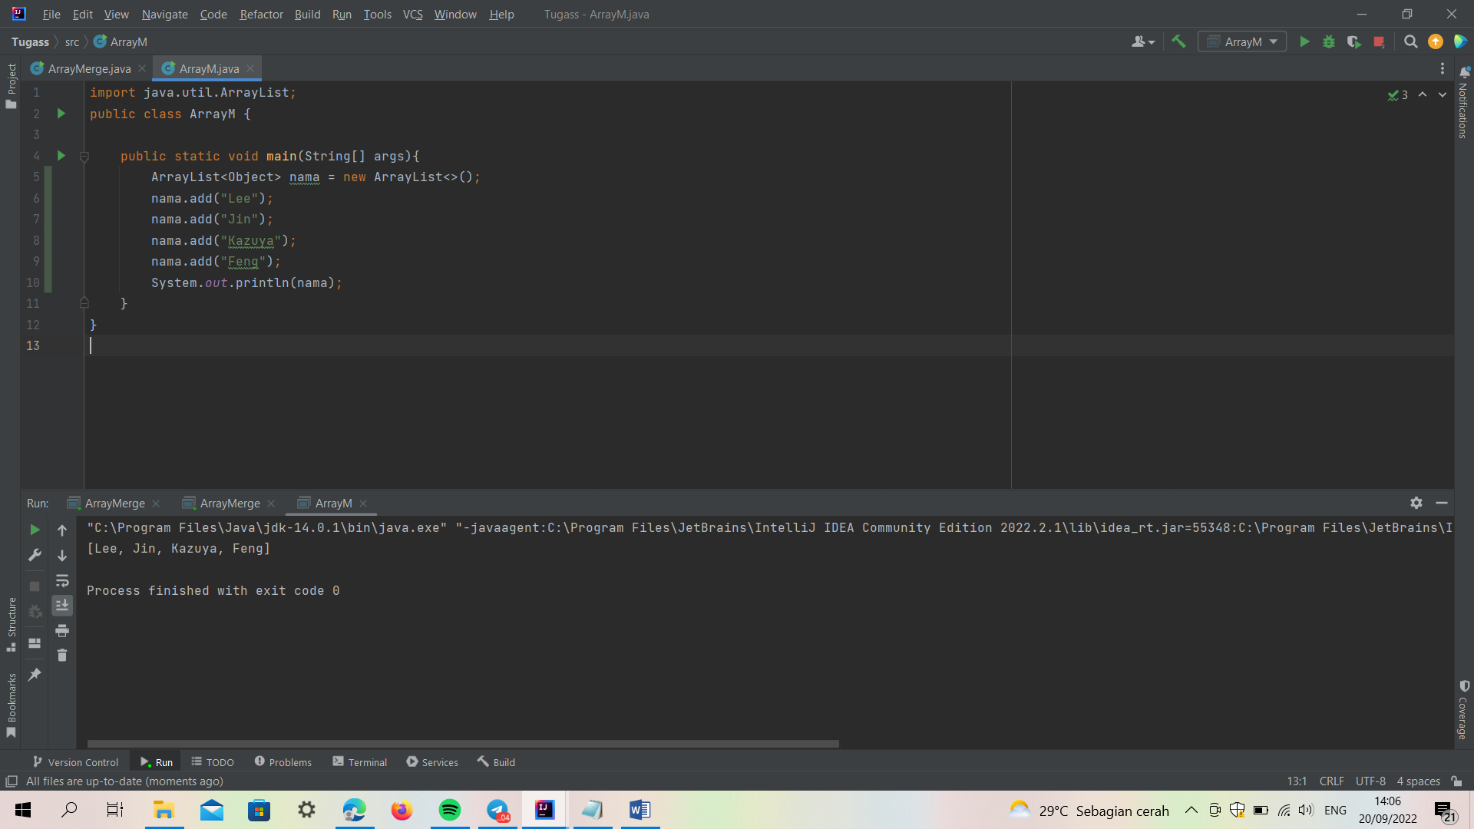

2. Angka muncul sekali

Input : “76523752”

Output : [6,3]

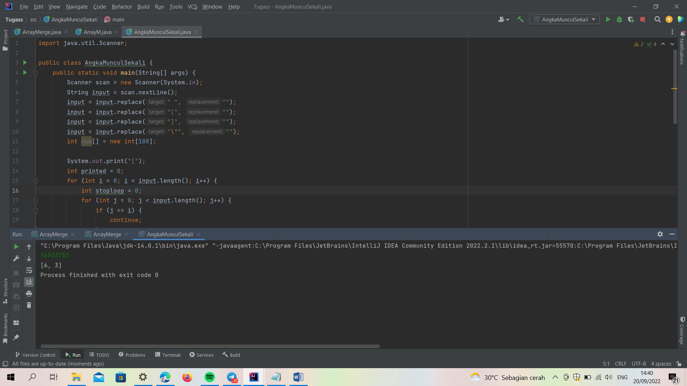

Input: “1122”

Output : []

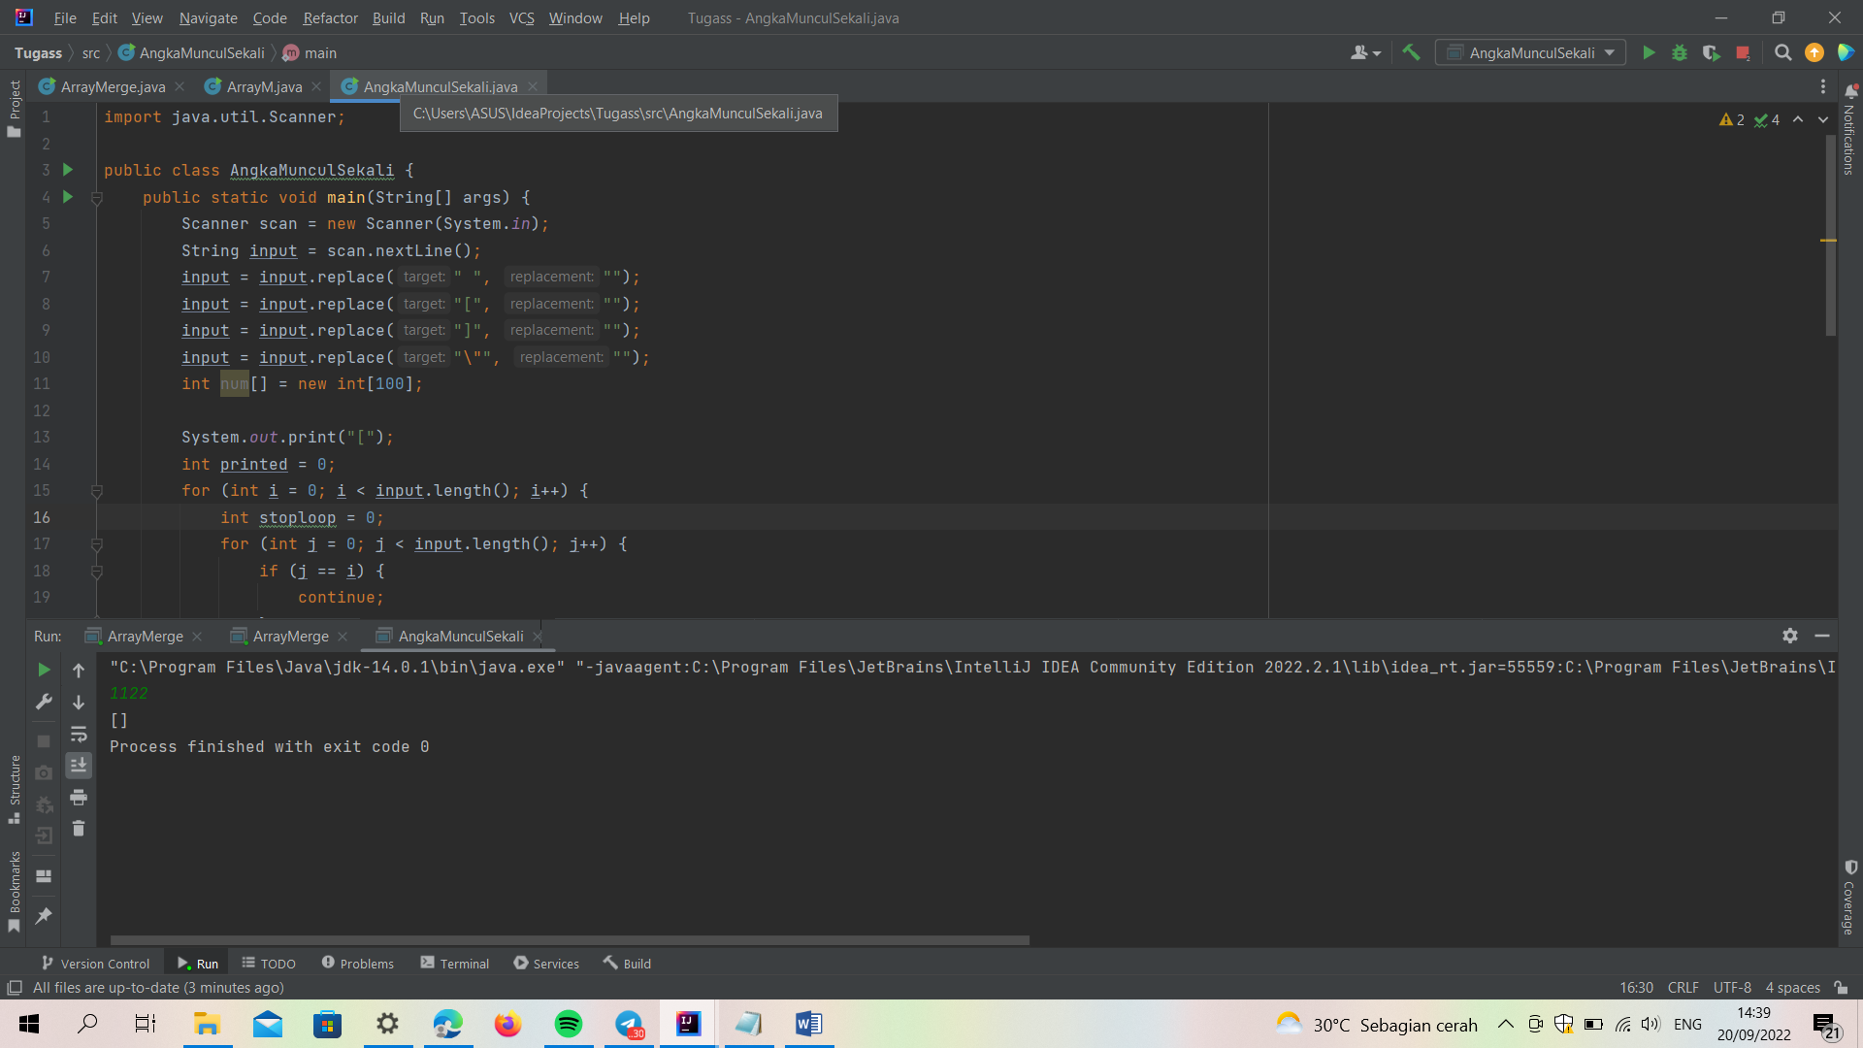

3. Pair With Target Sum

Input :{1,2,3,4,6]

Output : [1,3]

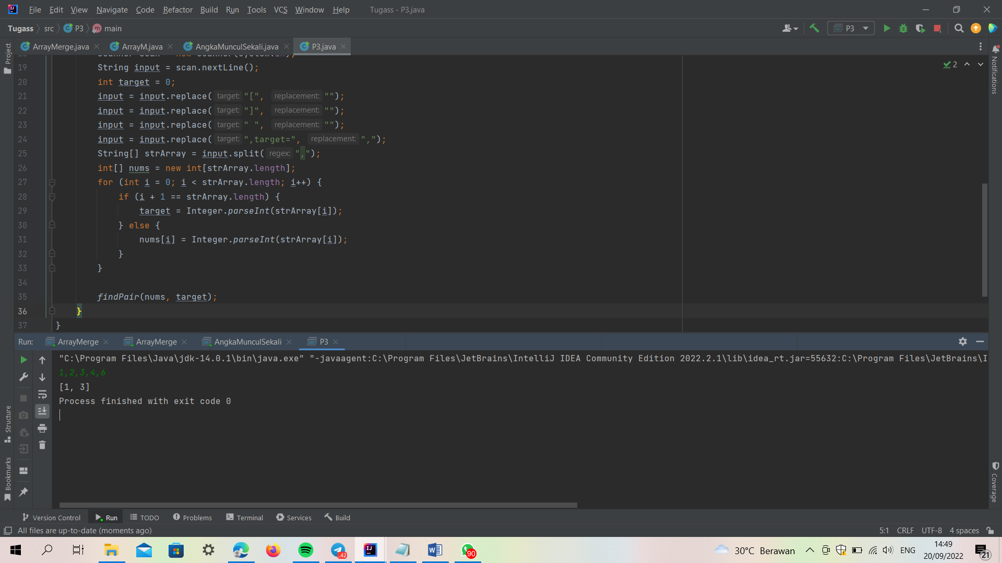

Input : [2,5,9,11]

Output : [0,2]

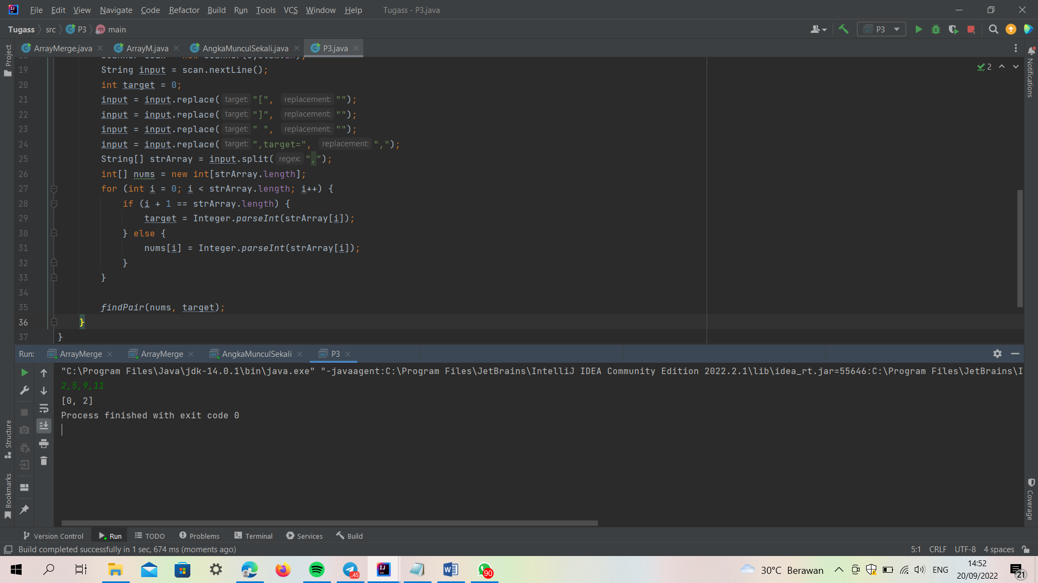

4. Array Unique

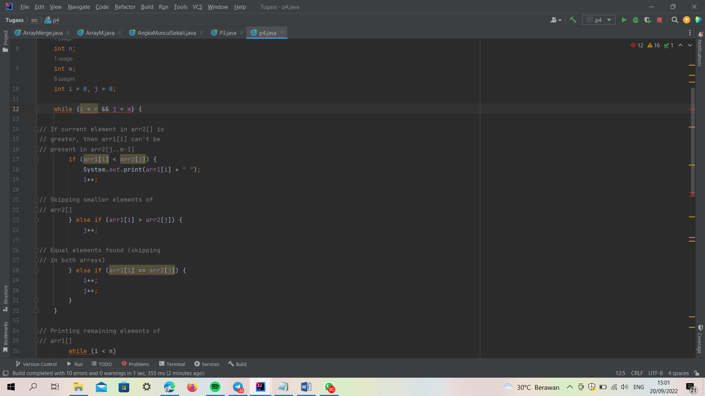

5. Remove Duplicates

Input : [2, 3, 3, 3, 6, 9, 9]

Output : [4]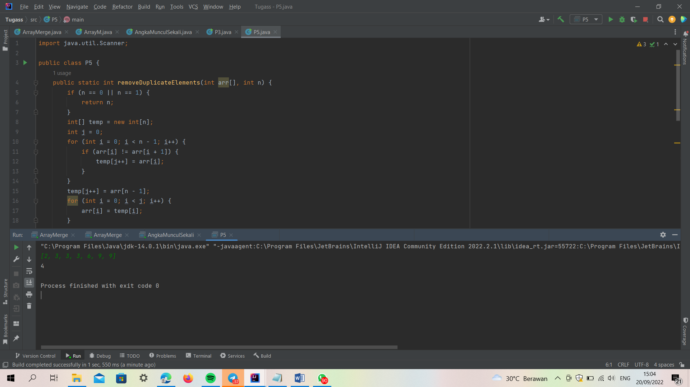

Input : [2,2,2,11]

Output : [2]

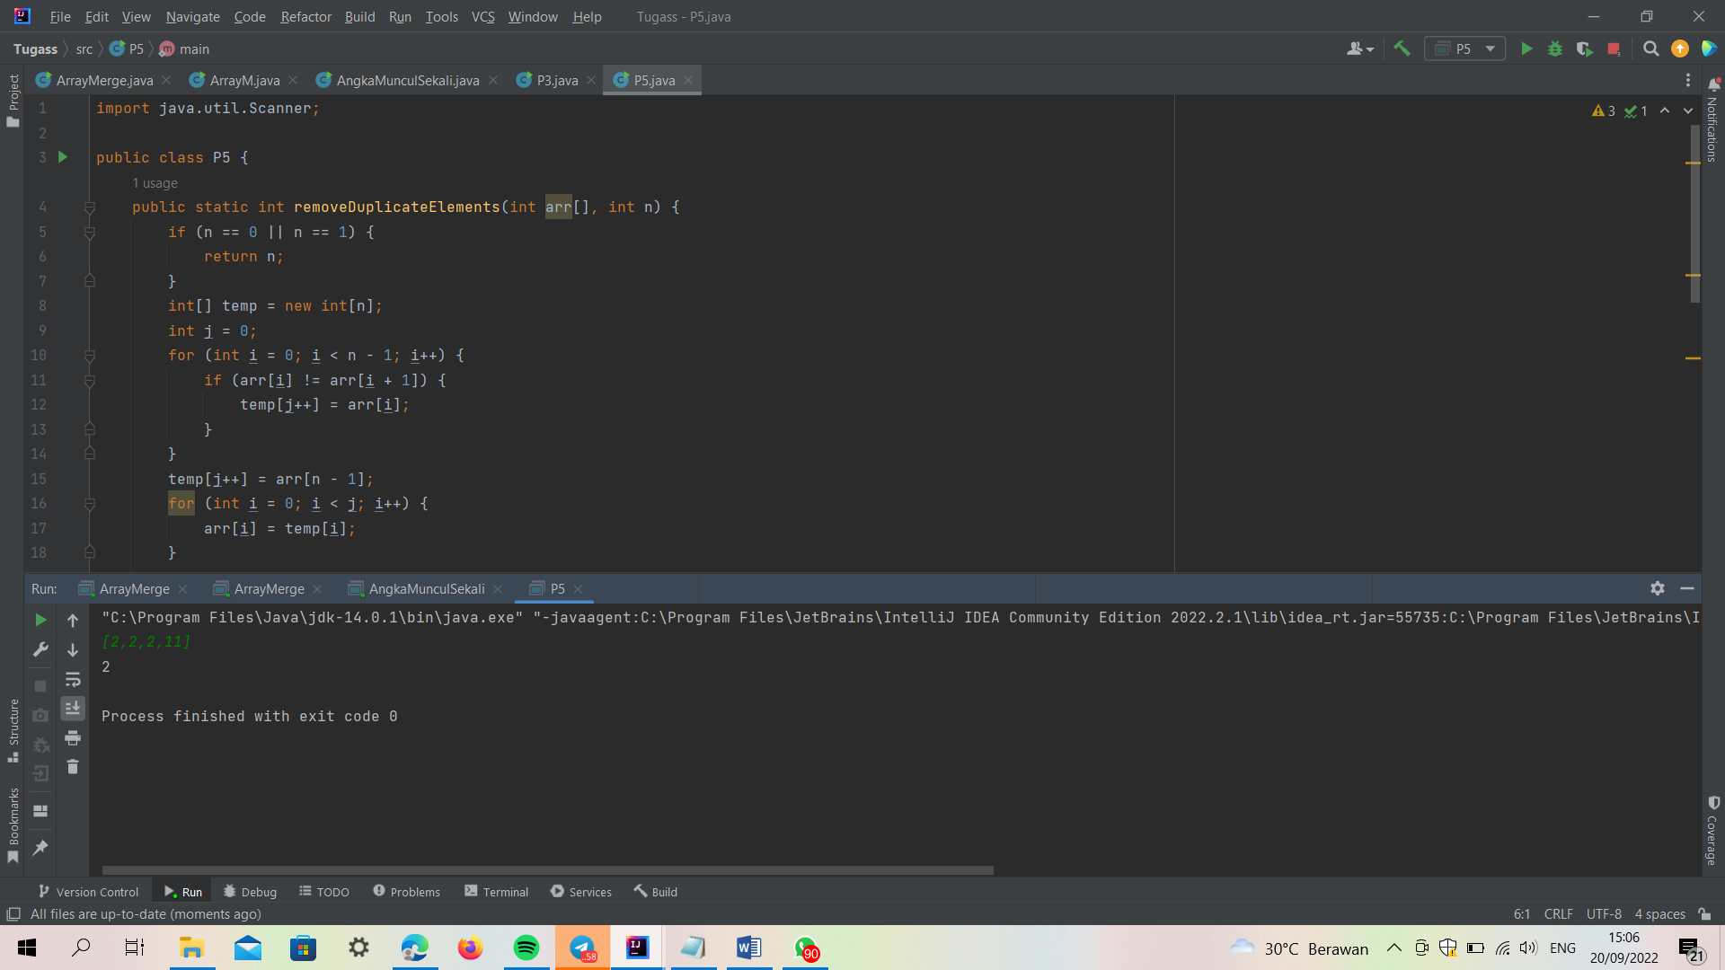

6. Maximum Sum Subarray of Size K (Optional / Nilai Tambah)

Input: [2, 1, 5, 1, 3, 2], k=3

Output: 9

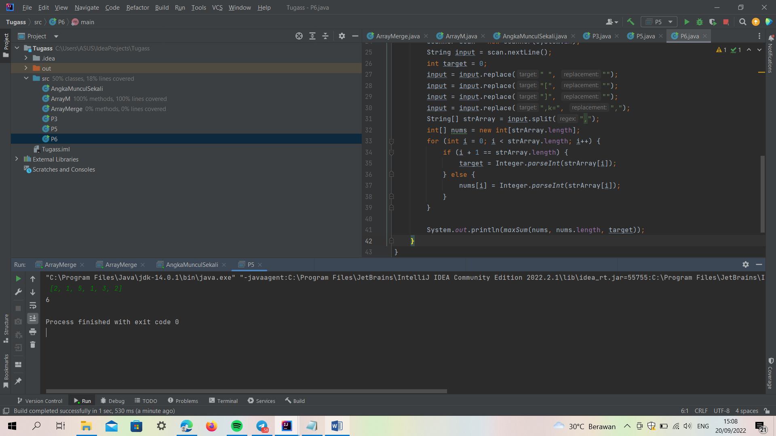

Input: [2, 3, 4, 1, 5], k=2

Output: 7

