**Hands-on task**

1. **PRM:**
   1. The function GeneratePRM is implemented in PRM.py. (We chose to implement the algorithm such that the graph will hold N nodes, i.e. if a sampled node coordinates falls on an obstacle we would sample new coordinates until they are obstacle free).
   2. The plots of different PRM’s are provided below. Obstacles are in red, edges in black and nodes in blue. Number of edges and number of average node degree are indicated for each graph configuration.

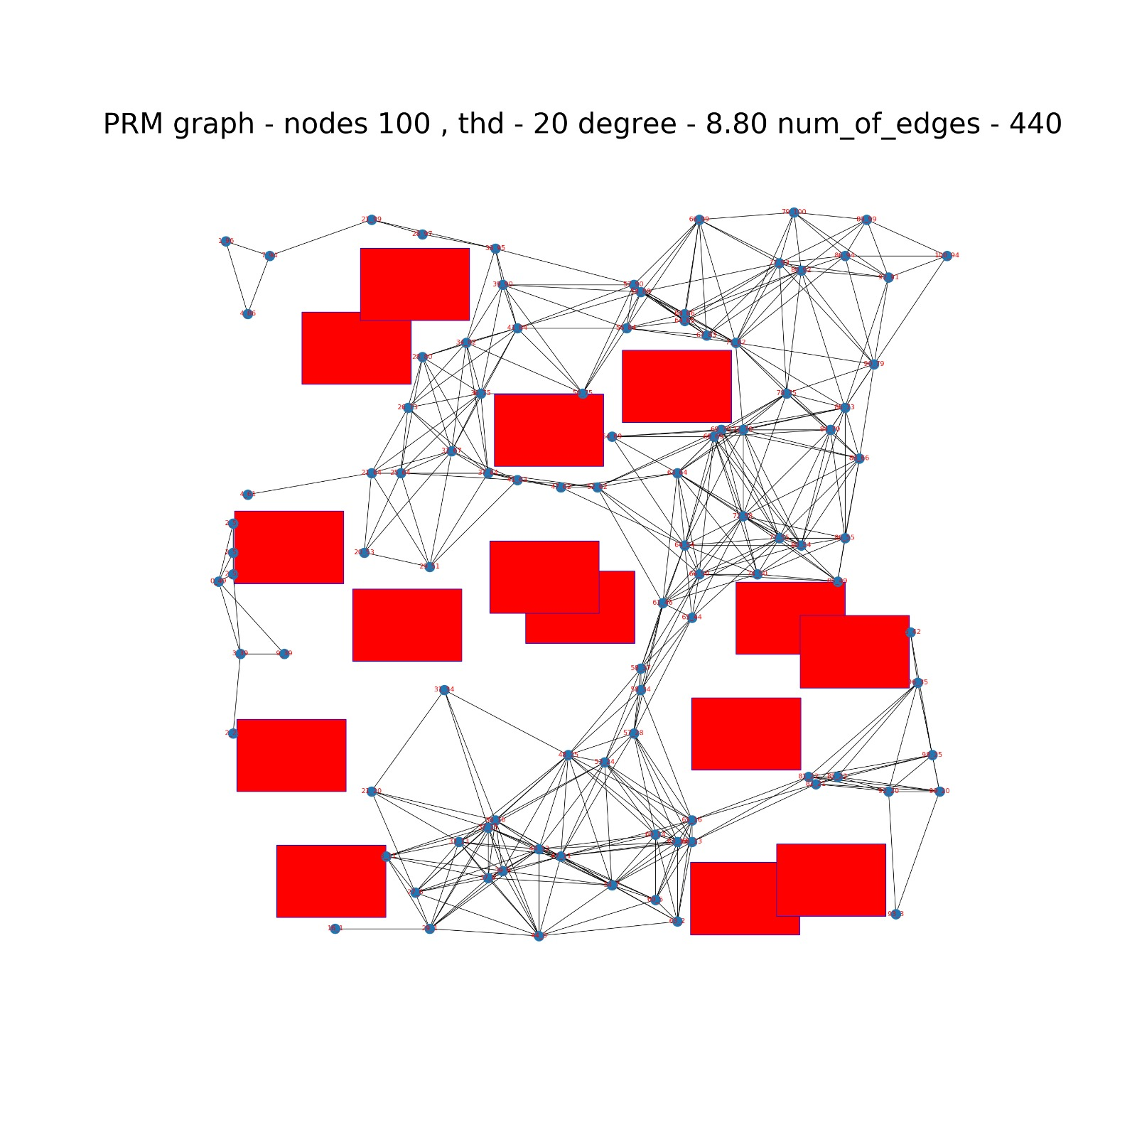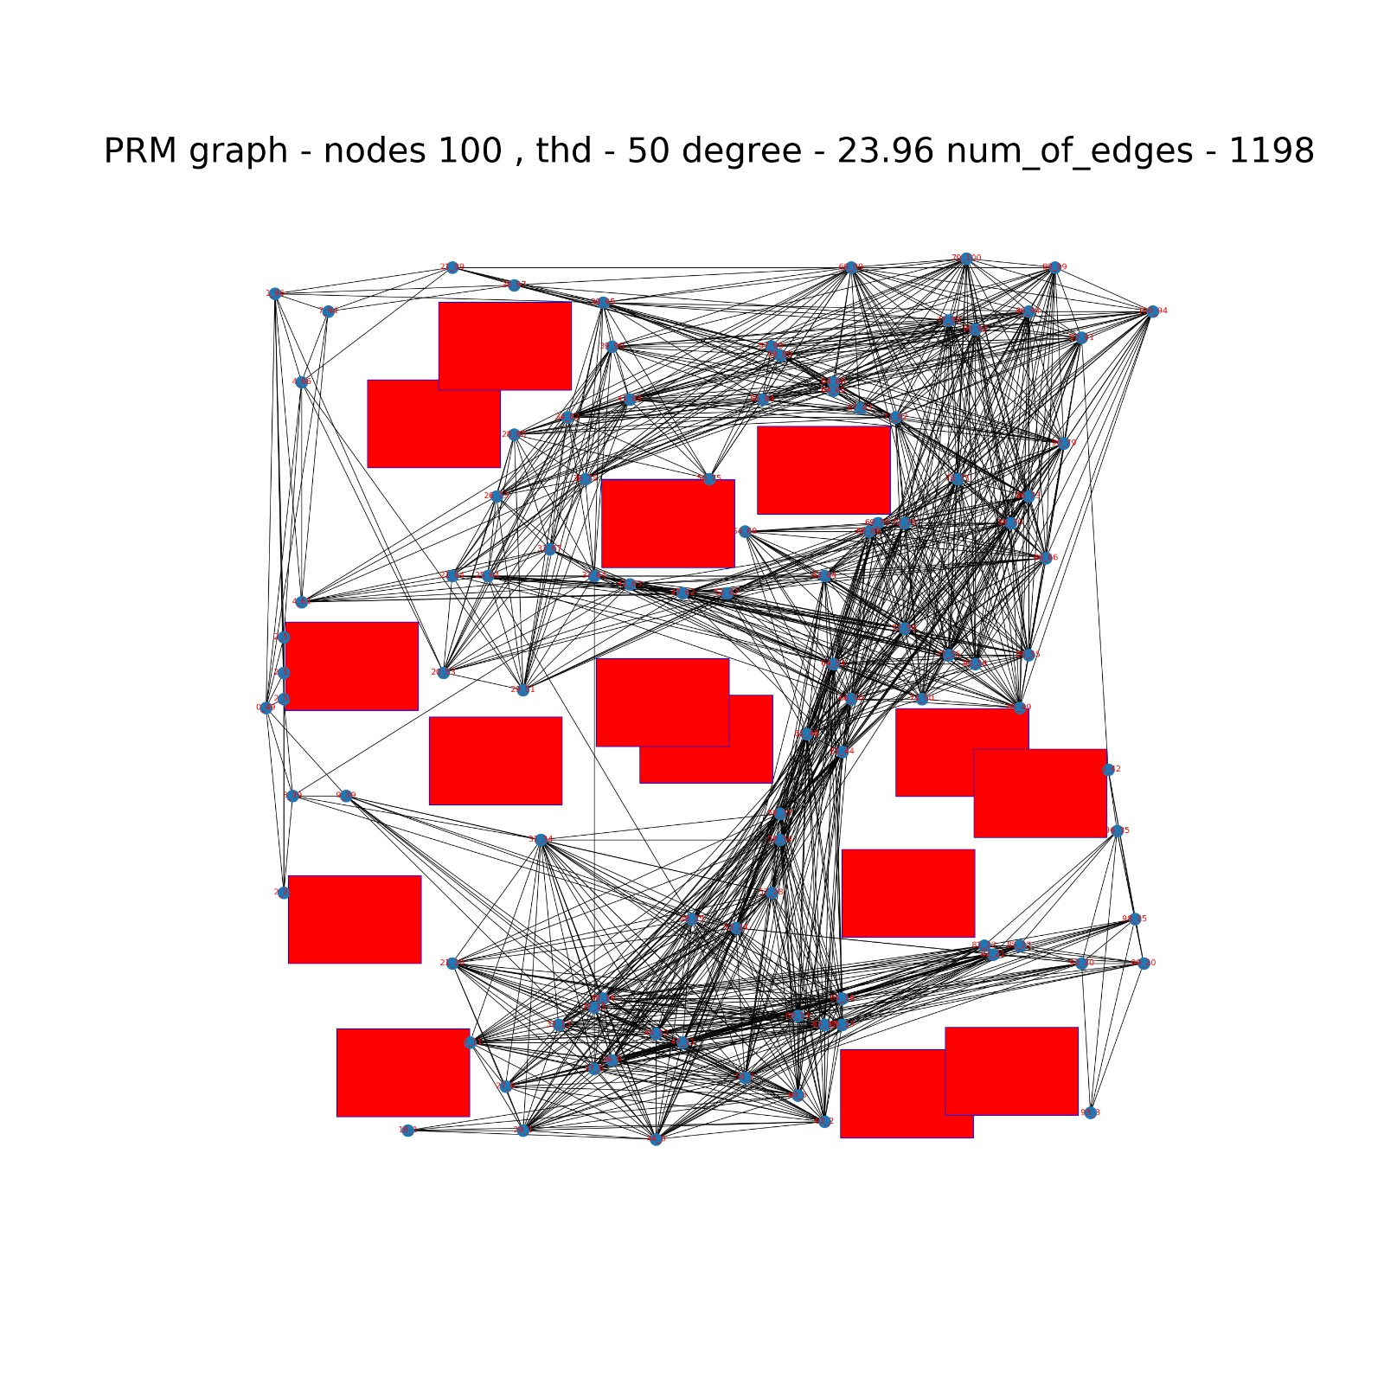

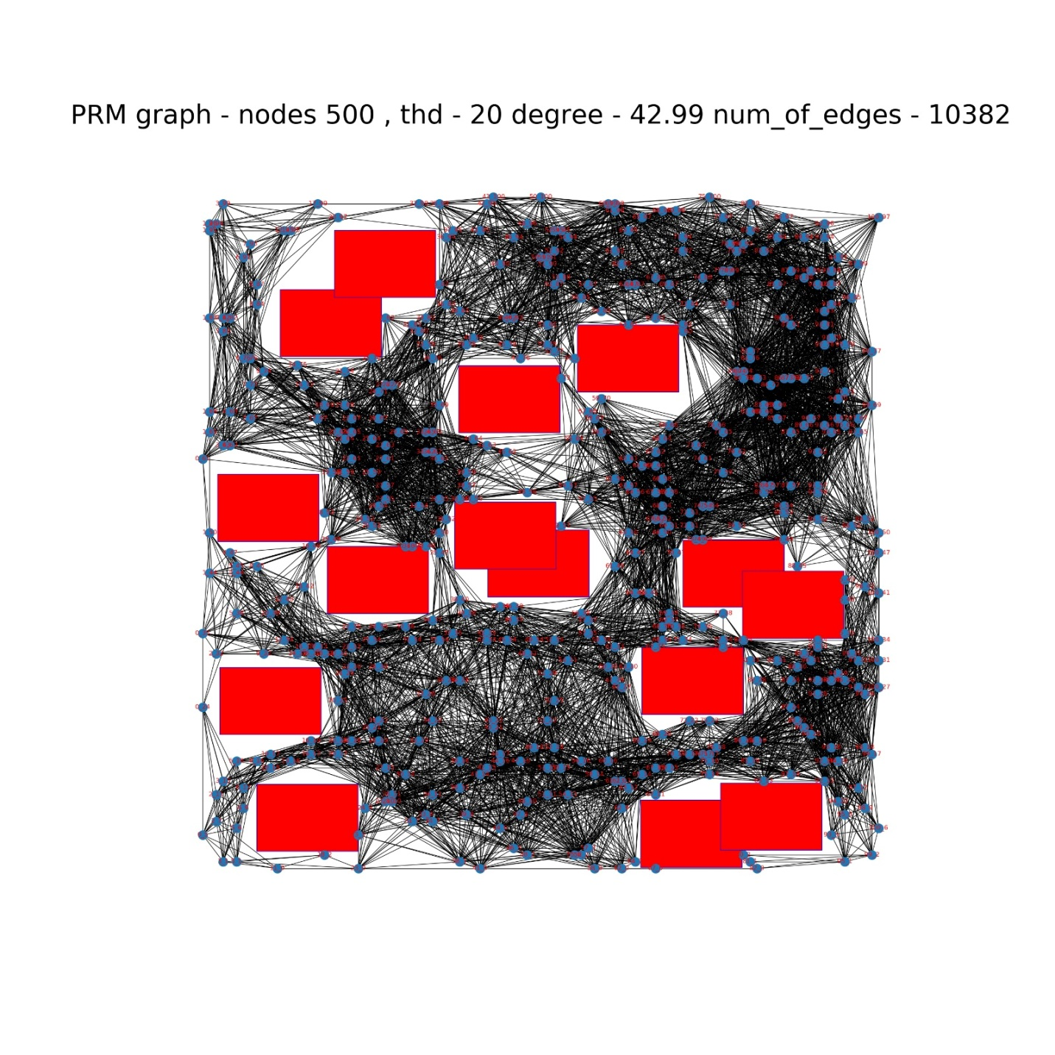

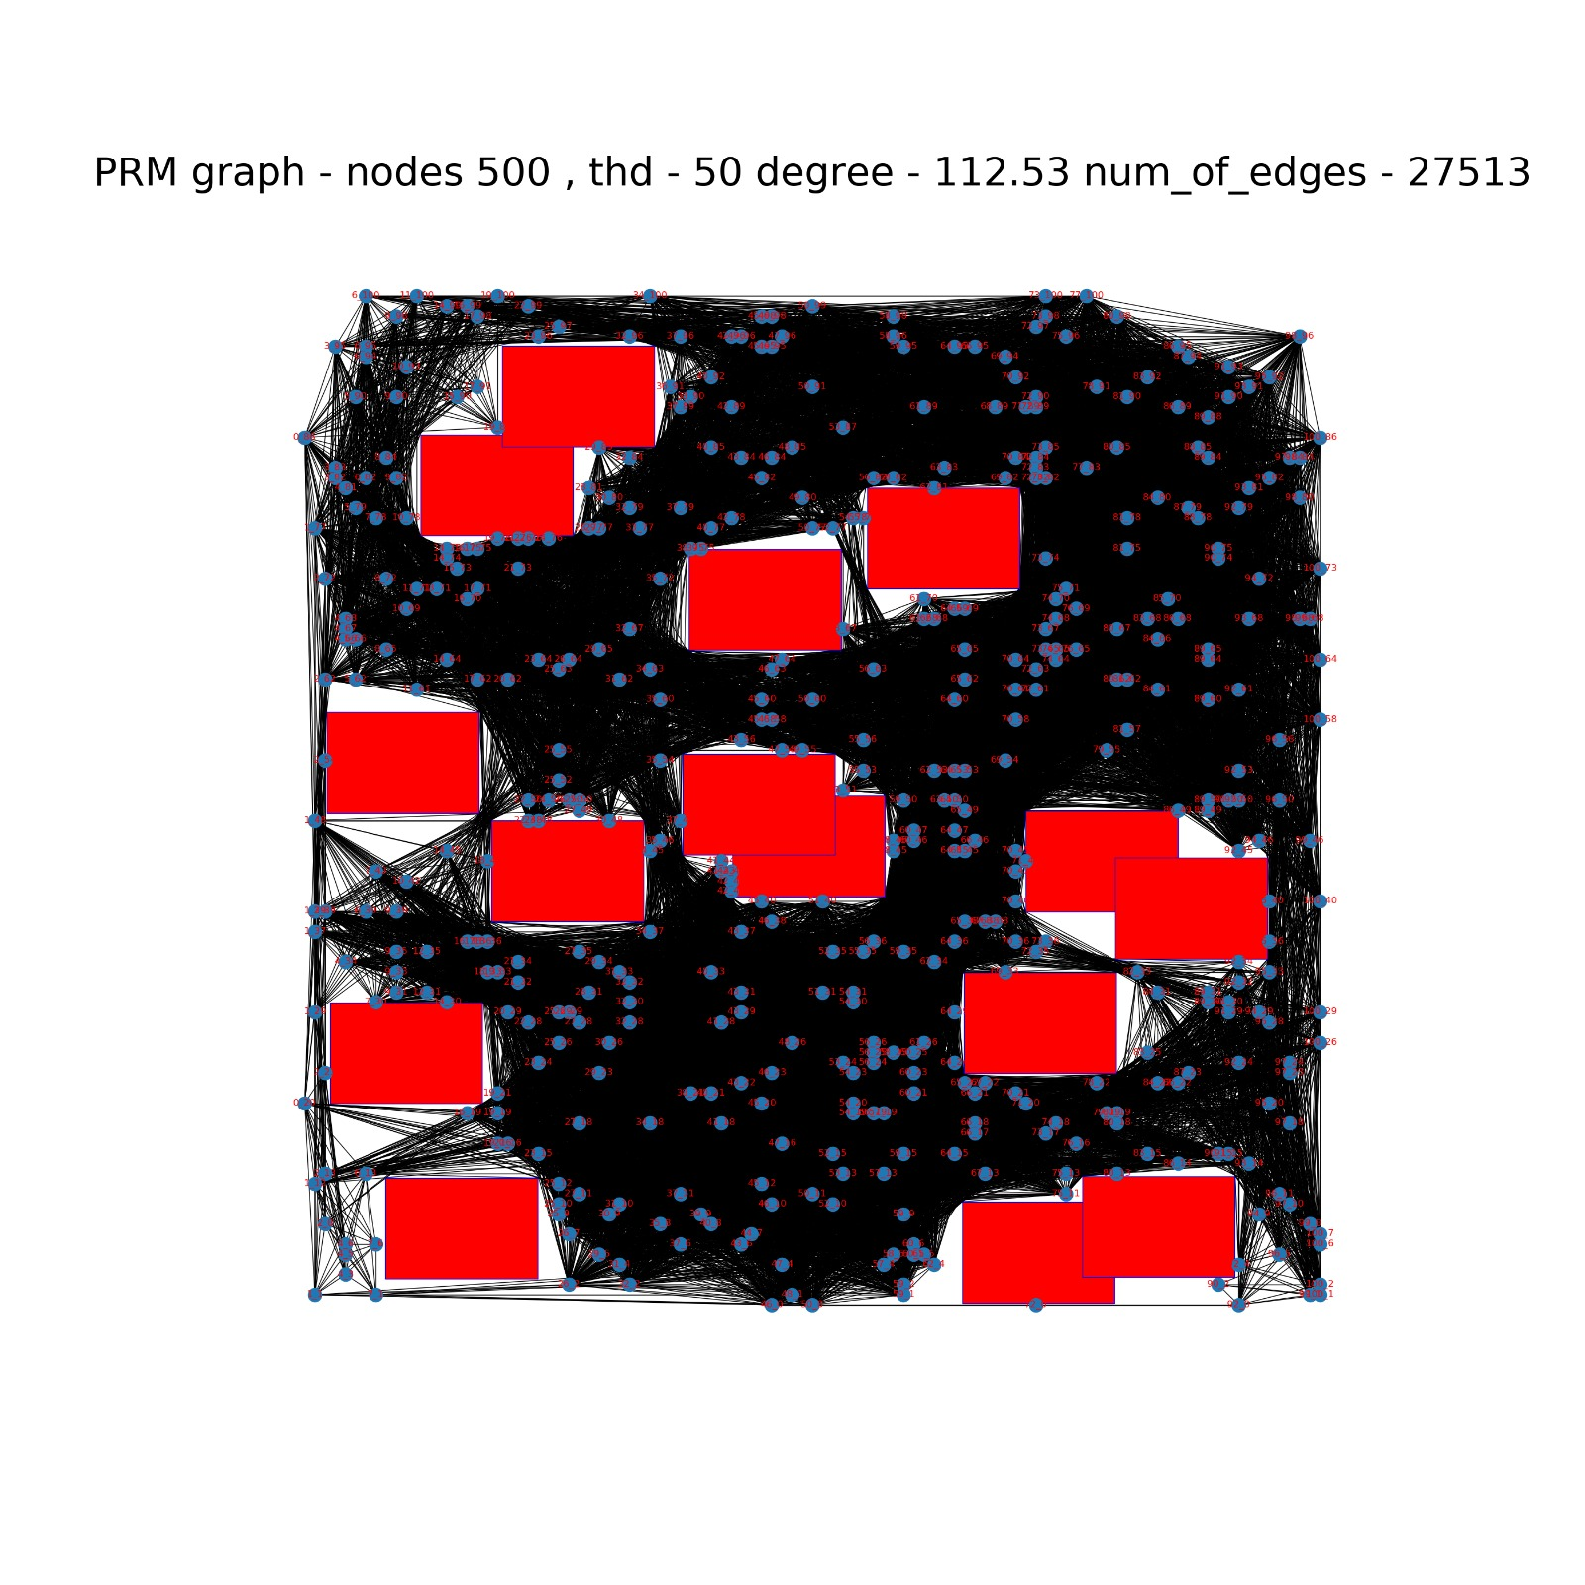

1. **Graph search:**

We implemented the Dijkstra algorithm in GraphSearch.py.

Edges are in yellow and shortest path edges are in green.

The plot for the shortest path computed by Dijkstra:

