1. **Quantization**
   1. As can be seen in the histogram, the distribution of the gray levels is not uniform.

* 1. Implemented in code

* + 1. As Expected, The Intervals that determined by the decision levels are not uniformly distributed. They are more concentrated where the pdf is denser. Therefore, the Max-Lloyd algorithm achieves a smaller MSE especially when the number of bits for representation is small. We can also see that the Max-Lloyd algorithm MSE is always lower since its decision levels are initialized uniformly and at each step the error can not get bigger.

1. **Subsampling and Reconstruction**
   * 1. sub-sampled image in the MSE sense, for all different sub-sampling factor:

The MSE as a function of the integer sub-sampling factor:

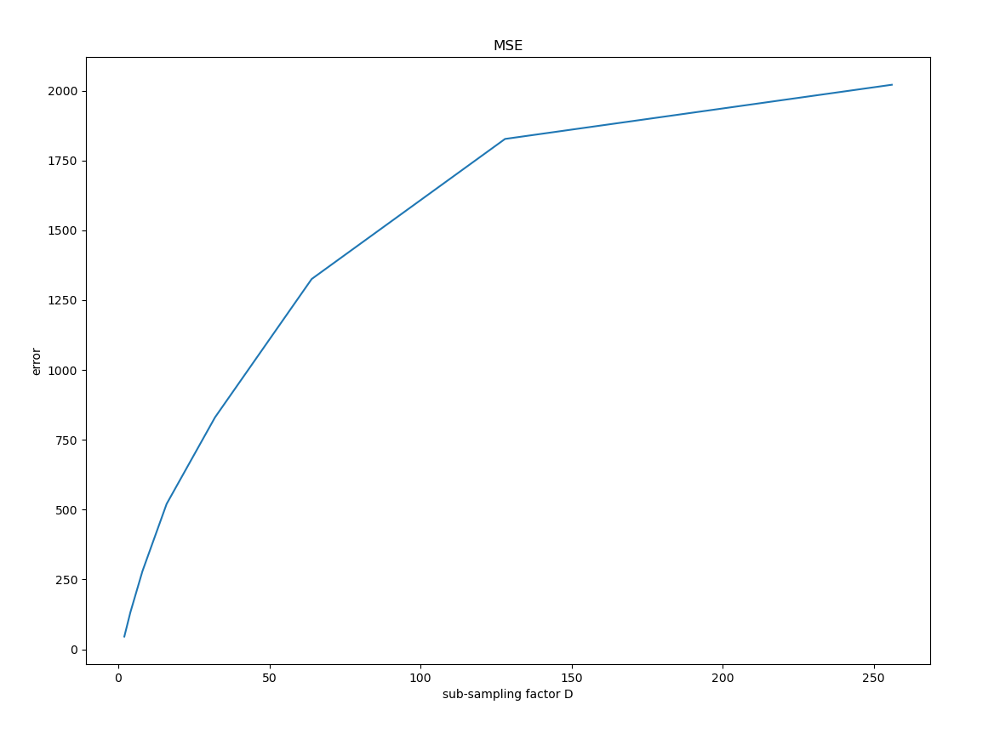

* + 1. sub-sampled image in the MAD sense, for all different sub-sampling factor:

The MAD as a function of the integer sub-sampling factor:

* 1. reconstructed MSE:

Reconstructed MAD:

* 1. As expected, the bigger the sub-sampling integer D is, the more information the picture loses and thus the picture gets blurrier. For $D≥2^{5}$ the picture is not recognizable both in the MSE and MAD sense.

1. **Solving the L p problem using the L 2 solution**
   1. Pseudo-code:
   2. Implemented in code
   3. Implemented in code
   4. …
   5. Solution does not converge