Main screen

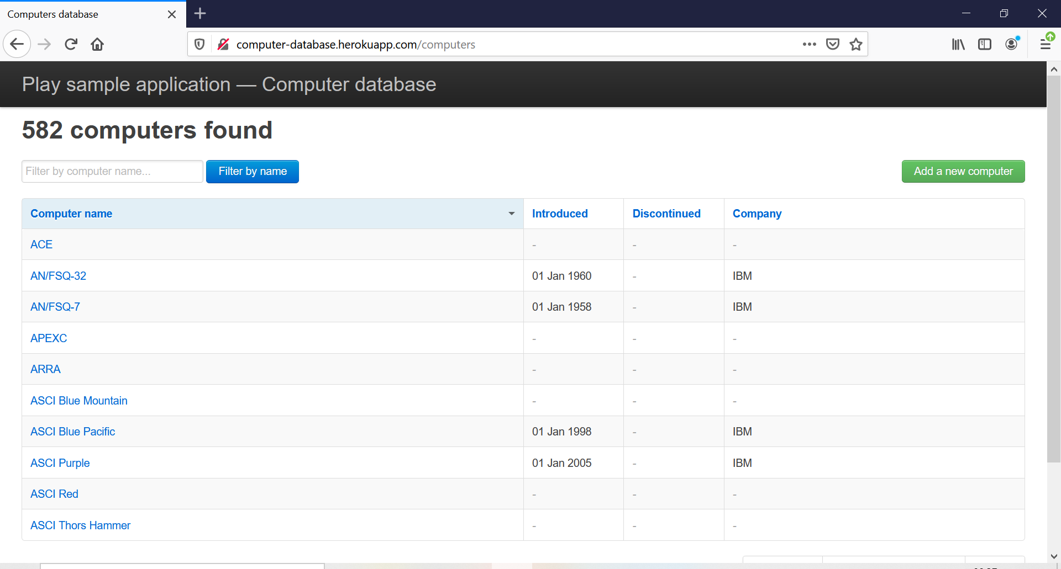
http://computer-database.herokuapp.com/computers

Bottom part screen
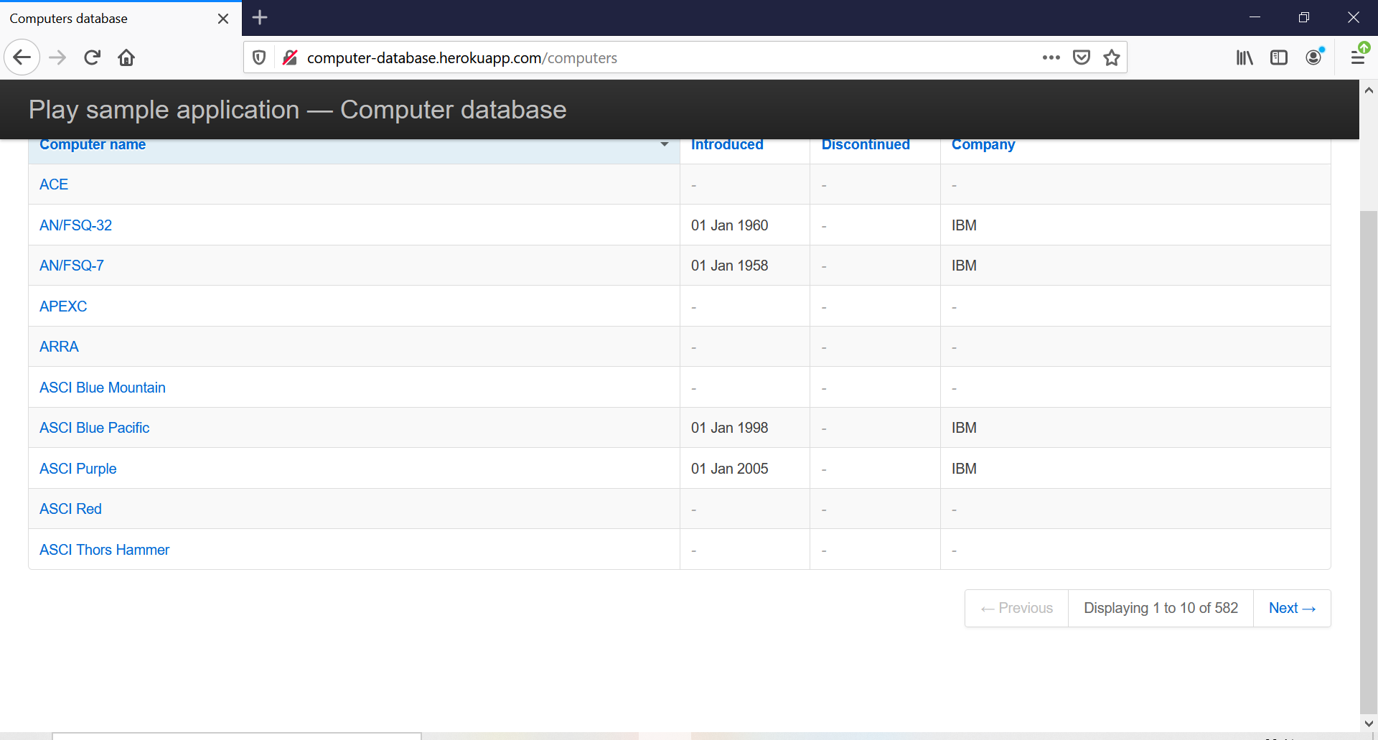

Add page
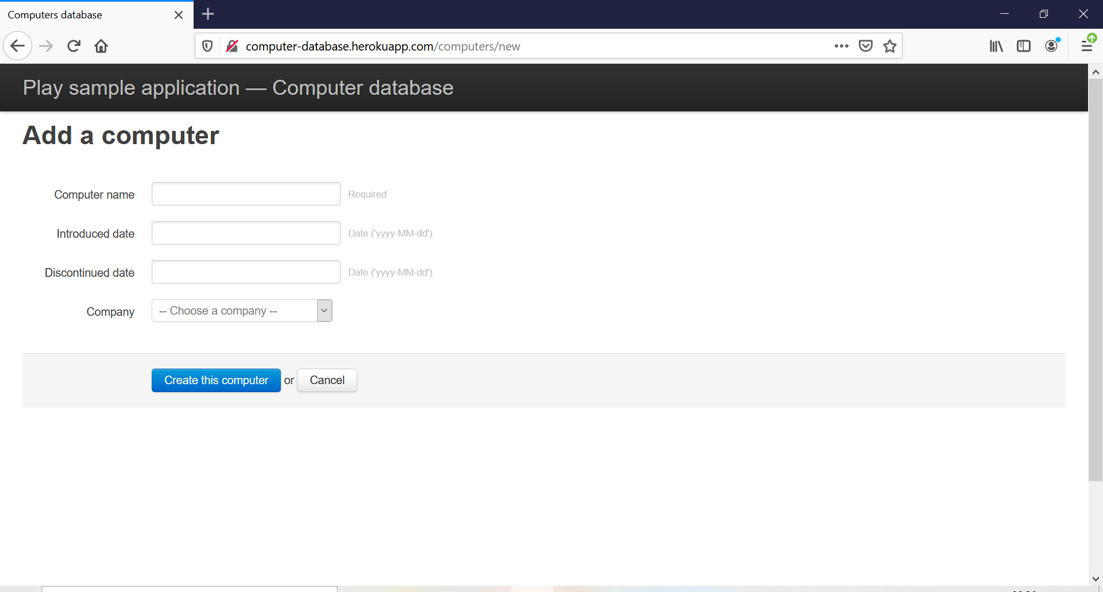
http://computer-database.herokuapp.com/computers/new
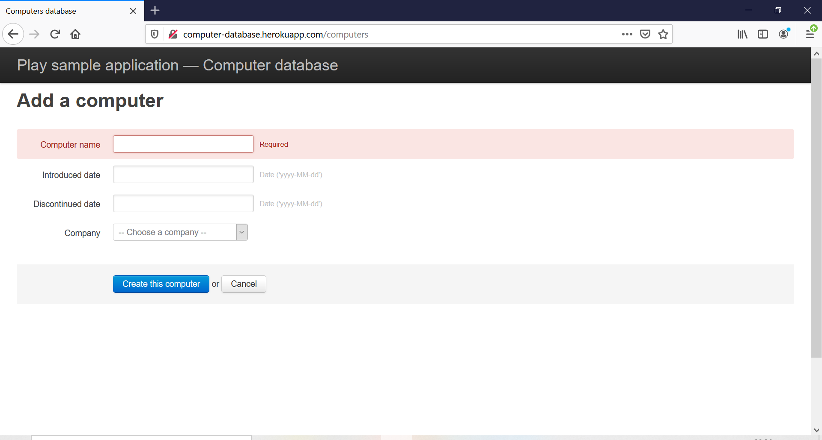
Warning

Succesfull addition
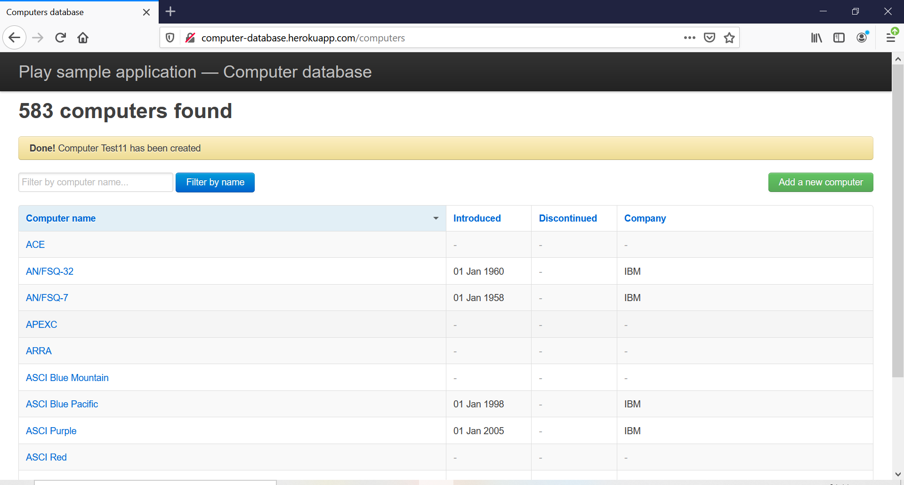

583 computers found

Done! Computer testcomp has been created
<div class="alert-message warning">
<strong>Done!</strong> Computer testcomp has been created
</div>

<input type="search" id="searchbox" name="f" value="" placeholder="Filter by computer name...">

