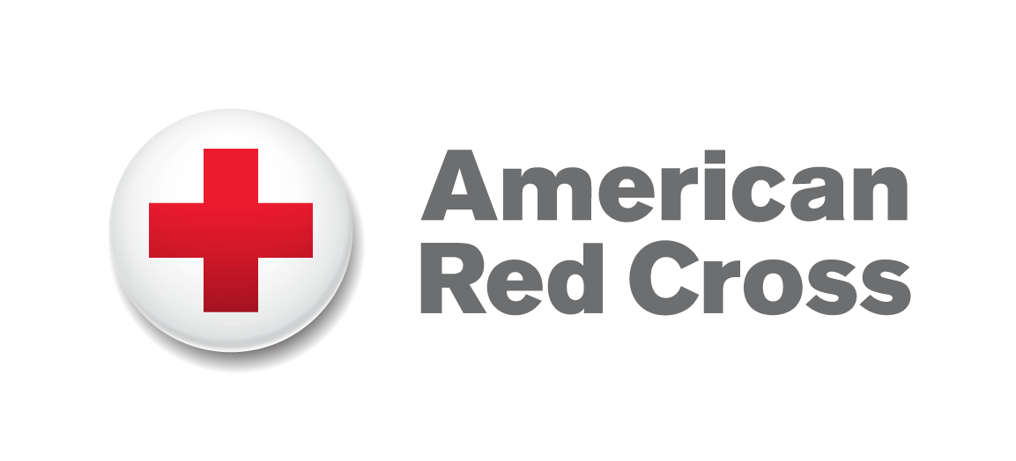

I. COVER SHEET (to be filled in by ARC)

Project Name
Project Location(s)
Project Sector(s)
Donor
ARC Contact
Project Duration
Budget
Project Goal
Project Components
Estimated Beneficiaries
Partners and Their Roles
ARC Office Location/s
Number of ARC Field Staff | Expatriate: National:
Operating Modality for ARC

List of Acronyms

II. EXECUTIVE SUMMARY (1 page)

Funding Request:
Please fill in the following statement:
The _________ RC is requesting $_________ from the American Red Cross for the ____________(Program) to increase our national societies’ foundations of sustainability, service delivery effectiveness and ultimately greater success in fulfilling our mandate.

Problem Statement:
Briefly state the organizational development (OD) challenge/opportunity to be addressed, and why your National Society is focusing on this area.

Goal, Objectives and Main Outputs/Results:
State the goal for your initiative.

List the objectives of your OD initiative. Objectives should be Specific, Measurable, Achievable, Realistic and Time-bound.

State the expected outputs/results to be achieved within the timeframe of this grant.

Roles and Responsibilities:
Provide a brief description of the role and type of support provided by:

Your National Society

American Red Cross

Federation (if applicable)

Other Partnering National Societies (if applicable)

Other non-Movement Partners (if applicable)

Sustainability:
Briefly describe how the proposed change process will lead to scalable and sustainable development for the organization as a whole.

- ASSESSMENT FINDINGS AND DESIGN METHODOLOGY (1-2 pages)

Describe the assessment tools (i.e. STAR, OCAC, other…) and approaches used (or to be used) to identify the OD challenge/opportunity to be addressed. Include a description of the process; and NS personnel/volunteers, ARC, Federation, others (as applicable) who participated in the assessment process.

Provide a brief background on the specific OD challenge/opportunity identified through the assessment process that is to be addressed in this initiative. Include any accomplishments achieved in this area to date. Describe where your NS is in its overall development of this area and where it wants to be at the end of this grant period.

Describe how the proposed initiative will benefit the development of the organization as a whole.

- OVERVIEW OF TARGET AREA AND BENEFICIARY POPULATION
(1-2 pages)

Describe the proposed program area, department or region (provide a map if possible/applicable). Is this initiative focused on headquarters, branches, sub-branches or a combination?

Who are the targeted beneficiaries (i.e. governing boards, leadership, staff, volunteers, communities, etc…)?

List the process and rationale used to select these areas and target beneficiaries.

- PROJECT GOAL, OBJECTIVES, OUTPUTS, AND CRITICAL ACTIVITIES
(1-2 pages)

This section is intended to be a narrative description relating directly to the Logframe and M&E Plan in Appendix II.

State the goal, objectives, outputs of the proposed program.

Include the proposed activities to be utilized to achieve the stated goal(s)/outputs.

Describe, in narrative form, the theory of change connecting the proposed activities to the broader outputs/results and goal(s) sought through this initiative.

Describe why the proposed activities are the most appropriate response to the problem, opportunity or challenge.

Describe how the proposed program contributes to existing NS initiatives, plans or broader strategies.

- MONITORING AND EVALUATION PLAN (1/2 page)

The M&E plan (attached as a template in Appendix II) should include:
- A baseline for each indicator
- Indicator definitions – what is the indicator measuring?
- How will data on each indicator be collected? Who will collect the data? How often will they collect the data? Why are we collecting the data?
- Who will use the data and information collected?

Evaluation/Learning Events:
- Describe here in narrative form your plans and methods for conducting reviews, evaluations, and any additional assessments to learn from proposed activities, outputs and outcomes.

- NATIONAL SOCIETY, ARC AND PARTNER ROLES AND
RESPONSIBILITIES (1-3 pages)

Describe the methods for managing and implementing the proposed program and include a diagram of the NS management structure.

Define the roles and responsibilities of key individuals within the project management structure and each partner (including the American Red Cross) in detail. You may use the Roles and Responsibilities Matrix to illustrate the roles of all stakeholders.

Describe supporting and participating partner organizations and why these particular partners were chosen to support this initiative (either through financial, technical, in-kind or other types of support)

Please include letters of support from all participating partners, agreeing to their defined roles, with the proposal or as soon as possible.

If the Federation or other Partner National Societies are supporting other programs (not just, but including OD / capacity building projects) please describe how they may be complementary to this proposed project and its outputs.

- SECURITY and RISK ANALYSIS (1 page)

Describe any risks associated with the proposed program that may affect the program outcomes. Include factors both within and outside your organization’s control.

List strategies you will use to reduce risk and ensure the proposed results are achieved.

- SUSTAINABILITY (1 page)

Describe in detail the plan for ensuring sustainability beyond the period of this grant and external donor support.

Consider the following:
- Is the project finite or ongoing?
- Will the proposed intervention contribute to self-sufficiency of your agency and/or enable it to expand services that might be revenue generating?
- Will the project make your organization attractive to other donors in the future?

- COST PROPOSAL (1/2 page)

The budget and the budget narrative should be attached as Appendix IV in the template provided.

Please make sure you consider the following:
- Detail all direct costs associated with the implementation of the proposed activities, as well as indirect costs and any costs related to sub-agreements and/or contracts.
- A detailed budget narrative must be provided for all costs.
- NS are encouraged to provide cost share to this proposed program. Cost share may be a combination of cash and in-kind from internal national society resources, other partners, other donors, community members, businesses, government, etc…

If cost share is not available at the start of the project, describe here in narrative form opportunities and a plan (or the lack of opportunities depending on your context) to obtain cost share and or additional support in the future.

- APPENDICES

Appendix I: Roles and Responsibilities Matrix
Appendix II: Logical Framework and M&E Plan
Appendix III: Timeline / Implementation Plan
Appendix IV: Budget

