EECE 2140: COMPUTING FUNDAMENTALS FOR ENGINEERS
Spring 2026

Git and GitHub Tutorial

Source Control Management (SCM), i.e. a tool, allows you to track and manage changes to your file over a period, making it possible to revert to a file.

- Check if git installed.
Open command prompt/ terminal on your system, type “git” and hit Enter. If you see the git usage screen, then it's already installed.
  - Windows user: git is not automatically installed.
  - Mac user: git is typically already installed.
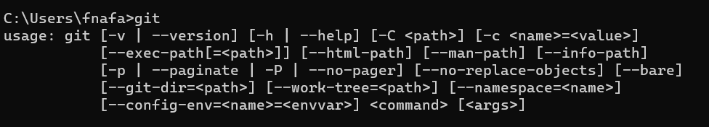
Please begin the installation process by clicking on the link below if it has not been installed yet.
- Installation: https://git-scm.com/downloads
Note: when git is installed, git Bash is automatically installed.
Open Git Bash (or any terminal of your choice)
To launch Git Bash from the Windows Command Line (CMD) or PowerShell
Using start Command: You can use the start command in CMD to launch Git Bash

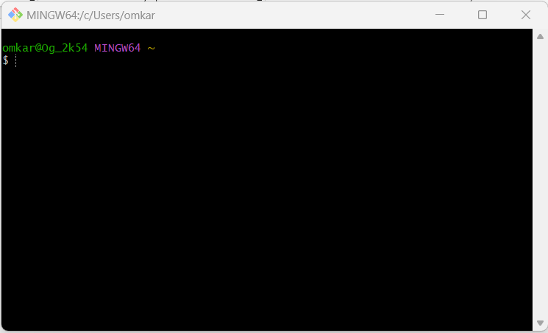

- Verify your current path by executing the command: type “pwd” and hit Enter
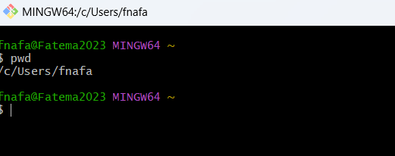
- Create a directory you want to set as your repository type “mkdir foldername” and hit Enter 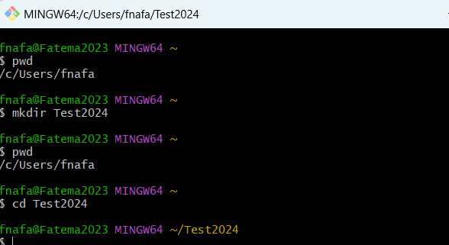

- Then navigate to the folder that you want to set as your local repository by writing the following command type “cd” followed by your path
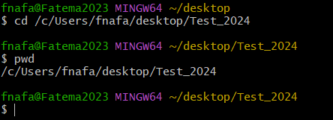

- Create a repository.
- type “git init” and hit Enter The command with no parameters initializes the current directory (i.e. folder) as the repository.
- type “git init nameOfRepo” and hit Enter The command with parameter (fileName) creates and initializes a new repository (i.e. subdirectory/subfolder) in the current directory. You can name it whatever you please.
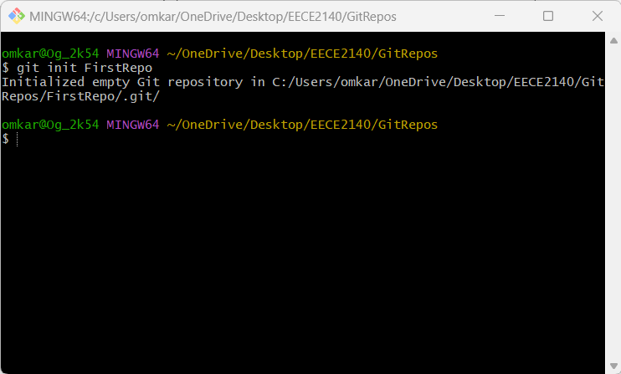

- type “git config --global init.defaultBranch” and hit Enter
- $git config --global init.defaultBranch main //rename the name of the default branch in our repository to ‘main’ (a typical default name).
- Type "git branch -m main” //set the name of the master branch; make sure you are in the subdirectory if you used $git init with parameters. (Notice how the name “(master)” gets changed to “(main)” on the right the first time you do this).
- Type “git config --global user.name” “nameHere” //you need this for when you commit later
- Type ”git config --global user.email “emailHere” //note, executing this command resets your email if you already have one.
- Check that your repository has the. git directory in it (this is what makes the directory a fit repository and what tracks the changes of the files within the target directory). You can check by navigating to the directory/folder through your terminal or file system (file explorer for windows or Finder for Mac); you might need to unselect hidden files in your system to see it.
- Type “ls -a” //type this in your terminal to see directory or use your file explorer (windows) or Finder (Mac) to view directory from there
- Quick Helper tip:
  - Type “git command –h" //displays help information about the config command in the terminal.
  - Type “git help command” //opens a manual (a more detailed description) that is hosted on your computer.
  - Type “git status” //to show current branch and commits. It also allows you to see tracked vs. untracked files. It is a very useful command!

Part1: Summary to Create a Git Repository
- Initialize the directory as a repository:
$git init
$ls -a #check that git exists
$ ls -la #give more details
$git config --global init.defaultBranch main
$git branch -m main

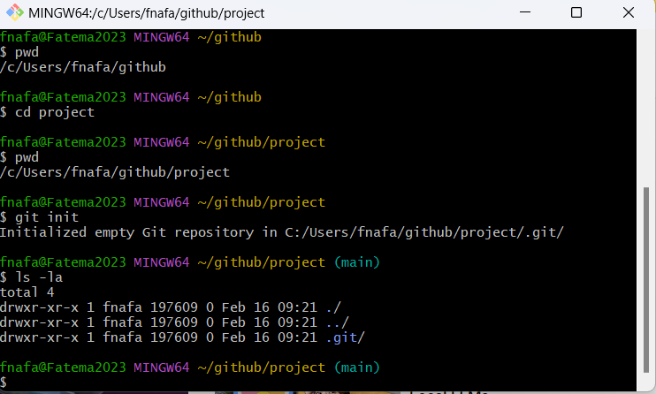
- Use config to add your name and email:
$git config --global user.name “nameHere”
$git config --global user.email “emailHere”
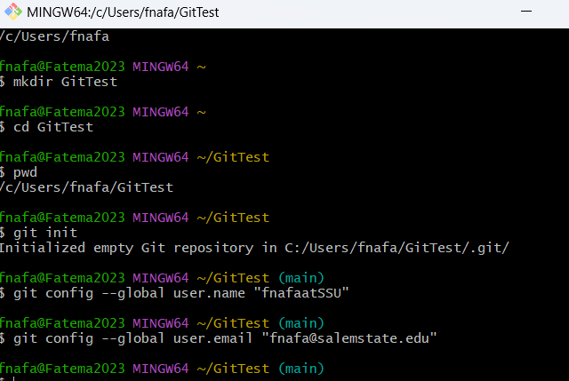

- Create a New File in your Repository.
Open your directory where you have initialized git now, create a python file and name it for e.g. “main.py”

Part2: Add/remove the file to/from the repository:
  - working directory = Untracked files (red); working directory - you can make changes in file and don’t have to commit those changes; git won’t care about these files.
  - staging area = Tracked files (green). Changes that are ready to be committed, meaning git will keep track of the changes in these files.
  - commit = Officially saving the repository at a point in time (i.e. saving the current state of all the tracked files in our git record). //you can read more on the staging area at https://git-scm.com/about/stagingarea
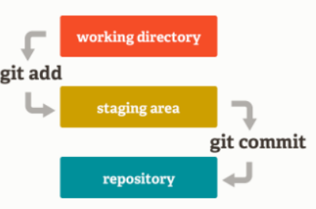
  - Type “git status” //use git status to help you see staged files and unstaged files.
  - Type “git add fileName”// track one file (move into the staging area)
  - Type “git status”
  - Type “git rm --cached fileName” //untrack a file (move back into working directory.)
  - Type “git status”
  - Type “git commit -m “messageHere” //This command commits everything that is in staging. The current state of the repository is what will be logged. Make sure to add a concise description or summary in the quotation marks of what you changed/added/deleted (i.e. the metadata); this helps other programmers who might look through your commits. If you don’t provide a description, then you will get prompted to add one.
  - Type “git status” //enter git status to see what changed after committing.
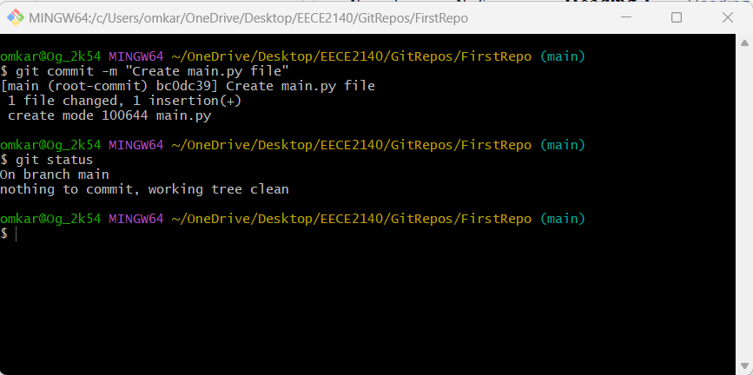
  - To see changes you make in a tracked file:
* Note: git will only tell you changes that happens to tracked files (ex. modified, deleted ,…)
Type “git diff filename”
Type “git log” //shows you everything.
Type “git log –oneline” //shows just one line
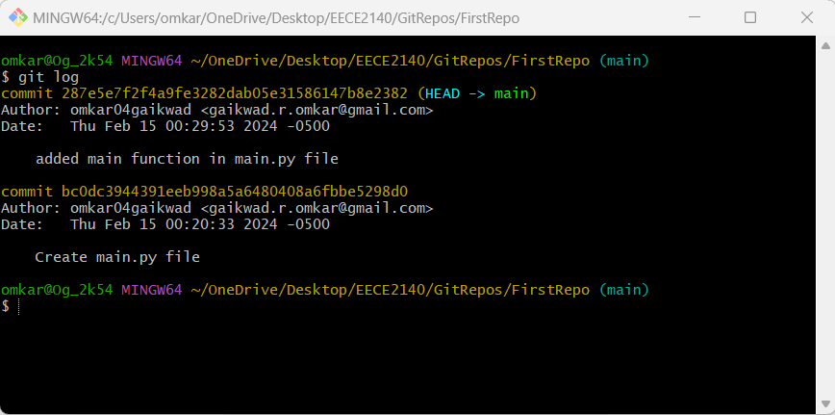

GitHub
GitHub is a web-based platform that provides hosting for version control and collaboration, allowing users to work together on projects from anywhere in the world. Built around Git, the open-source version control system invented by Linus Torvalds, GitHub facilitates code sharing and editing, feature development, bug tracking, and review processes in a collaborative environment.
- Create a GitHub account.
  - Link: https://github.com/
- Setup a new remote repository (go to the new repo page):
Notes:
  - Setting a description is helpful and good practice.
  - Make it public (it can be searched, and any can see it) or private (it cannot be searched, but you can still share it amongst collaborators).
  - (optional) add ReadMe file and/or a .ignore file. Adding a ReadMe file is a very good practice, it helps others who are interested in what your repository is all about. These are optional because they can be added at any point. For example, if you decide later that there is a file you don’t want to git to track, you can manually create a simple. ignore file.
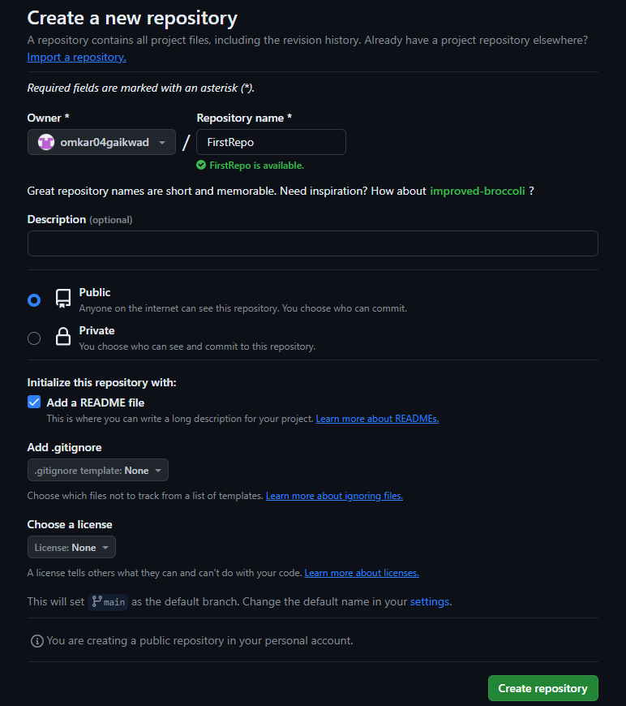
- To copy the URL of the repository you've created, please refer to the following:
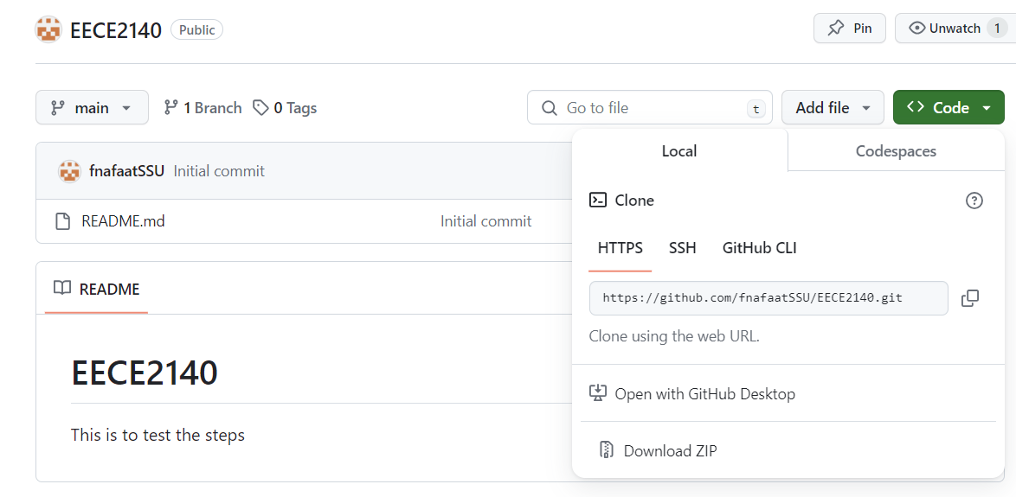

- Push an existing repository (through the terminal):
  - Type “git remote add origin urlLink” //establishing a remote connection with GitHub and calling it origin (a common name used), with the address we are connecting to.
  - Type “git branch -M main” //sets the target branch to main.
  - Type “git push -u origin main” //push all our contents from our local repository to the cloud.
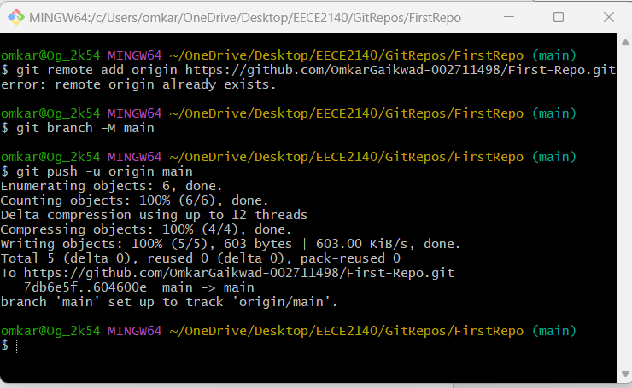
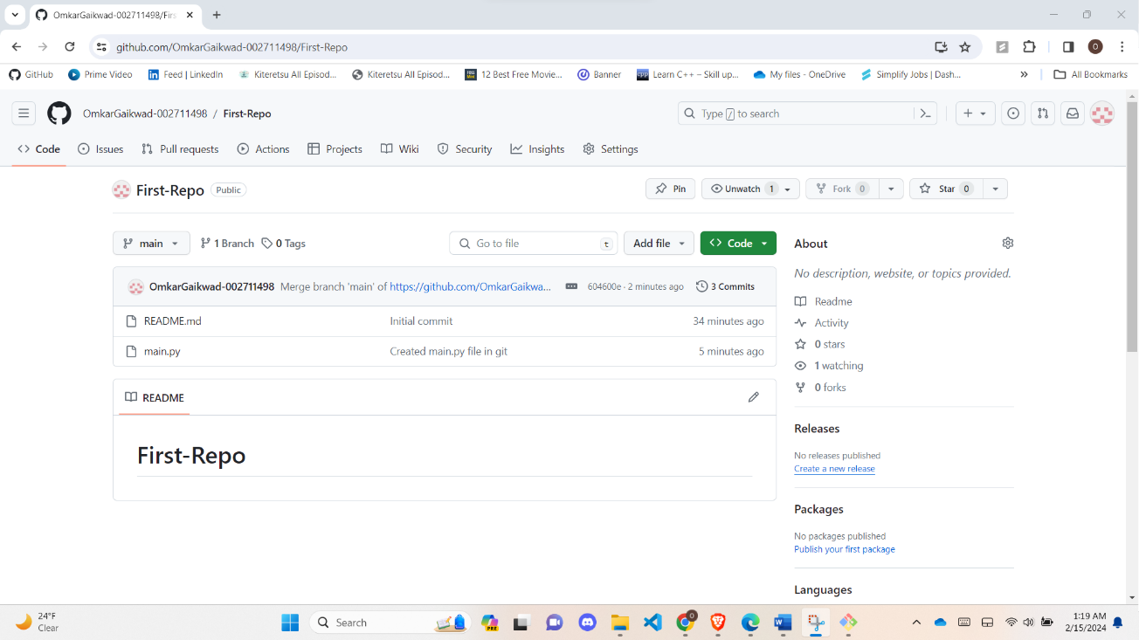
- Check your pushed repository on GitHub: (it should be synced on GitHub)
*re-click the name of the repository you created on GitHub and your pushed data should appear.
    - Review the commits in your GitHub repository.
    - Add a file directly on GitHub.
    - Edit a file directly on GitHub.

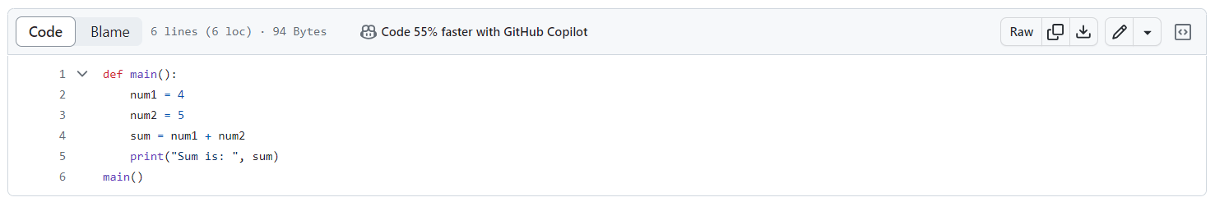
- Updating your local repository (through terminal):
  - $git pull // is used to fetch and download content from a remote repository and immediately update the local repository to match that content. (recommended)
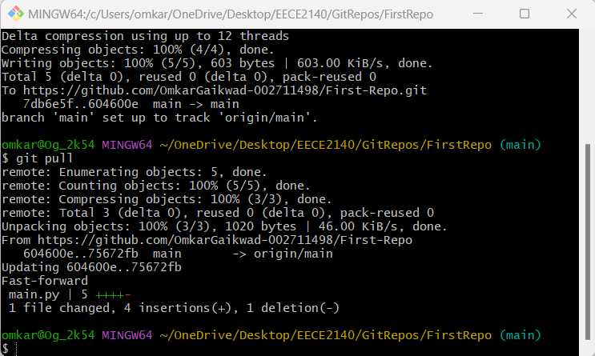
  - $git fetch and $git merge // git fetch downloads all the history from the remote tracking branches, but we need to execute a git merge after it (on a new line). $git pull = $git fetch + $git merge
- Adding collaborators
  - Go under your GitHub settings and you will see on the left side “collaborators” which is how you can add collaborators to your repository.
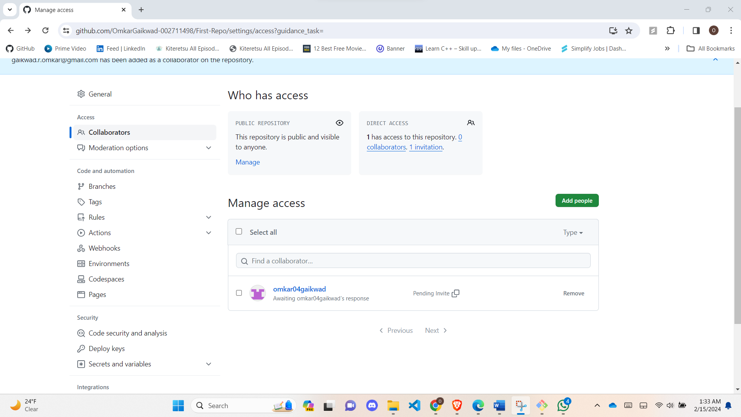
  - Cloning: *The act of copying a remote repository then downloading into our local git repository so we can make commits to it and push it back.
    - $git clone urlLink
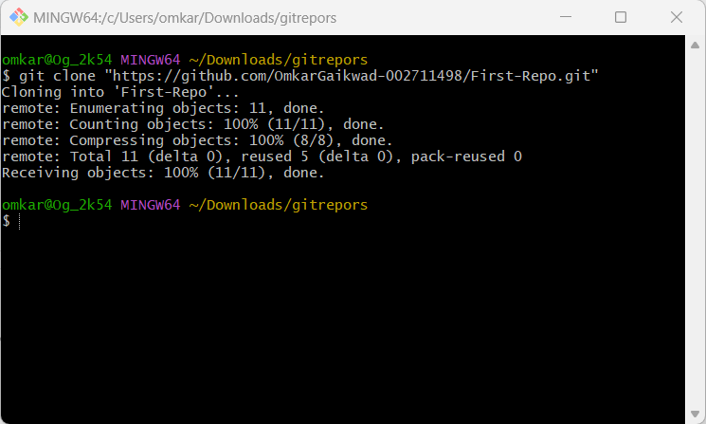
- After cloning make changes in the main.py and push it back

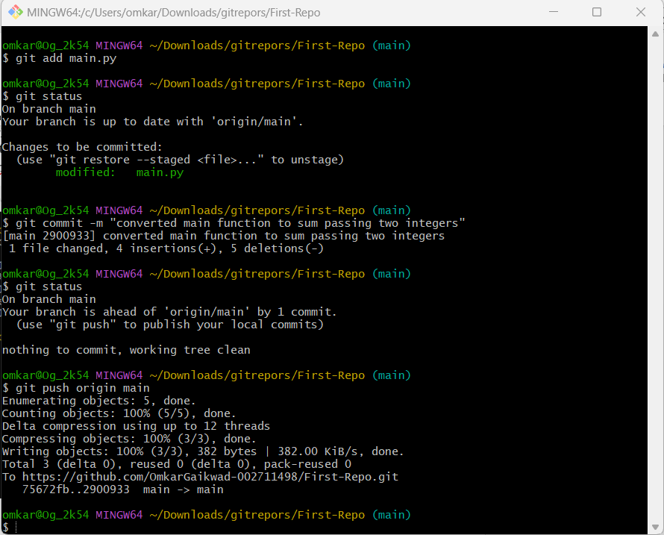
- In the website you will see the new changes are made
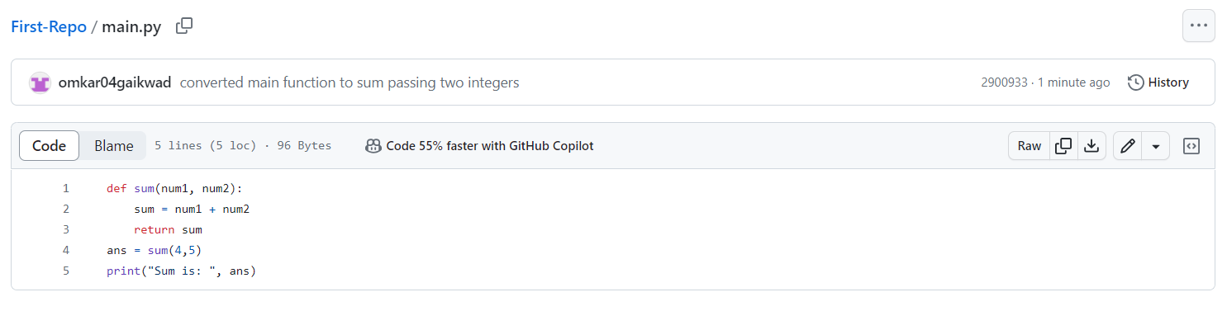
- Create branch name version_1 and checkout or switch to that branch
git branch <branch name>
git checkout <branch name>
make changes in the main.py and push the changes
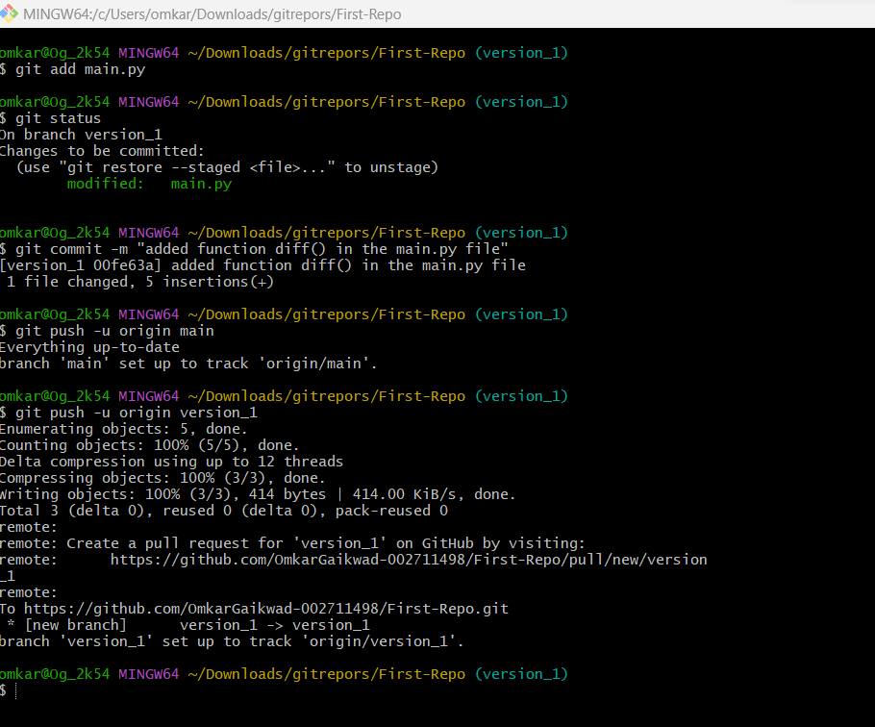
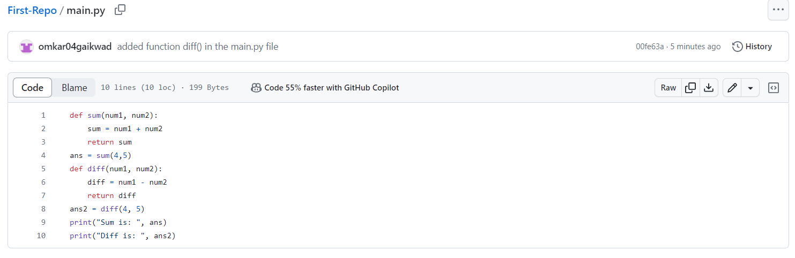

- Merge two branches.
  - Checkout the Target Branch:
    - Ensure you are on the branch where you want to merge changes. For example, if you want to merge into the main branch:
$ git checkout main
  - Merge the Source Branch:
    - Use the git merge command to merge changes from the source branch (feature-branch) into the target branch (main):
$ git merge feature-branch
    - This command incorporates changes from the source branch into the target branch. If there are no conflicts, Git will automatically perform the merge.

  - Resolve Conflicts (if needed):
    - If there are conflicts between changes in the target and source branches, Git will notify you, and you'll need to resolve the conflicts manually. Open the conflicted files, make the necessary changes, and then commit the resolved changes:
$ git add <conflicted-file>
$ git commit -m "Merge branch 'feature-branch' into main"
Replace <conflicted-file> with the actual filename.

  - Complete the Merge:
    - After resolving conflicts (if any), complete the merge:
$ git merge --continue
    - This finalizes the merge and commits the changes.

  - Push Changes (if merging a branch from a remote repository):
    - If you are merging a branch that was pushed to a remote repository, you may need to push the changes to the remote repository:
$ git push origin main
Replace main with the name of your target branch.
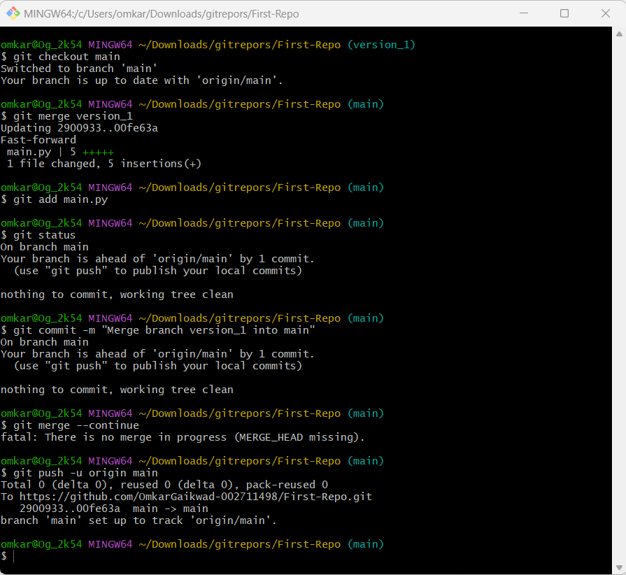
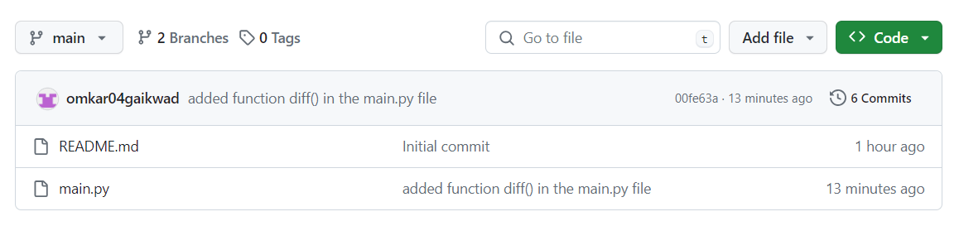
- To get log enter $git log
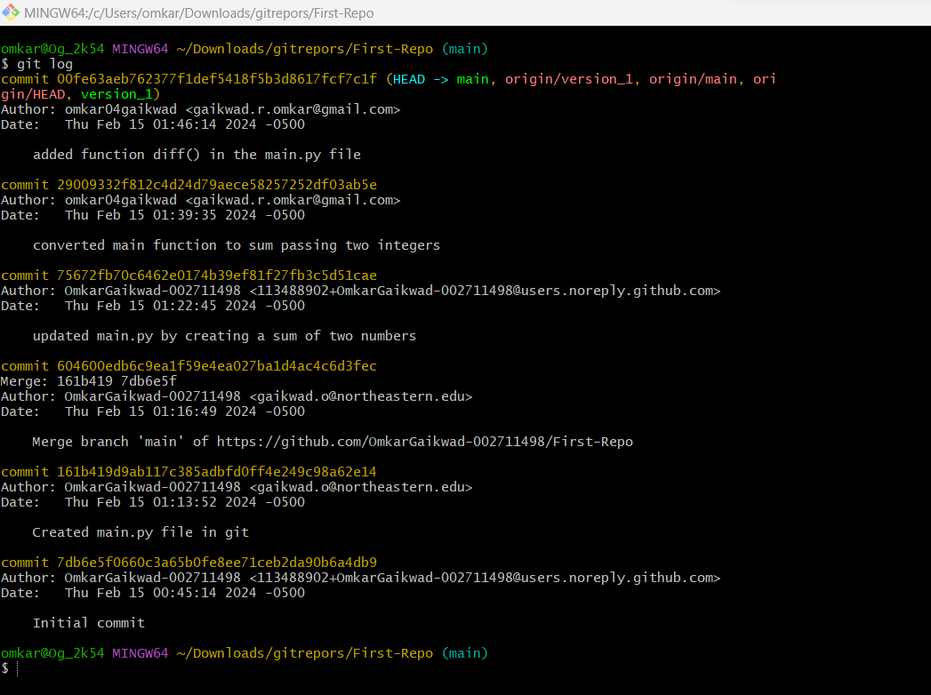
- In Activities tab you can see the work done by the collaborator
