FLOWER ORDER AND DELIVERY MANAGEMENT SYSTEM

A BAM - 285 Final Coursework
Presented to the Faculty of the
College Information Technology Education
Phinma University of Iloilo
Rizal, Iloilo City

In Partial Fulfillment
of the Requirements for the Degree
Bachelor of Science in Information Technology

BY
Ronel A. Atyaw
Raydel S. Canomay
Karl Laurens J. Dela Cruz
Rodemil M. Dimaclid
Vince T. Dubal
Joel D. Duran
Antonio Gelangre Jr.
Josh Florenz H. Tolentino
Andrian, Sumido

October 2026
Approval Sheet

FLOWER ORDER AND DELIVERY MANAGEMENT SYSTEM
Automates flower orders, delivery assignments, delivery status, and customer tracking

A BAM - 285 Final Course Work
Presented to the Faculty of the
College Information Technology Education
Phinma University of Iloilo
Rizal, Iloilo City

In Partial Fulfillment
of the Requirements for the Degree
Bachelor of Science in Information Technology

BY
Ronel A. Atyaw
Raydel S. Canomay
Karl Laurens J. Dela Cruz
Rodemil M. Dimaclid
Vince T. Dubal
Joel D. Duran
Antonio Gelangre Jr.
Josh Florenz H. Tolentino
Andrian, Sumido

Marlo Kyn B. Bunda Kristine Anne Laguna
Panel Panel

Jenny Rose Montille Jireh A. Flavio
Panel Adviser

Concurred:
Marlo Kyn B. Bunda Seth D. Nono, MSCS
BAM – 285, Project Lead CITE Dean

October 2026

ACKNOWLEDGEMENT

The researchers would like to extend their sincerest gratitude to all those who have contributed to the successful completion of this study titled "Flower Order and Delivery Management System".

Above all, to Almighty God, for His unfailing grace, wisdom, and strength that guided us throughout the conduct of this research.

To our research adviser, Sir, Jireh A. Flavio for his patience, guidance, and valuable insights that helped us improve and complete this study.

To our panel of evaluators, Sir, Marlo Kyn B. Bunda, Ma'am, Kristine Anne Laguna and Jenny Rose Montille for their constructive comments, suggestions, and recommendations for the betterment of our system.

To Margie's Flower Shop/Mary Grace Gabrido, for allowing us to conduct our study in your establishment and for sharing valuable information needed for the development of the system. To our families and parents, for their unconditional love, moral and financial support, and constant encouragement. And to everyone who, in one way or another, has extended their help and support, our heartfelt thanks.

The Researchers,
Ronel A. Atyaw
Raydel S. Canomay
Karl Laurens J. Dela Cruz
Rodemil M. Dimaclid
Vince T. Dubal
Joel D. Duran
Antonio Gelangre Jr.
Josh Florenz H. Tolentino
Andrian, Sumido

October 2026

EXECUTIVE SUMMARY
The flower shop currently manages customer orders through different methods such as phone calls, messages, and social media. While this allows customers to place orders, it can sometimes cause problems in tracking orders, assigning deliveries, and updating customers.
The proposed Flower Order and Delivery Management System will help organize and automate the ordering and delivery process. Customers can place their flower orders, provide delivery details, and check the status of their orders.
The system will help staff manage orders, assign deliveries, update delivery status, and keep customer information in one place. It will also help the owner monitor orders and create simple reports.
The project uses business analysis tools such as process mapping, stakeholder analysis, requirements analysis, SWOT analysis, and current-state and future-state process analysis.
The proposed system is expected to make the flower ordering process faster, more organized, and easier to manage.

TABLE OF CONTENTS
ACKNOWLEDGEMENT 4
EXECUTIVE SUMMARY 5
LIST OF TABLES 8
LIST OF FIGURES 9
CHAPTER I - INTRODUCTION 1
1.1 Background of the Project 1
1.2 Statement of the Problem 2
1.2.1 General Problem 2
1.2.2 Specific Problems 2
1.3 Objectives of the Project 4
1.3.1 General Objective 4
1.3.2 Specific Objectives 4
1.4 Significance of the Project 5
1.5 Purpose and Description 5
1.6 Scope and Limitations 7
Scope : 7
CHAPTER II 8
REVIEW OF RELATED LITERATURE AND SYSTEMS 8
2.1 Review related literature (RRL) 8
2.2 Related Systems 12
2.3 Synthesis 13
CHAPTER III 15
METHODOLOGY, RESULTS AND DISCUSSION 15
3.1 Requirements Analysis 15
3.1.1 Stakeholder Analysis 15
Stakeholder 16
Organizational Role 16
Core Responsibilities 16
Points / Needs 16
Expectations 16
3.1.2 SIPOC Analysis 18
3.1.3 Current-State Process 20
3.1.4 Problems Identified 21
3.1.5 Root-Cause Analysis 23
3.1.6 Requirements 23
3.2 Framework of the Project 27
Figure 2. Project Implementation Roadmap 27
Figure 2. Proposed Automated Process 28
28
3.2.1 Proposed Future-State Process 28
3.2.2 Before and After Comparison 29
3.2.3 Proposed System Modules 29
3.2.4 Automation Rules 30
3.2.5 Sample Flower Order 30
3.2.6 Admin Dashboard 31
3.3 Development and Testing 32
3.3.1 Prototype 32
3.3.2 Test Cases and Verification Scenarios 33
3.3.3 Sample Test Result 35
3.4 Implementation Plan 35
3.4.1 Implementation Schedule 37
3.4.3 Risk Analysis and Mitigation 38
3.4.4 User Training and Change Management 39
CHAPTER IV 40
RECOMMENDATION 40
Development Tools 40
Hardware Requirements 41
Required for online access and related services. 42
Input and Outputs of the Study 42
Results Interpretation and Analysis 43
Results 43
Interpretation 45
Analysis 45
System Evaluation Results 46
CHAPTER V 46
CONCLUSION AND RECOMMENDATIONS 46
5.1 Introduction 47
5.2 Summary of the Proposed Study Design and Implementation 47
5.3 Summary of Findings 48
5.4 Conclusion 48
5.5 Recommendations 49
References 50
APPENDIX A RESOURCE PERSON AND INTERVIEW TRANSCRIPTS 50
INTERVIEW METADATA & PROFILE 50
STRUCTURED INTERVIEW INSTRUMENT AND FINDINGS 50
APPENDIX C DISCLAIMER 52

LIST OF TABLES

LIST OF FIGURES

Figure 1. Current IT Support Process
Figure 2. Proposed Automated Process
Figure 3. Project Framework
Figure 4. System Architecture
Figure 5. Implementation Roadmap

CHAPTER I

INTRODUCTION

Background of the Project

Flowers are commonly ordered for birthdays, anniversaries, graduations, weddings, and other special occasions. Many flower shops receive orders through phone calls, Facebook messages, text messages, or walk-in customers.
When orders are handled manually, it can be difficult to keep track of customer information, flower orders, delivery schedules, and payment details. There may also be cases where an order is forgotten, a delivery is delayed, or the customer does not receive an update.
The Flower Order and Delivery Management System is proposed to help solve these problems. The system will provide one place where the flower shop can manage customer orders, delivery assignments, and order status. This can help the staff work more efficiently and provide better service to customers.

1.2 Statement of the Problem

1.2.1 General Problem
The main problem of this project is the difficulty of managing flower orders and deliveries using manual methods. Some flower shops rely on phone calls, messages, and written records to handle orders, which can sometimes lead to mistakes, forgotten orders, and delayed deliveries. It can also be difficult for staff to keep customer information organized and update customers about their orders. These problems may affect customer satisfaction and cause the shop to lose money, especially when flowers are not delivered on time and begin to wilt. To help solve these problems, the proposed Flower Order and Delivery Management System will make it easier to manage orders, organize delivery schedules, update order status, and help customers track their flower orders in one system.

1.2.2 Specific Problems
1. Difficulty in Organizing Flower Orders: The flower shop receives orders through phone calls, text messages, social media, and walk-in customers. Managing orders from different sources can make it difficult to keep track of every customer's request.
2. Incorrect or Incomplete Order Information: Some orders may have missing or incorrect details, such as the flower arrangement, quantity, delivery address, or preferred delivery date. This can cause misunderstandings between the staff and customers.
3. Problems with Delivery Scheduling: Arranging delivery schedules manually can be confusing, especially when several customers request deliveries on the same day. This may lead to scheduling conflicts and late deliveries.
4. Lack of Order Status Updates: Customers may find it difficult to know the progress of their orders. Without regular updates, they may need to contact the shop to ask whether their flowers are being prepared or have already been delivered.
5. Difficulty in Managing Customer Records: Keeping customer information and order history in separate records makes it harder for staff to find previous orders, check delivery details, and respond to customer concerns.

1.3 Objectives of the Project

1.3.1 General Objective
- To design a Flower Order and Delivery Management System that will help the flower shop manage orders, deliveries, and customer updates more efficiently.

1.3.2 Specific Objectives
Specific Objectives :
- To develop a system that keeps flower orders, customer information, and delivery records organized in one place.
- To automate the recording and management of flower orders to make the ordering process easier and faster.
- To provide a feature for assigning deliveries and updating delivery statuses to help staff manage orders efficiently.
- To create a dashboard that allows the shop owner and staff to monitor orders, deliveries, and their current status.
- To reduce manual work and recording errors, save time, and provide customers with updates about their flower orders and deliveries.

1.4 Significance of the Project
Customers
The system can make it easier for customers to place orders and check the status of their deliveries.
Flower Shop Staff
The system can help staff organize orders, customer information, and delivery schedules in one place.
Delivery Staff
Delivery personnel can easily view their assigned deliveries and update the delivery status.
Future Researchers
This project can be used as a simple reference for students who want to study business process automation and ordering systems.

1.5 Purpose and Description
The purpose of this project is to develop a Flower Order and Delivery Management System that will help a flower shop manage customer orders, flower arrangement requests, and delivery schedules in one system. It aims to address problems in the current manual process, such as incorrect order details, difficulty tracking customer purchases, confusion in assigning deliveries, and delays in updating order status.
The system will allow staff to record customer information, select flower arrangements, enter order details, and set delivery dates and addresses. It will also help the shop owner and staff view all orders, assign delivery personnel, and update each order's status from preparation to delivery. Customers will be able to check the progress of their orders, making it easier for them to know when their flowers are being prepared, sent out for delivery, or delivered.
Specifically, this project aims to make order processing faster, keep customer and delivery records organized, reduce mistakes in recording orders, and prevent confusion with delivery schedules. It will also help the shop owner monitor daily orders and allow staff to handle customer requests more efficiently. Through this system, the flower shop can improve its daily operations and provide customers with a more convenient and reliable ordering and delivery experience.

1.6 Scope and Limitations

Scope :
- Flower Order Management – Records customer orders, including flower arrangements, quantities, prices, and special requests.
- Customer Information Management – Stores customer names, contact numbers, and delivery addresses for easier order processing.
- Delivery Scheduling and Assignment – Allows staff to set delivery dates and assign delivery personnel based on customer orders.
- Order Status Monitoring – Allows staff to update order progress, such as pending, preparing, out for delivery, and delivered.
- Dashboard and Order Summary – Displays order information, delivery schedules, and order statuses to help the owner and staff monitor daily operations.
- Centralized Record Keeping – Stores order, customer, and delivery information in one place to make records easier to manage and access.
Limitation :
- Online Payment Processing – The system does not directly process online payments or connect to banks or digital wallets.
- Automatic Flower Inventory Deduction – The system may not automatically calculate the remaining stock of every flower, ribbon, wrapper, and other material used in arrangements.
- Real-Time GPS Tracking – Customers cannot track the exact location of delivery personnel while their orders are on the way.
- Delivery Service Integration – The system does not automatically connect with third-party courier services for delivery bookings.
- Internet Connection Requirement – Users need an internet connection to access the system if it is web-based.

CHAPTER II

REVIEW OF RELATED LITERATURE AND SYSTEMS

2.1 Review related literature (RRL)
Flower Shop Management System
Flower shops handle different transactions, including customer orders, flower arrangements, sales, and order information. When these activities are managed manually, it may be difficult to organize records, monitor orders, and process customer requests efficiently. The study Development of Intelligent Flower Shop Management System Based on MIS (2018) discussed the development of a management information system designed to support flower shop operations. The study highlighted the use of information technology to organize business information and improve the efficiency of flower shop management [1].
The findings of the study are relevant to the proposed Flower Order and Delivery Management System because flower shops need an organized way to manage customer information, flower orders, and delivery schedules. By using a computerized system, the shop can store order records in one place, make it easier to retrieve customer information, and monitor the progress of orders. This can help reduce recording errors, improve order management, and provide better service to customers [1].
https://www.researchgate.net/publication/327335056_Development_of_Intelligent_Flower_Shop_Management_System_Based_on_MIS
Citations: Wang, J., & Lei, Y. (2018). Development of intelligent flower shop management system based on MIS. Journal of Physics: Conference Series, 1069, 012049.
Online Flower Shop Ordering System
Flower shops can use online systems to make it easier for customers to place orders and for staff to manage sales transactions. In the study Web-Based Sales Information System Design for Andre Florist (2025), the researchers discussed the use of a web-based system to support flower shop sales and order management. The study is related to the proposed project because it demonstrates how digital technology can help organize flower shop transactions and improve the handling of customer orders [2].
The findings are relevant to the proposed Flower Order and Delivery Management System because customers need a convenient way to submit their flower orders and provide delivery details. The system will allow staff to manage order information in one place instead of relying only on phone calls, text messages, and social media messages. This can help make order processing more organized, reduce mistakes in recording customer requests, and improve the efficiency of flower shop operations [2].
Citations: Ambarita, J. A., Purba, E. N., & Lumbantoruan, G. (2025). Web-Based Sales Information System Design for Andre Florist
https://doi.org/10.46880/icofematics.2025.1-1.(INF-004).1-8
Order Tracking and Delivery Management
Online order tracking plays an important role in helping businesses monitor deliveries and keep customers informed about their purchases. Akturk, Mallipeddi, and Jia (2022), in their study Estimating Impacts of Logistics Processes on Online Customer Ratings: Consequences of Providing Technology-Enabled Order Tracking Data to Customers, examined how order processing time and delivery time affect customer ratings. The findings showed that longer processing and delivery times were associated with lower customer ratings. The study highlights the importance of managing orders efficiently and providing customers with information about their delivery progress [3].
The findings are relevant to the proposed Flower Order and Delivery Management System because flower orders are often needed for special occasions, such as birthdays, anniversaries, and graduations. Delayed deliveries may cause inconvenience to customers. The proposed system will help staff assign deliveries, update order statuses, and monitor delivery schedules. It will also allow customers to check their order status, helping them stay informed about the progress of their purchases [3].
Citations:
Akturk, M. S., Mallipeddi, R. R., & Jia, X. (2022). Estimating impacts of logistics processes on online customer ratings: Consequences of providing technology-enabled order tracking data to customers. Journal of Operations Management, 68(6–7), 775–811.
https://doi.org/10.1002/joom.1204

2.2 Related Systems
1. FloristWare is a flower shop management system designed to help florists manage orders, customer information, deliveries, and business operations. It serves as a reference for organizing flower shop transactions and coordinating deliveries.

2. Details Flowers Software is a florist business management system that supports flower order processing, customer management, point-of-sale transactions, and delivery operations. Its features are relevant to improving the organization of flower shop activities.

3. Lovingly is an online flower ordering platform that allows customers to browse floral arrangements and place orders for delivery. It serves as a reference for making flower ordering more convenient for customers.

4. Shopify is an e-commerce platform that enables businesses to sell products online, manage customer orders, process payments, and monitor order fulfillment. Its features provide a reference for developing an organized online ordering process for flower shops.

2.3 Synthesis
The reviewed literature shows that managing flower shop orders and deliveries manually can cause problems, such as misplaced orders, incorrect customer information, and delayed deliveries. The studies also show that using computerized systems can help businesses organize their records, process orders efficiently, and provide better customer service. These findings highlight the importance of using technology to improve flower shop operations.
The related systems, such as FloristWare, Details Flowers Software, Lovingly, Shopify, and WooCommerce, also demonstrate how digital platforms can help manage customer orders, product information, payments, and deliveries. These systems serve as references for identifying useful features that can be applied to the proposed project. However, some existing platforms may require subscription fees or additional setup, which may not be practical for small flower shops.

The researchers believe that the reviewed literature and related systems are relevant to the proposed Flower Order and Delivery Management System. Unlike general e-commerce platforms, the proposed system focuses on the specific needs of flower shops, including managing customer information, recording flower orders, assigning deliveries, updating order statuses, and monitoring delivery schedules. Through this system, the researchers aim to make order management easier, reduce errors, avoid forgotten orders, and help staff provide better service to customers. Overall, the proposed system is designed to provide a simple and organized way for flower shops to manage their daily operations.

CHAPTER III

METHODOLOGY, RESULTS AND DISCUSSION

3.1 Requirements Analysis

3.1.1 Stakeholder Analysis
The main stakeholders were identified based on their roles in the flower shop, such as managing orders, handling customer information, and delivering flowers. Their responsibilities, common problems, and expectations were considered to make sure the proposed system meets their needs.
Currently, some flower shops manage orders through phone calls, text messages, Facebook messages, or handwritten records. This can make it difficult to keep track of customer details, order information, and delivery schedules. As a result, orders may be forgotten, information may be recorded incorrectly, and deliveries may be delayed. The proposed system aims to make these tasks easier by keeping order records organized, helping staff manage deliveries, and allowing customers to check their order status.

Table 1. Stakeholder Analysis Matrix
Stakeholder | Organizational Role | Core Responsibilities | Primary Pain  Points / Needs | System Impact /  Expectations
Customer | End User / Order Requester | Place flower orders, provide contact and delivery details, and check order status. | Difficult to track orders; lack of updates; possible errors in order details. | Easy ordering process, accurate order details, and convenient order tracking.
Flower Shop Staff | Order Processing Personnel | Place flower orders, provide contact and delivery details, and check order status. | Manual recording, misplaced orders, and difficulty organizing multiple requests. | Centralized order records, easier order processing, and fewer recording errors.
Shop Owner | Business Owner | Manage orders, monitor business activities, assign deliveries, and oversee staff operations. | Difficulty monitoring all orders, delivery schedules, and order progress using separate records. | Centralized dashboard, organized order management, and clear delivery monitoring.
Delivery Rider | Delivery Staff | Receive delivery assignments, review delivery addresses, deliver flower orders, and report delivery status. | Incomplete delivery information, unclear schedules, and difficulty communicating delivery updates. | Clear delivery assignments, accurate customer details, and simple delivery status updates.
System Administrator | Technical Support / System Manager | Manage user accounts, maintain system information, and ensure that the system works properly. | Difficulty managing user access, maintaining accurate records, and resolving system issues. | Secure user access, reliable system performance, and organized data management.

3.1.2 SIPOC Analysis

Table 2. SIPOC Analysis Framework
Supplier | Input | Process | Output | Customer
Customer | Order details | Submit order | New flower order | Flower Shop Staff
Customer | Delivery information | Review order | Confirmed order | Customer
Flower Shop Staff | Order details | Prepare flowers | Prepared order | Delivery Staff
Flower Shop Staff | Delivery details | Assign delivery | Assigned delivery | Delivery Staff
Delivery Staff | Delivery information | Deliver order | Completed delivery | Customer
System | Order records | Update status | Updated order status | Customer/Manager
Shop Manager | Order records | Generate report | Order and delivery report | Shop Manager

3.1.3 Current-State Process
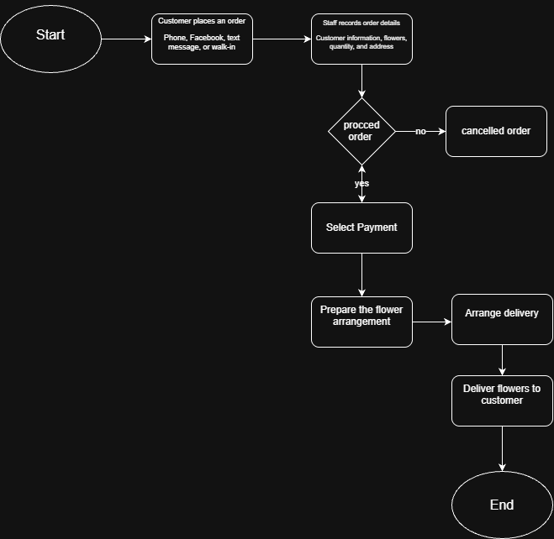
Figure 1. Current State of the System

3.1.4 Problems Identified
Based on the common challenges in flower shop operations, five key problems were identified in managing flower orders, customer information, delivery schedules, and order tracking. These problems may affect the daily operations of the flower shop and the quality of service provided to customers.

Table 3. Problems and Root Causes Analysis
Problem | Root Cause | Effect
Disorganized Order Records | Orders are received through different channels, such as phone calls, text messages, Facebook messages, and walk-in customers. | Orders may be forgotten, misplaced, or recorded incorrectly.
Incorrect Customer Details | Customer information and delivery addresses are recorded manually. | Staff may have difficulty contacting customers or delivering orders to the correct location.
Delivery Scheduling Issues | Delivery schedules and assignments are managed manually. | Deliveries may be delayed, and overlapping schedules may cause confusion.
Lack of Order Status Updates | No Order progress is not consistently recorded or communicated to customers. | Customers may have difficulty knowing the current status of their orders.
Difficulty Monitoring Orders | Order details and delivery records are kept in separate messages, papers, or files. | The shop owner and staff may find it difficult to monitor pending, ongoing, and completed orders.

3.1.5 Root-Cause Analysis
To identify the main causes of problems in managing flower orders and deliveries, a root cause analysis was conducted based on the roles and common challenges of the key stakeholders: Customer, Flower Shop Staff, Shop Owner/Administrator, and Delivery Personnel.

3.1.6 Requirements
Functional Requirements
Functional requirements describe the main features and actions that the Flower Order and Delivery Management System must perform. These requirements explain how customers, flower shop staff, administrators, and delivery personnel will use the system to manage flower orders, customer information, delivery assignments, and order status.
Table 4. Functional Requirements Catalog
ID | Functional Requirement Statement | Stakeholder | Priority
FR01 | The system shall allow users to log in securely using their registered accounts. | All Users | High
FR02 | The system shall allow customers to submit flower orders with flower selections, quantities, and delivery details. | Customer | High
FR03 | The system shall record customer information, including name, contact number, and delivery address. | Customer / Staff | High
FR04 | The system shall generate a unique order number for every submitted order. | System / Staff | High
FR05 | The system shall allow staff to view, add, and update flower order records. | Flower Shop Staff | High
FR06 | The system shall allow the administrator to view and manage all customer orders. | Owner | High
FR07 | The system shall allow the administrator to assign delivery personnel to confirmed orders. | Administrator | High
FR08 | The system shall allow delivery personnel to view their assigned deliveries and delivery details. | Delivery Personnel | High
FR09 | The system shall allow authorized staff to update order statuses, such as Pending, Confirmed, Preparing, Out for Delivery, Delivered, or Cancelled. | Staff / Delivery Personnel | High
FR010 | The system shall allow customers to check the current status of their flower orders. | Customer | High
FR011 | The system shall display delivery schedules and assigned orders to help prevent scheduling conflicts. | Administrator / Delivery Personnel | High
FR012 | The system shall maintain order history so authorized users can review previous and completed orders. | Administrator / Staff | Medium

Non-Functional Requirements
Table 5. Non-Functional Requirements Specification
Requirement | Description
Usability | The system should be simple and easy to understand.
Security | Only authorized users should access customer and order information.
Availability | The system should be available during the flower shop's business operations.
Performance | Order submission and status updates should be completed within a reasonable time.
Reliability | Customer, order, and delivery information should be stored accurately.
Maintainability | The administrator should be able to update products, users, and system information.

3.2 Framework of the Project

Figure 2. Project Implementation Roadmap
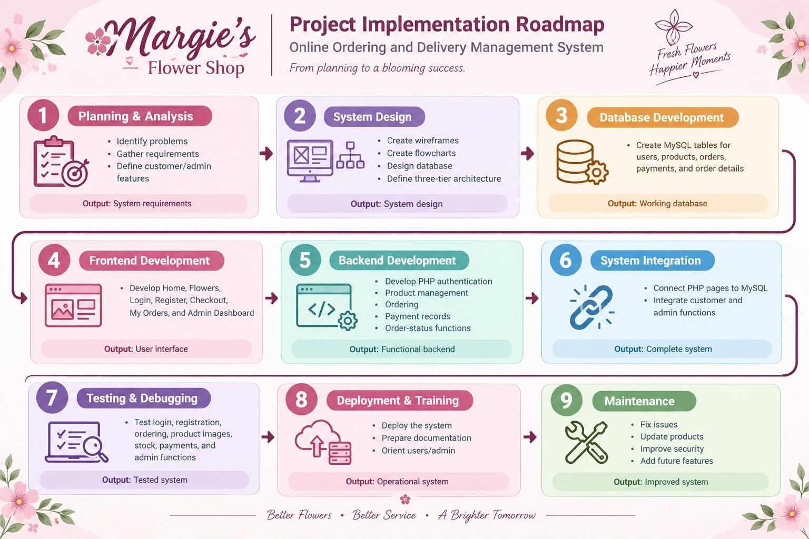

Figure 2. Proposed Automated Process
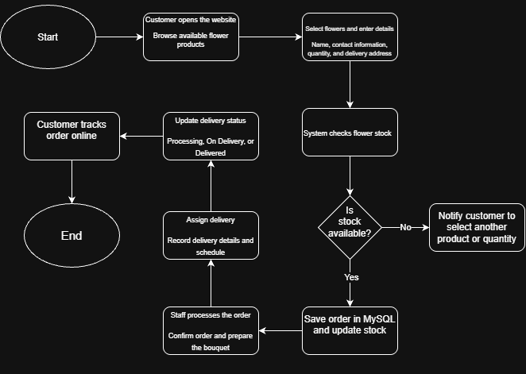

3.2.1 Proposed Future-State Process
The Proposed Future-State Process shows how the Flower Order and Delivery Management System will manage flower orders, customer information, delivery assignments, and order status updates to improve daily operations and customer service.

3.2.2 Before and After Comparison
Table 6. Before-and-After Process Comparison
Activity | Current Process | Proposed Process
Order submission | Call/message/wall-in | Online form
Order number | None/manual | Automatic
Order recording | Manual | Centralized
Order confirmation | Manual | System-assisted
Delivery assignment | Manual | Organized assignment
Order tracking | Manual | Dashboard
Notification | Manual | Automatic
Status monitoring | Difficult | Real-time
Reporting | Manual | Automated
Order history | Inconsistent | Centralized
Order completion | Manual | Workflow-based

3.2.3 Proposed System Modules
The Proposed System Modules describe the main features of the Flower Order and Delivery Management System, including customer management, flower order management, product management, delivery assignments, order status tracking, and admin dashboard monitoring. These modules work together to help the flower shop manage orders efficiently, organize deliveries, and provide better customer service.

3.2.4 Automation Rules
Table 7. Automation Rules
Rule ID | Operational Trigger / Condition | Automated Action Executed by System
RULE-01 | Order is marked Urgent | Notify the shop staff immediately
RULE-02 | Order is Confirmed | Add order to flower preparation list
RULE-03 | Order is Ready | Notify assigned delivery staff
RULE-04 | Delivery is Assigned | Update delivery schedule
RULE-05 | Delivery is Completed | Notify customer and update order status
6 | Customer confirms receipt | Mark order as Completed

3.2.5 Sample Flower Order
Table 8
Field | Sample Value
Order # | FL-2026-00125
Customer | Maria Santos
Contant Number | 0916-756-0072
Flower Type | Red Rose Bouquet
Quantity | 1 Bouquet
Order Type | Delivery
Delivery Date | October 15, 2026
Delivery Address | Iloilo City
Priority | Urgent
Special Request | Birthday message included
Assigned Delivery Staff | Pedro Reyes
Status | Out for Delivery
Payment Status | Paid
Delivery Status | Delivered
Customer Confirmation | Confirmed
Final Status | Completed

3.2.6 Admin Dashboard

The Admin Dashboard provides a summary of important information about the flower shop's daily operations. It allows the shop owner and staff to easily monitor flower orders, sales, customers, products, and delivery status in one place. It also helps identify pending orders, completed deliveries, and products with low stock. These features can help the shop owner make better decisions, organize daily tasks, and provide better service to customers.
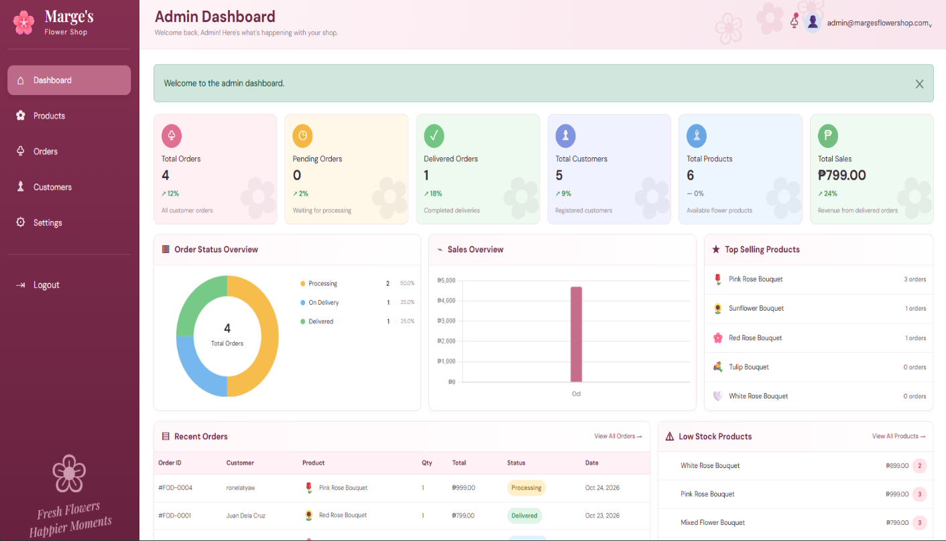

3.3 Development and Testing

3.3.1 Prototype
Prototype Screen 1 – Login:
Flower Order and Delivery Management System login page with username, password, and login button.
Prototype Screen 2 – Flower Order:
Customer order page with flower type, quantity, delivery date, delivery address, priority, special request, and submit order button.
Prototype Screen 3 – My Orders:
Customer order page showing order number, flower type, delivery date, and order status.
Prototype Screen 4 – Order Management:
Staff page showing customer orders, assigned delivery staff, delivery schedule, payment status, and order status.
Prototype Screen 5 – Delivery Tracking:
Page for viewing assigned deliveries and updating the delivery status from Pending → Out for Delivery → Delivered → Completed.

3.3.2 Test Cases and Verification Scenarios
Table 10.
Test ID | Test | Expected Result | Result
TC-01 | Login using valid credentials | User successfully logs in | Passed
TC-02 | Submit complete flower order | Order is successfully created | Passed
TC-03 | Submit incomplete order | System displays required fields | Passed
TC-04 | Generate order number | Unique order number is generated | Passed
TC-05 | Assign delivery staff | Order is assigned to delivery staff | Passed
TC-06 | Update order status | Order status is successfully updated | Passed
TC-07 | Update delivery status | Customer can see the updated delivery status | Passed
TC-08 | Generate order report | Order and delivery report is successfully generated | Passed

3.3.3 Sample Test Result
Based on the sample testing, the proposed Flower Order and Delivery Management System successfully performed the main
ordering and delivery functions. The important functions tested were customer login, flower order creation, order number generation, delivery assignment, status updates, customer tracking, and report generation.
The prototype should undergo additional user acceptance testing before actual deployment.

3.4 Implementation Plan
Table 11. Project Implementation Phasing
Phase | Major Activities | Output
Phase 1 - Preparation | Identify stakeholders, confirm requirements, and document the current flower ordering and delivery process. | Approved requirements document
Phase 2 - System Design | Design the ordering workflow, database, user interface, and automation rules. | System design and prototype
Phase 3 - Development | Develop customer ordering, order management, delivery assignment, status tracking, notification, and report modules. | Functional prototype
Phase 4 - Testing | Conduct functional, integration, user acceptance, and security testing. | Tested system
Phase 5 - Implementation | Deploy the system, train staff, and monitor the actual ordering and delivery process. | Operational flower order and delivery process
Phase 6 - Monitoring and improvement | Monitor KPIs, collect feedback, identify recurring problems, and improve the workflow. | Continuous improvement plan

3.4.1 Implementation Schedule
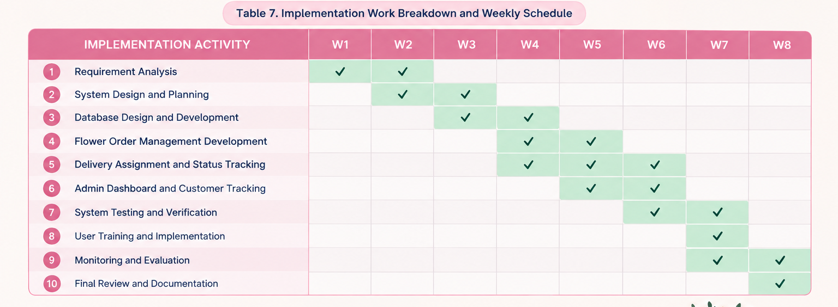
Table 12. Implementation Work Breakdown and Weekly Schedule

3.4.3 Risk Analysis and Mitigation
Table 13. Risk Assessment and Mitigation Matrix
Risk | Probability | Impact | Mitigation
Staff do not use the system properly | Medium | High | Provide simple user training and instructions
Incorrect flower order information | Medium | Medium | Use required fields and review order details before confirmation
Delivery information is incorrect | Medium | High | Verify customer address and contact information
System downtime | Low | High | Use regular backups and a recovery plan
Customers have difficulty tracking orders | Low | Medium | Provide a simple order tracking page and clear status updates

3.4.4 User Training and Change Management
The implementation of the Flower Order and Delivery Management System will include user training to help the shop owner and staff adjust from manual order recording to using the digital system.
The owner and staff will be introduced to the purpose and features of the system, particularly customer management, flower order management, product management, delivery assignments, order status updates, and dashboard monitoring. Training will focus on entering customer information, recording flower orders, managing delivery schedules, updating order statuses, and monitoring order progress.
The training will be conducted through system demonstrations, hands-on practice, and guided activities using sample flower orders and delivery information. Users will also receive simple instructions on how to use the system and correct common data-entry errors.

CHAPTER IV

RECOMMENDATION

This section discusses the implementation of the Flower Order and Delivery Management System. It explains how the system was developed to manage flower orders, customer information, delivery assignments, and order status. It also describes how the system helps the shop owner and staff organize daily operations and provide customers with order updates.

Development Tools
This section presents the tools used to develop the system.
Development Tool | Purpose
HTML | Creates the structure of the web pages.
CSS | Designs the layout, colors, and appearance of the system.
JAVASCRIPT | Adds interactive features to the website.
VISUAL STUDIO | Used to write and edit the source code.
XAMPP | Provides a local development environment for database management, if configured for the project.

Hardware Requirements
This section describes the hardware needed to develop and use the system.

Hardware | Minimum Requirement
Computer or Laptop | Capable of running the development tools and web browser.
Processor | Intel Core i3 or equivalent.
RAM | 4 GB or higher.
Storage | At least 10 GB of available space.
Internet Connection | Required for online access and related services.

Required for online access and related services.
The following software is needed to develop and run the system.
- Windows, Linux, or another compatible operating system
- Visual Studio Code or another code editor
- MySQL database
- A modern web browser, such as Google Chrome.

Input and Outputs of the Study
This section describes the information entered into the system and the results produced after processing that information.
Input | Process | Output
Customer information | Records customer details | Organized customer records
Flower order details | Processes and saves orders | Order confirmation and order number
Product information | Manages flower products and stock | Updated product records
Delivery information | Assigns delivery personnel and schedules | Delivery assignments and schedules
Order status | Updates order progress | Current order status for customers and staff
Sales and payment information | Records and summarizes transactions | Sales records and reports

Results Interpretation and Analysis
The developed Flower Shop Website successfully provides an organized platform where customers can browse available flower products, create an account, log in, select flowers, enter delivery information, choose a payment method, and place an order. The system connects the website to a MySQL database, allowing important information such as customer accounts, products, orders, quantities, prices, and stock to be stored and managed properly.

Results
The implementation showed that the major functions of the website work together as one ordering system. Customers can register their information, and their account details are stored in the database. After logging in, customers can browse the available flower products and select the product they want to purchase.
When the customer clicks the Order Now button, the selected product is displayed on the checkout page together with its price and available stock. The customer can then provide delivery information, select the desired quantity, and choose a payment method such as Cash on Delivery, GCash, or Maya. After the order is submitted, the order information is saved in the database and the available product stock is updated.
The website therefore provides the following functional results:
- Customer registration information can be stored in the database.
- Registered customers can log in to the website.
- Flower products can be retrieved from the product database.
- Customers can select a flower and proceed to checkout.
- The system automatically calculates the total amount based on price and quantity.
- Customer, delivery, payment-method, and order information can be recorded.
- Product stock can be updated after an order is successfully placed.
- Customers receive an order confirmation after completing the ordering process.

Interpretation
The results indicate that the website can improve the flower shop's ordering process by keeping important information in one system instead of relying on separate or manually recorded transactions. Connecting the website to a database makes customer, product, and order information easier to organize and retrieve.

Analysis
Overall, the results demonstrate that the Flower Shop Website can provide a more organized, convenient, and efficient approach to flower ordering. By combining product browsing, customer accounts, checkout, order recording, and database management into one website, the system reduces manual work and provides the flower shop with a centralized way of managing customer orders.
The developed website therefore meets its main purpose of improving the organization of the flower ordering process while providing customers with a simple and accessible way to browse flowers and submit orders online.

System Evaluation Results
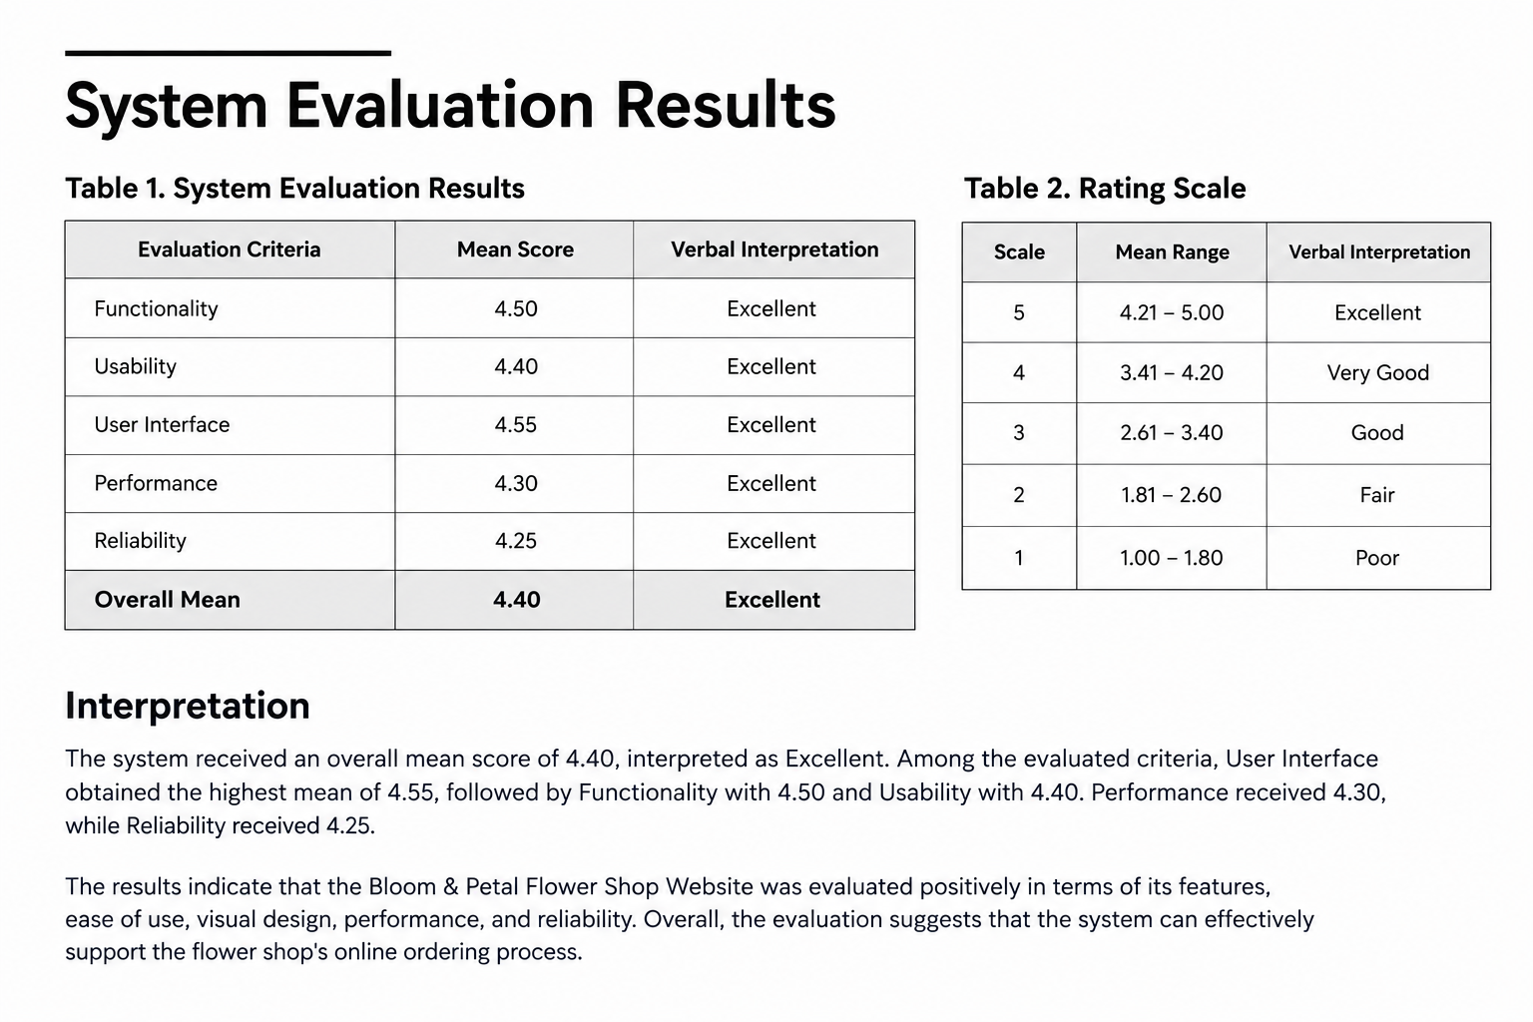
The Bloom & Petal Flower Shop Website was evaluated based on functionality, usability, reliability, performance, and user interface. A 5-point Likert scale was used to determine the respondents' level of satisfaction with the developed system.

CHAPTER V

CONCLUSION AND RECOMMENDATIONS

5.1 Introduction
This chapter presents the summary of the proposed Flower Order and Delivery Management System, its findings, conclusions, and recommendations. It discusses how the system aims to improve the management of flower orders, customer information, delivery assignments, and order status tracking. It also provides recommendations for future improvements to make the system more useful and efficient.

5.2 Summary of the Proposed Study Design and Implementation
The proposed Flower Order and Delivery Management System was designed to help flower shops manage their daily operations more easily. The system focuses on organizing customer information, recording flower orders, managing products, assigning deliveries, and updating order statuses. It aims to reduce problems caused by manual recordkeeping, such as misplaced orders, incorrect information, and delayed deliveries.
The system includes an admin dashboard that allows the shop owner or administrator to monitor orders, customers, products, sales, and delivery activities. Customers can also check the status of their orders, helping them stay informed about their purchases.

5.3 Summary of Findings
The study identified several common problems in manual flower shop operations, including disorganized order records, incorrect customer details, difficulties in scheduling deliveries, and limited order status updates. These problems can affect the efficiency of staff and the quality of customer service.
The proposed system addresses these concerns by providing a centralized platform for managing orders and delivery information. Its features are intended to help staff organize records, monitor order progress, coordinate deliveries, and provide customers with clearer updates. Actual system testing and user evaluation are needed to determine how effectively these objectives are achieved.

5.4 Conclusion
The proposed Flower Order and Delivery Management System aims to improve the way flower shops handle orders and deliveries. By organizing customer information, flower orders, delivery assignments, and order statuses in one system, it can help reduce reliance on manual records and make daily tasks easier to manage.
The system also provides the shop owner with a dashboard for monitoring important business activities. Overall, the project offers a practical approach to improving order management, delivery coordination, and customer service in flower shop operations.

5.5 Recommendations
1. Improve Order Tracking: Provide timely updates so customers can easily check the status of their flower orders.
2. Enhance Delivery Management: Add features that help staff organize delivery schedules and assignments to avoid confusion and delays.
3. Maintain Accurate Records: Regularly update customer information, product details, and order records to ensure that the system contains reliable information.
4. Strengthen System Security: Use secure login features and appropriate user permissions to protect customer and business information.
5. Conduct User Training: Provide simple instructions to help the shop owner and staff understand how to use the system properly.
6. Perform Regular Testing and Maintenance: Check the system regularly to identify errors, improve performance, and ensure that its features continue to work correctly.

References

APPENDIX A RESOURCE PERSON AND INTERVIEW TRANSCRIPTS

INTERVIEW METADATA & PROFILE
Name of Resource Person: Mary Grace Gabrido
Position: Owner of Margie’s Flower Shop
Location: 217-A Fermin Caram Avenue, Iloilo City
Date & Time: October 14, 2026 | 1:30 PM PST

STRUCTURED INTERVIEW INSTRUMENT AND FINDINGS
- Can you briefly describe your business and its daily operations?
- Margie’s Flower Shop sells different flower arrangements and bouquets for birthdays, anniversaries, graduations, and other special occasions. Daily operations include receiving customer orders, preparing flower arrangements, checking available flowers and supplies, processing payments, and arranging orders for delivery.
- How do you currently handle customer orders and transactions?
- Customer orders are currently received manually through direct messages, phone calls, social media, or in-store transactions. Customer details, selected flowers, payment information, and delivery details must be recorded and monitored manually. How do you currently manage your flowers and supplies inventory?
Flowers and supplies are currently monitored manually by checking the available stock. This can make it difficult to maintain accurate inventory information.
- What are the main problems or challenges you experience in your current process?
- The main challenges are organizing orders from different platforms, keeping customer and delivery information organized, monitoring available flower stocks, preventing forgotten or delayed orders, and tracking transactions. Manual processes can also make it difficult to quickly determine which orders are pending or completed.
- What specific problem would you most like to solve?
- The main problem we want to solve is the lack of a centralized ordering and management system.

APPENDIX C DISCLAIMER
This final course work and its corresponding documentation entitled “BLOOM & PETAL FLOWER SHOP WEBSITE: A Web-Based System for Streamlining Flower Ordering, Inventory, Payment, and Delivery Management” is submitted to the College of Information
Technology Education, PHINMA University of Iloilo, in partial fulfillment of the requirements for the BAM – 285 Business Analysis for IT course for the degree Bachelor of Science in Information Technology.
This project is the product of our own work, except where references, sources, and other materials are properly acknowledged and indicated in the text.
We hereby grant the College of Information Technology Education, PHINMA University of Iloilo, permission to freely use, publish in local or international journals or conferences, reproduce, or publicly distribute the paper and electronic copies of this software project and its corresponding documentation, in whole or in part, provided that proper acknowledgment is given to the authors.

