# Introduction

The main screens are used by all types of users. The system supports the following user roles: regular user, business user, and admin user.

* Login and Registration
  + Every user is required to log in as the first step to access the system.
  + New users can select the registration link at the bottom of the login page. Once the user completes the registration process, they must log in again.
  + The system will keep the user logged in, so they will be automatically logged in on subsequent visits.

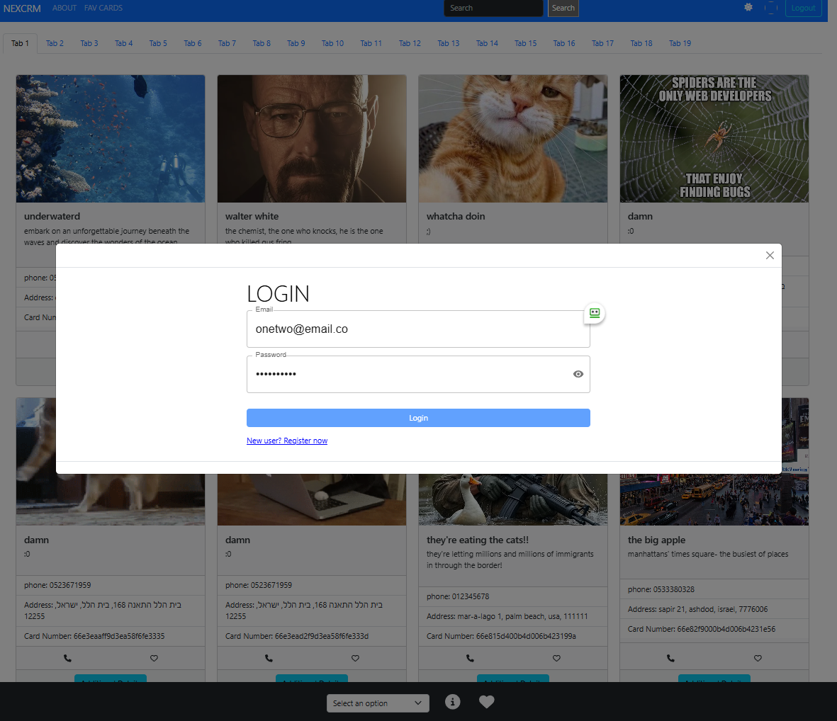

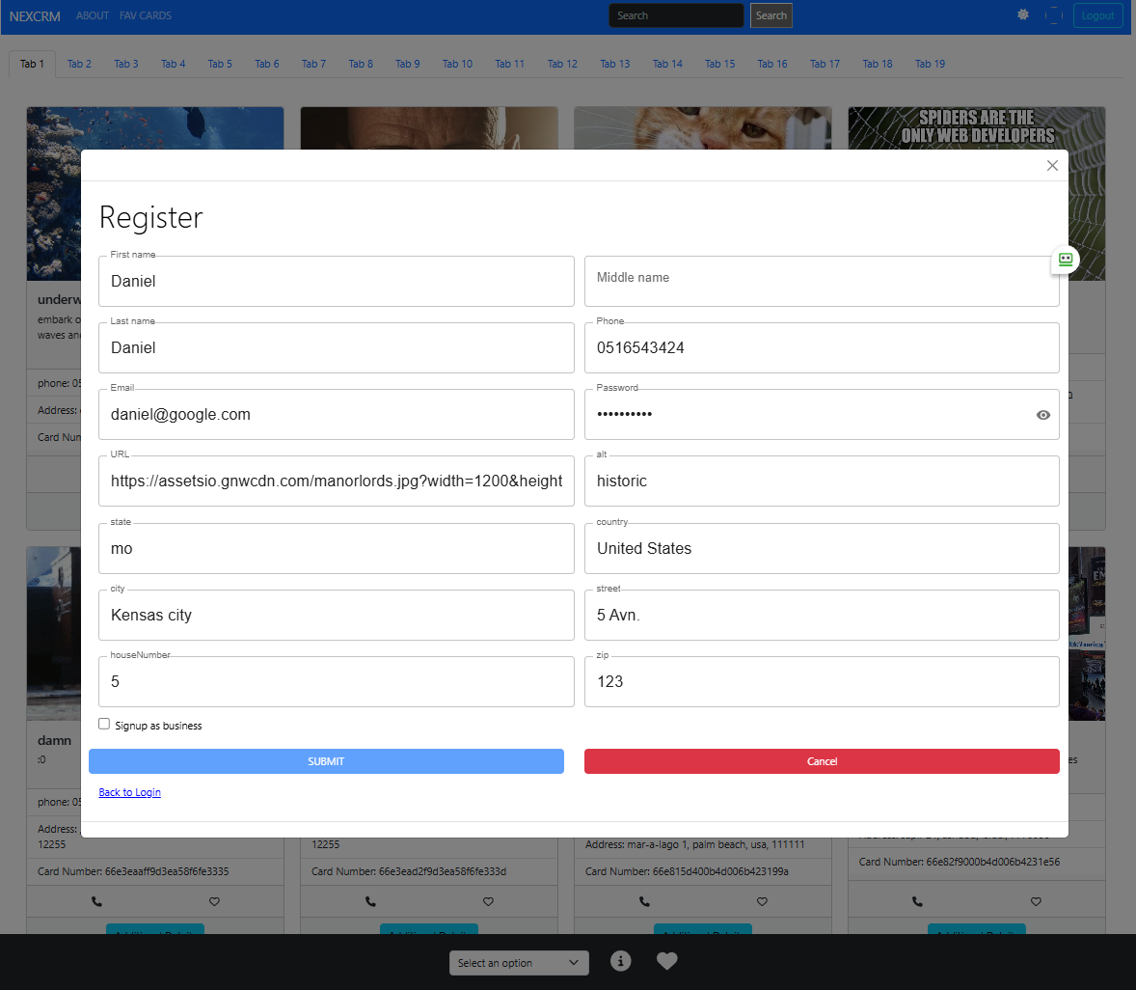

* Main Screen Overview

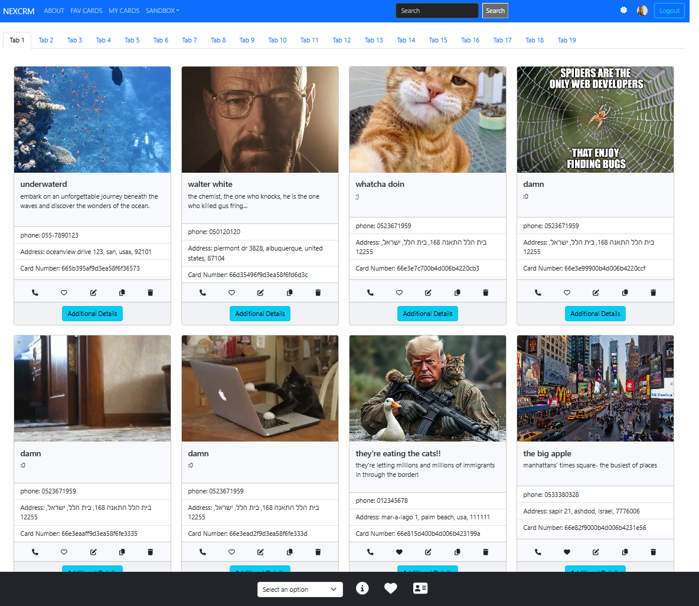

The main screen consists of the following sections

* Top Menu
  + Left section
    - NextCRM – return to home screen
    - About – Provides access to the user guide
    - Fav Cards - Displays cards that the user has selected as favorites
    - My Cards (Business user only) – Allow Users to Create Edit Delete their own cards
    - SandBox (Admin user only) – Allow Admin to review system Statistics and Health
  + Search input box to search tickets – Allows users to search for tickets. The search can be performed based on card name, description, email, phone, or address.
  + Right section
    - Dark mode control: Enables or disables dark mode
    - User picture: Displays the user's profile picture
    - Logout button: Logs the user out of the system
* Main Screen Cards

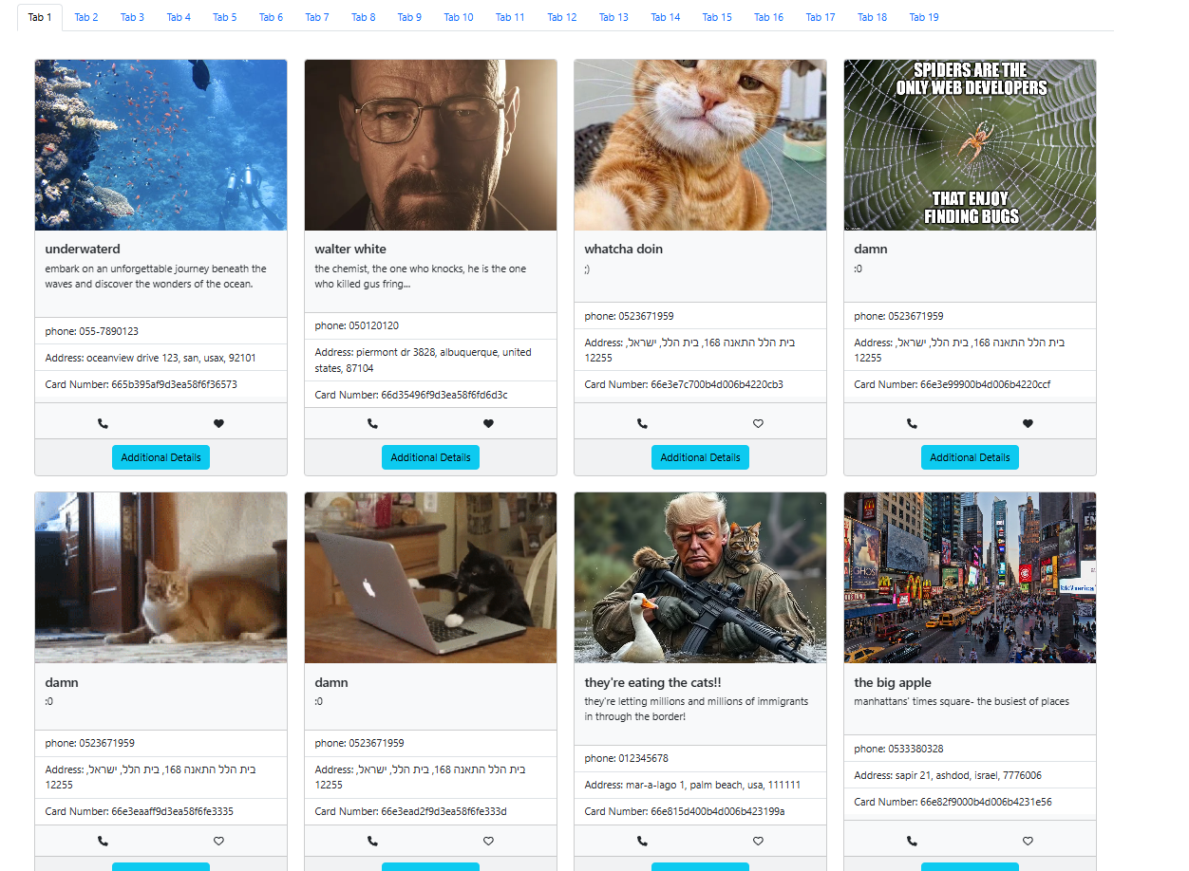

* + Users can select the tab they would like to visit
  + Each card allows users to select or deselect it as a favorite by clicking the heart symbol
  + The "Additional Details" button provides more business information, including the business location map
* Bottom section
  + Sorting cards:
    - Sort by business name
    - Sort by create date
    - Sort by card “likes”: Allows users to view the cards that are most liked by other users.
  + I-icon allow navigation to About screen
  + Heart-icon navigation to Fav Cards screen

# Business User – My Cards

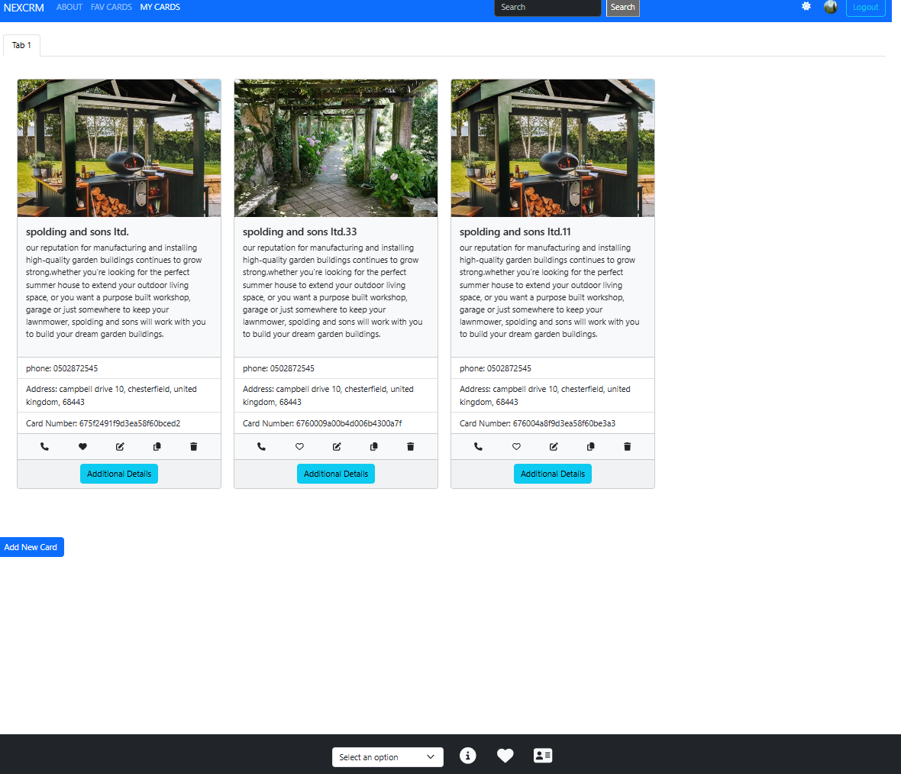

* Add New Card button – Allows users to add a new card to their library.
* Cards Management Icons
  + Pen-icon – allow users to edit existing card
  + Copy-icon – Allows users to create a new card based on an existing one, saving time in the card creation process.
  + Delete-icon – Allows users to delete a card

# Admin User

Admin users can access the admin screen options by pressing **SANDBOX**.

* All Users – the data grid will present all users in the system
* Options
  + **Search and filter**: Can be applied to each column for more specific results
  + **Display Lines**: Users can select the number of lines displayed per page.
  + **Pagination**: Users can navigate to additional pages if there is more data.

* All Cards – present all cards in the system
* Options:
  + **Search and Filter**: Can be applied to each column for more specific results.
  + **Display Lines**: Users can select the number of lines displayed per page.
  + **Pagination**: Users can navigate to additional pages if there is more data.
  + **Ensuring Data Quality**: Admins have the ability to identify and address errors in card image loading and data accuracy.
    - To identify image load errors, select "Image Error" = true.
    - To identify address errors (via Google Maps API verification), select "Address Error" = true

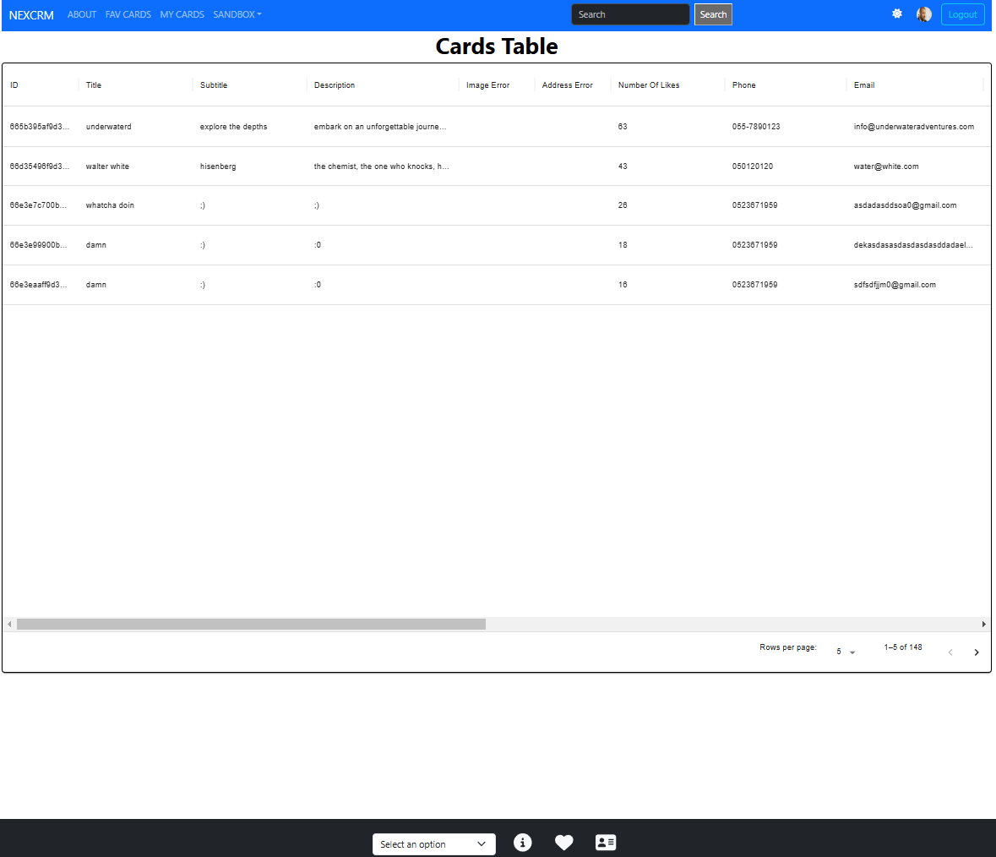

* Admin System Dashboard
  + **Tickets Grouped by Likes Count**: This view displays user selections of liked cards. In the example below, the light blue section represents the number of cards with one selection. Clicking the section in the circle will reveal how many cards have one selection (e.g., 35 cards).
  + **New Cards by Month**: Users can view the number of new cards created in the system. The selection options below the graph allow the admin to view data for different months.
  + **New Users by Month**: Admin users can view how many new users were added to the system each month.
    - Users can select different timelines to see the growth of the user population.
    - Users can filter the new user population by user type (regular user, business user, admin user)

