**Udacity Machine Learning Engineer Nanodegree**

Cryptocurrency Signal Generation Capstone Project

Ronen Shohat

1. **Definition**

# Description/Overview

Asset managers have been utilizing algorithmic models to generate investment decisions for decades, using both real-time and historical data. With the introduction of the first cryptocurrency, Bitcoin, in 2009 along with its emergence in popularity in 2017 as major cryptocurrencies hit all-time highs, the growth of crypto asset managers has emerged as a new industry. These firms are trying to implement similar quantitative investment strategies found in traditional asset classes to build predictive models for cryptocurrency prices.

A few academic studies related to tracking cryptocurrency prices can be found here:

<https://scholar.smu.edu/cgi/viewcontent.cgi?article=1039&context=datasciencereview>

<https://pdfs.semanticscholar.org/477c/211d4bcb3668906513e31aba951da1b33128.pdf>

# Problem Statement

Although the technology of cryptocurrencies has substantial potential, its volatile price swings have deterred many investors from entering the market and has seen other investors suffer substantial losses. In order to solve this issue, I will try to determine key features that drive the price of BTC to gain insight on the forward direction of price, in order to generate trading strategies (which will be further discussed).

# Datasets and Inputs

[CryptoCompare API-](https://www.cryptocompare.com/) price and volume data for BTC/USD prices as well as other major cryptocurrencies (LTC, ETH, XRP, BCH, XMR)

Blockchain website for data related to bitcoin market structure/fundamentals

Label will be based on the week over week percentage price of BTC/USD. There will be 3 classes:

* Downward (DoD change was less than -1%)
* Stable (DoD change was between -1% and 1%)
* Upward (DoD change was greater than 1%)

There are 100 features (including transformations) in the dataset, with 558 daily data points ranging from 2017-08-30 to 2019-03-10

The list of features are:

['close',

'high',

'low',

'open',

'volumefrom',

'volumeto',

'intraday_range',

'dod_change',

'rolling_price_vol_7',

'rolling_price_vol_30',

'rolling_DoD_vol_7',

'rolling_DoD_vol_30',

'close_ETH',

'high_ETH',

'low_ETH',

'open_ETH',

'volumefrom_ETH',

'volumeto_ETH',

'intraday_range_ETH',

'dod_change_ETH',

'rolling_price_vol_7_ETH',

'rolling_price_vol_30_ETH',

'rolling_DoD_vol_7_ETH',

'rolling_DoD_vol_30_ETH',

'close_LTC',

'high_LTC',

'low_LTC',

'open_LTC',

'volumefrom_LTC',

'volumeto_LTC',

'intraday_range_LTC',

'dod_change_LTC',

'rolling_price_vol_7_LTC',

'rolling_price_vol_30_LTC',

'rolling_DoD_vol_7_LTC',

'rolling_DoD_vol_30_LTC',

'close_XRP',

'high_XRP',

'low_XRP',

'open_XRP',

'volumefrom_XRP',

'volumeto_XRP',

'intraday_range_XRP',

'dod_change_XRP',

'rolling_price_vol_7_XRP',

'rolling_price_vol_30_XRP',

'rolling_DoD_vol_7_XRP',

'rolling_DoD_vol_30_XRP',

'close_BCH',

'high_BCH',

'low_BCH',

'open_BCH',

'volumefrom_BCH',

'volumeto_BCH',

'intraday_range_BCH',

'dod_change_BCH',

'rolling_price_vol_7_BCH',

'rolling_price_vol_30_BCH',

'rolling_DoD_vol_7_BCH',

'rolling_DoD_vol_30_BCH',

'close_XMR',

'high_XMR',

'low_XMR',

'open_XMR',

'volumefrom_XMR',

'volumeto_XMR',

'intraday_range_XMR',

'dod_change_XMR',

'rolling_price_vol_7_XMR',

'rolling_price_vol_30_XMR',

'rolling_DoD_vol_7_XMR',

'rolling_DoD_vol_30_XMR',

'block_size',

'cost_pct_volume',

'cost_per_transaction',

'mining_difficulty',

'transaction_volume_usd',

'transaction_volume',

'tera_hashes',

'confirm_time',

'mempool_count',

'mempool_size',

'mining_revenue',

'sent_btcusd',

'sent_buybitcoin',

'sent_bitcoin',

'sent_cryptocurrency',

'wallet_users',

'trans_ex_long',

'trans_ex_popular',

'transactions_per_block',

'transactions_total',

'trans_per_day',

'unique_addresses',

'output_volume',

'num_bitcoins',

'usd_volume',

'mining_fees_usd',

'trans_per_second',

'unspent_transactions']

# Solution Statement

This project is going to try to build predictive signals on whether a specific cryptocurrency will increase in price, decrease in price, or remain stable. As a classification problem, we will test several supervised learning algorithms to optimize predictive performance.

Potential Algorithms to use:

* Random Forest
* Gradient Boosting
* XGBoost
* SVM (RBF and sigmoid kernels)
* Decision Trees

An ensemble algorithm would be a preferred method as global and local interpretation of the results are very transparent in determining which features drove the prediction

# Metrics: Evaluation Metrics (Absolute Alpha vs Relative performance vs benchmark)

Apart from traditional metrics like precision and recall, the main measure that will be used is the USD gained from implementing the algorithm’s price predictions, after considering trading costs. We will also assess traditional performance metrics like precision and recall, while considering the fact that 1 step misclassifications (ie upward vs stable) should be penalized less than 2 step classifications (ie downward vs upward). This will determine whether this algorithm provides better price prediction than simply buying and holding the asset.

Formulas for Precision and Recall:

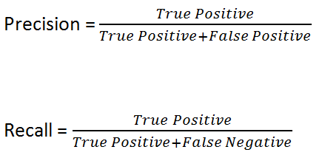

# Project Design

* Collecting/Structuring Data from various APIs
* Data Preprocessing/Cleaning
* Feature engineering
* Model testing/training
* Deciding between regression and classification
* Picking optimal model based on continuous P&L backtests
* Model tuning with gridsearch
* Final conclusion

1. **Analysis**

**Feature Engineering**

In order to capture changes in momentum over time, I decided to add rolling percent changes and standard deviations over a DoD, WoW, and MoM period

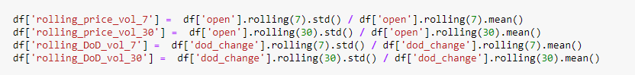

**Data Exploration/Exploratory Visualization**

Visually, it is apparent that cryptocurrencies have experienced incredible volatility over time, peaking at almost $20,000 at the end of 2017. The asset has also experienced significant levels of volatility over time, with mean adjusted standard deviation hovering at 0.1. There is also significant tail risk in the distribution of volatility over time

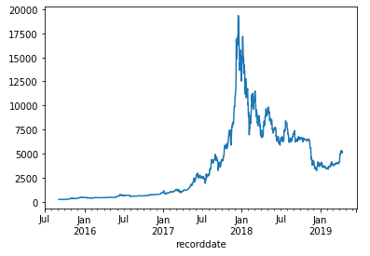 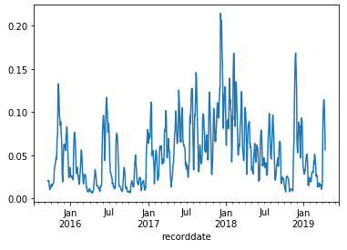

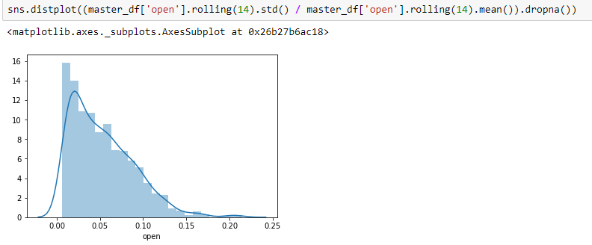

In terms of other fundamental data, there were few outliers in the set and all features showed relatively normal distributions

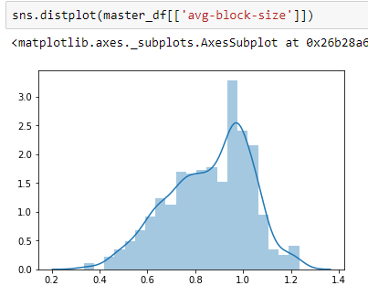

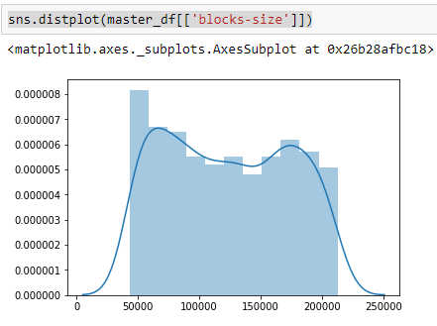

In terms of the distribution of the labels, there wasn’t an incredibly significant imbalance, though labels weren’t perfectly balanced

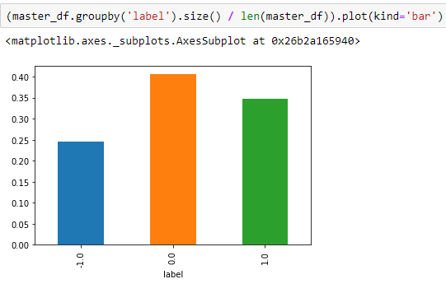

# Metrics/Analysis: Benchmark Model

To benchmark our model performance, we will backtest the algo’s investment decisions to calculate a P&L amount in USD, then compare to a passive strategy of just buy-and-hold.

1. **Methodology**

# Preprocessing/Time Series Matching

Since I am trying to model predictions in price movement, I had to make sure my forward looking model wasn’t incorporating data from the future to predict the past. I also had to adjust my data to make sure it would be available within the same time frame to make my predictions. Because of this, I decided to model a prediction in price change t+2, and was thus unable to incorporate any data in the model that was available later than that

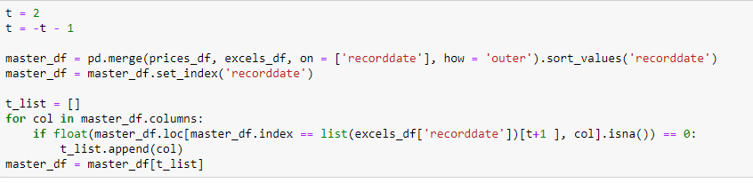

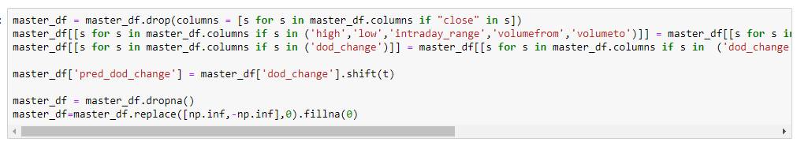

**Model Labeling**

I created the shifted label pred_dod_change to generate a prediction t-3 days in advance, so that I could make an actionable trade at t+2. I then bucketed the changes into 3 buckets; -1 if below -0.01, 0 if between 0 and 0.01, and 1 if greater than 0.01. The distributions weren’t perfectly even at approximately 25/40/35, but it wasn’t extreme enough to warrant a resampling of the data

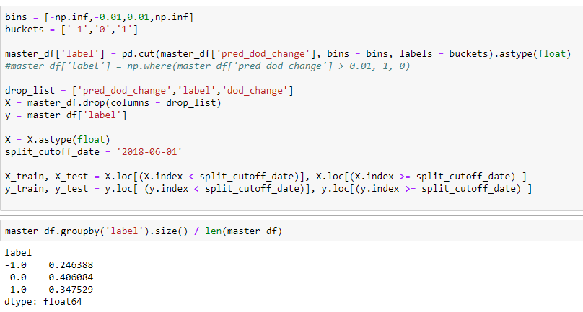

**Refinement: Model Selection/Hyperparameter Optimization**

After experimenting with several classification algorithms, it seemed ensemble methods yielded the best performance. I decided to fit Random Forest and XGBoost models on my labels, as well as created versions of these models with optimized hyperparameters (using a time series validated Grid Search). Due to the nature of this problem, I emphasized performance as the precision of label 1. Because most exchanges don’t allow short selling, having high precision for 1 would allow me to decide whether to buy if there is an upside opportunity.

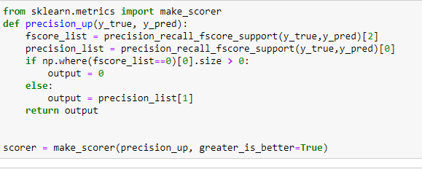

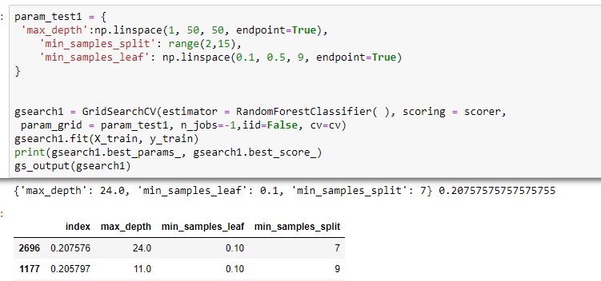

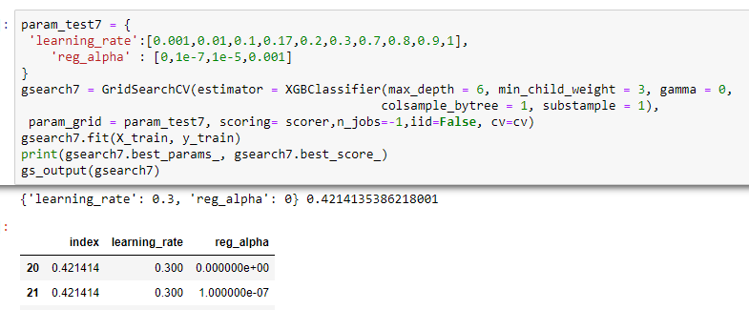

1. **Results**

**Performance Analysis**

Random Forest Results:

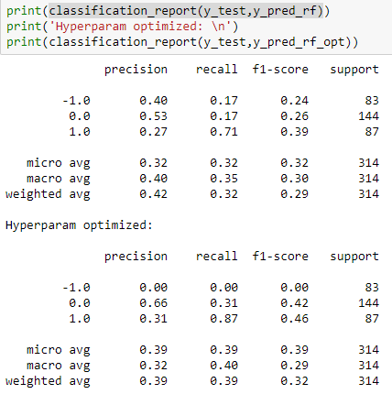

XGBoost Results:

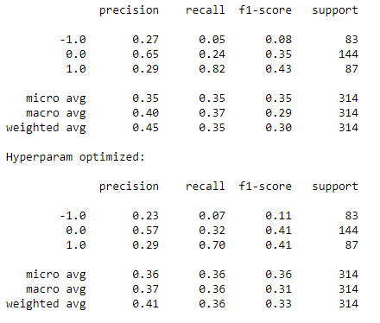

As noted in the results, the hyperparameter tuned Random Forest seemed to yield the best performance in terms of label 1 precision. However, at 0.31 it seemed unlikely this would yield significant alpha generating opportunities.

Feature Importances of Optimized Random Forest

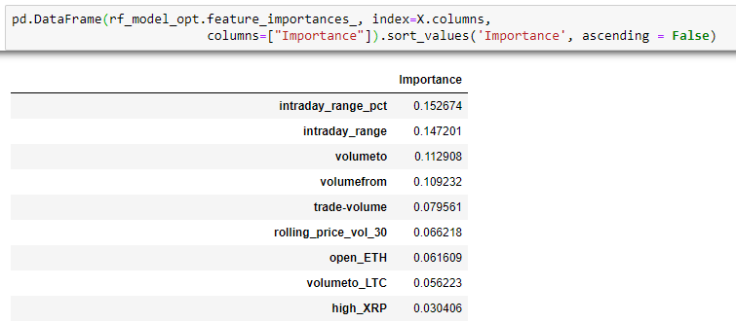

Based on feature importances, it seems most weight was put towards trade volume and volatility metrics (intraday range, rolling 30 days standard deviation)

**Backtesting Model Evaluation**

Due to the lack of any strong overall performance, I tried experimenting with trading strategies that would rely more on label 1 precision. Because of this I designed 3 trading strategies:

1. Profit: Buy if label is 1 and you have USD. Sell if label is -1 and you have BTC
2. Profit_nosell: Buy if label is 1 and you have USD. Sell if label is != 1 and you have BTC
3. Profit_nosell_churn: Buy if label is 1 and you have USD. Then sell your BTC position next day into USD

I then decided to compare both absolute and relative returns (vs just holding BTC **shown in the black line**) over the testing time period.

Performance of Strategy 1:

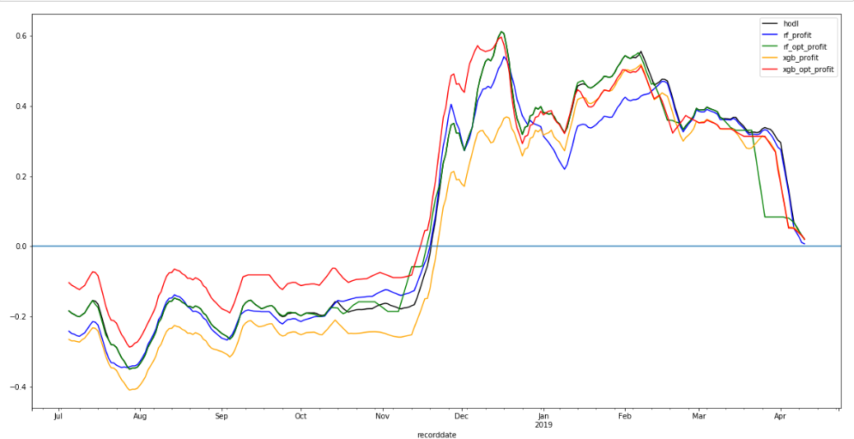

Performance of Strategy 2:

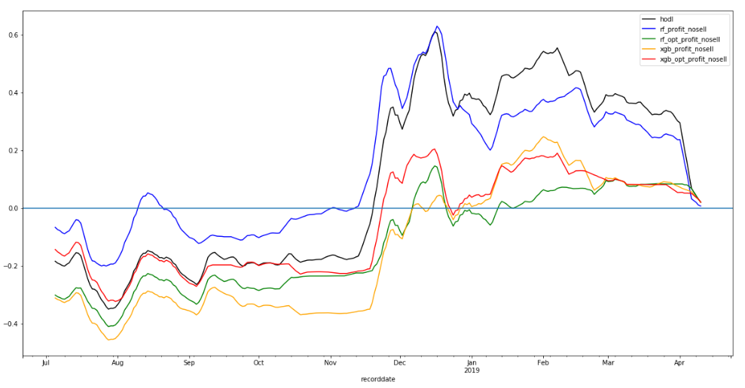

Performance of Strategy 3:

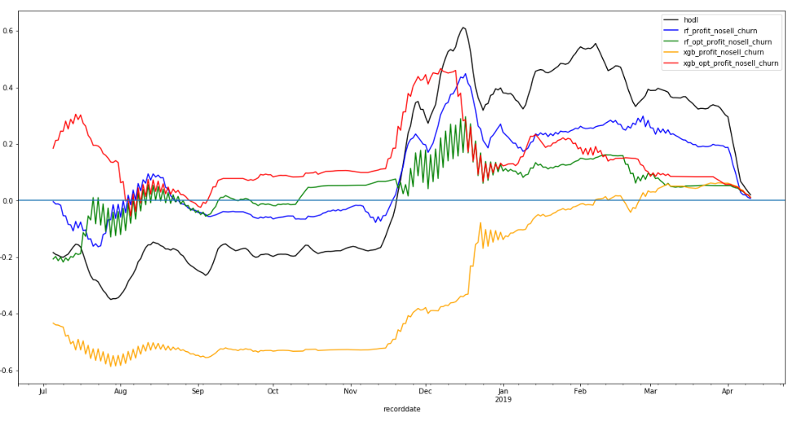

1. **Conclusion**

**Free Form Visualization**

Performance of strategies compared:

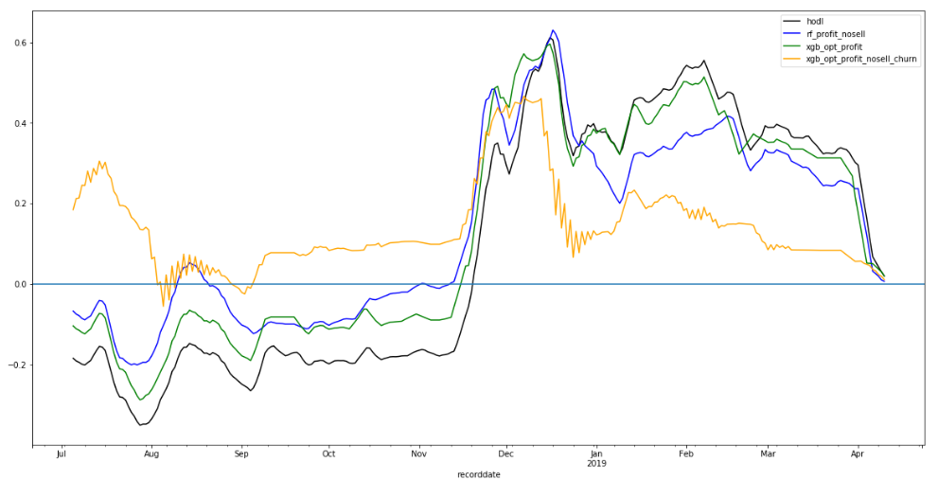

Distribution of annualized returns over time:

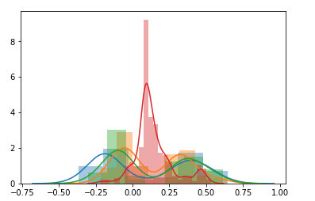

**Reflection**

Based on the backtesting, there didn’t seem to be any specific strategy that significantly outperformed on a relative basis when compared to just holding BTC. However, the churn strategy using the XGB optimized model seemed to have the most impressive absolute return stability when compared to any other strategy. When backtested, it seemed to consistently yield positive returns with much lower standard deviation than other strategies

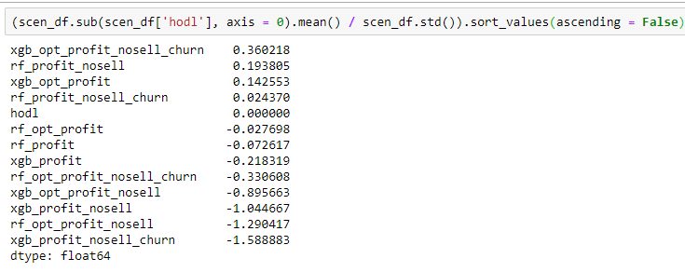

In this sense, the model did seem to be successful in creating an alpha opportunity given an absolute return strategy, and delivering significant risk adjusted return. Yielding a Sharpe ratio of 0.36 isn’t significantly impressive, but is respectable

**Improvement**

In terms of improvement of the model, I feel next steps are to gather more insightful features from other external sources and invest more time in engineering features. For example, gathering and cleaning data related to real-time sentiment on crypto forums or social media platforms could potentially have significant explanatory power. Another source of improvement could be on the model generation end. While I have been focusing on ensemble methods in this project, I could experiment with implementing recurrent neural networks and evaluate performance. For example, LSTMs (Long Short Term Memory) are renowned for recognizing both longer and short term patterns in data. Having the ability to create a robust model that captures both long and short term trends could yield higher performance, and ultimately higher outperformance.