Deep Generative Models

Programming Exersice 2

Ron Ferens, 037222825

Code
Implementation of the VAE.py file:
"""NICE model
"""
import torch
import torch.nn as nn
import torch.nn.functional as F
import typing

class Model(nn.Module):
def __init__(self, latent_dim: int, device: str):
"""
Initialize a VAE
Args:
latent_dim: dimension of embedding
device: run on cpu or gpu
"""
# -----------------------------
# Encoder
# -----------------------------
super(Model, self).__init__()
self.device = device
self.latent_dim = latent_dim
self.encoder = nn.Sequential(
nn.Conv2d(1, 32, 4, 1, 2), # B, 32, 28, 28
nn.ReLU(True),
nn.Conv2d(32, 32, 4, 2, 1), # B, 32, 14, 14
nn.ReLU(True),
nn.Conv2d(32, 64, 4, 2, 1), # B, 64, 7, 7
)
self.mu = nn.Linear(64 * 7 * 7, latent_dim)
self.log_var = nn.Linear(64 * 7 * 7, latent_dim)
# -----------------------------
# Decoder
# -----------------------------
self.upsample = nn.Linear(latent_dim, 64 * 7 * 7)
self.decoder = nn.Sequential(
nn.ConvTranspose2d(64, 32, 4, 2, 1), # B, 64, 14, 14
nn.ReLU(True),
nn.ConvTranspose2d(32, 32, 4, 2, 1, 1), # B, 32, 28, 28
nn.ReLU(True),
nn.ConvTranspose2d(32, 1, 4, 1, 2), # B, 1, 28, 28
nn.Sigmoid()
)

def sample(self, sample_size: int, mu: float = None, log_var=None) -> typing.List:
"""
Sampled images from the model
:param sample_size: Number of samples
:param mu: z mean, None for prior (init with zeros)
:param log_var: z log-STD, None for prior (init with zeros)
:return:
"""
if mu is None:
mu = torch.zeros((sample_size, self.latent_dim)).to(self.device)
if log_var is None:
log_var = torch.zeros((sample_size, self.latent_dim)).to(self.device)
# Making sure the model is not trained while sampling and no gradients are accumulated
samples = []
with torch.no_grad():
z = self.z_sample(mu=mu, log_var=log_var)
output = self.decoder(self.upsample(z).view(-1, 64, 7, 7))
for i in range(sample_size):
samples.append(output[i].squeeze().data.cpu().numpy())
return samples

def z_sample(self, mu: torch.Tensor, log_var: torch.Tensor) -> torch.Tensor:
"""
Applying the reparameterization trick to generate Z
:param mu: Z mean
:param log_var: z log-STD
:return: samples of Z
"""
# Getting the STD from log−variance input
std = torch.exp(0.5 * log_var)
# Sampling epsilon from Normal (0, 1)
eps = torch.rand_like(std).to(self.device)
# Applying the reparameterization trick for Gaussian
z = mu + eps * std
return z

@staticmethod
def loss(x: torch.Tensor, recon: torch.Tensor, mu: float, log_var: float):
"""
Calculating the model's loss composed of BCE and KL elements
:param x: input data
:param recon: reconstructed data
:param mu: Z mean
:param log_var: Z log-STD
:return:
"""
# Calculating the binary cross entropy loss
bce_loss = F.binary_cross_entropy(recon, x, reduction='sum')
# Calculating the KL Divergence loss
kl_loss = torch.sum(1 + log_var - torch.exp(log_var) - torch.pow(mu, 2)) / 2.0
# Calculating the ELBO(p, q, x)
elbo = bce_loss - kl_loss
return elbo

def forward(self, x: torch.Tensor) -> typing.Tuple[torch.Tensor, torch.Tensor, torch.Tensor]:
""""
Running the model's forward pass
:param x: input data
"""
# Encoder forward pass
x = self.encoder(x)
x = x.reshape(-1, 64 * 7 * 7)
# Generating the mean and variance values
mu = self.mu(x)
log_var = self.log_var(x)
# Decoder forward pass
z = self.z_sample(mu=mu, log_var=log_var)
output = self.decoder(self.upsample(z).reshape(-1, 64, 7, 7))
return output, mu, log_var

Implementation of the train.py file:
"""Training procedure for NICE.
"""
import argparse
import torch, torchvision
from torchvision import transforms
import numpy as np
from VAE import Model
import matplotlib.pyplot as plt
import torch.nn as nn

PLOT_DIM = 5

def train(vae: nn.Module, trainloader: torch.utils.data.DataLoader, optimizer: torch.optim) -> float:
# set to training mode
vae.train()
# Setting an accumulated epoch loss
running_loss = 0
num_iterations = 0
# Going over the training dataset (single epoch)
for inputs, _ in trainloader:
# Loading the batch input
inputs = inputs.to(vae.device)
# Model forward pass
model_res, mu, log_var = vae(inputs)
# Calculating the loss criteria
optimizer.zero_grad()
loss = vae.loss(x=inputs, recon=model_res, mu=mu, log_var=log_var)
running_loss += loss
num_iterations += 1
# Backprop and optimization
loss.backward()
optimizer.step()
epoch_loss = running_loss / num_iterations
return epoch_loss.item()

def test(vae: nn.Module, testloader: torch.utils.data.DataLoader) -> float:
vae.eval() # set to inference mode
with torch.no_grad():
running_loss = 0
for batch_idx, (inputs, _) in enumerate(testloader):
# Loading the batch input
inputs = inputs.to(vae.device)
# Model forward pass
model_res, mu, log_var = vae(inputs)
# Calculating the loss criteria
loss = vae.loss(inputs, model_res, mu=mu, log_var=log_var)
running_loss += loss.item()
test_loss = running_loss / (batch_idx + 1)
return test_loss

def main(args):
device = torch.device("cuda:0" if torch.cuda.is_available() else "cpu")
transform = transforms.Compose([
transforms.ToTensor(),
transforms.Lambda(lambda x: x + torch.zeros_like(x).uniform_(0., 1. / 256.)), # dequantization
transforms.Normalize((0.,), (257. / 256.,)), # rescales to [0,1]
])

if args.dataset == 'mnist':
trainset = torchvision.datasets.MNIST(root='./data/MNIST',
train=True, download=True, transform=transform)
trainloader = torch.utils.data.DataLoader(trainset,
batch_size=args.batch_size, shuffle=True, num_workers=2)
testset = torchvision.datasets.MNIST(root='./data/MNIST',
train=False, download=True, transform=transform)
testloader = torch.utils.data.DataLoader(testset,
batch_size=args.batch_size, shuffle=False, num_workers=2)
elif args.dataset == 'fashion-mnist':
trainset = torchvision.datasets.FashionMNIST(root='~/torch/data/FashionMNIST',
train=True, download=True, transform=transform)
trainloader = torch.utils.data.DataLoader(trainset,
batch_size=args.batch_size, shuffle=True, num_workers=2)
testset = torchvision.datasets.FashionMNIST(root='./data/FashionMNIST',
train=False, download=True, transform=transform)
testloader = torch.utils.data.DataLoader(testset,
batch_size=args.batch_size, shuffle=False, num_workers=2)
else:
raise ValueError('Dataset not implemented')
# Creating an instance of the VEA model
vae = Model(latent_dim=args.latent_dim, device=device).to(device)
# Defining an Adam optimizer
optimizer = torch.optim.Adam(vae.parameters(), lr=args.lr)

# Resetting the ELBO arrays for train and validation
elbo_train = []
elbo_val = []

for epoch in range(args.epochs):
# Running a single training epoch
epoch_loss = train(vae=vae, trainloader=trainloader, optimizer=optimizer)
elbo_train.append(epoch_loss)
# Running model validation
val_loss = test(vae=vae, testloader=testloader)
elbo_val.append(val_loss)
print(f'Epoch {epoch}: Train Loss={epoch_loss}, Validation Loss={val_loss}')

# Plotting the model's train and validation ELBO
plt.figure()
plt.plot(elbo_train, label='Train')
plt.plot(elbo_val, label='Validation')
plt.title(f"{args.dataset}: Model ELBO vs Epochs")
plt.xlabel("Epoch")
plt.ylabel("ELBO")
plt.legend()
plt.grid(True)
plt.show()

# Saving samples generated by the trained model
samples = vae.sample(sample_size=args.sample_size, mu=None, log_var=None)
fig, ax = plt.subplots(nrows=np.ceil(args.sample_size / PLOT_DIM).astype(np.uint8),
ncols=PLOT_DIM)
for i in range(args.sample_size):
ax[(i // PLOT_DIM), (i % PLOT_DIM)].imshow(samples[i])
[axi.set_axis_off() for axi in ax.ravel()]
fig.suptitle(f"{args.dataset}: Trained Model - Output Samples")
plt.show()

if __name__ == '__main__':
parser = argparse.ArgumentParser('')
parser.add_argument('--dataset',
help='dataset to be modeled.',
type=str,
default='fashion-mnist')
parser.add_argument('--batch_size',
help='number of images in a mini-batch.',
type=int,
default=128)
parser.add_argument('--epochs',
help='maximum number of iterations.',
type=int,
default=50)
parser.add_argument('--sample_size',
help='number of images to generate.',
type=int,
default=25)
parser.add_argument('--latent-dim',
help='.',
type=int,
default=100)
parser.add_argument('--lr',
help='initial learning rate.',
type=float,
default=1e-3)
args = parser.parse_args()
main(args)

Results

1. Dataset - MNIST
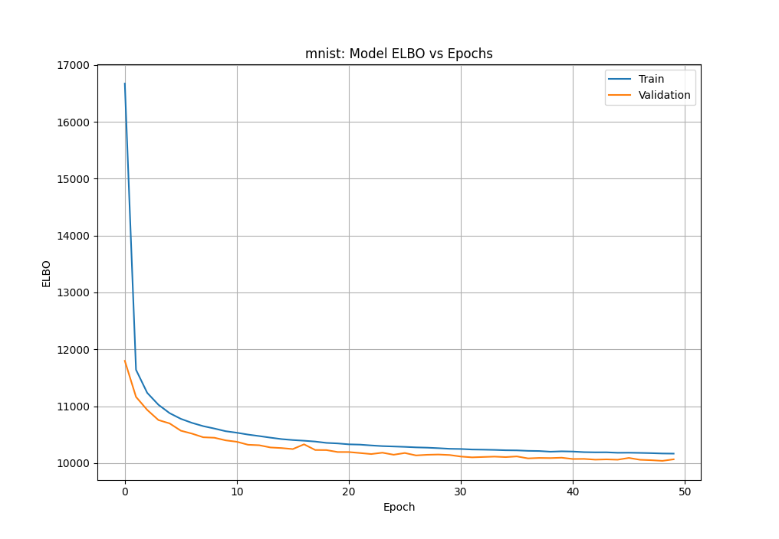
The following plot show the train and test ELBO values per epochs:

The following plot show 25 sampled images from the trained model:

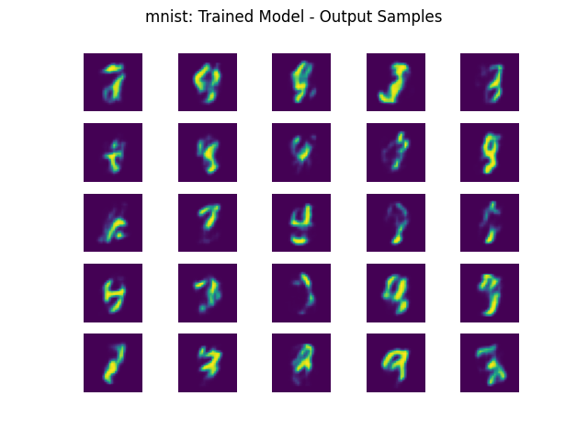

2. Dataset - Fashion-MNIST
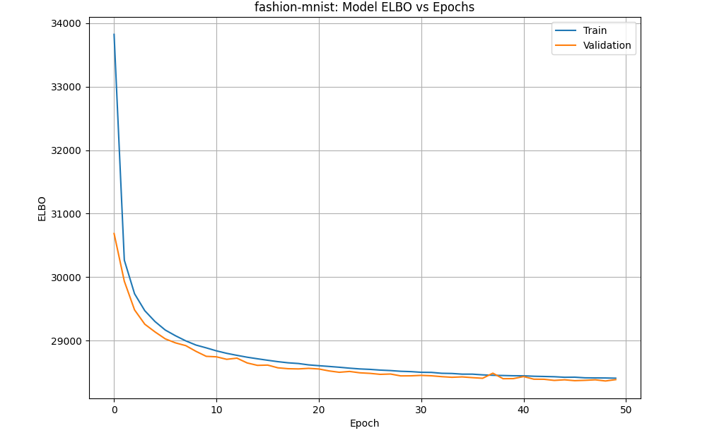
The following plot show the train and test ELBO values per epochs:

The following plot show 25 sampled images from the trained model:

