**ECE374 SP23 HW1**

Ziyuan Chen – ziyuanc3

Zhirong Chen – zhirong4

Problem 1

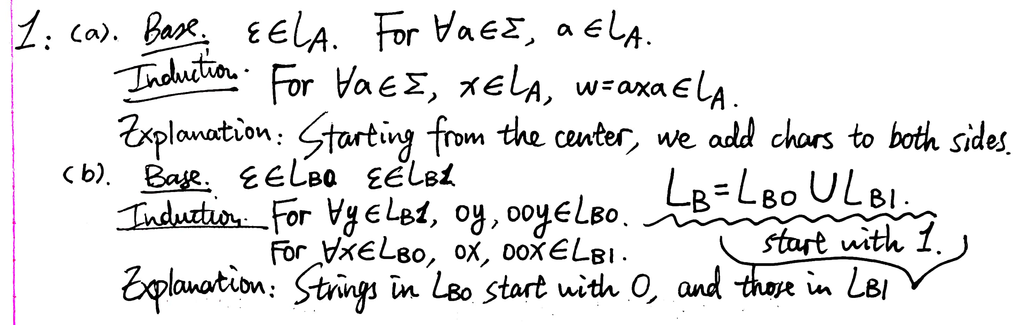

**ECE374 SP23 HW1**

Ziyuan Chen – ziyuanc3

Zhirong Chen – zhirong4

Problem 2

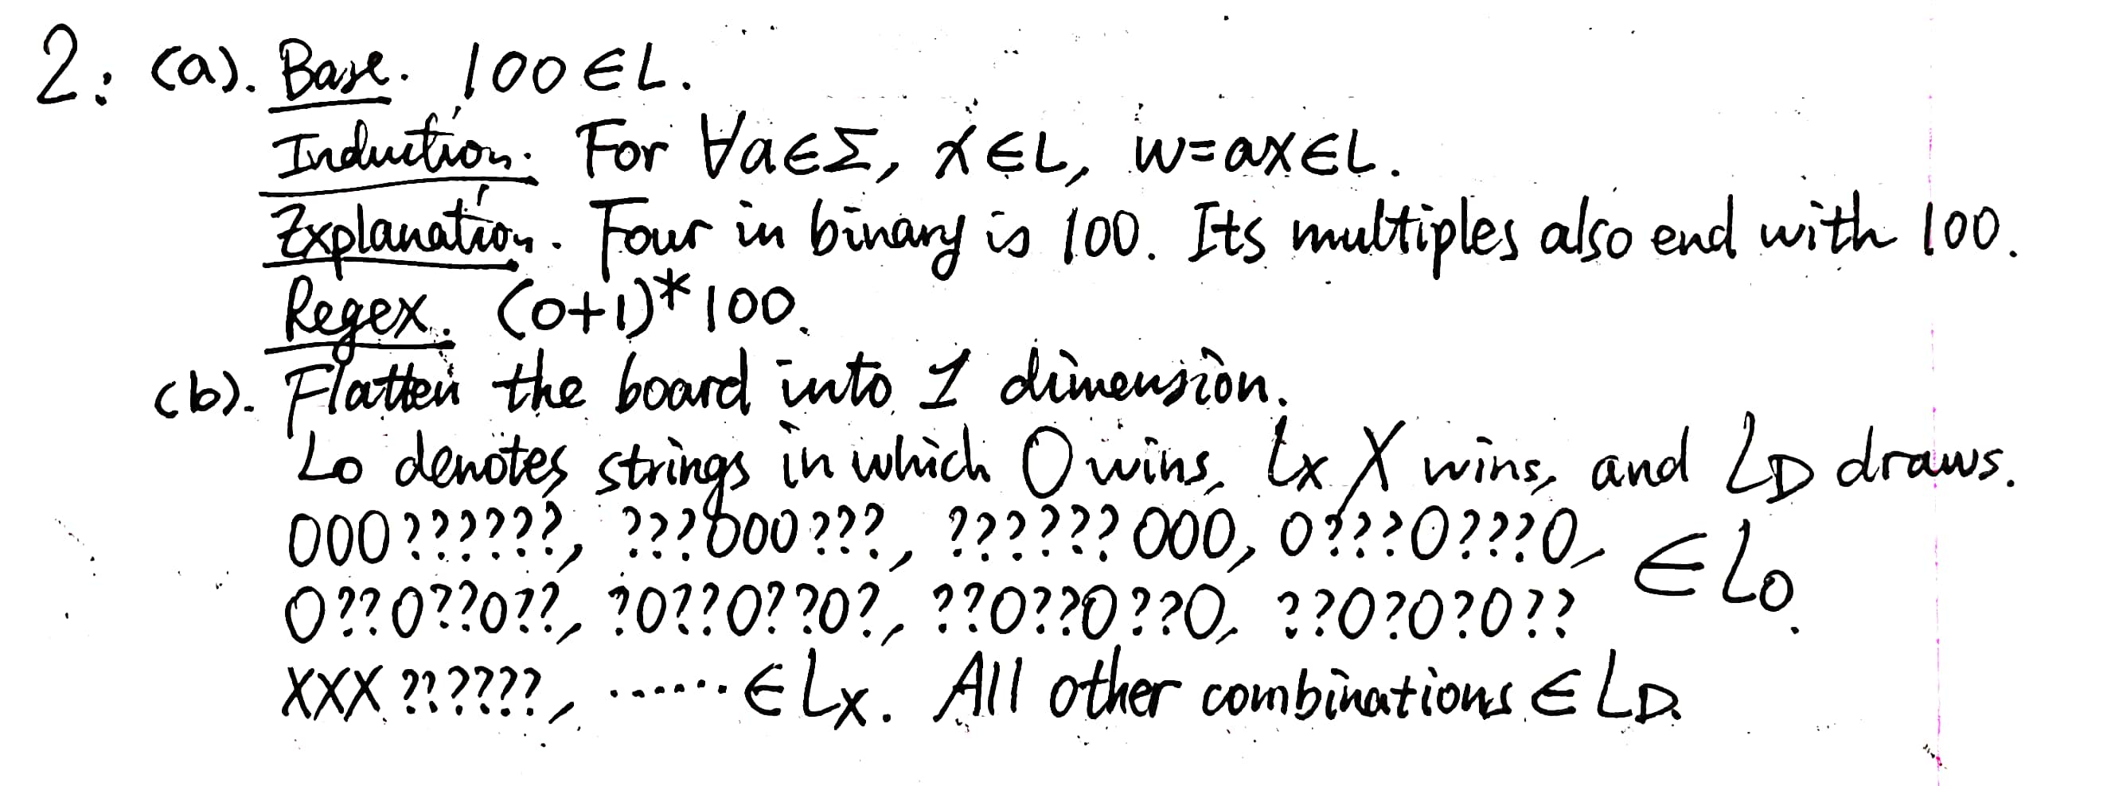

**ECE374 SP23 HW1**

Ziyuan Chen – ziyuanc3

Zhirong Chen – zhirong4

Problem 3

**ECE374 SP23 HW1**

Ziyuan Chen – ziyuanc3

Zhirong Chen – zhirong4

Problem 4

