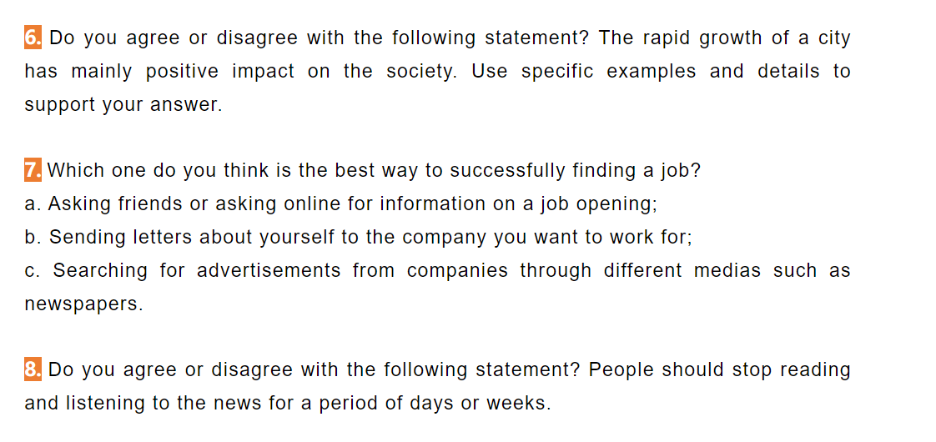

Nowadays, people are talking about a hot topic whether we should stop reading and listening to news for a period of days or weeks. As for me, I think that it would not be beneficial for us to stop getting the news for couple of days.

To begin with, if we stop reading and listening to the news, we may have trouble in maintaining the friendship with other people. As we all know, the topic we and our friends talk is about the news or interesting things happening recently, thus if we stop getting the news, maybe we will have less topic to talk about with our friends. When we have less topic to chat with our friends, we may have difficulty in communicating with them. They may even regard us as weird guys since we know little what happen recently. It is hard for us to maintain friendship with them if we have little time chatting with them. For example, my friend Mariado stopped reading and listening to the news for a while, because she didn’t want to be bothered by those uncountable information. Then since almost everyone would chat about the news when we have lunch, but then it seemed that she didn’t understand what we talked about during the lunch, and some of her friends gradually didn’t talk to her anymore because they didn’t have the common topic anymore. Finally, she resumed to get news every day in order to maintain her social relationship.

Secondly, if we stop reading or listening to news for a while, we may lose one of the most enjoying moments in our daily life. Nowadays, more and more people are working over 9 hours for their subsistence, so they really need something to relax themselves. If we choose to stare at our phones, it may harm our eyes. If we choose to exercise, it may make us more tired. Therefore, reading or listening to news seems to be a reasonable choice for people to have a comfortable time, since neither will them have to run nor will do harm to their eyes. When you listen to the news, not only will we get the funny things making us laugh out, but also will immerse ourselves into a more broaden world, which is really enjoying. For example, I would like to listen to the news each day after dinner, because I’m always looking forward to the news. Last week, I get the news that there is an organization to be founded in a few days in order to help the poor children in Africa, which made me so excited because thousands of children may get help from this organization. Although I had a really hard time on that day, this news really refreshed me a lot.

To sum up, reading and listening to news is really helpful to us, making us strengthen the friend bonds and offering the enjoyable time every day, so we’d better not stop doing it.