CIS451

Rongbo Guo

Final project report

Video store to find video you want

1: A Simple summary----------------p2

2: ER-Diagram-------------------------p3

` 3: Description all Table--------------p3

4: Description all Application------p4

5: Conclution---------------------------p5

6: WebLink-----------------------------p5

A Simple summary

For my final project part II am want to make the website to help people find video they are interesting. When you find the movie, there will be the link to the website to watching it. In my database, it has video table as the main table. In this table it include the table id and the video link. Video has been divided by tree main category. There are movie, news and sport. Each category will give us the information about the video and the people who make it. So that it will make us to know the basic information about the video.

In the website we can find the certain video that make by a director like ‘James Cameron’. You can also find the movie come with you favorite actor. For the sport, you can find the sport you want to take look.

ER-Diagram

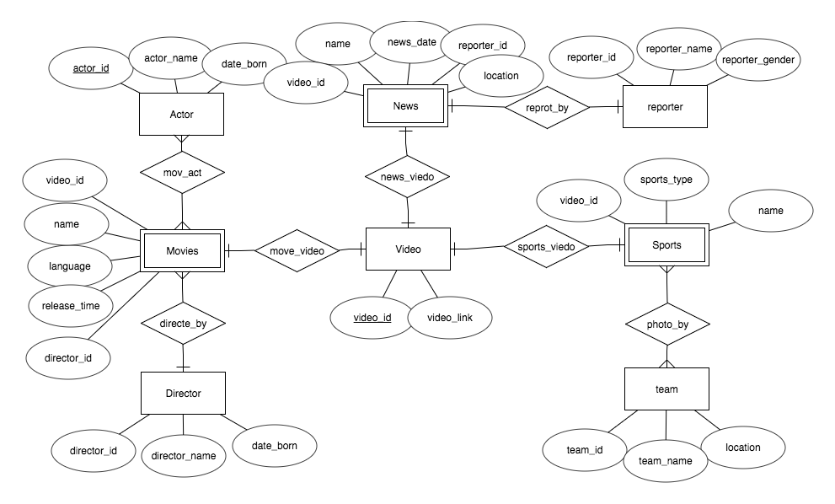

Description all Table

For the Video Table: It come with the primer key “video_id” and the website link that to that video.

For the Movies Table: It is the week table come with the “video_id”, the name of the movie “name”, with language for the movie speek “language”, The “release_time” and the director_id.

For the Director Table: It come with the primer key “director_id”, “Director_name” and the data for the director born “director_born”.

For the Actor Table: It come with “actor_id”, “actor_name” and “date_born”.

For the News Table: It is the week table, it come with “video_id”, “name”, “news_date”, “location” and “reporter_id”

For the reporter Table: It come with primer key “reporter_id”, “reporter_name”, “reporter_gender”.

For the Sport Table: It is the week table. It come with “video_id”, “sprot_type” and “name”.

For the team Table: It come with primer key “team_id”, “team_name” and “location”.

Description all Application

1: We can find all the video for the movies, news or the sports. By insert “Videos”, “Movies” or “Sports”. It will shows all the video name come with the link.

2: We can find some movie that come with the language you prefer. You can insert “english”, “chinese”, “japanese” or “korean”.

3: We can find the movie that direct by some specific director. By insert the integer. Each integer represents on director.

4: We can find some sport video by insert sport type. You can insert basketball, football, LOL for different sport.

5: We can find some News video by insert news location. It will give you the news happen in that location. You can insert America, Japan, China, Korean or Australian.

Conclusion

In my project you can find the project easily. I think it is easy tool to help people to find video they are interest.

WebLink

<http://ix.cs.uoregon.edu/~rongbo/fProject/findVideo.html>