Results:
Training and Testing
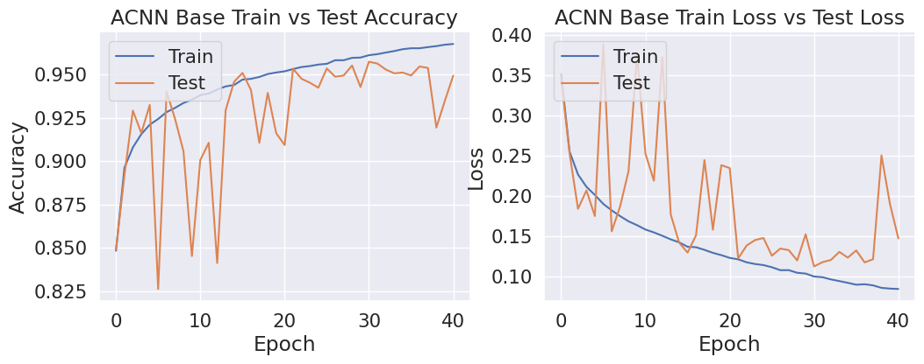

Model Size and parameter distribution
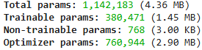

Model Hyperparameters
- Optimizer: Adam
- Lr = 0.0001
- Activation functions relu (Hidden Layers) | sigmoid (Output Layer)
- Rescaling (1/255)
- Epochs 41 (was set to 100 epochs with patience of 10)
Confusion Matrix
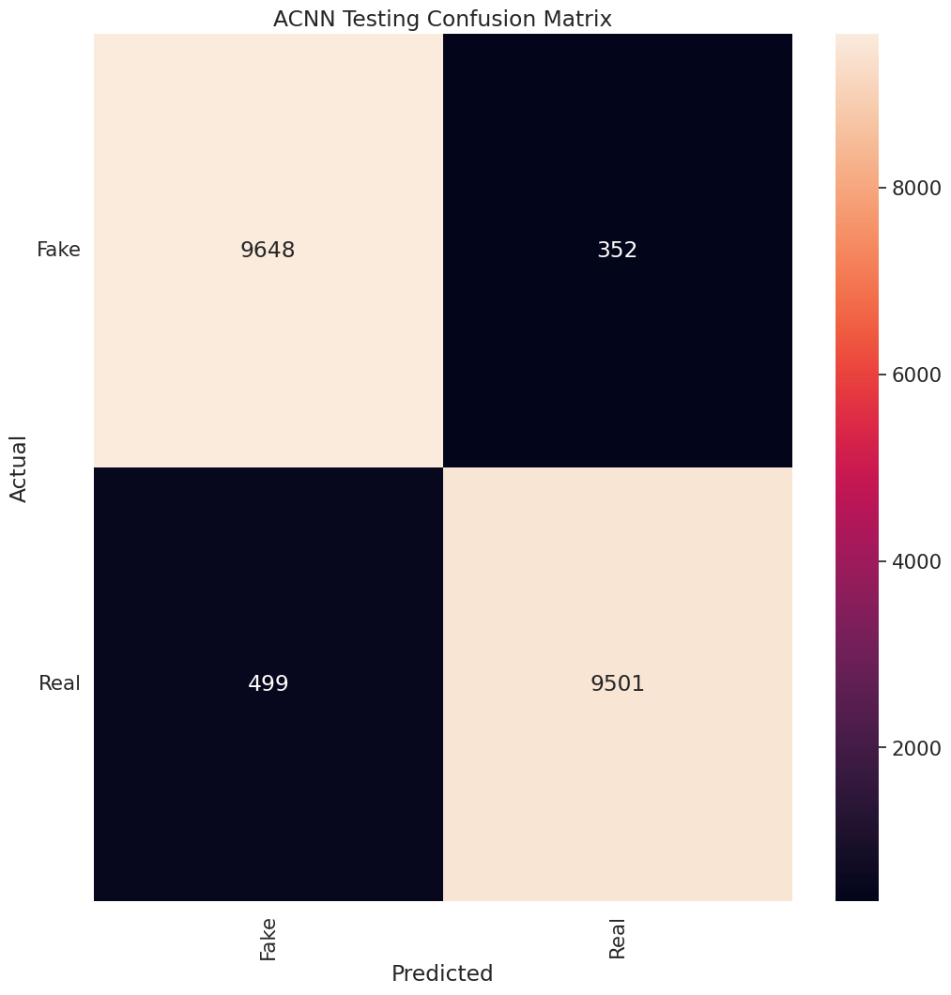

Model Accuracy and Loss
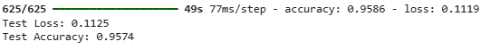

Model Plot
