Q41. Write a program to swap the first and last digit of a number.
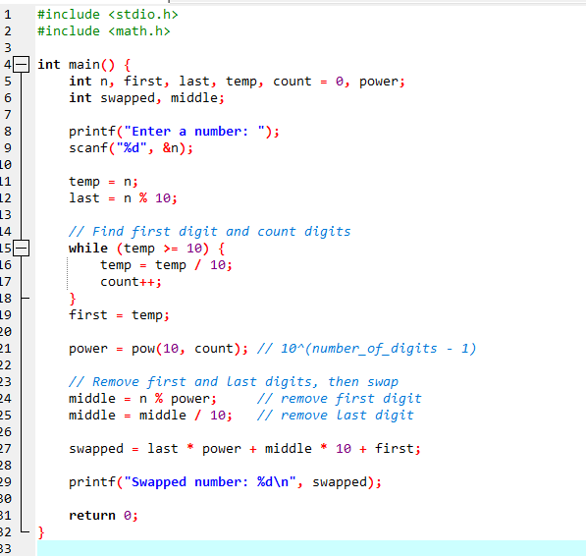
Result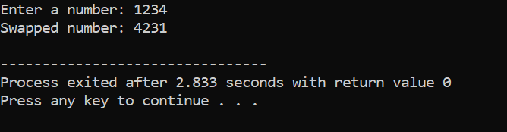
Q42 Write a program to check if a number is a perfect number.

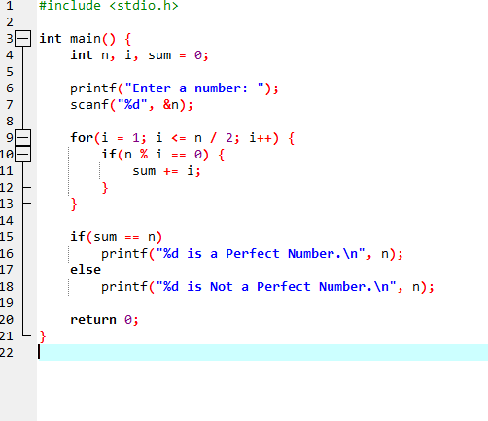
Result
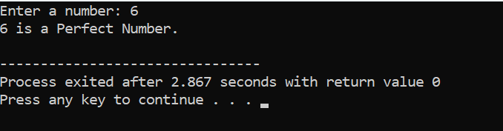
Q43 Write a program to check if a number is a strong number.

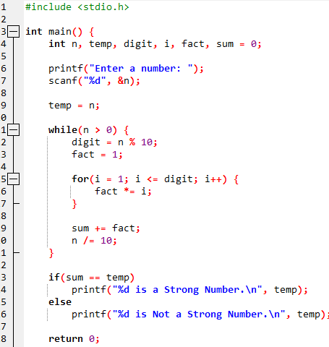
Result
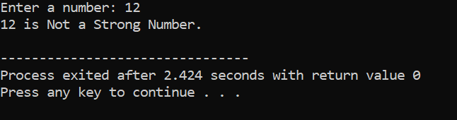
Q44. Write a program to find the sum of the series: 1 + 3/4 + 5/6 + 7/8 + … up to n terms.

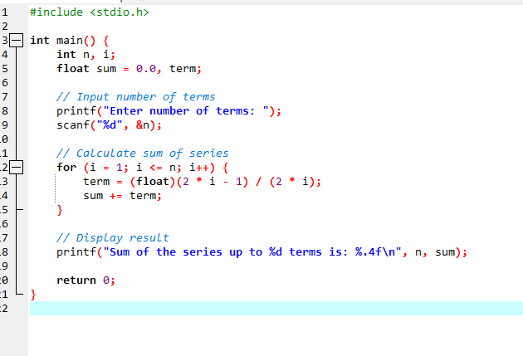
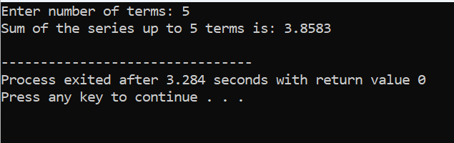
Q45. Write a program to find the sum of the series: 2/3 + 4/7 + 6/11 + 8/15 + ... up to n terms.

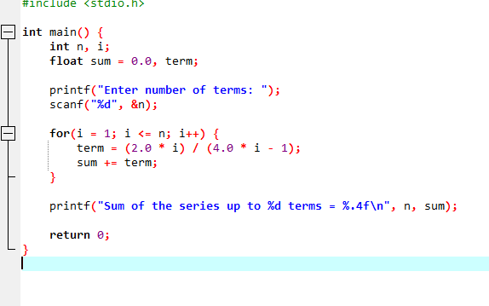
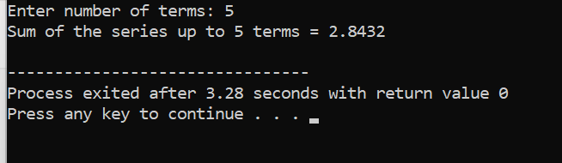
Q46 Write a program to print the following pattern:
*****
*****
*****
*****
*****

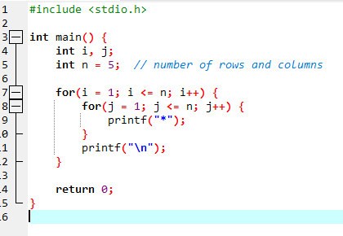
Result
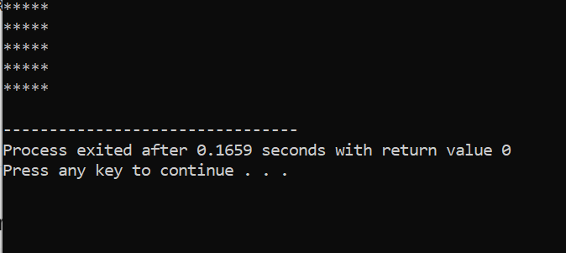
Q47Write a program to print the following pattern:
*
**
***
****
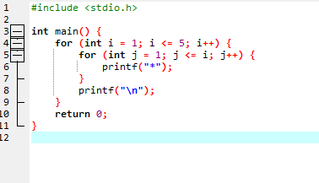

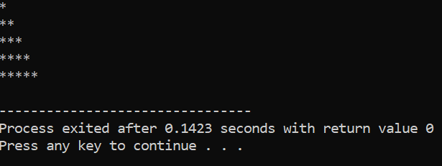
Q 48 Write a program to print the following pattern:
1
12
123
1234
12345

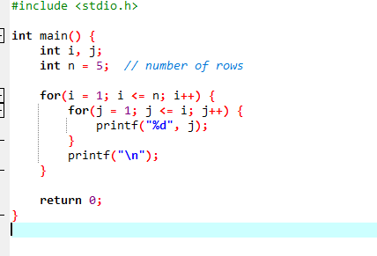

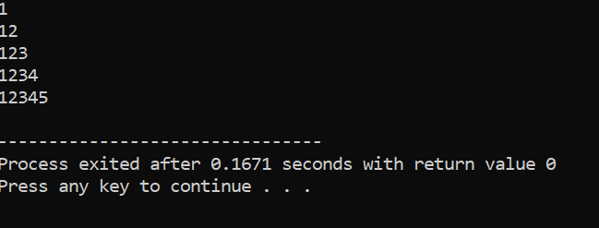
Q49Write a program to print the following pattern:
5
45
345
2345
12345

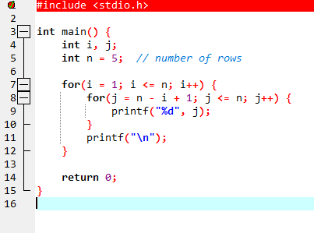
result
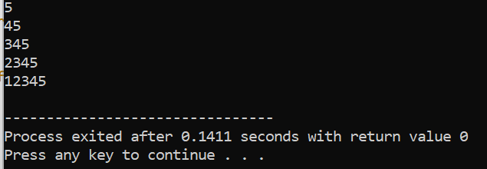
Q50
Write a program to print the following pattern:
*****
****
***
**
*
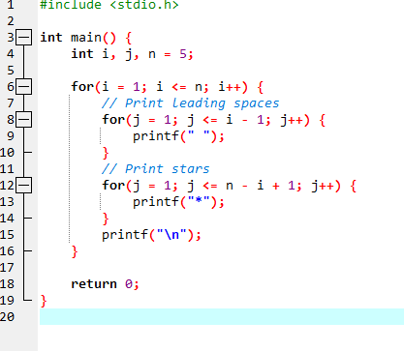
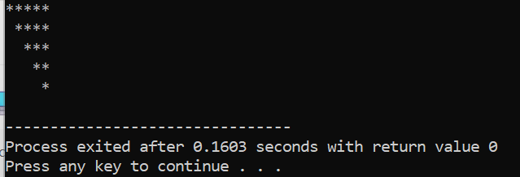
Q51 Write a program to print the following pattern:
5
45
345
2345
12345

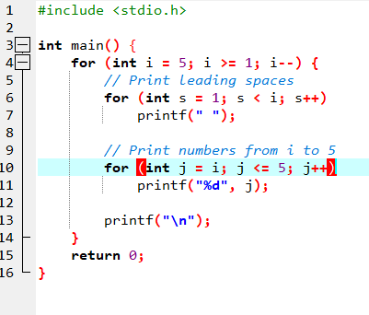
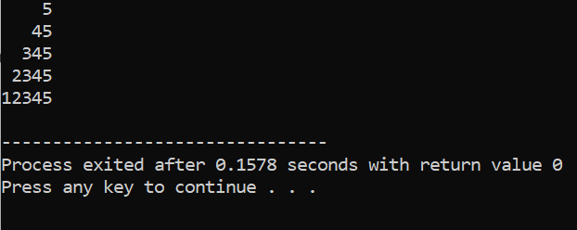
Q52 Write a program to print the following pattern:

*

*
*
*

*
*
*
*
*

*
*
*

*

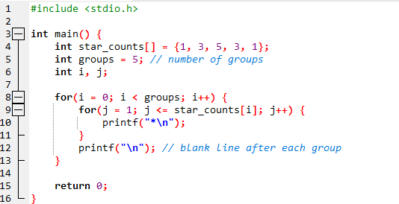
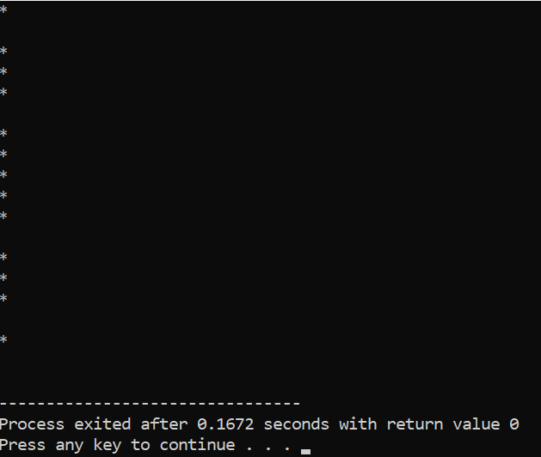
Q53
Write a program to print the following pattern:
*
***
*****
*******
*********
*******
*****
***
*

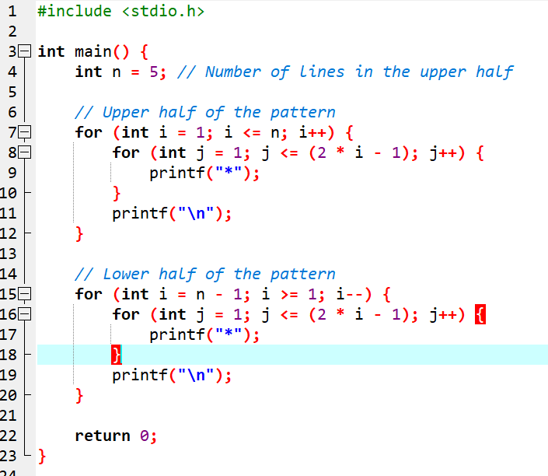

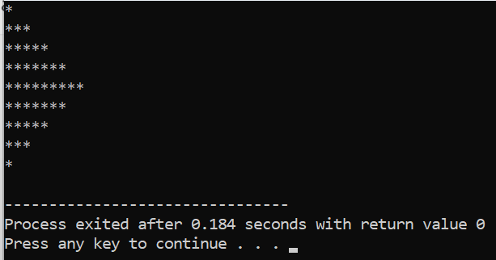
Q54
Write a program to print the following pattern:

*
***
*****
*******
*****
***
*

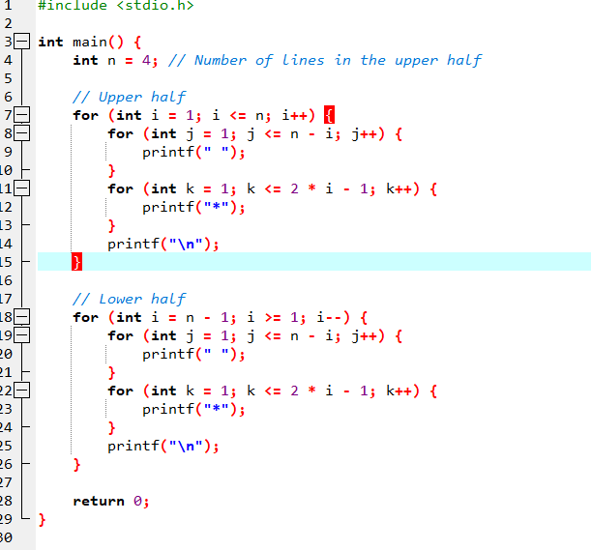
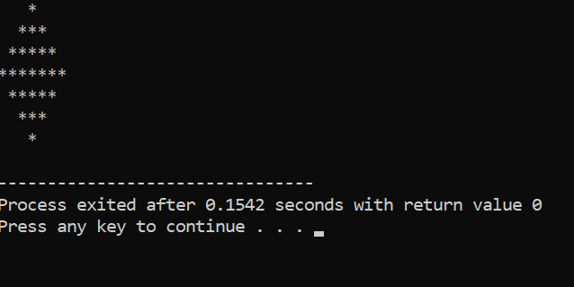
Q55 Write a program to print all the prime numbers from 1 to n.

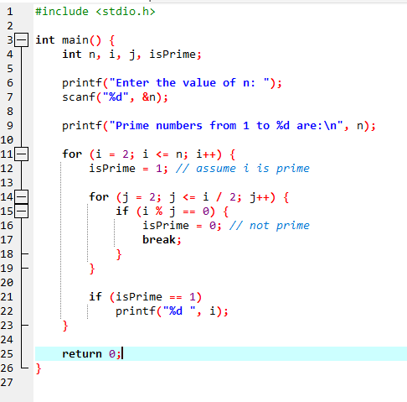
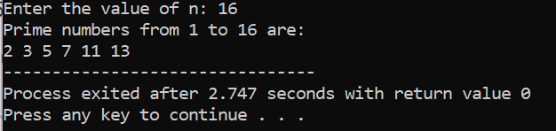
Q56 Read and print elements of a one-dimensional array.

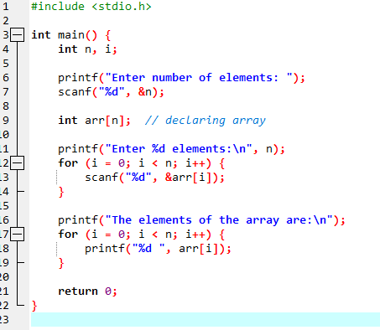
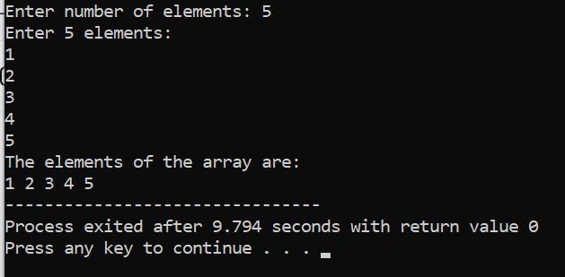
Q57 Find the sum of array elements.

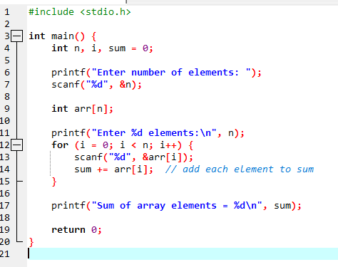
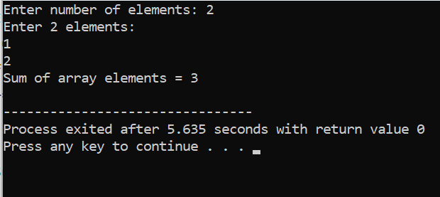
Q58
Find the maximum and minimum element in an array.
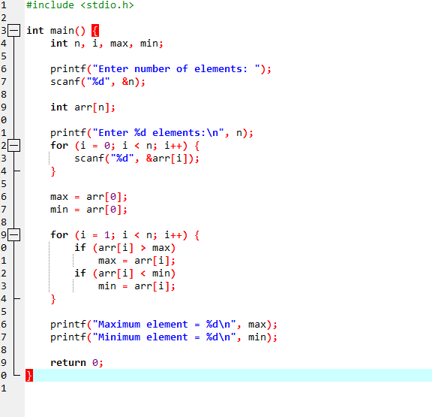
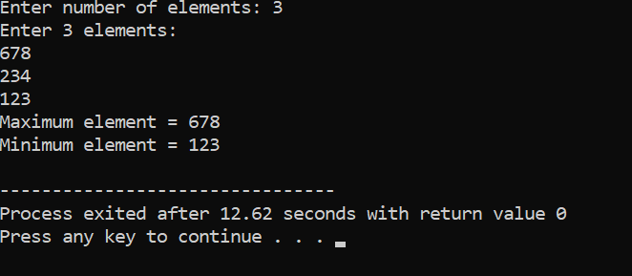
Q59 Count even and odd numbers in an array.

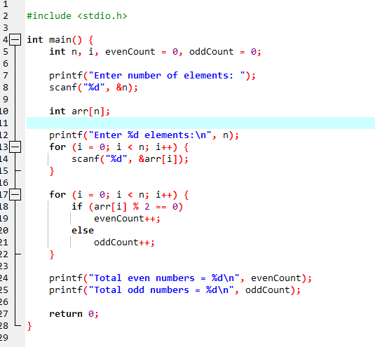

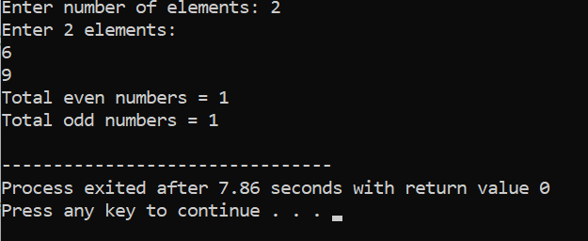
Q60 Count positive, negative, and zero elements in an array.

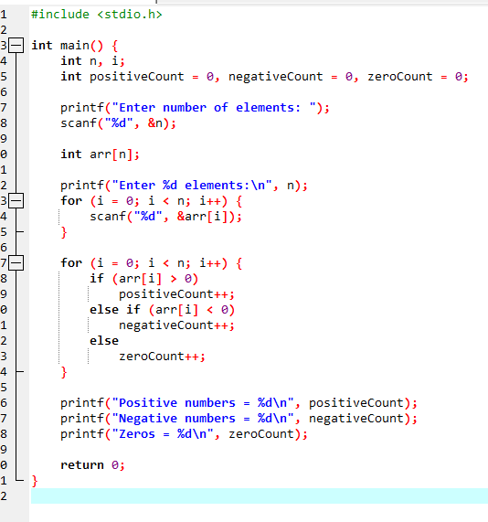
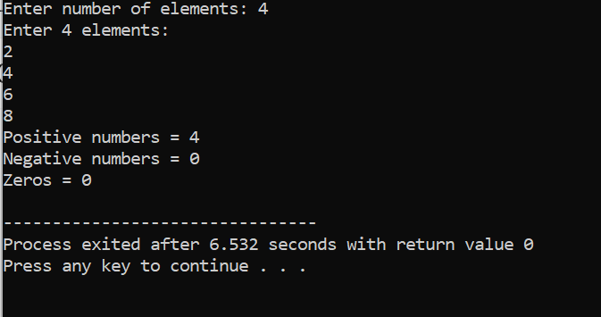
Q61 Count positive, negative, and zero elements in an array.

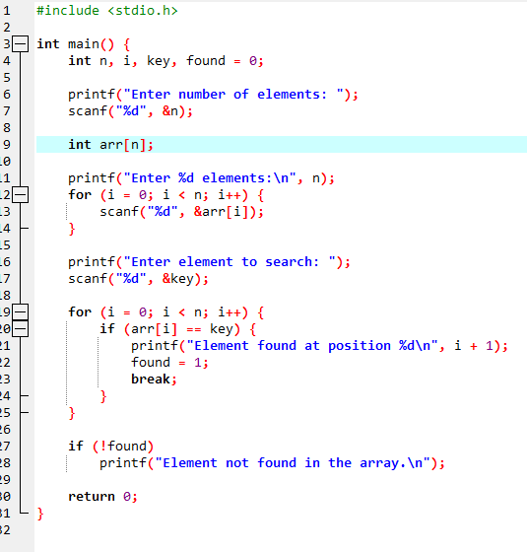
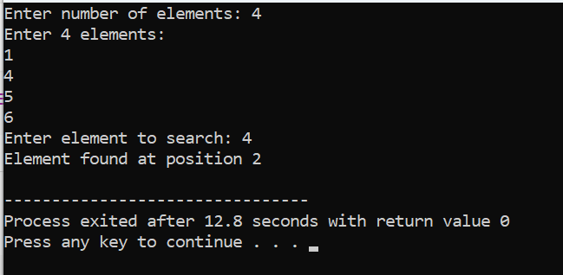
Q62 Reverse an array without taking extra space.

