Sankalp Ronge
SAP ID – 590027268
Batch 77

- Function: printf()
Header: stdio.h
Algorithim
- Start
- Use printf() to display a message
- End

Pseudocode
START
PRINTF “Hello World”
END
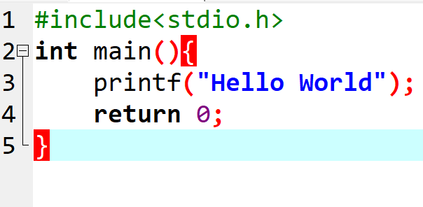
Result
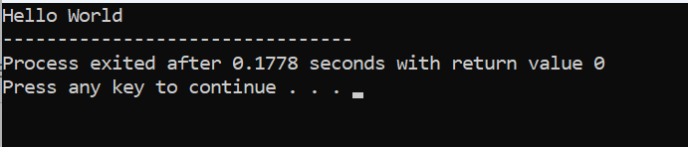

- Function: scanf()
Header: stdio.h
Algorithm
1. Start
2. Ask user for a number
3. Read number using scanf()
4. Print number
5. End

Pseudocode
START
INPUT num
PRINT num
END
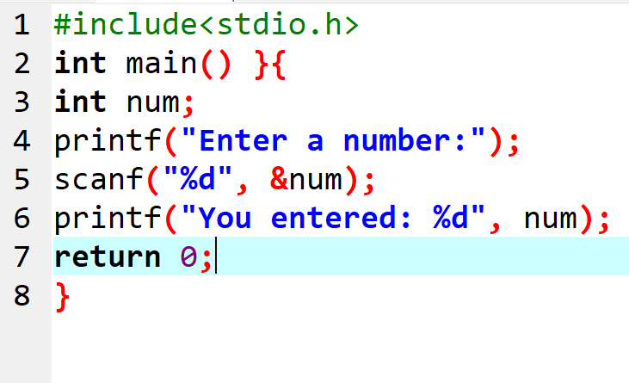
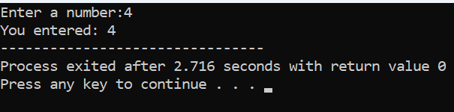

- Function: toupper()
Header:ctype.h
Algorithm
1. Start
2. Input a character
3. Convert to uppercase using toupper()
4. Print result
5. End
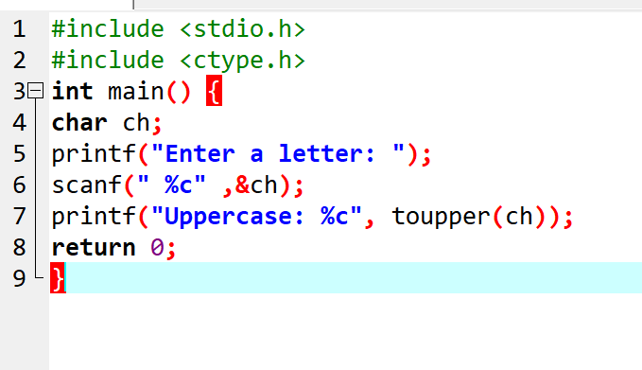
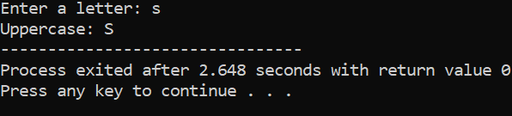

- Function: isdigit()
Header: ctype.h

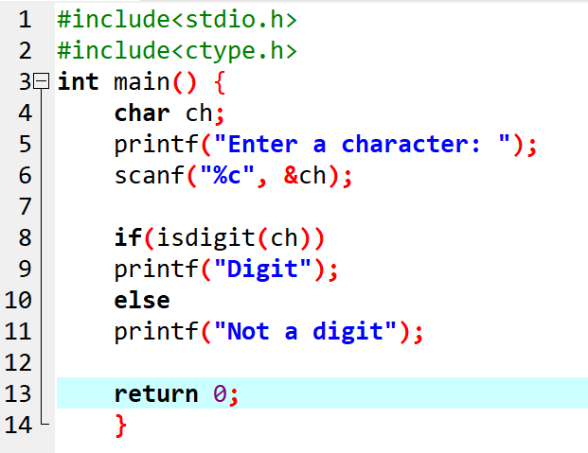

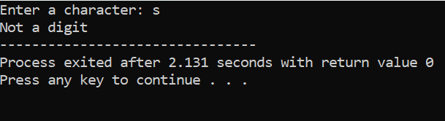

- Function: strlen()
Header:string.h

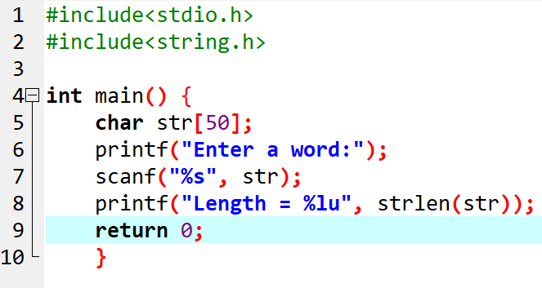

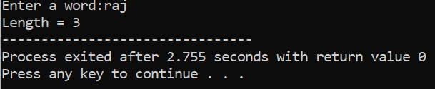

6.Function strcpy()
Header:string.h
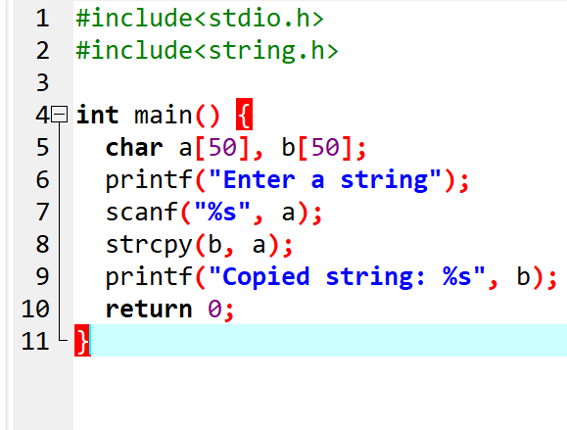
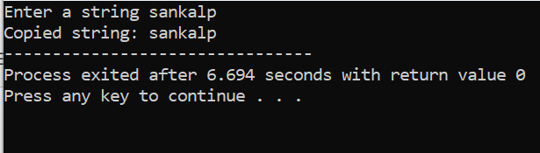

7.Function: sqrt()
Header:math.h
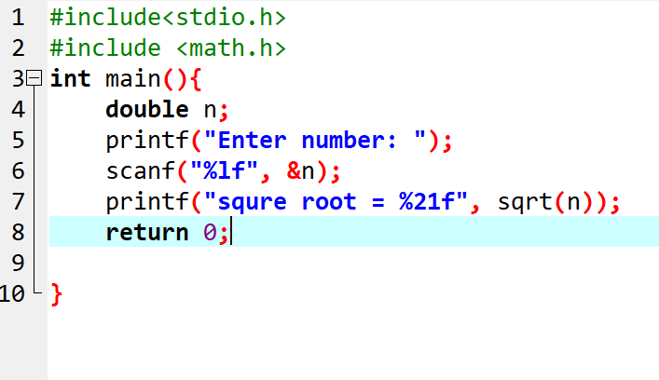

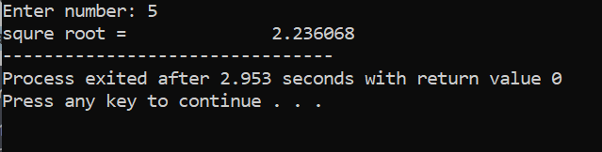

8.Function: malloc()
Header:stdlib.h

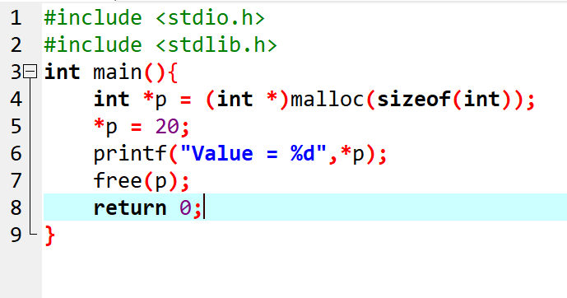

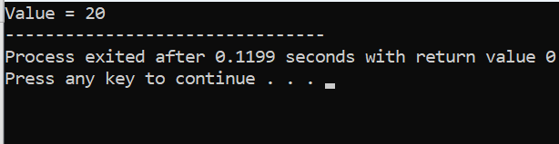

9. Function: free()
Header:stdlib.h
(Used together with malloc)
Explanation:
Free (ptr) releases memory that was allocated using malloc()

10.Function:assert()
Header:assert.h
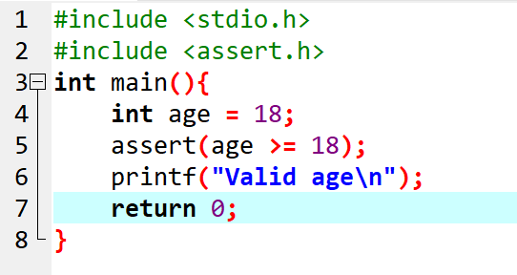
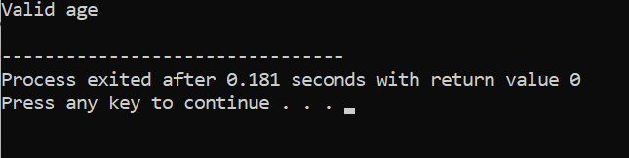

Q1. Static Library vs Shared Library
Static Library (.a / .lib)
• Added to the program during compilation
• Final executable becomes bigger
• Faster execution
• No need for library file during runtime
Shared Library (.so / .dll)
• Linked during program execution
• Reduces executable size
• Same library can be used by many programs
• Requires library file during runtime

Q2. Dynamic Memory vs Static Memory
Static Memory
• Allocated at compile time
• Fixed size
• Example:
int a[10];
Dynamic Memory
• Allocated at runtime
• Flexible size
• Uses malloc(), calloc(), realloc()
• Must use free() to release memory
Example:
int *p = malloc(5 * sizeof(int));

Q3. Garbage Collection
• C does not have automatic garbage collection
• Programmer must manually free memory
• Use free() for memory allocated by malloc()
• Prevents memory leaks

