Gunitskiy Ron. Task 2. Ice Hockey

1. Design the short-lists of free, freemium, and paid Ice Hockey games (3 of each type, 9 in total). Give a link to a description of each game.

**Free**:

1. Ice League Hockey (<https://play.google.com/store/apps/details?id=com.koalitygame.iceleaguehockey>)
2. Mini Ice Hockey Game (<https://play.google.com/store/apps/details?id=com.papps.MiniIceHockeyGame>)
3. Tap Ice Hockey (https://play.google.com/store/apps/details?id=com.koalitygame.iceleaguehockey)

**Freemium**:

1. Ice Rage: Hockey Multiplayer (<https://play.google.com/store/apps/details?id=com.herocraft.game.free.icerage>)
2. Stickman Ice Hockey (https://play.google.com/store/apps/details?id=com.djinnworks.StickmanIceHockey)
3. Superstar Hockey (<https://play.google.com/store/apps/details?id=com.bigideagames.googleplay.superhockey> )

**Paid**:

1. Ice Rage: Hockey (https://www.microsoft.com/ru-ru/p/ice-rage-hockey/9wzdncrdcrcs?cid=msft_web_search&activetab=pivot:overviewtab)
2. Ice Rage Premium (https://play.google.com/store/apps/details?id=com.herocraft.game.icerage)
3. NHL 22 (<https://www.microsoft.com/ru-ru/p/nhl-22-xbox-one/9nrdc9pxdq5n?cid=msft_web_search#activetab=pivot:overviewtab>)
4. From your shortlist give overall picture of a niche (casual game, hardcore game, etc.), audience (use gamer’s classification), game goals and the requirements for their achievements.

All these games fall into the casual sports niche, mostly played by teens according to classification, with the goal of beating your opponent (opposing team) by scoring more points, and the ability to complete various achievements with the possibility to unlock new characters.

1. Analyze differences and similarities of Ice Hockey games and create the matrix of features (obligatory and distinctive) for a mobile ice hockey game based on your short-lists.

Differences:

1. Visuals (styles, player models)
2. PvP or PvE availability
3. Controls (hockey vs. air hockey)

Similarities:

1. Win condition is to score more points
2. Battling against AI/ other AI presence

Feature matrix:

|  |  |  |  |  |  |
| --- | --- | --- | --- | --- | --- |
|  | View | Character control with tapping | Local PvP | Online PvP | Ability to hit other players |
| Ice League Hockey | Top-down | + | - | - | - |
| Mini Ice Hockey Game | Top-down | + | - | - | - |
| Tap Ice Hockey | Top-down | + | - | - | - |
| Ice Rage: Hockey Multiplayer | Top-down | + | + | - | + |
| Stickman Ice Hockey | Top-down | + | - | - | - |
| Superstar Hockey | Top-down | + | - | - | - |
| Ice Rage: Hockey | Top-down | + | + | + | + |
| Ice Rage Premium | Top-down | + | + | + | + |
| NHL 22 | Third person | + | + | + | - |

1. Think about the originality. Make up and explain 3 original features of your ice hockey game.

Features:

1. Attacks from all the players, including AI allies and AI opponents, with enough attacks landed knocks out and puts player activity on pause.
2. Accessories: different shapes, forms and print on hockey pucks and sticks with possibly slightly different effects and abilities.
3. Describe UI Patterns used in applications from the short-lists. Give examples.

Most of the games have a similar UI pattern: the screen shows the field, players’ and puck positions, the score and hp stats are located closer to top or bottom of the screen. The games have several action buttons and usually a stick movement controller along with a button for accessing the pause menu.

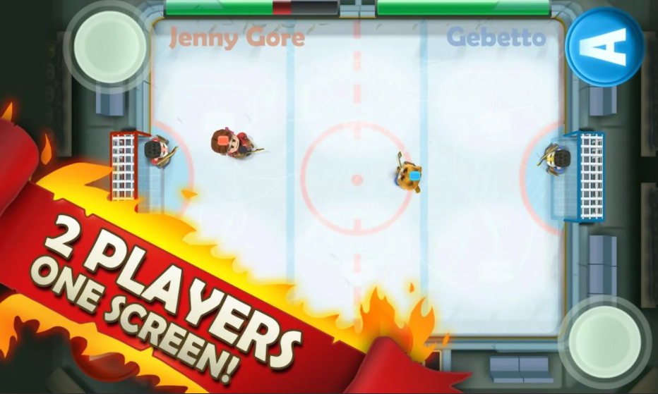

1. Examine the types of user’s input/output in the ice hockey games from the short-list. Give examples.

* Controller: some games support controller input using sticks for player movement and buttons control actions like passing or taking a shot
* Touch: mobile games mostly use a joystick-like controller for movement and some buttons for the actions, which is very similar to a controller input, implemented for mobile devices.
* Click(touch)-to-move: some games use clicks (touches) to determine where to move the platform in air hockey (or maybe the active player in classic hockey)

1. Explain the user’s input/output modes in your ice hockey game.

Our game’s input will be touch-based. We will use the pseudo-classic joystick to move and buttons to pass, shoot or change the defender while not on offense.

1. Explain your set of UI Patterns.

Our game will have a main menu, which will contain an exit, settings, achievements buttons, and the game start button. The game menu contains the shop button, where users will be able to equip owned cosmetics or buy new ones. The game itself takes place and hence displays a hockey field where all the players are located, which is viewed from top-down, along with a HUD displaying the score, game time and the above-mentioned controls.

1. Analyze game engines used in your short-lists and create the pool of engines suitable for your genre.

Most (simpler) games were probably developed using the Unity engine or Unreal since they are arguably the most popular engines among mobile games, but EA Sports’ NHL 22 was developed using Frostbite, but we can use several engines, for example, Unreal Engine 4 or Unity, making use of their vast documentation and community to learn and try new techniques and possibilities.

1. Suggest a monetization model for your ice hockey game, expose the characteristics of the model.

Since this is a new game, I think it would be wiser to release it for free with in-app purchases of better customization to attract more initial players to this new game from a previously unknown developer. For instance, I would never buy even a cheap a game developed by someone I haven’t heard of before, so I would prefer to make a name with a free or freemium game first.