**CSE - 4020**

**Machine Learning**

1. Title of the project (Problem Statement& method developed/used)

**Leaf Disease detection using Image Processing and Machine Learning.**

Plants can suffer from various diseases like Alternaria alternate (fungal), Anthracnose, Bacterial Blight (bacteria), Cercospora Leaf Spot etc. These may be categorized as fungal viral, fungal or bacterial. This situation can cause a lot of damage to the plant itself and plants near to the disease affected plant. In return a farmer may not get proper output from the crops.  
To overcome this we aim to make a system to detect and classify leaf diseases

1. **Objectives of the project**

Objective-1

To prevent the losses and quality of agricultural product.

Objective-2

To apply our knowledge of Image processing and Machine Learning in the field of agriculture and identify the disease at early stages, recommending farmers to avoid the harm in the production of the crop to increase their yield.

Objective-3

To pre-process and segment the image into different clusters then extract features out of each clustered image. Based on the features present in the cluster with disease, classifying the leaf disease into categories using SVM Classifier.

3. Data Set used in your project

**The dataset used contains a total of 15 plants with diseases Anthracnose or Black Spot. It has a table containing 15 rows and 13 columns specifying the features of the row’s data.**

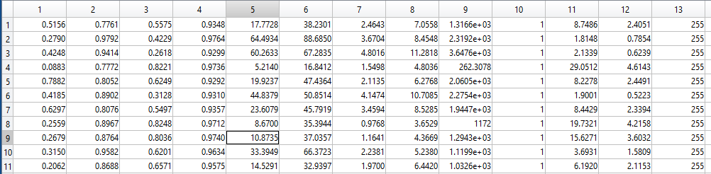

**Images of real leaves having diseases are given as input to the system to be checked.**

Google images were referred as inputs for test cases:

https://www.elitetreecare.com/wp-content/uploads/2016/06/sycamore-anthracnose.jpg\

http://www.missouribotanicalgarden.org/Portals/0/Gardening/Gardening%20Help/images/Pests/Leaf_Spot_of_Trees154.jpg

https://www.planetnatural.com/wp-content/uploads/2012/12/leaf-spot-fungus.jpg

4. Methodologies applied to your project

The methodology applied has 5 steps as shown below:

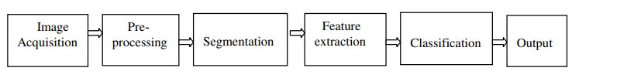

* **Image Acquisition:** Taking the image as input to be checked for the type of disease.

[filename,pathname] = uigetfile({'*.*';'*.bmp';'*.tif';'*.gif';'*.png'},'Pick a Disease Affected Leaf');

I = imread([pathname,filename]);

* **Pre – Processing:** Convert Image from RGB Color Space to L*a*b* Color Space, where L will represent the Brightness, a will represent the Reddish Green Component and b will tell about the Yellowish Blue parts.

cform = makecform('srgb2lab');

lab_he = applycform(I,cform);

* **Segmentation:** K-means clustering algorithm is used in segmenting the given image into three sets as a cluster that contains the background, non-diseased part and diseased part of the leaf.

[cluster_idx, cluster_center] = kmeans(ab,nColors,'distance','sqEuclidean','Replicates',3);

* **Feature Extraction:** We extract 13 different kinds of features as in our dataset to match what kind of disease the plant has.

stats = graycoprops(glcms,'Contrast Correlation Energy Homogeneity');

Contrast = stats.Contrast;

Correlation = stats.Correlation;

Energy = stats.Energy;

Homogeneity = stats.Homogeneity;

Mean = mean2(seg_img);

Standard_Deviation = std2(seg_img);

Entropy = entropy(seg_img);

RMS = mean2(rms(seg_img));

Variance = mean2(var(double(seg_img)));

a = sum(double(seg_img(:)));

Smoothness = 1-(1/(1+a));

Kurtosis = kurtosis(double(seg_img(:)));

Skewness = skewness(double(seg_img(:)));

m = size(seg_img,1);

n = size(seg_img,2);

in_diff = 0;

for i = 1:m

for j = 1:n

temp = seg_img(i,j)./(1+(i-j).^2);

in_diff = in_diff+temp;

end

end

IDM = double(in_diff);

* **Classification:** Using SVM Classifier trained the dataset and classified.

load Diseaseset.mat

svmStructDisease = fitcsvm(diseasefeat,diseasetype);

svmStructDisease

CVSVMModel = crossval(svmStructDisease);

CVSVMModel

[validationPredictions, validationScores] = kfoldPredict(CVSVMModel);

* **Confusion Matrix:** Calculating the confusion matrix.

ConfusionMatrix=confusionmat(validationPredictions,Y)

* **Loss and Accuracy:** Calculating the Loss and Accuracy for the model.

Loss = loss(svmStructDisease,X,Y)

Accuracy=1-Loss

KFoldLoss = kfoldLoss(CVSVMModel);

KFoldLoss

KFoldAccuracy = 1 - kfoldLoss(CVSVMModel);

KFoldAccuracy

* **Prediction:** Using SVM Classifier predict the class for input image.

species_disease = predict(svmStructDisease,feat_disease);

species_disease

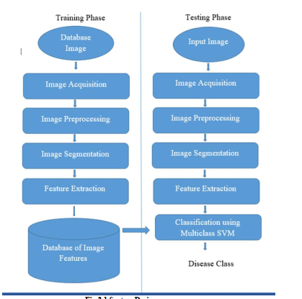

**5. Result (outcome of the project) and discussion**

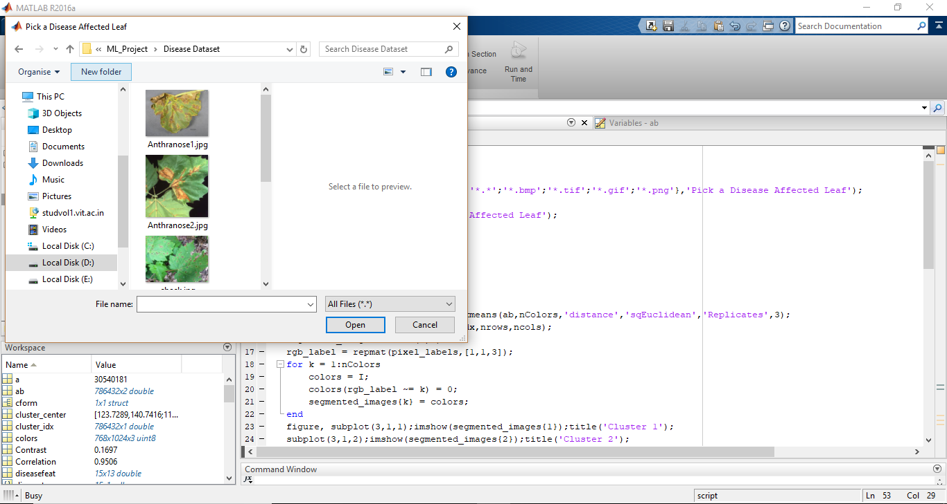

**Fig:** Select the Image to be checked

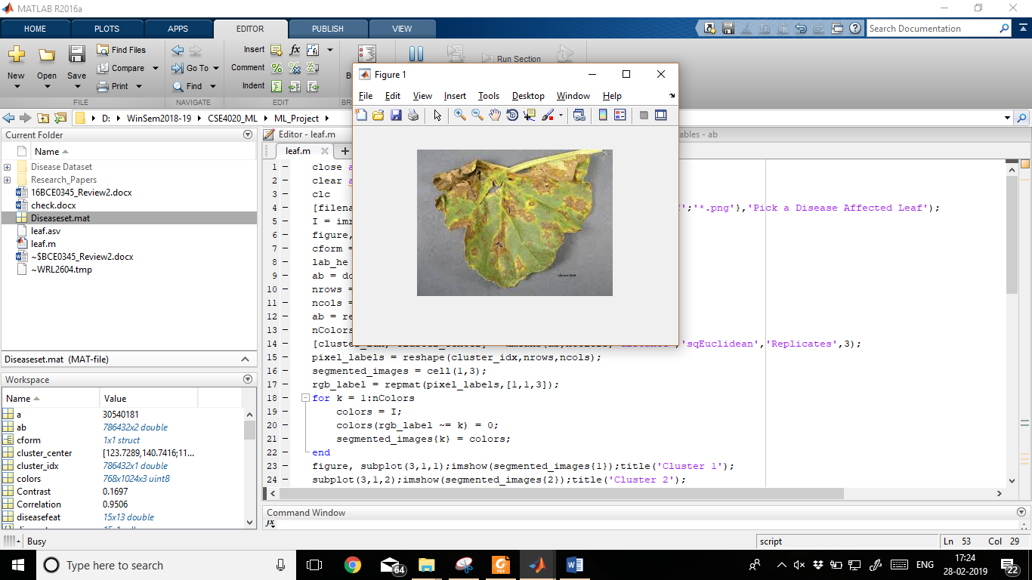

**Fig:** The image input is loaded successfully

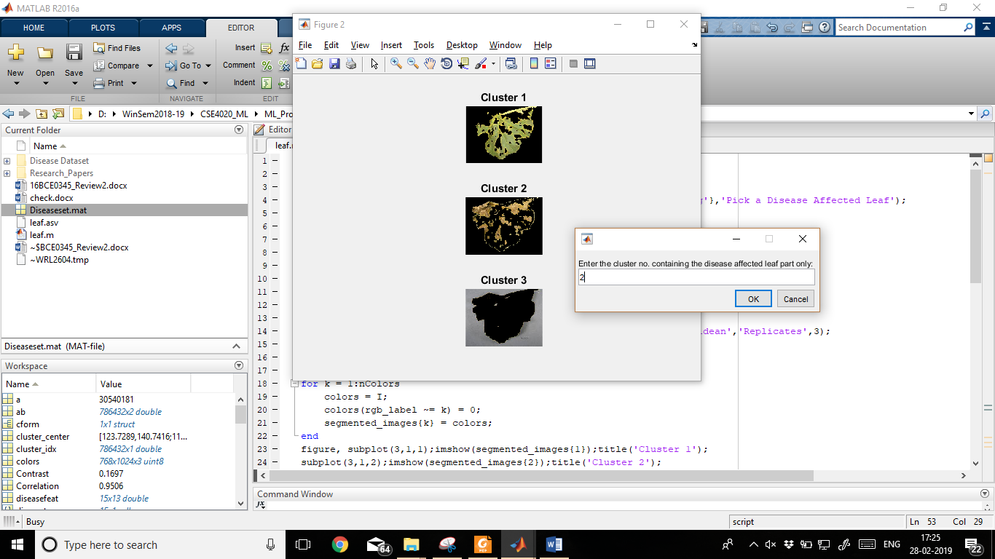

**Fig**: Enter the cluster with disease

|  |  |  |  |  |  |  |  |  |  |  |  |  |
| --- | --- | --- | --- | --- | --- | --- | --- | --- | --- | --- | --- | --- |
| Contrast | Correlation | Energy | Homogeneity | Mean | Standard_Deviation | Entropy | RMS | Variance | Smoothness | Kurtosis | Skewness | IDM |
| 0.71949 | 0.86113582 | 0.62604 | 0.93541524 | 24.5405 | 54.90475952 | 2.15787 | 6.2525 | 2753.655 | 0.99999973 | 5.93762 | 2.0783829 | 255 |

**Table:** Features Extracted from the Input Image

**svmStructDisease** =

ClassificationSVM

ResponseName: 'Y'

CategoricalPredictors: []

ClassNames: {'ANTHRANOSE' 'BLACKSPOT'}

ScoreTransform: 'none'

NumObservations: 15

Alpha: [9x1 double]

Bias: 0.5763

KernelParameters: [1x1 struct]

BoxConstraints: [15x1 double]

ConvergenceInfo: [1x1 struct]

IsSupportVector: [15x1 logical]

Solver: 'SMO'

**CVSVMModel** =

classreg.learning.partition.ClassificationPartitionedModel

CrossValidatedModel: 'SVM'

PredictorNames: {'x1' 'x2' 'x3' 'x4' 'x5' 'x6' 'x7' 'x8' 'x9' 'x10' 'x11' 'x12' 'x13'}

ResponseName: 'Y'

NumObservations: 15

KFold: 10

Partition: [1x1 cvpartition]

ClassNames: {'ANTHRANOSE' 'BLACKSPOT'}

ScoreTransform: 'none'

**ConfusionMatrix** =

0 2 9

0 2 2

0 0 0

**Loss** =

0.2000

**Accuracy** =

0.8000

**KFoldLoss** =

0.2667

**KFoldAccuracy** =

0.7333

**species_disease** =

'ANTHRANOSE'

6.Output in form of Graphs

**Fig:** Comparison with Respect to the Dataset

* **Analysis:** Of all the Graphs, Tables and Results
* The table feat_disease is the table of all 13 features extracted from the input table that need to be compared.
* The above Plotted Graph is the representation of the dataset that is used to classify the diseases.
* **svmStructDisease:**  It is the model trained using SVM Classifier.
* **CVSVMModel:** Cross Validation of the SVM Model.
* **Confusion Matrix:** Confusion matrix of the test dataset and the output values.
* **Accuracy:** Accuracy of our model.
* **Loss:** Loss in the model.
* **KFoldAccuracy:** Using K-Fold Accuracy to get a better approximation of the accuracy of the model.

7. Reference papers:

**1.** **Grape Leaf Disease Detection Using SVM Classifier**Shweta.S. Kothawale 1, S.R.Barbade 2 , Pradnya .P.Mirajkar 3 P.G. Student, Department of Electronics Engineering, Walchand Institute of Technology, Solapur, India1 Associate Professor, Department of Electronics Engineering, Walchand Institute of Technology, Solapur, India2 Associate Professor, Department of Electronics Telecommunication Engineering, ADCET, Ashta, India

**2. Classification of leaf disease based on Multiclass SVM classifier**

Pooja Kulinavar Department of Computer Science & Engg, KLE DR M S, Sheshgiri College of Engg. & Tech, poojakulinavar17@gmail.com

Vidya I. Hadimani, Department of Computer Science & Engg, KLE DR M S, Belagavi Sheshgiri College of Engg. & Tech, Belagavi, [vidya4279@gmail.com](mailto:vidya4279@gmail.com)