Arab Open University

Lebanon Branch

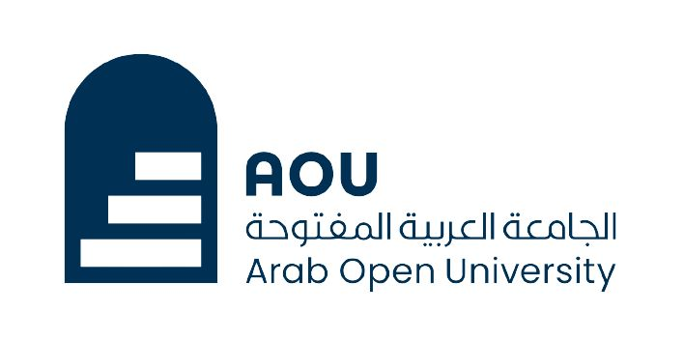

Faculty of Computer Studies

Data Science Program

TM471: Graduation Project

***Water Scarcity in the Arab world***

**Name:** Rony Al Moussa

**Id:** 220339

**Supervisor:** Dr. Maya Dawood

05/ 2024

First link of my codes:

<https://colab.research.google.com/drive/1dksNRU-2am_UtMIOECmBRFr16h8Pnu-6?usp=sharing#scrollTo=Fv8OvXmeRRU5>

Second link of my codes:

<https://colab.research.google.com/drive/1cjWLphO8BpU0OVFxlQogq7xN9WCYCL-U?usp=sharing#scrollTo=nH1tm2zItIVh>