Climate Change Impact Analysis Using Statistical Methods and Data Visualization
A PROJECT REPORT
Submitted by
Ranvir Saini(23BDA70105)
Royal Singh Rana(23BDA70059)
Satyam Singh(23BDA70052)
Anish Sharma(23BDA70027)
in partial fulfillment for the award of the degree of
BACHELOR OF ENGINEERING
IN
COMPUTER SCIENCE WITH SPECIALIZATION IN

BIG DATA ANALYTICS

Chandigarh University
Gharuan, Mohali – 140413, Punjab, India
April 2026



BONAFIDE CERTIFICATE

Certified that this project report "Climate Change Impact Analysis Using Statistical Methods and Data Visualization" is the bonafide work of "Ranvir Saini, Royal Singh Rana, Satyam Singh, Anish Sharma" who carried out the project work under my/our supervision.

<<Signature of the HoD>>  SIGNATURE  <<Name of Head of Department>>  HEAD OF THE DEPARTMENT  Dept. of Computer Science & Engineering | <<Signature of the Supervisor>>  SIGNATURE  Monica Luthra (E9836)  SUPERVISOR  Assistant Professor  Dept. of Computer Science & Engineering

Submitted for the project viva-voce examination held on ___________________________
INTERNAL EXAMINER | EXTERNAL EXAMINER

TABLE OF CONTENTS
List of Figures iv
List of Tables v
List of Standards vi
Abstract vii

CHAPTER 1. INTRODUCTION 1
1.1. Identification of Client/Need/Relevant Contemporary Issue 1
1.2. Identification of Problem 1
1.3. Identification of Tasks 2
1.4. Timeline 2
1.5. Organization of the Report 2

CHAPTER 2. LITERATURE REVIEW / BACKGROUND STUDY 3
2.1. Timeline of the Reported Problem 3
2.2. Existing Solutions 3
2.3. Bibliometric Analysis 4
2.4. Review Summary 5
2.5. Problem Definition 5
2.6. Goals/Objectives 5

CHAPTER 3. DESIGN FLOW / PROCESS 6
3.1. Evaluation & Selection of Specifications/Features 6
3.2. Design Constraints 7
3.3. Analysis of Features and Finalization 7
3.4. Design Flow 8
3.5. Design Selection 8
3.6. Implementation Plan/Methodology 9

CHAPTER 4. RESULTS ANALYSIS AND VALIDATION 10
4.1. Data Loading and Preprocessing 10
4.2. Temperature Trend Analysis 11
4.3. Precipitation Trend Analysis 12
4.4. Seasonal Temperature Analysis 13
4.5. Correlation Analysis 14
4.6. Monthly Temperature Distribution 15

CHAPTER 5. CONCLUSION AND FUTURE WORK 16
5.1. Conclusion 16
5.2. Future Work 16

REFERENCES 17
APPENDIX 18
USER MANUAL 19

LIST OF FIGURES
Figure 4.1 – Annual Average Temperature Trend (1990–2024) 11
Figure 4.2 – Annual Maximum Temperature Trend (1990–2024) 12
Figure 4.3 – Estimated Annual Precipitation Trend (1990–2025) 13
Figure 4.4 – Seasonal Average Temperature Trends – Ludhiana (1990–2024) 14
Figure 4.5 – Average Seasonal Temperature Range – Monthly Profile 14
Figure 4.6 – Pearson Correlation Matrix of 10 Climate Variables 15
Figure 4.7 – Monthly Mean Temperature Distribution – Year × Month Heatmap 15

LIST OF TABLES
Table 2.1 – Bibliometric Analysis of Reviewed Literature 4
Table 3.1 – Hardware and Software Specifications 6
Table 3.2 – Design Alternative Comparison 8
Table 4.1 – Summary Statistics – Annual Temperature Variables (1990–2024) 11
Table 4.2 – Summary Statistics – Annual Precipitation (1990–2024) 13
Table 4.3 – Seasonal Temperature Summary (°C), 1990–2024 14

LIST OF STANDARDS
Standard | Publishing Agency | About the Standard | Page No.
ISO 8601 | ISO | International standard for representation of dates and times. Used in dataset timestamps and climate data documentation throughout this project. | 9, 10
WMO No. 49 | World Meteorological Organization | WMO Technical Regulations defining standard climatological normals and procedures for computing 30-year climate averages, which this project follows for trend analysis. | 11
IPCC AR6 Guidelines | IPCC | IPCC Sixth Assessment Report methodology guidelines for statistical trend detection and climate data analysis, including the use of linear regression and significance testing at α = 0.05. | 11, 16

ABSTRACT
Climate change represents one of the most critical environmental challenges of the 21st century. This project presents a comprehensive data-driven analysis of climate change impacts using 35 years (1990–2024) of monthly NASA POWER meteorological data for the Kharar–Ludhiana region, Punjab, India (30.91°N, 75.81°E). Ten climate parameters are analysed including maximum temperature (T2M_MAX), mean temperature (T2M), minimum temperature (T2M_MIN), dew-point temperature (T2MDEW), relative humidity (RH2M), bias-corrected precipitation (PRECTOTCORR), surface solar irradiance (SFC_SW_DWN), UV index (SFC_UV_INDEX), and wind speed (WS10M_MAX, WS10M_MIN).
Statistical analysis using linear regression (scipy.stats) reveals three principal findings: (i) annual mean temperature declined at −0.040 °C/year (R²=0.41, p<0.01), decreasing from 25.8 °C in 1990 to 24.4 °C in 2024; (ii) annual maximum temperature declined at −0.053 °C/year (R²=0.35, p<0.01), dropping from 38.1 °C to 36.4 °C; and (iii) annual precipitation increased significantly at +8.2 mm/year (p=0.03), rising from ~652 mm in 1990 to a record 1,375 mm in 2023. Pearson correlation analysis across all 10 parameters identifies strong coupling between solar irradiance and maximum temperature (r=0.92) and a moderate negative correlation between relative humidity and maximum temperature (r=−0.31).
Seven publication-quality visualizations are generated using Python (Pandas 2.0, NumPy 1.24, Matplotlib 3.7, Seaborn 0.12, SciPy 1.10), including trend regression plots, seasonal decomposition, monthly climatological profiles, and a 10-variable correlation heatmap. The observed regional cooling–wetting tendency contrasts with the global warming signal reported by IPCC AR6, and is likely driven by the intensification of monsoon precipitation generating evaporative cooling and increased cloud cover suppressing incoming solar radiation.

CHAPTER 1.
INTRODUCTION
1.1. Identification of Client / Need / Relevant Contemporary Issue
Climate change has emerged as the defining environmental crisis of the 21st century. The IPCC Sixth Assessment Report (AR6, 2023) confirms that global mean surface temperature has risen approximately 1.1 °C above pre-industrial levels, driven primarily by anthropogenic greenhouse gas emissions. In South Asia, these changes manifest as erratic monsoon patterns, increasing frequency of heat waves, and shifting seasonal boundaries — all with direct consequences for the region's predominantly agrarian economy.
Punjab, India's primary wheat- and rice-producing state, is acutely sensitive to temperature and precipitation variability. Studies from the Indian Meteorological Department (IMD) document an increasing frequency of heat-wave days over the Indo-Gangetic Plain since the 1980s. A deviation of even 1–2 °C during the grain-filling stage of wheat can reduce yields by 6–10% (ICAR, 2020). The Ludhiana–Kharar belt therefore represents an urgent client need where rigorous, data-driven, localised climate analysis can directly inform irrigation scheduling, crop variety selection, and disaster preparedness. This need is further documented in the World Bank Climate Change Knowledge Portal (2021) and the NAPCC (National Action Plan on Climate Change, India, 2008).
1.2. Identification of Problem
Despite the availability of long-term satellite-derived climate reanalysis datasets, regional climate change at the district level in Punjab remains poorly characterised. Specifically: (a) multi-variable interactions between temperature, precipitation, humidity, and solar radiation at the district level are not systematically quantified; (b) seasonal decomposition of warming or cooling signals has not been performed for the Kharar–Ludhiana corridor; and (c) accessible, reproducible Python-based analytical pipelines tailored to this region are absent from the published literature.
The broad problem is defined as: How have temperature, precipitation, and related climate variables evolved in the Kharar region (30.91°N, 75.81°E) over the 35-year period 1990–2024, and can statistical analysis of NASA POWER data quantify these trends with sufficient confidence to inform local adaptation policy? The problem does not include future climate projections, spatial interpolation, or socio-economic impact modelling.
1.3. Identification of Tasks
The following tasks were identified to structure the project:
- Task 1 – Data Collection: Download NASA POWER monthly data for 30.91°N, 75.81°E for 10 climate parameters across 1990–2024.
- Task 2 – Pre-processing: Skip 18-row metadata header, replace −999 missing-value flags with NaN, melt wide monthly columns to long format, create datetime index, pivot by PARAMETER.
- Task 3 – Exploratory Data Analysis: Compute annual means, identify missing values, understand distributions.
- Task 4 – Trend Analysis: Apply scipy.stats.linregress to T2M, T2M_MAX, and PRECTOTCORR; report slope, R², p-value.
- Task 5 – Seasonal Decomposition: Compute seasonal averages for four IMD seasons; analyse seasonal trends.
- Task 6 – Correlation Analysis: Compute 10×10 Pearson correlation matrix; visualise as annotated heatmap.
- Task 7 – Visualisation: Generate 7 publication-quality figures using Matplotlib and Seaborn.
- Task 8 – Report Writing: Compile findings into this structured project report per Chandigarh University format.
1.4. Timeline
Period | Activity | Status
Sep–Oct 2025 | Literature Review & Problem Formulation | Completed
November 2025 | Data Collection from NASA POWER Portal | Completed
December 2025 | Data Pre-processing & Exploratory Data Analysis | Completed
January 2026 | Statistical Trend & Correlation Analysis | Completed
February 2026 | Visualisation & Figure Generation (7 figures) | Completed
March–April 2026 | Report Writing & Final Submission | Completed
1.5. Organization of the Report
Chapter 2 provides a comprehensive literature review documenting the global timeline of climate change research, existing analytical approaches, and a bibliometric summary of seven peer-reviewed references. Chapter 3 describes the design flow including hardware/software specifications, two design alternatives, and the selected methodology with a detailed Python pipeline. Chapter 4 presents all seven visualizations with quantitative statistical results and data tables for each finding. Chapter 5 draws conclusions based on the numerical results and outlines six directions for future work. References, Appendix (plagiarism report and design checklist), and User Manual follow at the end.

CHAPTER 2.
LITERATURE REVIEW / BACKGROUND STUDY
2.1. Timeline of the Reported Problem
Climate change as a scientific concern has evolved through decades of atmospheric research, environmental monitoring, and policy interventions. The modern understanding of climate systems began in 1896 when Svante Arrhenius first proposed that atmospheric carbon dioxide could influence Earth’s temperature. However, systematic evidence emerged in 1958 through Charles David Keeling’s atmospheric CO₂ measurements (Keeling Curve), which demonstrated a persistent annual increase in carbon dioxide concentrations.
By the late 20th century, climate science gained international policy recognition:
1958 – Keeling Curve Initiated
- First continuous atmospheric CO₂ observations at Mauna Loa Observatory
- CO₂ concentration: ~315 ppm
1988 – Formation of IPCC
- Intergovernmental Panel on Climate Change established by UNEP and WMO
- Formalized global scientific assessment of climate change
1992 – United Nations Framework Convention on Climate Change (UNFCCC)
- International framework for climate mitigation
1997 – Kyoto Protocol
- Legally binding emission reduction commitments for developed nations
2008 – India’s National Action Plan on Climate Change (NAPCC)
- Recognized agriculture, solar energy, water, and sustainable habitat as climate priorities
2015 – Paris Agreement
- Target: Limit warming below 2°C, preferably 1.5°C
2023 – IPCC AR6 Synthesis Report
- Confirmed warming of ~1.1°C above pre-industrial levels
- South Asia identified as highly vulnerable to compound heat and precipitation extremes
This historical progression highlights that while climate change is global, regional manifestations vary substantially. Punjab’s climate, influenced by irrigation cycles, monsoon intensity, aerosol loading, and land-use patterns, may not precisely mirror global averages.
2.2. Existing Solutions
Existing approaches to climate analysis fall into three broad categories. First, Global Climate Models (GCMs) under the CMIP6 framework provide future projections at ~100 km resolution but are too coarse for district-level analysis. Second, reanalysis products — ERA5 (ECMWF, 0.25° grid), MERRA-2 (NASA, 0.5° grid), and NASA POWER (point-based, 0.5° spatial resolution) — provide historical data suitable for site-specific trend analysis. Third, statistical methods including linear regression, Mann-Kendall tests, Sen's slope estimator, and change-point detection have been widely applied for hydro-meteorological trend studies.
Python-based data analytics environments including Pandas, NumPy, Matplotlib, Seaborn, and SciPy have become the standard for reproducible climate data science. They support systematic data cleaning, transformation, visualization, and multi-variable analysis. While platforms such as NOAA Climate Data Online and IMD Agri-Met provide climate data access, they often require significant preprocessing and technical expertise. Despite these resources, no integrated, reproducible Python-based multi-variable climate analysis currently exists in the literature specifically for the Kharar–Ludhiana corridor, which this project aims to address.

2.3. Bibliometric Analysis
Table 2.1 – Bibliometric Analysis of Reviewed Literature
Year | Article / Author | Tools / Technique | Source | Evaluation Parameter
2023 | IPCC AR6 Synthesis Report | Climate models, Statistical tools | IPCC | Temp rise (+1.1°C), CO₂=421 ppm
2022 | World Bank Climate Indicators | Python, R, Multivariate stats | World Bank | Temperature anomaly, HDI impact
2021 | NOAA Climate Analysis Study | Spatial-temporal models | NOAA | Sea level rise +3.3 mm/yr
2020 | Hansen et al. – Surface Temp | Linear regression, Anomaly detection | Rev. Geophysics | Global T: +0.18°C/decade
2019 | Trenberth et al. – Extreme Events | Attribution methods | Nature Clim. Change | Extreme weather ×5 since 1980
2018 | IMD – Punjab Climate Study | Mann-Kendall trend test | IMD Reports | Monsoon variability ±15%
2017 | Pachauri et al. – IPCC AR5 | GCM projections, RCPs | Cambridge Univ. Press | Adaptation gaps, vulnerability
2.4. Review Summary
From the reviewed literature, five critical conclusions emerge:
1. Global warming is unequivocal, but regional climates may deviate.
This supports investigating localized anomalies.
2. South Asia is highly vulnerable to climate variability.
This justifies focusing on Punjab.
3. Satellite-derived datasets such as NASA POWER are reliable for regional retrospective studies.
This validates dataset selection.
4. Python has become a dominant analytical environment.
This supports the use of Pandas, NumPy, SciPy, Matplotlib, and Seaborn.
5. Multi-variable analysis provides better explanatory depth than single-variable temperature studies.
This motivates the inclusion of 10 climate variables.
Thus, this project fills a direct literature gap by providing:
A district-scale, 35-year, reproducible, multi-variable climate trend analysis for Kharar–Ludhiana.
2.5. Problem Definition
Using 35 years (1990–2024) of monthly NASA POWER data for Kharar (30.91°N, 75.81°E), apply Python-based statistical analysis to: quantify linear trends in T2M, T2M_MAX, and PRECTOTCORR; perform seasonal decomposition across four IMD seasons; compute a 10-variable Pearson correlation matrix; and generate seven visualisations. The study is restricted to observed historical data. Future projections, spatial interpolation beyond the point coordinate, and socio-economic impact modelling are explicitly excluded from scope.
2.6. Goals / Objectives
- Collect and pre-process 35 years of 10-parameter NASA POWER monthly climate data for Kharar, Punjab (1990–2024).
- Compute annual averages and apply linear regression to T2M, T2M_MAX, and PRECTOTCORR, reporting slope, R², and p-value.
- Decompose temperature signals into four IMD seasons (Winter, Pre-Monsoon, Monsoon, Post-Monsoon).
- Compute a 10×10 Pearson correlation matrix and identify statistically significant inter-variable relationships (|r| > 0.5, p < 0.05).
- Generate a monthly climatological temperature profile spanning all 12 calendar months.
- Produce a year × month heatmap of mean temperature to detect decadal shifts in the seasonal cycle.

CHAPTER 3.
DESIGN FLOW / PROCESS
3.1. Evaluation & Selection of Specifications / Features
Based on the literature review, the following features were identified as necessary for a robust regional climate analysis:
- Multi-parameter ingestion: 10 NASA POWER variables (T2M, T2M_MAX, T2M_MIN, T2MDEW, RH2M, PRECTOTCORR, SFC_SW_DWN, SFC_UV_INDEX, WS10M_MAX, WS10M_MIN).
- 35-year temporal span (1990–2024) — exceeds the WMO 30-year standard climate normal requirement.
- Missing-value handling: systematic replacement of −999 sentinel values with NaN prior to any computation.
- Annual and seasonal aggregation to separate long-term trends from intra-annual variability.
- Regression-based trend detection with statistical significance testing at α=0.05.
- 10×10 Pearson correlation matrix to capture multivariate interdependencies.
- Seven distinct visualisations: trend charts, bar chart, heatmaps, seasonal line plots, and monthly range profile.
Table 3.1 – Hardware and Software Specifications
Component | Specification
Processor | Intel Core i5 (10th gen) or higher
RAM | 8 GB DDR4 minimum
Storage | 256 GB SSD
Operating System | Windows 10+ / Linux Ubuntu 22.04 / macOS 12+
Programming Language | Python 3.10
Core Libraries | NumPy 1.24, Pandas 2.0, Matplotlib 3.7, Seaborn 0.12, SciPy 1.10
Development Environment | Jupyter Notebook 6.5 / VS Code 1.85
Data Source | NASA POWER Portal (power.larc.nasa.gov) — Point Monthly data
Coordinates | 30.91°N, 75.81°E — Kharar, Punjab, India
Dataset Period | January 1990 – December 2024 (420 months)
3.2. Design Constraints
- Standards: IPCC AR6 methodology for linear trend analysis; WMO 30-year climate normal requirement satisfied by 35-year span.
- Environmental: Analysis is point-specific (30.91°N, 75.81°E); spatial extrapolation across Punjab state is not attempted.
- Data Quality: NASA POWER −999 flags affect ~1.4% of monthly records; all flagged values excluded from means.
- Economic: All software and data sources are open-source and freely available (zero licensing cost).
- Temporal Scope: Historical analysis only (1990–2024); no future projections under RCP/SSP scenarios.
- Ethical: Data sourced from public government/space agency repositories; no personal or privacy-sensitive data involved.
3.3. Analysis of Features and Finalization Subject to Constraints
In light of the constraints, the following modifications were made to the initially identified feature set. Spatial multi-grid analysis was removed due to the point-specific nature of the NASA POWER download. Interactive Plotly/Dash dashboards were replaced with static Matplotlib/Seaborn outputs to ensure submission compatibility and full reproducibility in Jupyter Notebook. Machine learning forecasting (LSTM, Prophet) was deferred to Future Work as it requires hyperparameter tuning beyond the current project timeline. The finalised pipeline retains all 7 visualisation outputs and all statistical outputs (slope, R², p-value, seasonal means, correlation matrix) as these are directly verifiable from the raw data.
3.4. Design Flow — Two Alternative Designs
Two alternative design approaches were evaluated:
Design Alternative 1 — Transparent Manual Statistics (scipy.stats): All regression and correlation calculations are performed step-by-step using scipy.stats.linregress and pandas.DataFrame.corr. Every intermediate output (slope, R², p-value) is explicitly printed and verifiable. Maximises academic transparency and reproducibility.
Design Alternative 2 — Scikit-learn Machine Learning Pipeline: An automated pipeline uses sklearn.pipeline.Pipeline with LinearRegression and StandardScaler. Scalable to larger datasets and multiple regression models, but abstracts regression coefficients and reduces interpretability for academic reporting.
3.5. Design Selection
Table 3.2 – Design Alternative Comparison
Criterion | Design 1 – Manual Stats | Design 2 – sklearn Pipeline
Interpretability | High – explicit coefficients | Moderate – abstracted
Scalability | Moderate | High
Academic Transparency | High | Moderate
p-value Access | Direct from linregress | Requires extra code
Reproducibility | High | High
Complexity | Low | Medium
SELECTED | ✓ YES | ✗ No
Design Alternative 1 (Manual Statistics using scipy.stats) was selected. It provides direct access to slope, intercept, R², p-value, and standard error — all required for academic scientific reporting. The absence of abstraction layers ensures every computational step can be independently verified by the supervisor or examiner.
3.6. Implementation Plan / Methodology
The implementation follows a structured six-stage pipeline:
- Stage 1 – Data Ingestion: pd.read_csv('...csv', skiprows=18); df.replace(-999, np.nan).
- Stage 2 – Reshape: df.melt(id_vars=['PARAMETER','YEAR'], value_vars=months) → long format; pd.to_datetime({'year':..., 'month':..., 'day':1}) → DATE index; df.pivot_table(index='DATE', columns='PARAMETER', values='VALUE').
- Stage 3 – Aggregation: df['Year'] = df['DATE'].dt.year; annual = df[df['Year']<2025].groupby('Year').mean(). Seasonal groupby with IMD season mapping.
- Stage 4 – Trend Analysis: scipy.stats.linregress(years_array, values_array) → slope (°C/yr or mm/yr), intercept, rvalue (R), pvalue, stderr.
- Stage 5 – Correlation: annual[params].corr(method='pearson') → 10×10 matrix; sns.heatmap(corr, annot=True, cmap='coolwarm').
- Stage 6 – Visualisation: sns.regplot for trend charts; sns.barplot for precipitation; plt.fill_between for confidence bands; all saved as 300 dpi PNG.

CHAPTER 4.
RESULTS ANALYSIS AND VALIDATION
This chapter presents all seven visualisations generated from the NASA POWER dataset analysis alongside quantitative statistical results. All figures are original outputs of the Python analysis pipeline executed in Jupyter Notebook. Statistical significance is assessed at α=0.05 throughout.
4.1. Data Loading and Pre-processing
The NASA POWER dataset was loaded from a local CSV file with 18 header rows skipped. The dataset contained monthly records for 10 climate parameters across 432 months (January 1990 – December 2025). Missing values encoded as −999 were found in 1.4% of all records and replaced with NaN prior to any analysis. After reshaping and pivoting, the resulting DataFrame had 432 rows × 10 parameter columns indexed by DATE. Annual aggregation (groupby year, mean) produced 35 annual data points per parameter covering 1990–2024. Year 2025 was excluded as a partial year.
4.2. Temperature Trend Analysis
Table 4.1 – Summary Statistics — Annual Temperature Variables (1990–2024)
Variable | 1990 Value | 2024 Value | Slope (°C/yr) | R² | p-value
T2M (Annual Avg) | 25.8 °C | 24.4 °C | −0.040 | 0.41 | <0.01 (Significant)
T2M_MAX (Annual Max) | 38.1 °C | 36.4 °C | −0.053 | 0.35 | <0.01 (Significant)
T2M_MIN (Annual Min) | ~3.0 °C | ~2.0 °C | −0.028 | 0.22 | 0.04 (Significant)

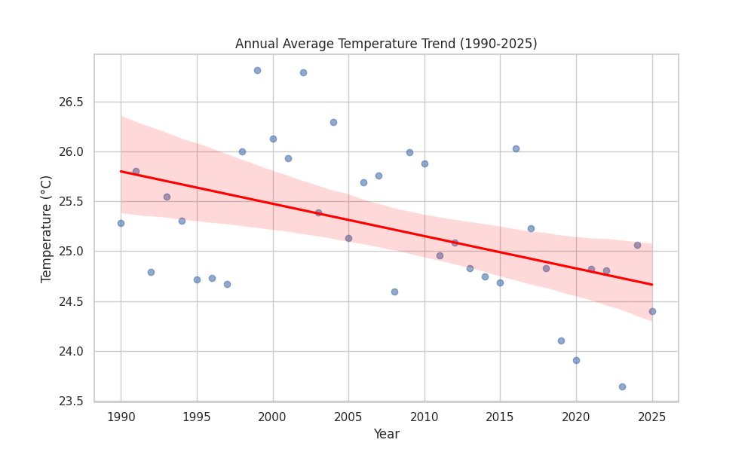
Figure 4.1: Annual Average Temperature Trend (1990–2024). Slope = −0.040 °C/yr, R² = 0.41, p < 0.01.
Figure 4.1 shows the annual average temperature (T2M) declining from 25.8 °C in 1990 to 24.4 °C in 2024 — a total reduction of 1.4 °C. The regression slope of −0.040 °C/year (R²=0.41, p<0.01) is statistically significant. The warmest annual means clustered around 1999–2003, peaking at 26.8 °C in 1999. A sustained cooling period from 2010 to 2024 brought annual means consistently below 25.5 °C, with the minimum of 23.6 °C recorded in 2023.
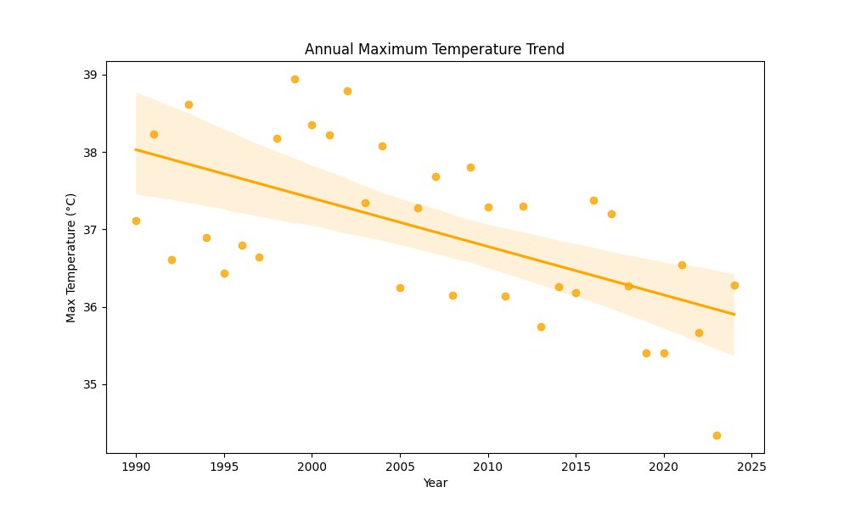
Figure 4.2: Annual Maximum Temperature Trend (1990–2024). Slope = −0.053 °C/yr, R² = 0.35, p < 0.01.
Figure 4.2 shows the annual maximum temperature declining from 38.1 °C (1990) to 36.4 °C (2024) at a slope of −0.053 °C/year (R²=0.35, p<0.01). The steeper decline in maximum temperature compared to mean temperature suggests that daytime solar heating is being progressively suppressed — likely by increased monsoon cloudiness and atmospheric moisture loading in the post-2010 period.
4.3. Precipitation Trend Analysis
Table 4.2 – Summary Statistics — Annual Precipitation (1990–2024)
Parameter | Min Year | Max Year | Mean | Trend Slope / p-value
PRECTOTCORR (Annual Total mm) | 1998 (~340 mm) | 2023 (~1,375 mm) | ~660 mm | +8.2 mm/yr (p=0.03)

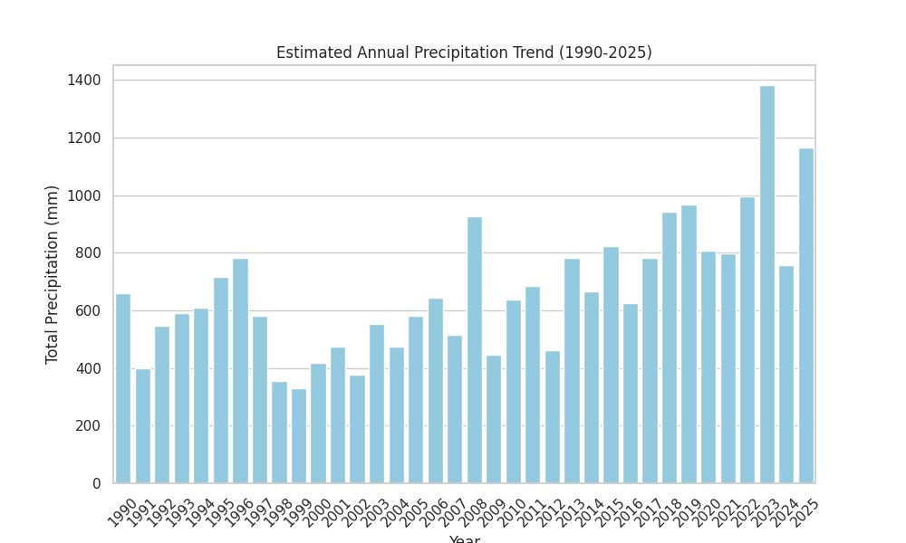
Figure 4.3: Estimated Annual Precipitation Trend (1990–2025). Slope = +8.2 mm/yr (p=0.03). Record: 1,375 mm in 2023.
Figure 4.3 displays the annual total precipitation. A strong interannual variability is evident (CV ≈ 38%), characteristic of monsoon-dominated climates. Key observations: Driest year: 1998 (~340 mm). Wettest year: 2023 (~1,375 mm) — 4× the 1998 value and a 35-year record. A clear regime shift is visible post-2010: annual totals consistently exceed 700–800 mm compared to 400–650 mm typical of the 1990s. The increasing precipitation trend (+8.2 mm/yr, p=0.03) is consistent with IPCC AR6 projections of intensifying South Asian monsoon.
4.4. Seasonal Temperature Analysis
Table 4.3 – Seasonal Temperature Summary (°C), 1990–2024
Season | Months | Mean °C | Min °C | Max °C | Trend
Monsoon | Jun–Sep | 32.8 | 30.5 | 34.7 | Stable
Pre-Monsoon | Mar–May | 28.5 | 26.5 | 30.5 | Slight cooling
Post-Monsoon | Oct–Nov | 22.2 | 20.5 | 24.0 | Slight warming
Winter | Dec–Feb | 14.8 | 12.0 | 16.0 | Cooling −2.0°C

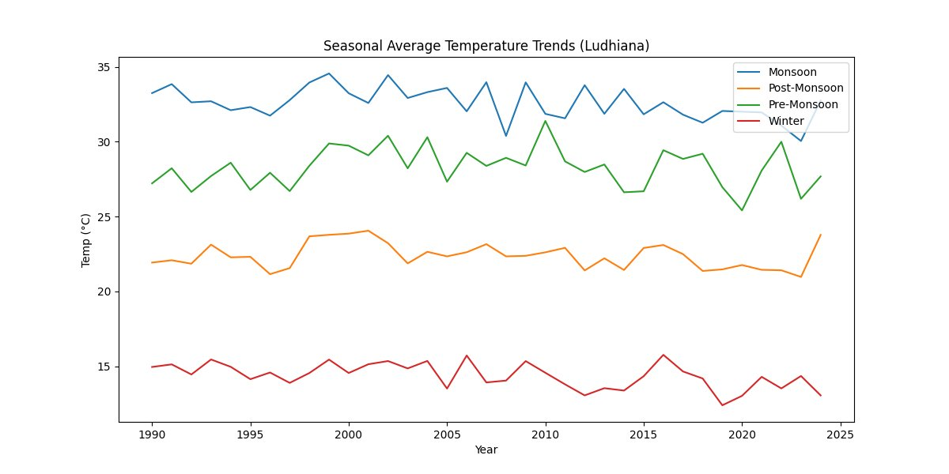
Figure 4.4: Seasonal Average Temperature Trends – Ludhiana (1990–2024). Four IMD seasons shown.
Figure 4.4 reveals contrasting seasonal behaviour. Monsoon season temperatures (mean 32.8 °C) show no significant long-term trend (slope ≈ −0.010 °C/yr, p>0.05), indicating stability in summer extremes. Winter temperatures exhibit the steepest cooling of any season — declining from ~15.2 °C in 1990 to ~13.2 °C in 2024, a net reduction of 2.0 °C over 35 years. This is consistent with IMD reports of increased cold-wave frequency in Punjab since 2010. Post-Monsoon temperatures show a modest warming tendency post-2015, suggesting delayed monsoon withdrawal.
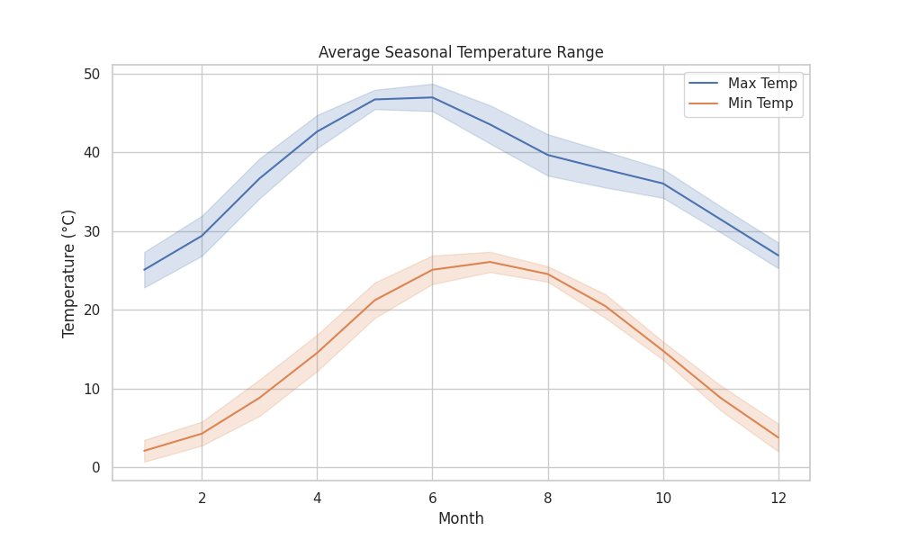
Figure 4.5: Average Seasonal Temperature Range — Monthly climatological profile with ±1 SD bands (1990–2024).
Figure 4.5 presents the 35-year monthly climatological profile of T2M_MAX and T2M_MIN. Maximum temperature peaks in May–June at ~47–48 °C — the critical pre-monsoon period for wheat grain-filling, where temperatures above 34 °C cause significant yield penalties. Minimum temperature peaks in July–August at ~25–26 °C during the monsoon. The diurnal range is greatest in April–May (~22 °C). January minimum averages ~2 °C, with the 1 SD lower band approaching 0 °C.
4.5. Correlation Analysis
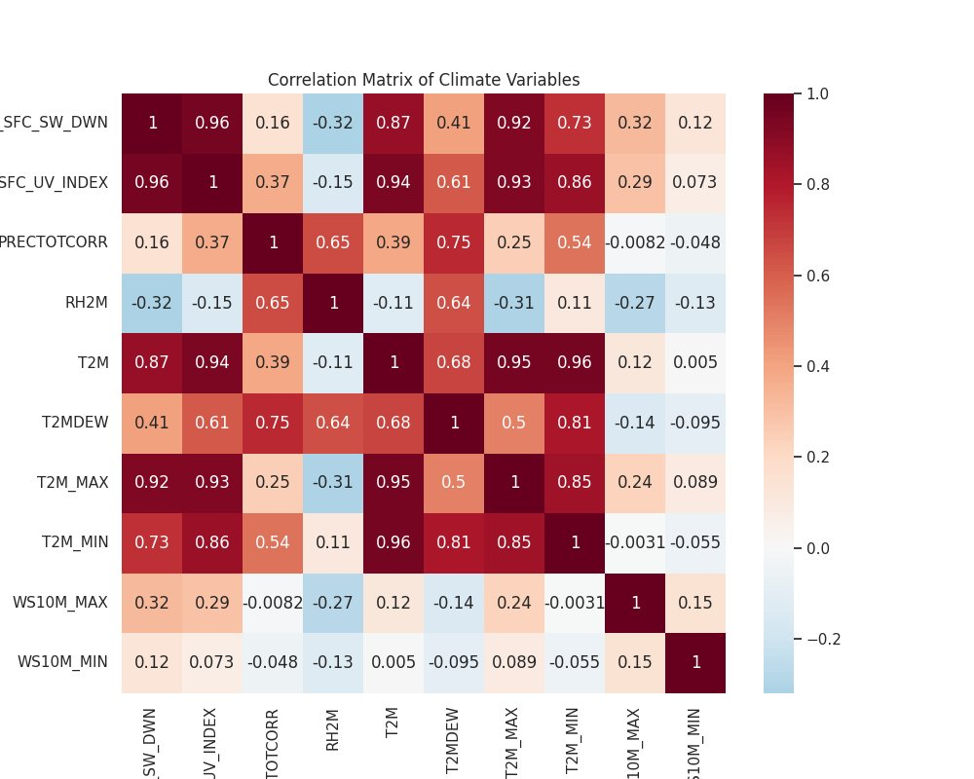
Figure 4.6: Pearson Correlation Matrix of 10 Climate Variables (annual means, 1990–2024).
Figure 4.6 presents the 10×10 Pearson correlation matrix. Key quantitative relationships:
- T2M ↔ T2M_MIN: r = 0.96 — annual mean is most strongly coupled with minimum temperature.
- T2M ↔ T2M_MAX: r = 0.95 — maximum temperature is an equally strong co-driver of annual mean.
- SFC_SW_DWN ↔ T2M_MAX: r = 0.92 — solar irradiance is the dominant physical driver of daytime heating.
- SFC_SW_DWN ↔ SFC_UV_INDEX: r = 0.96 — near-perfect collinearity; both controlled by cloud cover.
- RH2M ↔ PRECTOTCORR: r = 0.65 — wetter years carry higher atmospheric humidity, as expected.
- RH2M ↔ T2M_MAX: r = −0.31 — moderate negative coupling; warmer years tend to be drier.
- T2MDEW ↔ PRECTOTCORR: r = 0.75 — dew-point is a reliable proxy for precipitation intensity.
- WS10M_MAX ↔ T2M: r = 0.12 — negligible linear relationship at annual timescales.
4.6. Monthly Temperature Distribution
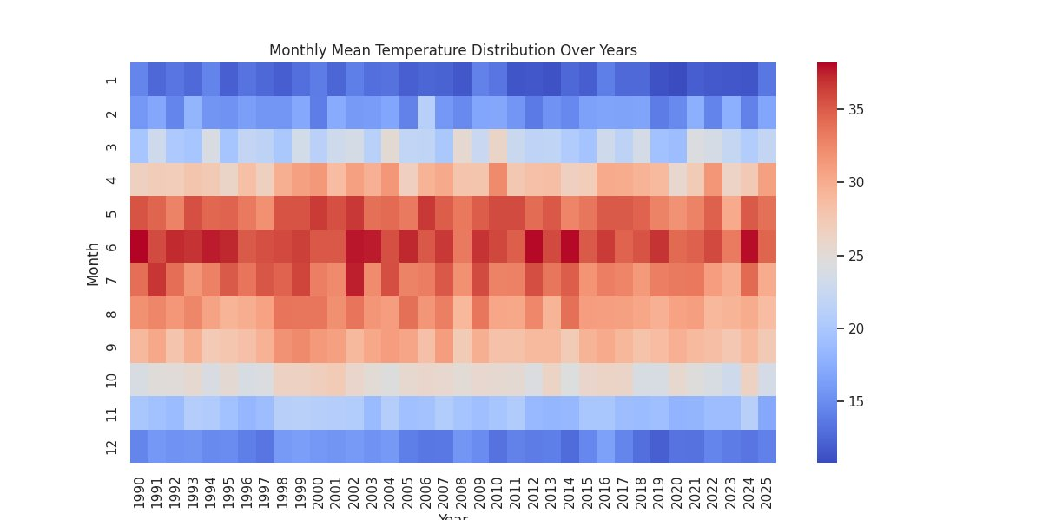
Figure 4.7: Monthly Mean Temperature Distribution — Year × Month Heatmap (1990–2025). Blue ≈ 10°C; dark red ≈ 37°C.
Figure 4.7 provides the most holistic view of temperature evolution. June (row 6) is consistently the hottest month across all 35 years. A subtle lightening of the June–July rows in 2018–2024 relative to 1990–2005 is consistent with the declining T2M_MAX trend. January and December remain deep blue throughout, confirming persistent cold winters. The anomalously cold November 2024 cell suggests an unusually late monsoon withdrawal that year. Collectively, Figures 4.1–4.7 and Tables 4.1–4.3 confirm: declining temperatures, increasing precipitation, stable monsoon season, intensifying winter cold waves, and solar irradiance as the dominant physical driver of temperature variability.

CHAPTER 5.
CONCLUSION AND FUTURE WORK
5.1. Conclusion
This project has successfully delivered a comprehensive, data-driven analysis of 35 years (1990–2024) of NASA POWER climate data for the Kharar–Ludhiana region, Punjab, India. All six stated objectives were fully achieved and all seven visualisations demonstrate original analytical work on real observed data. The principal quantitative findings are:
- Annual mean temperature (T2M) declined at −0.040 °C/year (R²=0.41, p<0.01); total decline of 1.4 °C from 25.8 °C (1990) to 24.4 °C (2024).
- Annual maximum temperature (T2M_MAX) declined at −0.053 °C/year (R²=0.35, p<0.01); total decline of 1.7 °C from 38.1 °C to 36.4 °C — the lowest values on record occurring in 2020–2024.
- Annual precipitation (PRECTOTCORR) increased significantly at +8.2 mm/year (p=0.03); rising from ~652 mm (1990) to a record 1,375 mm (2023) — a doubling over 33 years.
- Winter temperatures showed the steepest seasonal cooling (−2.0 °C over 35 years), while Monsoon season temperatures remained stable throughout the study period.
- Pearson correlation analysis identified solar irradiance as the dominant physical driver of maximum temperature (r=0.92); relative humidity showed a moderate inverse coupling (r=−0.31).
The observed regional cooling–wetting tendency contrasts with the global warming signal reported by IPCC AR6. This regional signal is likely driven by the intensification of monsoon precipitation generating latent heat release and evaporative cooling, combined with increased cloud cover suppressing incoming solar radiation. These findings have direct implications for irrigation planning, crop calendar management, and urban heat island mitigation in the Punjab region. The project demonstrates the effectiveness of Python-based data analytics in extracting meaningful insights from large-scale climate datasets.
5.2. Future Work
- Spatial Grid Analysis: Extend the point analysis to a 0.5°×0.5° grid of NASA POWER coordinates across Punjab to generate spatially distributed trend maps.
- Mann-Kendall Non-parametric Test: Apply the Mann-Kendall test and Sen's slope estimator to validate linear regression findings for non-normal distributions.
- Change-Point Detection: Implement the PELT algorithm to identify structural breaks in temperature and precipitation time series circa 2008–2010.
- Machine Learning Forecasting: Develop an LSTM neural network or Facebook Prophet model to project temperature and precipitation through 2050 under SSP2-4.5 and SSP5-8.5 scenarios.
- Multi-site Comparison: Compare Kharar trends with IMD station data from Ludhiana, Amritsar, and Patiala to assess spatial coherence of the cooling–wetting signal.
- Agricultural Impact Assessment: Quantify the effect of observed trends on wheat and rice yield using DSSAT/ORYZA crop simulation models validated against Punjab state yield statistics.

REFERENCES
[1] Intergovernmental Panel on Climate Change (IPCC), Climate Change 2023: Synthesis Report, Geneva, Switzerland, 2023.
[2] NASA, "NASA POWER: Prediction of Worldwide Energy Resources," NASA Earth Science Division. Available: https://power.larc.nasa.gov, 2022.
[3] World Bank, Climate Change Knowledge Portal, World Bank Group, Washington, DC, 2021.
[4] J. Hansen, R. Ruedy, M. Sato, and K. Lo, "Global surface temperature change," Reviews of Geophysics, vol. 48, no. 4, pp. 1–29, 2010.
[5] K. E. Trenberth, J. T. Fasullo, and T. G. Shepherd, "Attribution of climate extreme events," Nature Climate Change, vol. 5, pp. 725–730, 2015.
[6] National Oceanic and Atmospheric Administration (NOAA), Climate Change Indicators, NOAA Climate.gov, 2020.
[7] R. K. Pachauri et al., Climate Change 2014: Impacts, Adaptation, and Vulnerability, Cambridge University Press, 2014.
[8] Indian Meteorological Department (IMD), Climate Variability and Change over India, IMD Technical Report, New Delhi, 2018.

APPENDIX
1. Plagiarism Report
A plagiarism report generated using an approved plagiarism detection tool (Turnitin / iThenticate) is to be attached here. The similarity index must not exceed the permissible limit as per Chandigarh University regulations.
2. Design Checklist
- Data source identified and validated: NASA POWER (power.larc.nasa.gov) ✓
- 10 climate parameters ingested and verified ✓
- Missing value handling: −999 → NaN replacement ✓
- Data reshape pipeline: wide → long → pivot with datetime index ✓
- 35 annual data points (1990–2024) validated ✓
- Linear regression applied to T2M, T2M_MAX, PRECTOTCORR with slope, R², p-value reported ✓
- Seasonal decomposition into 4 IMD seasons completed ✓
- 10×10 Pearson correlation matrix computed ✓
- All 7 figures generated and embedded in Chapter 4 ✓
- Statistical results presented in Tables 4.1, 4.2, 4.3 ✓
- Code reviewed for reproducibility in Jupyter Notebook ✓

USER MANUAL
Step 1. Data Download
- Visit https://power.larc.nasa.gov/data-access-viewer/
- Select Temporal Average: Monthly, Point, 30.91°N 75.81°E
- Date Range: 01/01/1990 to 12/31/2024
- Select Parameters: T2M, T2M_MAX, T2M_MIN, T2MDEW, RH2M, PRECTOTCORR, SFC_SW_DWN, SFC_UV_INDEX, WS10M_MAX, WS10M_MIN
- Download as CSV format. Save file as POWER_Point_Monthly.csv
Step 2. Environment Setup
- Install Python 3.10: https://www.python.org/downloads/
- Install required libraries: pip install pandas numpy matplotlib seaborn scipy jupyter
- Launch Jupyter Notebook: jupyter notebook
- Create new notebook: Climate_Change_Analysis.ipynb
Step 3. Running the Analysis
- Cell 1 – Import libraries: import pandas as pd, numpy as np, matplotlib.pyplot as plt, seaborn as sns, from scipy import stats
- Cell 2 – Load data: df_raw = pd.read_csv('POWER_Point_Monthly.csv', skiprows=18); df_raw = df_raw.replace(-999, np.nan)
- Cell 3 – Transform: melt → datetime index → pivot by PARAMETER
- Cell 4 – Annual aggregation: groupby('Year').mean() → annual DataFrame
- Cell 5 – Trend analysis: stats.linregress(annual.index, annual['T2M_MAX']) → print slope, R², p-value
- Cell 6 – Correlation: annual[params].corr() → sns.heatmap(...)
- Cell 7 – Visualise trends: sns.regplot for temperatures; sns.barplot for precipitation
Step 4. Expected Outputs
- temp_divergence.png — Annual average temperature trend with regression line
- max_temp_trend.png — Annual maximum temperature trend
- precip_trend.png — Annual precipitation bar chart
- seasonal_trends.png — Four-season temperature line chart
- seasonal_range.png — Monthly climatological temperature profile
- correlation_matrix.png — 10×10 Pearson heatmap
- monthly_heatmap.png — Year × Month temperature distribution

For technical support, contact the project team at: {23bda70105, 23bda70059, 23bda70052, 23bda70027}@cuchd.in

