

**DATA SCIENCE LAB**

**Experiment No.: 1**

**Aim**

Programs to handle data using pandas.

**Q1 - Pandas Series**

1. How to create Series with nd array.

import pandas as pd

import numpy as np

data = np.array(['a', 'b', 'c', 'd', 'e'])

s = pd.Series(data)

print(s)

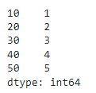

1. How to create Series with Mutable index.

import pandas as pd

import numpy as np

arr=np.array(['a','b','c','d','e'])

m=pd.Series(arr, index=['one','two','three','four','five'])

print (m)

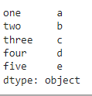

1. Creating a series from a Dictionary.

import pandas as pd

a={'Name':'Susan','Department':'MCA','COllege':'AJCE'}

d=pd.Series(a)

print (d)

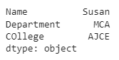

1. Print all the values of the Series by multiplying them by 2.

import pandas as pd

import numpy as np

a=10,20,30,40,50

m=pd.Series(a, dtype=float)

print(m*2)

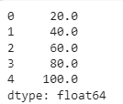

1. Print Square of all the values of the series.

import pandas as pd

import numpy as np

a=10,20,30,40,50

m=pd.Series(a, dtype=float)

print (m**2)

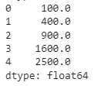

1. Print all the values of the Series that are greater than 2.

import pandas as pd

import numpy as np

a=1,2,3,4,5

g=pd.Series(a)

print(g[g>2])

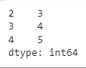

1. Addition of two series.

import pandas as pd

a=pd.Series([1,2,3,4,5])

b=pd.Series([6,7,8,9,10])

s=(a+b)

print(s)

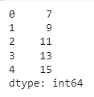

1. Print the first and last 5 elements of a series

import pandas as pd

a=pd.Series([10,20,30,40,50,60,70,80,90,100])

print(a.head(5))

print(a.tail(5))

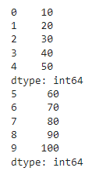

1. Print the values from index 0 to 5

import pandas as pd

a=pd.Series([11,12,13,14,15,16,17,18,19,20])

print(a.iloc[0:6])

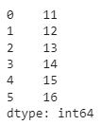

1. Selection Using loc, iloc index label

import pandas as pd

s=pd.Series(['a','b','c','d','e','f','g','h','i','j','k'])

print(s.loc[1:5])

print(s.iloc[1:5])

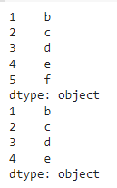

1. Retrieve subsets of data using slicing

import pandas as pd

s=pd.Series(['a','b','c','d','e','f','g','h','i','j','k'])

print(s[1:10:2])

