

**NETWORKING&SYSTEM ADMINISTRATION LAB**

**Experiment No: 25**

**Aim**

Setting Up an Apache Container

**Procedure:**

## Setting Up an Apache Container

One of the amazing things about the **Docker** ecosystem is that there are tens of standard containers that you can easily download and use.

In the following example, we will instantiate an **Apache 2.4** container named **tecmint-web**, detached from the current terminal. We will use an image called **httpd:2.4** from [**Docker Hub**](https://hub.docker.com/).

Our plan is to have requests made to our public IP address on port **8080** be redirected to port **80** on the container. Also, instead of serving content from the container itself, we will serve a simple web page from **/home/user/website**.

We do this by mapping **/home/user/website/** on the **/usr/local/apache2/htdocs/** on the container. Note that you will need to use **sudo** or login as **root** to proceed, and do not omit the forward slashes at the end of each directory.

$ sudo docker run -dit --name tecmint-web -p 8080:80 -v  /home/user/website/:/usr/local/apache2/htdocs/ httpd:2.4

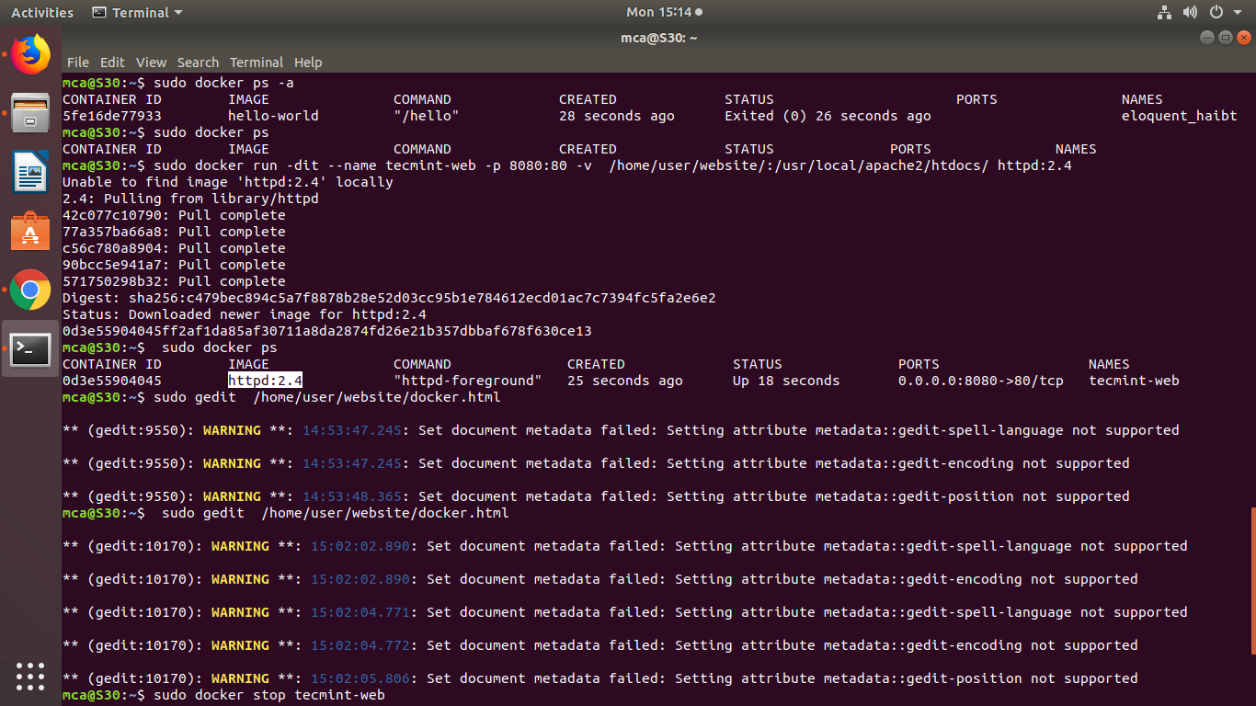

Pull Docker Apache Container

At this point, our **Apache** container should be up and running.

$ sudo docker ps



Check Apache Docker Container

Now let’s create a simple web page named **docker.html** inside the **/home/user/website** directory.

$ sudo gedit  /home/user/website/docker.html



Add the following sample HTML content to the file.

<!DOCTYPE html>

<html lang="en">

<head>

    <meta charset="UTF-8">

    <title>Learn Docker at Tecmint.com</title>

</head>

<body>

    <h1>Learn Docker With Us</h1>

</body>

</html>

Next, point your browser to **c**(where **Server-IP** is your host’s public IP address). You should be presented with the page we created previously.

Check Apache Page

If you wish, you can now stop the container.

$ sudo docker stop tecmint-web

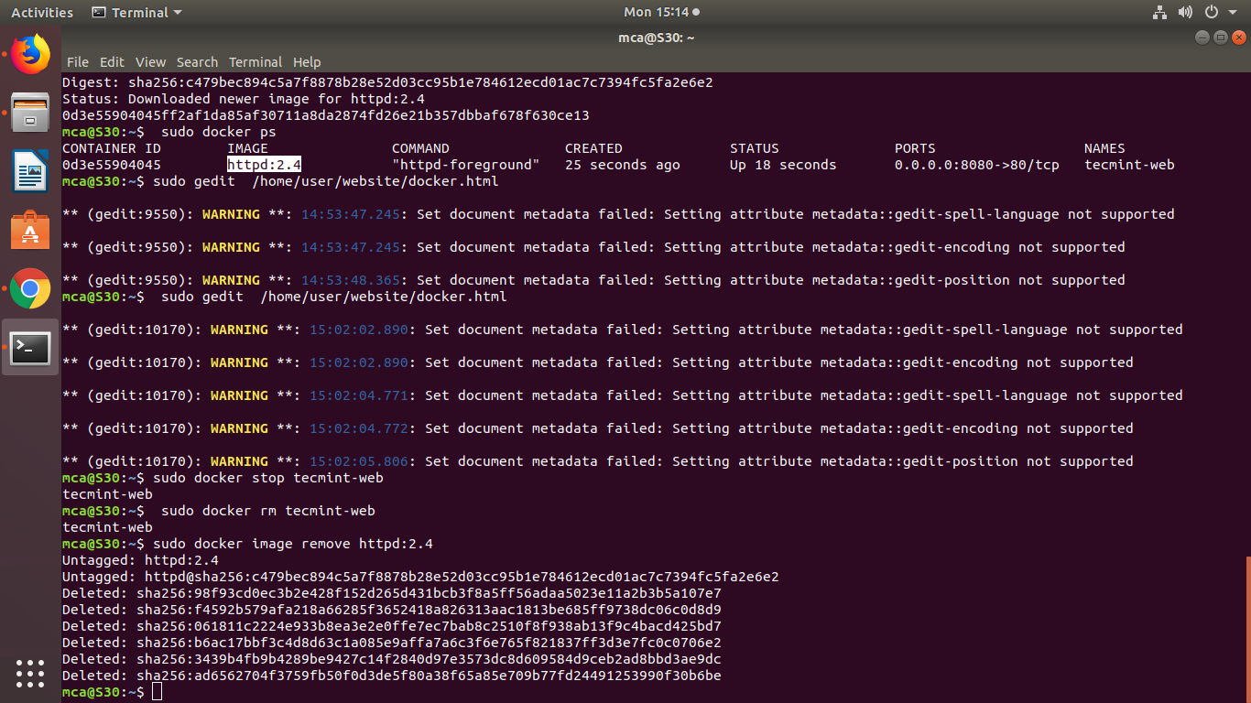

and remove it:

$ sudo docker rm tecmint-web



To finish cleaning up, you may want to delete the image that was used in the container (omit this step if you’re planning on creating other **Apache 2.4** containers soon).

$ sudo docker image remove httpd:2.4



Note that in all the above steps we never had to install the webserver on our host.

$ sudo docker run -dit --name tecmint-web -p 8080:80 -v  /home/user/website/:/usr/local/apache2/htdocs/ httpd:2.4

