

**NETWORKING&SYSTEM ADMINISTRATION LAB**

**Experiment No: 24**

**Aim**

Docker Installation

**Procedure:**

**1.** Open the terminal on Ubuntu.

**2.** Remove any [Docker files](https://www.simplilearn.com/tutorials/docker-tutorial/what-is-dockerfile) that are running in the system, using the following command:

| $ sudo apt-get remove docker docker-engine docker.io |
| --- |

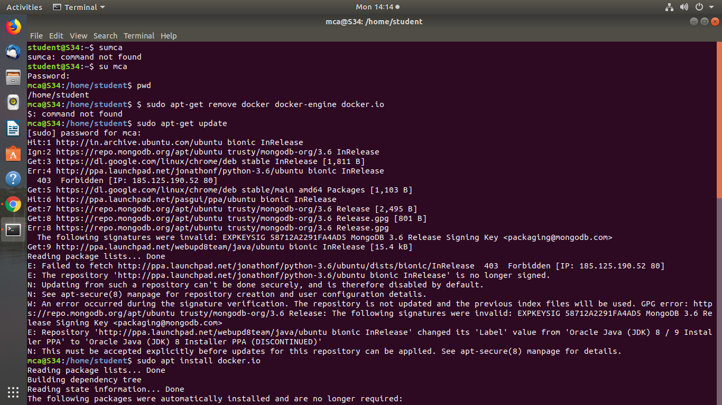

After entering the above command, you will need to enter the password of the root and press enter.

3. Check if the system is up-to-date using the following command:

| $ sudo apt-get update    4. Install Docker using the following command:   | $ sudo apt install docker.io | | --- |   You’ll then get a prompt asking you to choose between y/n - choose *y*  5. Install all the dependency packages using the following command:   | $ sudo snap install docker    6. Before testing Docker, check the version installed using the following command:   | $ docker --version | | --- | | | --- | --- | |
| --- | --- | --- | --- |

7. Pull an image from the Docker hub using the following command:

| $ sudo docker run hello-world    Here, *hello-world* is the docker image present on the Docker hub.  8. Check if the docker image has been pulled and is present in your system using the following command:   | $ sudo docker images | | --- |   9. To display all the containers pulled, use the following command:   | $ sudo docker ps -a | | --- | |
| --- | --- | --- |

10. To check for containers in a running state, use the following command:

| $ sudo docker ps |
| --- |

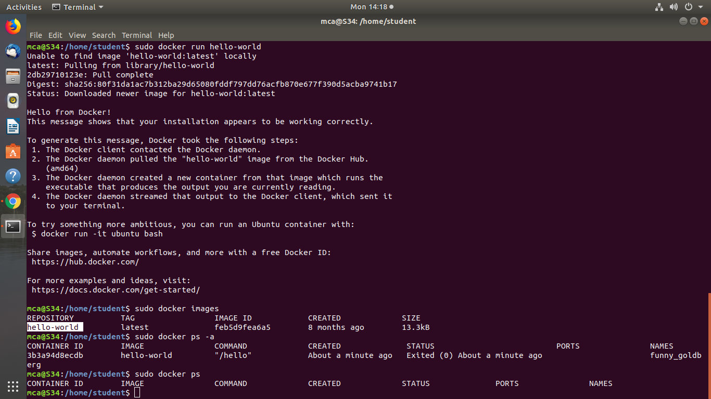

You’ve just successfully installed Docker on Ubuntu!