COP

ASSIGNMENT 3

1 Write a Java program to sum values of an array.

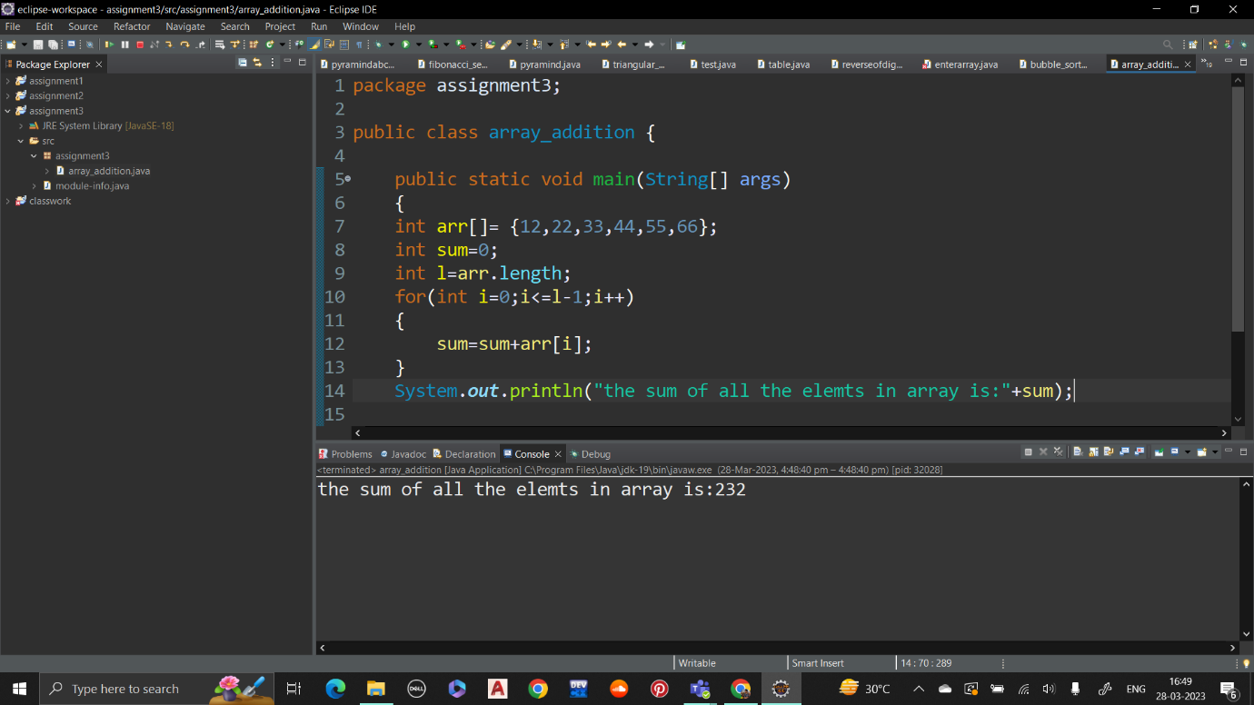

Output:

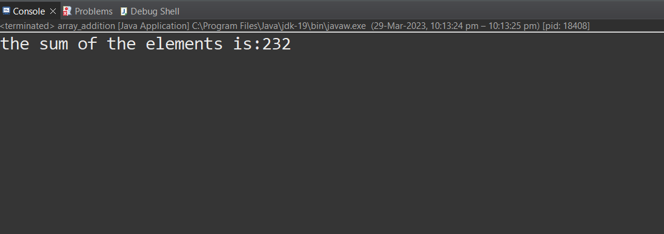

Q 2 Write a Java program to calculate the average value of array elements

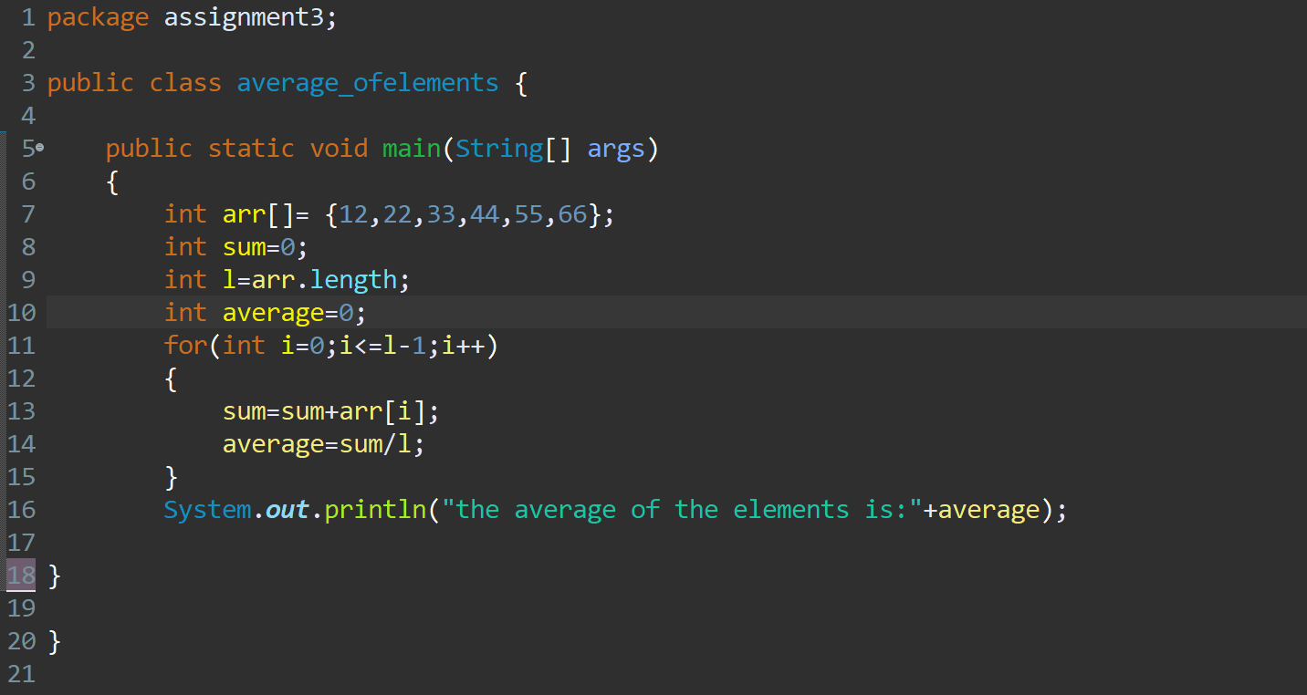

Output:

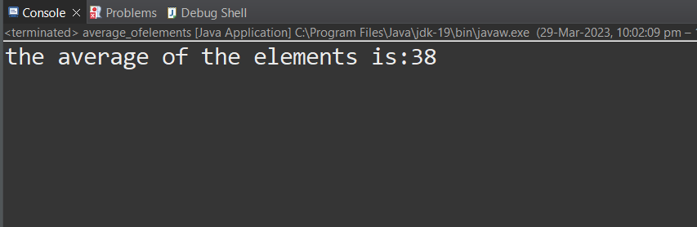

Q 3 Write a Java program to test if an array contains a specific value

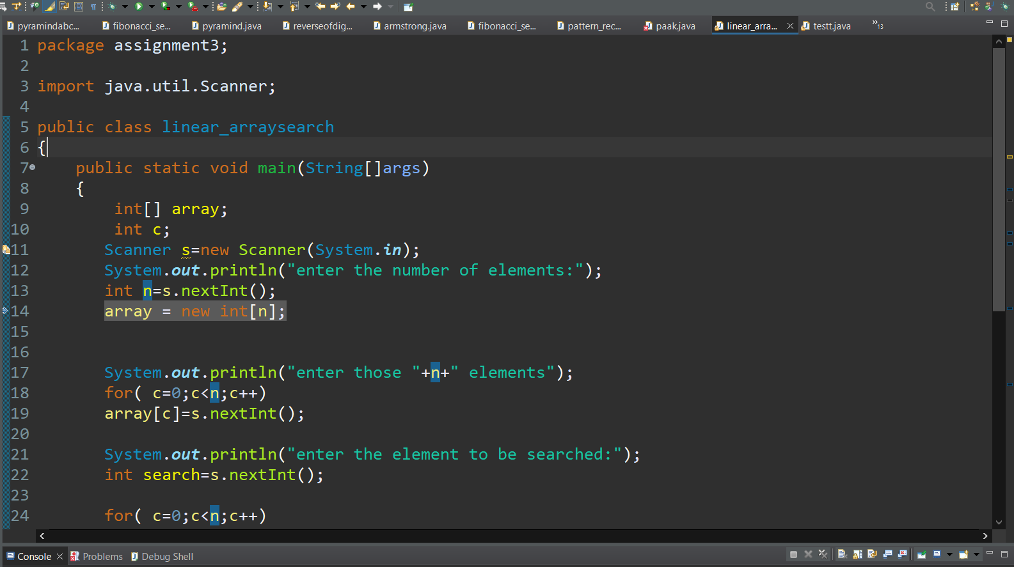

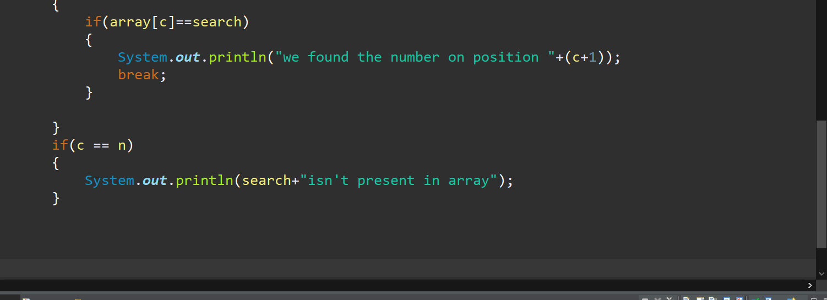

Output1:

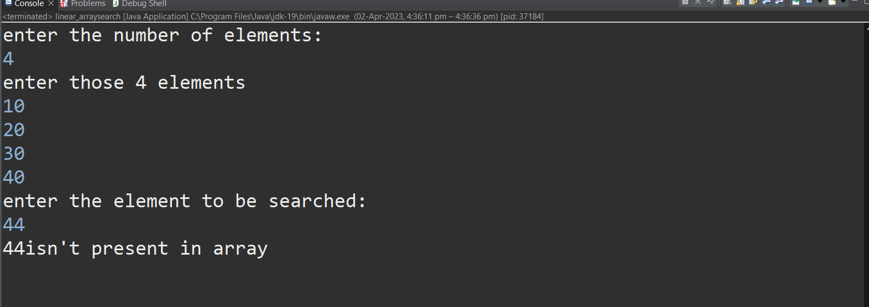;

Output2:

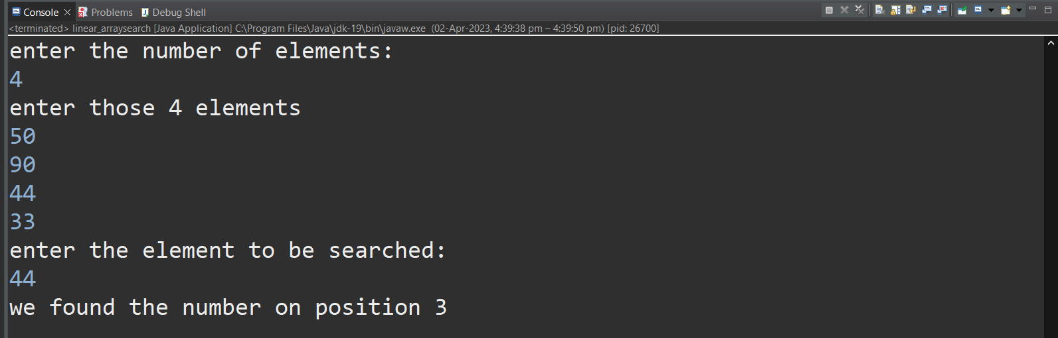

}

o

Q 4Write a Java program to find the index of an array element

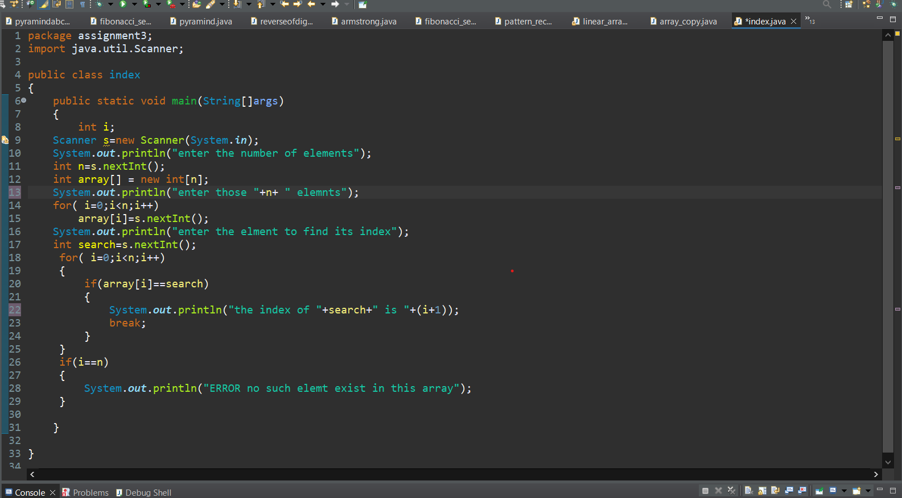

Output:

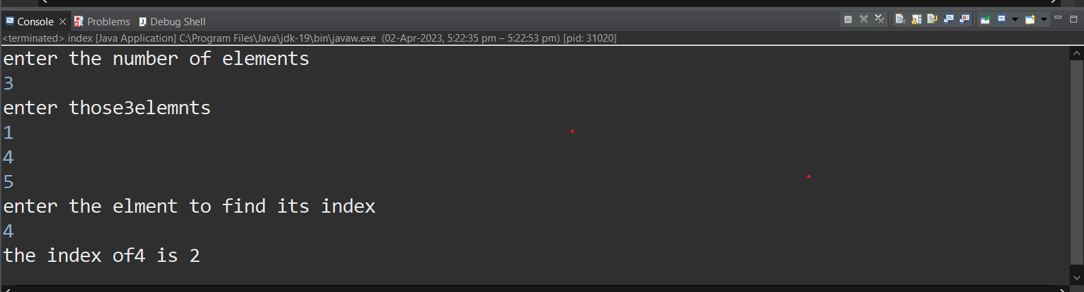

Q 5 Write a Java program to copy an array by iterating the array

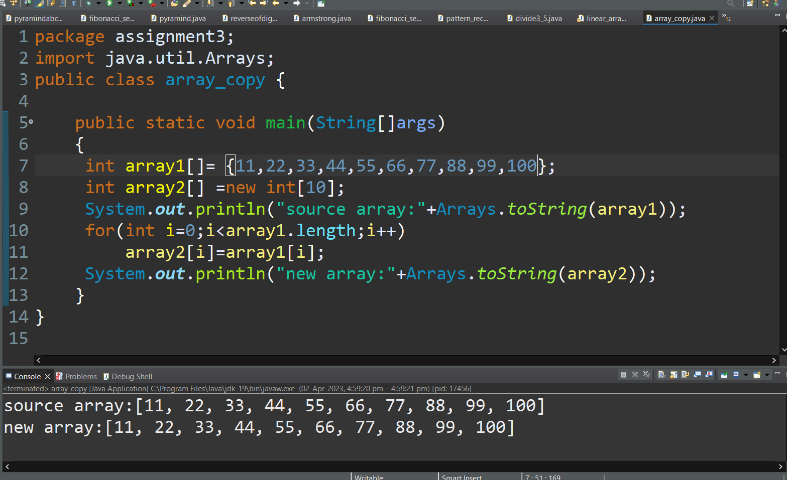

Q 6Write a Java program to find the maximum and minimum value of an array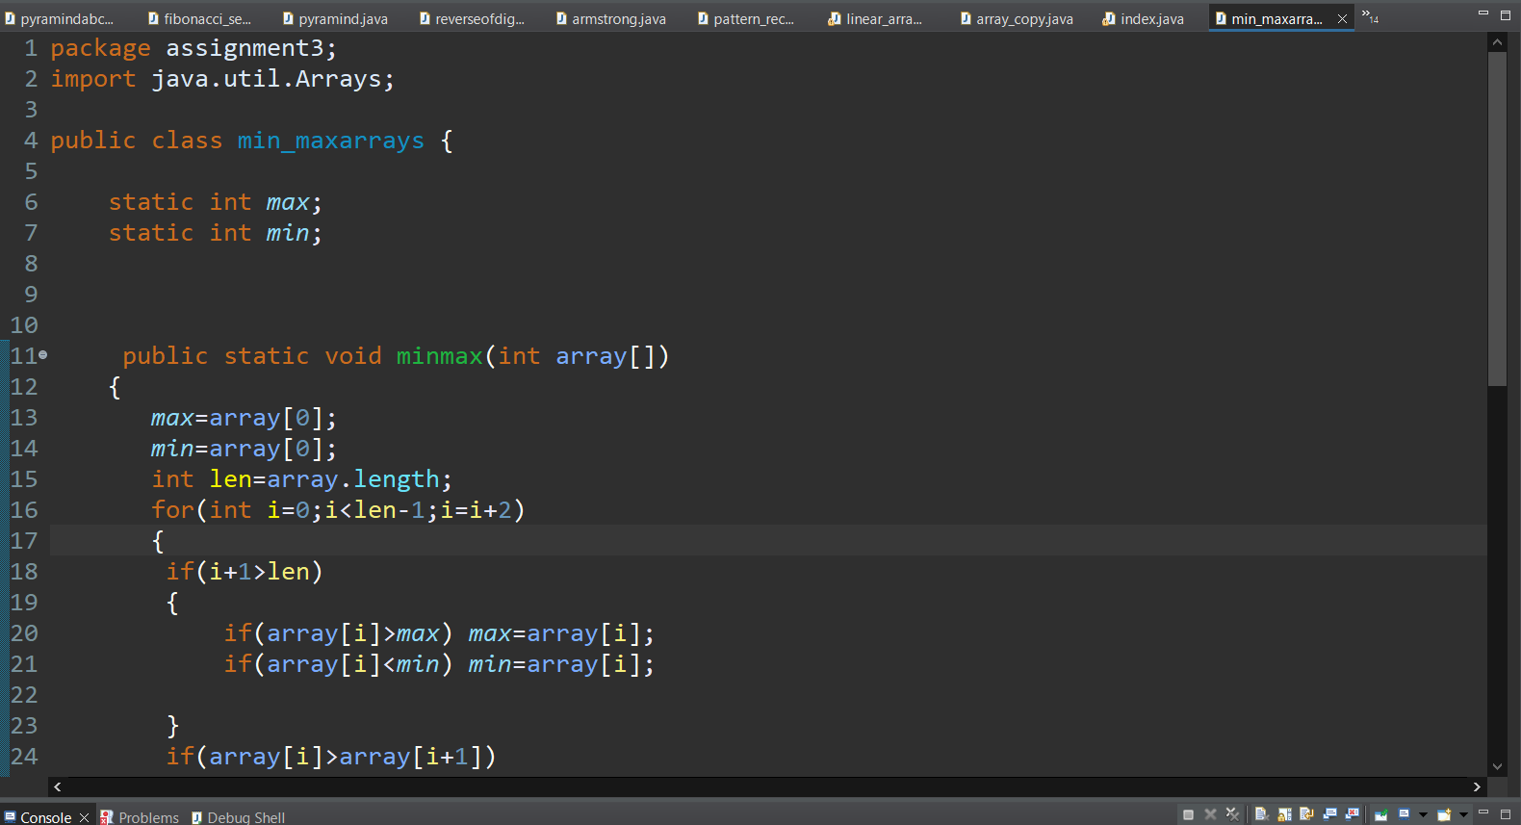

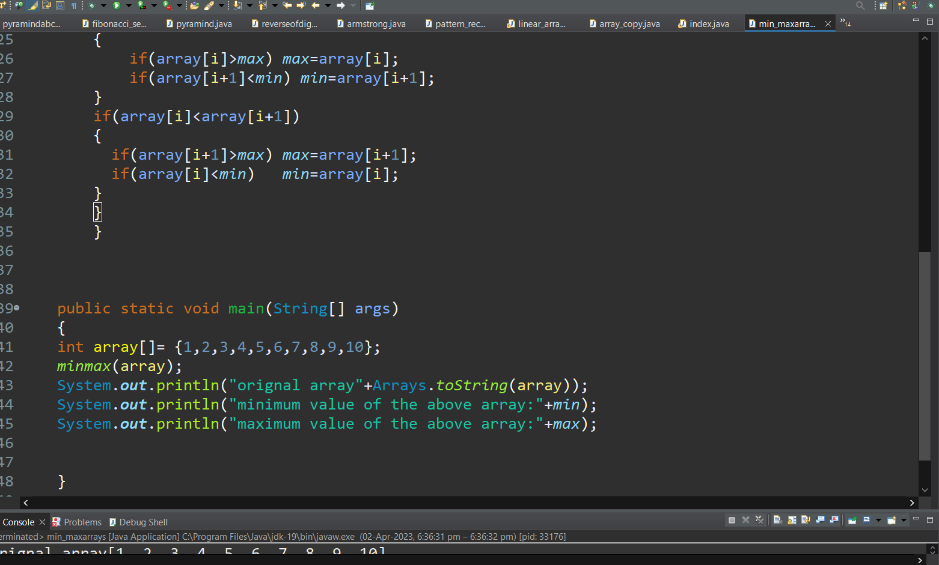

Output: 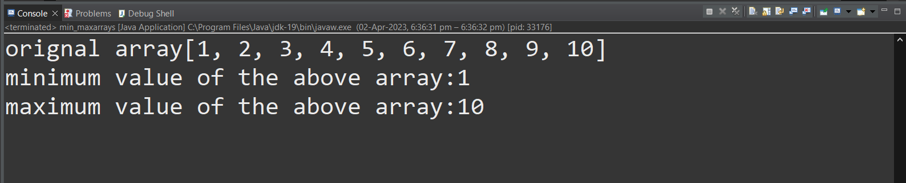

Q 7Write a Java program to reverse an array of integer values.'

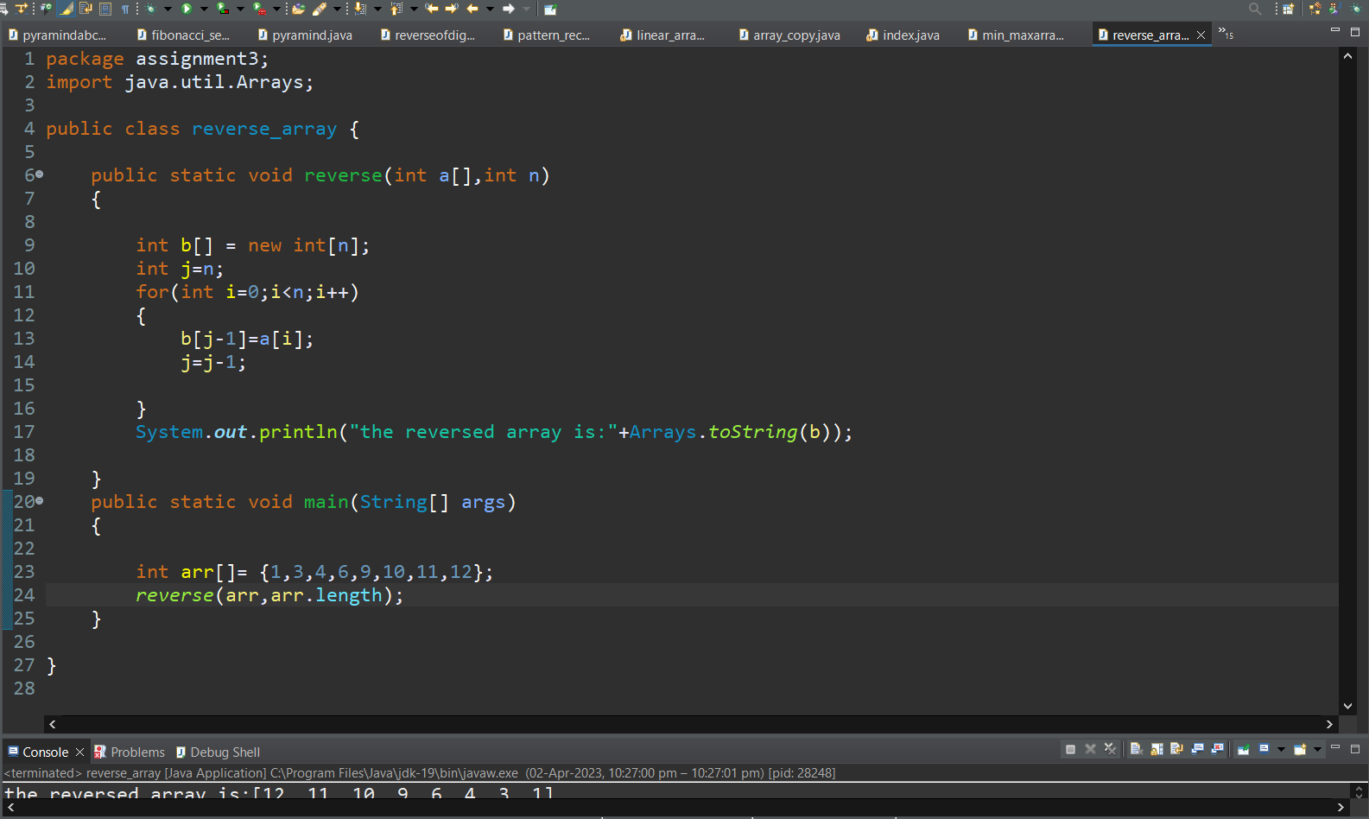

Output:

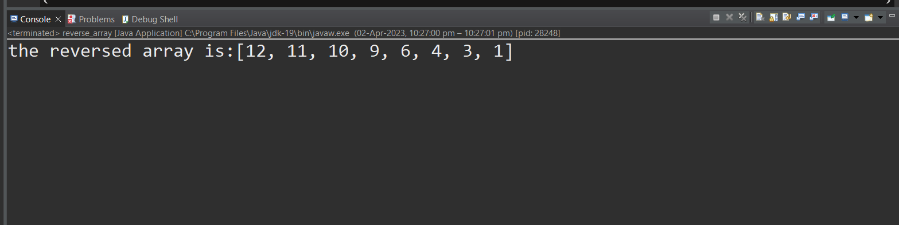

Q 8 Write a Java program to test the equality of two arrays

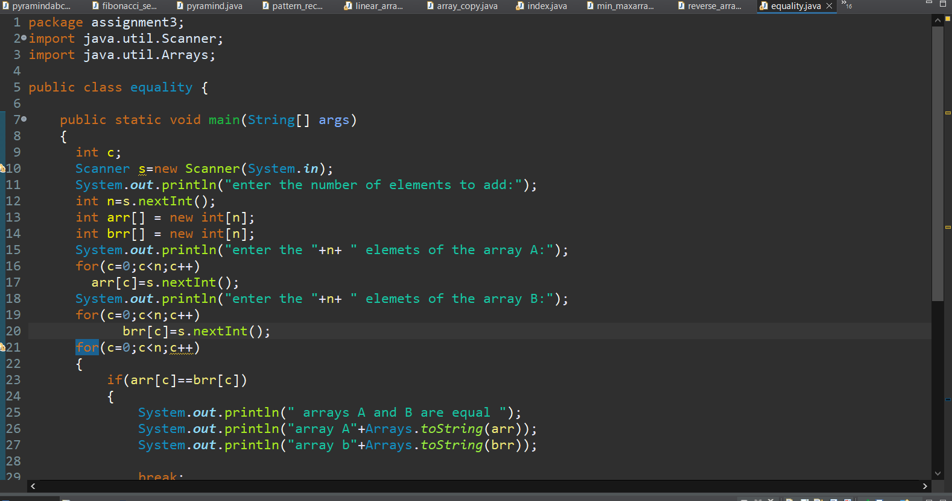

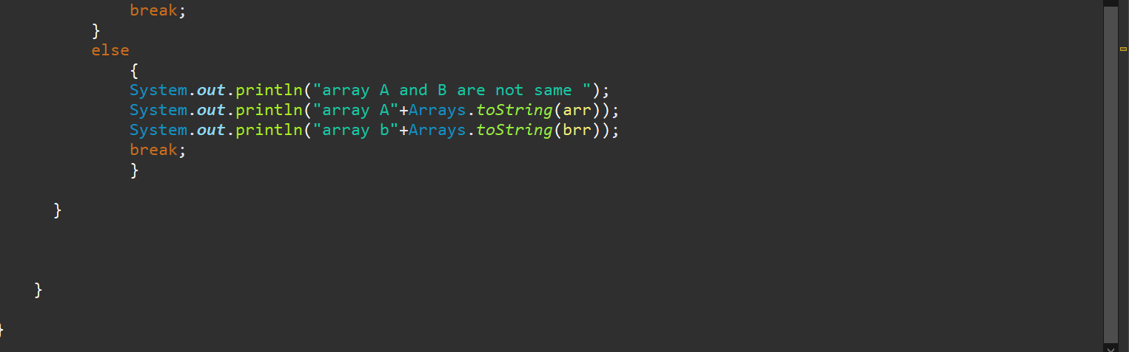

Output 1:

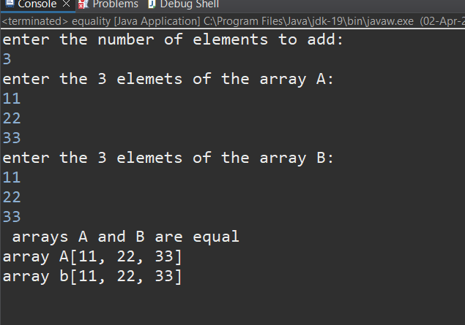

Output 2

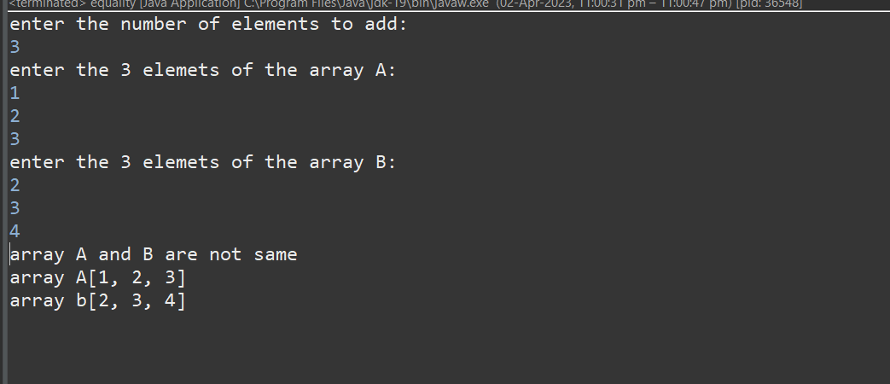

Q 9Write a Java program to find the number of even and odd integers in a given array of integers.

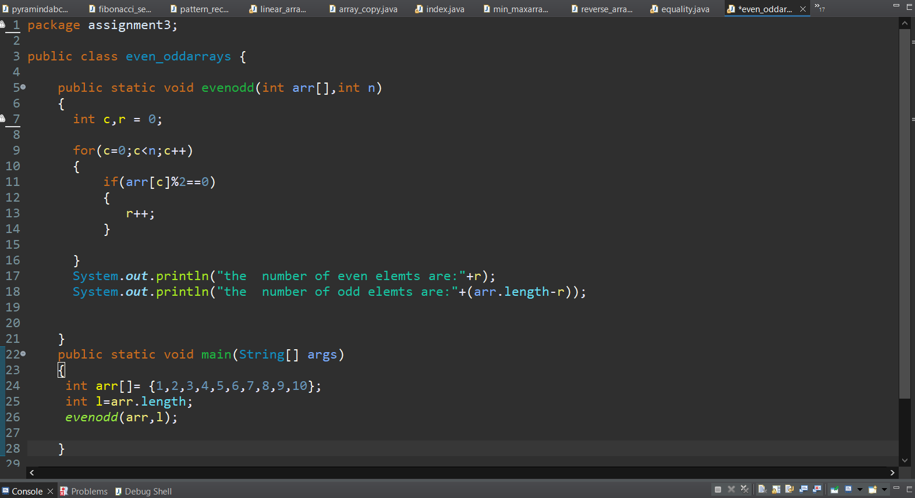

Output:

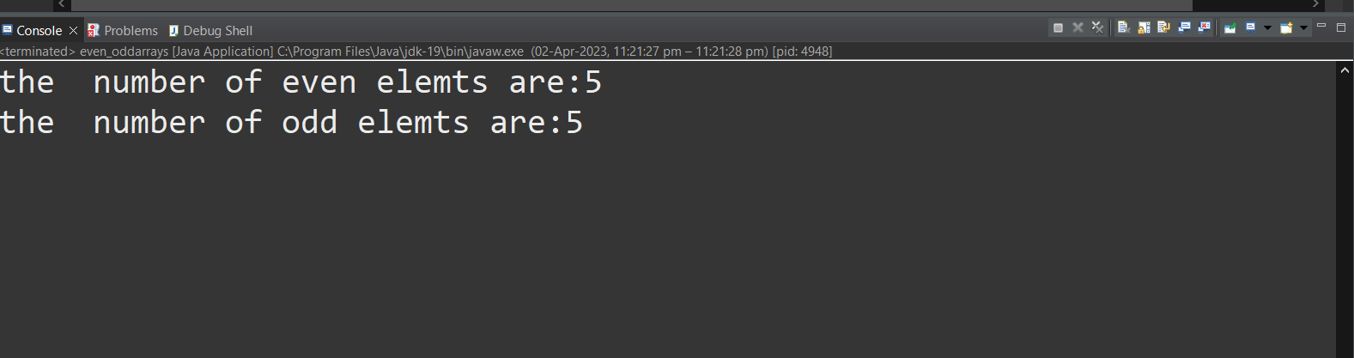

Q 10 Write a program to search element in array using binary search.

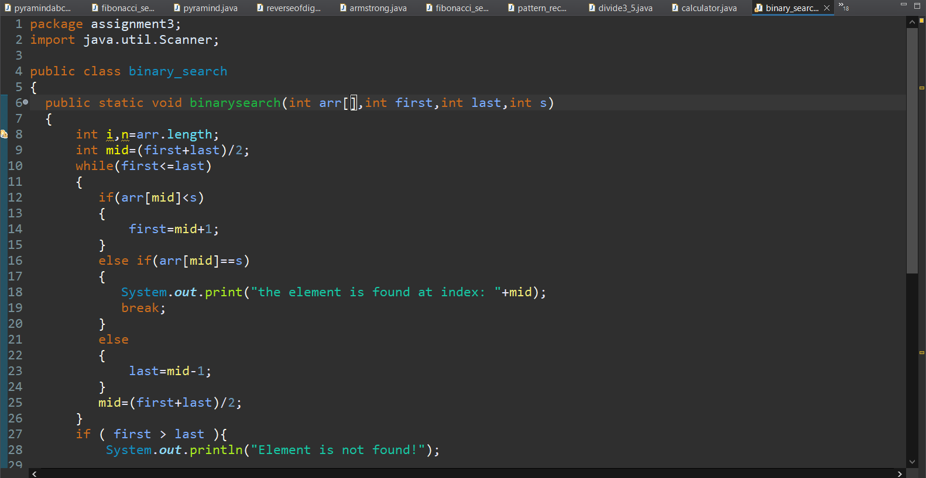

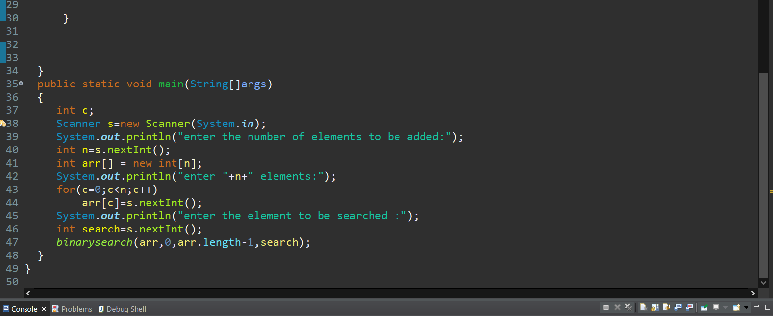

Output:

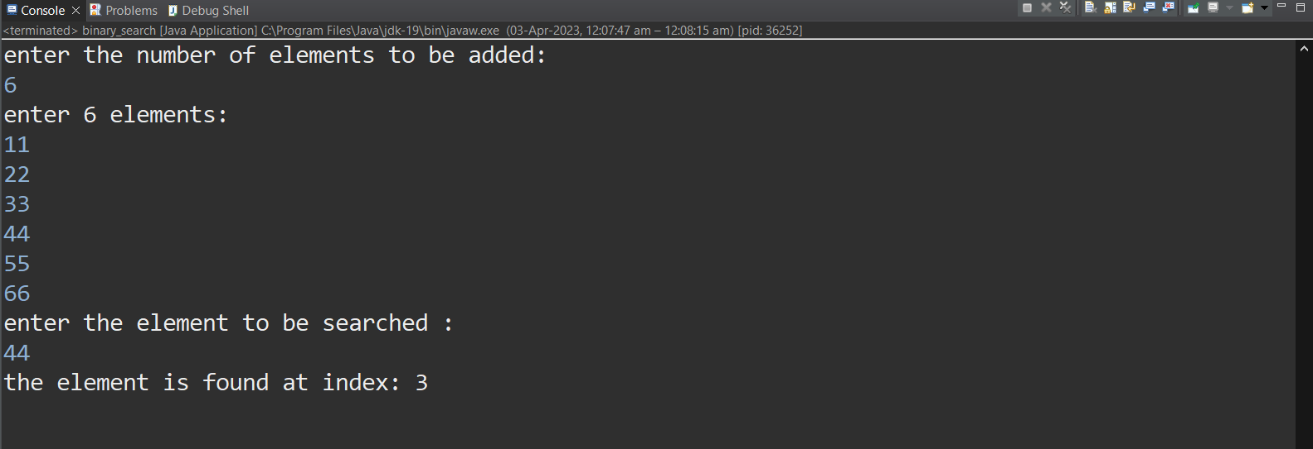

Q 11 Take 20 integer inputs from user and print the following:  
number of positive numbers  
number of negative numbers  
number of odd numbers  
number of even numbers  
number of 0s.

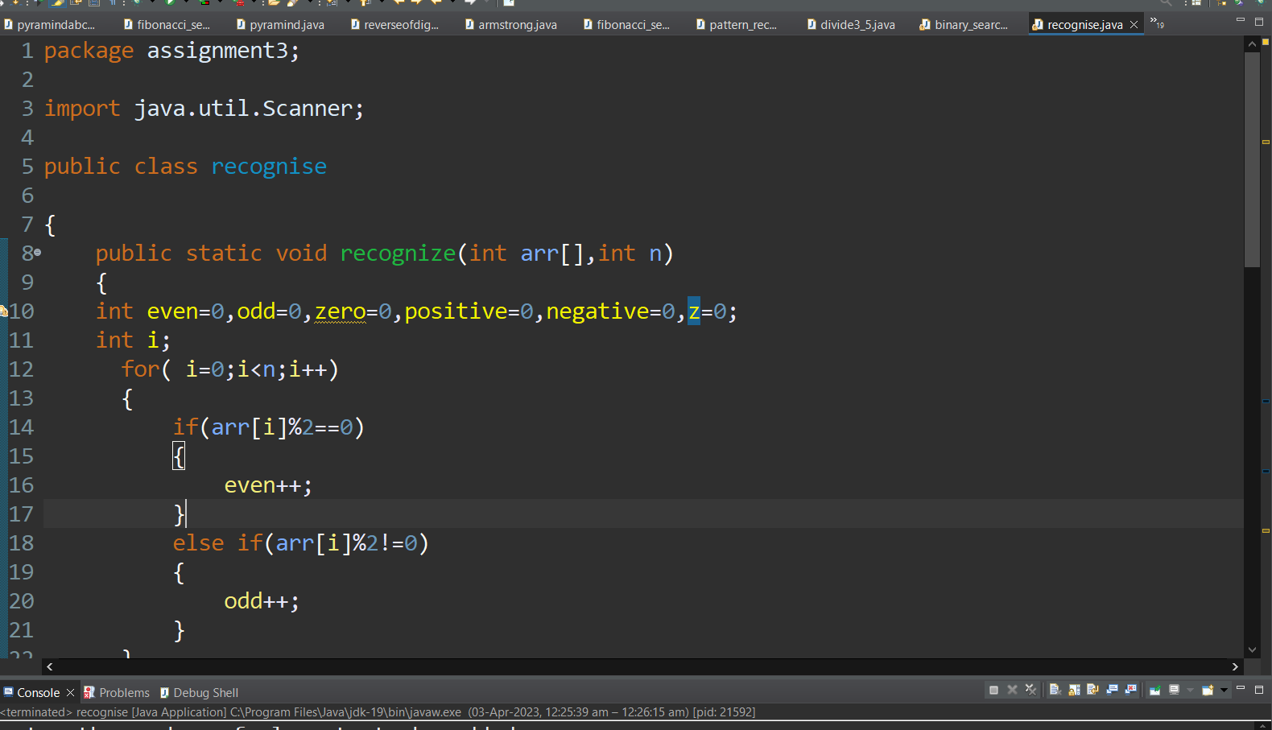

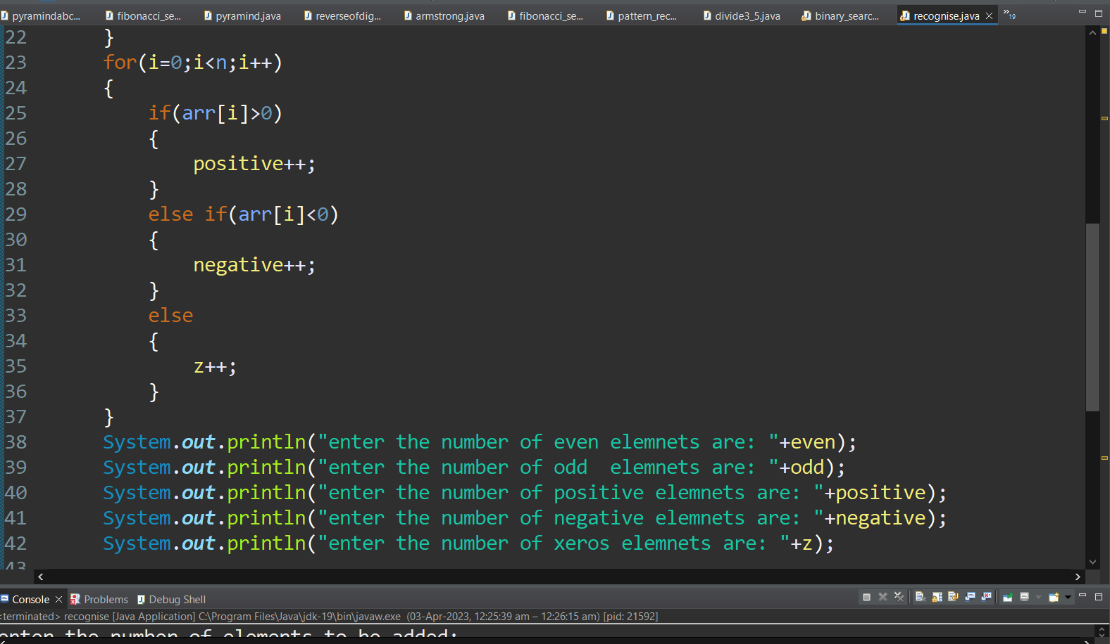

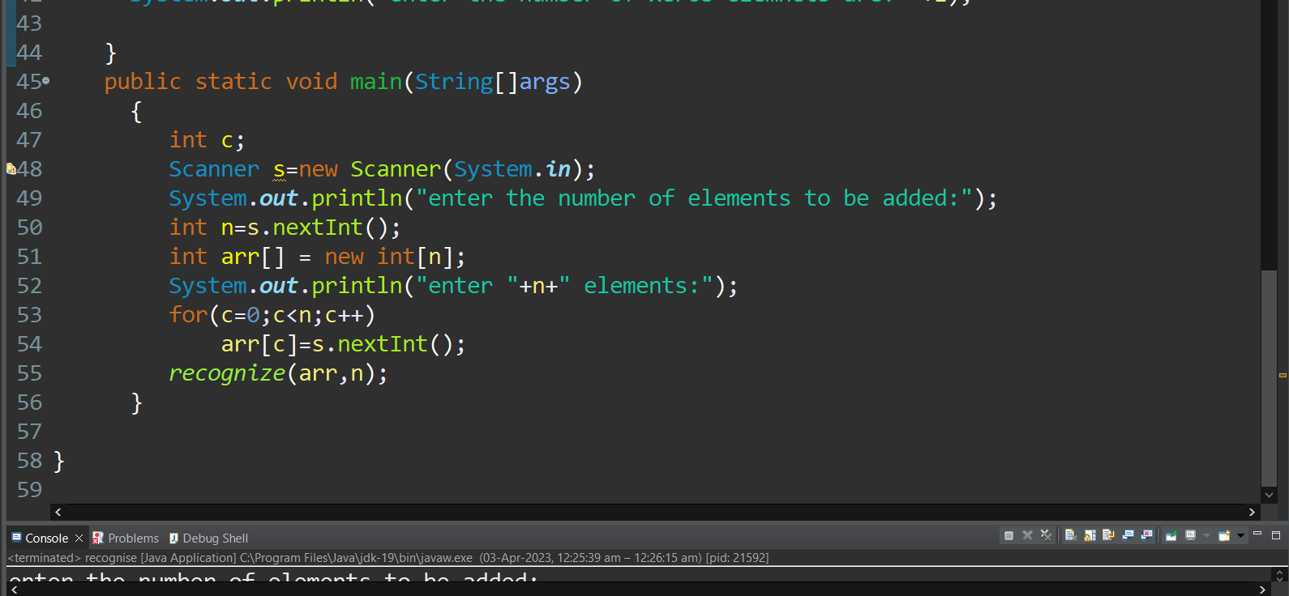

output:

