Sub Menus and Backend Permissions for Joomla 1.5 RC3

Sub Menu | Manager | Administrator | Super Administrator
Site | 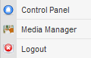 | 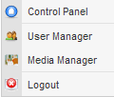 | 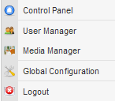
Menus | 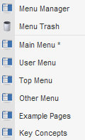
Content | 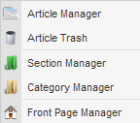
Components | 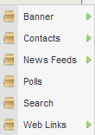
Extensions | Not Available | 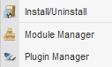 | 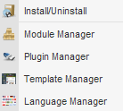
Tools | Not Available |  | 
Help | 