# **Wireframes for Superhero Sightings Spring MVC application**

## **“Home” tab**

### Home Page (includes general info about website & news feed about recent 10 sightings)

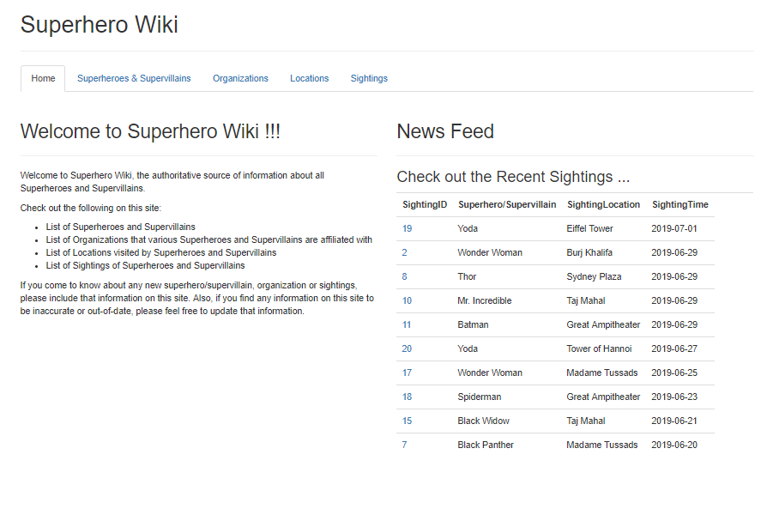

## **“Superheroes & Supervillains” tab**

### Main Superheroes Listing page (comes with ability to Create & Delete Superheroes too)

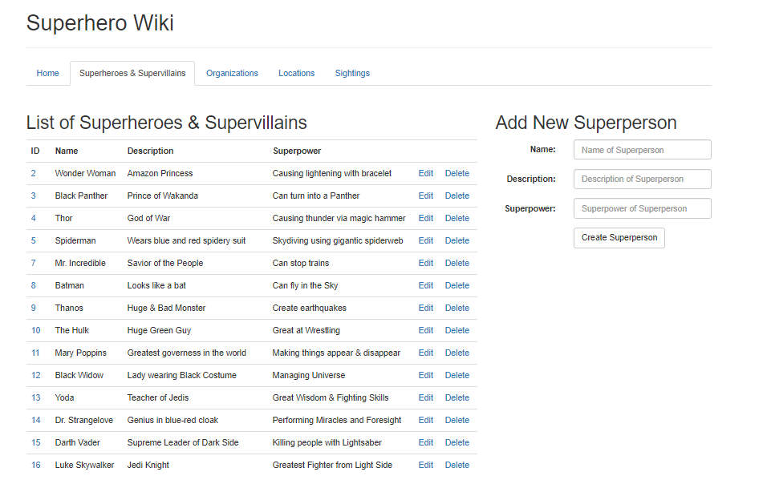

### View Superhero Details Page (includes info about Org affiliations & Visited Locations too)

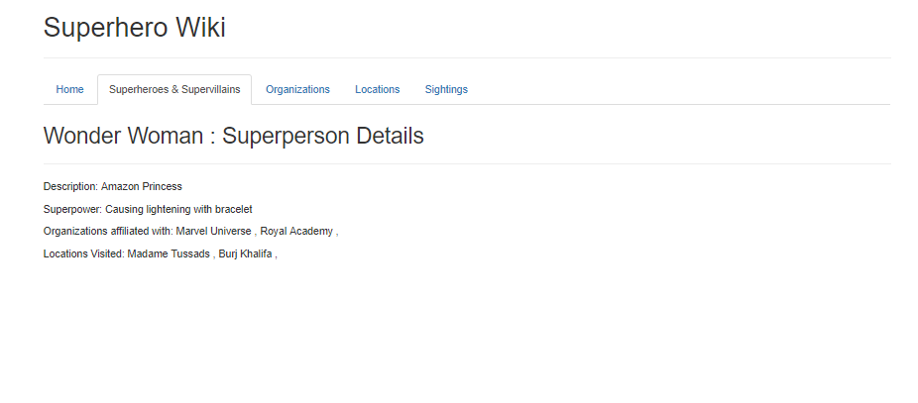

### Edit Superhero Page

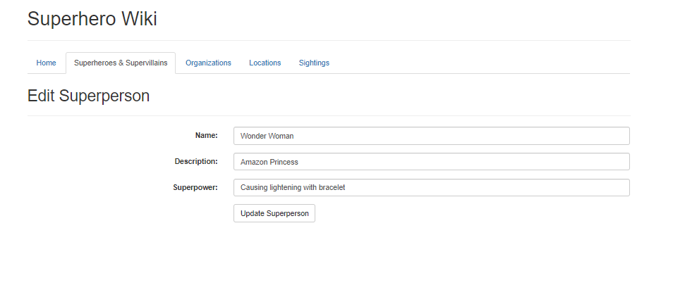

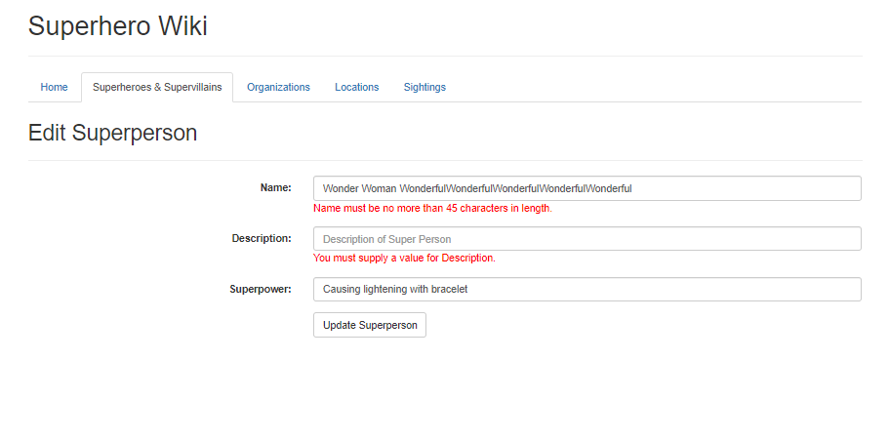

## **“Organizations” tab**

### Main Organizations Listing page (comes with ability to Create & Delete Organizations too)

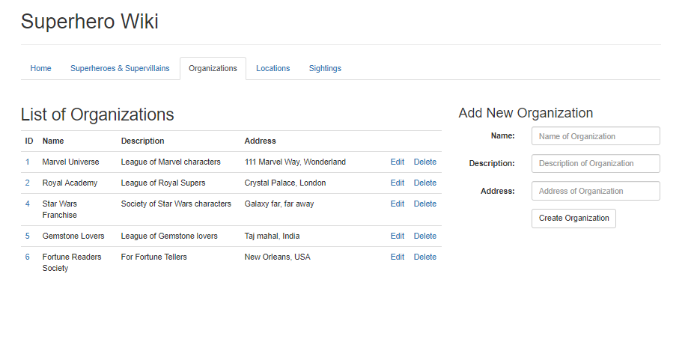

### View Organization Details Page (includes info about Superperson affiliations)

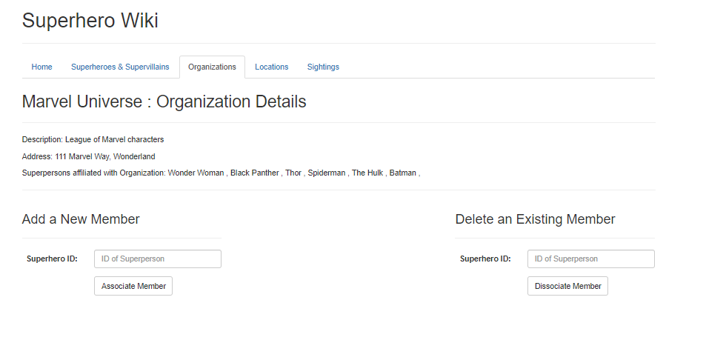

### Edit Organization Page (comes with ability to link/delink Superpersons)

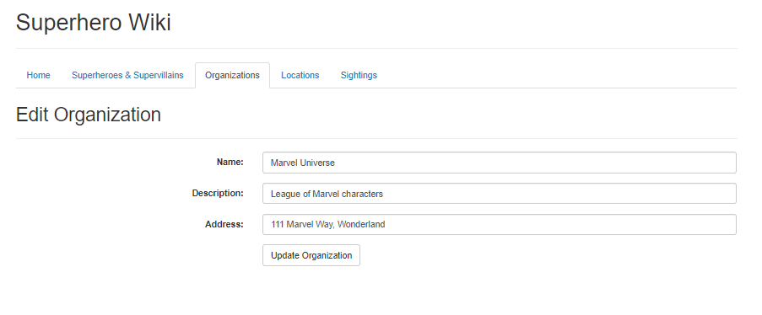

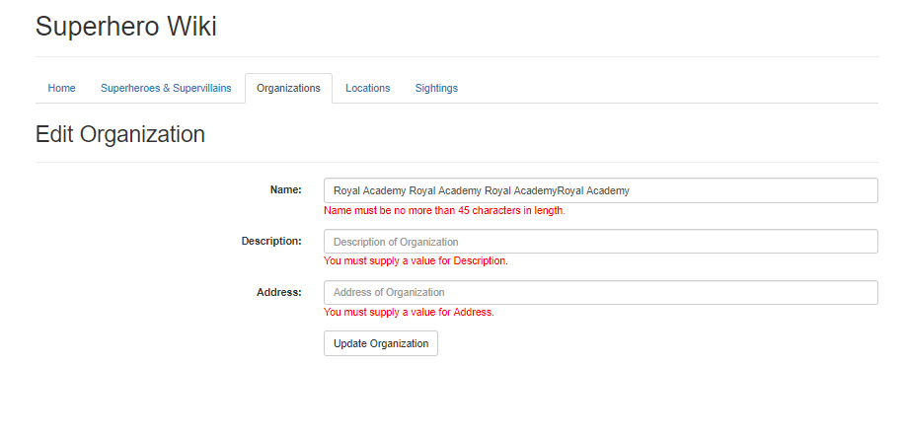

## **“Locations” tab**

### Main Locations Listing page (includes ability to Create & Delete Locations too)

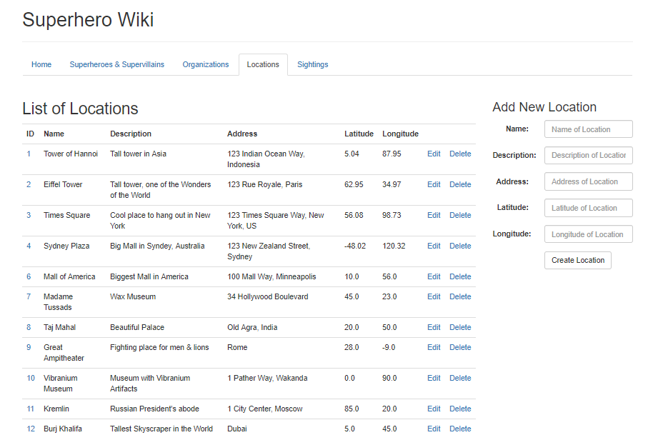

### View Location Details Page (includes info about Superpersons who visited that Location)

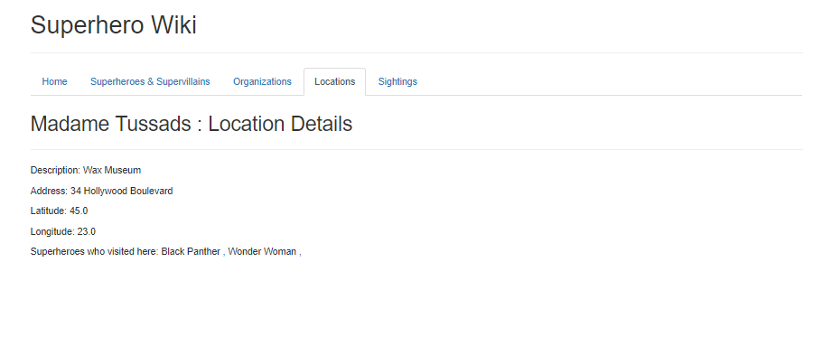

### Edit Location Page

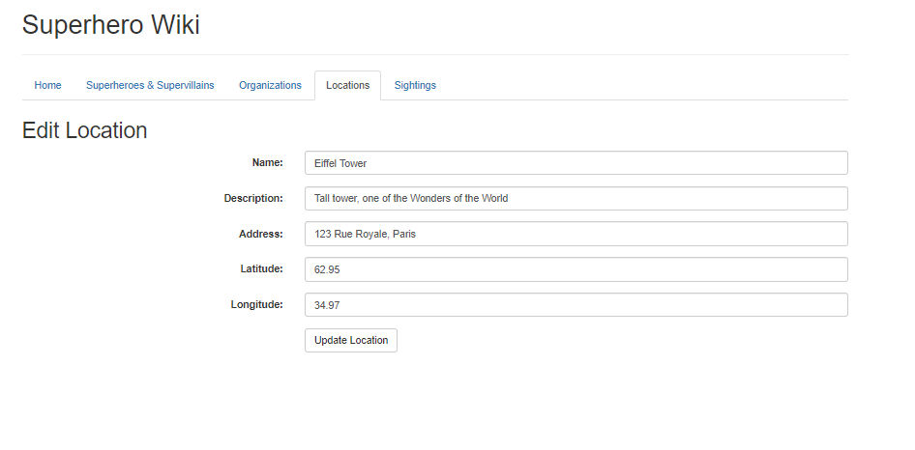

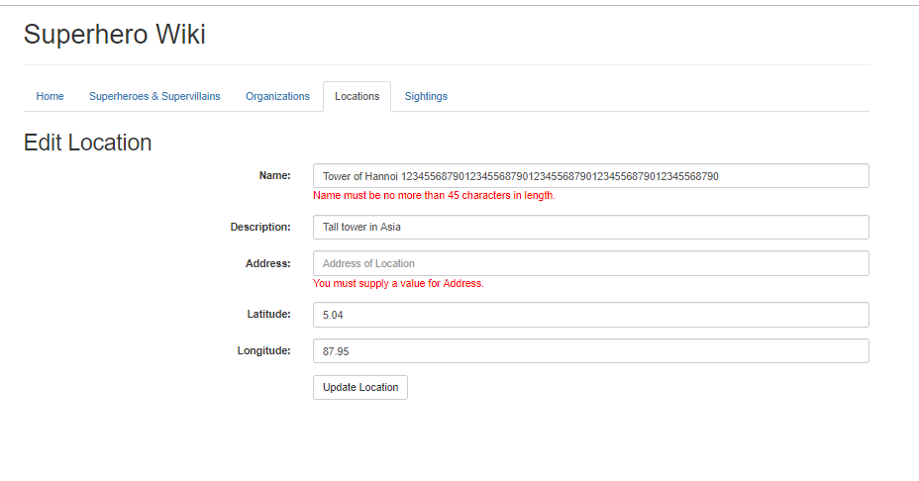

## **“Sightings” tab**

### Main Sightings Listing page (includes ability to Create & Delete Sightings, Search Sightings too)

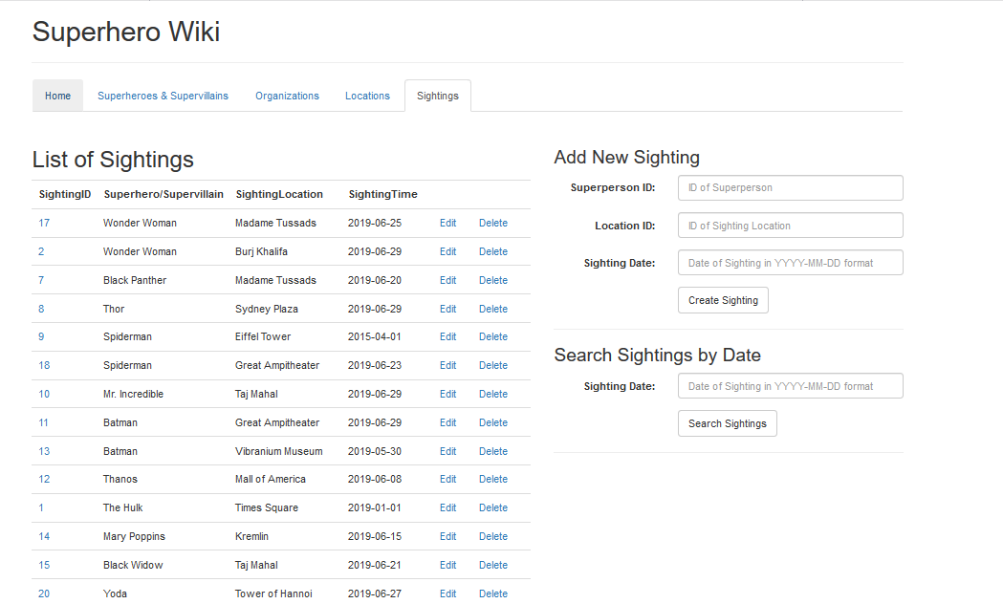

### View Sightings Details Page (includes info about Superpersons who visited that Location)

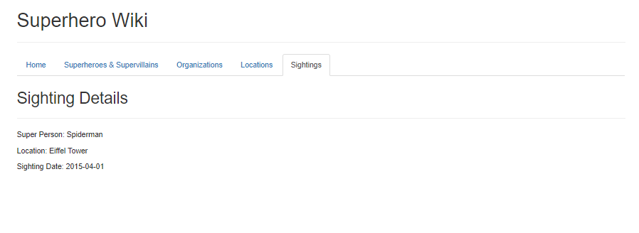

### Edit Sightings Page

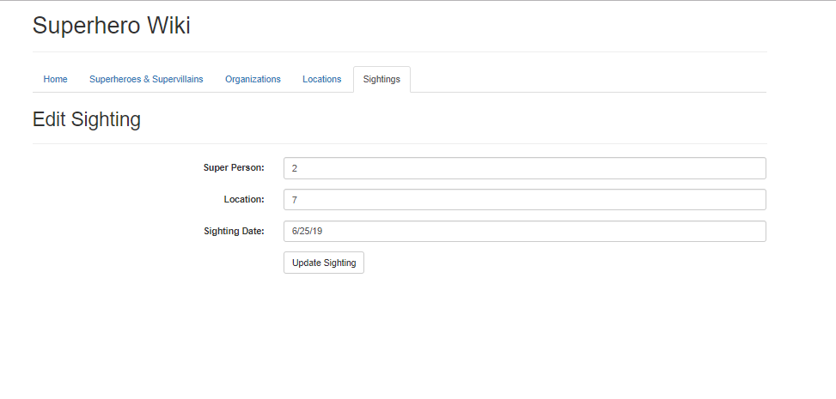

### Sightings Search Results Page

