MEMO to Minister Evan Solomon, Minister of Artificial Intelligence and Digital Innovation

October 31, 2025
Minister Solomon,
As part of the AI Strategy Task Force you asked for proposals to move Canada’s government and industry to action in adopting AI. My key strategic proposals are:
- Make it easy and profitable to build AI-powered companies in Canada
- Fix government incentives to adopt AI
- Empower our defence leaders to buy AI
I’ve invested in startups for over 15 years including in AI, quantum, robotics, genomics, space, fusion, software and defence. I’ve taught on the public policy implications of exponential technologies and was a founding partner of the Creative Destruction Lab, an accelerator for early stage science-based companies. This year, I co-founded Build Canada, a national movement to make Canada the most prosperous country on earth. Through Build Canada, many of Canada’s top entrepreneurs have shared ideas to grow the country; I’ve included many below.
Since your request, I’ve also spoken to:
  - CEO’s of AI scaleups and startups
  - CEO’s of major Canadian employers
  - Senior leaders within the Canadian public service & armed forces.
  - Academics and policy advisors to Canadian, US and the UK governments
Here is what I heard:

AI is a disruptive “general purposeˮ technology
Like previous general purpose technologies (e.g. electricity, steam engines, automobiles or the internet) AI will create large, broadly distributed, productivity gains. And — broad social change.

Without AI leadership, our sovereignty will be at risk
AI will impact all areas of economic growth and defence. States around the world — including the US and China — are racing to develop, adopt and commercialize the technology. Economic and national power is accruing to those who act with urgency to create and use the
AI-powered businesses, products and services of the future¹. If Canada lags in this race, we risk not only falling further behind on economic competitiveness but the very sovereignty of our nation.

¹ “The one who becomes the leader in [AI] will be the ruler of the world.” Vladimir Putin, 2017

Canada has faced disruption before
Canada built a transcontinental railway as a public-private partnership to ensure the country’s sovereignty – and it was the foundation of massive economic growth. Canadian entrepreneurs built hydroelectric dams, power plants and electric transmission at the same time as Edison – and powered growth. Canadian companies built vehicles and auto parts from the start of the auto age and drove our economy.

In every case Canada did not shy from disruption. Each technology brought challenges: tensions between provincial and federal authority, job losses, social change and environmental impact. But, by acting boldly in the face of disruption, Canada harnessed our entrepreneurial nature to secure the country’s sovereignty and create prosperity for all.

Canada needs entrepreneurial urgency
AI presents risks of dislocation, disruption and unintended consequences. It’s natural to wish to eliminate this risk. However, our greatest risk is the failure to rapidly adopt and commercialize. If we delay to try and eliminate all risk we guarantee the race will be won by others. This is the pragmatic reality.

Urgency on AI will get us to the future faster. Access to cheap ‘intelligence’ will supercharge productivity for every individual and every industry. Canada has natural advantages — energy, minerals and talent — to capture AI benefits, but only if we act with urgency.

Entrepreneurs are the key
Mass adoption of new technologies requires entrepreneurial experimentation, tinkering and competition.² In every transition, broad-based progress is driven by entrepreneurs fiercely competing in markets to innovate and deliver new products and services. We learn about the future and discover issues by urgently building; not by delay and theorizing.

In the past, Canadian builders were able to seize new opportunities to build successful businesses. Today, friction from complex regulations, misaligned incentives and an uncompetitive tax code is slowing entrepreneurs. Canada must remove the friction that is hampering independent Canadian companies. This will enable Canadian entrepreneurs to do what they do best: build the future.

² See, eg: “The Most Powerful Idea in the World: A Story of Steam, Industry and Invention.” or The Lever of Riches: Technological Creativity and Economic Progress

Make it easy and profitable to build AI in Canada
For Canada to lead in building AI-powered companies it must create a more dynamic economy where the most innovative companies flourish. This means more entrepreneurship, commercialization, and competition.

Encourage entrepreneurship
Entrepreneurs, investors, and early employees drive the success of new technologies. Yet many Canadian tech founders and employees now choose to build in the U.S. Recent research from Leaders Fund shows a collapse from 70% to 32% of Canadian-founded companies being built in Canada³. To win with AI we can’t ignore this crisis.
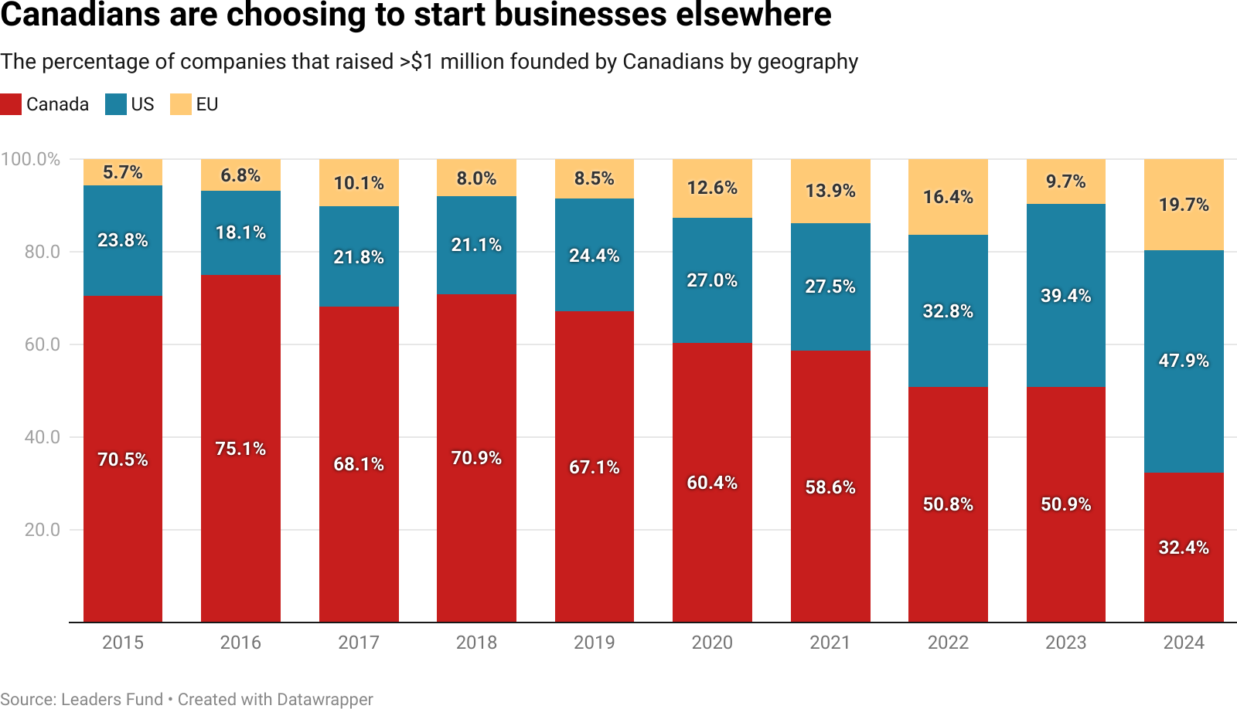
Chart: Canadians are choosing to start businesses elsewhere. Subtitle: The percentage of companies that raised over $1 million founded by Canadians by geography. In 2015: Canada (70.5%), US (23.8 %), EU (5.7%). The percentage of US and EU companies rises steadily until 2023, until it rises sharply in 2024. In 2024: Canada (32.4%), US (49.9 %), EU (19.7%).
To stop this flow Canada needs to remove friction and create better incentives. We should:

Defer capital gains taxes for founders, investors and employees when they
re-invest in a Canadian private company. Canadian founders often leave to raise risk capital. This change will increase risk capital for our early and growth stage companies.
  - Increase capital gains exemptions for founders and early employees to $25 million per business. Canadian talent is leaving because their economic upside is greater elsewhere. This change will re-balance the economic playing field to retain key talent.
  - Keep the rules that govern AI clear and lightweight . New complex regulations and uncertainty will stifle AI adoption. Do not revive AIDA and avoid new regulations. Instead apply existing laws (e.g. privacy, security, and impersonation). Any AI regulatory approach must be completed within six months to create clarity and certainty.

³ https://www.leaders.vc/canadianstartups
  - Provide Canadian firms with in-year deductibility for AI-focused solutions purchased from Canadian firms using immediate expensing rules similar to policies in China⁴.
  - Provide a rapid pathway for AI and technical talent to come to Canada. We will lose if talent has to wait for months. We need rapid action, like a Discovery Visa: a zero-cost, 30-day pathway for the world’s best scientists and engineers to work in Canada.

Focus support on commercialization
Canada has long led in AI research but has had limited success converting this to business success. Policy has favored research over IP commercialization. Canada spends billions annually on industrial R&D support. We must re-focus these efforts on commercialization.
Bold action would simplify, accelerate, and focus the over 130 different programs and agencies for grants, funding and assistance. The alphabet soup is endless - SRED, BDC, EDC, SIF, ISC, IRAP, etc. It is slow, fragmented, confusing, bureaucratic and ultimately ineffective.
As repeated analyses have found, this system isn’t working.
The entire system urgently needs to focus on speed, commercialization and market-based capital allocation that prioritizes proven innovation — focussing on companies that have proven their value by attracting private investment. Our current crisis presents the opportunity to consolidate all programs into a single, market-based, market-compensated,
commercially-driven entity. This must include deep coordination with other levels of government with overlapping mandates.
More incrementally, we should:
  - Reform SR&ED to make it easier to apply directly and fund those who need support most. The current process forces companies to hire consultants and submit lengthy applications. This complex system rewards the wrong companies and wastes money. Simplifying SR&ED would cut out middlemen and help new businesses grow.
  - Refocus IRAP to make use of market validation and simplifying applications. This reform will help Canadian AI companies access funding faster to compete. Today complex processes slow innovation and waste taxpayer money on overhead.

Create the conditions for AI to succeed
AI requires massive data processing which in turn relies on a nation's capacity to process rare earth minerals, provide essential infrastructure, generate massive amounts of energy, and build and run data centres. To enable these technologies Canada must:
  - Unlock the country’s mining potential by reforming permitting and creating new competitive financial instruments to revitalize the Canadian mining industry.

⁴ https://www.gov.cn/zhengce/zhengceku/202309/content_6902076.htm

  - Increase competition in foundational industries like telecommunications, banking, and housing. Barriers to competition prevent the creative destruction needed for growth.
  - Lead in AI infrastructure by leveraging cheap energy, abundant land and cold weather with special economic zones and accelerated permitting for firms who wish to invest billions in Canada.

Fix government incentives to adopt AI
Government adoption will lead to better services, lower costs and will spur AI adoption in industry. If the government can use AI to improve productivity, businesses will have no excuse to lag. In addition, the government must learn to be an early customer to accelerate Canadian innovators. To do this the government must reform incentives and operations.

Demonstrate value to inspire trust and earn public support
The best way to build trust in AI is through tangible results. When Canadians see, feel and experience the value of AI services, they will choose to adopt the technology.
The government should create trust.canada.ca for every AI project in government—its goals, real-time status, completion timeline, and outcomes. Public visibility will create accountability, prevent duplication, and demonstrate how AI is improving services Canadians use every day.
The first wins should come from the tax and immigration systems. The CRA, one of the government’s least efficient and lowest performing departments, is a natural test case for AI. AI at the CRA will improve customer service, reduce wait times and improve their ability to get straight, correct answers - an urgent need.⁵ In addition AI can boost revenue collection, and reduce costs by helping employees find precedents and assisting auditors to identify comparable cases—speeding up reviews and improving consistency.
IRCC faces similar challenges with backlogs and long waits. AI can streamline how applications are reviewed and processed. Automated systems could handle standard cases and send only complex ones to officers, to cut processing times. AI-powered chat can answer routine questions for immigrants and help officers make faster, more consistent decisions.

Urgently upgrade talent
Canada’s government cannot lead on AI without people who understand the technology. Top engineers and AI experts work in industry because the government cannot match their compensation or offer meaningful technical roles. Canada must compete for world-class talent.

⁵ “In scathing report, AG finds CRA call centres are slow to answer and often inaccurate”

To start, build a small, embedded team of elite engineers and AI specialists to drive implementation across departments. With the leverage AI provides, a few exceptional people can have enormous impact. To attract them, the government should pay competitive, performance-based salaries benchmarked to leading tech firms—often exceeding $1.5 million CAD—and empower them to focus on the highest-value work.

Each department should also create a technical-track Assistant Deputy Minister role. In a world where technology is driving policy and implementation every DM should have at least one ADM with software engineering or data science experience to lead technical projects.

Re-structure incentives to reward results
Government executives are rewarded for managing larger teams and budgets—not improving results. Leaders who use AI to cut costs and deliver better outcomes should be promoted, not penalized. Compensation must reflect performance.
Executive pay should no longer depend on “Physical Scale (FTEs)” or “Area of Impact (Magnitude),” both tied to total budget. An executive who provides the same services with 50% fewer staff or 50% less spending currently receives a lower score. This system must be scrapped. Instead, executive compensation (DM and ADM) should be based on measurable service outcomes and efficiency gains. Executives who achieve equal or better results with fewer resources should increase their classification level. Bonuses must be at risk—reduced if performance targets in spending or service delivery are missed.
Within six months, every Deputy Minister should submit an AI plan with clear, quantifiable and impactful goals such as “reduce waits by 75%” or “process applications 50% faster” without adding staff. Failure to deliver on an aggressive plan —or setting unambitious targets—should result in dismissal.

Give government leaders the authority to act
Government leaders theoretically have the authority to procure tools but bureaucracy and fear of criticism paralyze decision-making. Clear direction can restore confidence to act.
All self-imposed procurement limits on DMs and ADMs should be removed. Guidance such as the Office of Procurement Ombudsman’s report on low-value contracting has discouraged leaders from using existing powers. The PMO should make clear that DMs may procure up to legal limits without additional justification.
Authority over standards and major digital investments should be consolidated under a Chief Information Officer with power to enforce consistency and block redundant systems.
Finally, Shared Services Canada’s veto over infrastructure modernization must end. SSC cannot deliver modern AI or cloud systems but can block those who try. It should retain roles in standards for security and shared services—but lose the power to obstruct modernization.

Empower our defence leaders to buy AI
Canada is preparing to increase defence spending, but today procurement is centralized, slow, and bound by outdated processes that block warriors from getting the tools they need.
Adversaries are deploying new capabilities in months, while our system takes years. The war in the Ukraine is demonstrating the rapid shift to attritable, nimble, AI-powered warfare. Reform must focus on simplifying procurement and decentralizing decisions to accelerate commanders who will use AI on the ground.

Simplify procurement for new defence technology
Overlapping and outdated policies mean it takes years to buy simple AI tools. Procurement must be streamlined so the military can get technology when it’s needed.
A small team should map the entire procurement process across Defence, ISED, Treasury Board, PSPC, and SSC, reducing thousands of steps to about 20. Redundant approvals should be eliminated, overlapping policies consolidated, and outdated frameworks like ITSG-33, TBIPS and SBIPS retired.
Regulatory barriers that block AI adoption—such as privacy, data residency, accessibility, and language rules—must be modernized into a single, clear framework. Startups should be able to understand compliance without navigating contradictions across agencies.
Canada should also adopt the UK’s security model, replacing the Protected A/B/C system with Official/Sensitive/Secret standards based on modern data practices. Security checks and background verification should be done with a digital portal in days not months.

Give commanders freedom to invest in innovation
Commanders know what tools their troops need but wait months for approval on purchases that should take days. Giving them purchasing authority will lead to faster, better decisions.
Procurement should be decentralized, with new contracting vehicles to support commercialization of defence technology and fast-track capabilities that leverage AI. Service commanders (three-star and above) should have full authority for purchases up to $5 million.
At the same time the government can speed up commercialization and scaling of new technologies from Canadian companies through continuous validation trials, direction from the government for Canadian financial institutions to boost defence investment and new financing mechanisms for scaling Canadian defence companies.
Finally, ITB rules should be reformed to require offsets be assigned within 90 days, rather than waiting in limbo, and contractor reinvestments have the ability to reach innovative Canadian defence firms, strengthening our military capability and industrial base.

Minister, these suggestions are far from comprehensive. However, I hope that they spur action and further investigation. I am available to answer any questions or follow up at your request.

Sincerely,
Daniel Debow Chair, Build Canada

