31 October 2025
Minister Solomon,
Thank you for the invitation to participate in the AI Strategy Task Force on the topic of AI security and the opportunity to help inform Canada’s refreshed National AI Strategy.
As you know, Canada’s growing reliance on foreign AI models and cloud infrastructure has introduced new risks that will only expand and deepen as AI becomes embedded in critical systems. Alongside AI’s immense economic, scientific and social potential, there is increasing concern about AI-related security risks and the threat of AI weaponization.
AI security is intricately connected to the other AI themes, particularly AI safety, and also has significant areas of overlap and dependency with traditional cybersecurity. Weak AI security can have grave downstream impacts such as supply-chain poisoning with compromised data, model weights, or dependencies silently degrading system integrity over time.
This submission touches on aspects of AI security and draws largely from the lessons learned navigating Canada’s cybersecurity challenge over the past couple decades. Ideas for your consideration are categorized along five interrelated AI security themes:
- Using AI to achieve a step change in Canada’s foundational cybersecurity
- Setting unambiguous AI leadership and governance (including AI security)
- Investing in Canadian AI security frameworks, AI security research
- Contesting and countering adversary AI
- Collaborating internationally
Canada’s reputational advantage
In the field of AI security, Canada is already starting from a recognized position of strength in at least two key areas: (i) world-leading AI research capacity and results, and (ii) world-class cybersecurity leadership and capabilities.^{i} These reputational advantages provide a springboard for Canada to lead in key areas of AI security and should be considered as guiding context for each of the proposed themes.

Improve Canada’s foundational cybersecurity
AI security sits squarely on the shoulders of traditional cybersecurity rooted in its core principles of confidentiality, integrity and availability. A strong national cybersecurity culture – with robust strategies, standards, information sharing and incident response – creates more defensible systems, fortified supply chains and strengthens the muscle memory needed to help manage the risks of other online harms (e.g., disinformation, fraud) as well as improve readiness to securely adopt emerging technologies, like AI and quantum.
Security investment has always been a tough sell. We know from experience that market drivers too often win out over “security-by-design/default” guidance. There is great opportunity now to leverage AI in the secure development and lifecycle of software systems (secure design, vulnerability detection and remediation at build or deployment time) to build less vulnerable software and to improve cybersecurity going forward.
Canada’s most mature cybersecurity organisations have been leveraging AI and machine learning for decades to improve their cybersecurity posture. Today, more Canadian organisations can have access to AI services that generate up-to-date network inventories, assess for vulnerabilities against cybersecurity standards and propose mitigations. This can significantly enhance resilience and may even help find ways to mitigate longstanding risk in legacy systems thought to be prohibitively expensive to address.
AI also offers hope to Canada’s least mature and most vulnerable organisations many of which struggle to implement basic cybersecurity practices. Through open-source AI-enabled cyber assistants, small businesses, municipalities, Indigenous communities and not-for-profit organisations can get advice customized for their specific needs in a genuinely helpful, “no shame” environment.
AI represents an opportunity to raise Canada’s cybersecurity bar and avoid preventable exploitation (whether traditional or AI-enabled) and be better prepared for higher-risk AI systems on our national doorstep.
Achieve a step change in baseline cybersecurity for large and medium organisations (and those who can afford professional cybersecurity services).
- Prioritize federal investment in Canadian vendor products and services using AI to remediate traditional cybersecurity risks within a system.
- Offer incentives and/or obligations to medium and large organisations to onboard Canadian AI-enabled cybersecurity products and services.
- Benefits include more resilient supply chains, fewer and less serious cyber incidents, faster recovery time.

Apply basic cybersecurity measures to Canada’s smallest, least mature and most vulnerable organisations (e.g., small business, rural and remote municipalities, Indigenous communities, not-for-profits).
- Government with private sector can develop open-source assistants for different domains, e.g., small retail businesses, health, education, charitable organisations.
- Partner with local and regional associations to match under-resourced organisations to technical advisors (cybersecurity professionals, practitioners, university graduates) and offer first-line support in use of open-source AI-enabled assistants
- Benefits include getting small organisations practicing better cyber hygiene and a pathway toward continuous improvement nationwide.

Canadian AI leadership and governance
The need for visible, accountable and coordinated federal leadership cannot be overstated. The Gordian knot of AI considerations (economic, safety, security, environmental, ethical, among others) demands tightly coupled leadership and integrated governance. Canada’s experience with cybersecurity offers a cautionary tale. Nearly a decade was spent sorting out cybersecurity leadership and governance questions among the dozen or so government entities jockeying to reconcile their respective mandates before confirming two clear leads: Public Safety (PS) and Communications Security Establishment (CSE). Canada cannot afford to repeat a similar delay in defining AI leadership and governance.
AI requires an expanded and tightly aligned core federal leadership table, and even more tightly coupled horizontal teaming across key portfolios. This should include the Minister of AIDI (importantly, as the Prime Minister’s personal “AI quarterback”) in lockstep with key ministers and officials from ISED, DND (including CSE – for AI security) and PS. This federal AI pact must apply a truly systems view of the challenge and not let the knot of opportunity, prosperity, safety and security alter the “playbook” or slow down implementation of AI plans.
Transparency and communication are critical. Frequent PM and ministerial communications that signal strategic intent and point to progress in AI security (and foundational cybersecurity, for that matter) will build public trust and confidence. This, in turn, will help Canadians be less susceptible to adversary efforts to drive wedges in society through disinformation or influence campaigns.
The Canadian federal AI pact must include AI security in its remit. Historically, there has been a tendency to carve out security as a separate or parallel government track because it is often seen to be burdened by classification barriers and sharing challenges. Canada’s cybersecurity experience to date, however, has shown that this can be mostly addressed through institutionalised transparency, by sanitizing or declassifying intelligence and by sharing sensitive information within understood guidelines and protocols (e.g., the Traffic Light Protocol). Ultimately, embracing CSE as the AI security lead in an integrated national AI governance model best leverages Canada’s national technical authority/expertise in cybersecurity, its classified research institute^{ii} and its domestic and international security partnerships.

Establish and clearly communicate the federal model for AI leadership and governance.
  - Unambiguously communicate AI strategic intent, federal roles, and the governance model in the AI strategy refresh.
  - Align (or at least cross-reference) the AI priorities, dependencies or commitments in other national strategies (e.g., compute, cybersecurity, quantum, etc.).
  - Communicate regularly on challenges and progress/successes; consult often and with a wide cross-section of experts and stakeholders.
  - Benefits include more successful implementation of the strategy through aligned priorities and greater public trust and confidence.

Bolster Canada’s AISI contribution and reputation by adding security to CAISI’s remit.
  - Rebrand CAISI to be the Canadian AI Safety and Security Institute (CAISSI).
  - Integrate CSE, NRC, Statistics Canada or other experienced GC technical leaders and practitioners in CAISSI for maximum alignment with and leverage of existing federal AI security expertise.
  - Deliver an ambitious AI safety and security implementation plan (focused on agentic AI) as a complement to the updated Canadian AI strategy.
  - Establish a strategic foresight function to continuously map AI’s intersection with national security, critical infrastructure, and economic resilience through horizon scanning, scenario analysis, and adversarial wargaming. Findings should be integrated into defence, cybersecurity, and innovation planning.
  - Take a leadership role, with the UK, in an international secretariat for the ring-main of national AISIs, promoting global AI security complementarity and interoperability.
  - Pursue practical initiatives such as building AI sandboxes and co-sponsoring joint testing exercises with allied AISIs.
- Benefits include nationally streamlined approach to AI safety and security and credibility among AISI partners.

AI security frameworks, research
Set expectations regarding AI security standards
Improved cybersecurity practices contribute to the protection of all systems, whether traditional, AI or hybrid. However, AI introduces distinct risks that must be explicitly managed: an expanded threat surface (data, models, training and inference pipelines) and key AI assets (training data, model weights, prompts, supporting infrastructure). As the world moves rapidly toward the next frontier – agentic AI – secure agent protocols based on an accepted standard are required.
Over the past couple years, several principles-based codes of practice for the secure development, deployment and use of generative AI systems (e.g., OECD, UN, EU, GPAI, co-badged agency advice, etc.) have been published. The Canadian Cyber Centre has endorsed some of these codes^{iii} which contain useful guidance.
Yet, as higher-risk agentic AI systems emerge, practitioners are seeking to move from broad principles to technically specific, pragmatic and implementable tools. Having evidence that risk exists and evidence that those risks have been managed requires a “standard” for naming and specifying the version of the AI against which these principles-based codes can be applied. This would help track provenance, authenticate content and correlate dependencies (e.g., this AI system was trained on this infrastructure or that data). There are various initiatives aimed at developing an AI identity or AI bill of materials (AI BOM) to help manage AI systems and their associated risks.
Select an “AI Bill of Materials” aligned with global standards but based on values and assurances important to Canada.
- Consider the various models and choose one that prioritises information to be included in a trusted, unambiguous record and supply chain for components (which, in turn, are aligned to existing global standards) used in building an AI system.
- Collaborate with the UK on best practices in AI identity.
- Benefits include having a useful “ingredients” list to map provenance and security of AI system components to more accurately assess and mitigate risks.

Legislate risk-based security provisions for designated AI systems in Canada.
- Operators of large models or ones that will be widely used should be required to meet minimum security requirements during training, deployment and maintenance. These should include requirements to have a cybersecurity program, conduct third-party risk assessments, produce an AI BOM, report critical incidents and near-misses, along with other safety-related provisions.
- Benefits include better distributing accountability and ensuring appropriate security measures are implemented.
Use AI risk-based security provisions in GC and military contracting as catalyst for adoption.
- Require that all Canadian government and military procurement involving AI includes attestations from contractors that designated AI standards and best practices have been followed.
- Introduce a reporting obligation for serious cybersecurity incidents.
- Consider a requirement for vendors to contribute back to Canadian AI research.
- Benefits include setting an example at the federal level to build confidence in AI systems
security and propagating a private sector contagion model.
Strategic defence of nationally critical AI infrastructure
Over-reliance on foreign AI infrastructure and proprietary models threatens strategic autonomy, exposing critical sectors to external control, tampering, or economic coercion.

Establish a phased roadmap for sovereignty in Canadian government systems.
  - By 2030, require that critical government systems use a “Canadian-controlled” (Canadian or as part of a long-term trusted partner arrangement) technology stack (data centres → compute → models → applications).
  - By 2035, define what comprises a fully sovereign Canadian stack and certify sovereign AI cloud and compute environments.
  - Incentivize private sector alignment to scale a Canadian AI supply chain beyond government systems.
  - Benefits include increased Canadian capacity and autonomy to support critical Canadian information and services.

Create sector-specific AI security models.
  - Experts from industry, government and academia should collaborate to create AI security models (and estimate compute requirements) for key sectors.
  - Chair regular Canadian roundtables on threat and security risk mitigations.
  - Create a “secure channel” (based on commercial encryption and commodity hardware) for sensitive information exchange among sector teams.
  - Create certification or conformity-assessment programs or promote open standards and reference architectures.
  - Benefits include fostering a community of trust and collaboration while increasing adoption of co-created security measures customised for key sectors.

Provide national-level protections to designated AI systems.
  - Designate national-level or widely used AI systems as “systems of importance” to the government of Canada under the Communications Security Establishment Act (CSE) Act s.21(1).
  - With this designation and at the request of the system owner and the approval of the Minister of National Defence and the Intelligence Commissioner, CSE may acquire ministerial authorisation to provide expert, intelligence-informed advice, guidance and technical services (e.g., host-based sensors) to help protect designated AI systems of importance.
  - Benefits include enhanced cybersecurity and defensive posture for vital AI systems Canadians and the Canadian economy most depend on.

Create the foundations for an AI-powered, self-learning national cyber defence ecosystem.
- Integrate host-based or endpoint telemetry from government and other designated system

- o
o o
o
sensors with machine learning and large language models. Improve detection capabilities for AI-enabled threats.
Apply federated analytics and privacy-preserving data sharing, allowing trusted entities to contribute threat telemetry without compromising sensitive data.
Train AI models on anonymized national datasets to identify emerging threat patterns before they spread across sectors.
Open and expand the program to invite other Canadian systems as participants, e.g., national critical infrastructure operators.
Benefits include developing a national digital immune system that strengthens both security and sovereignty; evolving the Canadian cybersecurity ecosystem from reactive detection to proactive, adaptive cyber resilience across traditional, AI and hybrid systems.
Integrate AI security research
AI security risks will continue to outpace the policy needed to address them. Increased collaboration and coherence among government, academia and industry researchers across Canadian jurisdictions and sectors can improve awareness and coordination of efforts. Bridging the classified and unclassified research domains – domestically and internationally – can help cover the increasing waterfront of AI security research pressures. Yet again, Canada’s differentiators in research and cybersecurity may combine to present a real opportunity to punch well above its weight in the global arena.
Compile a national problem/opportunity book for key AI and AI-related research challenges, including AI security research.
- Benchmark with other nations’ priorities for research and lead in areas where Canada is already indisputably strong.
- Leverage CAISSI/CIFAR and the AI labs to cast a broader net and track progress against
challenges laid out in the national problem/opportunity book.
- Benefits include knowing that research investment is geared toward top challenges and
tracking progress made against them.
Synchronize classified research initiatives with the unclassified problem/opportunity book.
- Match classified researchers (e.g., from the Tutte Institute of Mathematics and Computing) with lead academics on specific AI-related security challenges to bridge classified unclassified research disciplines, where possible and appropriate.
- Join efforts with the Laboratory for AI Security Research^{iv} (LASR) program in the UK.
- Benefits include adding research talent, capacity, and perspective to AI security challenges.

Contest or counter adversary AI-enabled operations
Much has been written about the threat of well-resourced state actors exploiting or sabotaging AI systems or using AI for strategic influence, deception, and disruption. Adversary use of AI will challenge cyber defences as well as ongoing efforts by the security and intelligence community and major IT players, researchers and investigative journalists to monitor and mitigate disinformation, synthetic media, and deepfake campaigns.
However, in the near term, we can expect the most persistent and pervasive threat to Canadians and Canadian organisations to be financially motivated and highly adaptive cybercriminals as they use AI to automate and adjust their tradecraft on a 24/7 and industrial scale. Individuals will be outmatched by cybercrime’s capacity and resolve, and network defenders will struggle to manage real-time orchestration and the improvements in speed, volume, quality and agility. Attributing these activities to specific groups and actors will also become more challenging.
The federal government can draw on existing authorities^{v} and capabilities (which have already been used to dismantle some traditional foreign cybercrime IT infrastructure and marketplaces^{vi}) to focus on targeting AI-enabled cybercrime.
A Canadian inter-agency team, guided by clear Cabinet-endorsed technical intelligence priorities^{vii}, could coordinate an ambitious and sustained Canadian campaign to contest or counter AI-enabled cybercrime and its supporting infrastructure. CSE and RCMP could lead a Canadian government team working with (i) industry partners to profile and prioritise AI-enabled cybercrime campaign actors and (ii) with allied government counterparts and international law enforcement to conduct coalition cyber operations to degrade or disable their distributed enterprise. While this won’t stop cybercrime, it could disrupt operational tempo or increase costs to a point they abandon certain efforts. Deeper insight into cybercrime tactics may inspire other mitigations or defences.
Conduct defensive cyber operations at scale to defend GC and other important Canadian systems from foreign AI-enabled cybercrime actions.
- Respecting legal guardrails and privacy protections, investigate options to scale and automate defensive cyber operations that block or thwart foreign cybercriminal AI- enabled campaigns against Canadian networks (e.g., CSE Act, s.18).

Build an enduring active cyber campaign to disrupt or undermine foreign AI-enabled cybercrime enterprise.
- Update foreign intelligence priorities to reflect growing need for insights into adversarial

- ​
o

o
AI groups, their targets and technical capabilities.
Establish an inter-agency team (led by CSE and RCMP) to profile key cybercrime groups and their tactics (with key partners) to develop an intelligence-informed view of AI- enabled cybercrime enterprise directed at GC and other important Canadian systems. Conduct proportionate and necessary Canadian-led and coalition cyber operations to neutralize malign actor capabilities (e.g., CSE Act, s.19).
Benefits in both cases include fewer incidents to manage, raised cost of entry for cyber threat actors that affects their resolve to target Canadians and Canadian organisations.
- Global AI security leadership
Canada’s reputation for advanced research, cybersecurity capability and other unique AI-nexus selling points (e.g., values and ethics), should be used to differentiate Canadian leadership in global AI security governance.
Host next international AI Safety (and Security) Summit
- Offer to host the next significant gathering of AI safety and security experts (following in the spirit of the 2023 Bletchley Safety Summit, 2024 Seoul Summit and 2025 Paris AI meeting).
- Propose the creation of and participate in a permanent secretariat for the international network of AISIs to promote coherence and coordination among AISIs and to serve as a ring main for the extended enterprise of AI lead organisations.
On margins of AI Summit, host allied security and intelligence counterparts engaged in advanced cybersecurity of AI systems and adversary weaponization of AI.
- Share key findings and emerging challenges.
- Invite key industry partners for joint discussions.
In the end, Canada’s ability to navigate the complex and high-risk AI landscape will largely depend on clear and coherent federal leadership and integrated governance to align and drive key priorities in the updated AI strategy.
I applaud the current approach of wide (and hopefully frequent) consultation and engagement with the raft of expert voices in Canada and likeminded countries. I am grateful to the experts in my circle for their insight and sense of community in wanting to help with this assignment. They are ready to tackle these challenges in the interests of our collective prosperity, safety, security and strategic autonomy.
Thank you for the opportunity to participate.


Shelly Bruce

Annex – Interconnectedness and/or interdependencies of AI security recommendations
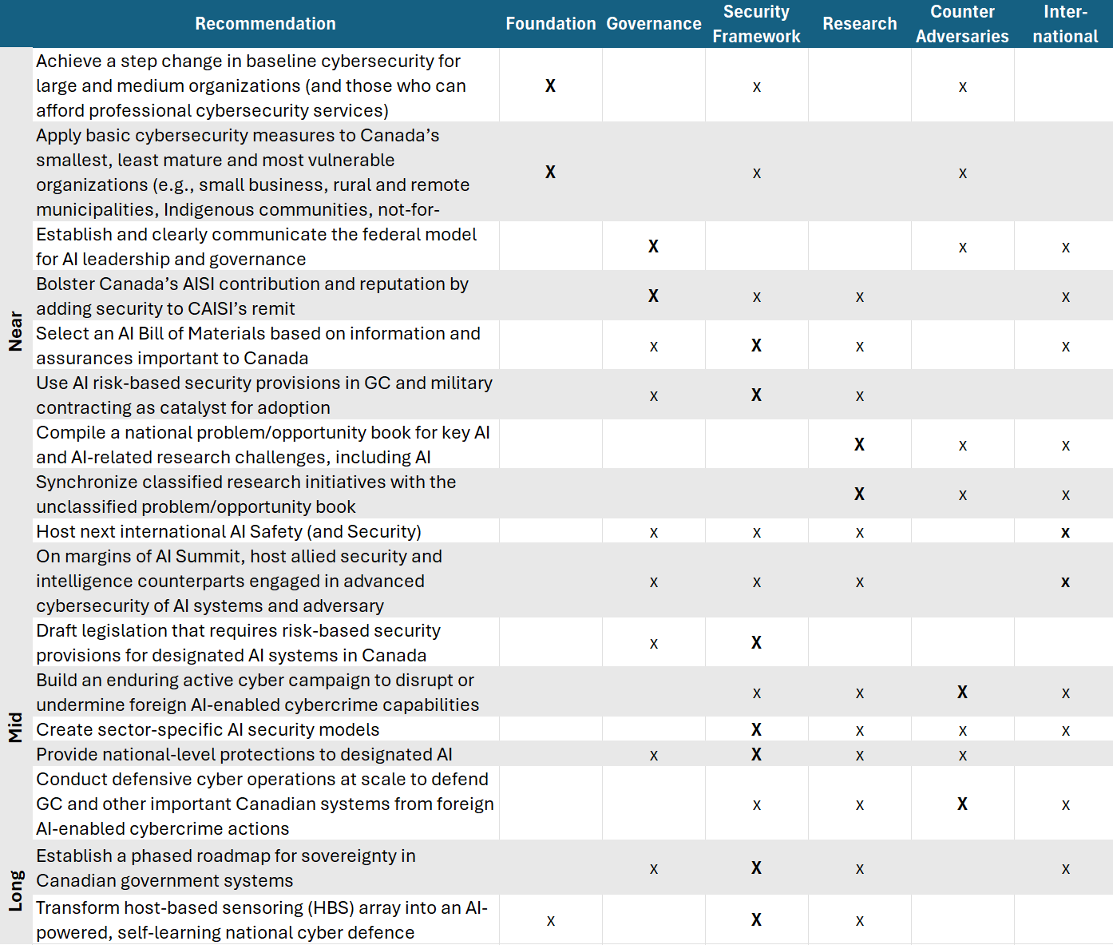

i https://isc.independent.gov.uk/wp-content/uploads/2023/12/ISC-International-Partnerships.pdf
ii https://www.cse-cst.gc.ca/en/mission/research-cse/tutte-institute-mathematics-computing
iii https://media.defense.gov/2024/Apr/15/2003439257/-1/-1/0/CSI-DEPLOYING-AI-SYSTEMS-SECURELY.PDF https://www.ncsc.gov.uk/collection/guidelines-secure-ai-system-development
iv https://www.plexal.com/our-work/laboratory-for-ai-security-research-lasr/
v https://rcmp.ca/en/federal-policing/cybercrime/combatting-cybercrime https://www.cse-cst.gc.ca/en/mission/cyber-operations#aco https://www.cse-cst.gc.ca/en/mission/cyber-operations#dco https://www.cse-cst.gc.ca/en/mission/assistance-federal-partners
vi https://www.cse-cst.gc.ca/sites/default/files/communications-security-establishment-canada-annual- report-2024-2025-v2-e.pdf (p.21)
https://rcmp.ca/en/news/2023/04/rcmps-national-cybercrime-coordination-centre-announces-canadas- participation-global-day-action
vii https://www.canada.ca/en/privy-council/services/publications/canada-intelligence-priorities.html

