Memo #1 - Adoption across industry and governments
To the attention of: The Honourable Evan Solomon
Minister of Artificial Intelligence and Digital Innovation Minister responsible for FedDev Ontario

Dear Minister Solomon,

Thank you for the opportunity to contribute to your AI Task Force as you shape the future of Canada. I remain at your disposal for discussion and any other support you require in this process.
Yours truly, Sonia Sennik

This document draws on data and insights provided by Creative Destruction Lab (CDL). While CDL contributed underlying information, the analysis and positions expressed are independently developed by the author and do not represent CDL’s institutional views.

Executive Summary
Canada faces an AI adoption crisis, with its business sector lagging G7 peers in digital intensity and uptake of AI technologies. This failure to rapidly integrate transformative technology is a critical headwind to the nation’s productivity crisis, a multi-faceted challenge. Learnings from Creative Destruction Lab (CDL) include outcomes from the structured, cohort-based models that accelerate technology adoption at scale, including initiatives such as Putting AI to Work (PAI2W) program, the CDL Rapid Screening Consortium (CDL RSC), and the core CDL program for deep-tech startup companies. Recommendations in this memo encourage the Canadian government and enterprises to focus on practical applications of AI to drive measurable economic outcomes, specifically by:

- Focusing AI Adoption Efforts on Productivity-Driven Use Cases: AI initiatives must be
purpose-driven, emphasizing measurable productivity gains over implementation of technology for its own sake. This focus drives the implementation of practical tools that raise output or reduce costs across all sectors, building organizational awareness and helping organizations capture business value.

- Leveraging Peer-Sharing Networks to Rapidly Accelerate AI Adoption Across Canada: Enterprises must move beyond isolated AI adoption efforts, and instead formalize a nation-wide collaborative knowledge exchange. Development of actionable playbooks, best practices, and
peer-to-peer mentorship will enable companies and public organizations to adopt AI more efficiently.

- Targeting High-Impact Industries to Benefit Canada: AI efforts should be directed to sectors where productivity gains offer the highest return on investment. Examples are Healthcare to improve quality, efficiency, and personalized care and Critical Minerals to accelerate discovery, extraction, and minerals processing, positioning Canada for global leadership.

By addressing barriers like fear, misaligned incentives, and lack of guidance, Canada can leverage AI to drive productivity outcomes.

Introduction
Canada is facing an AI adoption crisis. According to the OECD, Canada’s business sector lags behind peer countries in digital intensity, with the largest share of low-digital-intensity activities among G7 economies [1]. Firm-level survey evidence also suggests Canada’s uptake of AI technologies is below many other OECD and G20 countries [2]. The failure to adopt AI technology at a pace comparable to peer nations is a critical headwind to Canada's productivity crisis, a multi-faceted problem extending far beyond technology adoption alone [3]. Accelerating AI integration within high-growth ventures and established firms is a critical and concrete lever for strengthening overall economic performance.

Creative Destruction Lab (CDL) is a Canada-led global non-profit entrepreneurship organisation that has admitted thousands of startups since 2012, delivering an objectives-based mentorship program for scalable, early-stage, science & technology-based companies. CDL has also delivered two large-scale initiatives to accelerate adoption of new technologies - the CDL Rapid Screening Consortium and CDL’s Putting AI to Work Program. Drawing on learnings from these programs demonstrate that Canada has an opportunity to (1) focus AI adoption entirely on use cases that drive productivity outcomes, (2) leverage peer-sharing networks to accelerate AI adoption across the public and private sector, and (3) target efforts toward industries where a productivity increase would meaningfully improve the lives of Canadians, the global competitiveness of our Canadian businesses, and Canada’s leadership position globally.

AI Adoption in Practice: Facilitating AI Adoption by Enterprises
In 2024, CDL launched “Putting AI to Work” (PAI2W), a 12-month program designed to help organizations achieve a 20% productivity increase within two years through the practical adoption of AI solutions (Figure 2). Participants design and implement targeted AI strategies, guided by established implementation frameworks [4]. The program helps leaders navigate today’s abundance of off-the-shelf AI tools by identifying those with the highest ROI and deploying them at speed. Each business unit develops a focused plan to either raise output or reduce costs, and the program provides a structure for expert mentorship, peer learning, networking and exposure to AI product and service providers. At program completion, organizations not only have deployed AI in key areas, ranging from sales and HR to operations and cybersecurity, but have also measurable, tangible gains in efficiency, cost savings, and decision quality. Most importantly, the enterprise team has built the muscle for adoption, having gone through the process twice, and can embed these learnings into other areas of their business.

Figure 1: CDL’s Putting AI to Work Program Structure
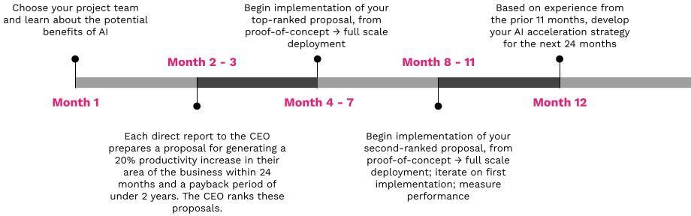
Leveraging AI can have a meaningful impact on productivity for large enterprises, small and medium-sized businesses, healthcare systems, and public institutions. Shifting from sensationalist notions of the “endless possibilities of new technology” [5] and instead towards a practical focus on productivity, emphasizes the implementation of tools that deliver real results and extract true value from AI, not unlike other transformational tools (e.g., computers, the internet, or cloud computing). AI adoption can be viewed in layers (Figure 3), in layer 1, tools that delegate repeatable tasks; layer 2, tools that make sense of messy, unstructured data to build organizational awareness; and layer 3, tools that help us build new products and services. The fourth layer captures the future capabilities of AI & emerging tech. While theoretical and philosophical discussions about the future of AI can take centre stage in the media, practical AI adoption is key to extracting value in the present moment.

Figure 2: The layers of AI adoption
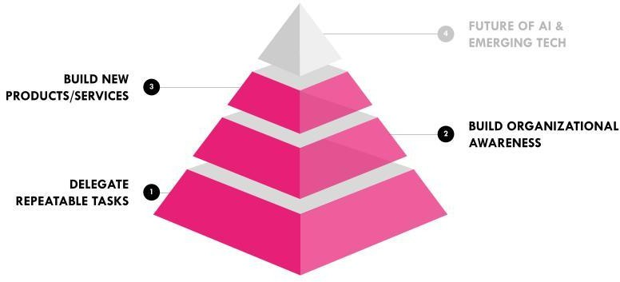

Below is a set of case studies that illustrate the AI adoption process at each of these levels.

Callout 1: Delegate Repeatable Tasks
AI can significantly boost productivity by handling simple, repeatable tasks (e.g., drafting standard emails or assisting through chatbots and autocomplete tools). These small, tangible improvements are a good starting point for many organizations, but must be focused on measurable productivity outcomes.
For example, an IT value-added reseller with $1B in annual revenues was facing slowing growth and high sales costs, so they adopted an AI-powered enterprise chatbot to help automate several aspects of responding to RFPs (Requests for Proposals): vetting relevance, drafting responses, and evaluating drafts based on past successful bids. Getting the team onboarded to the solution required multiple rounds of training and iterating on the team’s incentive-based targets. By using AI to generate accurate, consistent proposals, the company streamlined its sales process with a 10% increase in win rate, and is now projecting a $30M increase in annual revenue.
As another example, a major financial institution sought to improve employee productivity across multiple lines of business. They created a highly scalable internal chatbot that was generally capable but augmented with distinct modules for common workflows such as drafting documents, transcribing and summarizing meetings, and reviewing legal documents. As they rolled out the platform to the entire organization, they increasingly learned more about the important workflows and training required to upskill workers. The solution has driven substantial, measurable productivity improvements.
Key Lessons: AI can significantly increase productivity by enhancing simple, repeatable workflows in high-value areas like sales enablement. Clear coaching and training are essential. AI tools aren’t instantly intuitive, and sustained behaviour change is required to make them part of daily workflows.

Callout 2: Build Organizational Awareness
AI can unlock the hidden value of an organization’s internal data, transforming unstructured data into actionable insights that drive better decision-making. For example, a 90 year old machinery manufacturer with $850M in
annual revenue was losing in sales of replacement parts because customers struggled to identify and order the correct parts. The company’s customer information was scattered and unstructured, requiring an estimated 30,000 hours of manual cleanup, making the project impractical in a world without advanced technology. By building a custom AI agent, the company automated the data organization process - searching internal data, extracting diagrams, and creating an interactive and visual website that allowed customers to easily find and purchase parts. This solution is projected to generate an additional $25M in annual revenue.
Key Lessons: AI can turn messy data into a powerful driver of efficiency, growth, and customer satisfaction. AI’s value isn’t just in speed, it also empowers people to do things that wouldn’t otherwise be possible. It may seem counterintuitive, but businesses in legacy or more traditional industries have the opportunity for the biggest improvement with the adoption of new technology [6].

Callout 3: Build New Products and Services
Organizations can use AI to create entirely new, innovative products and services, rather than just improving existing systems. For example, AI-assisted coding tools help developers build faster and more efficiently.
One company facing declining legacy revenue, new regulatory limitations, and reduced demand for traditional communication channels created an AI-powered review agent to automatically screen digital messages for safety and compliance. This new service dramatically reduced review times, provided near-instant feedback, and improved user engagement, resulting in $36M increases in annual revenue, an 18% increase in platform usage, and a 2% rise in active users. By insourcing AI development, the company built an internal rapid-prototyping capability, delivering over 20 proof-of-concepts in 9 months and accelerated deployment timelines by 18 months.
Another company in a heavily regulated industry was unable to meet their annual target number of safety reviews, requiring them to prioritize the most critical reviews. The primary constraint for the safety risk assessment process was many hours of pre-work, followed by very long sessions with a large group of stakeholders. To improve their throughput, the company worked with a third party implementation partner to create an AI agent that saves time by completing a first-draft of the pre-work and then joining a video-conference with stakeholders to answer questions and make suggestions, and transcribe and incorporate the discussion into a final risk assessment report. The company projects that they will complete 30% more safety risk assessments and $2.7M in annual savings on incident cost using this tool.
Key Lessons: AI enables enterprises to build new tools that can drive growth with measurable impact even in highly regulated industries.

Cohort Learning at Scale: Facilitating Adoption of COVID-19 Rapid Antigen Screening In 2020, CDL designed, implemented, and scaled a nation-wide COVID-19 workplace rapid antigen screening program through a public-private collaboration with organizations spanning industries, sizes,
and geographies. CDL recognized the urgent, shared need across workplaces to develop a cost-effective system for reopening the economy during the pandemic [7], launching the CDL Rapid Screening Consortium (CDL RSC) in August 2020. By March 2022, CDL RSC achieved national scale in Canada (Figure 1), comprising almost 2,000 organizations operating across approximately 3,500 sites, having deployed 2,214,993 rapid antigen screens and receiving global recognition with the PMI Project of the Year Award.
Figure 1: Cumulative no. participants screening weekly in CDL RSC, Feb 2021 to March 2022
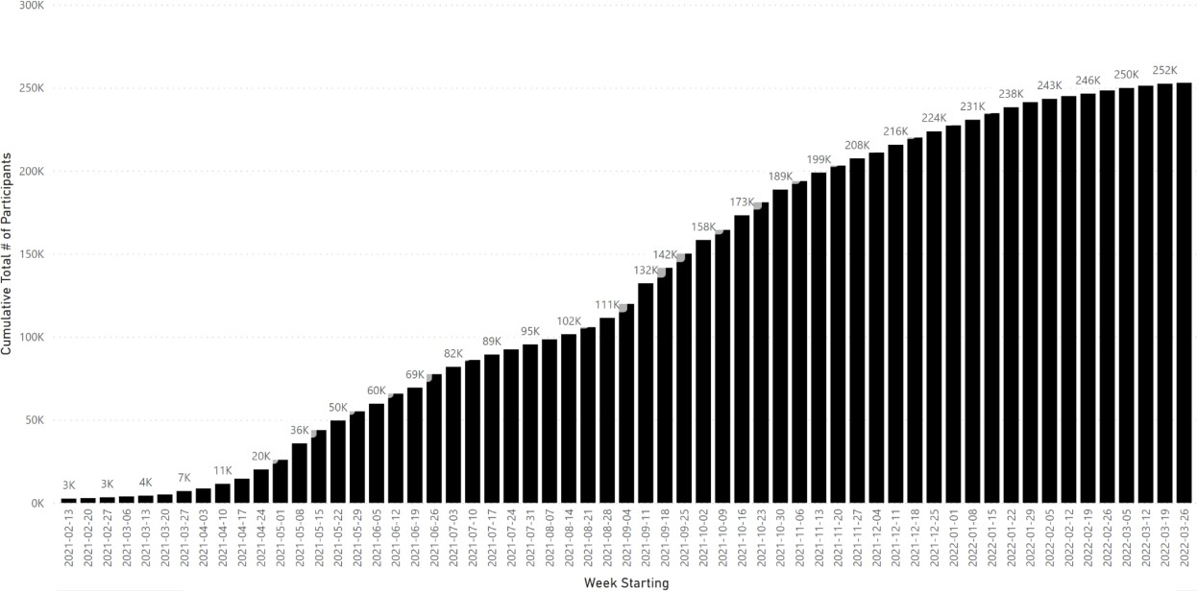
To achieve rapid scale, CDL RSC cultivated bridging and cohesive networks that provided flexible knowledge-sharing opportunities to organizations with different levels of maturity. In a cohesive network, members are connected to one another, which builds trust and mutual support, facilitating communication and coordination. In a bridging network, there is a single connector (CDL RSC) between disparate entities that has control over the nature, frequency, and content of communication [8, 9].

“…[CDL RSC was an] Incredible forum for knowledge sharing. The biggest benefit we’ve experienced is simply learning from other organizations’ challenges, successes, experiments, debates, etc… Being part of the community has enabled us to proactively explore various strategies and continuously improve our program, all while feeling like we aren’t alone in our efforts and have a whole community of supporters to lean on for feedback and insights.”

The project leveraged a very Canadian “pay-it-forward” mindset among participating organizations, where the CDL RSC network allowed companies to access peer-to-peer support, accelerate knowledge-sharing, and therefore minimized company onboarding time. Knowledge-sharing between companies included examples and best practices (e.g., media, infographics, and sample employee communications).

“The ‘pay it forward’ approach to scaling not only allowed cohorts to onboard faster, it also provided valuable resources and tools to smaller organizations that wouldn’t have been able to launch their own screening program.”

The CDL RSC team minimized the number and complexity of organizational decisions by developing an SOP manual (“The Playbook”) and providing training videos and onboarding resources. The CDL RSC led weekly Townhall meetings where they curated updates on the public health environment and encouraged knowledge sharing amongst participants.

“Every time we had a meeting and received new regulatory and policy information, it helped us communicate to our employees the new requirements. It allowed us to be always up to date with government policy changes and helped us ensure we were compliant.”

By combining structured support, curated knowledge-sharing, and peer-to-peer collaboration, CDL RSC enabled Canadian organizations to rapidly adopt and scale a new technology across diverse workplaces, despite a dynamic regulatory environment, significant uncertainty, and widespread public concern during an unprecedented global pandemic. The elements of this story are not unlike the current landscape of AI adoption, where organizations must similarly navigate a multitude of technologies, evolving regulations, uncertainty, and public apprehension while learning to integrate transformative technologies at scale.

Overcoming Barriers
There are three major barriers to adoption of new technologies among enterprises (Table 1). Table 1: Barriers to AI Adoption
Barrier | Elements | Root Causes | Practical Solutions
Fear | - Job Displacement  - Appearing Incompetent  - Failure  - Trust  - Unknowns | - Media Narratives  - Experience  - Education  - Communication | - “Lower the temperature”  - Experiential Education  - Transparent Communication  - Culture of Experimentation
Incentives | - Reward Structures  - Productivity Outcomes  - Policy & Permissions  - Market Impact  - Career Impact | - Media Portrayal  - Mixed Signals  - Executive Education  - Short-Term Focus | - Start Small & Iterate  - Clear Guidance  - Long-Term Perspective  - Leadership
Playbooks | - Lack of Strategy  - Inconsistent Approach  - Change Management  - Undefined Governance  - Misaligned Metrics | - Limited Experience  - Unclear Ownership  - No Guidance | - Develop AI Strategy with clear, measureable KPIs  - Establish a Centre of Excellence  - Adopt Standards  - Iterative Development of Playbook Content

Fear-based barriers to AI adoption include concerns about job displacement, insufficient skills, uncertainty that AI will deliver promised results, and worries over fairness, transparency, and accuracy. These concerns are amplified by inconsistent, utopian or apocalyptic media narratives, especially for those with limited hands-on experience with AI. Misconceptions, worst-case assumptions, and lack of clarity further fuel mistrust. Some recommended practical solutions are:
- “Lower the Temperature”: Avoid buzzwords and hyperbolic discussions; instead, frame initiatives as the adoption of practical tools to support employees’ work and productivity increases.
- Transparent Communication: Openly share plans and timelines. Involve employees and stakeholders to develop a shared understanding of the current technological landscape.
- Education & Experience: Provide training opportunities and encourage team members to use the tools and discuss them with their team and others in their professional networks for peer sharing.
- Culture of Experimentation: Promote experimentation and agility, ensuring failures are framed as learning opportunities and addressed appropriately.

Incentive-based barriers to AI adoption include misaligned reward structures, unclear policies that discourage experimentation, leadership pressure for rapid results, and risk-aversion on high-impact projects. These challenges are fueled by mixed management signals, limited executive understanding of AI’s realistic benefits (e.g., using an AI tool to save time, if not curated properly, may result in more work with no benefit), and short-term performance pressures that undermine investment in broader, transformational change. Some recommended practical solutions are:
- Long-term Perspective: Focus on developing capabilities that will allow the organization to continually improve in an era defined by increasing change and volatility.
- Top-Down Leadership: Build a culture of agility and iteration by prioritizing well-reasoned experimentation and communicating learnings as the first-order benefit of these experiments.
- Start Small: Maximize learning by prioritizing projects that can be completed in weeks, not months.
- Clear Guidance: Define clear policies promoting the safe use of AI tools and offering support.
- Revise Incentives: Align incentive structures to encourage experimentation and improve productivity.

Lack of playbooks is the last barrier to AI adoption. Organizations often lack clear principles for identifying and prioritizing AI use cases, leading teams to reinvent the wheel. Inconsistent training, poor change management with inadequate communication, unclear data governance, and misaligned metrics make proving ROI and scaling difficult. These issues stem from limited experience, unclear ownership, and absence of guidance or standards. Some recommended practical solutions are:
- Be Strategic: Define a framework and priorities to align AI efforts with overall business goals.
- Establish a Center of Excellence: Centralize AI knowledge and resources, offering support to business units, curating best practices, and providing training to build internal capabilities.
- Adopt Standards: Leverage established industry frameworks to ensure responsible, consistent, and transparent AI development (data handling, ethics, bias mitigation, etc.).
- Iterative Development of Playbook Content: Encourage peer-sharing to establish Playbooks that will be updated when new information and knowledge is available; this is a dynamic process that will benefit from multiple contributors across business units, industries, and sectors.

Taken together, enterprises of all sizes can overcome barriers to AI adoption by combining transparent communication, hands-on education, a culture of experimentation, aligned incentives, strategic frameworks, and centralized guidance to build trust, enable skill development, and scale effectively.

Two Key Opportunities for AI Adoption
- Healthcare: Canada’s healthcare system consumes a growing share of national and provincial expenditures, reaching $372B in 2024, or about 12% of GDP, a 5.7% increase from 2023 [10]. AI offers opportunities to improve efficiency, outcomes, and accessibility across care. Clinically, AI can enhance diagnosis, decision-making, and personalized treatment. Operationally, it can optimize scheduling, resource allocation, and patient flow. Population health and research can also benefit from AI-driven data analysis, supporting surveillance, preventive care, and drug development. Integrating AI across these domains, emphasizing preventative care, and can improve care quality and system efficiency [11].

  - Case Study: In the United Kingdom, the NHS has implemented a rapid national rollout of AI-enabled decision support software for stroke imaging. Management reduced the critical door-in to referral time by over 60 minutes [12]. This systemic efficiency gain led directly to a three-fold increase in the proportion of stroke patients recovering with little or no disability, rising substantially from 16% to 48% across participating hospitals. Since that time, AI-powered decision support has been rolled out to all 107 stroke units across England, improving care for around 80,000 patients annually [13].

- Critical Minerals: Canada is well-positioned to become a global leader in critical minerals, with rich deposits across multiple provinces and territories. Federal investments under the Canadian Critical Minerals Strategy total $3.8B through 2030, complemented by targeted funds and industry spending of several billion annually [14]. AI offers transformative potential across the value chain: accelerating exploration, optimizing mining and metallurgical processing, enhancing R&D, and improving supply-chain management. Combining AI with its resource base and public geoscience data, Canada can shorten development timelines, increase efficiency, and strengthen Canada’s global leadership in critical minerals.

  - Case Study: Implementation of AI-enabled Autonomous Haulage Systems (AHS) and Predictive Maintenance (PdM) at Australian & Chilean operations dramatically accelerated profitability; Fortescue Metals Group (Australia) achieved a 30% productivity increase with AHS, contributing to estimated annual savings of $120–$180 million per midsize mine. Another example is AI-driven process optimization in Latin America which provided a critical revenue boost, evidenced by Codelco (Chile) adding 8,000 metric tons of copper annually through machine learning models while reducing equipment downtime by up to 30% across their maintenance operations [15, 16, 17].

Key Takeaways and Recommendations
Canada faces a significant AI adoption gap. CDL’s cohort-based programs show that practical, structured approaches can rapidly scale new technology adoption. AI can drive measurable productivity gains, unlock insights from unstructured data, and enable continuous improvement, even in legacy industries.
Adoption barriers, namely fear, misaligned incentives, and lack of playbooks, can be overcome with training, experimentation, and centralized guidance. Canadian companies can collaborate to learn and move faster, together – recommendations follow:

Focus AI adoption efforts on productivity-driven use cases
  - Prioritize AI solutions that deliver measurable productivity gains and improved employee experiences.
  - Showcase clear, evidence-based success stories to build confidence and encourage adoption.
  - Ensure AI initiatives are purpose-driven, emphasizing outcomes rather than technology for technology’s sake.

Leverage peer-sharing networks to rapidly accelerate AI adoption across Canada
  - Provide actionable playbooks, best practices, and mentoring programs in order to enable companies and public organizations to adopt AI.
  - Encourage collaborative knowledge exchange with coast-to-coast peer sharing to scale successful approaches rapidly.

Target high-impact industries to benefit Canada
  - Direct AI efforts to sectors where productivity gains will meaningfully improve Canadians’ lives, enhance business competitiveness, and position Canada for global leadership through productivity-enhancing AI applications:

Recommendation for Public Sector Services
      - Deliver practical, cohort-based learning across the country to public sector leaders as soon as possible to incentivize AI adoption with the goal of increasing productivity - the efficiency and personalization - of public services.

Recommendation for Healthcare
      - Mandate interprovincial de-identified data sharing to build powerful, world-class AI models for prevention, early detection, diagnostics, and public health.
      - Incentivize adoption of AI tools across healthcare systems and providers through a centralized, formal structure.
      - Ensure revenue from AI-based solutions is reinvested back into Canada’s healthcare system.

Recommendation for Critical Minerals and Energy
      - Incentivize corporations and related sectors to adopt AI for higher efficiency, faster extraction, and streamlined operations as critical minerals and energy production hold significant and increasing global value and relevance
      - Advance education in these sectors to increase AI adoption as quickly as possible.

References
- OECD (2025), OECD Economic Surveys: Canada 2025, OECD Publishing, Paris, doi.org/10.1787/28f9e02c-en.
- OECD/BCG/INSEAD (2025), The Adoption of Artificial Intelligence in Firms: New Evidence for Policymaking, OECD Publishing, Paris, doi.org/10.1787/f9ef33c3-en.
- Leyton-Brown, K. et al. (2025). AI Is Not Rocket Science: Ideas for Achieving Liftoff in Canadian AI Adoption. C.D. Howe Institute. Available from cdhowe.org/publication/ai-is-not-rocket-science/
- Agrawal A, Gans J, Goldfarb A. Power and prediction: The disruptive economics of artificial intelligence. Harvard Business Press; 2022 Nov 15.
- Truong V. Hype and Adoption of Generative Artificial Intelligence Applications. arXiv preprint arXiv:2504.18081. 2025 Apr 25. Available from arxiv.org/abs/2504.18081
- Boston Consulting Group. Are You Generating Value from AI? The Widening Gap. Boston Consulting Group; 2025 Sep 30. Available from www.bcg.com/publications/2025/are-you-generating-value
- Rosella LC, Agrawal A, Gans J, Goldfarb A, Sennik S, Stein J. Large-scale implementation of rapid antigen testing system for COVID-19 in workplaces. Science Advances. 2022 Feb 25;8(8):eabm3608. Available from: pubmed.ncbi.nlm.nih.gov/35213224/
- Battilana J, Casciaro T. The network secrets of great change agents. Harvard business review. 2013 Jul 1;91(7):62-8. Available from: https://hbr.org/2013/07/the-network-secrets-of-great-change-agents
- Sennik S, Gatov E, Agrawal A, Gans J, Goldfarb A, Rosella L, Stein J. Tackling a Wicked Problem: An Innovation Story. Rotman Management Magazine. Winter 2025: 38-45. ISSN 2293-7722. Available from rotman.utoronto.ca/news-events-and-ideas/rotman-management-magazine
- Canadian Institute for Health Information. National health expenditure trends, 2024 - Snapshot. Available from: https://www.cihi.ca/en/national-health-expenditure-trends-2024-snapshot
- Al-Haque S, B-Lajoie M-R, Eizenman E, Milinkovich N. The potential benefits of AI for healthcare in Canada. McKinsey & Company. Published February 26, 2024. Available from mckinsey.com/industries/healthcare/our-insights/the-potential-benefits-of-ai-for-healthcare-in-canada
- Nagaratnam, K., Neuhaus, A., Briggs, J. H., Ford, G. A., Woodhead, Z. V. J., Maharjan, D., & Harston, G. (2024). Artificial intelligence-based decision support software to improve the efficacy of acute stroke pathway in the NHS: an observational study. Front Neurol, 14, 1329643. Available from www.frontiersin.org/journals/neurology/articles/10.3389/fneur.2023.1329643/full
- Hargroves D. How artificial intelligence is helping to speed up the diagnosis and treatment of stroke patients. NHS England Block. Available from
england.nhs.uk/blog/how-artificial-intelligence-is-helping-to-speed-up
- Government of Canada. Canadian Critical Minerals Strategy. Ottawa: Natural Resources Canada; 2023. Available from canada.ca/en/campaign/critical-minerals-in-canada
- Farmonaut. (2025). Autonomous Mining Equipment & AI: 2025 Market Insights. Farmonaut. Available from farmonaut.com/mining/autonomous-mining-equipment-ai-2025-market-insights
- Farmonaut. (2025). Case Studies of AI in Mining: 7 Top Innovations 2025. Farmonaut. Available from farmonaut.com/mining/case-studies-of-ai-in-mining-7-top-innovations-2025
- AI Expert Network. (2024). Case Study: AI at Fortescue Metals Group. Available from aiexpert.network/ai-at-fortescue/

