Memo #2 - Scaling Champions and Attracting Investment
To the attention of: The Honourable Evan Solomon
Minister of Artificial Intelligence and Digital Innovation Minister responsible for FedDev Ontario

Dear Minister Solomon,

Thank you for the opportunity to contribute to your AI Task Force as you shape the future of Canada. I remain at your disposal for discussion and any other support you require in this process.
Yours truly, Sonia Sennik

This document draws on data and insights provided by Creative Destruction Lab (CDL). While CDL contributed underlying information, the analysis and positions expressed are independently developed by the author and do not represent CDL’s institutional views.

Executive Summary
The success of early-stage, science- and technology-based ventures hinges on three critical factors: (1) the prioritization of scarce resources (2) mentorship to support rapid decision-making, and (3) access to global networks. For Canadian ventures to achieve massive scale, they must make early decisions to position themselves for global impact. And, it is key for Canada-led companies to scale internationally to become global leaders in their industry. CDL graduates have generated CAD $55 billion equity value.
Since 2015, CDL AI program graduates have generated a total of CAD $16.5 billion in equity value; or raised a total of CAD $4.8 billion in financing. Based on observations of the global innovation ecosystem over the last decade, recommendations to Minister Solomon’s AI Task Force are:

- Cultivate a Global Mindset within Canada-led Businesses: Encourage Canadian startups to engage international customers from day one, not "local first, global later". Canada should also actively attract foreign startups and talent to enrich the domestic innovation ecosystem and integrate Canadian founders with world-class ideas and networks.

- Position Canada as a Strategic Customer to Retain High-Quality Companies: Companies tend to set up offices near their customers. The government should shift from grant-heavy support to using public and private procurement to adopt emerging technologies and actively keep top companies in Canada. Streamlining federal programs and procurement processes to enable rapid decision-making and funding is essential, promoting a "fail fast, learn fast" culture.

- Supercharge Networks and Accelerate Innovation Through Speed and Connectivity: Networks like CDL can help identify high-potential ventures early in their development - whether domestic or international. Reducing legal and administrative complexity will make it easier for international founders to relocate, incorporate, service customers, and scale in Canada.

Introduction
Creative Destruction Lab (CDL) is a Canada-led global non-profit entrepreneurship organisation that has admitted thousands of startups since 2012, delivering an objectives-based mentorship program for scalable, early-stage, science- and technology-based companies. Graduates from the CDL program have generated CAD $55 billion in equity value. CDL’s role in accelerating AI startups across Canada and globally and its focus on rigorous data collection and analysis [1], illustrates the importance of early decision-making for startups, fostering a global mindset, leveraging network effects, and an emphasis on speed and momentum to scale champions and attract talent.

Startup programs like CDL offer a unique window into the early stages of startup formation [2]. CDL posits that it is not the lack of ideas, capital, or effort that prevents early-stage ventures from translating innovation into success. Instead, the primary reason is a failure in the market for high-quality judgment to bridge the gap between science (the knowledge produced in academic institutions and research labs) and technology (the commercial application of that knowledge) [3, 4]. Effective objective-setting is the cornerstone of the CDL program, connecting knowledge producers with businesspeople and investors to commercialize their work.

Early Decision-Making and the Global Mindset

Early decision-making is key in positioning ventures for scale, and for Canadian ventures, scaling outside of Canada is paramount to building a globally impactful business. The data suggests a need to actively encourage Canadian founders toward this global-first view.

When asked how CDL could provide the most value, the vast majority of ventures indicated goals related to raising money (82%), followed by sales and marketing (48%). However, ventures applying to CDL from outside Canada placed a greater emphasis on product-market fit validation, as well as on customer research and go-to-market (GTM) planning goals (Figure 1). This difference suggests a gap—Canadian-led ventures must be encouraged and supported to test global markets earlier. Domestic programs should drive a global first planning strategy from inception.

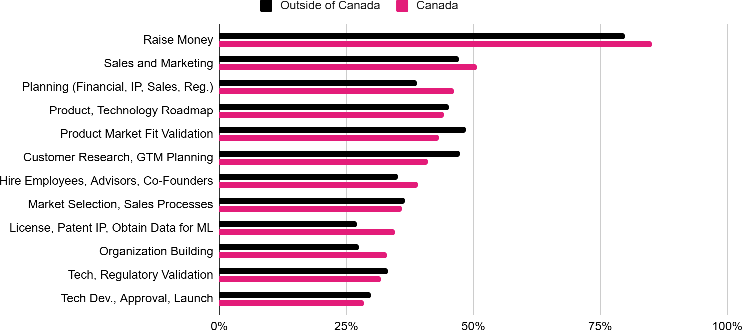
Figure 1: “How can CDL provide the most value to your venture?” (multi-select), among CDL applicant ventures with an AI or a Machine Learning component, 2022/23 - 2024/25

Furthermore, while Canadian ventures display early traction, it may be domestically anchored. A greater proportion of Canadian ventures reported non-dilutive funding, revenue, and incorporation status (Figure 2). While this indicates success in securing government or local grants, this reliance on
non-dilutive/public capital should be positioned as a springboard to global markets, not a shelter from international competition.

Figure 2: Self-report characteristics of ventures admitted to CDL AI and CDL Quantum streams, 2022/23 - 2024/25

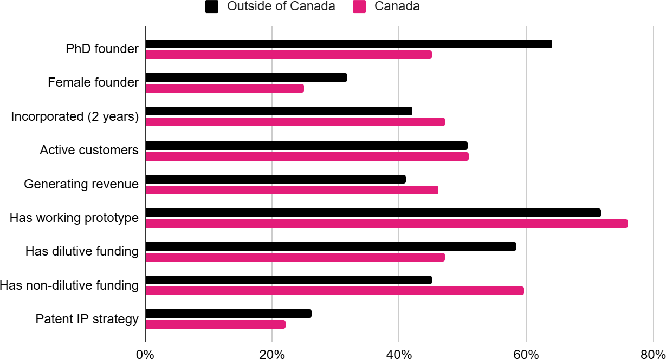

The chart is a horizontal bar graph comparing self-report characteristics of ventures admitted to CDL AI and CDL Quantum streams, 2022/23 - 2024/25, from within Canada and outside of Canada.

Callout 1: How Mentorship at CDL Influenced Validere’s Global Pivot
Validere developed technology that could identify the characteristics of a liquid in real time, with tremendous
potential to disrupt the workflow of sending samples to a lab, which often took days to get results back. They joined CDL in 2015/16 and were working with a global perfumery to uncover knockoffs of its top-selling perfume. CDL Mentors challenged founders to rethink their purpose and market focus, seeing beyond Validere’s original idea and helping the founders reimagine its potential. The Mentors supported Validere’s strategic pivot from verifying luxury perfume to solving a far more consequential problem: real-time oil-testing service. This early decision transformed Validere’s trajectory from a niche application to a company tackling one of the world’s most complex industrial challenges. Validere has since raised over $90M in funding.

Callout 2: Early Objectives Contributed to Massive Scale
Blue J is a Toronto-based legal technology company founded in 2015 by University of Toronto law professors Benjamin Alarie, Anthony Niblett, and Albert Yoon. Blue J develops AI-powered software that enables legal and tax professionals to conduct authoritative research and reasoning with exceptional accuracy and speed. Its platform combines trusted legal content with advanced language models to deliver verifiable, citation-backed answers across complex areas of law. During the 2015/16 CDL program year, Blue J advanced from early validation to commercialisation, securing foundational funding, building credibility, and establishing partnerships with PwC and the Canada Revenue Agency. The company has since scaled globally, serving more than 3,000 organisations and raising over C$200M in total financing to date.

To foster a global mindset, it is essential to be open to capital and talent from outside Canada. Geographically expansive networks are essential for both market opportunities and cap table diversity. At CDL, Canadian ventures accounted for 50% of all admitted AI ventures, followed by 27% European ventures, 18% US-based ventures, and 3% Asian ventures (Figure 3). To scale more Canada-led champions, our ecosystem must actively promote the attraction of foreign startups and talent to Canada.

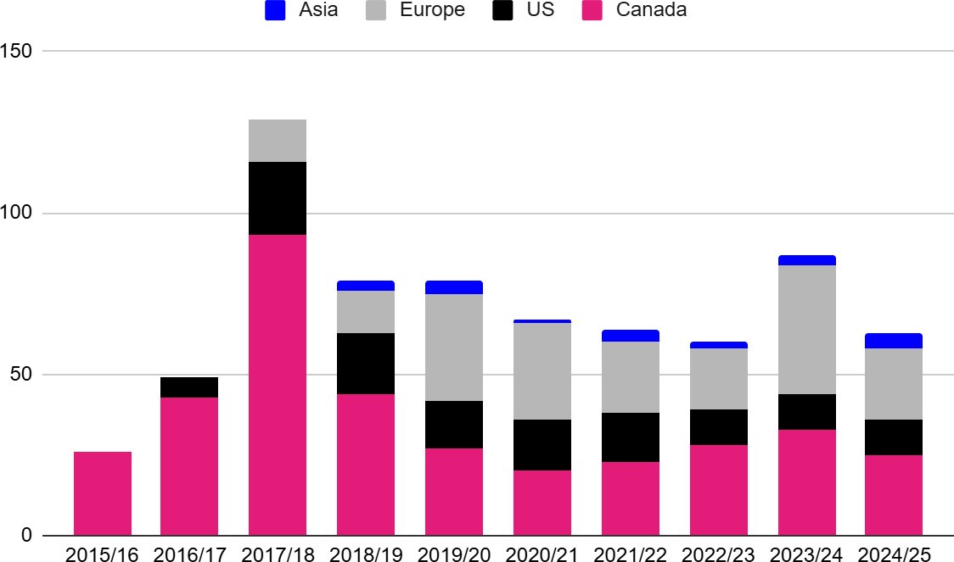
Figure 3: CDL AI admitted ventures, by geography, 2015/16 - 2024/25

Position Canada as a Strategic Customer
CDL AI companies, both Canadian-based and those based outside of Canada, have achieved notable markers of success. Since 2015, 159 CDL AI alumni ventures have had at least one funding round following program participation, raising a total of CAD $4.8B in financing, or CAD $16.5B in equity value created (EVC).

Table 1: Top performing Canadian CDL alumni
Canadian CDL  Venture | CDL  Cohort | No. raise  events | Total amount  raised, $CAD | EVC*,  $CAD, Billions
Canada Company A | CDL-Toronto AI 2016/17 | 5 | $ 0.24B | $ 1.49B
Canada Company B | CDL-Toronto AI 2015/16 | 7 | $ 0.35B | $ 0.48B
Canada Company C | CDL-Toronto AI 2015/16 | 4 | $ 0.30B | $ 0.41B
Canada Company D | CDL-Toronto AI 2015/16 | 4 | $ 0.3B | $ 1.13B
Canada Company E | CDL-Toronto AI 2016/17 | 6 | $ 0.30B | $ 0.38B
Canada Company F | CDL-Rockies Energy 2018/19 | 6 | $ 0.43B | $ 1.22B
Canada Company G | CDL-Toronto AI 2016/17 | 2 | $ 0.24B | $ 0.32B
Canada Company H | CDL-Montreal AI 2019/20 | 3 | $ 0.15B | $ 0.21B
Canada Company I | CDL-Toronto Prime 2015/16 | 6 | $ 0.23B | $ 0.62B
Canada Company J | CDL-Vancouver Health 2017/18 | 4 | $ 0.14B | $ 0.54B
Canada Company K | CDL-Toronto Prime 2018/19 | 4 | $ 0.22B | $ 0.63B
Canada Company L | CDL-Toronto AI 2016/17 | 5 | $ 1.24B | $ 3.65B
Canada Company M | CDL-Toronto AI 2017/18 | 3 | $ 0.19B | $ 0.78B
Canada Company N | CDL-Toronto Prime 2016/17 | 5 | $ 0.2B | $ 0.62B
Canada Company O | CDL-Toronto AI 2016/17 | 4 | $ 0.31B | $ 1.34B
*Equity Value Created (EVC) is the highest valuation of alumni ventures (completed, at minimum, any two CDL sessions), according to financing events taking place after their CDL enrollment. It is calculated as [amount raised] + [pre-money valuation]. If the pre-money valuation is unknown, 4x the amount raised is used to approximate its value. No upper limit is applied to follow-up time; ventures from earlier cohorts will have had longer to accrue financing events.

Table 2: Top 10 CDL AI ventures from outside of Canada
Outside of Canada CDL AI Venture (Country) | CDL Site | No. raise events | Total amount raised, $CAD | EVC,  $CAD, Millions
Company A (United States) | CDL-Montreal 2020/21 | 3 | $ 737.0M | $ 1002.7M
Company B (United States) | CDL-Montreal 2018/19 | 3 | $ 200.0M | $ 273.7M
Company C (Israel) | CDL-Montreal 2019/20 | 5 | $ 155.0M | $ 211.6M
Company D (Australia) | CDL-Montreal 2018/19 | 4 | $ 153.8M | $ 205.1M
Company E (Spain) | CDL-Montreal 2019/20 | 4 | $ 130.0M | $ 179.1M
Company F (United States) | CDL-Montreal 2019/20 | 3 | $ 125.0M | $ 156.3M
Company G (United States) | CDL-Montreal 2019/20 | 2 | $ 90.0M | $ 123.6M
Company H (Norway) | CDL-Toronto 2017/18 | 1 | $ 76.6M | $ 102.9M
Company I (United States) | CDL-Montreal 2020/21 | 3 | $ 66.0M | $ 90.9M
Company J (United States) | CDL-Toronto 2016/17 | 2 | $ 70.0M | $ 88.7M

To attract and retain this talent, investment, and innovation domestically, Canada must shift its support model from one focused on early subsidy to one focused on market validation.

- Procurement over grants: The government can become a strategic first customer to these potential billion-dollar-valuation companies. Adopting emerging technologies through public and private procurement acts as crucial market validation, keeping top-tier companies in Canada and preparing their technology for global markets. Estonia, for example, is a front runner in providing key public services digitally, scoring 98.9 out of 100 for digital public services for businesses [5].
- Role of innovation programs and networks: Canada can leverage CDL's de-risking and filtering capabilities to identify high-potential ventures that are globally competitive, ensuring the public sector engages with ventures with the highest potential for market leadership.

Callout 3: Highlighting Canadian AI, Quantum and Deep-Tech Companies
StackAdapt (Canada) builds an AI-driven programmatic advertising platform for planning, executing, and optimizing digital campaigns. Founded in Toronto in 2013, the company recognized early that its primary market opportunity was in the United States, where customers were more open to adopting AI technologies. With limited venture funding, StackAdapt operated profitably from the start, a constraint that drove capital efficiency and disciplined growth. In 2025, the company raised $235 million USD – today, StackAdapt employs over 1,500 people across 19 countries, with the majority of its 600-person technology team based in Canada. Its early global orientation and focus on sustainable growth positioned it as a Canada-led lighthouse for AI talent and innovation, illustrating how early, market-driven decision-making can translate into global competitiveness. Its experience highlights the importance of policies that enable Canadian innovators to compete globally from day one.

Tenstorrent (CDL-Toronto AI 2016/17) founded in Toronto in 2016 by Ljubiša Bajić, Ivan Hamer, and Miloš Trajković, builds next-generation computers for artificial intelligence. The company designs scalable AI accelerators and high-performance RISC-V CPUs that bring efficiency and flexibility to data centres, edge devices, and custom silicon applications. Its vision is to make advanced AI hardware more accessible through open, modular design and global collaboration. The company’s momentum grew when semiconductor pioneer Jim Keller joined as Chief Technology Officer in 2021 and later became CEO in 2023. Under his leadership, Tenstorrent raised over US $200M at a US $1B valuation, then secured an additional US $100M in strategic investment from Hyundai Motor Group and Samsung Catalyst Fund. By late 2024, the company had raised a further US $693M in a Series D round led by Samsung Securities and AFW Partners, with participation from Bezos Expeditions, LG, Hyundai, Fidelity, Baillie Gifford, and Export Development Canada, reaching an estimated valuation of US $2.6B.

Ada (CDL-Toronto AI 2016/17) is a Toronto-based company architecting the future of AI customer experience. Founded in 2016 by Mike Murchison and David Hariri, Ada builds conversational AI platforms that deliver personalized, omnichannel customer service at scale, in any language. Its technology enables companies to automate complex interactions, while maintaining brand voice and human warmth, reducing response times, and scaling service globally. What began as a small startup within Toronto’s growing AI ecosystem has become one of Canada’s leading artificial intelligence success stories. Ada’s platform now supports millions of customer interactions every day for global brands in financial services, telecommunications, retail, travel and hospitality, and technology. The company’s strength lies in combining deep natural language understanding with an intuitive,
low-code interface that empowers enterprises to deliver exceptional customer experiences, reduce their cost-to-serve, and increase customer lifetime value (CLTV). Backed by international investors including Accel, Bessemer Venture Partners, and Spark Capital, Ada has raised more than US $200 million, and achieved unicorn status in 2021. Its trajectory reflects Canada’s leadership in responsible, enterprise-grade AI, demonstrating how applied research, strong talent, and a collaborative ecosystem can produce globally competitive companies shaping the next era of digital communication.

Xanadu (CDL-Toronto AI 2016/17) is a Toronto-based quantum technology company advancing photonic quantum computing to transform how the world processes information. Founded in 2016 by Christian Weedbrook, the company is developing quantum computers that use photons as qubits, an approach that promises scalability, room-temperature operation, and seamless integration with existing optical infrastructure. At the core of Xanadu’s technology is Borealis, the first photonic quantum computer to demonstrate quantum advantage, performing tasks beyond the reach of classical supercomputers. The company also develops PennyLane, an open-source software library that connects quantum hardware with machine learning frameworks, enabling researchers and developers worldwide to design and test quantum algorithms. Supported by investors including Bessemer Venture Partners,
Georgian, and PSP Investments, Xanadu has raised over US $290M to accelerate its mission of building the world’s first large-scale, fault-tolerant quantum computer. Its work reflects Canada’s global leadership in deep
science and quantum innovation, anchored in rigorous research, world-class talent, and a vision to make quantum computing accessible for solving humanity’s most complex challenges.

Callout 4: International AI Champions Supported by CDL
Rilla (CDL-Montreal AI 2020/21) is a New York-based company pioneering voice intelligence for frontline teams. Its AI technology listens to real-world conversations, such as those between field sales or service staff and customers – and transforms them into data-driven insights that improve performance and customer experience. By analysing tone, keywords, and behavioural patterns, Rilla helps organisations understand what drives successful interactions and replicate best practices across teams. Rilla’s funding journey underscores its traction: the company raised a seed round of approximately US $3.7M in late 2022.

DeepCure (CDL-Montreal AI 2018/19) DeepCure is a Boston-based biotechnology company using artificial intelligence to design small-molecule drugs that were previously beyond human reach. Founded in 2018 by Mikhail Stoyanov, Dr. Kfir Schreiber, and Professor Regina Barzilay out of the Massachusetts Institute of Technology, the company applies deep learning to map the vast chemical universe and identify new therapeutic candidates with unprecedented precision and efficiency. At the core of DeepCure’s platform is a generative AI engine that models molecular interactions from first principles, exploring trillions of possibilities to optimize for efficacy, safety, and manufacturability. This approach allows the company to discover novel compounds for diseases where traditional drug discovery has stalled, dramatically shortening timelines from hypothesis to clinical lead. DeepCure has raised over US $60 million in funding, including a US $40M Series A in 2021 led by Morningside Ventures with participation from TLV Partners and others. The company has since expanded its pipeline across oncology, immunology, and rare diseases while building one of the largest known AI-driven chemistry data infrastructures.

Sensi.ai (CDL-Montreal AI 2019/20) is an Israel- and U.S.-based company using artificial intelligence to transform in-home senior care. Sensi.AI has developed the first audio-based, AI-driven virtual care assistant designed to provide 24/7 insight into the well-being of older adults receiving home care. Its system passively analyses sounds and patterns in the environment without recording or transmitting identifiable speech to detect signs of distress, falls, caregiver strain, or changes in behaviour. The company’s technology enables agencies and families to monitor quality of care while preserving privacy and independence. By translating ambient sound into actionable insights, Sensi.AI helps detect early indicators of medical or emotional issues that might otherwise go unnoticed. This approach bridges a crucial gap between human caregivers and technology, offering continuous oversight that scales across homes, shifts, and geographies. Sensi.AI has raised about US $90M in venture funding, including a $14M Series A round in 2022, a $31M Series B in 2024, and a $45M Series C in October 2025. The company has since expanded its footprint across North America, partnering with home-care providers and healthcare organisations to deliver AI-enhanced safety and quality monitoring.

Supercharge Networks and Accelerate Innovation
Startups thrive when speed and momentum are prioritized. Early-stage companies must design their organisations for scale and actively engage experienced advisors who can provide guidance. The CDL process demonstrates that mentorship is delivered through short-term objectives that are high-stakes early decision points, with significant implications for a company’s potential to achieve massive scale.

- Interdisciplinary mentorship: Roughly 500 mentors attended CDL AI or CDL Quantum sessions. Importantly, 82% of mentors are business mentors (i.e., exited entrepreneurs, angel investors, and experienced operators). This interdisciplinary structure, where experienced businesspeople advise deeply technical founders, enables startups to set a globally-minded growth strategy early and quickly.

- Speed and Momentum: The system would benefit from CDL’s model of structured, rapid decision-making by streamlining federal programs and procurement to enable rapid funding and promote a "fail fast, learn fast" culture. The time taken for crucial funding decisions should be proportional to program size, ensuring responsiveness that matches global standards (e.g., sub-month timelines for small grants/procurements).

- Attracting Global Talent and Companies: International founders travel to Canadian CDL sites for support at the early stages, demonstrating the value in our deep tech innovation ecosystem. The public sector can leverage these networks as strategic assets to engage as customers and adopters of cutting-edge technologies from around the world.

Callout 5: Global Quantum Pioneers Leverage Canadian Networks
Multiverse Computing S.L. (Spain) develops quantum and quantum-inspired software to optimize complex problems in finance, energy, manufacturing, and logistics. Its flagship platform, Singularity, integrates quantum algorithms into existing systems to deliver faster, more efficient decision-making. Multiverse Computing exemplifies how global innovators are drawn to Canada’s deep technology ecosystem. Founded in Spain, the company joined CDL Quantum in Toronto in 2019/20 to access a network of scientists, operators, and investors advancing the
practical frontier of quantum computing. Through CDL, Multiverse collaborated with the Bank of Canada on an early proof-of-concept, applying quantum algorithms to model complex financial systems, leveraging emerging quantum methods to augment risk analysis and portfolio optimisation, illustrating that scientific breakthroughs can translate directly into institutional innovation. This collaboration reflects Canada’s role as a global hub where deep science meets commercial application. Multiverse’s trajectory underscores the purpose of CDL: to connect the
world’s leading minds with the structures, mentorship, and rigour required to commercialise breakthrough technologies for the betterment of humankind. In 2025, the company announced a €189M Series B, and the Spanish government, via its agency SETT, committed a €67M investment in Multiverse.

PlanQC (Germany) builds quantum computers based on neutral atoms trapped by light, leveraging technology developed at LMU Munich and MPQ (Max Planck Institute of Quantum Optics). Their approach focuses on scalable, high-fidelity quantum systems for commercial and scientific applications. PlanQC represents the strength of Europe’s quantum research community and the global reach of CDL’s network. Founded in Germany, PlanQC builds quantum computers using neutral atoms trapped by light – a platform born from pioneering research at Ludwig Maximilian University of Munich and the Max Planck Institute of Quantum Optics. By participating in CDL’s Quantum stream, PlanQC connected its scientific depth with the commercial expertise and mentorship required to translate advanced physics into viable technology. Their work advances scalable, high-fidelity quantum systems capable of addressing complex computational challenges across science and industry. In 2024, PlanQC announced a Series A round of €50M.

Diraq (Australia): Diraq, headquartered in Sydney, Australia, with operations in Palo Alto, Chicago and Boston, USA, is engineering a path toward large-scale quantum computing through silicon. By using spin qubits fabricated within the same semiconductor processes that power modern microchips, Diraq bridges the gap between
cutting-edge quantum physics and proven industrial infrastructure. At CDL, the company engaged with mentors and investors who understand both the technological ambition and the commercial rigour required to scale such systems. This collaboration reinforced the value of a global network that links deep scientific expertise with the entrepreneurial precision needed to turn quantum potential into deployable technology. The company has raised
over US $60 million in venture capital since its establishment in 2022, including a US $22M round in 2024, together with more than US $100 million in research grant funding prior to incorporation. The company is also a participant in DARPA’s Quantum Benchmarking Initiative which aims to identify which technologies can lead to quantum computers with clear commercial impact.
To maximize this 'hub' effect, we must remove administrative barriers and offer targeted incentives to make it easier for international founders to relocate, incorporate, and scale in Canada, leveraging their success to enrich our domestic network.

Key Takeaways and Recommendations
Early-stage, science- and technology-based ventures succeed with the support of objective-driven mentorship to prioritize scarce resources, rapid decision-making, and access to global networks. Recommendations follow:

Cultivate a Global Mindset within Canada-led Businesses:
  - Encourage startups to engage international customers from day one, not “local first, global later.”
  - Embed global scaling, legal guidance, and international competitiveness into entrepreneurship programs, post-secondary schools, and mentorship initiatives in Canada.
  - Attract foreign startups and talent to Canada, enriching domestic innovation while exposing Canadian founders to world-class ideas and networks.

Position Canada as a Strategic Customer to Retain High-Quality Companies
  - Shift from grant-heavy support to using public and private procurement as a tool to keep top startups in Canada. The government and Canadian companies should actively adopt emerging technologies. Streamlining federal programs and procurement processes to enable rapid decision-making and funding is essential, promoting a “fail fast, learn fast” culture. Estonia is a front runner in providing key public services digitally, scoring 98.9 out of 100 for digital public services for businesses and 95.8 for digital public services for citizens, as assessed by the EU Commission on an annual basis [5].
  - Leverage CDL’s de-risking and filtering capabilities to identify high-potential ventures – whether Canadian or international – that are globally competitive, ensuring the public sector engages with companies that have the highest potential for market leadership.
  - Incentivize, mentor, and advise Canada-led companies to prioritize scalable, globally competitive business planning.

Supercharge Networks and Accelerate Innovation Through Speed and Connectivity
  - Strengthen Canada-led innovation networks like CDL to connect entrepreneurs with international advisors, talent, and capital, establishing Canada as a hub of global innovation.
  - Make it easier for international founders to relocate, incorporate, and scale in Canada by reducing legal and administrative complexity and offering targeted incentives.

References
- Sariri A, Gatov E, Neal G, Robinson K, Sennik S, Tham WY, Vertolli M, Goldfarb A. Database, Methodological Tools, and Research Opportunities: Creative Destruction Lab and Early-Stage Technology Ventures. National Bureau of Economic Research; 2025 Aug 18. Available from www.nber.org/papers/w34127
- Hallen BL, Cohen SL, Bingham CB. Do accelerators work? If so, how?. Organization Science. 2020 Mar;31(2):378-414. Available from papers.ssrn.com/sol3/papers.cfm?abstract_id=2719810
- Agrawal A, Gans J, Goldfarb A. Prediction, judgement, and uncertainty. NBER Working Paper. 2018;24243. Available from conference.nber.org/confer/2017/AIf17/Agrawal_Gans_Goldfarb.pdf
- Gans J. A Better Way to Bring Science to Market. MIT Sloan Management Review. Published February 28, 2018. Available from
sloanreview.mit.edu/article/a-better-way-to-bring-science-to-market/
- European Commission. (2023). Investment and funding needs for the Digital Decade connectivity targets. Available from digital-strategy.ec.europa.eu/en/node/12840/printable/pdf

