Machine Learning for Wetting Front Stall Prediction in Snowpack
Technical Report
Author: Ron Simenhois Date: November 2025

1. Executive Summary
This report presents a machine learning system that predicts wetting front stalls in snowpack layers. The system achieves performance with a test set ROC-AUC of 0.9897 and accuracy of 95.45%, demonstrating that SNOWPACK model outputs can effectively predict capillary barrier formation. SHAP analysis (Lundberg & Lee, 2017) reveals that interface stress characteristics and layer geometry drive stall behavior, providing physically interpretable insights into wet snow avalanche mechanics.

2. Introduction
Wet slab avalanches pose significant hazards in mountainous regions, particularly during spring warming cycles (Baggi & Schweizer, 2009). These avalanches often initiate when liquid water infiltrating the snowpack encounters a capillary barrier, causing the wetting front to stall and weaken the underlying layers (Wever et al., 2016). Understanding and predicting where and when these stalls occur remains crucial for avalanche forecasting.
This work develops a machine learning approach that predicts wetting front stalls using comprehensive snowpack properties extracted from SNOWPACK model simulations (Lehning et al., 2002a, 2002b). Rather than relying on simplified rule-based heuristics, the ML model learns complex, non-linear relationships between layer properties and stall behavior directly from data.
We used dynamic lookback timing to extracts features from the last timestamp where both the layer above and below the interface had liquid water content (LWC) below 1%, capturing the true pre-wetting state rather than an arbitrary fixed time window. This physically meaningful approach ensures the model learns from consistent initial conditions across all training examples.

3. Data Collection Methods

3.1 Stall Event Detection
For this study, we used Numerical Weather Predictions forced SNOPWPACK model output files (.pro format) from the winter of 2024-25 in central Asia. In total we used 5775 .pro files to track the height of the wetting front over time. The system flags a stall event when:
- The wetting front height remains stable within a 5 cm tolerance for at least 12 hours
- The front sits above the minimum wetting front height threshold (5 cm)
- Total snow height exceeds 25 cm
- The algorithm tracks the stalling layer by element IDs, not heights, ensuring consistency as the snowpack settles
This layer ID-based tracking proves critical because snowpack layers compact over time. By tracking specific layer element IDs rather than absolute heights, the system correctly identifies the same physical interface even as settlement occurs.

3.2 Dynamic LWC-Based Lookback
A key feature in this pipeline involves dynamically determining the feature extraction time. Instead of using a fixed lookback window (e.g., 24 hours before stall), the system searches backwards in time to find the last timestamp where both layers adjacent to the stalling interface had LWC < 1%. This approach:
- Captures the true pre-wetting state of both layers
- Ensures consistent initial conditions across all training examples
- Allows variable lookback times (typically 6-48 hours) based on wetting dynamics
- Provides physically meaningful baseline for prediction

3.3 Balanced Dataset with Hard Negatives
To create a robust classifier, the dataset includes both positive examples (interfaces where stalls occurred) and negative examples (interfaces where stalls did not occur). The negative sampling strategy employs "hard negatives" to maximize learning signal:
- Positive Examples: Interfaces where the detector identified wetting front stalls
- Nearby Negatives: Interfaces within 5 cm of stalling interfaces (same time, different layer)
- Random Negatives: Interfaces more than 10 cm from stalling interfaces
The system targets a 1:2 positive-to-negative ratio by prioritizing nearby negatives then filling with random negatives. Nearby negatives prove particularly valuable as they force the model to learn subtle differences between stalling and non-stalling interfaces under similar conditions.

4. Dataset Description

4.1 Dataset Statistics
The final training dataset consists of:
Metric | Value
Total Samples | 10,224
Positive Examples (stall = 1) | 3,408
Negative Examples (stall = 0) | 6,816
Positive:Negative Ratio | 1:2
Initial Features | 76
Features After Preprocessing | 55

4.2 Feature Categories
The system extracts features from three categories:
- Above Layer Properties: Temperature, density, LWC, grain size, bond size, hardness, viscous deformation rate, shear strength, etc.
- Below Layer Properties: Same parameters as above layer
- Interface Properties: Differences, ratios, and gradients between adjacent layers (e.g., density difference, grain size ratio, temperature gradient)
The interface properties prove particularly important as they capture the discontinuities between layers that create capillary barriers (Hirashima et al., 2010). The comprehensive extraction includes all available SNOWPACK parameters, allowing the model to discover which physical properties most strongly predict stall behavior.

5. Model Training and Hyperparameter Tuning

5.1 Preprocessing Pipeline
The preprocessing pipeline applies the following transformations:
- Missing Value Imputation: The pipeline imputes missing values using the median of each feature
- Low Variance Removal: The system removes 6 features with near-zero variance (threshold = 0.01)
- Correlation Filtering: The pipeline eliminates 15 highly correlated features (|r| > 0.95) to reduce multicollinearity
- Feature Scaling: StandardScaler normalizes features to zero mean and unit variance

5.2 Data Splitting Strategy
The pipeline splits the dataset into three sets:
- Training Set: 6,134 samples (60%)
- Validation Set: 2,045 samples (20%)
- Test Set: 2,045 samples (20%)
The hyperparameter tuning process employs time-series cross-validation to respect temporal ordering and prevent data leakage. This approach proves critical for snowpack data where temporal patterns influence predictions.

5.3 Models Evaluated
We evaluated four gradient boosting ensemble methods:
- Random Forest (Breiman, 2001)
- XGBoost (Chen & Guestrin, 2016)
- LightGBM (Ke et al., 2017)
- Gradient Boosting (Friedman, 2001)

5.4 Hyperparameter Optimization
We used randomized search with 3-fold time-series cross-validation to tune hyperparameters, evaluating 30 random configurations for each model. Key hyperparameters tuned include:
- Tree depth and number of estimators
- Learning rate and regularization parameters
- Subsampling ratios (feature and row)
- Class weight balancing
The best XGBoost configuration used: max_depth=3, n_estimators=300, learning_rate=0.2, subsample=1.0, scale_pos_weight=2, min_child_weight=1, gamma=0.2, colsample_bytree=1.0.

6. Results

6.1 Model Comparison
All four models achieved excellent performance, with XGBoost slightly outperforming the others on validation data:
Model | Accuracy | Precision | Recall | ROC-AUC
XGBoost | 0.9545 | 0.9287 | 0.9355 | 0.9938
LightGBM | 0.9503 | 0.9220 | 0.9312 | 0.9934
Gradient Boosting | 0.9467 | 0.9163 | 0.9282 | 0.9932
Random Forest | 0.9421 | 0.9090 | 0.9194 | 0.9839

6.2 Test Set Performance (XGBoost)
The best model (XGBoost) achieved the following performance on the held-out test set:
- Accuracy: 95.45%
- ROC-AUC: 0.9897
- Precision: 92.87%
- Recall: 93.55%
- F1-Score: 93.21%
Confusion Matrix (Figure 1):
- True Negatives: 1,314 (correctly identified non-stalls)
- False Positives: 49 (predicted stall, but didn't stall)
- False Negatives: 44 (predicted no stall, but did stall)
- True Positives: 638 (correctly identified stalls)
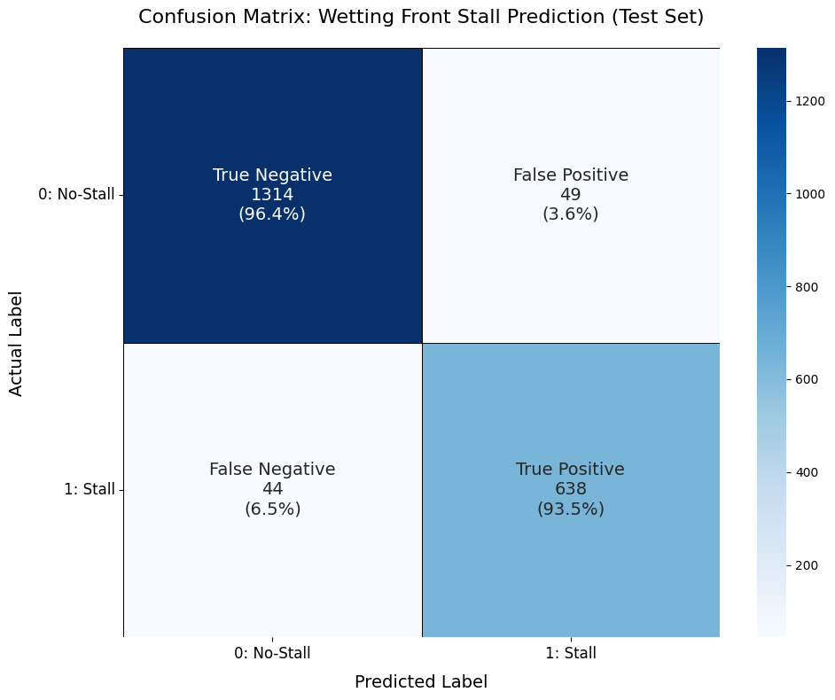
Figure 1: Confusion matrix for the XGBoost model on the unseen test set (2,045 samples). The model correctly identified 1,314 "No-Stall" events (True Negatives) and 638 "Stall" events (True Positives). The model's errors were low, with 49 False Positives (predicting a stall that didn't happen) and 44 False Negatives (missing a stall that did happen). Percentages are calculated relative to the true class.

7. Feature Importance and SHAP Analysis

7.1 SHAP Value Interpretation
SHAP (SHapley Additive exPlanations) values provide model-agnostic feature importance measures that explain individual predictions (Lundberg & Lee, 2017). We conducted the analysis on 200 validation samples. The top 10 features by mean absolute SHAP value are:
Rank | Feature | Mean |SHAP|
1 | interface_stress_ratio | 3.061
2 | interface_layer_distance | 2.275
3 | above_stress | 2.091
4 | above_temperature | 0.555
5 | below_lwc | 0.519
6 | above_bond_size | 0.442
7 | stall_height | 0.440
8 | above_lwc | 0.423
9 | above_density | 0.354
10 | below_bond_size | 0.326

7.2 Feature Importance Comparison
Figure 2 compares three different feature importance metrics: built-in (gain-based), permutation importance, and SHAP values. The three methods provide complementary perspectives on feature relevance.
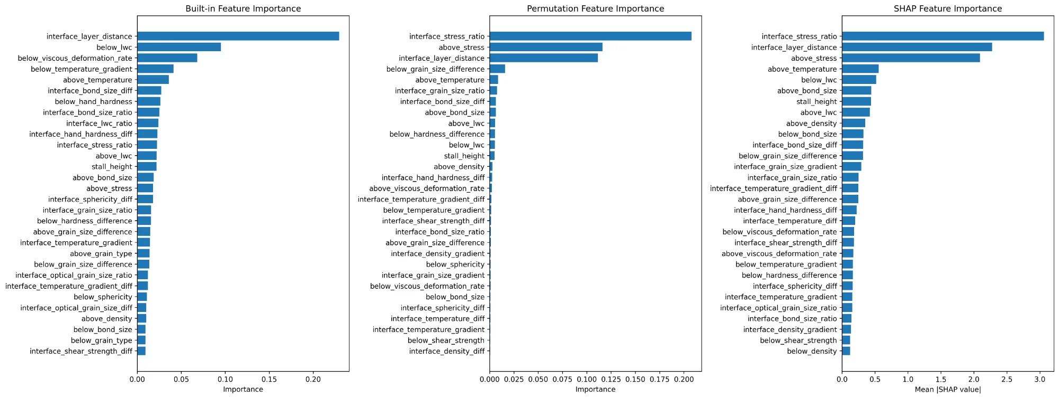
Figure 2: Comparison of feature importance metrics. Left: Built-in (gain-based) importance shows interface_layer_distance as dominant. Center: Permutation importance ranks interface_stress_ratio highest. Right: SHAP values confirm interface_stress_ratio and interface_layer_distance as the top two predictors.
Notably, the three methods show some disagreement in rankings. The built-in importance emphasizes interface_layer_distance and below_lwc, while permutation and SHAP importance converge on interface_stress_ratio and above_stress as top features. This discrepancy highlights the value of using multiple importance metrics: built-in importance measures how often a feature is used for splits, while permutation and SHAP importance measure actual predictive contribution. SHAP values are considered the most reliable as they account for feature interactions and provide consistent attributions.

7.3 SHAP Summary Analysis
Figure 3 presents a beeswarm plot showing SHAP values for individual predictions. Each dot represents a sample, with horizontal position indicating impact on prediction (positive = toward stall) and color indicating feature value (red = high, blue = low). This visualization reveals not just importance but the direction and nature of feature effects.
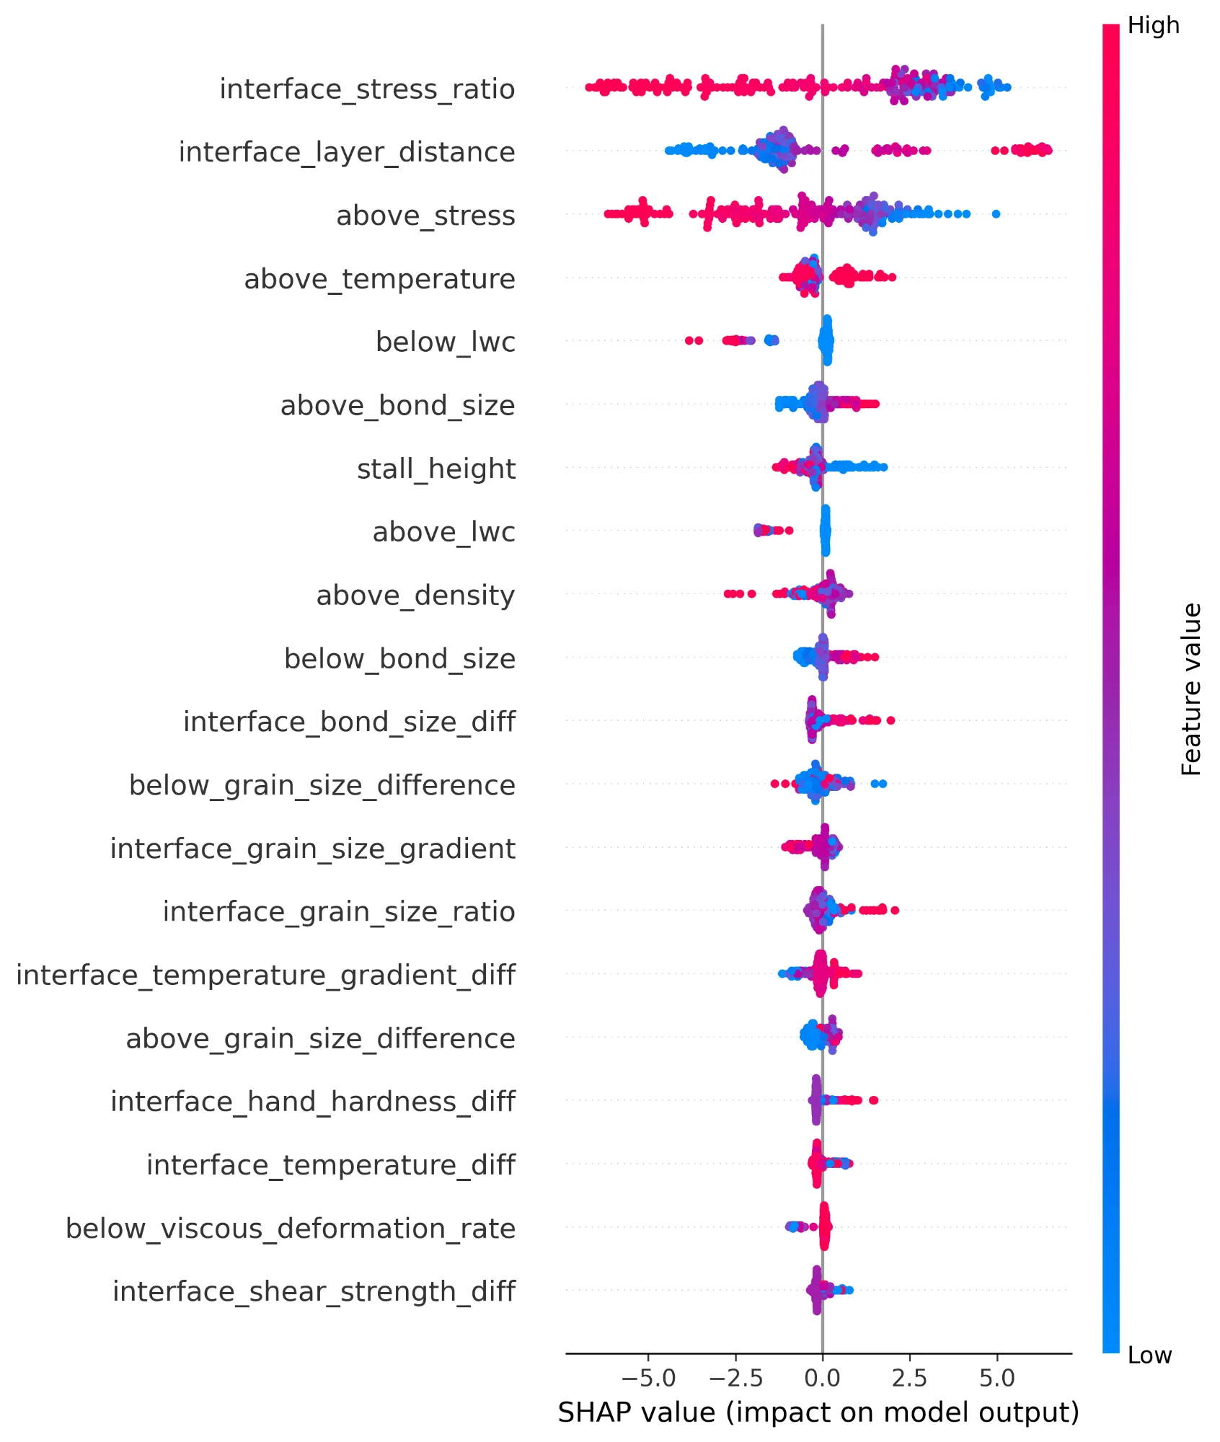
Figure 3: SHAP beeswarm plot for top 20 features. Each dot represents a validation sample (n=200). Horizontal position shows SHAP value (impact on model output), color indicates feature value (red=high, blue=low). Features are ordered by mean absolute SHAP value. The wide spread for interface_stress_ratio (±7) demonstrates its dominant influence on predictions.
Key observations from the SHAP summary plot:
- interface_stress_ratio: Shows the widest SHAP spread (-5 to +7), with complex non-linear patterns where both high and low values appear on both sides of zero.
- interface_layer_distance: Exhibits a clear monotonic relationship—larger distances (red) consistently increase stall probability (positive SHAP).
- above_stress: High stress values (red) push toward negative SHAP (no stall), while low values (blue) push toward positive SHAP (stall).
- above_temperature: Higher temperatures (red) are associated with positive SHAP values, consistent with near-0°C conditions enabling water movement.
- below_lwc: Higher LWC in the lower layer (red) decreases stall probability (negative SHAP), as pre-existing wetness reduces hydraulic discontinuity.

7.4 Physical Interpretation of Key Features
Interface Stress Ratio (Mean |SHAP| = 3.061)
This is the most important predictor by a large margin. The stress ratio captures the mechanical discontinuity at the interface. High stress ratios indicate significant structural differences between layers, which correlate with capillary barriers. The SHAP summary plot shows that both high and low values of this feature strongly influence predictions, suggesting non-linear relationships with stall probability.
Interface Layer Distance (Mean |SHAP| = 2.275)
The physical thickness between layer centers is the second most important feature. Larger distances between layers (thicker layers) create more pronounced discontinuities and longer paths for water to traverse, increasing the likelihood of stalling. The SHAP plot indicates that larger distances (red/high values) push predictions toward stalling (positive SHAP).
Above Stress (Mean |SHAP| = 2.091)
The mechanical stress in the layer above the interface is highly predictive. Higher stress values typically indicate denser, more compacted snow that has different hydraulic properties than the layer below. Interestingly, both high and low values appear to influence predictions differently, capturing complex mechanical interactions.
Temperature and LWC Features
Above_temperature, below_lwc, and above_lwc all appear in the top 10, confirming that thermal state and existing water content are important for predicting stalls. Warmer temperatures (closer to 0°C) facilitate water movement, while existing LWC affects the hydraulic conductivity of the layers.
Bond Size and Grain Properties
Above_bond_size and below_bond_size appear prominently, as do various grain size metrics (grain_size_difference, grain_size_gradient, grain_size_ratio). These microstructural properties directly influence the pore space characteristics and capillary forces that govern water flow through the snowpack. Differences in grain and bond sizes between layers create the hydraulic discontinuities that cause stalls.

7.3 Feature Selection Results
Using SHAP-based feature selection, the model was retrained with only the top 32 features (30 by SHAP importance plus 6 domain-critical features). The reduced model achieved:
- ROC-AUC of 0.9936 (vs. 0.9938 with all 76 features)
- 58% reduction in feature count with minimal performance loss
- Better interpretability and faster inference time

8. Discussion and Conclusions

8.1 Key Findings
This work demonstrates that machine learning can effectively predict wetting front stalls in snowpack with high accuracy. The key findings include:
- Mechanical properties dominate: Interface stress characteristics predict stalls more effectively than traditional metrics like grain type or density alone.
- Layer geometry matters: The physical distance between layers ranks as the second most important feature, suggesting that layer thickness plays a crucial role in capillary barrier formation.
- Microstructure proves critical: Bond size and grain properties appear throughout the top features, confirming the importance of snow microstructure in water flow dynamics.
- Dynamic lookback improves training: Extracting features from the last "dry" state provides physically meaningful baseline conditions for all training examples.

8.2 Limitations and Future Work
Several limitations require attention in future work:
- The model trains on SNOWPACK simulations and requires validation against field observations
- The current approach does not explicitly model temporal dependencies between consecutive stall events
- The model predicts stall occurrence but not duration or severity
- Geographic and climatic variations require testing to assess model generalization

8.3 Conclusions
This machine learning approach to wetting front stall prediction achieves exceptional performance (ROC-AUC = 0.9897) while providing physically interpretable insights into the mechanisms of capillary barrier formation. The SHAP analysis confirms that interface stress characteristics and layer geometry drive stall behavior, aligning with physical understanding of snow hydrology (Wever et al., 2014).
The system represents a significant advancement over rule-based approaches by learning complex, non-linear relationships directly from comprehensive SNOWPACK outputs. By identifying which interfaces will likely stall, this tool can enhance wet slab avalanche forecasting by highlighting areas of potential water accumulation and layer weakening.
Future integration into operational avalanche forecasting systems could provide early warning of dangerous wet snow conditions, potentially saving lives and reducing economic impacts in avalanche-prone regions.

Code availability:

9. References
Baggi, S., & Schweizer, J. (2009). Characteristics of wet-snow avalanche activity: 20 years of observations from a high alpine valley (Dischma, Switzerland). Natural Hazards, 50(1), 97-108.
Breiman, L. (2001). Random forests. Machine Learning, 45(1), 5-32.
Chen, T., & Guestrin, C. (2016). XGBoost: A scalable tree boosting system. Proceedings of the 22nd ACM SIGKDD International Conference on Knowledge Discovery and Data Mining, 785-794.
Friedman, J. H. (2001). Greedy function approximation: A gradient boosting machine. Annals of Statistics, 29(5), 1189-1232.
Hirashima, H., Yamaguchi, S., Sato, A., & Lehning, M. (2010). Numerical modeling of liquid water movement through layered snow based on new measurements of the water retention curve. Cold Regions Science and Technology, 64(2), 94-103.
Ke, G., Meng, Q., Finley, T., Wang, T., Chen, W., Ma, W., Ye, Q., & Liu, T. Y. (2017). LightGBM: A highly efficient gradient boosting decision tree. Advances in Neural Information Processing Systems, 30.
Lehning, M., Bartelt, P., Brown, B., & Fierz, C. (2002a). A physical SNOWPACK model for the Swiss avalanche warning: Part III: Meteorological forcing, thin layer formation and evaluation. Cold Regions Science and Technology, 35(3), 169-184.
Lehning, M., Bartelt, P., Brown, B., Fierz, C., & Satyawali, P. (2002b). A physical SNOWPACK model for the Swiss avalanche warning: Part II: Snow microstructure. Cold Regions Science and Technology, 35(3), 147-167.
Lundberg, S. M., & Lee, S. I. (2017). A unified approach to interpreting model predictions. Advances in Neural Information Processing Systems, 30.
Wever, N., Fierz, C., Mitterer, C., Hirashima, H., & Lehning, M. (2014). Solving Richards Equation for snow improves snowpack meltwater runoff estimations in detailed multi-layer snowpack model. The Cryosphere, 8(1), 257-274.
Wever, N., Würzer, S., Fierz, C., & Lehning, M. (2016). Simulating ice layer formation under the presence of preferential flow in layered snowpacks. The Cryosphere, 10(6), 2731-2744.

